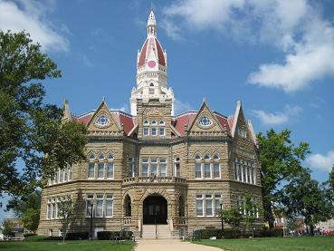
EMPLOYMENT OPPORTUNITY
Pike County is seeking applications for the position of Courthouse Maintenance Person. The responsibilities include daily janitorial duties, along with regular maintenance of the Pike County Courthouse, Courthouse grounds, Annex and Annex grounds. Assisting during events held on the Pike County Courthouse and Annex Grounds is required. General electrical, plumbing and carpentry abilities are required. Must have a valid driver’s license. Must have a positive attitude and able to work well with others along with an appreciation and respect for historical buildings. Salary is based on experience. Benefits for the position include IMRF retirement along with medical, dental/vision insurance and vacation, paid holidays and wellness reimbursements. Other benefits discussed during interview.
You can pick up applications at the Pike County Sheriff’s Department. All applications and resume’s must be dropped off no later than September 18th at 4:00 PM. Interviews will be conducted on September 19th and 20th.

