Pike County 708 Board

Notice of Funding Availability
FY 2022 (July 1, 2021 to June 30, 2022)

The Pike County 708 Board is seeking funding proposals for its fiscal year funding cycle. The Pike County 708 Board ensures there are services in Pike County in the areas of mental health, substance abuse prevention/intervention, and developmental/intellectual disabilities for all residents. Applications will be accepted from individuals, public, and private entities pursuant to the authority contained in the Community Mental Health Act, ILCS, Chapter 405, Act 20, Section 0.1, and et. seq.

The Pike County 708 Board reserves the right to begin negotiations with selected providers for all, or a part of the proposal components.

FY 2022 Total Funding Availability: $120,000

Who May Apply:

Applications for funding may come from an individual, public, or private entity that provides mental health, substance abuse prevention/intervention, and/or intellectual/developmental disability services to residents of Pike County. The applicant must demonstrate sound business practices for a minimum of two years prior to the submission of an application.

Both for-profit and not-for-profit corporations/organizations are eligible to apply for funding. If an applicant is a not-for-profit organization, the agency must be registered as a not-for-profit organization, in good standing, with the Illinois Secretary of State and must be established as a Section 501(c)(3) under the Internal Revenue Code.

Both must be appropriately licensed by the applicable state, national board or organization and demonstrate financial reliability and stability. It must demonstrate fiscal and administrative accountability. Applicants are encouraged to have a board of directors' representative residing in Pike County. Any 708 Board member with a conflict of interest related to an application will recuse themselves of voting on grant applications for that grant cycle.

Funding Timeline:

Applications will be available on May 4, 2021
Applications will be due by 3 p.m. June 4, 2021
(See below for submission guidelines)
Funding Announcements will be made on June 12, 2021
Funding is for the Pike County 708 Board Funding cycle of July 2021 to June 30, 2022. First Funding Installment will be made on July 1, 2021 Progress report will be due by 3 p.m. on October 15, 2021
Second Funding Installment will be made on October 30, 2021, pursuant to progress report. See application for further details regarding the mandatory progress report.

Submission Guidelines:

• Forms can be obtained by
a) downloading the application from the Pike County, IL website: www.pikecountyil.org. or

b) obtaining a blank application from: Pike County Clerk
121 E Washington Street Pittsfield, IL 62363

• Make a copy of the completed application for your files. Keep the last page for the Progress Report. If awarded funding, you will be required to submit a Progress Report based on the information provided on your application.

• Submit completed application, the required documentation, and SEVEN copies of BOTH the application AND required documents no later than 3 p.m. on June 4, 2021 to:
Pike County Clerk
121 E Washington Street Pittsfield, IL 62363
Forms may NOT be submitted electronically
If you have questions about the application process, please contact Pike County 708 Board Chair, Pollee Craven at 217-320-9190.

Evaluation Process:

All allocations and contracting decisions are made in meetings open to the public. Allocation decisions will be based on statutory mandates, priorities and defined criteria related to the needs assessment completed in partnership with The Pike County Health and Wellness Foundation. Decisions will be prioritized based upon completion of the application process, submittal of required forms and documentation, and how well the application matches the statutory mandates, priorities and criteria of the Pike County 708 Board.

Emphasis will be placed on the proposal's strength in addressing the criteria within the application.

Notification Process:

Funding recipients will be notified by mail, at the address provided on the application.

Grant recipients must participate in the formal funding award announcement and photo.

Page I 2
Progress Report Requirements:

• Pike County 708 Board contracts shall specify the relationship between funding, and the services provided to Pike County residents.
• Funding shall not be used for purposes other than those specified in the application.
• All funding is for the sole purpose of providing direct services to Pike County residents. It may only be used for the specific services reported in the submitted application.
• It is not to be used to pay for services provided in the past, but to fund future services as outlined in the application.

Recipients will be required to provide a Progress Report to the Pike County 708 Board no later than October 15, 2021.

Required Information will include:
• a report of money spent toward program objectives,
• the effectiveness of the services provided toward the program objective, method of evaluating the effectiveness, as well as any data accumulated,
• progress made toward goals/benchmarks that were provided on the application,
• total number of Pike County residents served, July 1, 2021 - October 1, 2021, the type of services provided to those Pike County residents.

To ensure that your application is complete, please review

FY 2022 Application
Budget Documents - current year's operating budget documents to include both projected expenses and revenues
Program Budget
Board of Directors Information (if applicable) Most recent Annual Report

Information provided is required to ensure the applicant meets the standards and the requirements stated in the document.

Page I 3
Pike County 708 Board FY 2022 Funding Application

All applications are due by 3 p.m. on June 4, 2021

Please use this application form to apply for Pike County 708 Board Funding for FY 2022. Other computer­ generated forms will not be accepted. Submit the completed application form, all other supporting and required documents, and SEVEN copies to:

Pike County Clerk
121 E Washington Street Pittsfield, IL 62363

If you need more space to answer a question, please include the extra page directly after the page that contains the question, and please label each additional sheet with the coordinating question number.

Date: ______________

Name of Agency: _____________________________

Maailing Address: _____________________________

Contact Person: ______________________________

Phone Number:

Email Address:

Agency Website: _________

What type of services are you requesting 708 Board Funds: (check all that apply)

___ Mental Health ____ Developmental/Intellectual Disabilities ___Substance Abuse

Total Amount of Funds Requested $ ___________

Is your agency accredited and/or licensed? __Yes __ No

If yes, list licensing/accrediting agency: ____________________

Have you applied for accreditation?

__ I have applied and am awaiting results from __________________

__ I have applied and been denied licensing/accreditation from _____________

__ I have not applied for licensing or accreditation

Page J 1
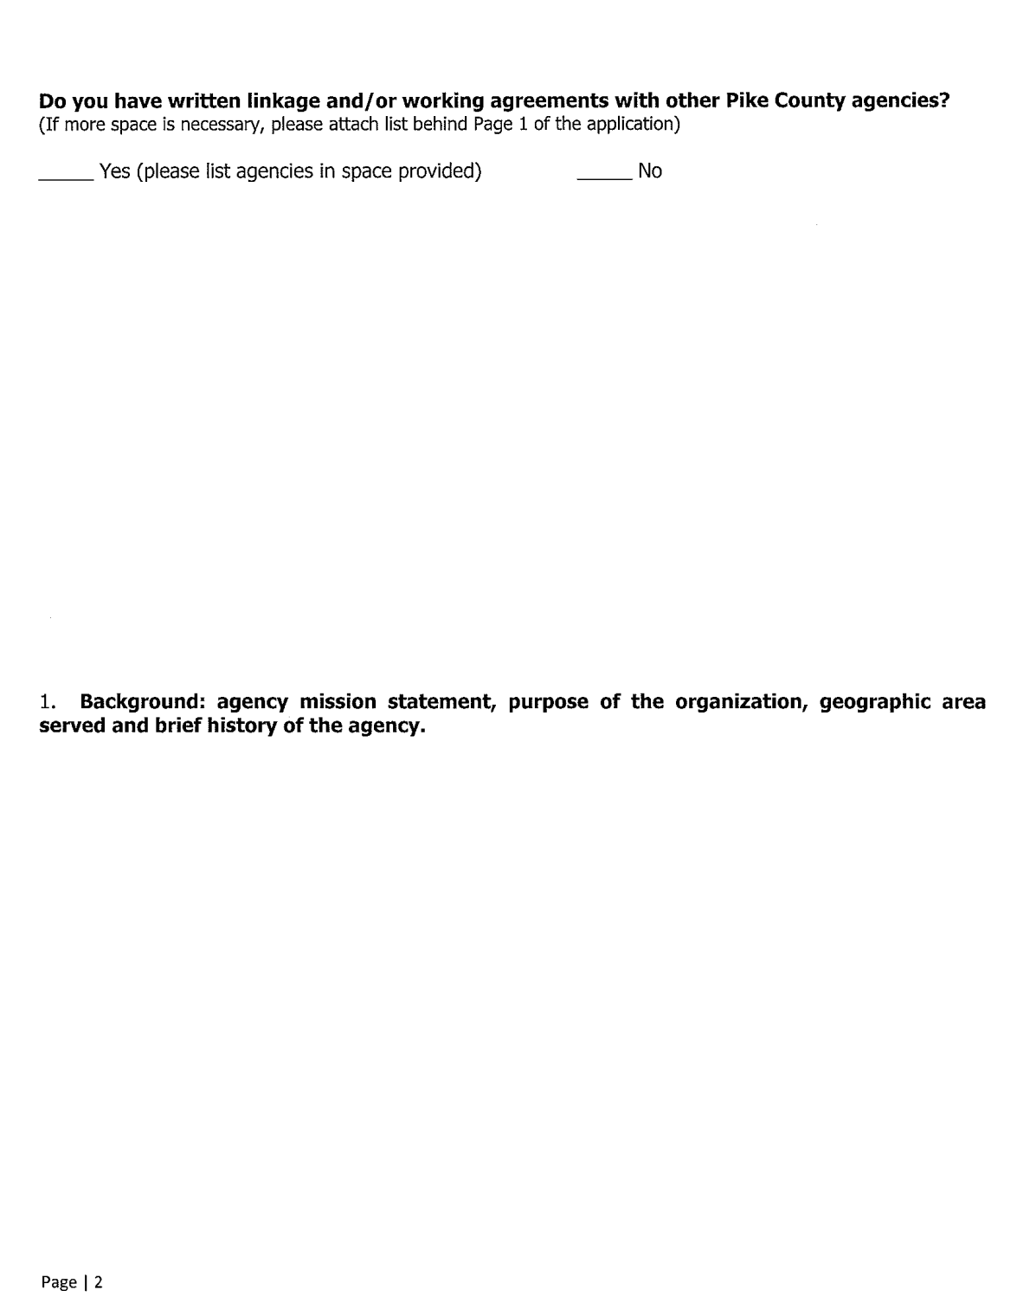
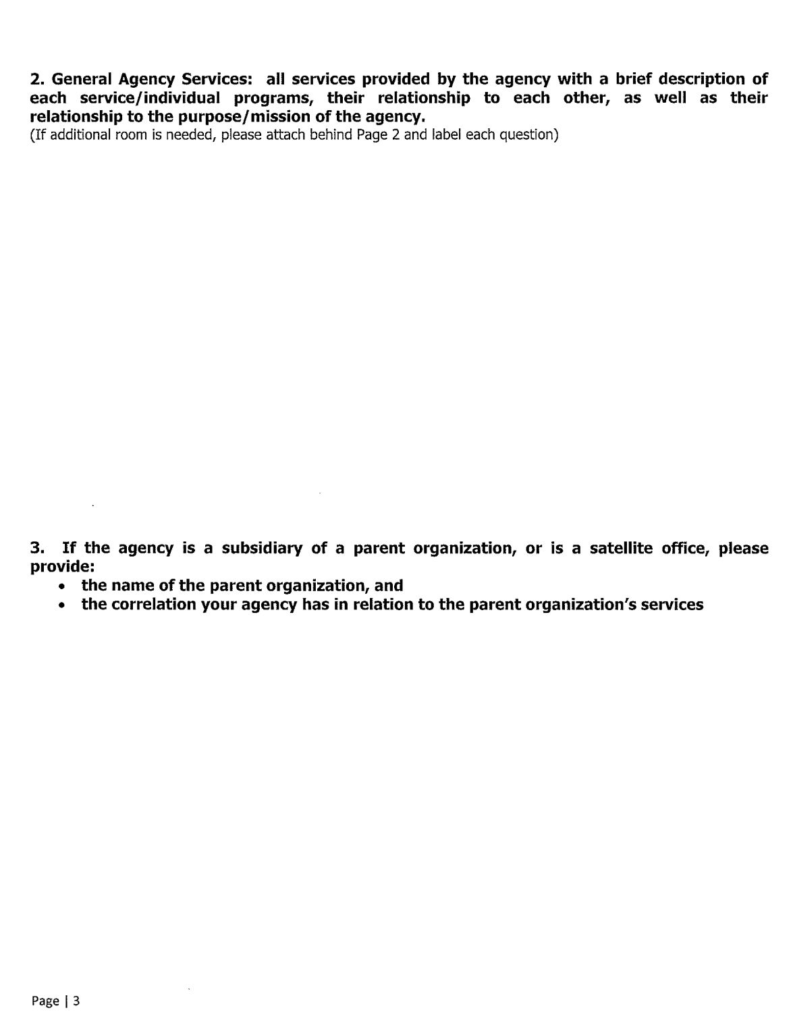
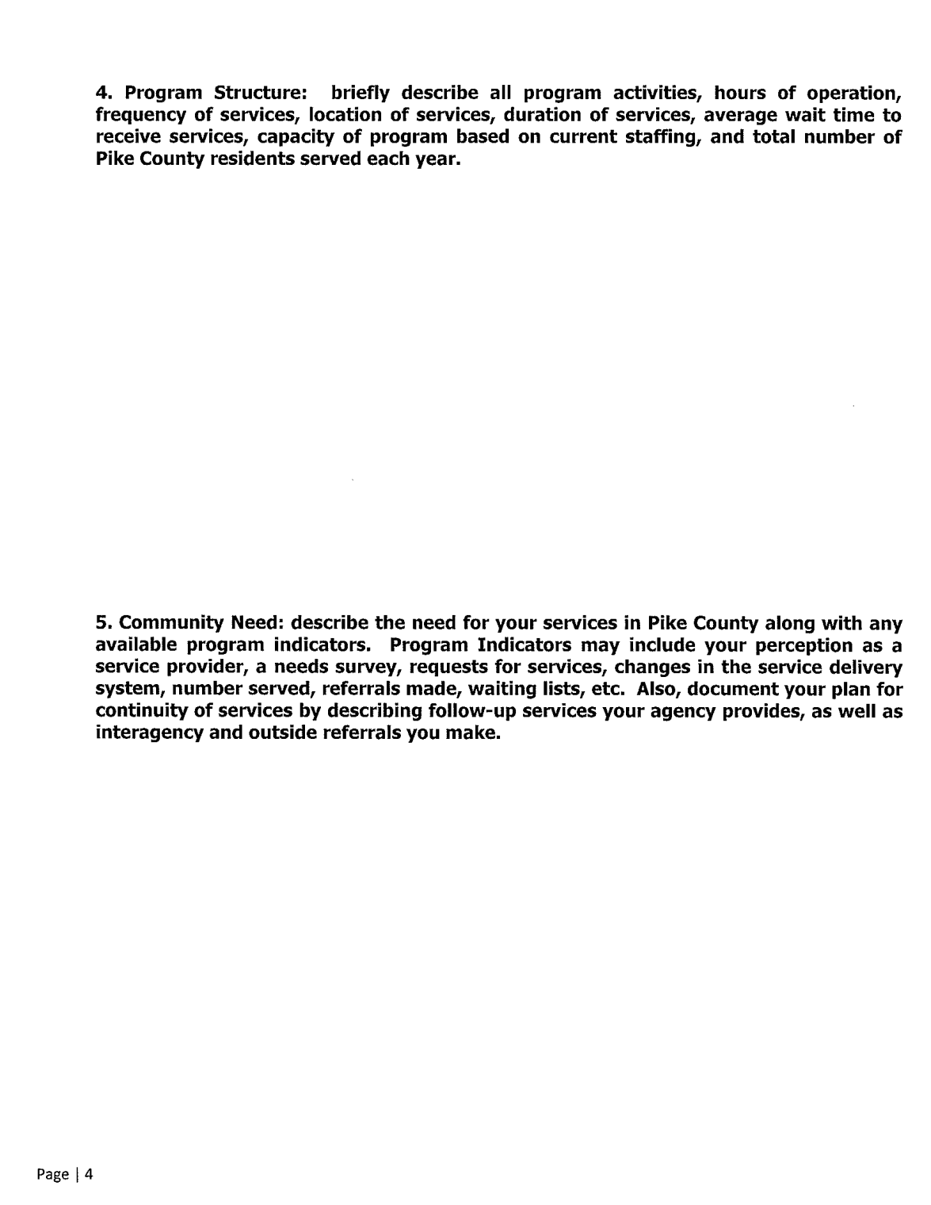
7. Request for Funds:

• describe the specific program you are requesting funding assistance,
• the types of support you will provide,
• the number of Pike County residents you expect to serve,
• any changes in the services currently provided,
• the expected goals, objectives and benchmarks of the service, and
• the results you expect to achieve by June 30, 2021, and
• how you plan to measure the effectiveness of the program.

If you are requesting funding for an existing program, please provide a summary of your outcome measurements for your most recent (completed) fiscal year, using the criteria listed.

Page I 6
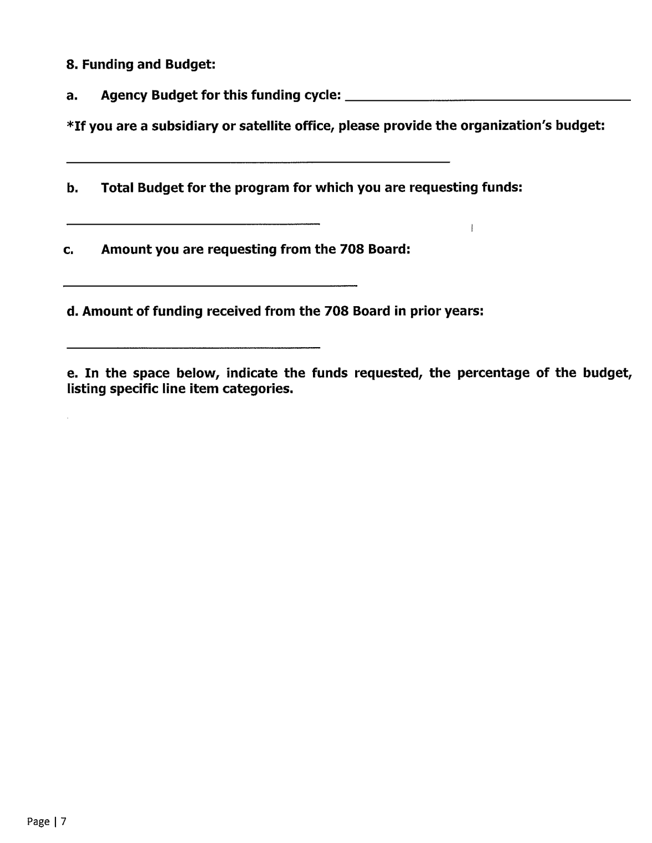
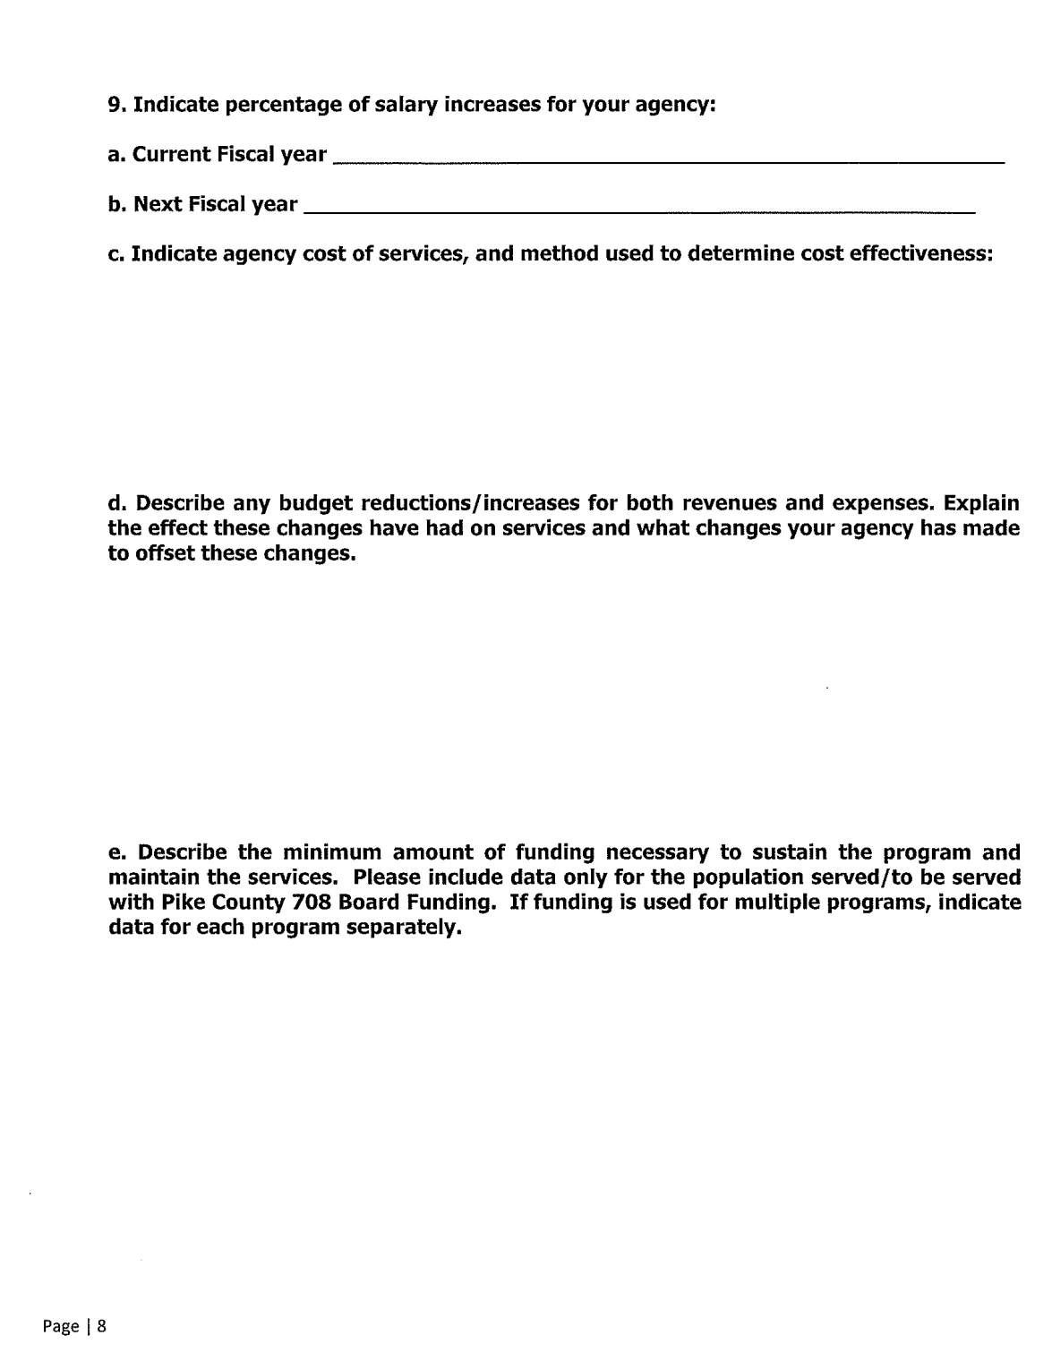
By signing this application, I certify the statements contained are true, complete and accurate to the best of my knowledge. I have provided the required documentation and I agree to adhere to the services as presented in the application. I will comply with any resulting terms when an award is accepted. I am aware that any false, fictitious or fraudulent statements of claims may subject me to criminal, civil or administrative penalties. I understand that the funding disbursement is contingent on the availability of tax revenues collected by Pike County. I understand that in order to receive further installments of funding, I am required to submit a Progress Report, no later than October 15, 2021, to be reviewed by the 708 Board.

Signature: ______________________________

Date:--------------------------------

Printed Name and Title:

Page I 9
Please Remove Page 10 prior to submitting your cation!

Progress Report due no later than October 15, 2021
(Please remember to make a copy of your application and remove this sheet prior to submitting. This will be the required report if the Board chooses to fund your request.)

Describe the Progress you have made toward your Program Objective, Goals and Benchmarks as outlined on your Funding Application. Detail the percentage of money spent toward the total funding request, demographic information of Pike County residents served, and any other information you wish to provide.

Page I 10
Pike County 708 Board FY 2022 Grant Agreement

__________________, (Grantee) has been awarded a grant by the Pike County 708 Board for the amount of$ ________. The purpose of the Pike County 708 Board is to plan, fund, coordinate and evaluate the public services available to Pike County residents in the areas of mental health, substance abuse, and developmental/intellectual disabilities. Funding awarded by the Pike County 708 Board is only for the purpose set forth in the FY 2022 Grant Application.

1. The Pike County 708 Board will distribute funds for FY 2022 in two separate payments. The first scheduled payment is July 1, 2021 and the second is October 30, 2021.
2. The second disbursement will be contingent on the completion and approval of the progress report due no later than October 15, 2021. The Pike County 708 Board will review the report.
3. The Pike County 708 Board shall have the right to request further documentation of all use of funds awarded to the Grantee.
4. The Pike County 708 Board may terminate or suspend payment of funds, in whole or in part, if the Board decides it is necessary or advisable. The Board will notify the Grantee in writing if there is any reduction or termination of grant funds.
5. By accepting funding by the Pike County 708 Board, the Grantee agrees to provide, for audit purposes, copies of all future documented expenditures and/or obligations to the Pike County 708 Board, in accordance with generally accepted auditing and statistical standards.
6. The Grantee agrees that any funds provided are for future services and not recoupment of payment for services provided in the past.
7. The Grantee agrees that any funds provided are solely for the benefit of services provided to the citizens of Pike County, IL.
8. The Grantee certifies that it agrees to use the grant funds provided for the sole purpose outlined in the application provided to the Pike County 708 Board.
9. By signing this agreement, the Grantee understands that any violation of the Pike County 708 Board grant agreement can cause a reduction or termination of grant funding.

The grant amount awarded to ___________________ (Grantee) for FY 2022 is

in the amount of $ _______________ ,

Grantee Representative:

Signature Date

Pike County 708 Board Representative:

Signature Date

