Pike County Board

Meeting Minutes
November 25, 2019
- Call to order
Chairman Andy Borrowman called to order the regular meeting of the Pike County Board at 7:00 p.m. in the upper courtroom of the Pike County Courthouse.
- Jerry Edison gave the invocation and Chairman Borrowman lead in the Pledge of Allegiance.
- Roll call
Secretary Name conducted a roll call. The following persons were present: John Birch, Andy Borrowman, Amy Gates, Rodger Hannel, Tom Lewis, Derek Ross, Jim Sheppard and Mark Sprague.
- Approval of Minutes from October 28th, 2019.
John Birch made a motion to approve the October 28th, 2019 County Board Minutes. Tom Lewis seconded. Voice vote 8-0. Minutes approved.
- Approval of 2019 additional County holiday.
Local 965 Union agreed to utilize their bonus holiday on Tuesday, December 24th, 2019. Amy Gates made a motion to approve the recommended holiday. John Birch seconded. Voice vote 8-0. Motion approved.
- Approval of 2020 County holidays.
Rodger Hannel made a motion to approve the recommended 2020 holiday schedule. Tom Lewis seconded. Voice vote 8-0. Motion approved.

- Approval of 2019 Budget Amendments
Jim Sheppard gave a summary of the presented budget amendments. Rodger Hannel made a motion to approve. Mark Sprague seconded. Voice vote 8-0. Motion approved.
- Approval of 2020 Budget
Jim Sheppard presented the 2020 budget for approval. Rodger Hannel made a motion to approve 2020 budget. Mark Sprague seconded. Voice vote 7-1. Motion approved. Rodger Hannel made a motion to approve the 2019-2020 Fiscal year Appropriation Resolution. Tom Lewis seconded. Voice vote 7-1. Motion approved. Mark Sprague thanked all involve in the budget process as the budget was able to be balanced without raising taxes. Chairman Andy Borrowman stated the board has done a good job over the years with the budget and that the rising EAV’s has contributed. Tom Lewis made a motion to approve the 2019-2020 Statement of Tax Levies Resolution. Rodger Hannel seconded. Voice vote 7-1. Motion approved.

- Action on proposed full and final release of all claims in the matter of The County of Pike v. The Valley City Drainage and Levee District; and Brice Lawson, Richard Byers, and Lane Wiese, in their official capacity as Commissioners of the Valley City Drainage and Levee District, 2017-MC-1.
Mark Sprague made a motion to release all claims. Jim Sheppard seconded. Voice vote 7-1. Motion approved.
- Appointment of Jeremy Thomas to the Rural Pittsfield Fire Protection District for a term to expire in May 2022.
Tom Lewis made a motion to appoint. Mark Sprague seconded. Voice vote 8-0. Motion approved.
- Solar Ordinance
John Birch made a motion to approve the proposed Solar Farm ordinance. Derek Ross seconded. Voice vote 8-0. Motion approved.
- County Anticipation Note
Treasurer Scott Syrcle addressed the board regarding the financial strain the county is under in the month. He summarized the bids for the 2020 anticipation note and stated that the lowest interest was Farmers State Bank at 2.47%. Tom Lewis made a motion to approve the anticipation note from Farmers State Bank. Jim Sheppard seconded. Voice vote 8-0. Motion approved.
- Committee Repots
Finance
The finance committee of the Pike County Board met at 5:00 p.m. on Wednesday November 13, 2019 in the conference room of the Pike County Government building. Members present were Amy Gates, Rodger Hannel, Board Chairman Andy Borrowman, and Jim Sheppard. Also present were Scott Syrcle, Natalie Roseberry, Zack Boren, Don Beard, the finance committee of the Board of Health, David Greenwood, Anita Andress and other health Department employees.
On a motion by Amy Gates and a second by Rodger Hannel, routine bill sin the amount of $106,490.55 were approved for payment.
It was noted that 2019 budget amendments and a copy of the 2020 budget were posted for review downstairs for full board action at the November meeting.
County Treasurer Scott Syrcle brought the bids for the county’s anticipation note for 2020. He stated that we would need to start using the note in December. The bids were as follows:
Farmers State Bank 2.47%
United Community Bank 2.79%
Carlinville National Bank 3.55%
Great Rivers Bank 3.05%
Rodger Hannel made a motion that we recommend for full board approval the bid of 2.47% from Farmers State Bank. Amy Gates seconded. Motion carried.
After Sheriff David Greenwood gave us a brief update on the purchase of a new car, we turned to the subject of the amount of money owed to the general fund for health insurance from the health department. Julie Plattner gave a presentation and figures were presented that were th result of a cooperative effort by the health department, the clerk’s office and the board. These are reflected in the attached document.
Rodger Hannel made a motion to accept the figure of $237,707.00 as the figure that the Health Department owes the general fund for the employer share of health insurance and that this amount is as of October 31, 2019. This is the figure to be used as the basis for the document forgiving $60,000.00 of previously paid liability insurance and transferring that amount from Liability insurance to general fund. Amy Gates seconded. Motion carried.
Julie Plattner next inquired about a plan going forward. It was stated that the health department could make their current health insurance payments but at this time they could not work on the $177,707.00 remaining balance. Rodger Hannel made a motion that we revisit this issue at the June 10th, 2020 finance meeting and invite members of the Board of Health to attend and discuss the matter. Amy Gates seconded. Motion carried.
After a review of health department bills and their process to pay, Amy Gates made a motion to adjourn. Rodger Hannel seconded. Motion Carried
Treasurer Scott Syrcle talked about the repayment of the County’s loan for the general fund and stated that it would be very tight on the repayment.
Meeting adjourned at 6:25 p.m. on a motion by Amy Gates and a second by Rodger Hannel.
Derek Ross had some questions regarding the liability fund transfer. Jim Sheppard stated that it was due to an overpayment in 2018. Derek asked who is responsible for the insurance billing of the internal departments. Jim Sheppard stated that Natalie Roseberry is currently working on that.
John Birch made a motion to approve amended finance committee report. Rodger Hannel seconded. Voice vote 8-0. Report approved.

Highway
The Road and Bridge Committee met Wednesday, November 14th, 2019 at 3:30 p.m. at the County Highway Department. The meeting was called to order at 3:30 p.m. Members present were Rodger Hannel, John Birch, Mark Mountain, and Andy Borrowman. Staff Present were Gary Laux Chris Johnson
No public comment.
A motion was made by John Birch seconded by Rodger Hannel to pay claims per claim reports dated November 13, 2019. All in favor. Motion carried.
A motion was made by John Birch, seconded by Rodger Hannel to approve the Fairmount Township Half Aid to Bridge project located on 352nd Ln in the Southeast Quarter of Section 30. Total project cost is $4,489.30, $2,244.65 to be paid from the County Road and Bridge Fund. All in favor. Motion carried.
A motion was made by John Birch, seconded by Rodger Hannel to approve the 2020 County and Township MFT Estimates in the sum of $649, 574.00 for the County and $1,961,692.50 for the Townships.
County Engineer’s report gave an update on the current veto session bill. Efforts continue regarding the recently closed bridge in Cincinnati Township and the County Engineer is working with the Sny Drainage District on a resolution. The Hadley Township emergency half aid project was discussed. An update was given on the Kiser Creek Bridge project. At this time construction is on hold while waiting on the beams to be delivered.
Employees salaries were discussed. No action taken.
A motion was made by John Birch, seconded by Rodger Hannel, to adjourn meeting at 3:48 p.m. Motion carried.
Tom Lewis made a motion to approve Half Aid to Bridge for Fairmont Township. John Birch seconded. Voice vote 8-0. Motion approved.
Amy Gates corrected the reporting of the section.
John Birch made a motion to approve the 2020 Motor Fuel Tax. Tom Lewis seconded. Voice vote 8-0. Motion approved.
Tom Lewis made a motion to approve the Highway committee amended minutes. Amy Gates seconded. Voice vote 8-0. Motion approved.
Building and Grounds
The Building and Grounds Committee met on Wednesday, November 20th, 2019 at 3:30 p.m. Present were Tom Lewis, Derek Ross, Rodger Hannel, Andy Borrowman, Sheriff David Greenwood, and Scott Syrcle.
Sheriff Greenwood began by updating the committee on several topics:
            - Lights are being installed to highlight the three new busts on the southwest corner of the Courthouse Law.
            - Ameren has offered approximately $15,000.00 to pay for the electrical surge that damaged electronics, etc. at the jail. Sheriff Greenwood stated that the damage estimate is closer to $19,000.000, so he will continue to negotiate with Ameren to cover these costs.
            - Joe Petty has told Sheriff Greenwood that work on the Courthouse security remodel will begin when all materials are received.
            - Sheriff Greenwood will discuss the cleaning schedule of the Annex building with Burdett Irwin.
            - The Annex roof project will be rebid in December 2019.
            - A county police resource officer will begin working with Western, Griggsville-Perry, and Pleasant Hill school districts beginning December 1, 2019. Costs for the resource officer will be shared equally among the three school districts and the Sheriff’s office.
The B & G committee approved a motion by Tom Lewis and seconded by Derek Ross to recommend to the full County Board that IDOT be permitted to install handicap access ramps to the south side Courthouse corners located along the state highway. If approved, Andy Borrowman will sign the agreement with IDOT. Motion passed.
Tom Lewis gave a detailed report on the location and use of the four outside electric meters located on the courthouse lawn, after much discussion, the B & G committee decided by consensus to leave the outlets and their use “as is” without changes.
The B & G committee decided to refer a request from a fiber optic company to the Transportation Committee as to an agreement to locate their lines on the county roads right of ways. Recently, “Uniti Telecommunications” has purchased already-installed fiber lines from the McLeod company. The Uniti company wants a new agreement signed with Pike County.
Tom Lewis made a motion to approve paying the bills totaling $5,455.58. Derek Ross seconded the motion, and it passed.
Derek Ross made a motion to adjourn the meeting at 4:32 p.m., and Tom Lewis seconded the motion. The motion passed.
Amy Gates made a motion to approve the agreement with IDOT to do walkways south east and southwest of the Courthouse lawn. John Birch seconded. Voice vote 8-0. Motion approved.
Tom Lewis made a motion to approve the Building and Ground committee minutes. Amy Gates seconded. Voice vote 8-0. Motion approved.
GIS/IT
The monthly meeting of GIS/IT was called to order at 5:30 p.m. on Wednesday, November 20, 2019 in the upstairs conference room of the Pike County Jail. Members present were Amy Gates, Mark Sprague, and Chairman Andy Borrowman, Dan Brennecke, Paula Dean, and Sandy Schacht.
Routine bills in the amount of $6,087.15 were approved for payment on a motion by Amy Gates and a second by Mark Sprague.
Sandy Schacht gave an update on the transition from Marco to GFI of our managed IT. The monitoring, antivirus, and ticketing systems are all in place. Installation of hardware should take place in December with top priority given to the government building due to unresolved issues from our last provider. It will take an adjustment period to get in the swing of the new ticketing system and Sandy had some suggestions for the office heads.
We discussed the Barracuda backup annual renewal. Sandy said she would have this resolved by the next meeting so we can bundle the renewals.
We also had a brief discussion about the next administrators meeting. We would like to cover hiring and firing practices.
Meeting adjourned at 6:21 p.m. on a motion by Amy Gates and a second by Mark Sprague.
Amy Gates made a motion to approve the GIS/IT committee minutes. Mark Sprague seconded. Voice vote 8-0. Motion approved.
Public Safety
The Pike County Public Safety Committee was called to order at 7:11 p.m. on November 20th, 2019. Those in attendance were committee members Derek Ross, Andy Borrowman, Tom Lewis, Amy Gates, Pike County Ambulance Administrator Josh Martin, and assorted guests.
Opening bids to borrow funds to finance the replacement of a police vehicle were the following:
Farmers State Bank 2.478%
CNB Bank and Trust 3.16%
Great Rivers Bank 3.40%
UCB 3.4%
A motion was made by Tom Lewis and seconded by Amy Gates to forward the bids onto the full board for their consideration and action.
Old Business was addressed by Sheriff David Greenwood updating the committee regarding the ongoing joint effort of the Sheriff’s Department, Pleasant Hill, Griggsville-Perry and Western School Districts and the implementation of a School Resource Officer to be shared between the districts. The cost of this new position is to be split evenly between all four parties. Also, the Insurance bill continues to be at the same amount and there is now confusion of how many employees are to be billed to the Ambulance Department. Jeanna and Josh will work and try and come to some reconciliation of the amount required.
New business was reported to the Chairman of the Public Safety Committee that the Full-Time EMT’s and Full-Time Paramedics of the Pike County Ambulance Department have joined a union. Therefore, all future labor negotiations for those employees will be handled by the Labor Committee. It was further discussed that Administrator Martin will get more details in the appropriate was to follow and implement disciplinary actions, should the need arise.
Administrator Marin updated the committee that there was only one response to the RFP send out requesting a bid on updating the Multi-Jurisdictional Natural Hazards Mitigation Plan (NHMP). American Environmental, the responding vendor, proposed a Cost Estimate stated “The entire cost to update the Pike County NHMP would be funded through a FEMA planning grant. This grant includes a 20% local match which AEC anticipates will be met through local participation and in-kind services.” It was addressed that there is potential Workman’s Compensation claim and asked for direction on who to contact regarding the issue. The committee recommended that he reach out to Natalie Roseberry. Starting in 2020, The Pike County Ambulance’s Medicaid reimbursement should be increasing.
There were no public comments
Amy Gates made a motion and seconded by Tom Lewis to pay bills in the amount of $32,366.69. The motion passed.
Amy Gates made a motion and seconded by Tom Lewis to adjourn. The motion passed and the meeting adjourned at 7:59 p.m.
Mark Sprague made a motion to approve the loan for the police vehicle through Farmer State Bank with an interest rate of 2.478% reimbursed within 4 years by the city of Griggsville. John Birch seconded. Voice vote 8-0. Motion approved.
Josh Martin summarized the HAZMAT plan to the county board and Tom Lewis made a motion to approve the facilitation by American Environmental. Derek Ross seconded. Voice vote 8-0.0 Motion approved.
Rodger Hannel made a motion to approve the Public Safety committee minutes. Amy Gates seconded. Voice vote 8-0.

- New Business
Board Members should have received in email form a copy of the recommended County Cannabis, Drug and Alcohol Use Abuse Policy. This policy will be on the agenda for approval in December.
- Old Business
- Derek Ross stated that he had requested additional information from Snedecker’s and the Hope Trust regarding re-insurance rates, PPO rates, administrator rates, and any other fees the Hope Trust includes in its health insurance rates. Some concerns were expressed on how the reinsurance was paid and the involvement of the county’s Liability fund. Derek Ross also asked Jim Sheppard if the HOPE Trust would be considered a joint-self-health -insurance-cooperative. Mr. Sheppard was not certain but believed it is. Jim Sheppard stated that he would check with Snedeckers on the rates and fees requested.
Treasurer Scott Syrcle stated that the county was $288,000.00 short to repay the anticipation note due at the end of November. He expressed some concerns regarding the Health Departments payments and the Liability fund. It was decided that the Treasurer would do an inter fund loan to make up the shortage.
- Chairman’s Remarks
None
- Summary of Expenses for the Month/Mileage & Per Diem Report
Motion to approve made by John Birch. Seconded by Amy Gates Voice vote 8-0. Summary and Report approved.
- Questions from Press and Visitors
Mike Boren requested some clarification on the presented budget.
- Closed Session pursuant to 5 ILCS 120(c)(11), pending probably/imminent litigation.
Tom Lewis made a motion to enter into closed session. John Birch Seconded. Voice vote 6-0. Motion passes
Closed Session entered: 8:18 p.m.
Closed Session exited 9:30 p.m.
- Action on proposed settlement agreement and release of all claims in the matter of Roger W. Hulbert d/b/a Sage Information Services v. Cindy A. Shaw, 2019-MR-83.
Rodger Hannel made a motion for settlement. John Birch seconded. Voice vote 6-0. Motion carried.
- Action on proposed full and final release of all claims in the matter of the County of Pike v. The Valley City Drainage and Levee District; and Brice Lawson, Richard Myers, and Lane Weise, in their official capacity as commissioners of the Valley City Drainage and Levee District, 2017-MC-1.
Tom Lewis made a motion to table the release of claims. Derek Ross seconded. Voice vote 6-0. Motion carried.
- Adjourn
Tom Lewis made a motion to adjourn. Seconded by John Birch. Voice vote 6-0. Meeting adjourned at 9:31 p.m.
Minutes submitted by: Natalie P. Roseberry
Minutes approved by: (Pending Board Approval)

SOLAR FARM
PROPOSED
Pike County Zoning Ordinance Amendment
ARTICLE Xl - RULES AND DEFINITIONS
Sec. 11.2 Definitions
Fence. A continuous barrier from the surface of the ground to a uniform height; constructed of wood, stone, steel, or other metal, or any substance of similar nature and strength.
Front. All property on one (1) side of a highway, road, street, alley, or other public way.
Solar Farm. A solar panel or array composed of multiple solar pane's on groundmounted rack or poles which are one of the primary use(s) for the parcel of land on which it is located, or any solar energy system that has a primary purpose for wholesale or retail sates of generated electricity. The term Solar Farm includes any associated cabling, devices, equipment, and structures located on site that are associated with the operation of a solar farm. The use of solar collectors for residential or business consumption that occurs on site is not considered a Solar Farm.
ARTICLE - ZONING DISTRICTS
Sec. 3.4 Agricultural District (A)
1. Permitted Uses
(h) Solar Farms (SF or SFS) which meet the following requirements:
A. Solar farms, also known as solar power plants and solar energy generation facilities, shall be permitted in the A district as a Permitted Use, in accordance with the following minimal regulations and design standards. The County has the right to enter the premises of a Solar Farm at any time to inspect and ensure continued compliance with all requirements of this Ordinance. Furthermore, in the discretion of the Zoning Administrator or the County, the County may hire a private engineering firm to give an opinion about whether an applicant has met all requirements under this ordinance, and all applicable laws and regulations, prior to issuing a building permit. The applicant shall bear the costs of this private engineering review, if the County requires it.
1. Design standards. The design standards and bulk regulations listed in the A - Agriculture district for setbacks, lot size, lot coverage, lot area, height, and signage shall be suspended for all SFS and the following regulations shall apply instead. All other design standards and bulk regulations of the district shall apply.
- Foundations - The manufacturer's engineer or another qualified engineer shall certify that the foundation and design of the solar panels is within accepted professional standards, given local soil and climate conditions.
- Other Standards and Codes- All SFS shall be in compliance with any applicable local, state and federal regulatory standards, and the National Electric Code as amended.
- Power and Communication Lines — Power and communication lines running between banks of solar panels and to electric substations or interconnections with buildings shall be buried underground as follows: a minimum of five (5) feet of top cover where they cross Cropland; a minimum of five (5) feet of top cover where they cross pastureland or other non-Cropland classified as Prime Farmland under the Illinois Department of Agriculture's Standard Agricultural Impact Mitigation Agreement Pertaining to the Construction of a Commercial Solar Energy
Facility (hereinafter the "Standard AIMA"); a minimum of three (3) feet of top cover where they cross pastureland and other agricultural land not classified as Prime Farmland; a minimum of three (3) feet of top cover where they cross wooded/brushy land. Provided that the facility owner removes the cables during deconstruction, underground electric cables may be installed to a minimum depth of 18 inches within the fenced perimeter of the Facility; or when buried under an access road associated with the Facility provided that the location and depth of cabling is clearly marked at the surface. If underground cables within the fenced perimeter of the Facility are installed to a minimum depth of five
(5) feet, they may remain in place after deconstruction.
Exerfiptions or variances may be granted in instances where
shallow bedrock, water courses, or other elements of natural landscape interfere with the ability or bury lines.
- Height — Systems, equipment and structures shall not exceed twenty (20) feet in height when ground mounted and oriented at maximum tilt. Excluded from this height requirement, however, are electric transmission lines and utility poles.
- Setbacks — Ground mounted solar energy structures as part of an SF shall have a setback for all equipment excluding fences a minimum of 100 feet on the front and 50 feet from all other property lines, with the exception of residential zoned property lines, in which case the solar energy system shall be setback 100 feet. In non-residential zoned areas, a SF structure shall be 100 feet from any existing residence or church, measured from the principal building in that non-residential area. The zoning administrator, or his or her designee, may grant a variance to such setback requirements if the proposed or existing buffer is sufficient to screen the project from view from adjoining property or public rights-of-way, and if the owners of the adjoining properties agree to waive these setback requirements.
- Any development within five hundred (500) feet of the existing or proposed rights-of-way of freeways, expressways, interstate, and controlled access traffic way, and within fifteen hundred (1,500) feet of their existing or proposed interchange or turning lane rights-of-way shall require a Conditional Use Permit in addition to the requirement set forth in the Solar Facility Ordinance.
- Screening and Fencing — All systems equipment and structures shall be fully enclosed and secured by a fence with a minimum height of seven (7) feet. The fence shall be maintained to prevent growth of woody vegetation within and along the fence. Knox boxes and keys shall be provided at locked entrances for emergency personnel access. A SF located adjacent to a residential area shall have a minimum landscape buffer of thirty (30) feet. The buffer shall contain evergreen trees or bushes planted no more than eight (8) feet apart and at least four (4) feet tall at time of planting. The buffer shall obtain a height of ten (10) feet within three (3) growing seasons. The trees or bushes may be trimmed but no lower than a height of ten (10) feet. A buffer area will not be required between a SF and an industrial, agricultural, or business use. A planted buffer will not be required if an opaque fence is installed. An opaque fence shall be defined as a continuous opaque, unperforated barrier extending from the surface of the ground to a uniform height of not less than eight (8) feet from the ground at any given point, constructed of dirt, wood, stone, steel, or other metal, or any substance of a similar nature and strength which will hide the SF. Earth berms, other topographical features, and existing wooded areas may be accepted in lieu of or in combination with the above requirements, if they conceal the use from public view and are maintained.
- Lighting and Electrical Emissions — If lighting is provided at the site, lighting shall be shielded and downcast such that the light does not spill onto the adjacent parcel. In no case shall the SF produce light emissions, either direct or indirect (reflective), that would interfere with pilot vision and/or air traffic control operations. Furthermore, an SF shall not produce electrical emissions that would interfere with aircraft communications systems or navigation equipment. For SFS located within five hundred (500) feet of an airport or within approach zones of an airport, the applicant must complete and provide the results of the Solar Glare Hazard Analysis Tool (SGHAT) for the Airport Traffic Control Tower cab and final approach paths, consistent with the Interim Policy, FAA Review of Solar Energy Projects on Federally Obligated Airports, or most recent version adopted by the FAA.
- Noise - When an SF is located adjacent to an existing residence or residential district, noise levels measured at the property line shall not exceed fifty (50) decibels or the standard established by the Illinois Pollution Control Board, whichever is more restrictive.
- Installation and Design - Individual arrays/solar panels shall be designed and located in order to prevent glare toward any

inhabited buildings on adjacent properties as well as adjacent street rights- of -way.
- Signage — An appropriate warning sign shall be provided at the entrance to the facility and along the perimeter to the SF project. The sign at the entrance to the facility shall include the facility's 911 address and a 24 hour emergency contact number.
I. Outdoor storage - Only the outdoor storage of materials, vehicles and equipment that directly support the operation and maintenance of the SF shall be allowed with the exception of outdoor storage that is expressly allowed in the zoning district as specified herein. The Zoning Administrator or his or her designee shall have the discretion in determining whether the outdoor storage is in compliance with this provision. In any event all outdoor storage areas shall be paved with a bituminous surface or gravel to support traffic in all weather conditions, and either fenced or screened to prevent viewing from adjoining properties and uses. If the SF consists of batteries or storage of batteries, adequate design must be provided to ensure that all local, state and federal requirements regulating outdoor battery storage have been met.
- Materials Handling, Storage and Disposal — All solid wastes related to the construction, operation and maintenance of the Solar Farm shall be removed from the site promptly and disposed of in accordance with all federal, state and local laws. All hazardous materials related to the construction, operation and maintenance of the Solar Farm shall be handled, stored, transported and disposed of in accordance with all applicable federal, state and local laws.
- Coordination with Local Fire Protection District(s) — The Applicant, Owner or Operator shall submit to the local fire protection district(s) a copy of the site plan and all Materials,
5
Safety, Data Sheets (MSDS) or other substantially similar documents. Upon request by the local fire department, the Owner or Operator shall cooperate with the local fire department to develop the fire protection district's emergency response plan. The Solar Farm Owner/Operator shall cooperate with any and all local rescue authorities to provide training (at Owner's and/or Operator's expense) to personnel who can assist with a rescue at a Solar Farm. Nothing in this section shall alleviate the need to comply with all other applicable fire, life safety and/or emergency response laws and regulations.
- Stormwater Management —Where applicable, an IEPA Soil Disturbance Permit is required.
2. Application Requirements (zoning). Due to the unique nature and special requirements of SFS and their potential impacts to adjoining properties and government services, SFS applicants shall be required to submit to and obtain approval from the Pike County Zoning Administrator the following items:
a. A site plan with existing conditions showing the following:
    - Existing property lines and property lines extending one hundred feet from the exterior boundaries, including the names of adjacent property owners and current use of those properties.
    - Existing public and private roads, showing widths of the roads and any associated easements.
    - Location and size of any abandoned wells or sewage treatments systems.
    - Existing buildings and any impervious surfaces.
    - A contour map showing topography at two (2) foot intervals. A contour map of surrounding properties may also be required.
    - Existing vegetation (list type and percent of coverage:
i.e. cropland/ptowed fields, grassland, wooded areas, etc.).
  - Waterways, watercourses, lakes and public water wetlands.
  - Any delineated wetland boundaries.
  - A copy of the current FEMA FIRM map that shows the subject property. The map should also show the one hundred year flood elevation and any regulated flood protection elevation, if available.
  - Floodway, flood fringe and/or general flood plain district boundary, if applicable and not provided on the copy of the current FEMA FIRM map.
  - Surface water drainage patterns.
  - The location of any subsurface drainage tiles.
- Site Plan of Proposed Conditions:
  - Location and spacing of solar panels.
  - Location of access roads and access points.
jii. Planned location of underground or overhead electric lines connecting the SF to a building, substation or other electric load.
  - New electrical equipment other than at the existing building or substation that is to be the connection point for the SF.
  - Sketch elevation of the premises accurately depicting proposed solar energy conversion system and its relationship to structure on adjacent land.
  - Weed/Grass control- Applicant must present an acceptable weed control plan for property inside and outside fenced area for entire property. The Operating
Company during the operation of the SF must maintain the
fence and adhere to the weed/grass control plan. If the Operating Company does not do so, then the Zoning Administrator may impose a fine of $500 per week if the fence is not secure or the weed/grass control plan is not followed. At a minimum, dead or diseased vegetation shall be removed and must be replanted at the next appropriate planting time. Plants or grasses not part of landscaping shall be maintained by the facility operator not to exceed twelve (12) inches in height. All noxious weeds shall be eliminated.
- All SF applications shall be accompanied by a preliminary map and plan showing the roads and rights-of-ways that will be utilized for both the construction and operation of the SF. All access roads and storage areas shall be established on a thirty (30) foot wide minimum easement to a public road. Prior to the issuance of a building permit, the applicant shall submit to the Zoning Administrator an executed agreement between the SF owner/operator and all road district authorities with infrastructure affected by the SF. This agreement shall include at a minimum:
  - A final map identifying the routes that will be used.
  - A plan for maintaining and/or repairing the affected roads.
  - Other inclusions as specified by the Pike County
Zoning Administrator, the Pike County Zoning Board of Appeals, the Pike County Board, the Pike County
Highway Department, or the affected road authority.
- Manufacturer's specifications and recommended installation methods for all major equipment, including solar panels, mounting systems and foundations for poles or racks.
- The number of panels to be installed.
- A description of the method of connecting the array to a building or substation.
- At the time of submitting a Permitted Use application, a written statement shall be provided that the applicant is in the queue to acquire an interconnect agreement, or has already entered into an interconnect agreement, and if available a copy of the application to the utility company or the interconnect agreement itself will be provided at the time of submitting the Permitted Use application. In any event, before operation of the project, applicant shall provide the Zoning Administrator with a copy of an interconnect agreement with the appropriate electric utility, or a written explanation outlining why an interconnection agreement is not necessary.
- An affidavit or evidence of an agreement between the lot owner and the SF owner or operator confirming the owner or operator has permission of the property owner to apply for the necessary permit for construction and operation of the SF.
- A decommission plan shall be required to ensure that facilities are properly removed after their useful life. Decommissioning of solar panels must occur in the event they are not in use for twelve (12) consecutive months. The Operating Company has six months to complete all work required under the decommission plan or the County will take the necessary decommission steps. The plan shall include provisions for removal of all structures (including equipment, fencing and roads) and foundations to a depth of at least five (5) feet below grade, cabling to be removed as per part A.l.c of this section, restoration of soil and vegetation and a plan ensuring financial resources will be available to fully decommission the site. Decommissioning security financing shall be required by the County in order to assure the proper decommissioning of the site. This security financing should be in a form required by the County, which mav include an irrevocable letter of credit, posting of a bond, or cash placed in a County escrow account. In the event the State of Illinois enacts a law with regard to the decommissioning of solar farms, the strictest requirements shall prevail. The County may, at its option, require additional financial assurance, beyond that required in the Standard AIMA. Further, the County may require review of the
Applicant's estimate of decommissioning costs. Said review will be conducted by a qualified engineer, and the cost of said review will be borne by the Applicant. In no case will decommissioning costs include salvage value of any SF equipment or components.
An update to this decommissioning plan should be submitted to the County every three years. In addition, any decommissioning plans signed by the party responsible for decommissioning and the landowner (if different) shall be submitted with the application.
- An executed Agricultural Impact Mitigation Agreement (AIMA) with the Illinois Department of Agriculture, a blank copy of which is attached to this Ordinance Amendment as Exhibit 1.
3. General
- No construction is to begin prior to the requirements of this Ordinance, and any State or Federal requirements being met, and a Pike County Zoning Permit being issued. The Pike County Zoning Permit shall state that the County has the right to enter the premises of a Solar Farm at any time to inspect and ensure continued compliance with all requirements of this Ordinance.
- In no event may the Applicant begin to operate a Solar Farm until the County issues a Certificate of Completion, certifying that the Solar Farm as constructed is in compliance with all applicable laws, regulations, and this Ordinance. The Certificate of Completion will be issued by the Pike County Zoning Administrator who may, in his/her discretion, require a review by a qualified engineer prior to issuing the Certificate of Completion, and the cost of said review will be borne by the Applicant.
- Any development within a floodplain shall meet all federal, state and County requirements and comply with all applicable laws, regulations and ordinances.
(i) On-site energy production which does not meet the definition of a Wind Energy System Facility or a Solar Farm.

COUNTY OF *IKE
Offce of County Treasurer
Scott Syrcle | Pike County Government Building | Phone: (217)9854218
Treasurer/ Ex-Offcio Collector | 121 East Washington Street | Fax: (217)-285$451
SSyrcle@pikecountyil.org | Pittsfield, Illinois 62368 omce hours 8:80 to 4:30
November 8, 2019

In accordance with Chapter 50 ofthe Illinois Compiled Statutes, Section 420 entitled Tax Anticipation Note Act. The County is lookingto establish a l.üle of credit to draw from to alleviate a cash flow deficit for Nie General Fund.
Enclosed are; a copy of the resolution (name of Bank, rate and signature's to be added upon award); Pike Counys Statement of Net Position from 2018 Audit report (most recent); 2020 Annual Appropliaiion for the Genen.l Fund and Annual Tax Levy. Bids will be accepted at the Pike County Treasurer's office until the end of the day (4:30 p.m.) on November 18, 2019, (bids can be faxed or emailed to the address or number above and will be sealed in an envelope when received). All bids will be opened at mnance Committee meeting on November 13, 2019 (5:00 p.m.) and a recommendation made to the Full Board on November 26, 2019, at their regular monthly meeting.
We appreciate your continued support to our community! If you have any questions, feel free to contact me at the number or Email above.
Scott Symle
Pike County Treasurer
Cc: Bank ofKampsville (Pleasant Hill)
Cenlml State Bank (Pleasant Hill)
CNB Bank & Trust
Farrners State Bank
Fanners National Bank (Gricsvil.le)
Great Rivers Bank (Barry)
Prairie State Bank (Peny) Liberty Bank (Barry)
United Community Bank
COUNTY OF PIKE PIKE COUNTY COURTHOUSE
PITTSFIELD, ILLINOIS 62363
RESOLUTION
WHEREAS, The County of Pike anticipates a cash flow deficit:
WHEREAS, Chapter 50 of the Illinois Compiled Statutes, Section 420, entitled Tax Anticipation Note Act, authorized counties to issue _from time to time general obligation notes in an amount including principal, interest thereon and costs of issuance not to exceed 85% of the taxes levied for a specific fund for the year during which the notes are issued;
WHEREAS, The County of Pike deems it necessary and expedient to alleviate cash flow deficit by issuing said notes not to exceed $618,222.00 as deemed necessary by the Pike County Treasurer to be dated after December 1, 2019 with a maturity of November 30, 2020, with an interest rate to coincide with the last line of this resolution and further for the levy and collection of a direct annual tax upon all the taxable property of Pike County sufficient to pay the principal and interest on the notes to maturity;
WHEREAS, this loan is qualified for tax-exempt obligation within the meaning of Section 2658-3 of the Internal Revenue Code of 1986 as amended; and
WHEREAS, the Pike County Treasurer or his or her deputies in office, are hereby authorized for and on behalf of the County of Pike to advance funds, by written request, for the purpose of the General Fund.
NOW, THEREFORE, BE IT RESOLVED that the County of Pike issue said notes to the (Bank name here and rate here) % as a result of the bids, as deemed needed by the County Treasurer.

Date Andy Borrowman/Pike County Board Chairman

Natalie P Roseberry/Pike County Clerk
STATEMENT OF NET POSITION
November 30. 2018
Activities Activities  ASSETS AND DEFERRED OUTFLOWS OF RESOURCES |  |  | Total
ASSETS
Cash and Cash Equivatente | 5,692.016 $ | 382.867
Taxes Receivable  Accounts Recelvable, Net of Allowance | 138,624 |  | 138.624
for Uncollectlbles | 755,373 | 350.085
Due from Governmental Agencies | 398,996 |  | 398,996
Prepaid Expenses | 80,924 |  | 80,924
Internal Balances | (50,000) | 50.000
Net Pension Asset  Capital Assets, Net of | 278,016 | 511349 | 329,365
Accumulated Depreclatlon | 10 525 206 | 1 276 114 | 11 801 320
Total Assets | 17 819 155 | 2 110415 | 19 929 570
Governmental Business-Type
DEFERRED OUTFLOWS OF RESOURCES
Deferred outnows Related to Pensions 1 456 217 26B 954 1 725 171
Total Deferred Outflows of Resources 1.453.217 268 954 1 726 171
Total Assets and Deferred
Outflows of Resources 19 275 372
LIABILITIES, DEFERRED INFLOWS OF RESOURCES AND NET POSITION
LIABILTIES
Accounts Payable | 232,302 | 22,617 | 254,919
Accrued interest Payable | 4,628 |  | 4,628
Unearned Revenue | 16,349 |  | 16,349
Held for Others  Noncurrent Llab"itles:  Due Within One Year: | 1,727 |  | 1,727
Ambulance Loan |  | 262.591 | 262.591
CapRal Lease | 48,360 |  | 48,360
Bulldlng Renovation Loan | 60,617 |  | 60,617
Health Department Loan | 20,090 |  | 20,090
Boiler Loan | 70,000 |  | 70,000
Llghtlng Loan | 260,000 |  | 260.000
Emergency Telephone  Due In More than One Year: | 55,863 |  | 55.863
Compensated Absences | 208,976 | 14,325 | 223.301
Capital Lease | 60,876 |  | 50.875
Health Department Loan | 9B,776 |  | 98.776
Emergency Telephone | 57 637 |  | 57 637
Total Liabilltles  DEFERRED INFLOWS OF RESOURCES | 1 186 200 | 299 533 | 1 485 733
Deferred Inflows Related to Penslons | 2 540 346 | 469 186 | 3 009 632
Total Deferred inflows of Resources  Total Liabilites and Deferred Inflow | 2 640 346 | 469 186 | 3 009 532
of Resources NET POSITION (DEFICIT)  Net Investment In | 3 726 546 | 768 719 | 4 495 265
Capital Assets Restrlcled for: |  | 1,013.523
Public Safety | 757,771 | 597.127 | 1.35489B
Law and Judlolal | 715,535 |  | 7151535
Health and Welfare | 311 |  | 3111085
Transportation Retlrement | 792,101 |  | 792,101
Other Purposes | 9011892 |  | 901 ,892
 | (157,410) (157.410)
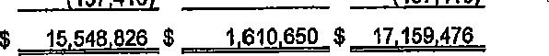
Unrestricted
741
Total Net Positiori
See accompanying notes to nnanclal statements
3
PIKE COUNTY, ILIfINOlS
COUNTY GENERAL FUND
ANNUAL APPROPRIATIONS ORDINANCE
Year Ending November 30,

 |  |  | 2018 | 2019 |  |  | 2019 | 2020
 | REVENUE |  | Actual | Appropriations |  |  | Estimate | Appropriations
 | Property Taxes  Inheritance Tax Accomodations Tax State of Illinois: |  | 707,568  67,579 |  | 673b582 |  | 673,582 |  | 727,320
 | Persona! Property  Replacement Tax |  | 72,120 |  | 75,000 |  | 87,000 |  | 78,000
 | Supv of Assess Salary |  | 26,308 |  | 26,908 |  | 26,908 |  | 27 ,508
 | State's Attorney Salary |  | 114,643 |  | 115,957 |  | 116,603 |  | 1 19,066
 | Public Defender |  | 59,059 |  | 59.361 |  | 59,059 |  | 59,361
 | Probation Office |  | 128,839 |  | 11 1 ,243 |  | 111 ,243 |  | 188,619
 | Election Reimbursement |  | 18,875 |  | 15,000 |  | 8,280 |  | 15,000
 | Sales Tax |  | 5711275 |  | 545,000 |  | 6161679 |  | 550,000
 | Video Gaming Tax |  | 8,478 |  | 24,000 |  | 35,419 |  | 35,000
 | Income Tax  Training Reimbursement |  | 538,750 |  | 535,000  32,000 |  | 575.000  7 ,090 |  | 550.000  8,000
 | Vlctlm Witness  Coroner Grant Other  Federal Grants: |  | 25,000  4,477  21 |  | 25,000 |  | 25,000 |  | 25,000  35,000
 | Deputy Sherffs Salary |  | 8,426 |  | 12,260 |  | 12,297 |  | 12,903
 | Emergency Services  Traffic Safety  Public Safety |  | 12,032  4,125 |  | 13,000  110,120 |  | 13,000  110,120 |  | 13,000  110,120
 | Circuit Clerk's Fees  Fines-State's Atty Drug Forfeiture  Fines and Forfeits-Sheriffs Fees |  | 677,027  956,219 |  | 600,000 |  | 578,667 |  | 570,000
 | County Clerk's Fees  Sheriffs Fees  Salary Reimbursements  Health Insurance Reimbursement |  | 253,964 |  | 255,000  753,000  92,239  230,000 |  | 262.811  766,722  102,807  160,393 |  | 255,000  753,000  39,419  2301000
i | Emergency Phone Reimbursement |  |  |  | 120,000 |  | 120,000 |  | 17,849
 | Landfill Tipping Fee |  | 327,019 |  | 267,750 |  | 259,276 |  | 273,105
 | Revenue from Services-Other interest |  | 22,911  4,304 |  | 25,000  35,000 |  | 23,271 |  | 23,500  3,010
 | Animal Control |  | 29,594 |  | 37,500 |  | 36,000 |  | 36,000
 | Arrestee Medical Costs Licenses and Permits |  | 3,695  1 ,500 |  | 10,ooo  11500 |  | 10,000 |  | 10,000  1 ,500
 | Other |  | 74,697 |  | 55,000 | 101 ,ooo
4,718,505 | 4 855,420
Total Revenue
3

PIKE COUNTY, ILLINOIS
ANNUAL TAX LEW
December 1, 2019 to November 30, 2020

COUNTY GENERAL FUND
Sheriff's Office:
Vehicle Maintenance | $ 381000
Salaries Court: | 276,213
Juror Fees Other: | 7,500
Emergency Management | 43,926
Buildings and Grounds | 361 681
Total County General Fund

COUNTY HIGHWAY AND EQUIPMENT RENTAL FUND
Maintenance and Construction of Roads

ROAD AND BRIDGE FUND
County and Township Bridges

AID MATCHING FUND
Road Projects
TUBERCULOSIS FUND
Contractual

MUNICIPAL RETIREMENT FUND
Municipal Retirement
PIKE COUNTY MENTAL HEALTH FUND Counseling Center

PIKE COUNTY HEALTH DEPARTMENT FUND

Salaries
LIABILITY INSURANCE FUND
Insurance and Tort Liability
SOCIAL SECURITY FUND
FICA 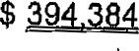
55

Agreement Regarding Health Insurance Payments
This Agreement is made this day of, 20 between the County of
Pike, Illinois (hereinafter "the County"), and the Pike County Health Department (hereinafter "PCHD"): WHEREAS, PCHD routinely pays to the County the employer share of its health insurance costs; and
WHEREAS, PCHD is approximately two hundred thirty-seven thousand seven hundred and seven dollars and no cents ($237,707.00) behind in its payments to the County for the employer share of its health insurance costs; and
WHEREAS, the County and PCHD are both willing to agree that two hundred thirty-seven thousand seven hundred and seven dollars and no cents ($237,707.00) is the number that correctly reflects the PCHD arrearage to the County for the employer share of health insurance costs as of October 31, 2019; and
WHEREAS, at various times PCHD has also paid to the County a portion of its property, casualty, and worker's compensation insurance premiums; and
WHEREAS, due to the financial constraint at PCHD, the County now wishes to refund sixty thousand dollars and no cents ($60,000.00) that PCHD has previously paid as its portion of its property, casualty, and worker's compensation insurance premiums, but immediately apply the refund to the PCHD arrearage for the employer share of its health insurance costs, with an effective date of October 31,
2019.
NOW, THEREFORE, it is hereby agreed as follows:
The County does hereby refund to PCHD sixty thousand dollars and no cents ($60,000.00) that PCHD has previously paid as its portion of its property, casualty, and worker's compensation insurance premiums, with the refund effective as of October 31, 2019, HOWEVER;
By agreement between the County and PCHD, the sixty thousand dollars and no cents ($60,000.00) is hereby immediately applied to the arrearage that PCHD currently owes to the County for the employer share of PCHD's health insurance costs, said arrearage being two hundred thirty-seven thousand seven hundred and seven dollars and no cents ($237,707.00).
Therefore, it is mutually agreed by the County and PCHD that the total amount PCHD owes to the County as of October 31, 2019, is one hundred seventy-seven thousand seven hundred and seven dollars and no cents ($177,707.00). This figure does not reflect any change in the amount the PCHD owes to the County after October 31, 2019.
1

By:

Andv Borrowman, Pike County Board Chairman Date:
2
Anita Andress PCHD Administrator
Date:

PIKE COUNTY HIGHWAY DEPARTMENT
LOCAL FUNDS
MONTHLY
October 10, 2019 - November 13, 2019
 | Recei |  | Ex enditures |  | Balance on Hand
Coun Hi hwa Fund | $85,407.33 |  | $15,816.95 |  | $455,202.09
E ui ment Rental Fund | $.22 |  |  | 0.00 | $1,047.88
Coun Road & Brid e Fund | $44,204.19 |  | $1,689.50 |  | $260,257.08
Federal Aid Matchin Fund | $42,481.76 |  | $11,292.08 |  | $311,841.02
Coun Motor Fuel Tax |  | 39,396.54 | $32,988.15 |  | $449,729.00
Townshi Brid e | $0.00 |  | $1,110.25 |  | $33,536.26
Townshi En ineer Revolvin | $0.00 |  |  | 0.00 | $267 096.62
Townshi Motor Fuel Tax |  | 362,306.72 | $519,780.12 |  | $897,445.71

FISCAL YEAR TO DATE
December 1, 2018 — November 13, 2019
 | Recei & |  | Ex enditures
Coun Hi hwa Fund | $416,004.02 |  | $366,450.62
E ui ment Rental Fund | $10,355.64 |  | $323,896.49
Coun Road & Brid e Fund | $147 206.28 |  | $260,257.08
Federal Aid Matchin Fund |  | 132,791.58 | 120,938.13
Townshi Brid e | $5,941.70 |  | $32,978.79
Townshi En ineer Revolvin | $98,304.64 |  | $98 996.67
Township Motor Fuel Tax

January 1, 2019 — November 13, 2019
 |  | Recei | Ex enditures
Coun | Motor Fuel Tax | $368 678.18 | $403 724.88
INVESTMENTS - November 13, 2019
Coun Hi hwa Fund | $0.00
E ui ment Rental Fund | $0.00
Coun Road & Brid e Fund | $100,000.00
Federal Aid Matchin Fund |  |  | 250,000.00
Coun Motor Fuel Tax | $50,000.00
Townshi Brid e | $0.00
Townshi En ineer Revolvin | $0.00
Townshi Motor Fuel Tax

Road and Bridge Conuni ttee Meeting Minutes
November 14, 2019
The Road & Bridge Committee met Wednesday, November 14, 2019 at 3:30 p.m. at the County Highway Department . The meeting was called to order at 3:30 p.m.
ROLL Call :
Present | Rodger Hannel, John Birch and Andy Borrowman
Absent : | Mark Mountain
Staff: | Chris Johnson and Gary Laux
Visitors: | None
PUBLIC CO&fMENT : None .
PAYMENT OF CLAIMS: A motion was made by John Birch seconded by Rodger Hannel to pay claims per claim reports dated November 13, 2019. All in favor. Motion carried.
HALF AID TO BRIDGE: A Motion was made by John Birch, seconded by Rodger Hannel to approve the Fairmount Township Half Aid to
Bridge proj ect located on 352 ^{nd} Ln in the Southeast Quarter of Section . Total project cost is $4, 489. 30, $2,244. 65 to be paid from the County Road and Bridge Fund. All in favor . Motion carried.
2020 MOTOR FUEL TAX: A motion was made by John Birch, seconded by Rodger flannel to approve the 2020 County and Township MFT Estimates in the sum of $649, 574 . 00 for the County and $1, 961, 692.50 for the Townships.
NEW BUSINESS :
COUNTY ENGINEER' S REPORT:
An update was given on the current veto session bill.
Efforts continue regarding the recently closed bridge in Cincinnati Township and the County Engineer is working with the
Sny Drainage District on a resolution.
The Hadley Township emergency ha-I f aid proj ect was discussed.
- 2
An update was given on the Kiser Creek bridge project . At this time construction is on hold while waiting on the beams to be delivered.
OLD BUSINESS :
Employee salaries were discussed. No action taken.
ADJOURN'MEN'I' : A motion was made by John Birch, seconded by Rodger Hannel, to adjourn meeting at 3: 48 p.m. Motion carried.
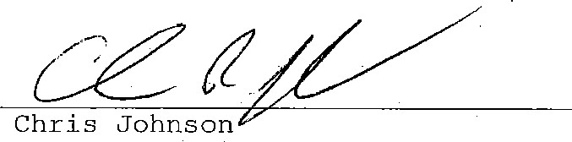Chris Johnson
County Engineer
- 2
Pike County MFT

DATE RANGE: 10/10/2019 to 11/13/2019
The following claims are hereby approved for payment:
AMOUNT
10/17/2019 01134 Income Tax Clearing Account | 2019-20 - co Eng | 026-000-5001 | 41154.33
10/17/2019 01134 Income Tax Clearing Account | 2019-20 - Day Labor | 02N)oc-5006 | 10,565.77
 |  | CHECK TOTAL: | 14,720.10
10/29/2019 01135 Callender Construction Company Inc | 29.6T Oil Mix@ $74.95; 14.9 CMG | 026-000-5007 | 21326.55
11/5/2019 01136 Income Tax Clearing Account | 2019-21 - co Eng | 026-000-5001 | 41154.33
111512019 01136 Income Tax Clearing Account | 2019-21 Day Labor | 026-000-5006 | 10,565.77
CHECK TOTAL: 14,720.10
11/8/2019 01137 Callender Construction Company Inc 1485T of CA-12 (oil mix) and 14.95T of CA-6 1018511 026-000-5007 11221.40
TOTAL CLAIMS: 32,988.15
APPROVED ON Wednesday, November 13, 2019 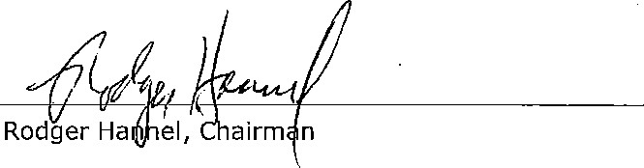
County
Engine

Mark Mountain
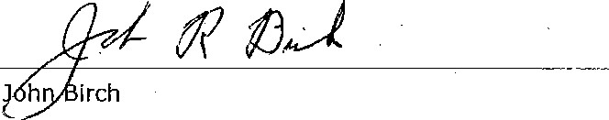
I

County Road and Bridge
Date Range: 10/10/2019 - 11/13/2019
The following claims are hereby approved for payment:

Dale: Wednesday, November 13, 2019

Check Vendor Name Description Invoice Account Amount
FUND: County Road and Bridge
1 1/8/2019 2-00972 Armistead Backhoe & Septic Services Half Aid 10 Bridge - Griggsville Twp install 8' K 8 1181 024-000-5000

APPROVED BY ROAD AND BRIDGE COMMITTEE:
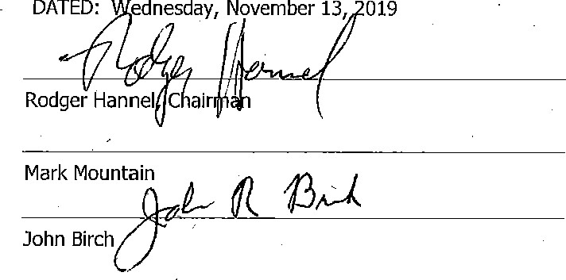DATED: ednesday, November 13, 019
FUND TOTAL: 1,689.50
TOTAL CLAIMS: 1,689.50
APPROVED BY:
DATED: Wednesday, November 13, 2019
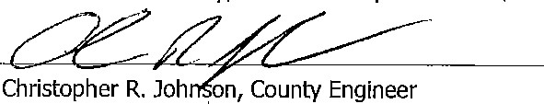
1

Federal Aid Match Date: Wednesday, November 13, 2019
Date Range: 10/10/2019 - 11/13/2019
The
following
claims
are
hereby
approved
for
payment:
DATE Check Vendor Nanie  FUND: Federal Aid Match | Description | Section | Invoice Account | Amount
0/17/2019 4-01110 Income Tax Clearing Accounl | 2019-20- Res Eng & Twp Eng | 15-00098-00-BR | 020-000-5805 | 5,646.04
Income Tax Clearing Account | 2019-21 - Res Eng & Twp Eng | 15-00098-00-BR | 020-000-5805  FUND TOTAL: | 5,646.04  11,292.08
 | TOTAL CLAIMS: | 11,292.08
APPROVED BY ROAD AND BRIDGE COMMITTEE: | APPROVED BY:
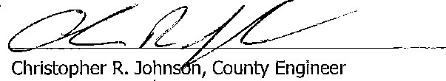
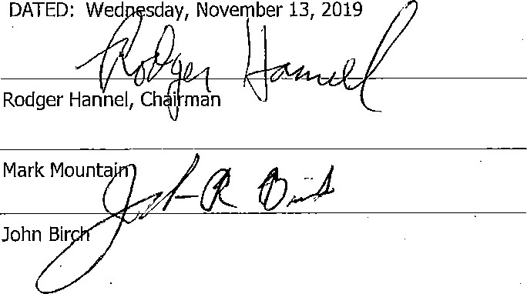DATED: Wed sday, November 13, 2019 DATED: Wednesday, November 13, 2019
1
County Highway Date: Wednesday, November 13,
Date Range: 10/10/2019 11/13/2019
The following claims are hereby approved for payment:

FUND: County Highway
Date: Check Vendor Name

10/17/2019 | 3851
1011812019 | 3852
10/1812019 | 3852
10/1812019 | 3852
10129/2019 | 3853
10/29/2019 | 3854
10/29/2019 | 3855
10/29/2019 | 3856
10/29/2019 | 3857
10/29/2019 | 3858
10/29/2019 | 3859
10/29/2019 | 3860
10/29/2019 | 3861
10/29/2019 | 3862
10/29/2019 | 3863
10129/2019 | 3864
10/2912019 | 3865
10/2912019 | 3866
10/29/2019 | 3867
10/29/2019 | 3868
10129/2019 | 3869
10/29/2019 | 3870
1012912019 | 3870
1012912019 3870
10/29/2019 3871
1012912019 3871
10/2912019 3872
11/512019 3873 Income Tax Clearing Account
Card Services
Card Services
Card Services
Generat Fund
General Fund Altorfer, Inc.
Prairieland FS, Inc.
Best System Builders Inc.
Amazon Capital Services, Inc.
Pike County Concrete Inc. Newman Traffic Signs Hall Signs, Inc. Productivity Plus Account
Golden Ruler
L.S.S.D. Inc.
Logan Agri-Service, Inc.
Cintas First Aid & Safety John D. Motley.
B & R Mechanical Contractor's Inc.
AT&T Mobility
Ameren Illinois
Ameren Illinois
Ameren Illinois
Farm & Home Supply
Farm & Home Supply
Calender Construction Company Inc Income Tax Clearing Account
Description Invoice Account Amount
2019-20 Payroll 019-000-0506 250.00
Northern .TooI - Keson Steel Measuring Tape 200 ft 019-000-0519 82.32
Filters USA - Carrier filters 019-000-0519 47.28
Weathertech - Phone holders 509370578 019-000-0519
Check Total: 251.36
October, 2019 - County's portion of employee dental/vision i 019-000-0517
October, 2019 - County's podion of employee heaith insuran 019-000-0517 3,885.00
L-2 - 176-0118 Driver (locks) ;120206554
 | Fertilizer - 2600 lbs DAP and 810 lbs. Potash 17003360 019-000-0515 |  |  | 890.13
 | D-1 - Speaker 16018 019-000-0520 |  |  | 49.00
 | Office supplies Glass screen protector for Samsung Galaxy WRY-LF91 019-000-0517 |  |  | 2297
 | CH-2 -3 yds @ $133.06 9328 019-000-0510 |  |  | 464.00
 | 911 signs: (2) 180th st, (2) 300th (2) 270th (l) 200th :'NV016042 019-000-0519 |  |  | 108.02
 | (2) School Bus Stop ahead signs | 019-000-0520 |  | 121.86
 | Brake Rod, Turnbuckle | 'F39242 019-000-0520 |  | 43.30
 | Monthly Copy Fee | 019-000-0517 |  | 40.00
 | S Oxygen Tank | 105334 019-000-0519 |  | 28.00
 | 398 Gal Gas @ 1.772 plus taxes | 11356 019-000-0516 |  | 861.27
 | Medicine Cabinet Refil 10.102019 | 1404349353 0194)00-0519
 | 2019 Shoe Allowance | 019-000-0517 |  | 150.00
 | Wire down over entryway to shed, tabor, bucket truck | 20622 |  | 175.00
 | (3) mobile phones | 019-000-0517 |  | 258.55
 | Electric - Office | 0194)00-0517 |  | 230.41
 | Electric - Old Twp Shed | 019-000-0517 |  | 46.30
 | Electric - Big Shop | 019-000-0519
 |  | Check Total: |  | 318.33
 | Shop supplies - Shop lowefs | 218578 019-000-0517 |  | 32.91
 | Shop supplies - Hydraulic Fluid 5 Gal; Anti-freeze, Durex I G 4228933 019-000-0519 |  |  | 97.94
 |  |  | Check Total: | 130.85
58.55T CM6; 14.40T CM6 SP |  |  | 019-000-0515 | 572.08
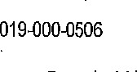

FUND: | County Highway
Date: | Check | Vendor Name | Description | Invoice Account | Amount
1118/2019 | 3874 | Card Services | 'ACE Meeting - Par-A-Dice Hotel and Casino room fee | 019-000-0517
111812019 | 3875 | Quincy Mack Sales & Setvice, Inc. | 1-8 Hyd Filter | 403793 019-000-0520 | 23.34
11/8/2019 | 3875 | Quincy Mack Sales & Service, Inc. | BC-I - Lube Filter (4) | Check Total: | 39.42
111812019 | 3876 | Golden Ruler | Copy fee | 510364 019-000-0517 | 44.00
1118/2019 | 3877 | City of Pittsfield | Water-Gas - 101917 | 019-000-0517 | 83.20
11/812019 | 3877 | City of Pittsfield | Gas - 106590 | Check Total: | 94.60
1118/2019 | 3878 | Callender Construction Company Inc | 56T CM6S@ $7.201T and 43.6T CM14 @$i2.951T | 1018510 019-000-0515 | I ,539.90
1118/2019 | 3879 | Halpin Auto Supply | T-3 Battery | 491136
11/8/2019 | 3879 | Halpin Auto Supply | C-1 - Ballery | 489619 019-000-0520 | 116.82
 |  |  |  | Check Total: | 233.64
111812019 | 3880 | Trinity RentalslD-C Electric, Inc. | Shop supplies - 24" Termocouple | 56610 019-000-0519 | 10.99
111812019 | 3881 | RNJ's Distribution Inc. | Bottled water | 019-000-0519 | 50.25
11/8/2019 | 3882 | Pike County Concrete Inc. | Concrete for 2 liners on CH-2, Valley City | 9393 019-000-0515 | 798.00
11/8/2019 | 3883 | Pike County Lumber Co. | Black plastic cement geocel (roof patch) to seal liners on CH | 00043753 019-000-0519
1 11812019 | 3884 | Getz Fire Equipment | Annual Service | 11-769198 019-000-0519 | 449.55
1 11812019 | 3885 | SS.S., Inc. | 199.94T of Sand @ $5.50 | 8929 019-000-0515 | 11099.69
11/8/2019 | 3886 | Altorfer, Inc. | T-8 - Hyd IOW Adv-I | :120208418 019-000-0520 | 418.75
11/8/2019 | 3887 | Roland Machinery Company | E-l - Gas spring, Seal | 37038169 019-000-0520 | 389.02
11/8/2019 | 3888 | Cass Communications Mgmt., Inc | Internet & Phone | 019-000-0517 | 94.38
11/812019 | 3889 | ILMO Products Company | C02 | 01082287 019-000-0519
I i18/2019 | 3890 | Safeguard Business Systems | 500 Counly Highway Computer Checks | 033775229 019-000-0517 | 183.85
11/8/2019 | 3891 | Lumley Trucking LLC | Hauling 199,94T of sand from Wayne B. Smith @$5.75/T | 9648 019-000-0515  FUND TOTAL: | 15,816.95
 |  |  | TOTAL CLAIMS:
APPROVED BY ROAD AND BRIDGE COMMITTEE: APPROVED BY:
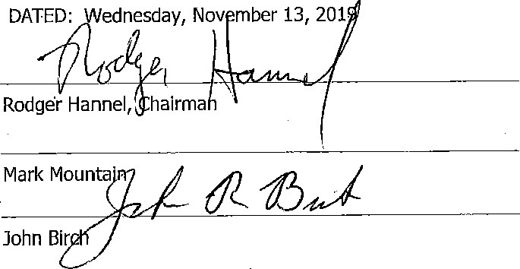DATED: ednesday, Nov mber 13, 201. 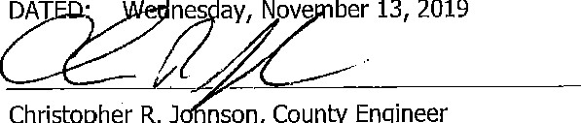
ber
13,
2019
Christopher
R.J
nson,
County
Engineer
2
STATEMENT OF COST TO PIKE COUNTY BOARD
FOR HALF AID BRIDGE PROJECT
FAIRMOUNT NOVEMBER 13, 2019 Township
LOCATION OF PROJECT:
352 ^{ND} LN IN THE SE QTR OF SECT 30

PROJECT CONSISTED OF:
Spesard Culvert Sales
36" x 20' 14-gauge culvert $626.40
36" x 30.' 14-gauge culvert $939.60
36 ¹ ' band $63.24 Handling Fee $1 96.00
Fill and surface rock $634.06 Chenoweth Dozing $2,030.00

TOTAL COST OF PROJECT: $4,489.30
ONE-HALF TO BE PAID BY PIKE COUNTY: $2,244.65

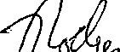
Rod | Ha | el, Chairma
ROAD & BRIDGE COMMITTEE: 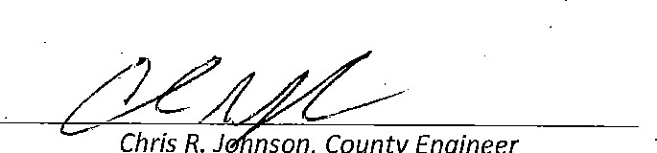
Chris
J
nson,
County
Engineer

Mark Mountain
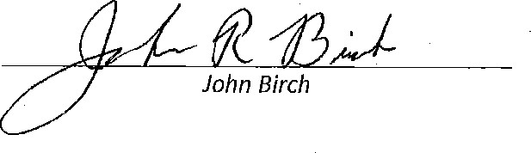
Is this project located on a Township line C] Yes
Your Full Time Crop Insurance Agency Devoted to Serving Area Producers
Let'sworktogethet to better manage:your ciskl Call today toenwre_you hye;the proper coverage^{l} in piece.

Brandon Pine
Diversified RjSk Månagement Specialist
Services Office: (217) 245-4599 -r cuie (217) 204-3354
1610 W. Lafayette Avenue • Jacksonville, IL 62650 We are Risk Management.
www.divers'ifiedservices.com
| Crop Insurance I Grain Marketing I Financial Services
Fairmount Township 3S - Range 4W
Copyright 0 2018 Mapplng Solutlons
BROWN COUNTY
Il Michael Roy Kurtmone Daniel' Ro Stacy L Richard & Patrcu Gail John F
l, McDowel[Tr Newion
178 1 14 John Richard Doubte He'burg42 Family 59 Reid Wabel Webel rr Patricia
Kurfman Etal Goit i: Michael o
LEN 180 HunllngLLC O Hun oubleDttng LLC 19 Emerson David Jeffrey l: Boupharac K cad R 78 LLC 159 158 Janet M Orr m 136
Kurt-nan Kurlman Etal
116
83 395TiH'AVE
Harry .79 R Harry R ManleyHaw R RonniaHam Jp Farmland MorhnTen James & Michael ComAebel A Hanküncoble Slacy L Webel JelrreyDo Jeffrey David& a MlchaelJohn MO nley
Manley 80 LLC
Choa & 83 158 40 10B 82 Webel 75 Slacy WebalL & Janelorr Janei Orr M eo Pike Farm 2 Community Tr E-tOi
i • 37 Kathy Schmid- _ HAW Donk 77 161
Over 7 53
50
carl R & 390TH
Pike Fa
Chad o Kalhy Kevin R Boupharac K LN Lo Ue 15 Unlfed L . Stocv WebelL Moss hc Femu
Dean R Dyer Henlhorn Kurfman $ 00. community WebelStacy Elol 76 c E 6 waters Issa FarmsMOSS 60
Rev Rehdg & A
Fox 83 237 Jose R Bank 164 78 Inc
Nolan S Kurfmøn 161
Derek E 385:n-/MVE Koto]ne Tayhr 72
Kurtma 126
Bowman k. 80 385-N=AVE 285TH?AVE
I GM Pike Denlse Rev S'acy L- Stacy L
Webel Eld
Farms Inc Lacroix C J Webel Tr
50 97 82 Tcvbr 77 Maia L cod & Kudman Moss Farms Stilwell Webel VanBebber
Farms GM PikeInc Dove b Bouphorac K MOIRn@Ter Q Forms Il LLC Webel Farms Il LLC 305
(man Whllm«e
102 Bel" po ncn 81 38 Z: 201
N Odin I
cod R &
104 45 goupharoc K Monly & MontyJeo FormsMoss pbet Farms We bel Fairns Patricia Orville E urray A Kürrmon 78 Eloi34 Marti Inc 44 Il LLC McKinney Whitmore
Mardn MarvinWilke D22 ceK K 17 WAL E-la( 185 182
8Walter n Phillip M & Jlmmy L David Wh11a
102 64 Kunz *imbedv A Marlin Jimmy nda Moss
82 James
El al 42 Martin Farms Gomes E
Murray A PENR Y rlln Inc 5 Cadle Ill Cade Ill 39 Ollhe el Mary40
163 Marlin 101 cad R 61 FISHHOOK Waller 119 James E orbaraavd & Lane E WIese
Z
Bou Kur%haracnan 94 John & Motti : Wilbur L&Shelia J Moniy K J Kun Cadte Ill Ristey38 79 LO Martin Un(v of cod R Dunks: 5B Slelnlnget51 Etu Jimmy L z Moss Farms IL.ÄT Ione E Murray A upha•ac K Marih Etal Inc 190 258 Marlln Trs (5
6 82 R'PE14 LLC a 32 80
Irene
Main Raymond E boupharoc K Mowen Moniy K & 369TH LN 8 Richard & Elle ele
, *man 97 19 Jean S RogerDelia Pairicia Univ o 24
163
) 59 Markin Harts' Hickory Spring Gail Illinois BOT PERRY-FISH
365.r.H'AVE Farms LLC Emerson 143 Ninoi;
Letha B 365TH'ST on 8 BOT
Denny
Waters Trs
Hecox 76 20 Donald 365T.HrAVEJames E
133 Stephen
John A Fox Randy K BN ^{O} IncFarms Dougherty & Jerry Mary L S& Cadle Risley JamesCodle Kevin
Waters Sr 85 155 Johnson -H Roberta & Moss James Cadle 40
245 Gregory & Rhonda 167 82 82 195
Coyano Patricla Liehr
Schwodz John A zok 125 1 2
Waters
F.VelmQ Jean R ndy K Scronlon 3Nö FORK George Philip K &
24 J sr Elux
Corrigan 'oh son Elux! Mary S Thomas Billie L l'Amigos 15B 165 Adam Kathy Gr gory Moss 181 Johnson l? Farms n 29 Fencik tricia 7 26 5 162 nneih W 69 zck
166
153 h 84 355TH AVE 355TH.AVE
352N Frances L Jimm J]mmy L LindaLee Unda Lee Jerry L & RLG
Ith Miller154 Martin I l lEl tux 47 Harry & Akin 80 Mary 79S Moss Jerry & RBEey Propernes Risiey
. Kevin 39 Mary LLC
Jimmy Marilyn& Ramey FRandyPamela John McLoughEn Paol & JosephTr Moss 501 79 -Mgityn JimmyMorlln\ M0F11n cO Gil 124 u7 78
Douglas 48 :
%hoel Sheila 350TH'AVE
Cobmbo
Gory D Bruce & Noncy John
Laura M Klolz MiklaUlsch :RondV paul&• Hobson Risiey Tr
306 AV_E 81 I Pa ela Joseph 158
^{M} Douglas & Gary W & ! Gary D McLaughlln While
Shena
Lou:a M
Darren G & Smith Martin K\olz 33 Jacquahne BarkerA
Krisfin L Woodrow 7 6
Smllh Engelmann Hnda Gory & Go Whlte Atlas LLC81 McGraw Newhouse-Form RLC
169 160 Mortln Janel Smllh 2' Earl C Lodge 161LLC S"lwetl properlies
337TH LN LLC 153
Earl C Ingersoll John S
80 79 Ingersoll ton c Gerald W Newhouse Trs
H JAE11 " '2 Ingelso'l 42 Wood 81 Elal 80 30 282
41
SEE PAGE 49 55

*SpesardCulyertSalesö
Mike Spesard at 217-304-1005 Payable to:
Steve Spesard at 2-17-304-7218 Spesard Culvert Sales
18185 E 200 North RD18185 E 200 North RD Ridge Farm, IL 61870 Ridge Färm, IL 61870
 | BILL TO: |  |  | DATE | 7-24-2019
 | Fairmount Township  38400 Perry Fishhook RD  Båylis, IL 62134  217-491-1325 |  |  | INVOICE # | #593
 |  |  |  | TAX EXEMPT
 |  |  |  | TERMS | '.NET.30 DAYS
I state that this-product will be primarily used in.
production agriculture. Sigo?turg
Quantity |  | Description |  |  |  | Amount
1  1  1 |  | 36" x 20' Altiminized 14 GaugeCulvert 36" x 30' Aluminized 14 Gauge Culvert •  36" x 2' Band  Handling |  |  |  | $626.40  $939.60  $63.24  196.00
 |  |  |  | Total |  | $1,825.24
Invoice Date | Invoice #
09/30/2019 | 1017929
Callender Construction Co., Inc —invoice 928 W. Washington St.
Pittsfield, IL 62363 Page 1
Bill To:
Account ID: FAM 05
FAIRMOUNT TOWNSHIP
CIO KEVIN RISLEY
38400 PERRY FISHOOK RD
BAYLIS, IL 62314
 | Description (Ticket, Date and Material) |  |  | Quantity | per Ton | Line Total
 | 180027 9/6/2019 IL RIPRAP 5B FOB  316221 9/5/2019 IL CM2 D QUALITY FOB  382489/512019 IL CMS D QUALITY FOB 316259 9/512019 IL CM6 D QUALITY FOB  316272 9/5/2019 FILL SAW FOB  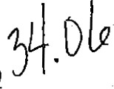  3162cg15f20191L.c.MSD QUALITY FOB  316343 9/6/2019 ti- CM6 D QUALITY FOB 316352 9/612019 QUARRY RUN FOB 316360 9/612019 QUARRY RUN FOB  316492 9/11/2019 IL CM2 D QUALtn• FOB  316498 9111/2019 IL CM2 D QUALITY FOB 316489111/2019 IL CM2 D QUALITY Foa316739 9/19/2019 IL CMG D QUALITY FOB |  |  | 13.75  13.70  13.00  13.30  14.20  1&65  13.35  14.60  13.40  •13.80  14.20 | $16.00/tn  $8.70/tn  $7.æ/tn  $7.65/tn $6.251tn  $7.65/tn  $8.45/tn $8.451tn  $8.7011n  $8.70ftn  $7.65/tn | $220.00  $119.19  $99.45  $101.75  $104.42  $102.13  $128.86  $123.37  $116.58  $119.63  $120.06 $108.63
 | Totals: |  |  | 179.95 |  | $1.552.82
 | Unpaid balances after 30 days accrue interest at 1.5% monthly (18% per annum). Customer is responsible for paying all accrued interest and Callender Construction Co., Inc.'s reasonable attorney's fees and court costs associated with collecting unpaid balances. |  | Sub Totals |  |  | $11552.82
 |  |  | Tax Total $0.00
 |  |  | Balance Due $1 ,552.82
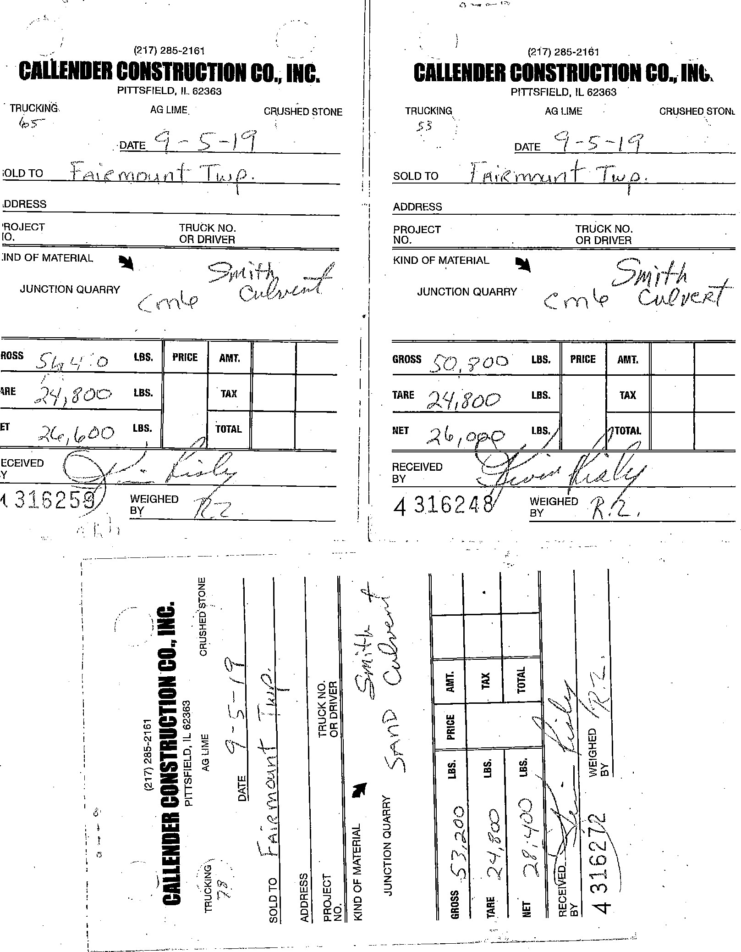
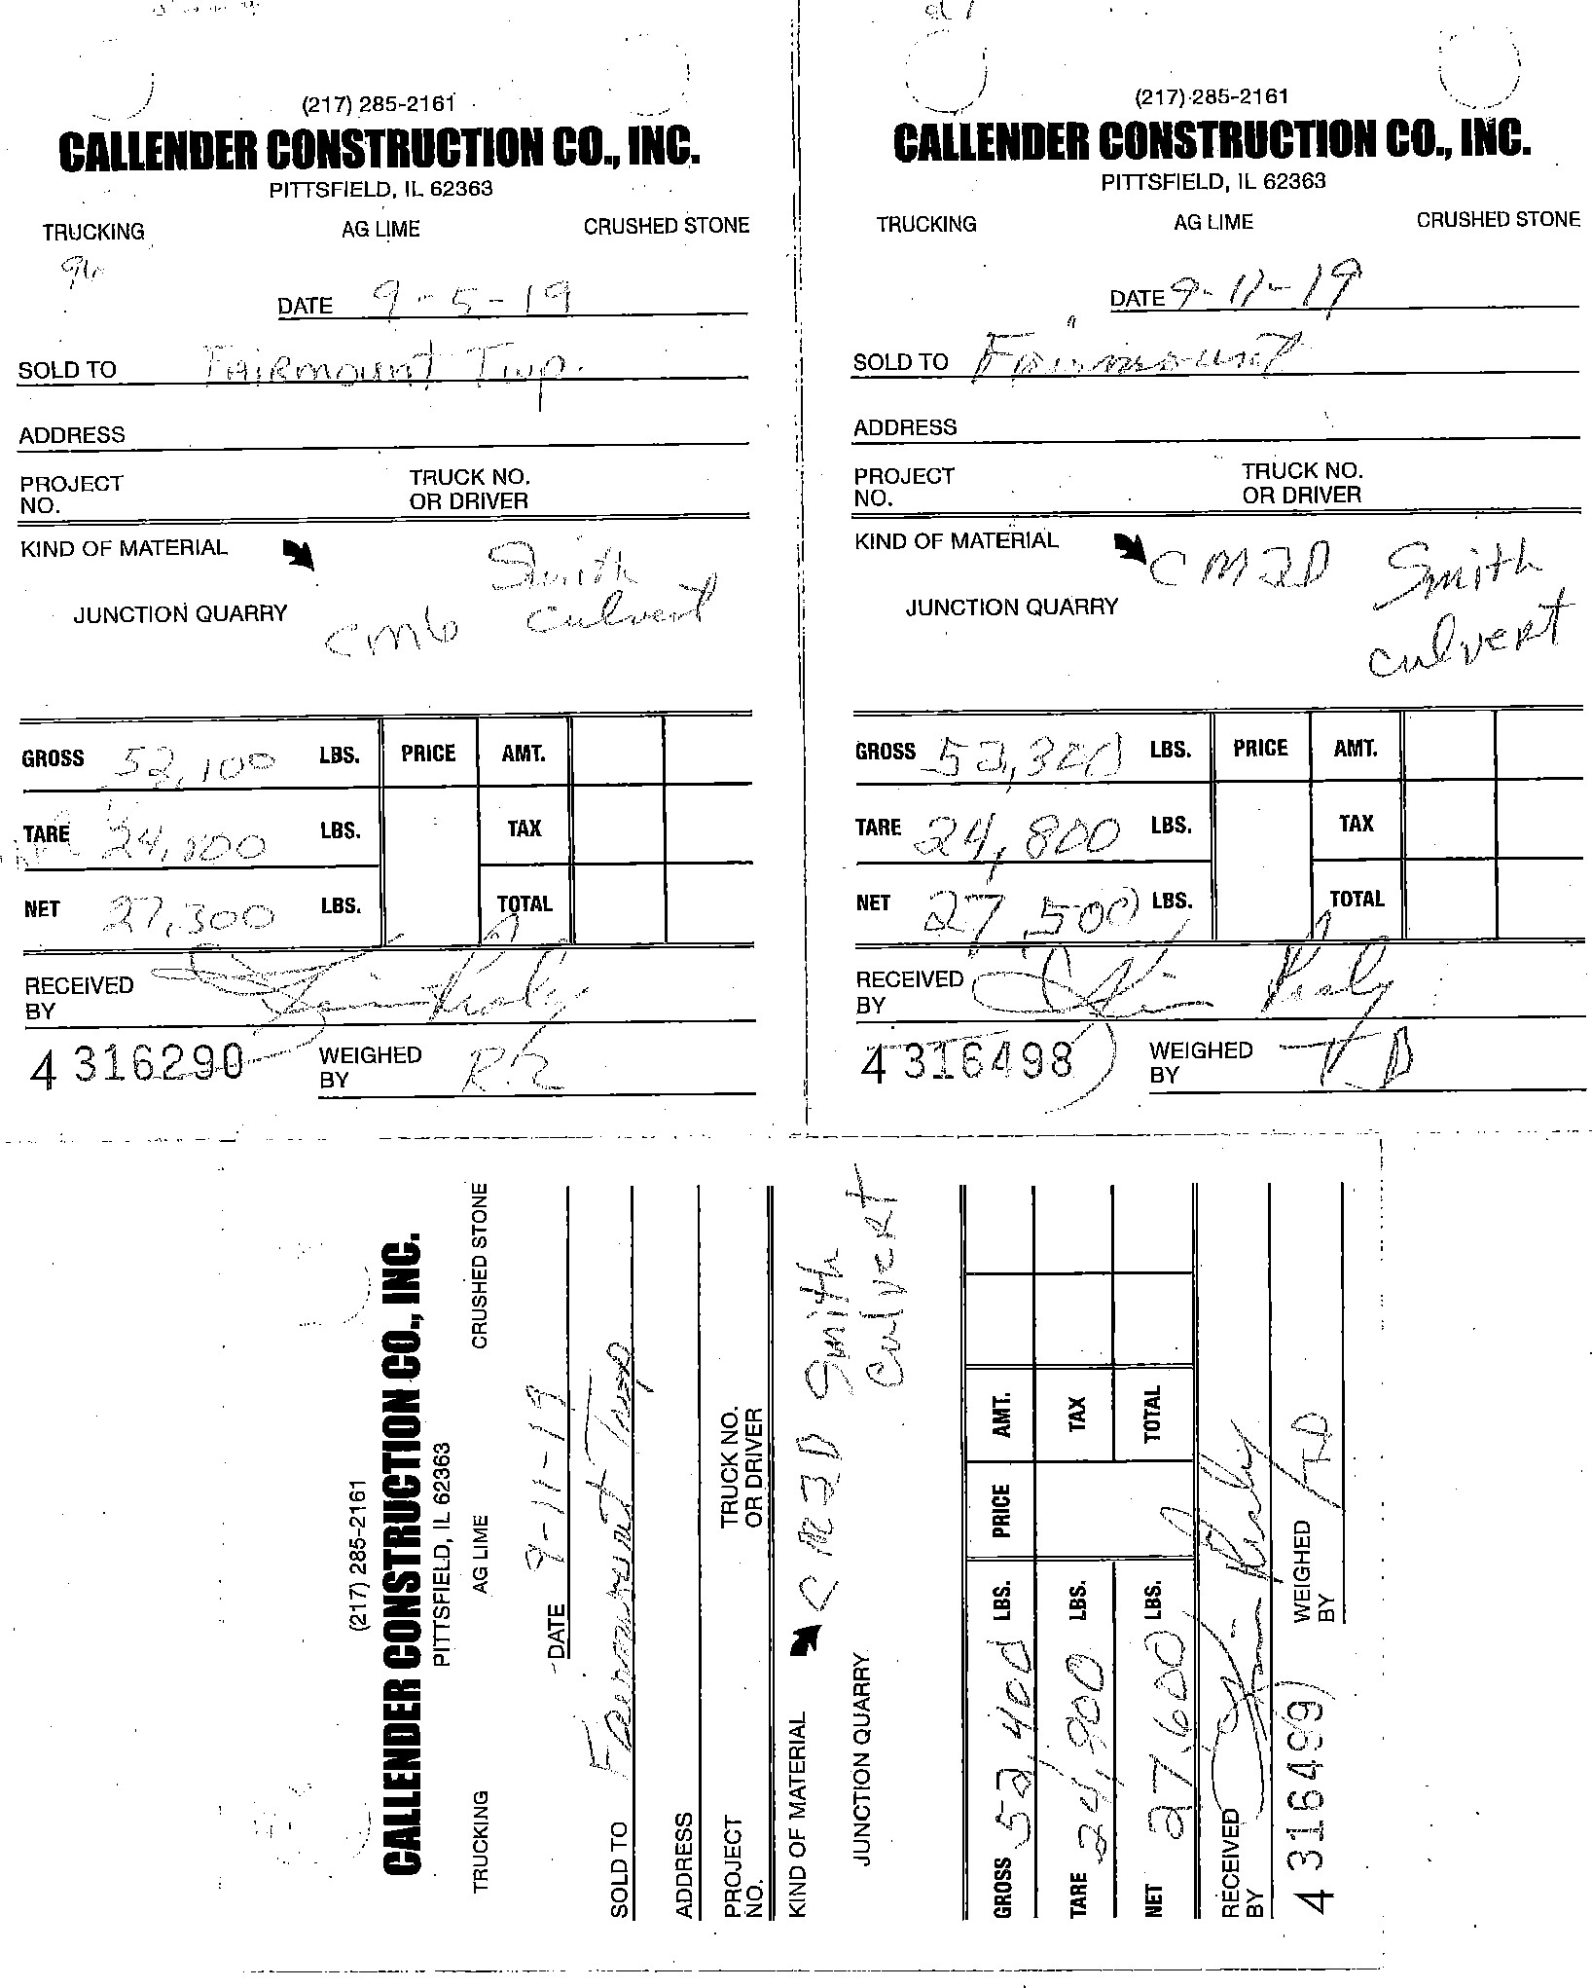

己んゑクプ
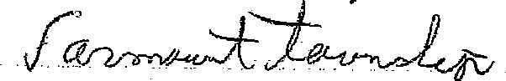
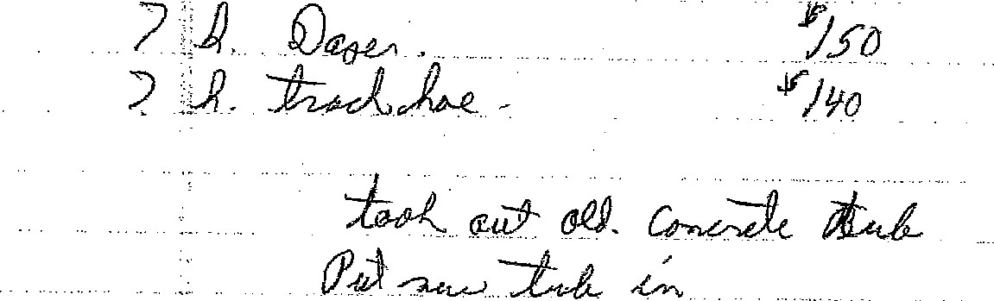
ノ乙り-00 アの00 身つ30。0

BILL BOARD REPORT
STATE OF ILLINOIS
COUNTY OF PIKE
PIKE COUNTY BOARD
Monday, November 25, 2019
MR. CHAIRMAN AND MEMBERS OF THE BOARD:
THE FINANCE COMMITTEE, PUBLIC SAFETY COMMITTEE AND THE BUILDING AND GROUNDS COMMITTEE WOULD RESPECTFULLY SUBMIT THE FOLLOWING EXPENSE AND TOTALS THAT THE COUNTY CLERK HAS BEEN DIRECTED TO ISSUE CHECKS FOR THE SAME.
BUILDING AND GROUNDS COMMITTEE | $5,455.58
PUBLIC SAFETY COMMITTEE | $32,366.69
FINANCE COMMITTEE | $106,490.55
GIS | $6,087.15
CORONER | $2,135.40
SHERIFF | $46,239.08
REGIONAL SUPERINTENDENT OF SCHOOLS | $0.00
COURTS | $3,225.00
PROBATION | $0.00
COUNTY BOARD | $675.00
COUNTY CLERK | $27,806.61
CIRCUIT CLERK | $0.00
STATES ATTORNEY | $709.32
STATE VITAL RECORDS | $8.00
TREASURER | $754.40
ZONING | $524.62
ESDA | $1,083.44
SUPERVISOR OF ASSESSMENTS | $11,866.08
CODE HEARING | $775.70
ANIMAL CONTROL | $600.29
PUBLIC DEFENDER | $608.80
RABIES | $32,048.39
LAW LIBRARY FUND | $0.00
COUNTY CLERK DOCUMENT STORAGE FUND | $19,010.00
COURT SYSTEM FUND | $2,811.18
CIRCUIT CLERK AUTOMATION FUND | $4,590.15
JUDICIAL SECURITY | $0.00
COUNTY TREASURER AUTOMATION FUND | $0.00
CIRCUIT CLERK DOCUMENT STORAGE FUND | $3,323.54
RECORDERS SPECIAL FUND | $0.00
STATES ATTORNEY AUTOMATION FUND | $0.00
REVOLVING LOAN FUND | $0.00
OPERATIONS & ADMIN FUND (NON COMPUTER ACCT) | $0.00
GRAND TOTAL | $158,815.72

Pike County Board Mileage & Per Diem

28-Oct-19
Board Meeting
10/28/2019
John Birch 157.54
Andy Borrowman 162.18
Amy Gates
Rodger Hannel 173.20 Tom Lewis 165.08
Mark Mountain
Derek Ross 167.40 Jim Sheppard 159.28 Mark Sprague 172.04
Total456.72
Economi and Community Development
10/28/2019
John Birch7.54
Andy Borrowman12.18
Amy Gates
Derek Ross17.40
Total37.12
Highway
11/13/2019
Andy Borrowman 162.18
John Birch 157.54 Rodger Hannel 173.20
Mark Mountain
Total192.92
Finane
11/13/2019
Andy Borrowman12.18 Jim Sheppard 159.28
Rodger Hannel23.20
Amy Gates 173.20
Total167.86
Buildig and Grounds
11/20/2019
Andy Borrowman 162.18
Rodger Hannel 173.20
Tom Lewis 165.08
Derek Ross 167.40
Total267.86
11/20/2019
Andy Borrowman12.18 Jim Sheppard 159.28 Amy Gates 173.20
Mark Sprague 172.04
Total216.70
Public Safety 11/20/2019
Andy Borrowman
Derek Ross17.40 Tom Lewis15.08 Amy Gates23.20
Total55.68
Total 1,394.86
As of November 4, 2019
To: Pike County Board Members
Juvenile: Juvenile Abuse (JA) - 27 Juvenile Delinquent (JD) -19
Juvenile (Truancy) (J) — 7
Civil Violation - 2
Ordinance Violation - O
Traffic: 100 Misdemeanor: 48
Felony: 97
DUI: 11
Mental Health Commitment: 3
Civil Law: 2
Closeouts: 54
Warrants: 97 (Open cases - people who failed to appear and warrants were issued.)
TASC: 10 (Open cases — people on TASC probation who may be eligible for expungement of their records.)
Total cases: 477
From: Keisha Morris, Public Defender

PIKE COUNTY ANn,fAL CONTROL

OCTOBER REPORT FOR 2019
TRIPS PICKUPS/ANNUAL TOTAL

WNUTES
9 2 14 dogs 210
O dogs
Chambersburg 9 50
Detroit 9 3 dogs 55
El Dara 9 0 55
Florence 9 O dogs 45
Griggsville 9 1 12 dogs 215
9 2 14 dogs 150
Kinderhook 9 0 3 dogs 50
Milton 9 14 dogs 130
Nebo 9 1 20 dogs 140
New Salem 9 1 4 dogs 60
Pearl 9 3 dogs 60
Pittsfield 10 2 19 dogs 255
Perry 9 2 8 dogs 120
Pleasant Hill 9 1 6 dogs 200
- dogs
New Canton 9 5 dogs 90
- 30 dogs

TOTAL DOGS TO SHELTER FOR 2019 13 FOR THE MONTH 163 FOR YEAR

DOGS ADOPTED | 4 | 59
DOGS RECLAnv1ED | 5 | 50
DOGS EUTHANIZED | 3 | 36
CATS ADOPTED | 6 | 41
CATS RECLAflv1ED |  | 3
CATS TO SHELTER | 5 | 59
CATS EUTHANIZED | 1 | 8
LIVESTOCK CASES | 1 | 4
ANMAL BITES | 4 | 52
NEGLECT | 7 | 59
TICKETS (VAC/REG) |  | 17
TICKETS (LEASH LAW) TICKETS (CRUELTY)  wuSC. TICKETS | 1 | 20
Adoptions, Reclaims, etc. | $ 265.00
Cash Donations | $1149.35
Cash donations by: Larry and Carol Sams, Elizabeth Miller, Eric and Anissa Miller, Old Orchard Counüy Club, Althea Hart and "N OF JOE YASENKO to numerous to list.
Dog food, cat food, bedding etc.
Made by: Wal Mart, County Market,( Jim Zahnen in Memory of Marsha Rothman),
Susan Ward, Jim and Valorie Dolbeare, Darrell Orris
VOLUNTEERS: Verla Dale, Amber Johnson, Jim Wood
RAN LEASH LAW ALL COÄMUNITIES AFTER 5, RAN LEASH LAW 5 covn,fUNITIES BEFORE 8 AM, ALL COB,MUNITIES ON SUNDAY, AND ALL COWåUNITIES ON SATURDAY (SONE MORE THAN 1
TO DATE FROM 12-1-2019 TO NOW, WE HAVE GIVEN OUT 558 SPAY AND NEUTER CERTIFICATES FROM THE GRAY TRUST TI--HS YEAR.

9-21 - Solid Waste Coordinator 250.00 I of2

