Pike County Board

Meeting Minutes
September 23rd, 2019
- Call to order
Chairman Andy Borrowman called to order the regular meeting of the Pike County Board at 7:00 p.m. in the upper courtroom of the Pike County Courthouse. Greg McClean gave the invocation and Chairman Borrowman lead in the Pledge of Allegiance.
- Roll call
Secretary Name conducted a roll call. The following persons were present: John Birch, Andy Borrowman, Rodger Hannel, Tom Lewis, Mark Mountain, Derek Ross, Jim Sheppard and Mark Sprague.
- Approval of Minutes from August 26th, 2019
Rodger Hannel made a motion to approve the minutes from the County Board meeting held on August 26th, 2019. Mark Mountain seconded. Voice vote 7-0. Minutes Approved.
- Approval of Minutes from Budget Hearing on September 5th, 2019
Tom Lewis made a motion to approve. Seconded by Mark Mountain. Voice vote 7-0. Minutes approved.
- Approval of Minutes from Budget Hearing on September 11th, 2019
Rodger Hannel made a motion to approve. Seconded by John Birch Voice vote
7-0. Minutes approved.

- Approval of Brice Lawson to the Valley City Drainage and Levee District for a 3-year term to expire on August 30th, 2022
Motion to approve nomination made by Mark Mountain. Seconded by Tom Lewis. Voice vote 7-0. Appointment approved.

- Consideration of the GFI Agreement
Jim Sheppard gave a background to the managed IT agreement that had previously went through GIS/IT committee. Questions were asked regarding payment of the agreement. Sheppard stated that offices would be able to help out with the payment and there were other ways that the county is able to get the funds. Derek Ross made a motion to allow Chairman Andy Borrowman to sign the GFI agreement as presented to the County Board. Mark Mountain seconded the motion. Voice vote 7-0. Motion approved.

- Vote on Pleasant Hill Zoning
Comments by board members were made requesting that the neighbors continue to work together to resolve their issues post vote. As well, it was clarified that this was not an alcohol vote, this was strictly a zoning vote. Motion was made to approve the Pleasant Hill Zoning map as recommended to the County Board allowing the Stage Coach Inn to be zoned as a B1. After a short discussion roll call vote was taken. Roll call vote was 7-1 to approve proposed Pleasant Hill zoning map.
- Committee Reports
Finance
The finance committee of the Pike County Board met at 5:00 p.m. on Wednesday, September 11th, 2019 in the conference room of the Pike County Government building. Members present were Amy Gates, Rodger Hannel, Board Chairman Andy Borrowman, and Jim Sheppard. Also present was Scott Syrcle.
On a motion by Rodger Hannel and a second by Amy Gates, routing bills in the amount of $81,520.98 were approved for payment.
The committee briefly discussed the agreement between the health department and the county. Scott Syrcle advised that the document should include some history of this matter to answer any questions the auditors may have.
Brian Keller was present to discuss the Pike County Emergency Corps need for new motors for their boats. He stated that currently they have to borrow boats in order to assist in rescue operation son the river. The committee provided some advice on the matter.
We then moved on to discussing the Cannabis Retailers Occupation Tax. There were questions about what other counties were doing and what about the cannabis produced in Barry? At what point is it taxed?
Amy Gates made a motion to adjourn. Rodger Hannel seconded. Motion carried.
Meeting adjourned at 6:05 p.m.
Motion to approve the Finance Committee minutes made by Tom Lewis. Seconded by John Birch. Voice vote 7-0. Minutes approved.

Highway
The Road and Bridge Committee met Wednesday, September 11th, 2019 at 3:30 p.m. at the County Highway Department. Members present were Rodger Hannel, John Birch and Andy Borrowman. Others present were Chris Johnson, Pike County Highway Engineer and Gary Laux, Resident Engineer. There were multiple visitors present that are reflected on the attached visitors list.
Public Comment: Visitors voiced concern over the recent closing and replacement of structure 075-3045.
A motion was made by Mark Mountain and seconded by John Birch to pay claims per claim reports dated September 11th, 2019. All in favor. Motion carried.
Half Aid to Bridge: None
White Bridge: No update
No Closed Session: none
New Business: County Engineer’s Report
            - The Landowner’s pertaining to the New Salem/Griggsville Township line Half Aid to Bridge project advised that they do not want changes to their property.
            - The 2019-2020 budget has been submitted to Jim Sheppard for tonight’s budget meeting of the full board.
            - A purchase agreement with the adjacent property owners is still being negotiated.
Old Business: None
A motion was made by John Birch and seconded by Rodger Hannel to adjourn the meeting at 4:30 p.m. All in favor. Meeting adjourned.

Motion to approve the Highway Committee minutes made by John Birch. Seconded by Mark Mountain. Voice vote 7-0. Minutes approved.

Building and Grounds
The Building and Grounds Committee met on Wednesday, September 18th, 2019 at 3:30 p.m. Present were Tom Lewis, Rodger Hannel, Andy Borrowman, Derek Ross, Darwin Feenstra, Kim Ator, Natalie Roseberry, Frank McCartney and Scott Syrcle.
Judge Frank McCartney reviewed the only bid Pike County received on the Courthouse security project. R.L. Vollintine, Inc. submitted a bid of $195,600.00. An alternate bid of $12,500 for extra work was also submitted by this firm. No other bids were received. Approximately $80,000.00 of this bid includes renovations of the Courthouse elevator. Judge McCartney stated that the alternate bid involved installing a bullet proof film on doors and windows on the Courthouse. Tom Lewis made a motion to recommend to the full County Board the R. L. Vollintine bid-including architect fees and project management fees. Judge McCartney will fund this project by transferring funds from Probation, Document Storage and Court Automation funds. Derek Ross seconded the motion, and the motion passed.
Derek Ross made a motion to reject all Annex roof bids due to lack of funds in this fiscal year in the Building and Grounds budget. Tom Lewis second the motion and the motion passed.
The Annex roof repair project will be re-bid after December 2019 and put in to be funded in next year’s Building and Grounds Budget.
Darwin Feenstra stated that the boiler inspector said outside automatic wall louvers need to be installed in the Pike County Courthouse basement to regulate air for the new boilers. Approximate cost to install will be $7,000.00 for the louvers and controls. The work must be completed within two years. The Building and Grounds committee will consider this project for the next fiscal budget year.
Tom Lewis made a motion to adjourn. Seconded by Derek Ross.
Meeting adjourned at 5:07 p.m.
Judge McCartney was present at the County Board meeting to discuss the proposed project and answered board questions. He stated he would be working with the Treasurer, Scott Syrcle, to figure out a budget and payment.
Mark Sprague made a motion to approve the amended Building and Ground minutes. Mark Mountain seconded. Voice vote 7-0. Minutes approved.
John Birch made a motion to accept the bid by R. L. Vollintine for Courthouse Security in the amount of $195,000.00. Seconded by Mark Mountain. Voice vote 7-0. Bid approved.

GIS/IT
The GIS Committee of the Pike County board met at 5:00 p.m. on Wednesday, September 18th, 2019 in the Emergency Operations Center of the Pike County Jail. Those present were Amy Gates, Dan Brennecke, Jim Sheppard, Board Chairman Andy Borrowman, State’s Attorney Zack Boren, Marty Fitz, and Sandy Schacht.
Routine bills in the amount of $14,947.94 were approved for payment on a motion by Amy Gates and a second by Jim Sheppard.
The committee reviewed the proposed contracts from GFI Digital and Great America Financial Services, GFI is for a managed IT service at a rate of $4,395.50 per month which includes a $710.50 per month for the Office 365 email. The Great America contract is for the lease of the equipment that needs upgraded throughout the county’s offices and some additions. The is for 60 months with a possible $1 purchase option at the end. This is at a cost of $3122.29 per month. Amy Gates moved that we recommend for full board consideration the contracts from GFI Digital and Great America Financial Services. Jim Sheppard seconded, and motion carried.
Amy Gates made a motion to adjourn and Jim Sheppard seconded. Motion carried.
Meeting adjourned at 6:25 p.m.
Rodger Hannel made a motion to approve the GIS/IT minutes. Seconded by Mark Sprague. Voice vote 7-0. Minutes approved.

Public Safety
The Pike County Public Safety Committee Meeting met on September 18th^{t}, 2019 at 7:09 p.m. at the Pike County Ambulance building. Those in attendance were committee members Derek Ross, Andy Borrowman, Tom Lewis, Amy Gates, Pike County Ambulance administrator Josh Martin, and assorted guests.
Old Business: None
New Business: Administrator Martin stated that the donation of $20,000.00 from Dakota Access Pipeline should be coming soon. This money will be used toward the purchase of a new ATV.
There was discussion of the proposed Public Safety budget and the possible need to increase projected salaries for the new fiscal year. The increase is due to the extra runs for transfers that Pike County Ambulance has performed and anticipates continuing to do in the future. The revenue generated by the addition runs more than offsets the increase in salaries, maintenance and fuel. The higher salary projection was suggested to give a more accurate amount for Workers Compensation Premium and to hopefully avoid any potential need for extra premiums at the time of an audit.
Public Comment: None
Tom Lewis made a motion and seconded by Amy Gates to pay b ills in the amount of $24,070.37. The motion passed.
Amy gates made a motion to adjourn and seconded by Tom Lewis. Motion passed.
Meeting adjourned: 7:58 p.m.
John Birch made a motion to approve the minutes submitted by the Public Safety Committee. Second by Mark Mountain. Voice vote 7-0. Minutes approved.

Agriculture
The Agriculture Committee met on September 16th, 2019 at 6:00 p.m. in the upper conference room at the Pike County Government building. Members in attendance were Mark Mountain and Rodger Hannel. Other in attendance were Zack Boren, Greg Wyatt, Regina Johns, Jane Johnson, Payton McKinnon and Debbie Lambeth.
No report from Supervisor of Assessments
No report from Pike County Health Department
Zoning ordinance: The committee reviewed and discussed possible changes in sections one, two and three. The committee reviewed FOIA request information received from SBA. Unfortunately, it does not look like there is anything here that addressed the zoning. After discussion, Rodger Hannel made a motion to refer Stagecoach zoning issue back to the full board with no recommendations from the committee. Mark Mountain seconded the motion all voting yes. Motion carried.
Animal Control: Debbie Lambeth advised the committee of the possible changes in the new legislation:
Public Act 101-0299 effecting 1/1/2020
Public Act 101-0210 effective 1/1/2020
Public Act 101-0295 effective 8/9/2019
Committee referred above to Zack Boren for review and will advise committee at October meeting.
New Business: Set October’s meeting for 10/7/2019 at 7:00 p.m. in upper conference room of the Pike County Government Building.
Old Business: none
Public Comment: Regina Johns presented to committee newspaper articles from 1986 to present. No further public comment was requested from those present.
Motion to adjourn by Rodger Hannel. Seconded by Mark Mountain. All in Favor.
Meeting adjourned at 7:07 p.m.
Motion to approve the Agriculture committee minutes made by Tom Lewis. Second by Mark Sprague. Voice vote 7-0. Minutes approved.
Insurance
The insurance committee of the Pike County Board met on Friday September 6th, 2019
at 2:30 p.m. in the conference room of the Pike County Government Building.
Members present were; Rodger Hannel, Derek Ross, Jim Sheppard, and Board Chairman Andy Borrowman. There were also several employees present.

The first item on the agenda dealt with the agreement between the county and the
Health Department. Anita Andress was present and said she wanted to present it to
her board. We then discussed the benefits fair for employees. It is to be held on
Thursday October 3rd, 2019 at the Pittsfield Fire Department from 9-3 p.m. We then
discussed the flue clinics at the Health Department. Rodger Hannel made a motion
that the county provides free flu immunizations for all.

Natalie Roseberry informed the committee that she had submitted the renewal
application for the property casualty and workers compensation coverage. We will get
those renewal numbers later this month.

The committee moved to then discuss the renewal rates for the County’s health
insurance. I have attached a copy of the proposed rates to this report. After some
discussion, Derek Ross made a motion to increase the employee’s portion of the premium by 10% per month. Rodger Hannel seconded; motion carried.

Anita Andress also gave a report on the status of operations at the Health Department.
She stated that she is optimistic about a forthcoming grant and that they are still treating Veterans Administration patients but that they are way behind in paying and she is doing her best not to have to suspend that service.

On a motion by Rodger Hannel and a second by Derek Ross. Meeting adjourned.

Meeting adjourned at 4:23 p.m.

John Birch made a motion to approve the Insurance committee minutes. Mark Mountain seconded. Voice vote 7-0. Minutes approved.

- New Business
None
- Old Business
The board set an upcoming budget meeting for October 3rd, 2019 at 7:00 p.m. in the Pike County Courthouse.
- Chairman’s Remarks
None
- Summary of Expenses for the Month/Mileage & Per Diem Report
Motion to approve made by John Birch. Seconded by Mark Mountain. Voice vote 7-0. Summary and Report approved.
- Questions from Press and Visitors
Mike Boren from the Pike Press asked Mr. Petty to clarify information regarding the bullet proof film proposed to be installed on the door windows. Mr. Boren also inquired to Mr. Zachary Bored as to a status on the White Bridge. Mr. Zachary Bored stated that there is a plan in the works.
Brenda Middendorf from the Pike County Economic Corp stated there is a collection of electronics by appointment only at Hollywood Appliances. More information to come. This will no longer be done by the city.
- Adjourn
John Birch made a motion to adjourn. Seconded by Jim Sheppard. Voice vote 7-0. Meeting adjourned at 8:57 p.m.
Minutes submitted by: Natalie P. Roseberry
Minutes approved by: (Pending Board Approval)

PIKE COUNTY HIGHWAY DEPARTMENT
LOCAL FUNDS
MONTHLY
August 15, 2019 — September 11, 2019
 | Recei | Ex enditures | Balance on Hand
Coun Hi hwa Fund | 163,723.78 | 31 566.15 | 407,624.95
E ui ment Rental Fund | .22 | 0.00
Coun Road & Brid e Fund | 83 521.32 | 2287.04 | 219,08624
Federal Aid Matchin Fund | 83,419.85 | 4,158.07 | 291,881.39
Coun Motor Fuel Tax | 176.76 | 18 682.03 | 427,938.93
Townshi Brid e | 0.00 | 0.00 | 34,617-57
Townshi En ineer Revolvin |  | 6,966.51 | 266 983.71
Townshi Motor Fuel Tax | 120,910.95 | 0.00 | 879,56026

FISCAL YEAR TO DATE
December 1, 2018 — September 11, 2019
 | Recei ts | Ex enditures
Coun Hi hwa Fund | 310,493.09 | 308,516.43
E ui ment Rental Fund | 10,35520 | 323,896.49
Coun Road & Brid e Fund | 89 862.94 | 65,954.58
Federal Aid Matchin Fund | 90,247.79 | 98,353.97
Townshi Brid e | 5 912.76 | 31 868.54
Townshi En ineer Revolvin | 98,191.73 | 98,996.67
Township Motor Fuel Tax

January 1, 2019 — September 11, 2019
 |  | Rece/ ts | Ex enditures
Coun | Motor Fuel Tax | 246,917.90 | 303,754.67
INVESTMENTS - September 11, 2019
Coun Hi hwa Fund | $0,00
E ui ment Rental Fund |  |  | 0.00
Coun Road & Brid e Fund |  | 100,000.oo
Federal Aid Matchin Fund | $250,ooo.oo
Coun Motor Fuel Tax | $50,ooo.oo
Townshi Brid e | $0.oo
Townshj En ineer Revolvin | $0.oo
Townshi Motor Fuel Tax | $1 750,000.oo
Road and Bridge Commi ttee Meeting Minutes
September 11 , 2019
The Road & Bridge Committee met Wednesday, September 11, 2019 at 3: 30 p.m. at the County Highway Department. The meeting was called to order at 3:30 p.m.
ROLL Call :
Present Absent : | Rodger Hannel, Mark Mountain, John Birch and Andy Borrowman
Staff: | Chris Johnson, County Engineer; Gary Laux, Resident Engineer
Visitors: | See attached Visitor's list.
PUBLIC COMMENT : Visitors present voiced concern over the recent closing and replacement of structure .0 7 5—3045.
PAYMENT OF CLAIMS: A motion was made by Mark Mountain seconded by John Birch to pay claims per claim reports dated
September 11, 2019. All in favor. Motion carried.
HALF AID TO BRIDGE: None.
WHITE BRIDGE: The County Engineer had no updates regarding the White Bridge.
CLOSED SESSION : None
NEW BUSINESS:
COUNTY ENGINEER'S REPORT:
1. The Landowner' s pertaining to the Salem/ Griggsville Township line Half Aid to Bridge project advised that they do not want changes to their property .
- . The 2019—2020 budget has been submitted to Jim Sheppard for tonight' s budget meeting of the full Board.
- . A purchase agreement with the adjacent property owners is still being negotiated.
Page 1 of 2
OLD BUSINESS : Ndne .
ADJOURNMENT : A motion was made by John Birch seconded by Rodger Hannel, to adjourn meeting at 4:30 p.m. Motion carried.
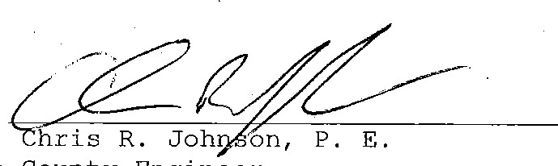
County
Engineer
2 2

Visitor Attendance Sheet
Meeting held at Pike County Highway Department
Month/Date Year Time
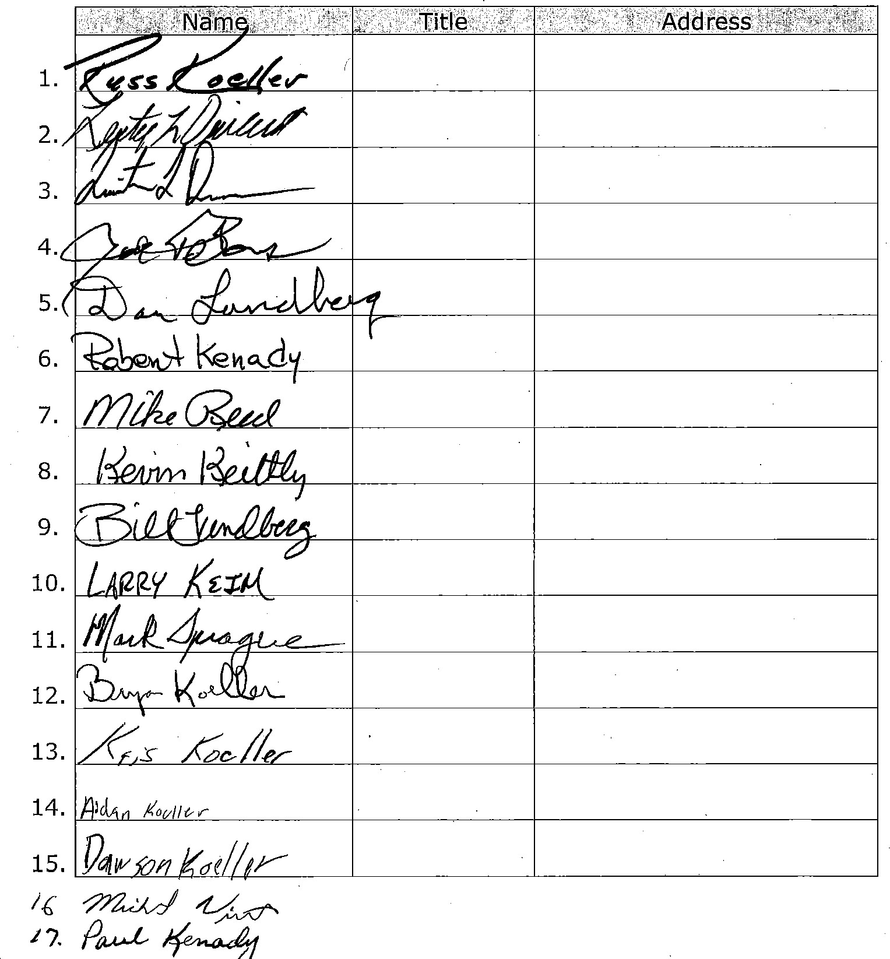
Pgu-L
4.4."

County Highway Date: Wednesday, September 11, 2019
Date Range: 8/15/2019 - 9/11/2019
The following claims are hereby approved for payment:

FUND: County Highway
8/30/2019 373 | VOIDED CHECK NUMBER | Description | Invoice | Account | Amount  0.00
 | VOIDED CHECK NUMBER | Voided |  | 019-000-0506 | 0.00
 | General Fund | July, 2019 - County's portion of Employee Health Insurance |  | 019-000-0517 | 3,885.00
 | General Fund | August, 2019 - County's portion of Employee Dental/Vision I |  | 019-000-0517 | 175.56
 | mcome Tax Clearing Account | 2019-16 - Boäl ramp - Craig |  | 019-000-0510
 | Income Tax Clearing Account | 2019-16- Boat ramp - Gary |  | 019-000-0510
 | Income Tax Clearing Account | 2019-16 - Boat ramp - John Mc |  |  | 41.66
 | Income Tax Clearing Account | 2019-16 - Boat ramp - John Mo |  | 019-000-0510 | 34.79
Date: Check Vendor Name

126.00
AT&T Mobility 291.83
Partsmaster 133.38 3-D Leasing, Inc. 232.84
3-D Leasing, Inc. 101.44

8/2112019 3769
8/2112019 3770
8/2112019 3771
8/21/2019 3772
8/21/2019 3772 8121/2019 3772
 |  | Check Total: | 359.90
Income Tax Clearing Account | 2019-16- Solid Waste Coordinator Salary | 019-000-0506 | 250.00
Income Tax Clearing Account | 2019-16- Part-time. help | 019-000-0510 | 768.00
8121/2019 3772
8/21/2019 3773
 | Check Total: | 1,018.00
Western Illinois Titte Services, LLC | Earnest money for purchase of Bergman property North of c 019-000-0517 | 1,000.00
Staples Credit Plan | Office supplies - tab dividers, paper '321320841 019-000-0517 | 52.41
Koenig Body & Equiprgent, Inc. | Purchase of tailgate conveyor/spreader box 019-000-5860 | 5,500.00
County Road & Bridge Fund | Reimbursement of funds deposited in error into County High Oi 9-000-0425 | 6,562.49
Interstate All Battery Center |  | 143.20
Dell Markeling L.P. |  | 1,565.72
Roland Machinery Company |  | 198.91
Wal Mart Community  Ace Hardware | 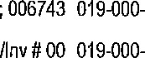 | 36.49
Thiele Garage, Inc. |  | 42.00
Thiele Garage, Inc. |  | 42.00
Thiele Garage, Inc. |  | 42.00
8/2112019 3773
812712019 3774
8/3012019 3775
8/3012019 3776
813012019 3777
8/30/2019 3778 22AH 90W High Rate FR Rebuild 1501016986 019-000-0519 8/30/2019 3779 Gary's Laptop - Dell Latitude 5500 BTX Base, docking statio 1337377369 019-000-0517
8/3012019 3780 E-l - Belt and Mirror 37037055 019-000-0520
813012019 3781 Cleaning & kitchen supplies '52; 006743
8/30/2019 3782 Shop supplies - Hillman fasteners; tape 019-000-0519
8/30/2019 3783 - IL safety Tesl 88859 019-000-0520
813012019 3783 - IL safety Tesl 88864 019-000-0520
 |  |  |  | Check Total:
8130/2019 | 3784 |  | Mobile Phones (3) | 019-000-0517
8130/2019 | 3785 |  | Shop supplies - mini blade; fuse; grease fitting | 23452999 019-0004)519
813012019 | 3786 |  | TM-2 - O-ring, JIC 37 swil strgt Thrd -Rg, Pwr CM? Hose; L | 76742 019-000-0519
8/30/2019 | 3786 |  | T-7 - Push In Lock Air Brake fitting and exhaust gasket | 76636 01900-0520
813012019 3783 T-7 - IL safely Test 88859 019-000-0520
 | 334.28
Hutchison Engineering, Inc. | 2,509.27
Check Total:
 |  |  |  | Check Total: | 1 ,212.09
8/30/2019 | 3792 | Farm & Home Supply | Shop supplies - cabie tie | 4196937 019-000-0519 | 19.99
813012019 | 3792 | Farm & Home Supply | Shop supplies Glyphosate, bean oil, bushing, 22' alumin su | 4195948 019-000-0519 | 106.95
813012019 | 3792 | Farm & Home Supply | Shop supplies - T Rod, Metric 10.0 bolts, nuts, flats, locks | 4201397 019-000-0519
813012019 | 3792 | Farm & Home Supply | Shop supplies - hose, nozzle | 4201979 019-000-0519 | 26.98
813012019 | 3792 | Farm & Home Supply | Shop supplies drive in tool straight fittings, fitting grease std | 4201320 019-000-0519
8/3012019 | 3792 | Farm & Home Supply | Shop supplies - bushings | 4201487 019-000-0519 | 5.98
8/30/2019 | 3792 | Farm & Home Supply | TG - Def diesel exhaust fluid 10 gal @ $6.99 ea | 4199237 019-000-0520 | 69.90
8/30/2019 | 3792 | Farm & Home Supply | T-7 2020 - seat cover | 4196936 019-000-0520
8/30/2019 | 3792 | Farm & Home Supply | 2 - Antenna's | 4413010 019-000-0520 | 27.98
8/30/2019 | 3792 | Farm & Home Supply | T-7 2020 - paint, tray liner 9", lag screws, antenna, wood pai | 4195781 O i 9-000-0520 | 70.59
8/30/2019 | 3792 | Farm & Home Supply | T-7 2020 - Floor mats, grade 5 hard bolts, Fan barrell | 019-000-0520  Check Total: | 145.59
8/31/2019 | 3794 | Potters Industries LLC | 8,000 lbs IL Type B MP BG 2000 Standard Highway Sa | 91238189 019-000-0515 | 2,776.00
91112019 | 3795 | Area Diesel Service Inc. | T-9 - Turbocharger 1000019316 019-000-0520 |  | I ,462.41
8/30/2019 3787 #18 - White Bridge- Engineering Expense; Project 4070, C 18 019-000-5850 FUND: County Highway
Date: |  | Check |  | Vendor Name |  | Description |  |  | Invoice |  | Account | Amount
8/30/2019 |  | 3788 |  | Gina L. Nottingham, CSR |  | Discovery Depositions of David Chenoweth, Brice Lawson, |  |  |  |  | 019-000-0517 | 521.00
8130/2019 |  | 3789 |  | Ameren Illinois |  | Office - 53430-07011 |  |  |  |  | 019-000-0517 | 238.38
813012019 |  | 3789 |  | Ameren Illinois |  | Big Shop 63430-071 18 |  |  |  |  | 019-000-0517
8/3012019 |  | 3789 |  | Ameren Illinois |  | Old Twp Shed 83430-07223 |  |  |  |  | 019-000-0517 | 42.93
 |  |  |  |  |  |  |  |  |  | Check Total: |  |  | 319.72
 | 8/30/2019 |  | 3790 |  | Concorde, Inc. |  | 3rd Quarter 2019 - Random Drug Testing Fee |  |  | 309807 019-000-0517 |  |  | 72.00
 | 8/30/2019 |  | 3791 |  | Altorfer, Inc. |  | Shop supplies• - Coolant 12 @ $66.14 each |  |  | :120204740 019-000-0519 |  |  | 808.68
 | 8/30/2019 |  | 3791 |  | Altorfer, Inc. |  | Shop supplies - Padlock |  |  | :120205110 019-000-0519 |  |  | 102.28
 | 8130/2019 |  | 3791 |  | Altorfer, Inc. |  | L-2 - Hyd IOW; element; filter; hose, coupling, seal O-rings |  |  | : 120205281 019-000-0520 |  |  | 301.13
 | 9/9/2019 |  | 3796 |  | Income Tax Clearing Accounl |  | 2019-17 - Landfill | 019-000-0506 |  |  |  |  | 250.00
 | 9111/2019 |  | 3797 |  | Affton Radiator |  | T-IO - Radiator | 019-000-0520  FUND TOTAL: |  |  |  |  | 525.00  31 ,566.15
FUND: County Highway Date: Check Vendor Name

Description Invoice Account Amount

TOTAL CLAIMS: 31,566.15
APPROVED BY ROAD AND BRIDGE COMMITTEE: APPROVED BY:
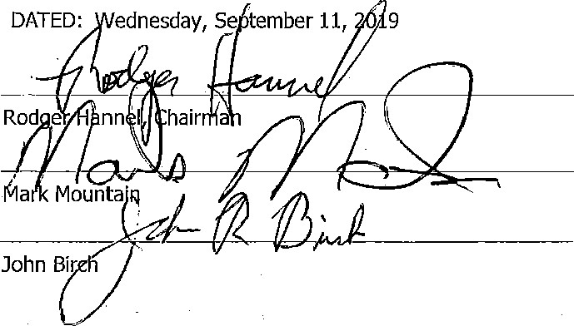ednesday, Se tember 11, 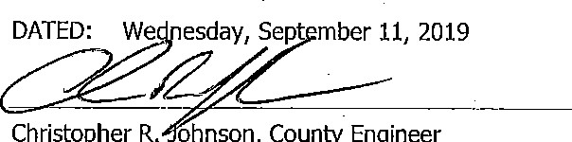
Christopher
R.
ohnson,
County
Engineer

County Road and Bridge
Date Range: 8/15/2019 - 9/11/2019
The following claims are hereby approved for payment:

Date: Wednesday, September 11, 2019

Check Vendor Name  FUND: County Road and Bridge | Description | Invoice Account | Amount
8/30/201 9 2-00968 Martinsburg Road District | Half Aid to Bridge ER repairs to Miller Branch | 024-000-5010 | 2287.04
 |  | FUND TOTAL: | 2,287.04
 | TOTAL CLAIMS: | 2,287.04
APPROVED BY ROAD AND BRIDGE COMMITTEE: | APPROVED BY:
DATED: Wednesday, S ptemberl 2019 | DATED: Wednesday, September 11, 2019
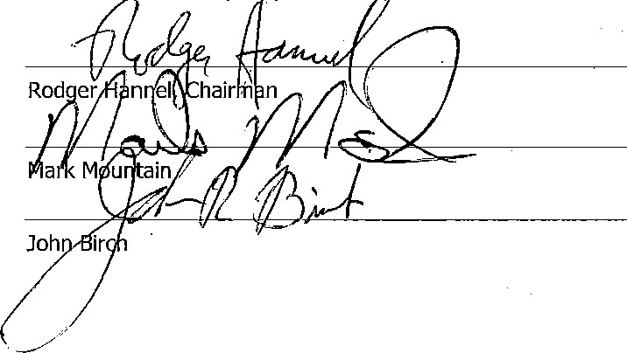
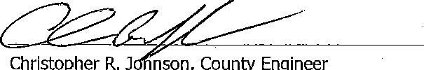
1 1
Christopher
R.J
nson,
County
Engineer
Federal Aid Match Date: Wednesday, September 11, 2019
Date Range: 8/15/2019 - 9/11/2019
The following claims are hereby approved for payment:
DATE Check Vendor Name Description Section Invoice Account Amount
FUND: Federal Aid Match
9/9/2019 4-01107 Income Tax Clearing Accounl 2019-17 - Res Eng & Twp Eng partial 15-00098-00-BR 020-000-5805 4,158.07

FUND TOTAL: 4,158.07 TOTAL CLAIMS: 4,158.07
APPROVED BY ROAD AND BRIDGE COMMITTEE: APPROVED BY: 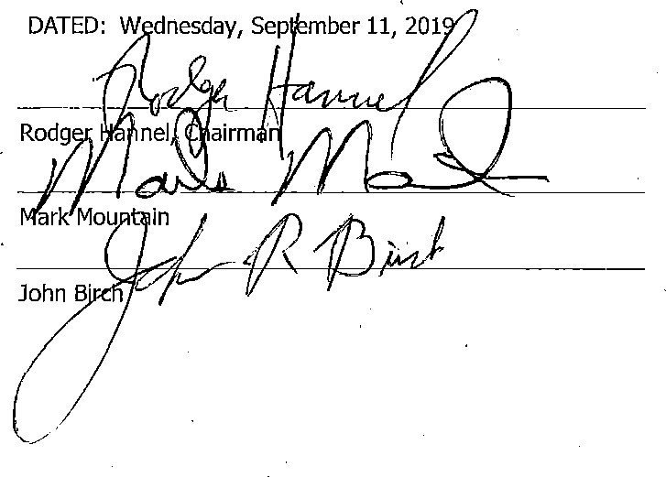DATED: W dnesday, Sep mber 11, 201 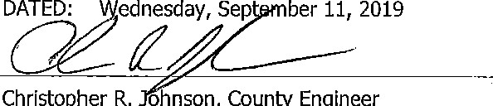DATED:
Christopher
R.
ohnson,
County
Engineer
1 1
Pike County MFT

DATE RANGE: 8/15/2019 to 9/11/2019
The following claims are hereby approved for payment:
AMOUNT
DESCRIPTION
DATE
812112019 01128 Income Tax Clearing Account 2019-16 co Eng 026-000-5001 4,154.33
8/2112019 01128 Income Tax Clearing Account 2019-16 - Day labor 026-000-5006 10,373.37
 |  |  | CHECK TOTAL: | 14,527.70
9/912019 | 01129 Income Tax Clearing Account | 2019-17 Co Eng | 026-000-5001 | 4, 154.33
919/2019 | 01129 Income Tax Clearing Account | 2019-17- Day labor | 026-000-5006 | 10,565.77

CHECK TOTAL: 14,720.10

TOTAL CLAIMS: 29,247.80
APPROVED ON Wednesday, September 11, 2019
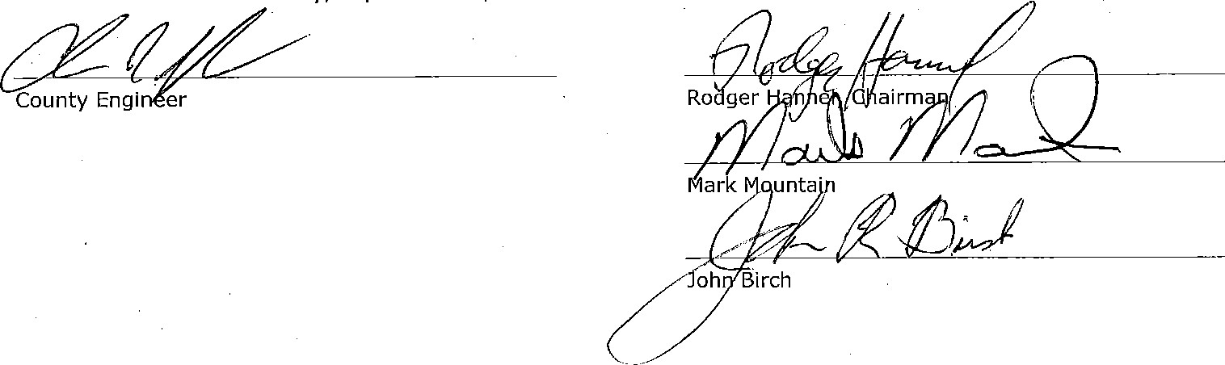

I
Township Engineer Revolving
Date Range: 8/15/2019 - 9/11/2019
The Committee for Pike County have met and approved the following Claims Date: Wednesday, September 1 1, 2019

DATE CHECK VENDOR NAME
8/21/2019 1206 Income Tax Clearing Account
9/9/2019 1207 Income Tax Clearing Account
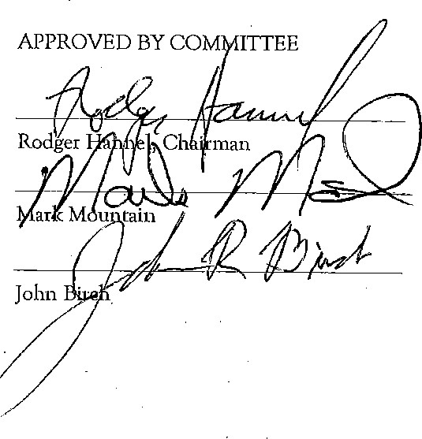
DESCRIPTION INVOICE ACCOUNT AMOUNT
2019-16 - Res Eng & Twp Eng 021-000-5000 5,478.54
2019-17 Twp Eng (partial) 021-000-5000

TOTAL CLAIMS: 6,966.51
APPROVED BY
Chris Johnson, County Engineer
1 1

