PIKE COUNTY BOARD MEETING MINUTES

June 24th, 2019

The regular monthly meeting of the Pike County Board was held on June 24th, 2019 at 7:00 PM in the Pike County Courthouse by Chairman Andy Borrowman. Jerry Edison gave the invocation and Chairman Andy Borrowman led the Pledge of Allegiance. Chairman Andy Borrowman asked County Clerk, Natalie Roseberry, to call the roll. Those answering the roll call were John Birch, Andy Borrowman, Amy Gates, Rodger Hannel, Tom Lewis, Mark Mountain, Derek Ross, Jim Sheppard and Mark Sprague.

APPROVAL OF MINUTES OF MAY 29TH, 2019 PIKE COUNTY BOARD MEETING

Roger Hannel made a motion to approve May 29th, 2019 Pike County Board minutes. John Birch seconded the motion. Voice vote was 8-0 to approve.

ACTION ON PROPOSED ORDINANCE ESTABLISHING CIVIL FEES AND CRIMINAL AND TRAFFIC ASSESSMENTS TO BE CHARGED BY THE CLERK OF THE CIRCUIT COURT.

Circuit Clerk Bryce Gleckler gave an overview of the proposed fee schedule to begin on July 1st, 2019. Amy Gates asked about the status of previous requested figures and Mr. Gleckler stated he would submit them to her. Jim Sheppard stated that the fee schedule mirrors Adams County. Chairman Borrowman clarified that the Board must pass a schedule but can amend the numbers at any time following.

John Birch made a motion to approve the submitted court fee schedule. Mark Mountain seconded. Voice vote 7-1, motion carried.

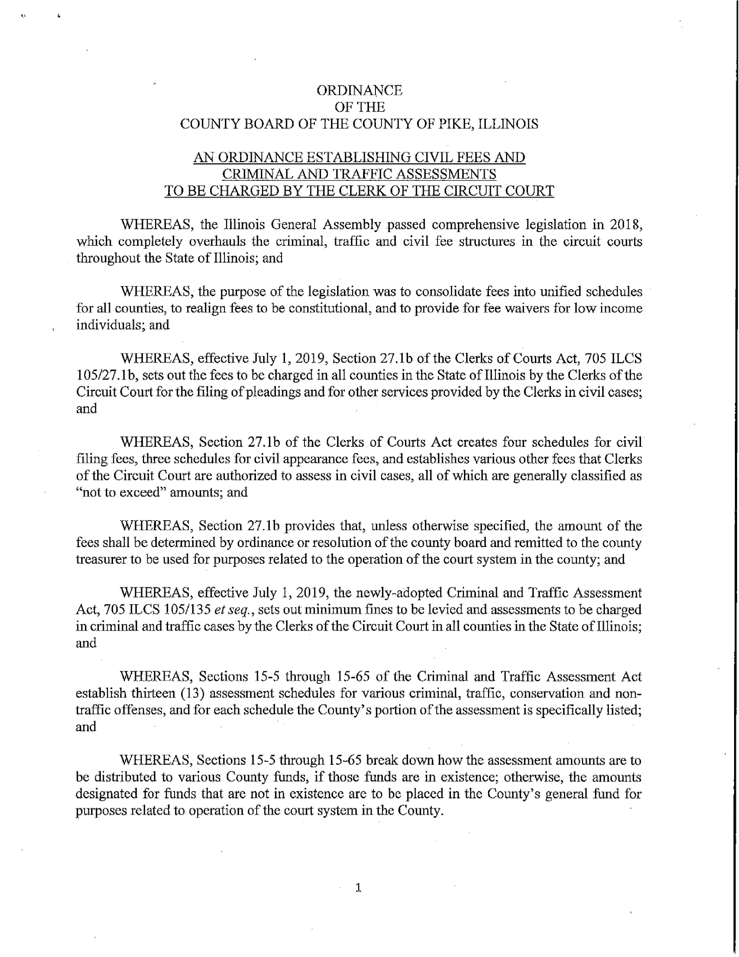
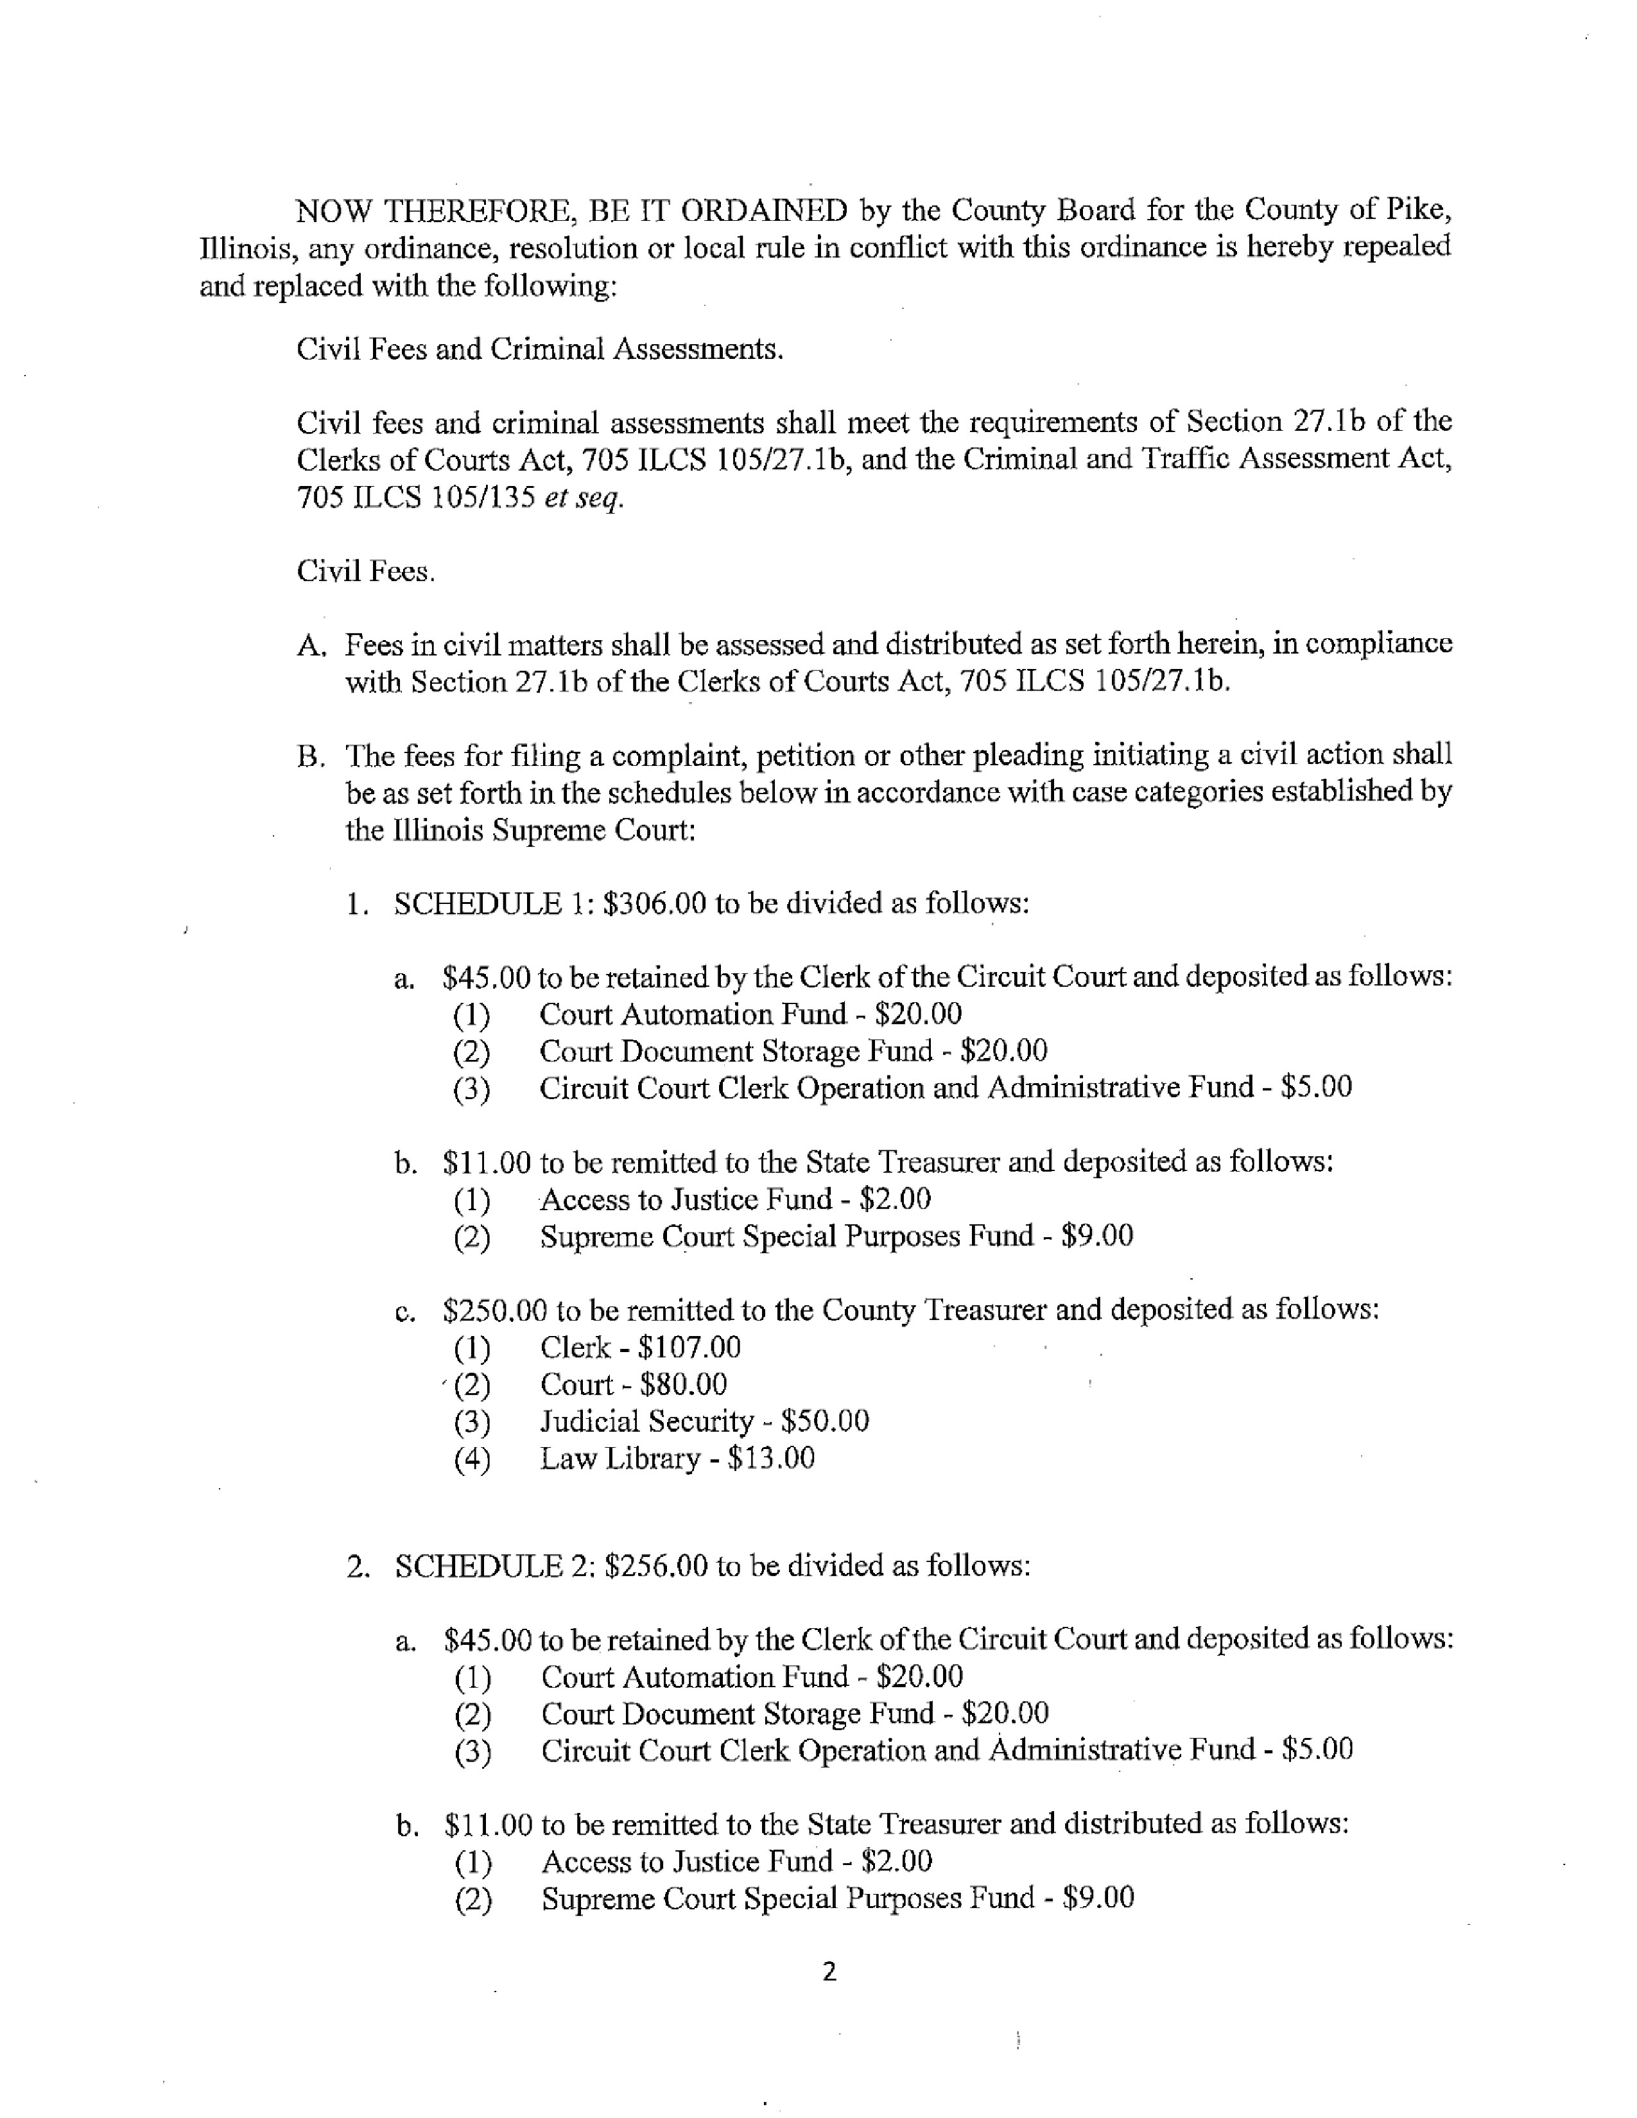
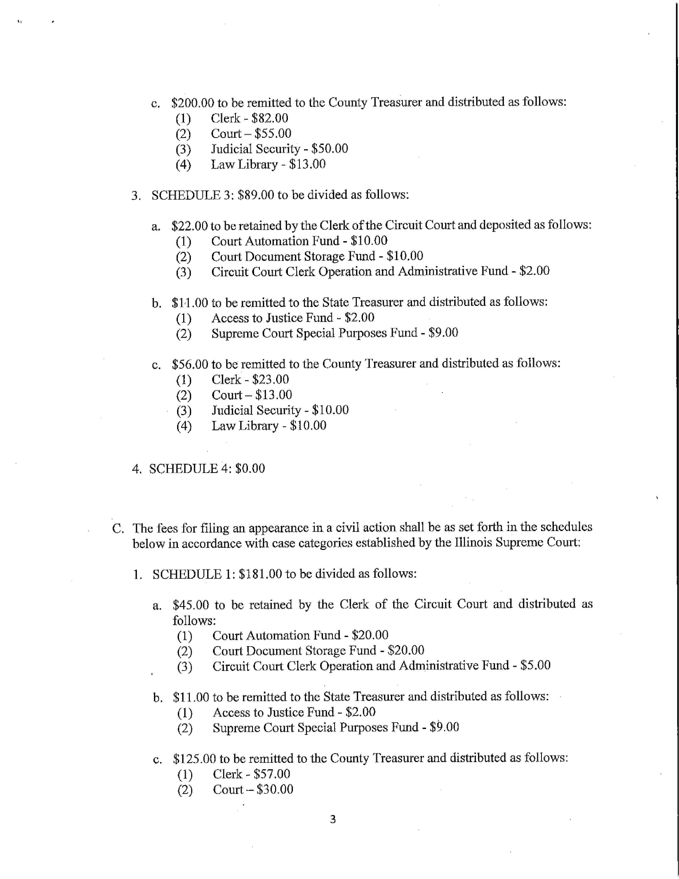
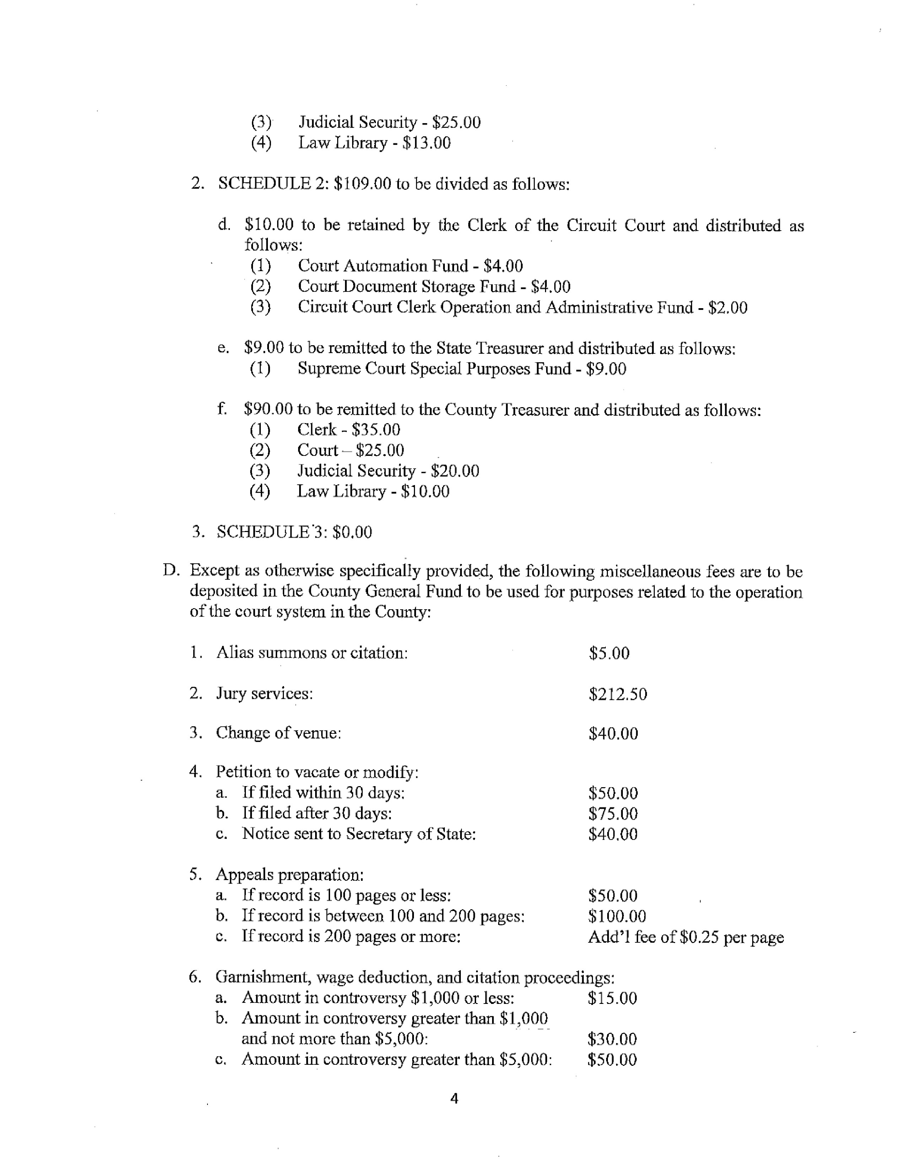
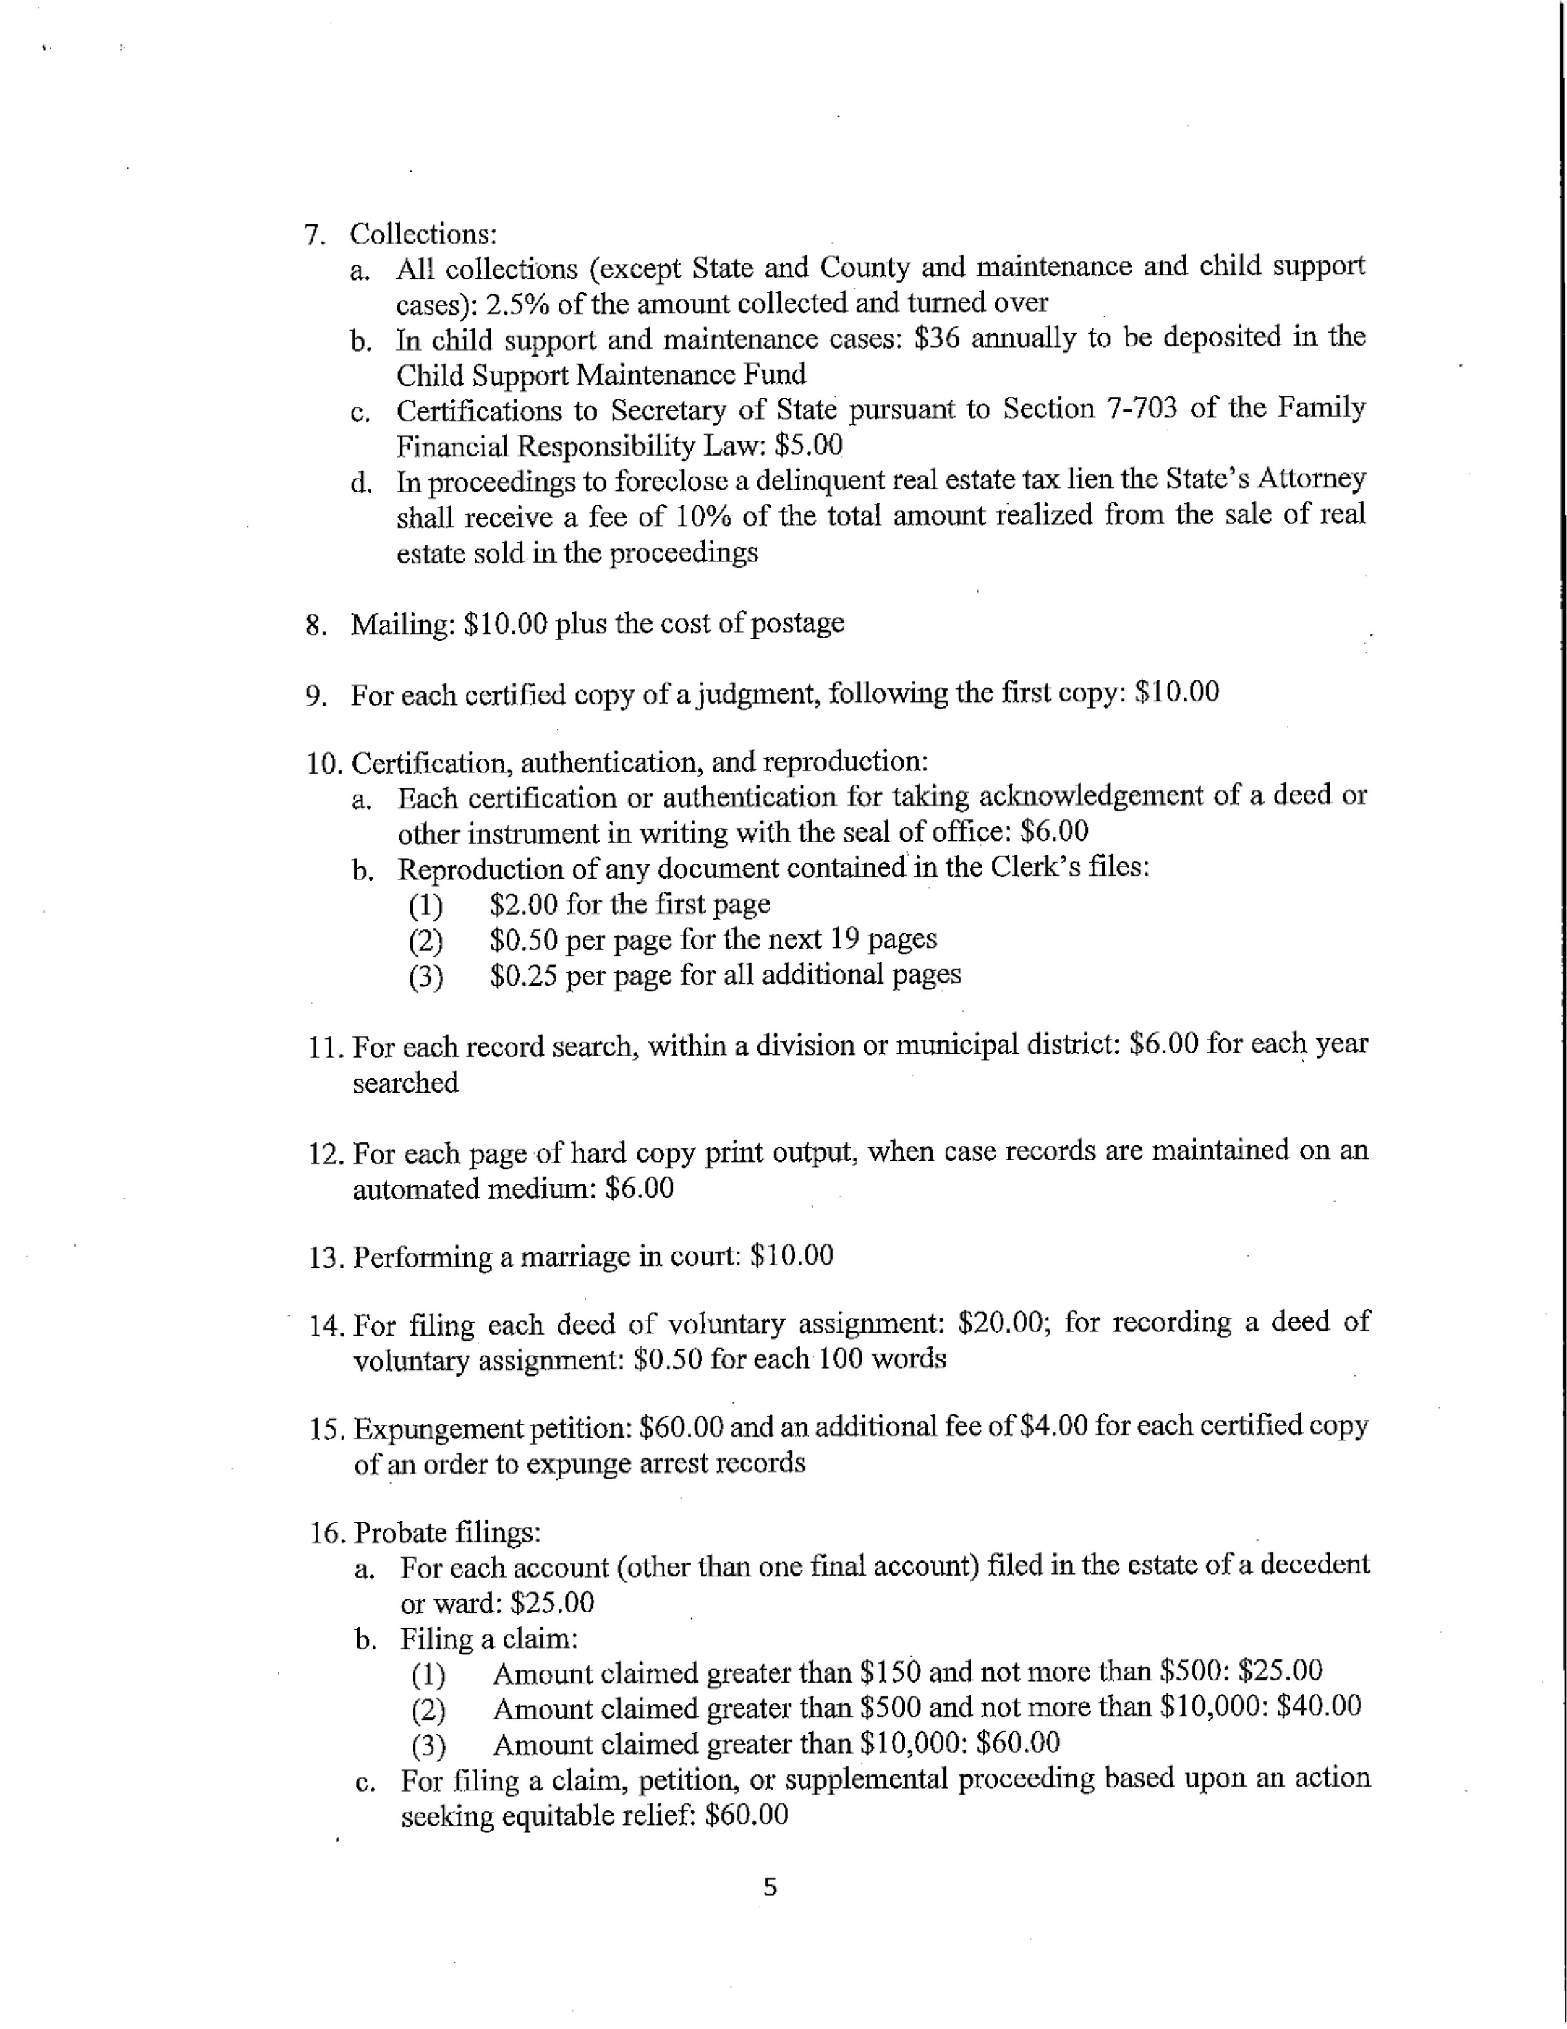
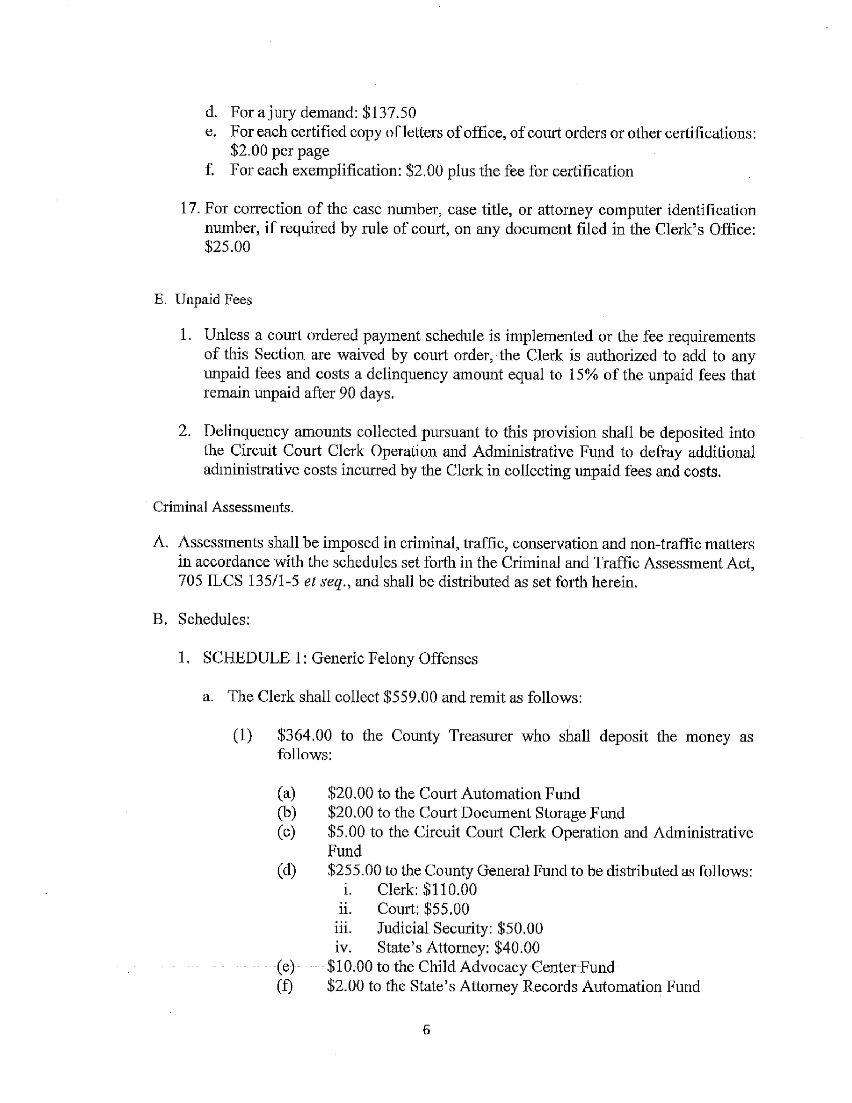
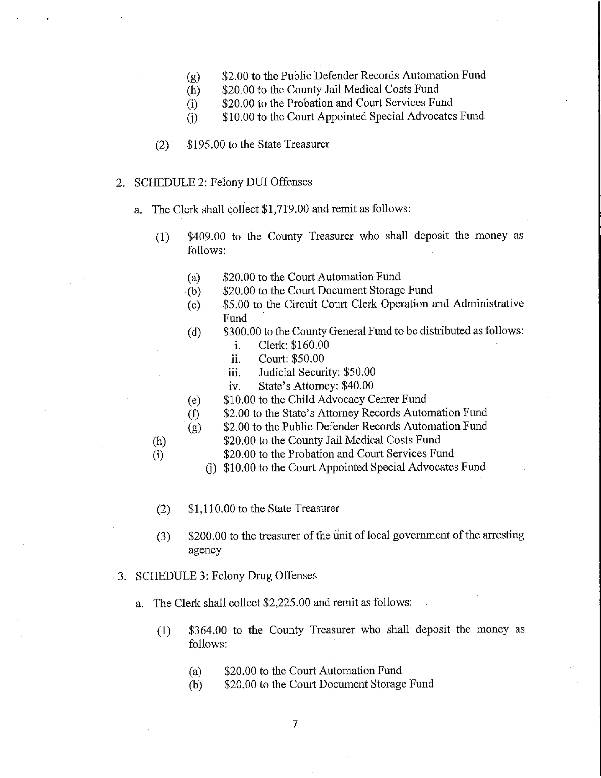
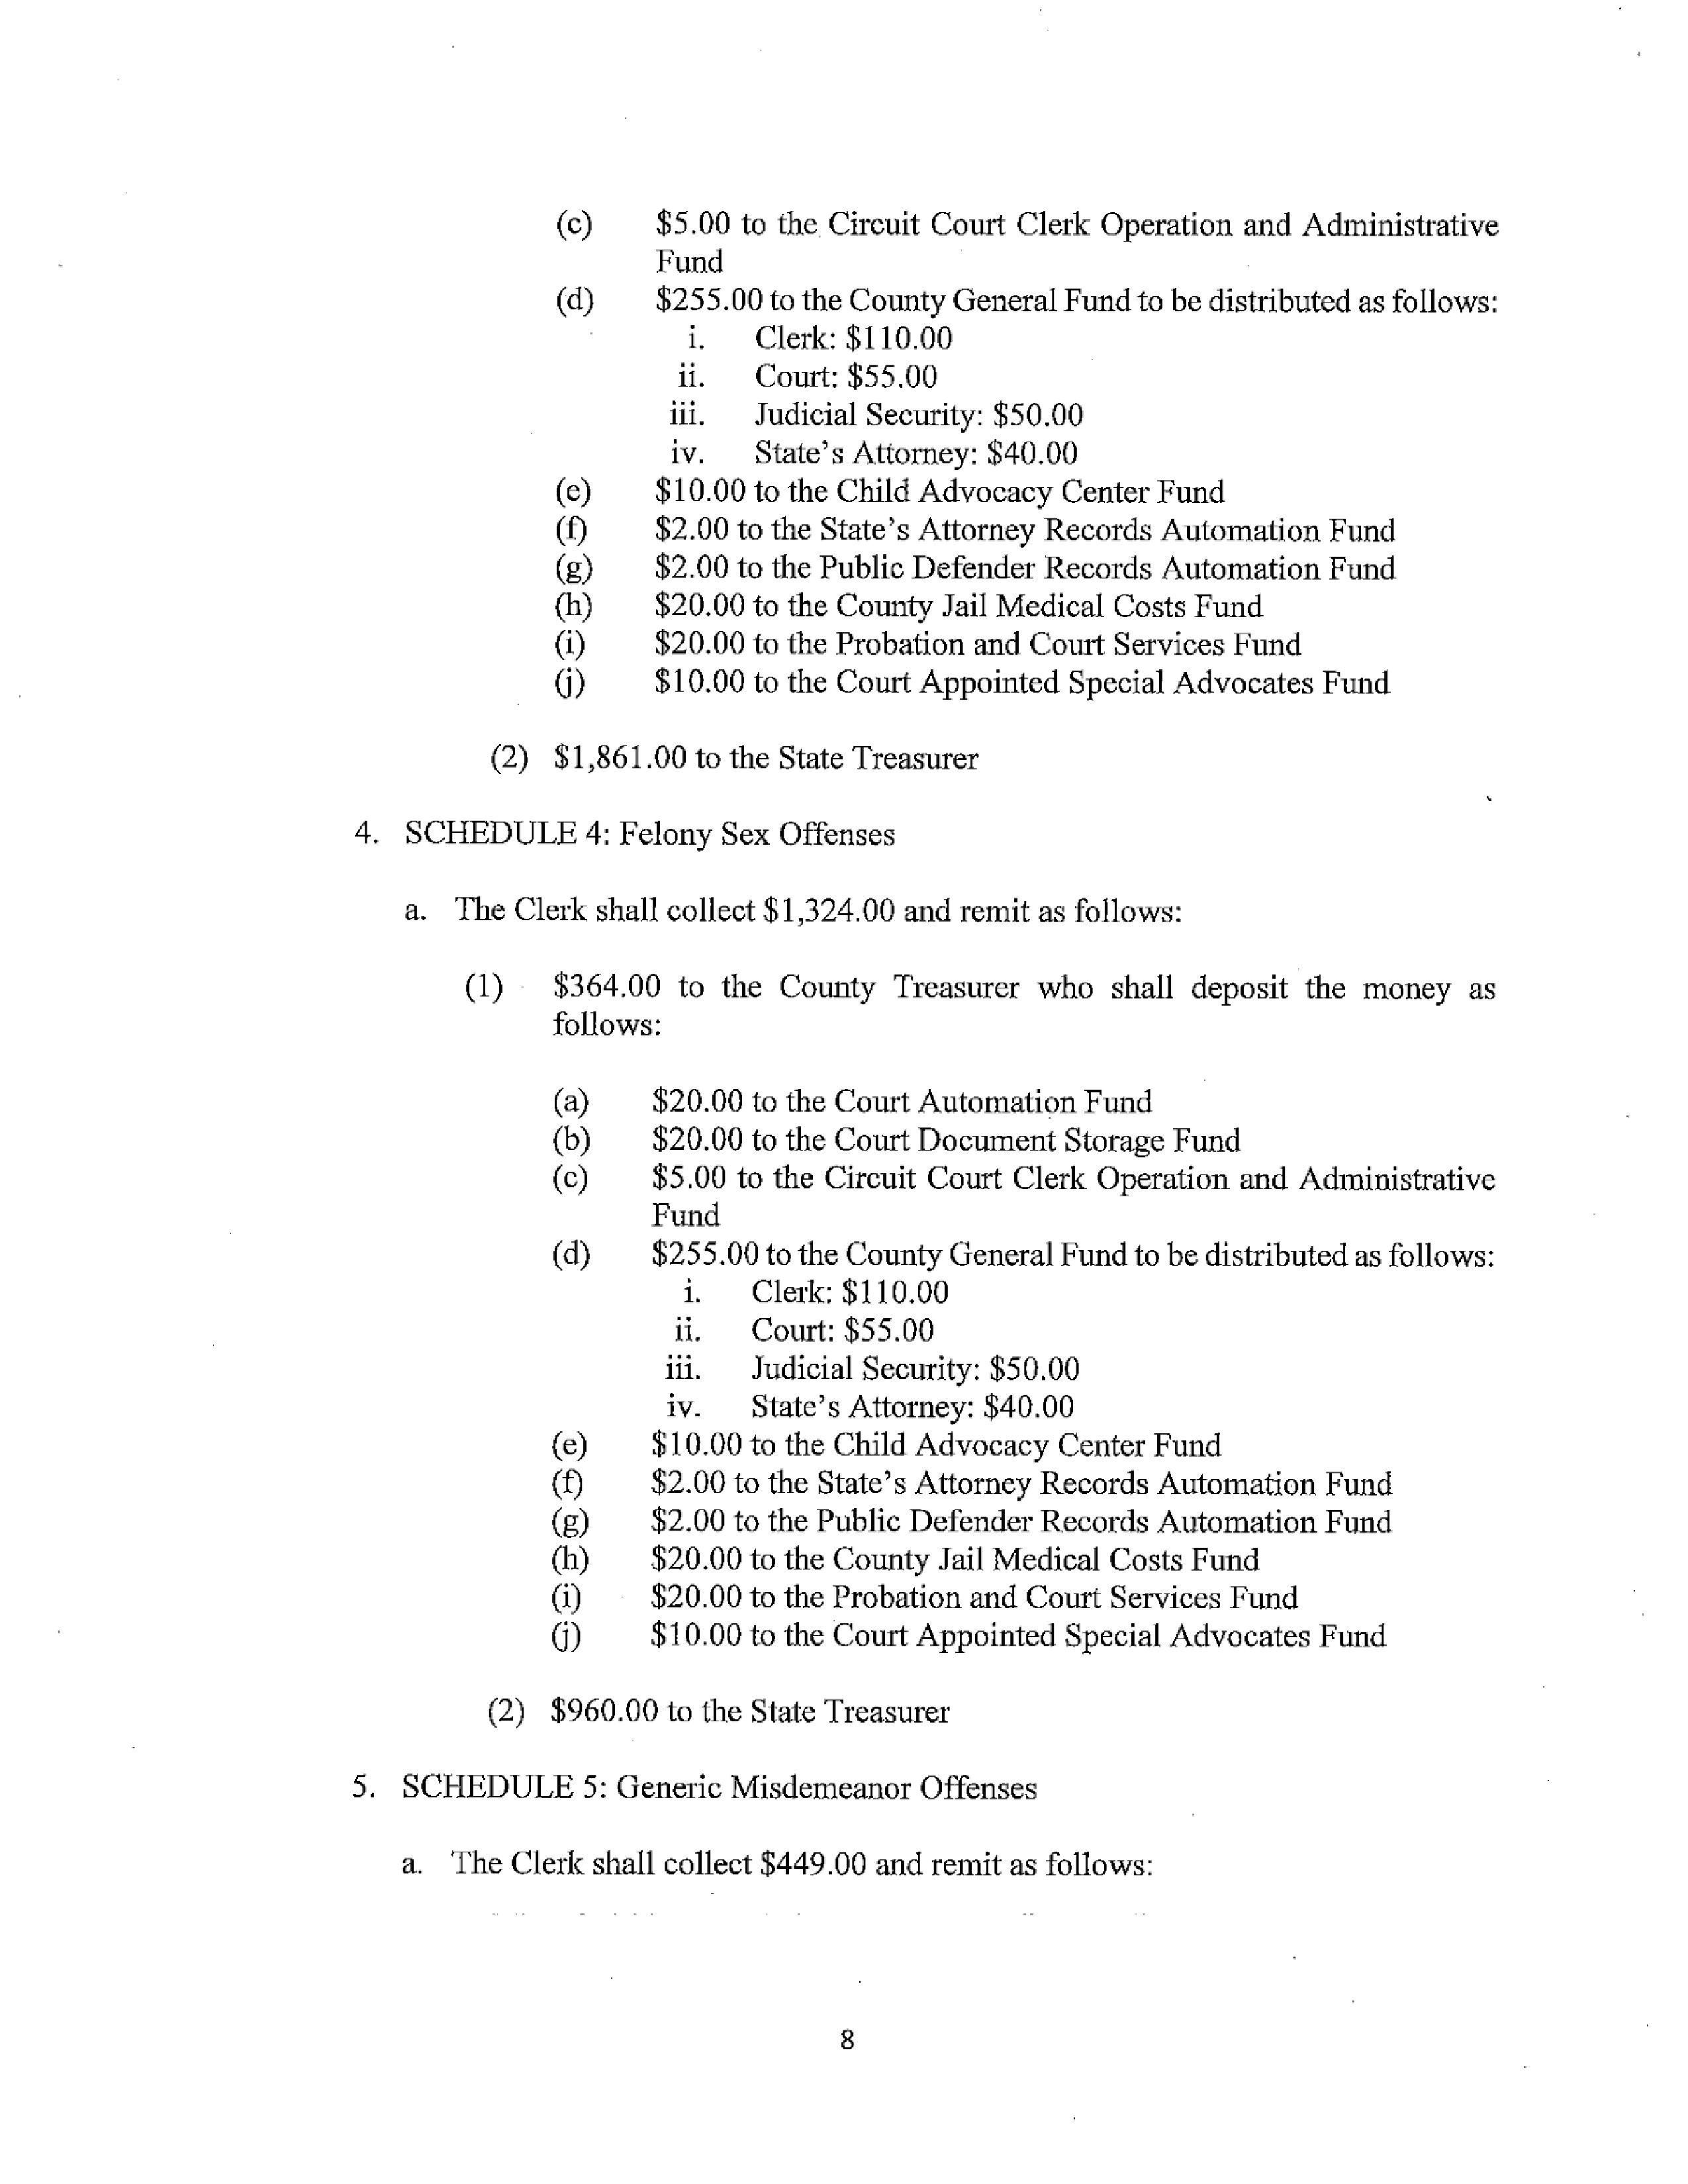
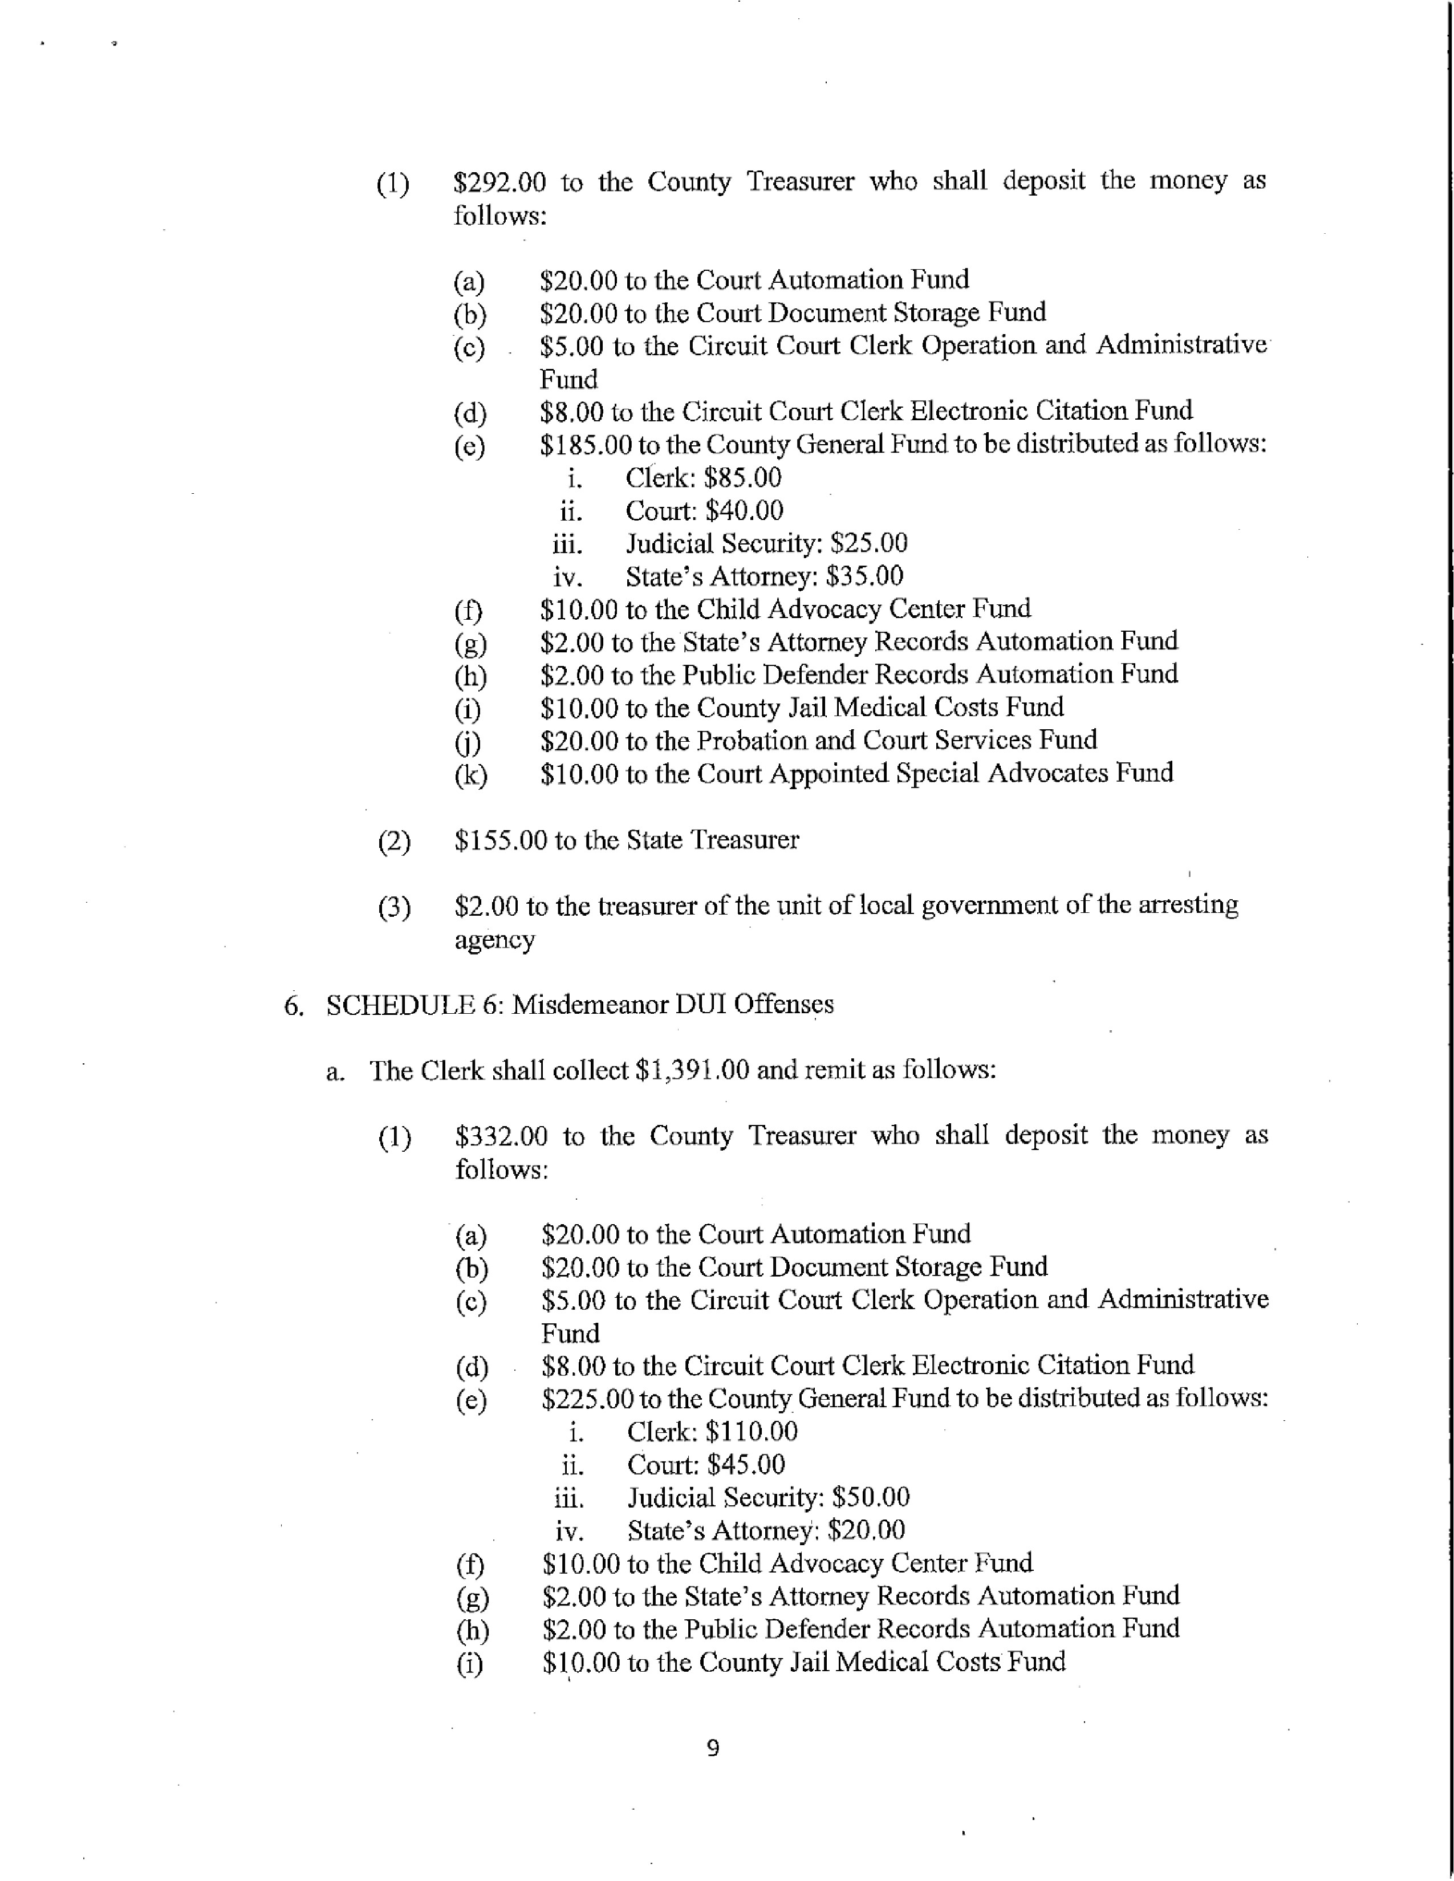
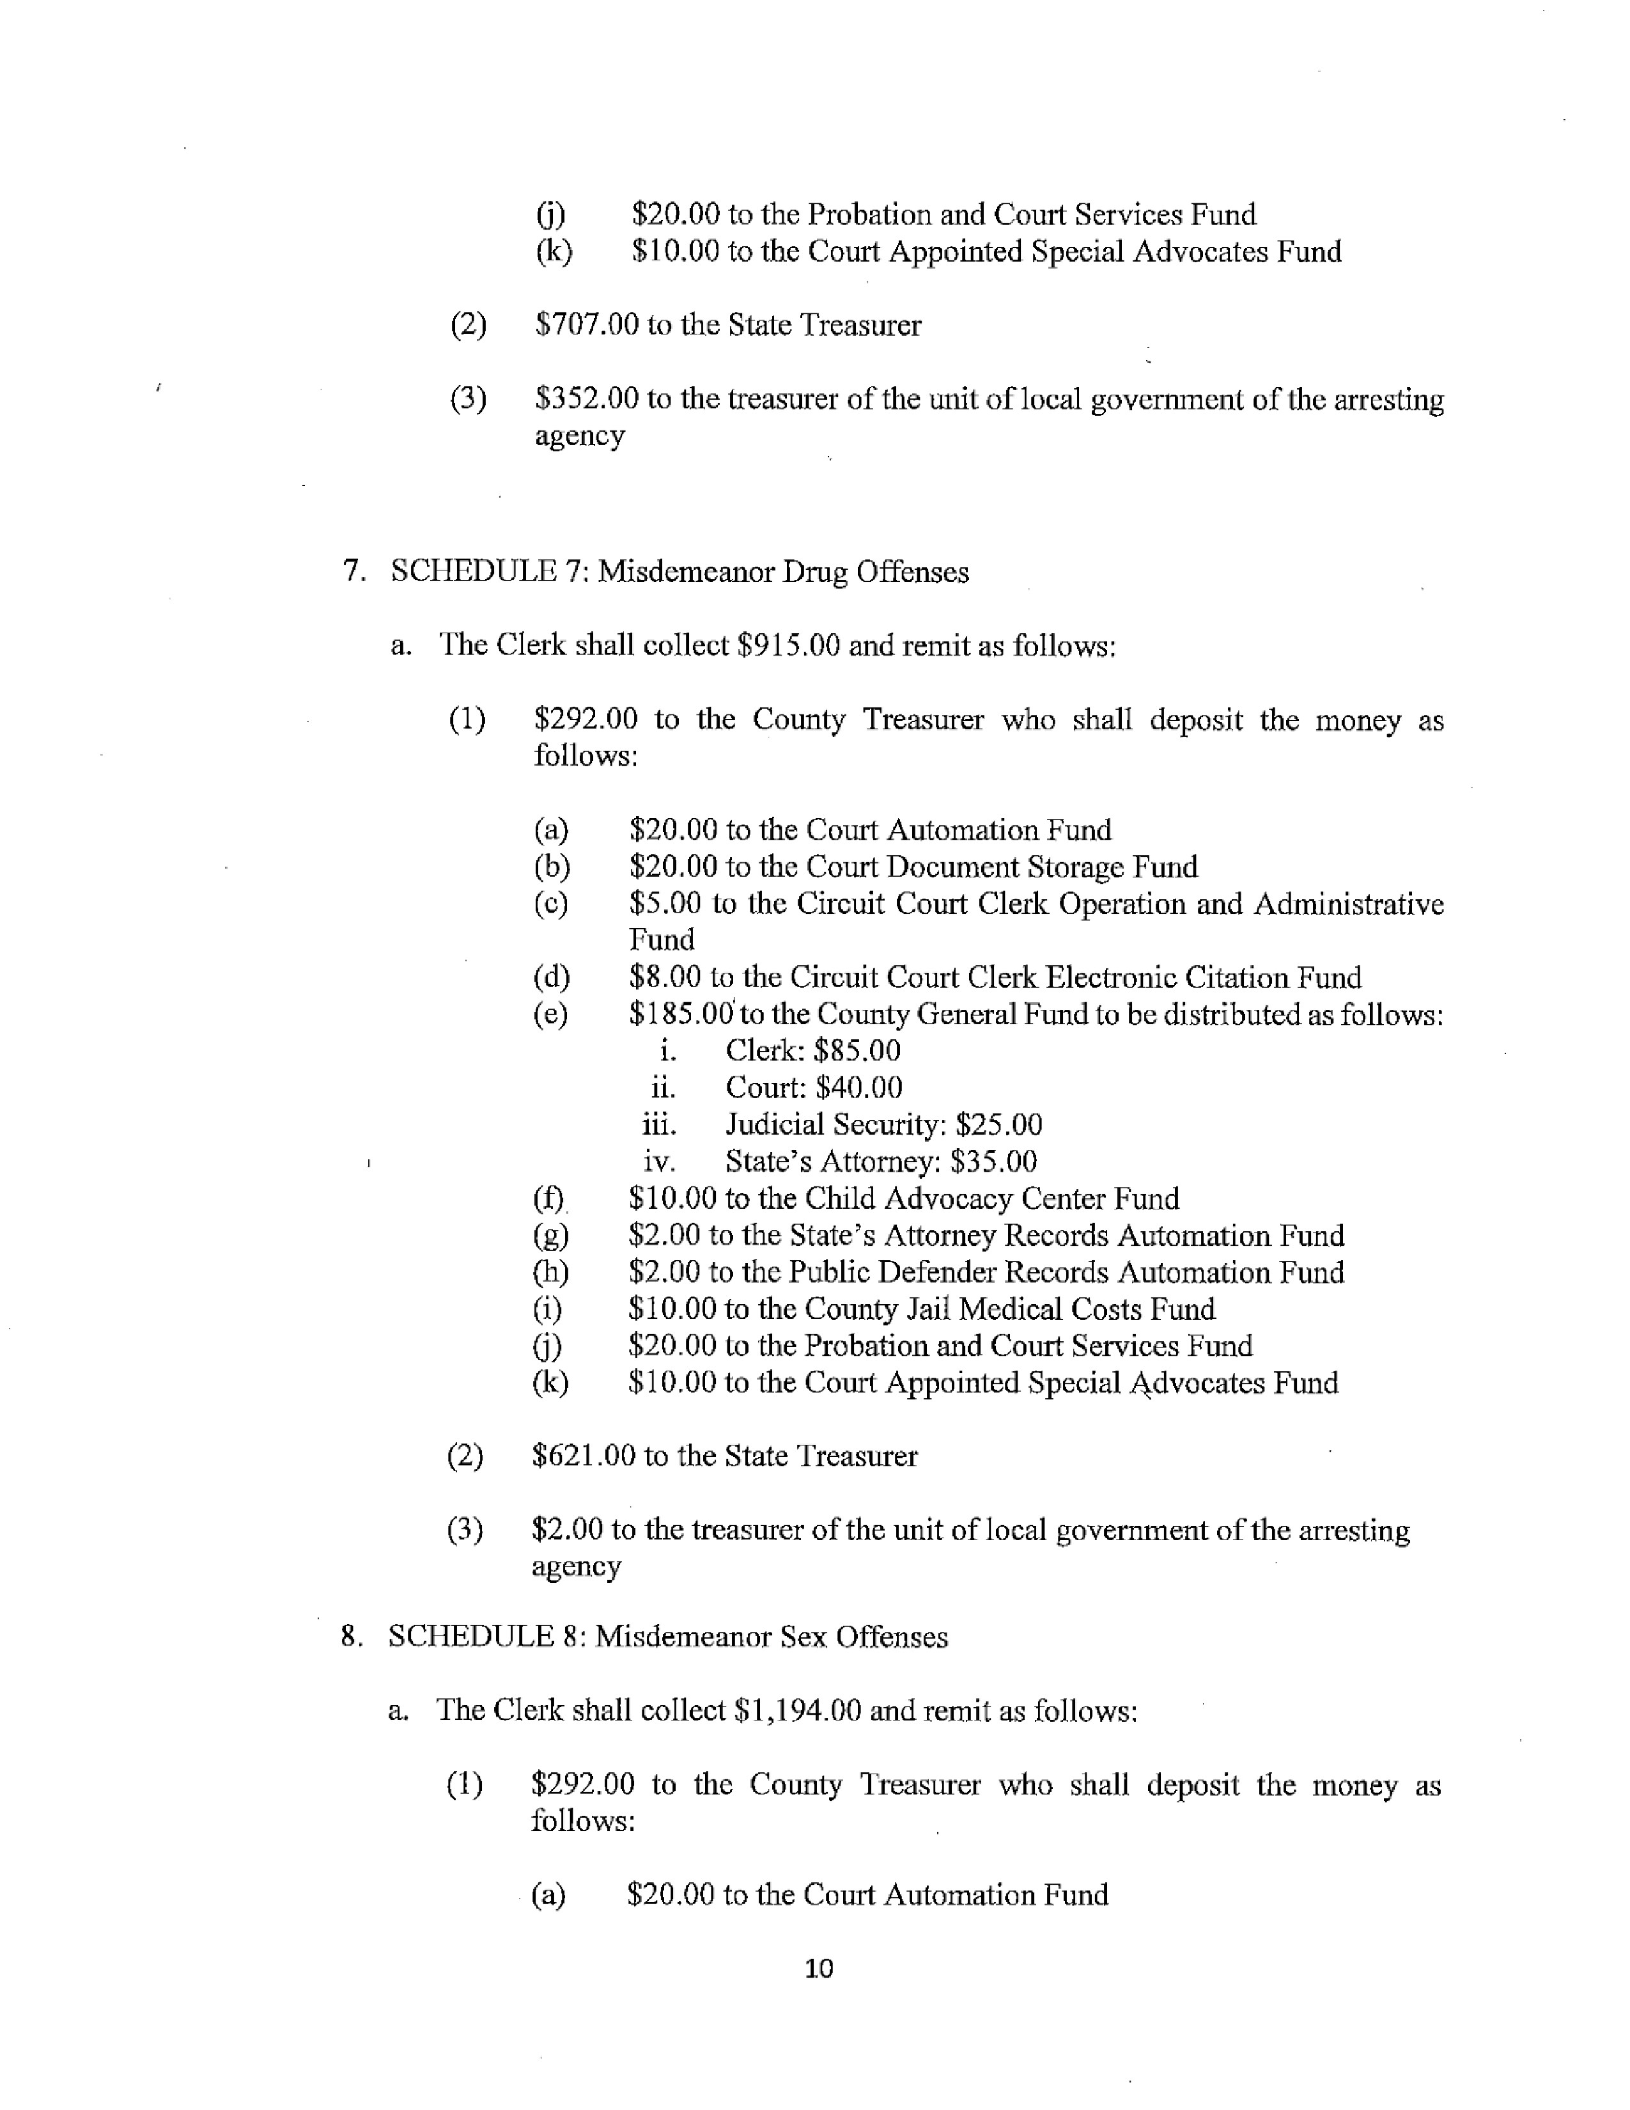
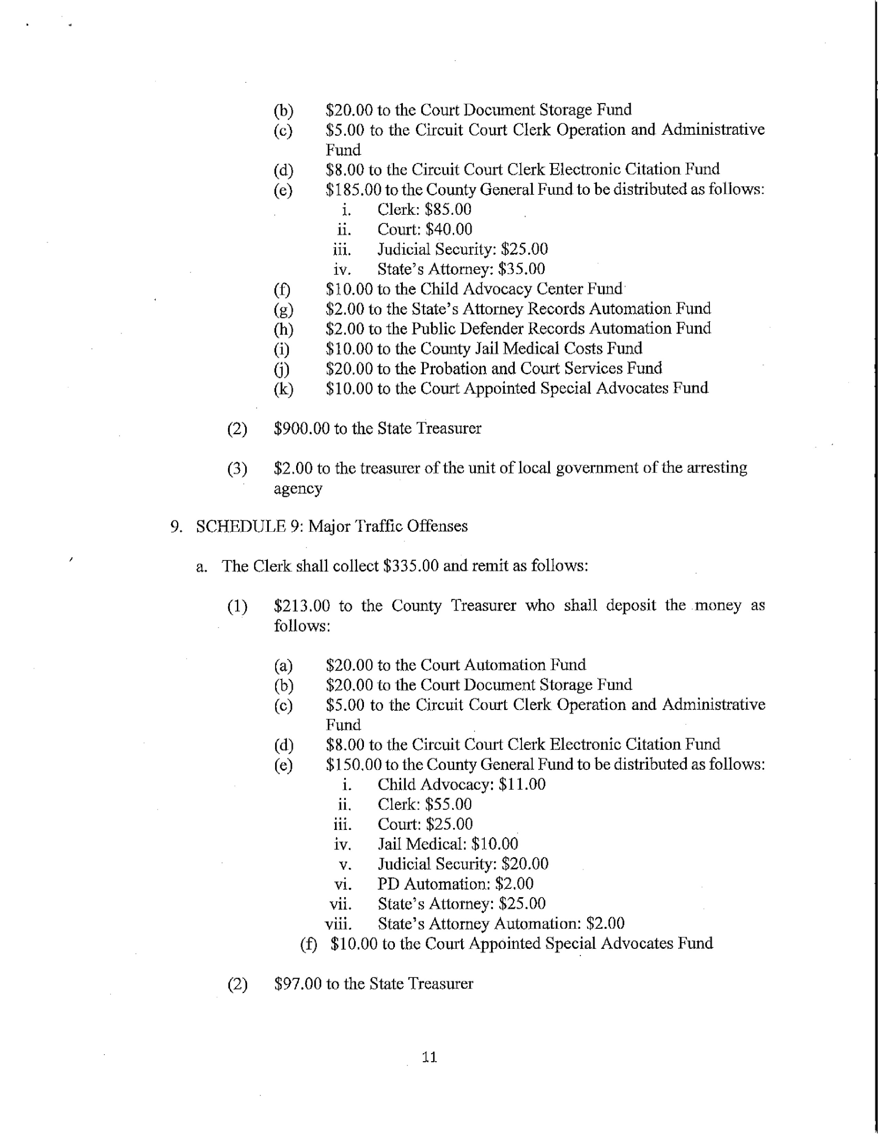
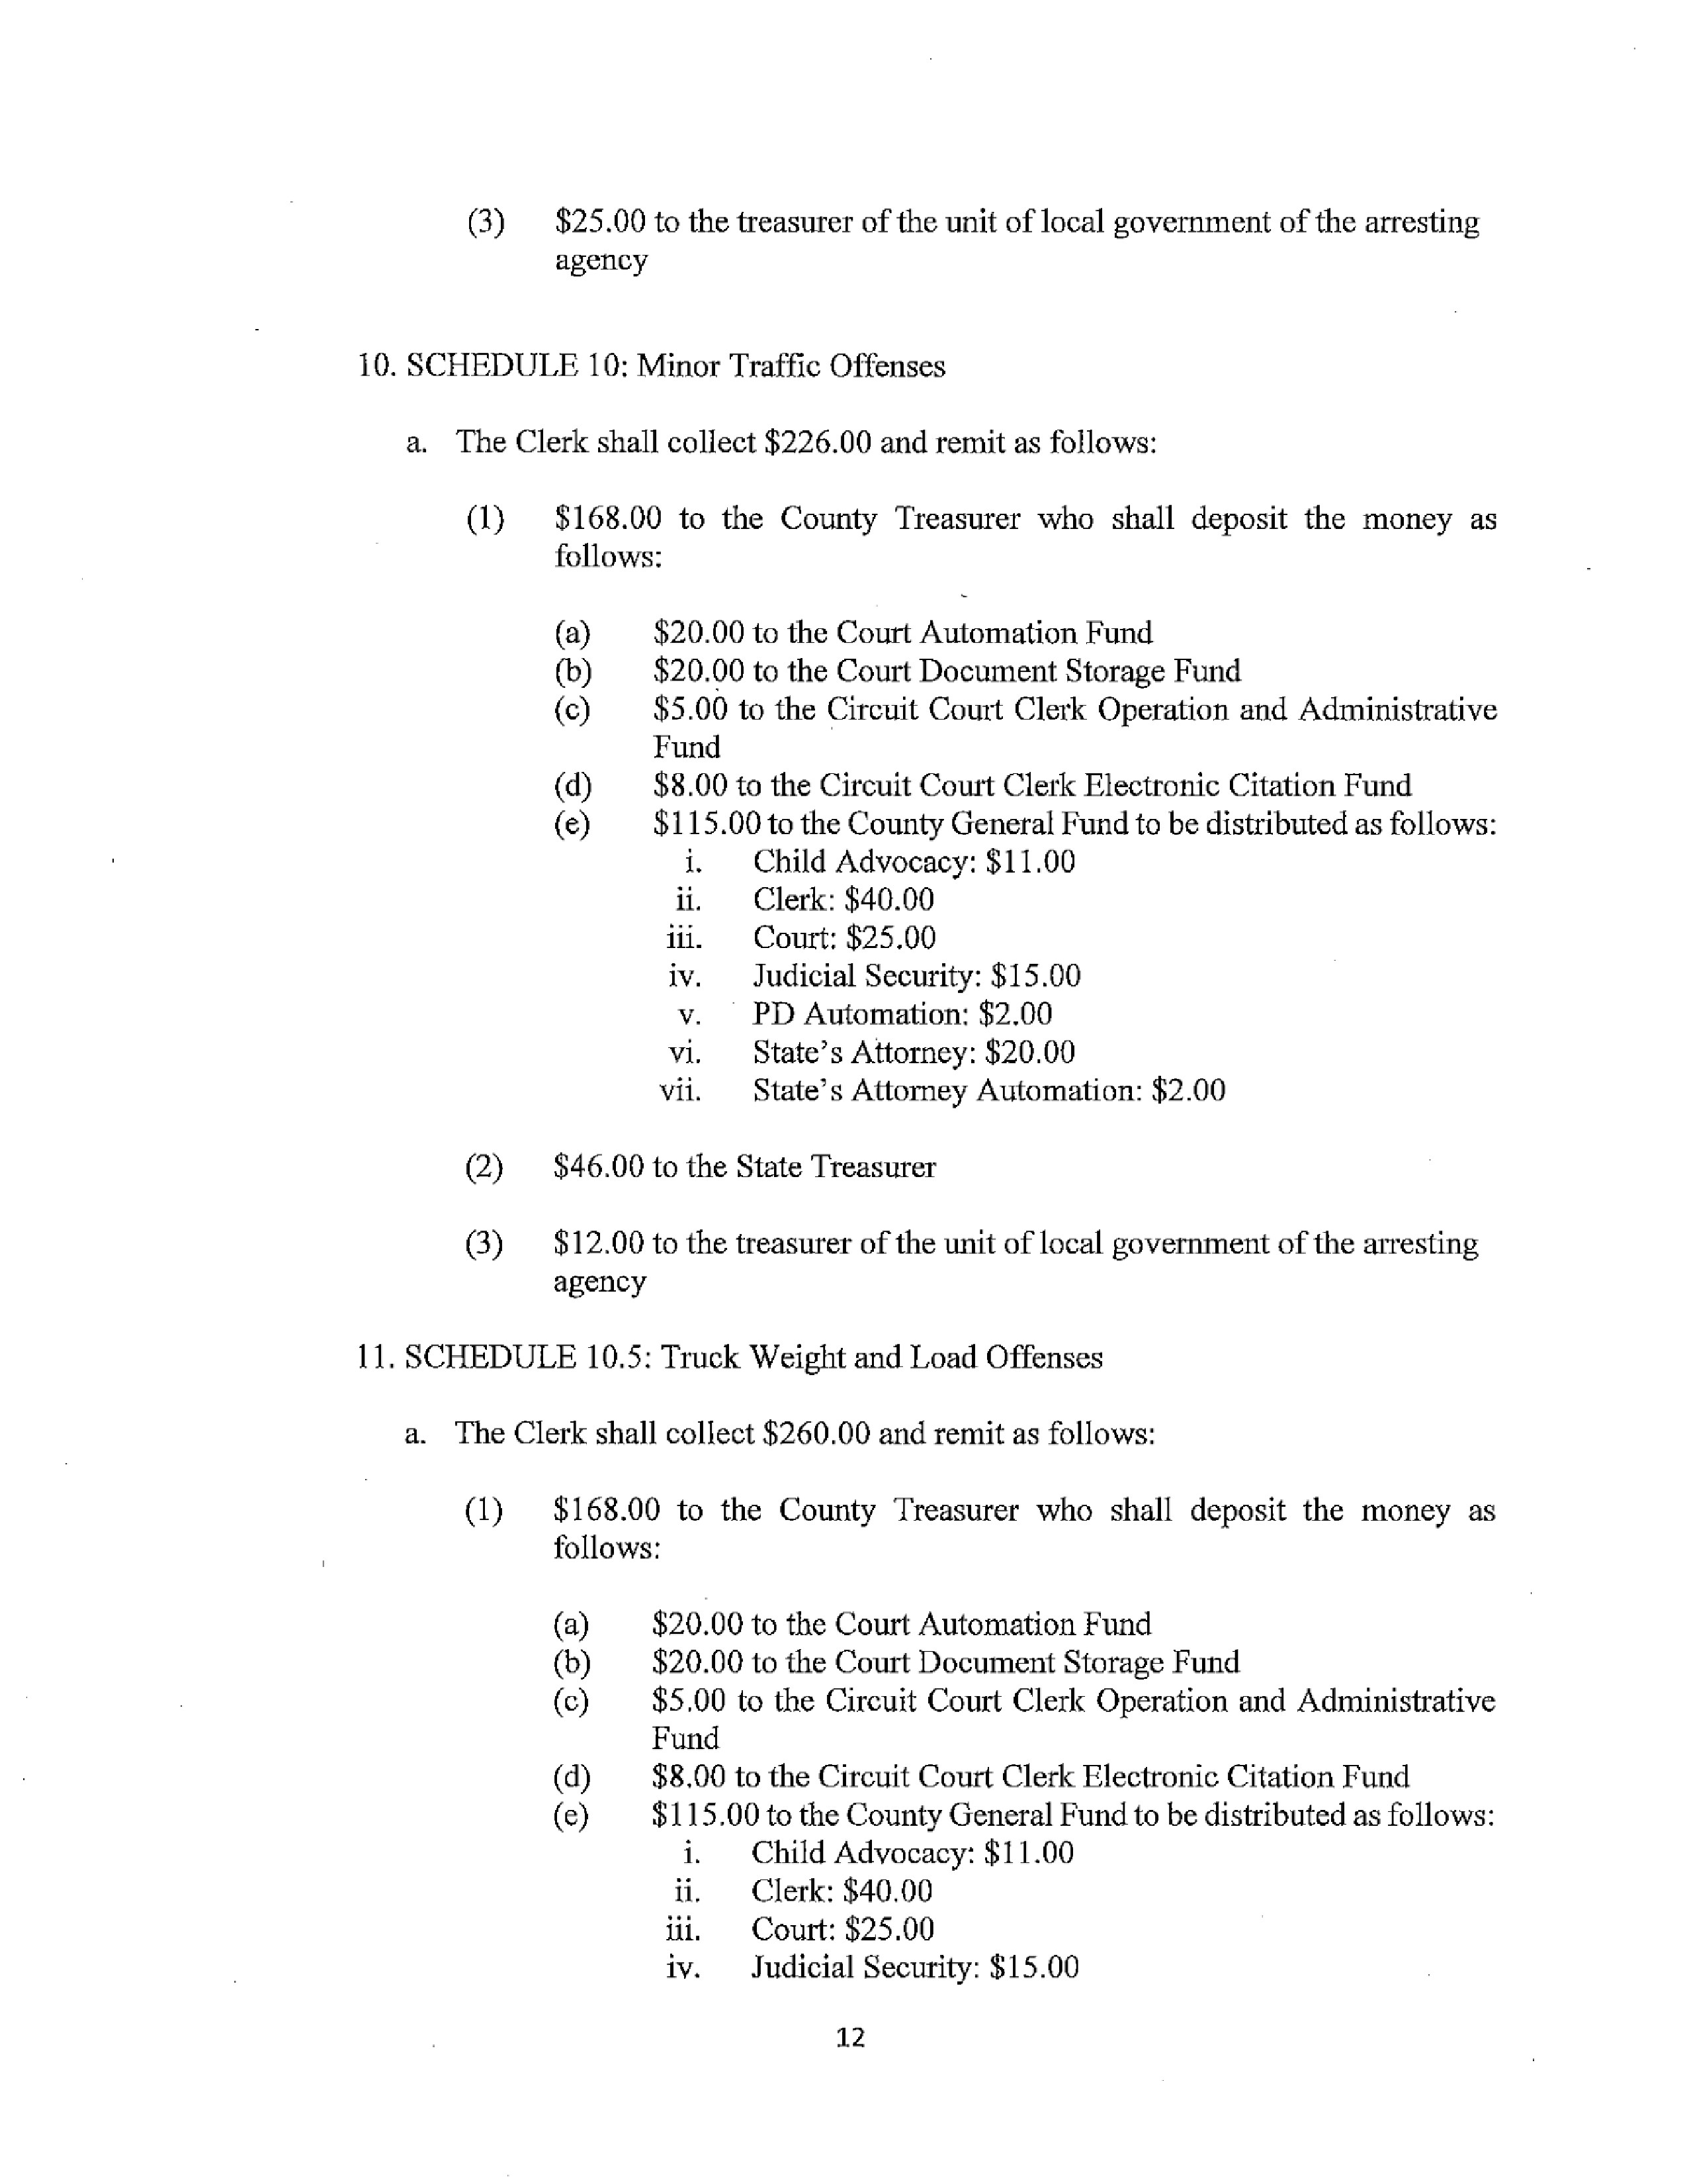
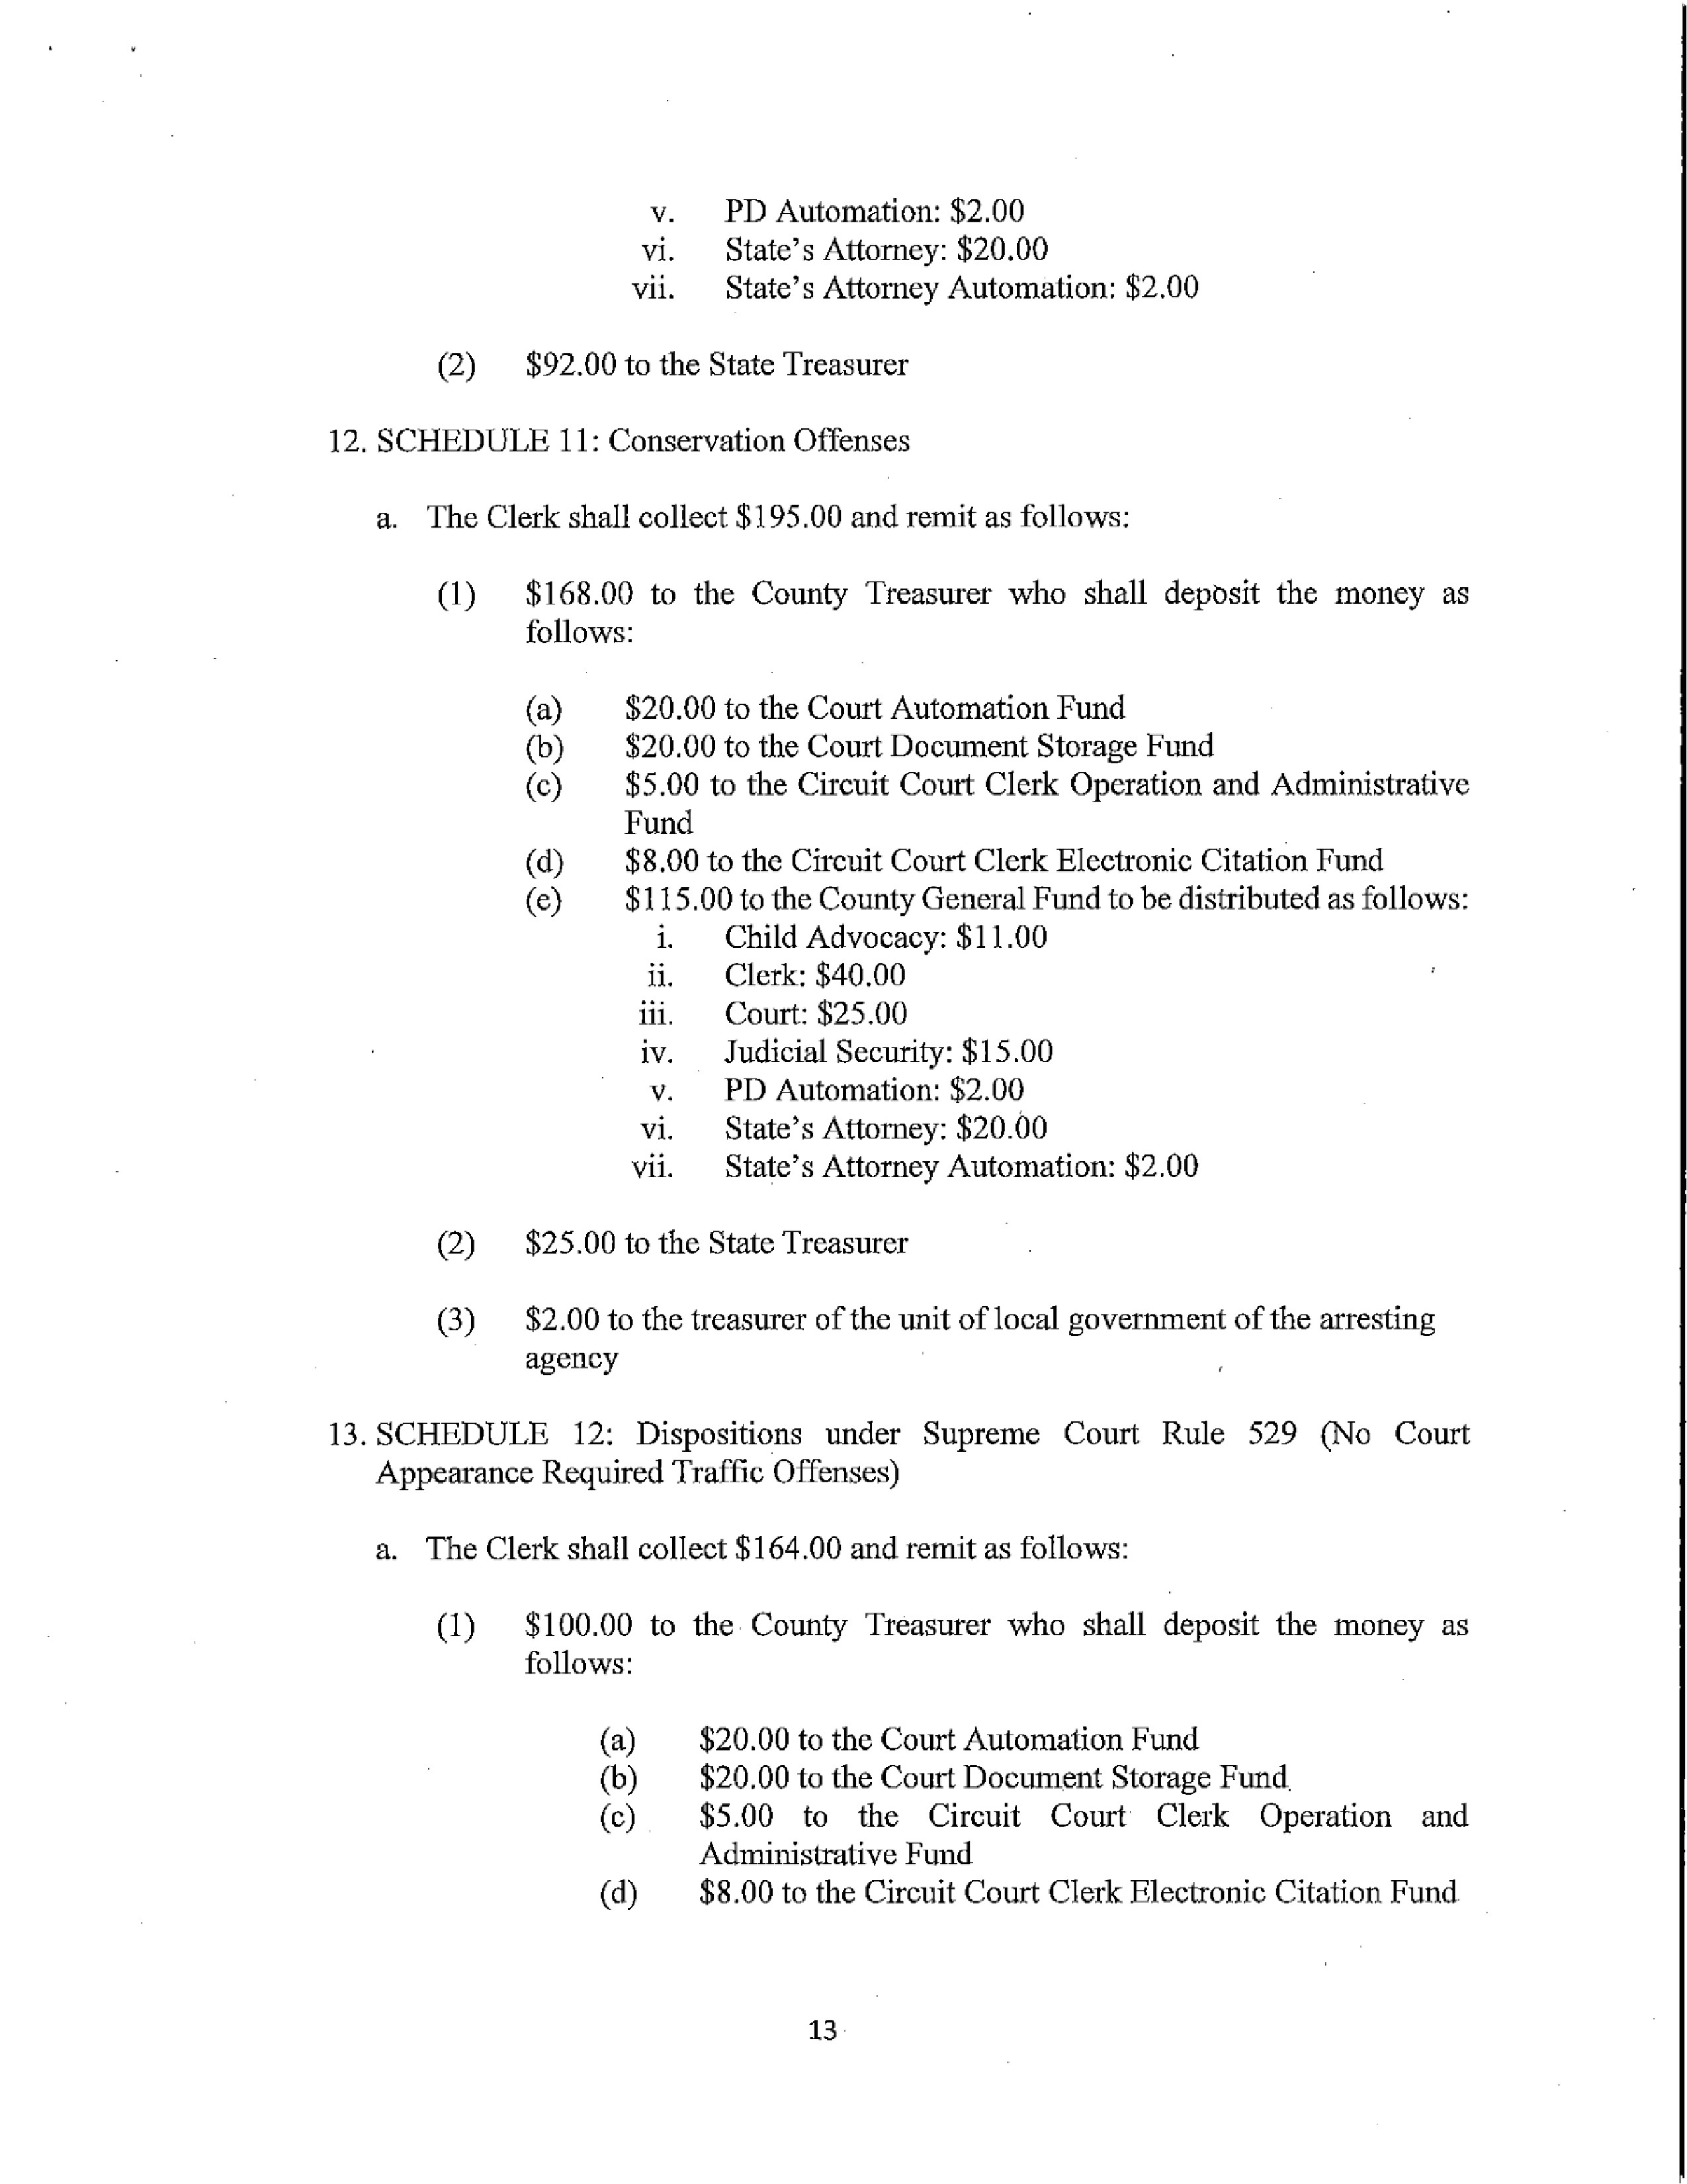
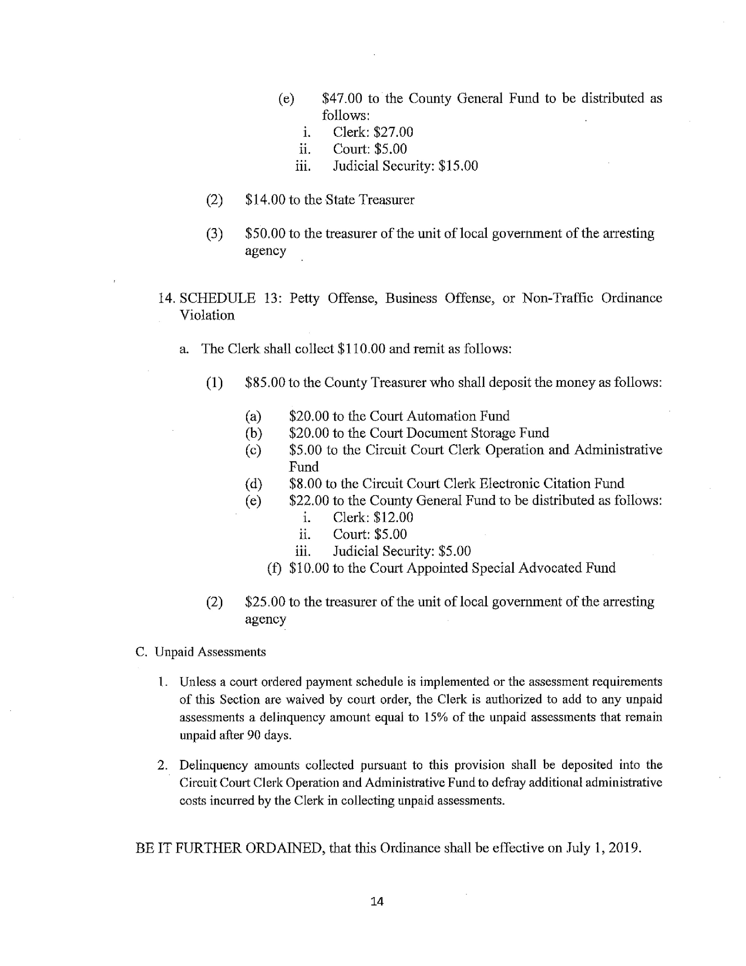
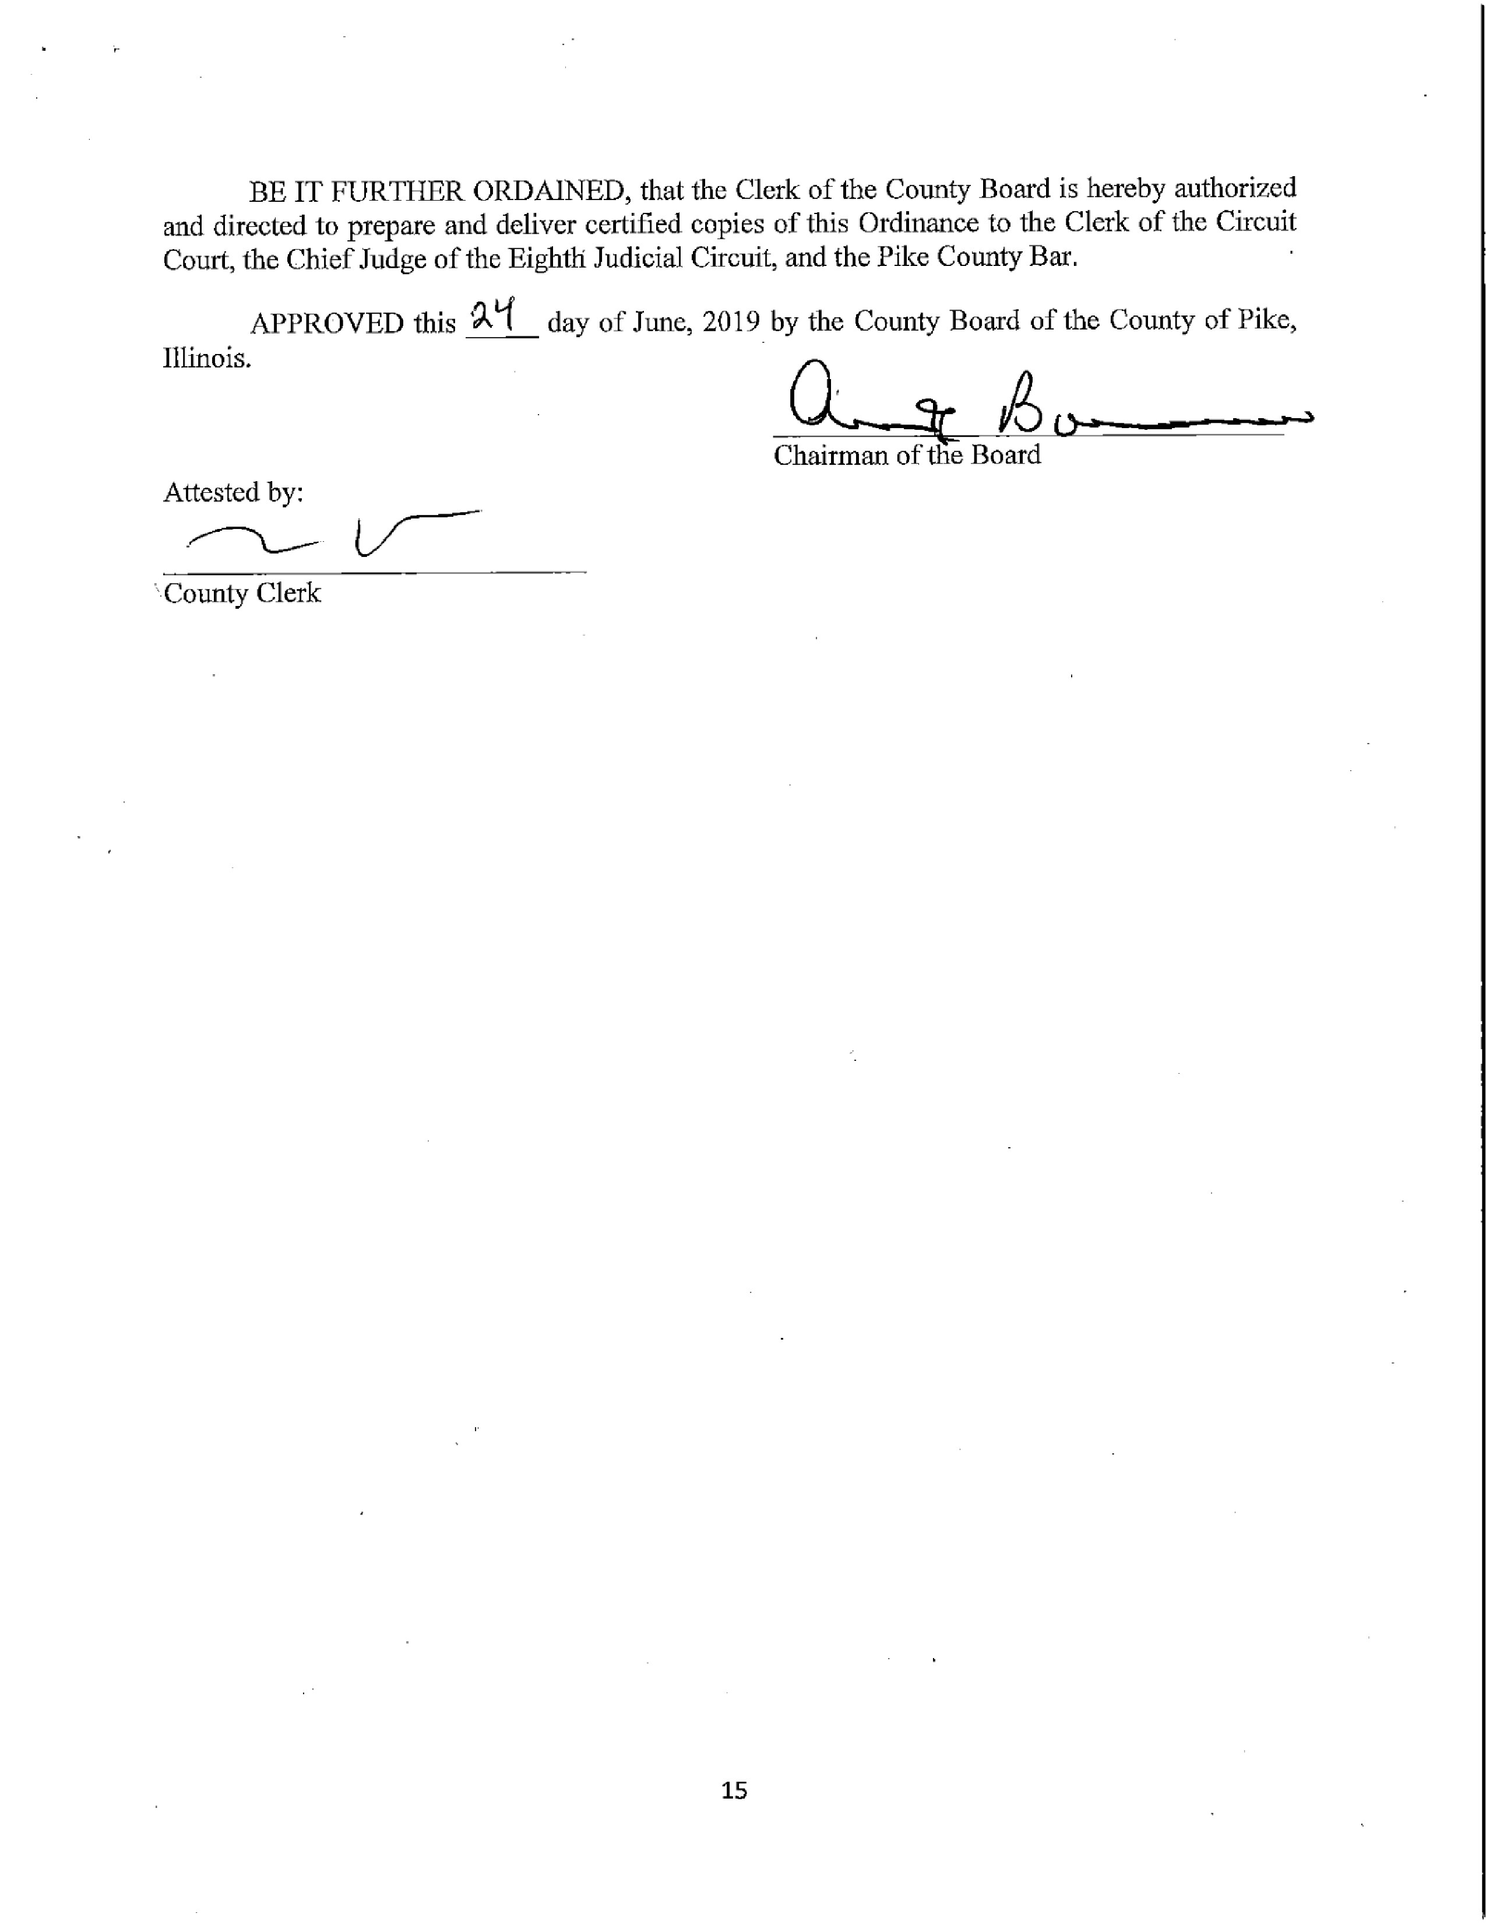

ACTION ON PROPOSED ZONING MAP CHANGES IN PLEASANT HILL, FORWARDED FROM THE PLANNING COMMISSION AND THE ZONNING BOARD OF APPEALS.

Zoning Administrator Fred Ruzich gave a historical background of the issue presented to the Board. Various discrepancies with zoning and the creation of a new map was submitted to the Planning Commission that then sent the recommendation to the Zoning Board of Appeals. Zack Boren, Pike County State’s Attorney, discussed the recent petition that was filed in the County Clerk’s Office. The petition requires to amend the ordinance it would take 75% of all board members. Thus, 7 votes are required and not a simple majority of who is present. Fred Ruzich stated the petition/protest was filed in the County Clerk’s office on June 14th, 2019. Chairman Borrowman agreed that the board can proceed due to all members being present and it would take a 3/4th vote to pass the presented map. Rodger Hannel stated that he has received multiple phone calls regarding the zoning issue and mainly the issue with the Stage Coach Inn. He questioned that if the board voted in favor of the map, would that make Stage Coach Inn B1? He stated he did not feel like the opposition had enough of an opportunity to express their options and should be given that in the means of a Public Hearing. Chairman Borrowman deferred to the State’s Attorney, Zack Boren. Zack Boren stated the board can vote individually on parcels or on the entire map.

Jim Sheppard asked if there was a public meeting would it be heard by the Zoning Board of Appeals. Chairman Borrowman stated that since the Zoning Board of Appeals forwarded the issue on to the full board, thus, the full board will host the Public Hearing. Jim Sheppard agreed and stated that he is interested in what the public has to say directly. Mark Mountain asked if the Stage Coach Inn was the only issue. Fred Ruzich stated that there was no other opposition to the map. Amy Gates stated that there seemed to be a large portion of Pleasant Hill citizens present so why schedule another meeting and not continue with the hearing now? Zack Boren stated that there are certain statutory requirements that need to be met. Amy Gates then suggested that to move things forward, could the board approve the map as presented except for the contested property? Lonnie Todero from the audience stated that there are other faults with the proposed zoning map that have not been addressed. Chairman Borrowman stated that this is the first he is hearing about other complaints. Regina Johns, owner of the Stage Coach Inn, stated that there are multiple issues with the map and was in favor of everyone present being able to speak. Zack Boren addressed the protest filed and stated that if the zoning map vote did not include the Stage Coach Inn, then it would only require a simple majority, and he is unaware that when the board readdresses the Stage Coach Inn then he would have to look at statue on the amount of board member votes needed.

Regina Johns stated that she had to close her restaurant down and turn away business due to the meeting tonight to be heard on this issue. Chairman Borrowman stated that there is a section for public comment built into the Agenda at the end of the meeting.

After board discussion on the date to hold the public meeting, it was decided that it would be held on Tuesday, July 16th, 2019 at 6:30 p.m. in the upper courtroom of the Pike County Courthouse. County Clerk will be present at 5:00 p.m. to allow individuals to sign in for speaking purposes.

Mark Sprague asked what the remedy is for other individuals that have issues with the proposed map? Fred Ruzich stated that individuals would need to submit protest to the Planning Commission and then to the Zoning Board of Appeals then to the County Board. There was a question if the fee would be waived as it has been in this current situation. Zack Boren stated that since the process has been started the Board could decide to waive the fee. Mark Mountain said going forward they can address the issues on a case by case basis and if they would like to address other zoning issues they can come to the Agriculture meeting on July 18th, 2019 at 6:0 p.m. in the government building.

Rodger Hannel made a motion to approve everything on the proposed Zoning map with the exception of the Stage Coach Inn and set up a Public Hearing to address the concerns. Motion seconded by Mark Mountain. Roll Call vote 5-3. Motion carried.

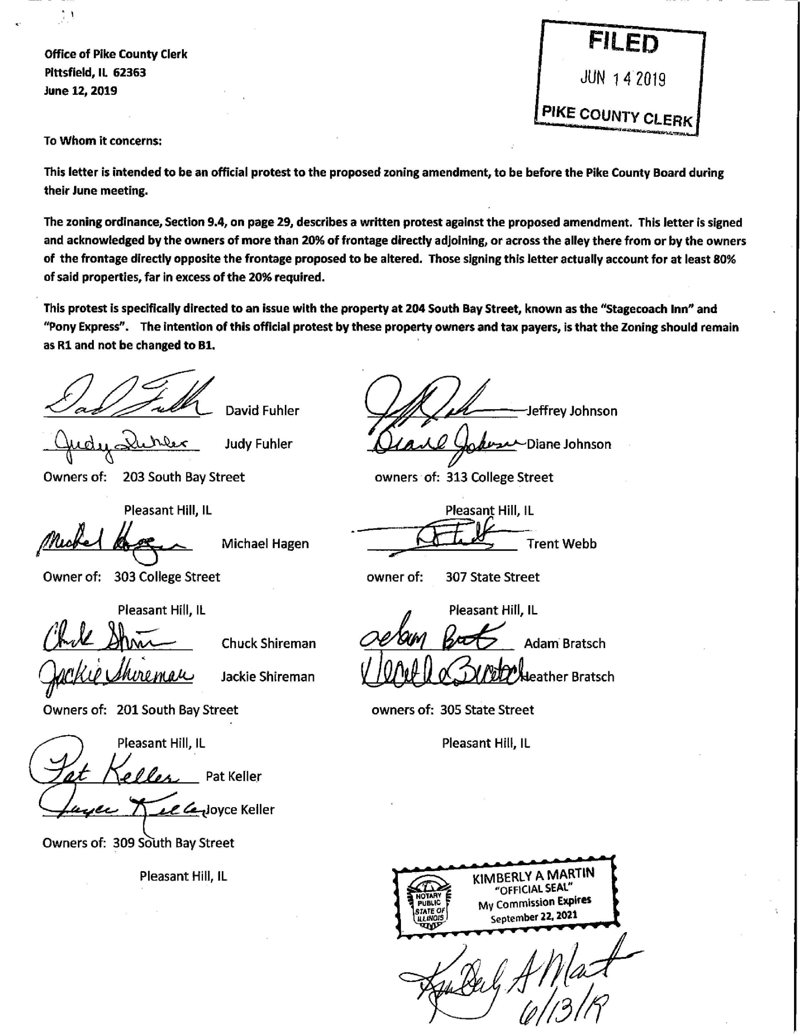
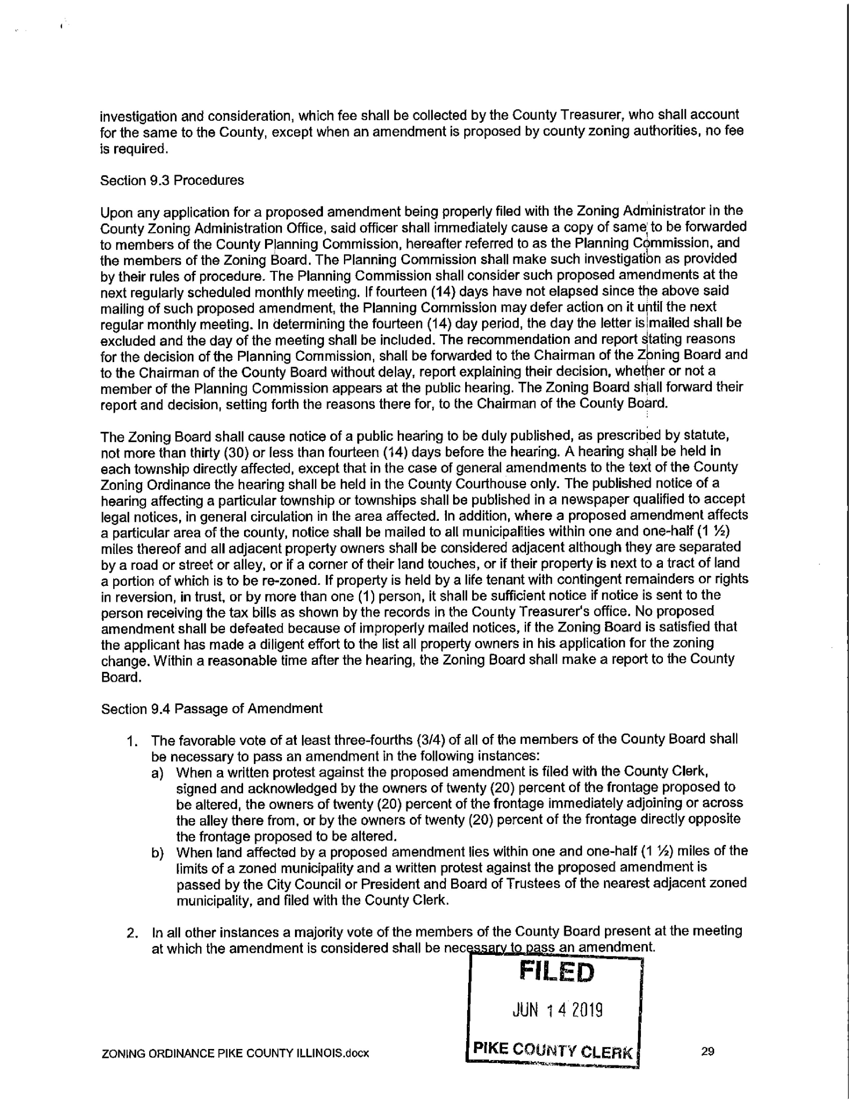
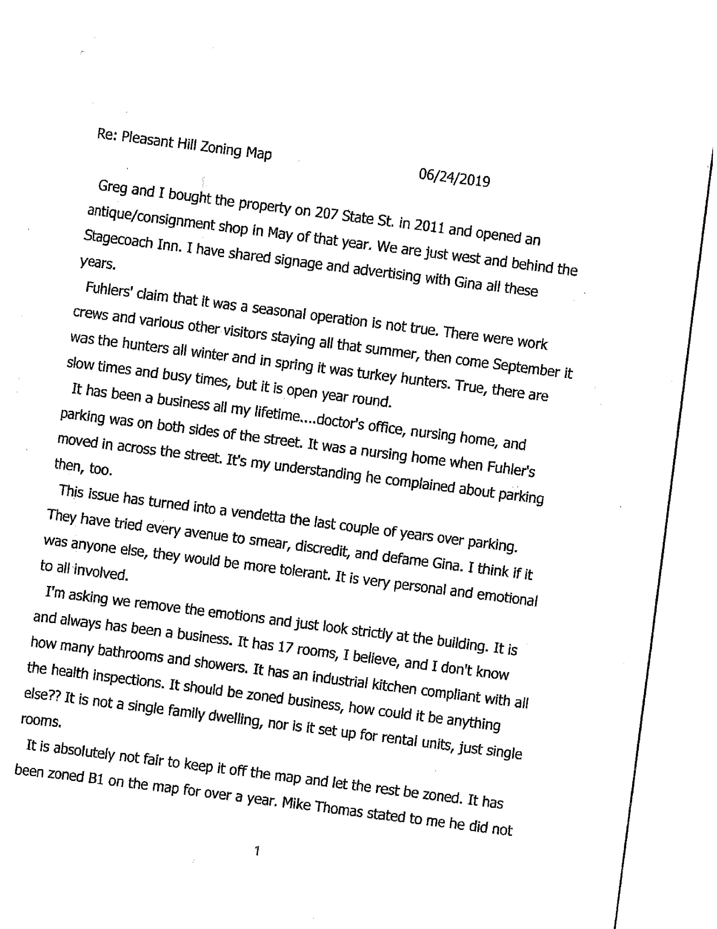
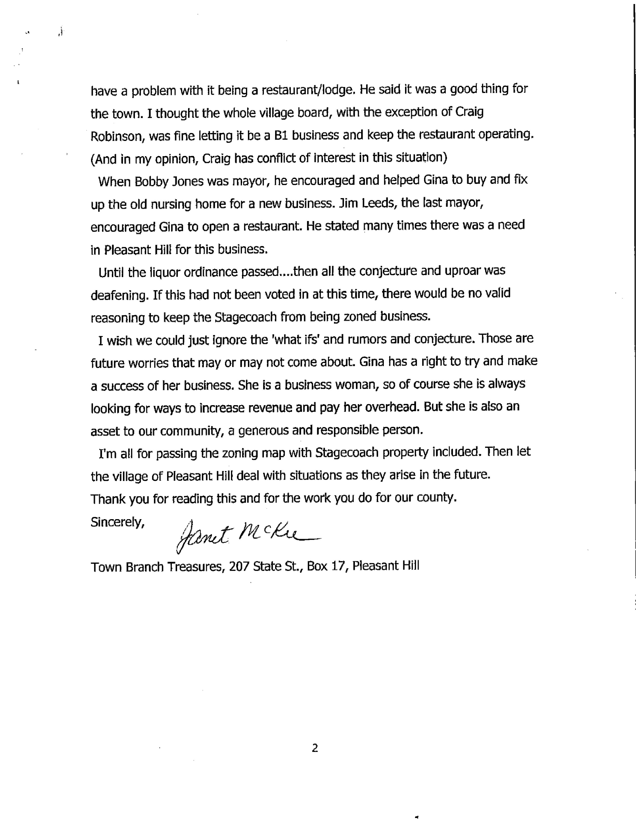
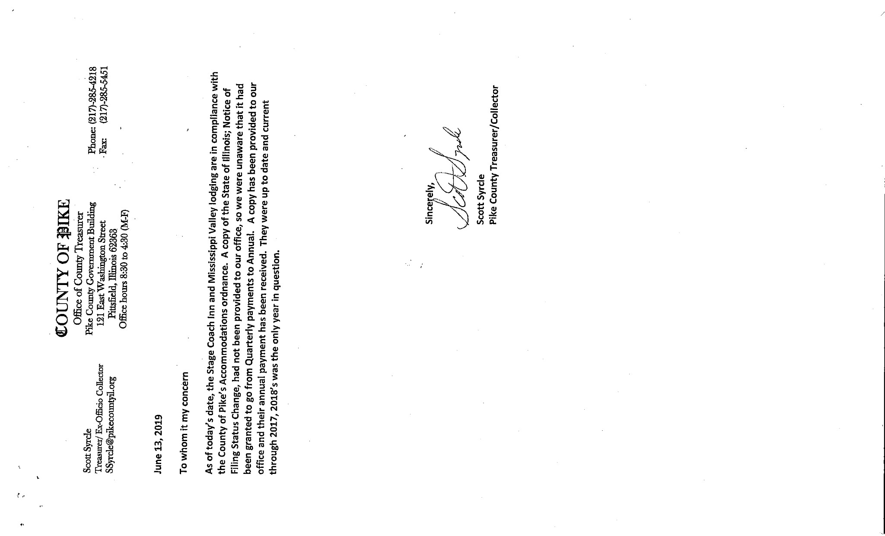
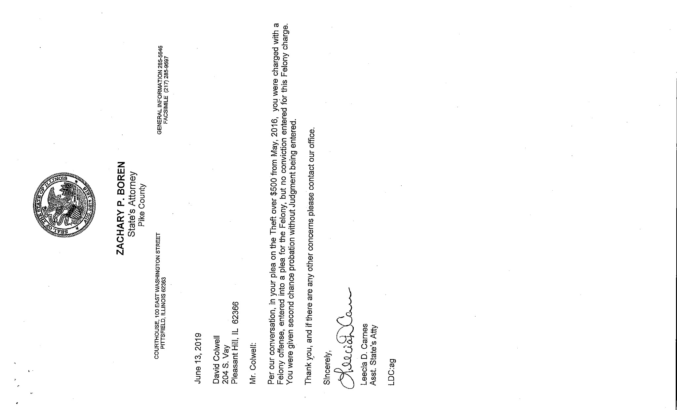
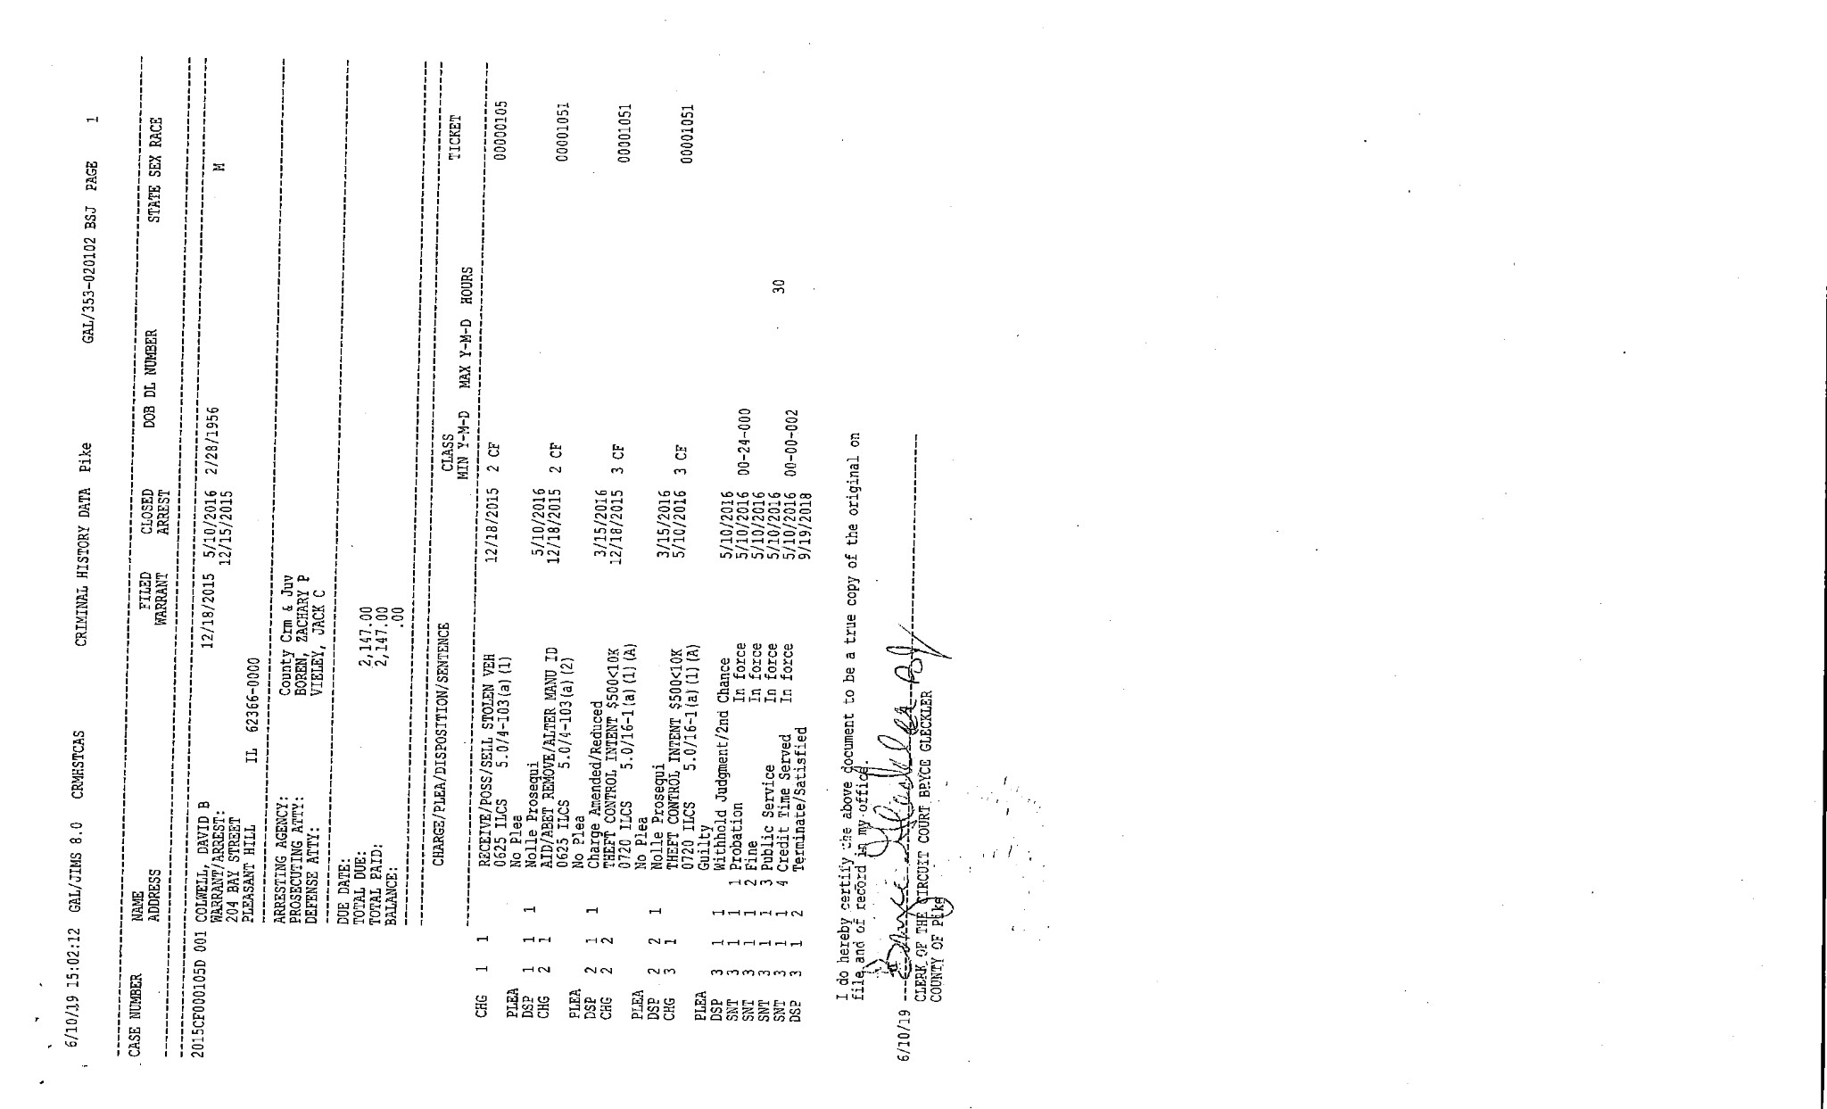
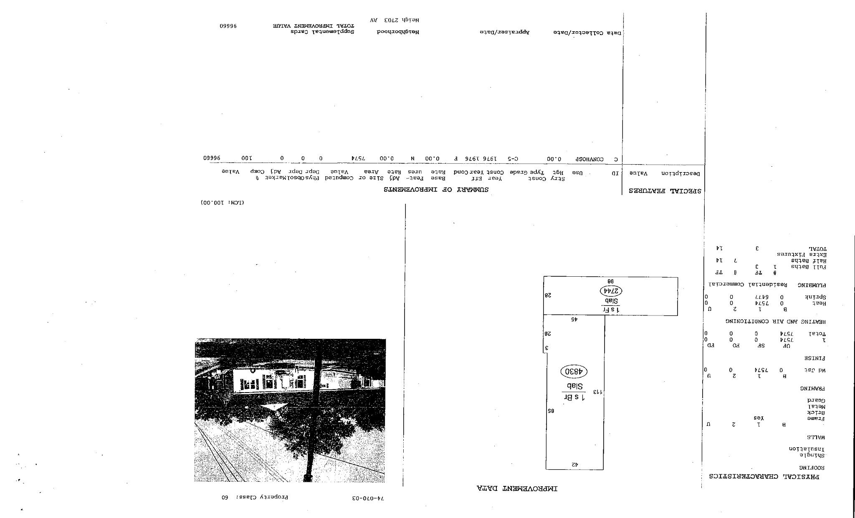
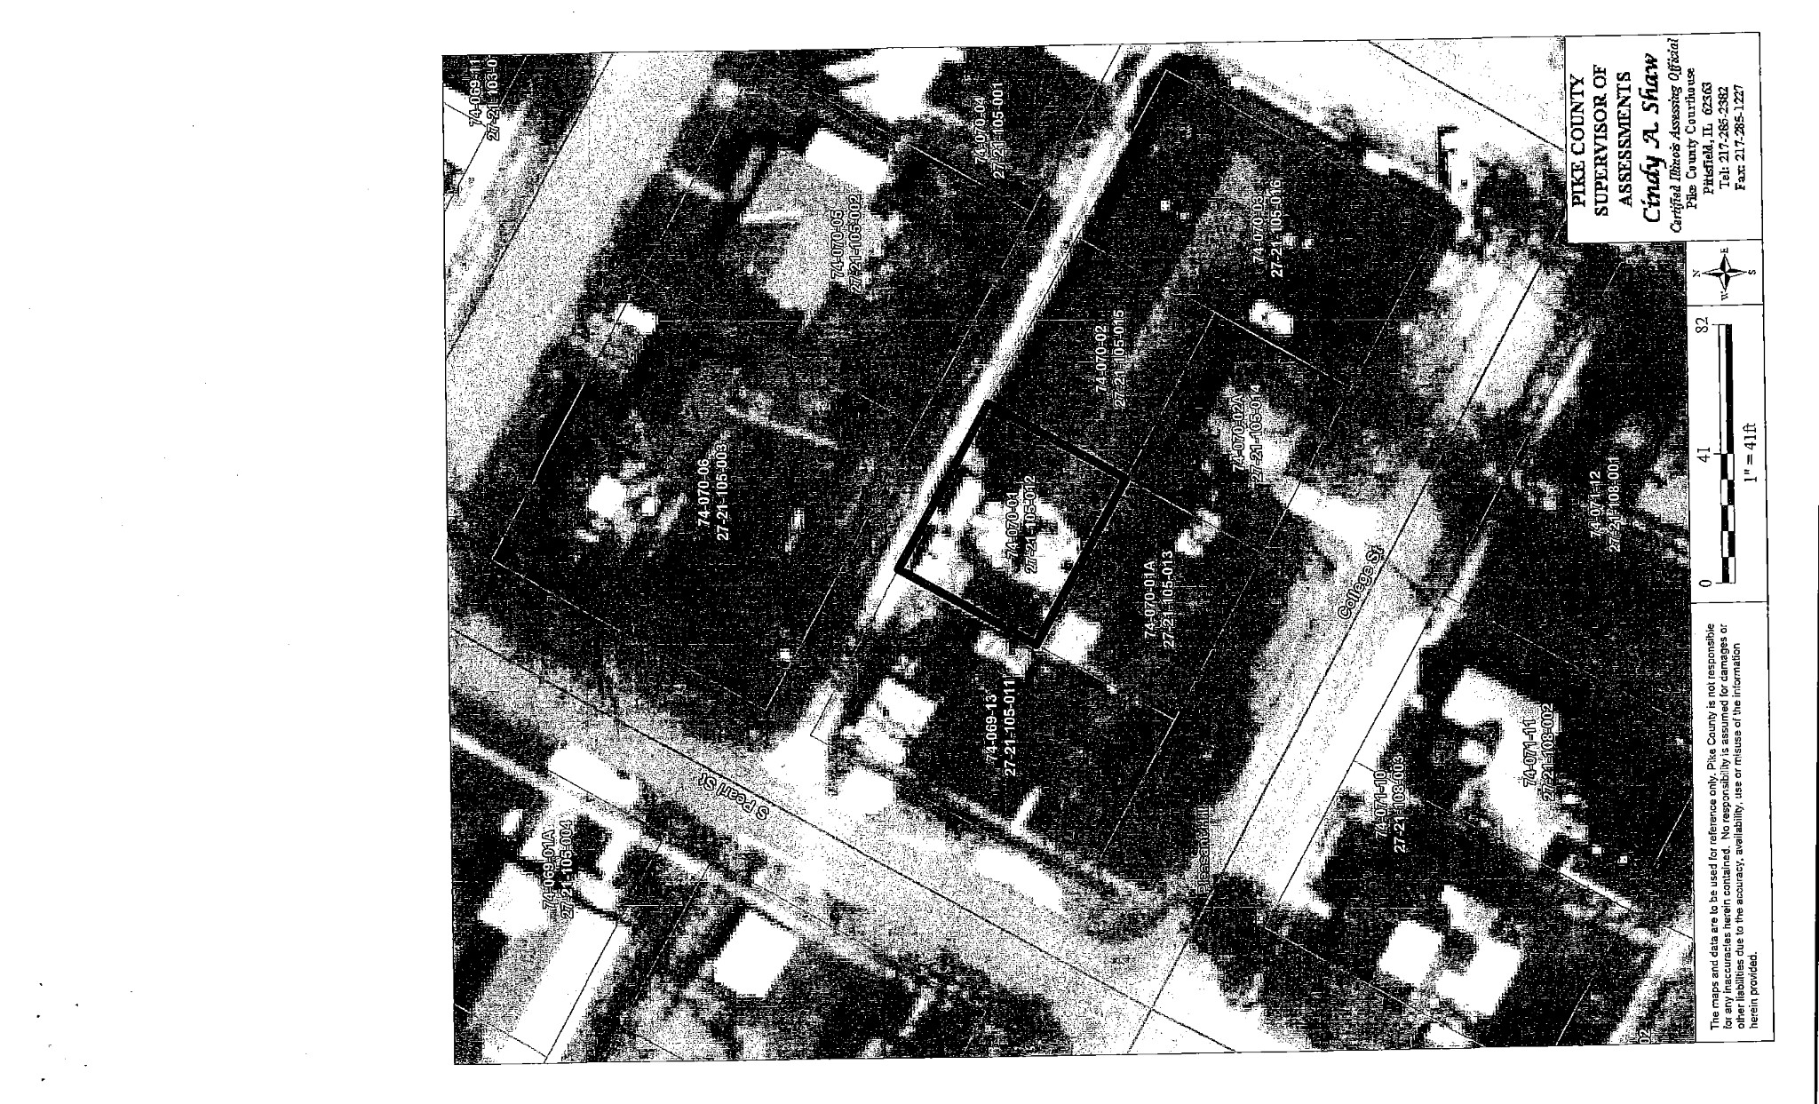
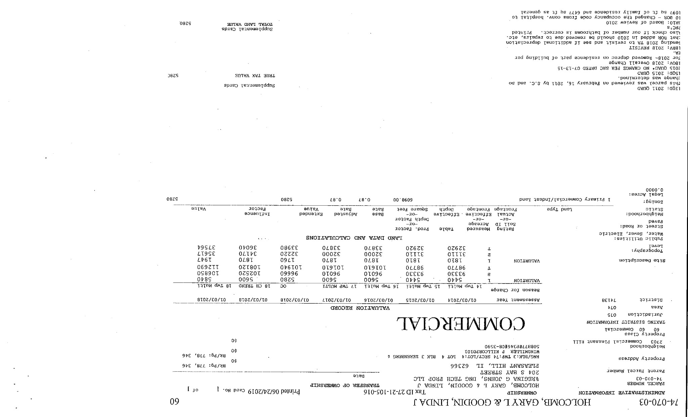
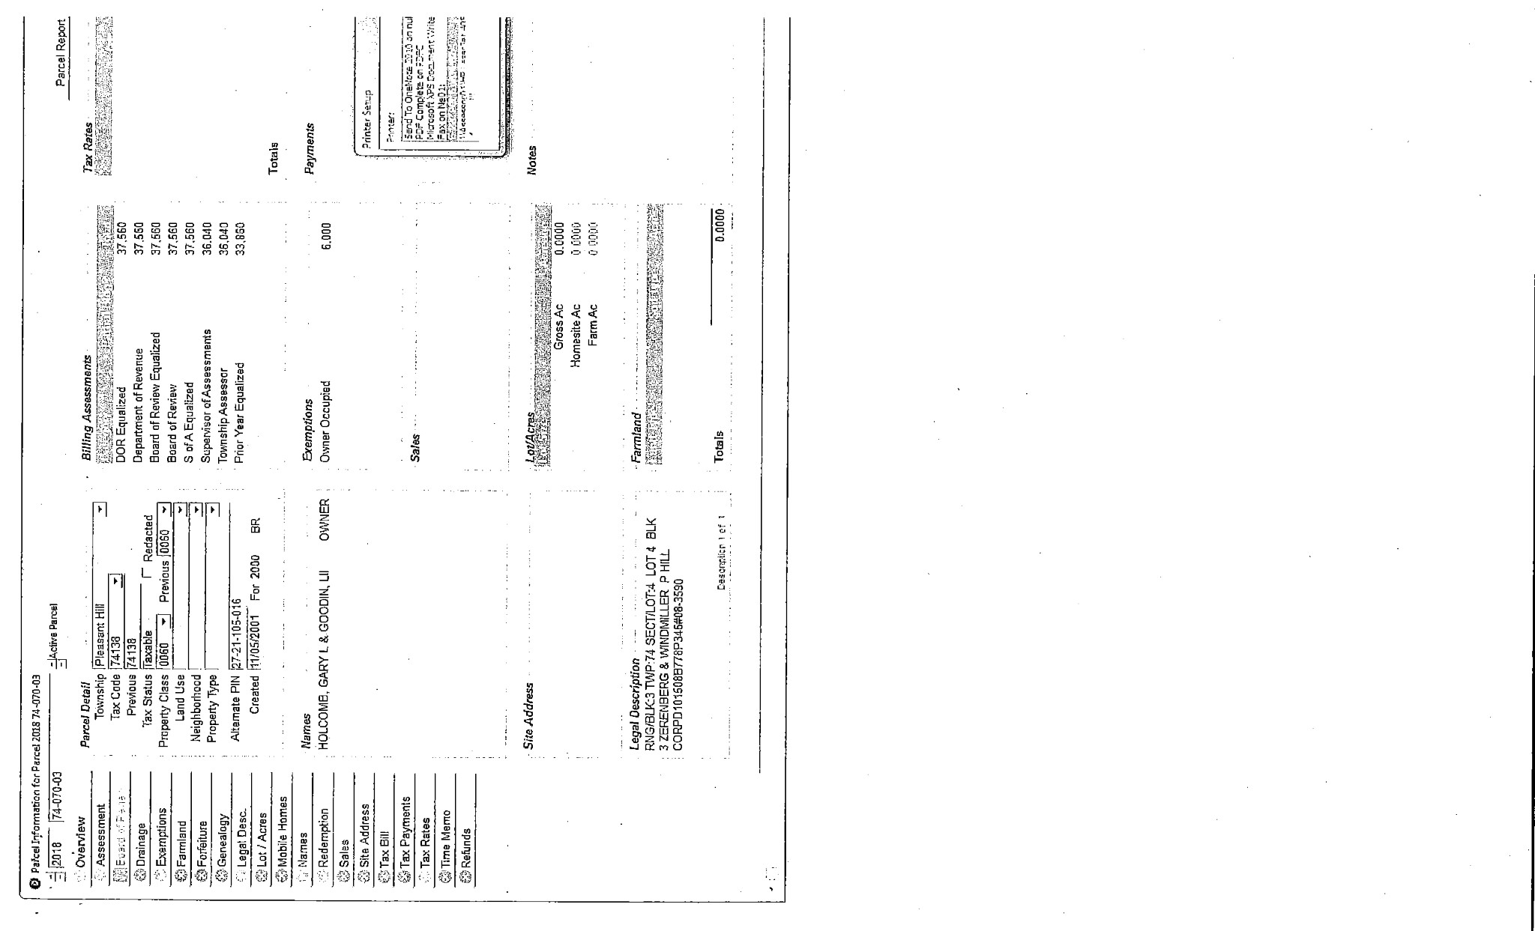
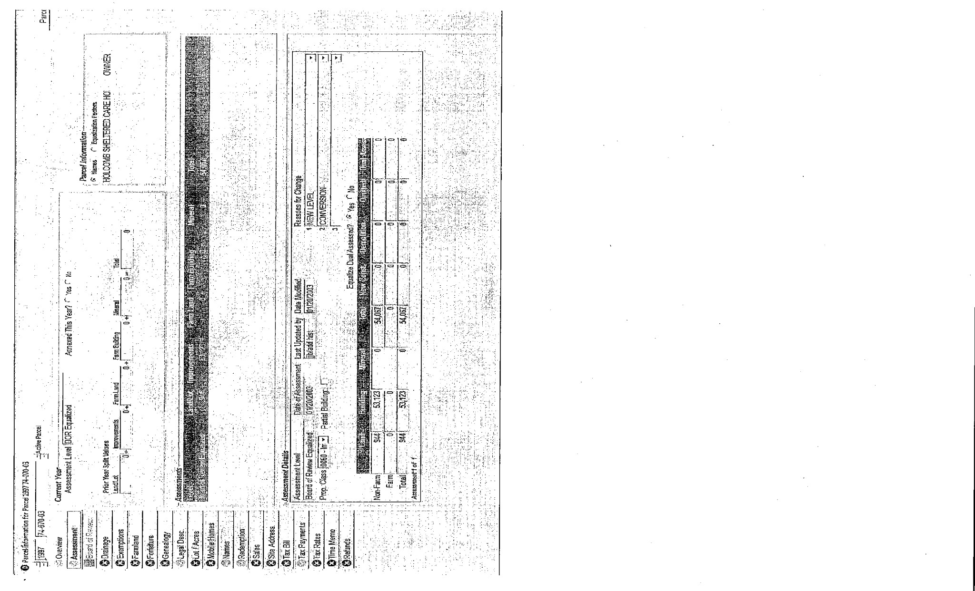
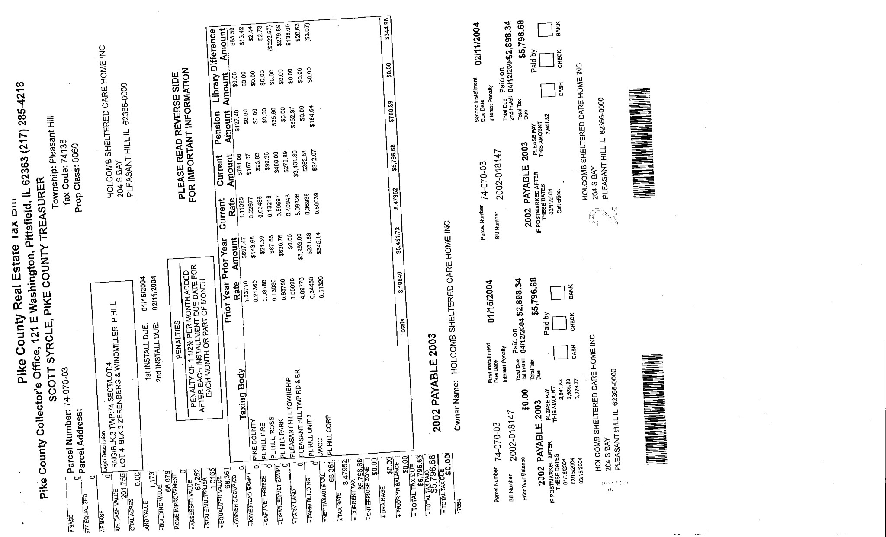
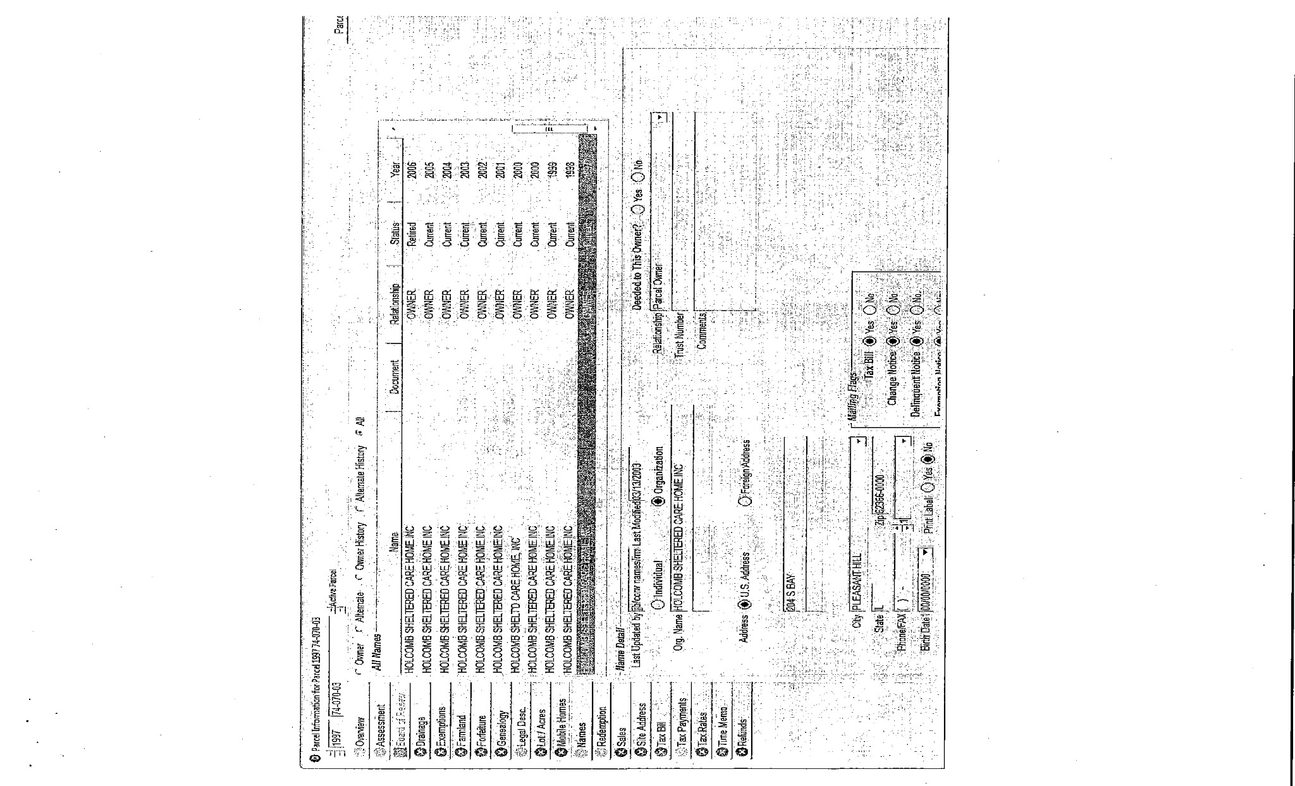
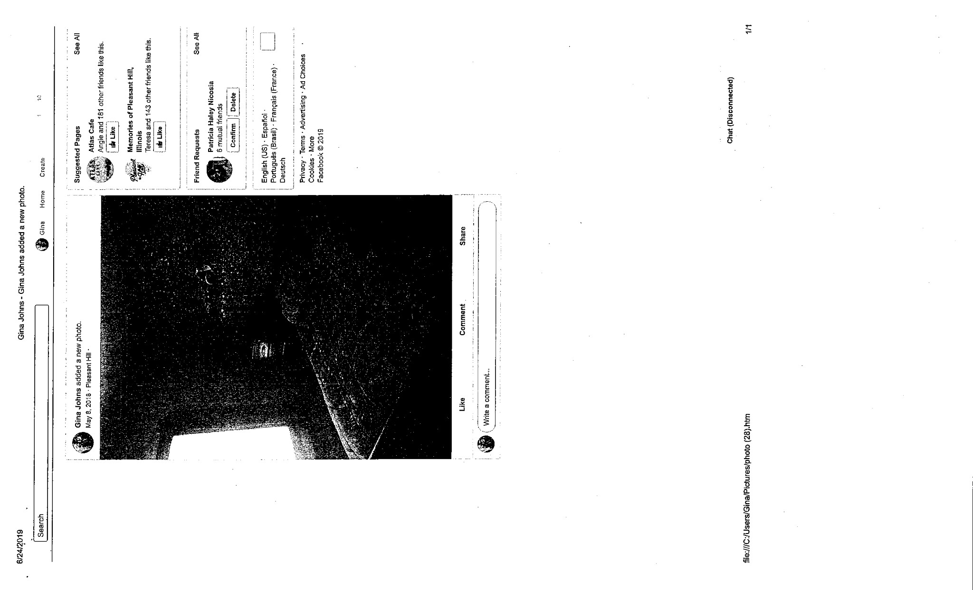
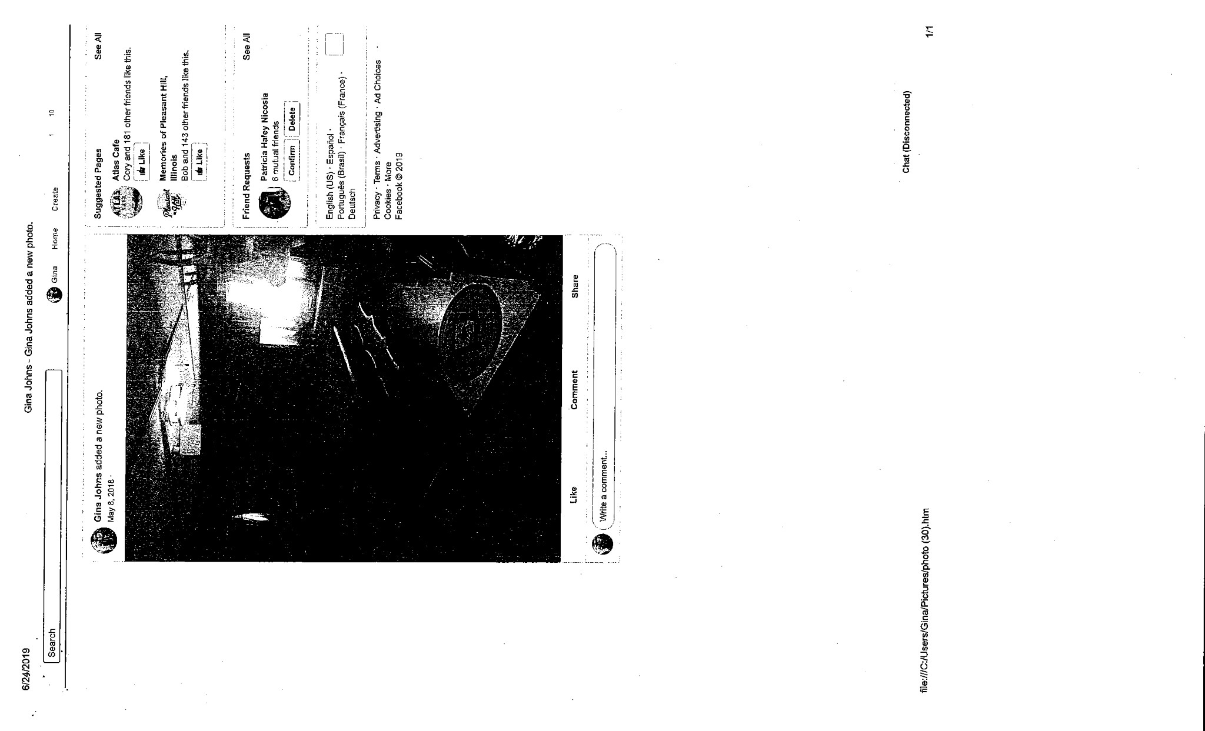
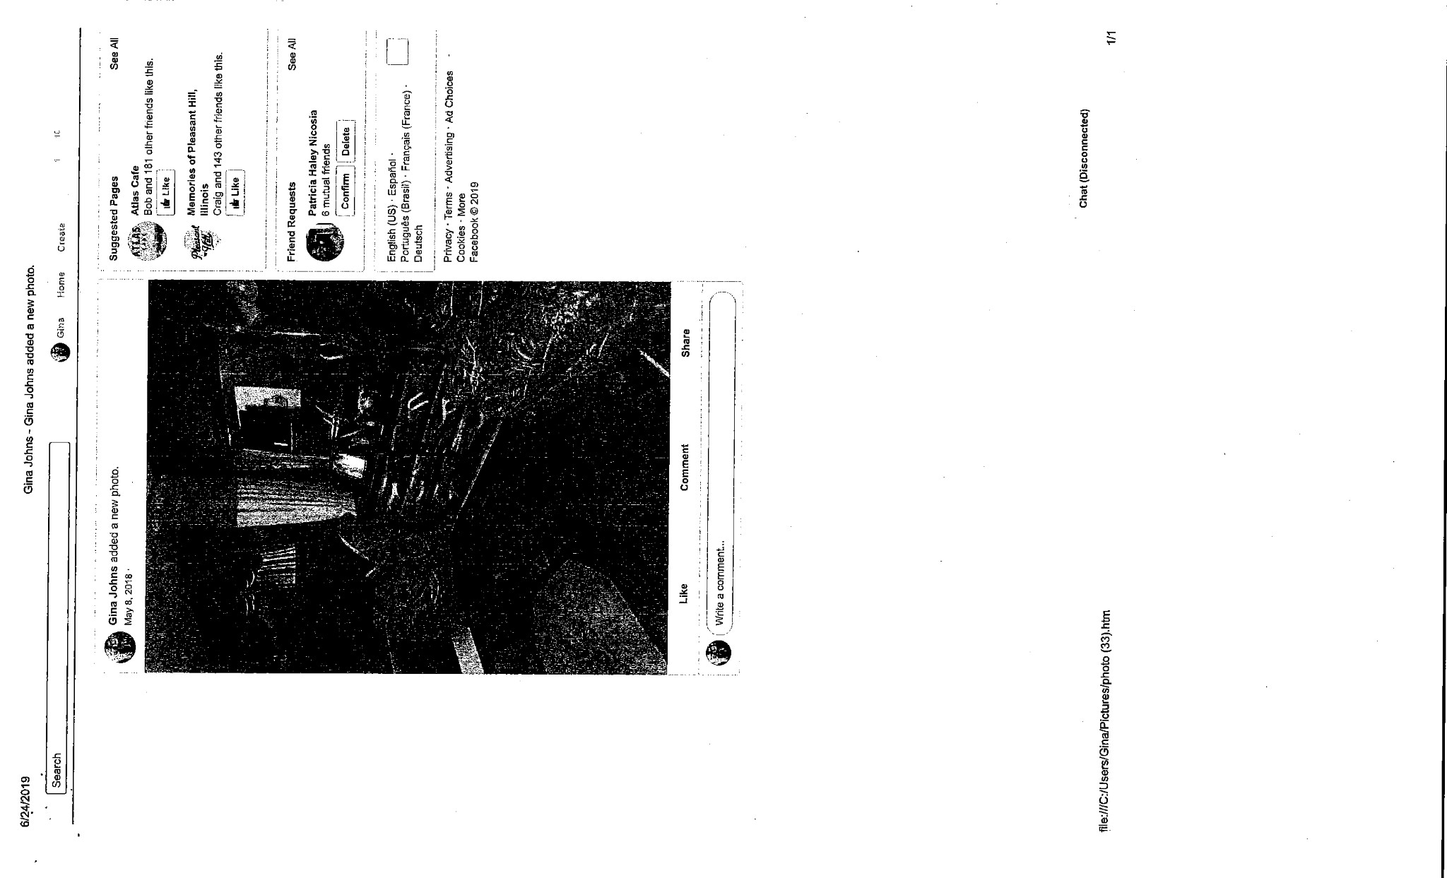
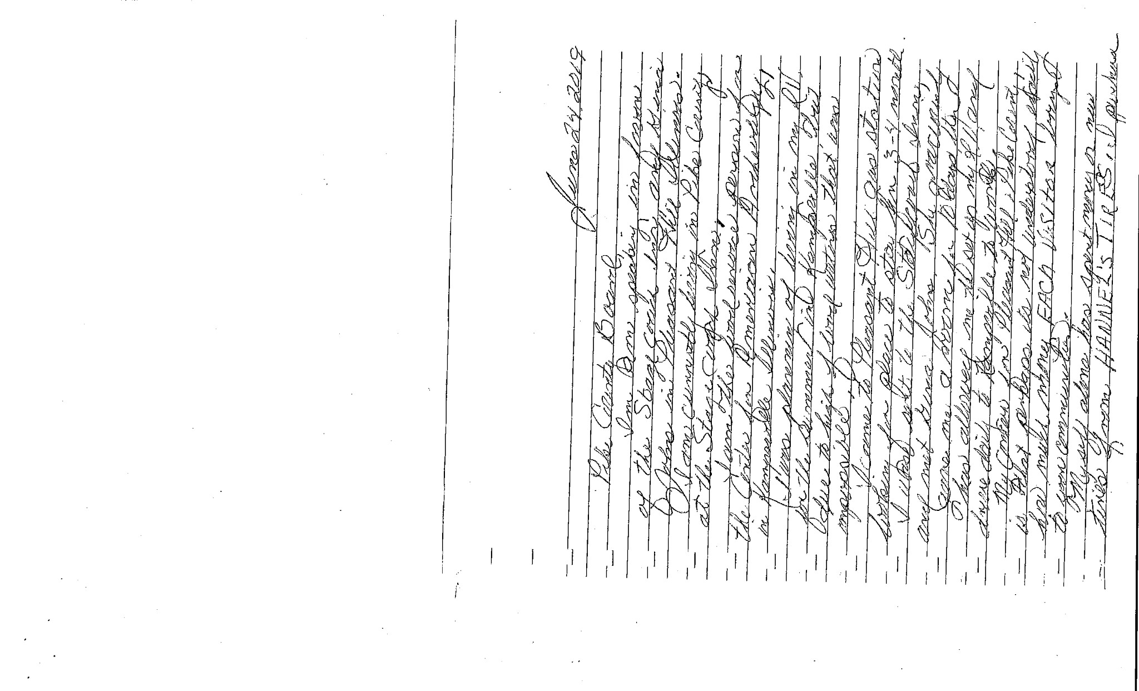
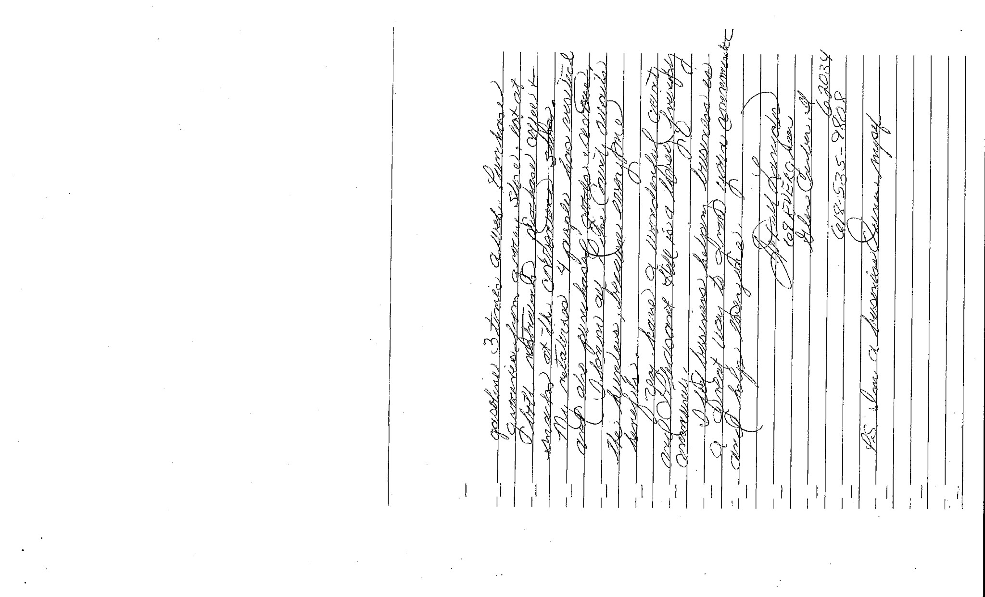
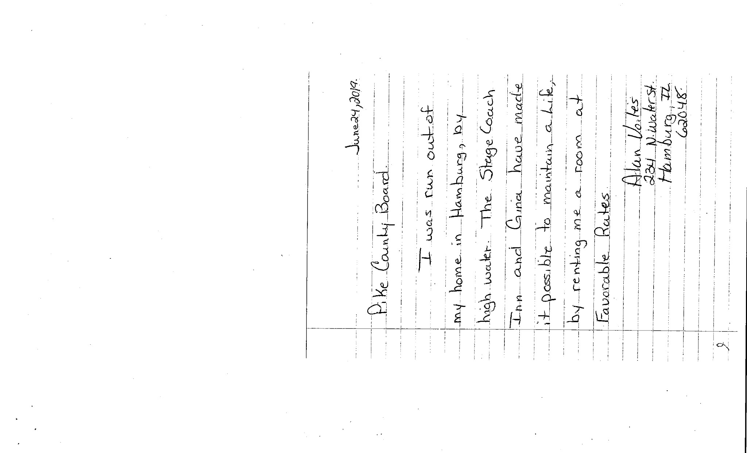
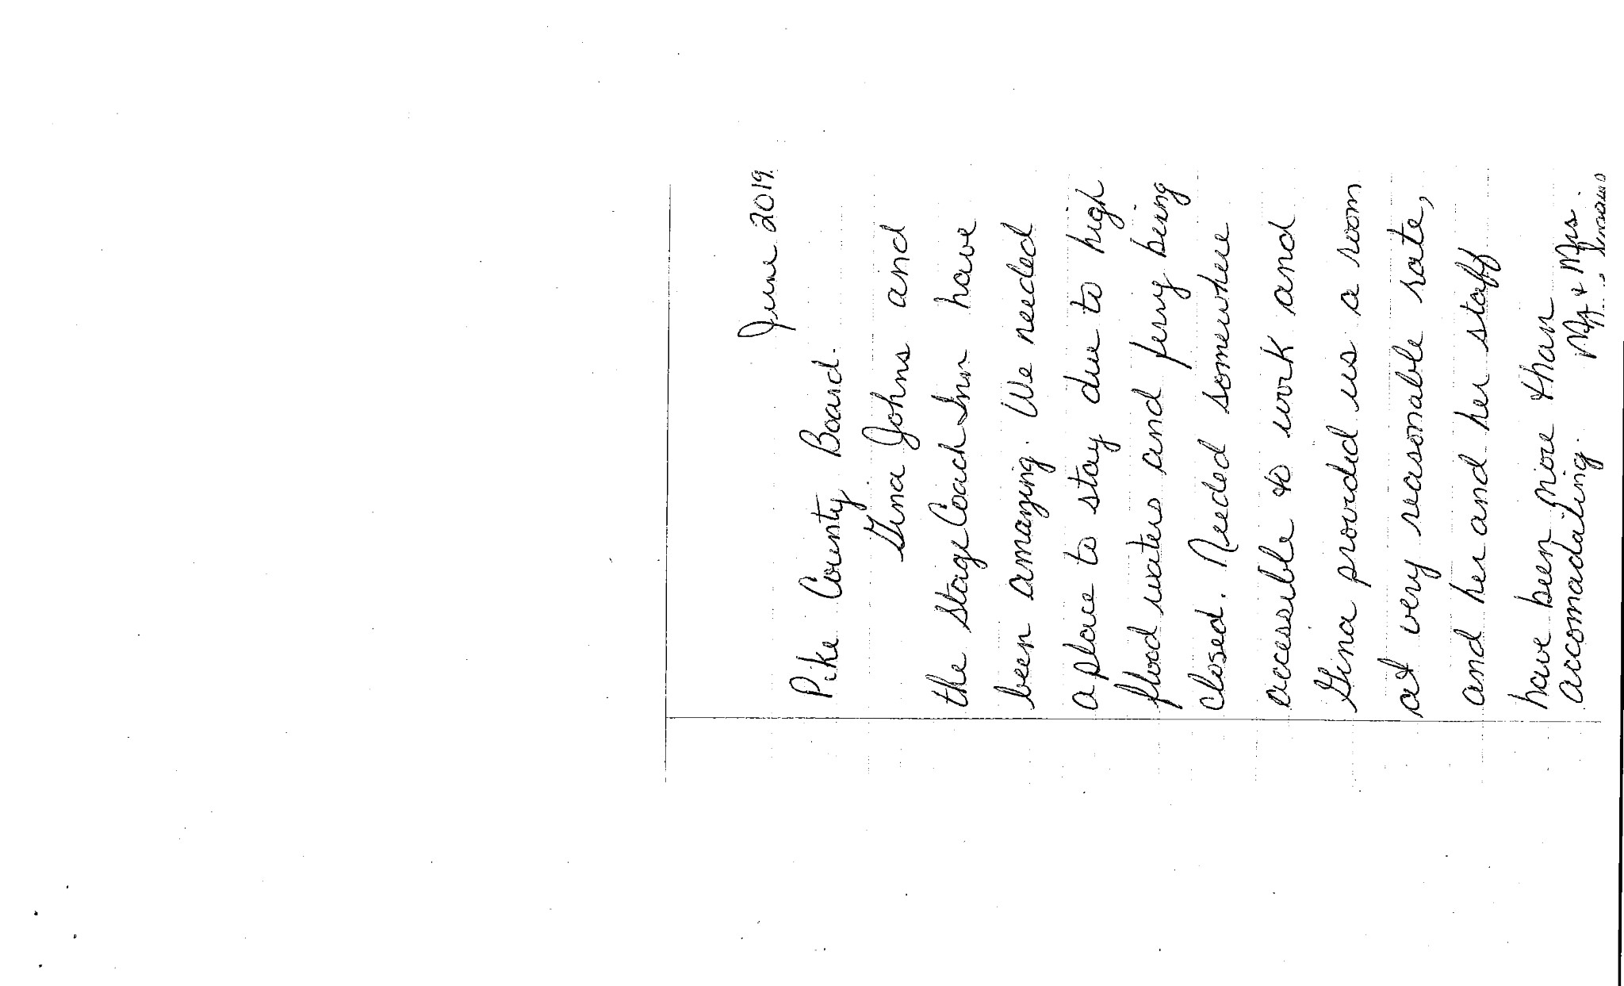
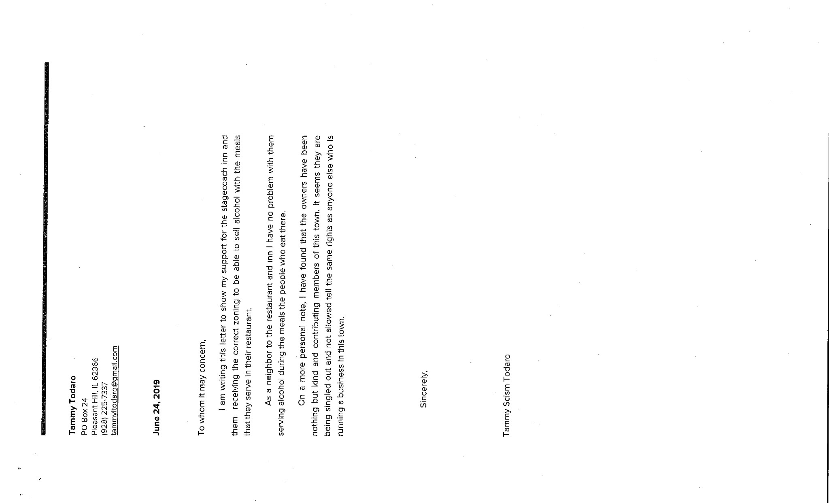

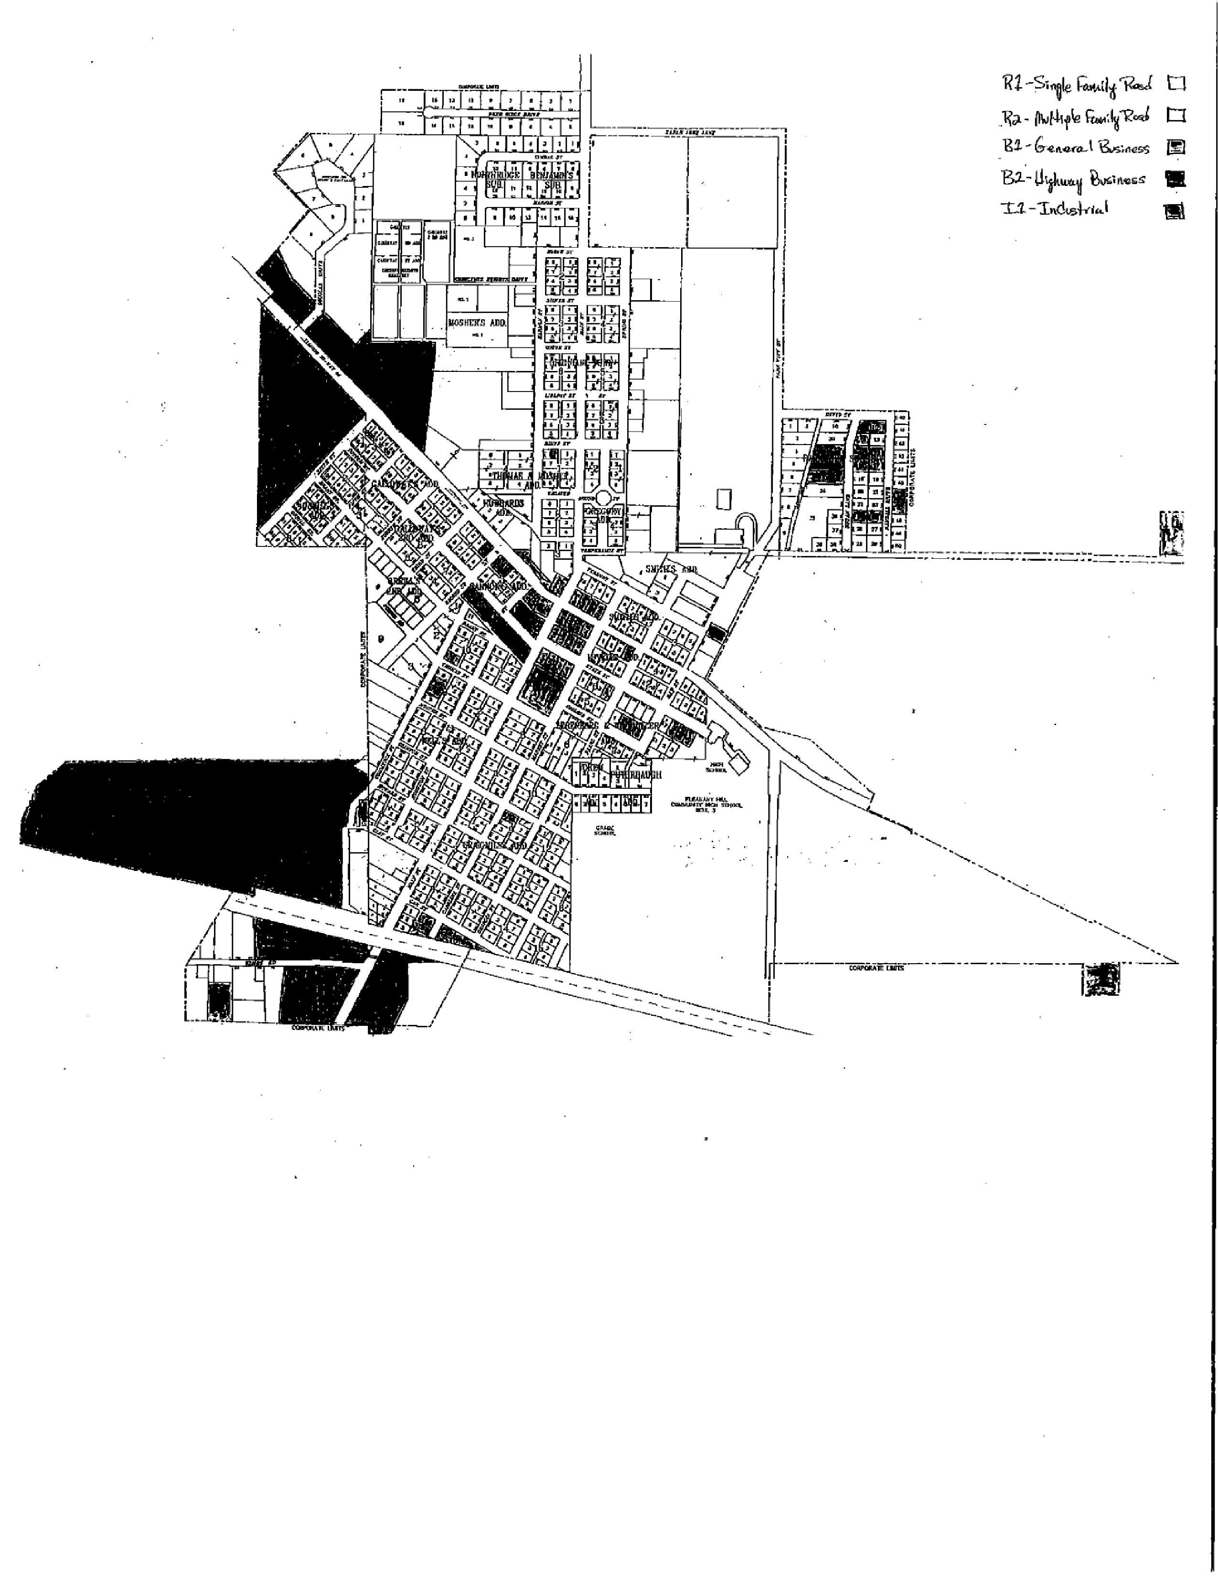

6 MONTH REPORTS
Debbie Lambeth submitted her 6 month report to the County Board through the County Clerk due to a required absence. 6 month reports were heard from Natalie Roseberry, Bryce Gleckler, who stated he hired Nikki Klatt as a new employee and was glad to have her back in the office, and Scott Syrcle who stated his office was over budget on payroll due to the union contract adjustments.

Motion to approve the 6 month reports was made by Tom Lewis and seconded by Amy Gates. Voice vote 8-0, motion carried.

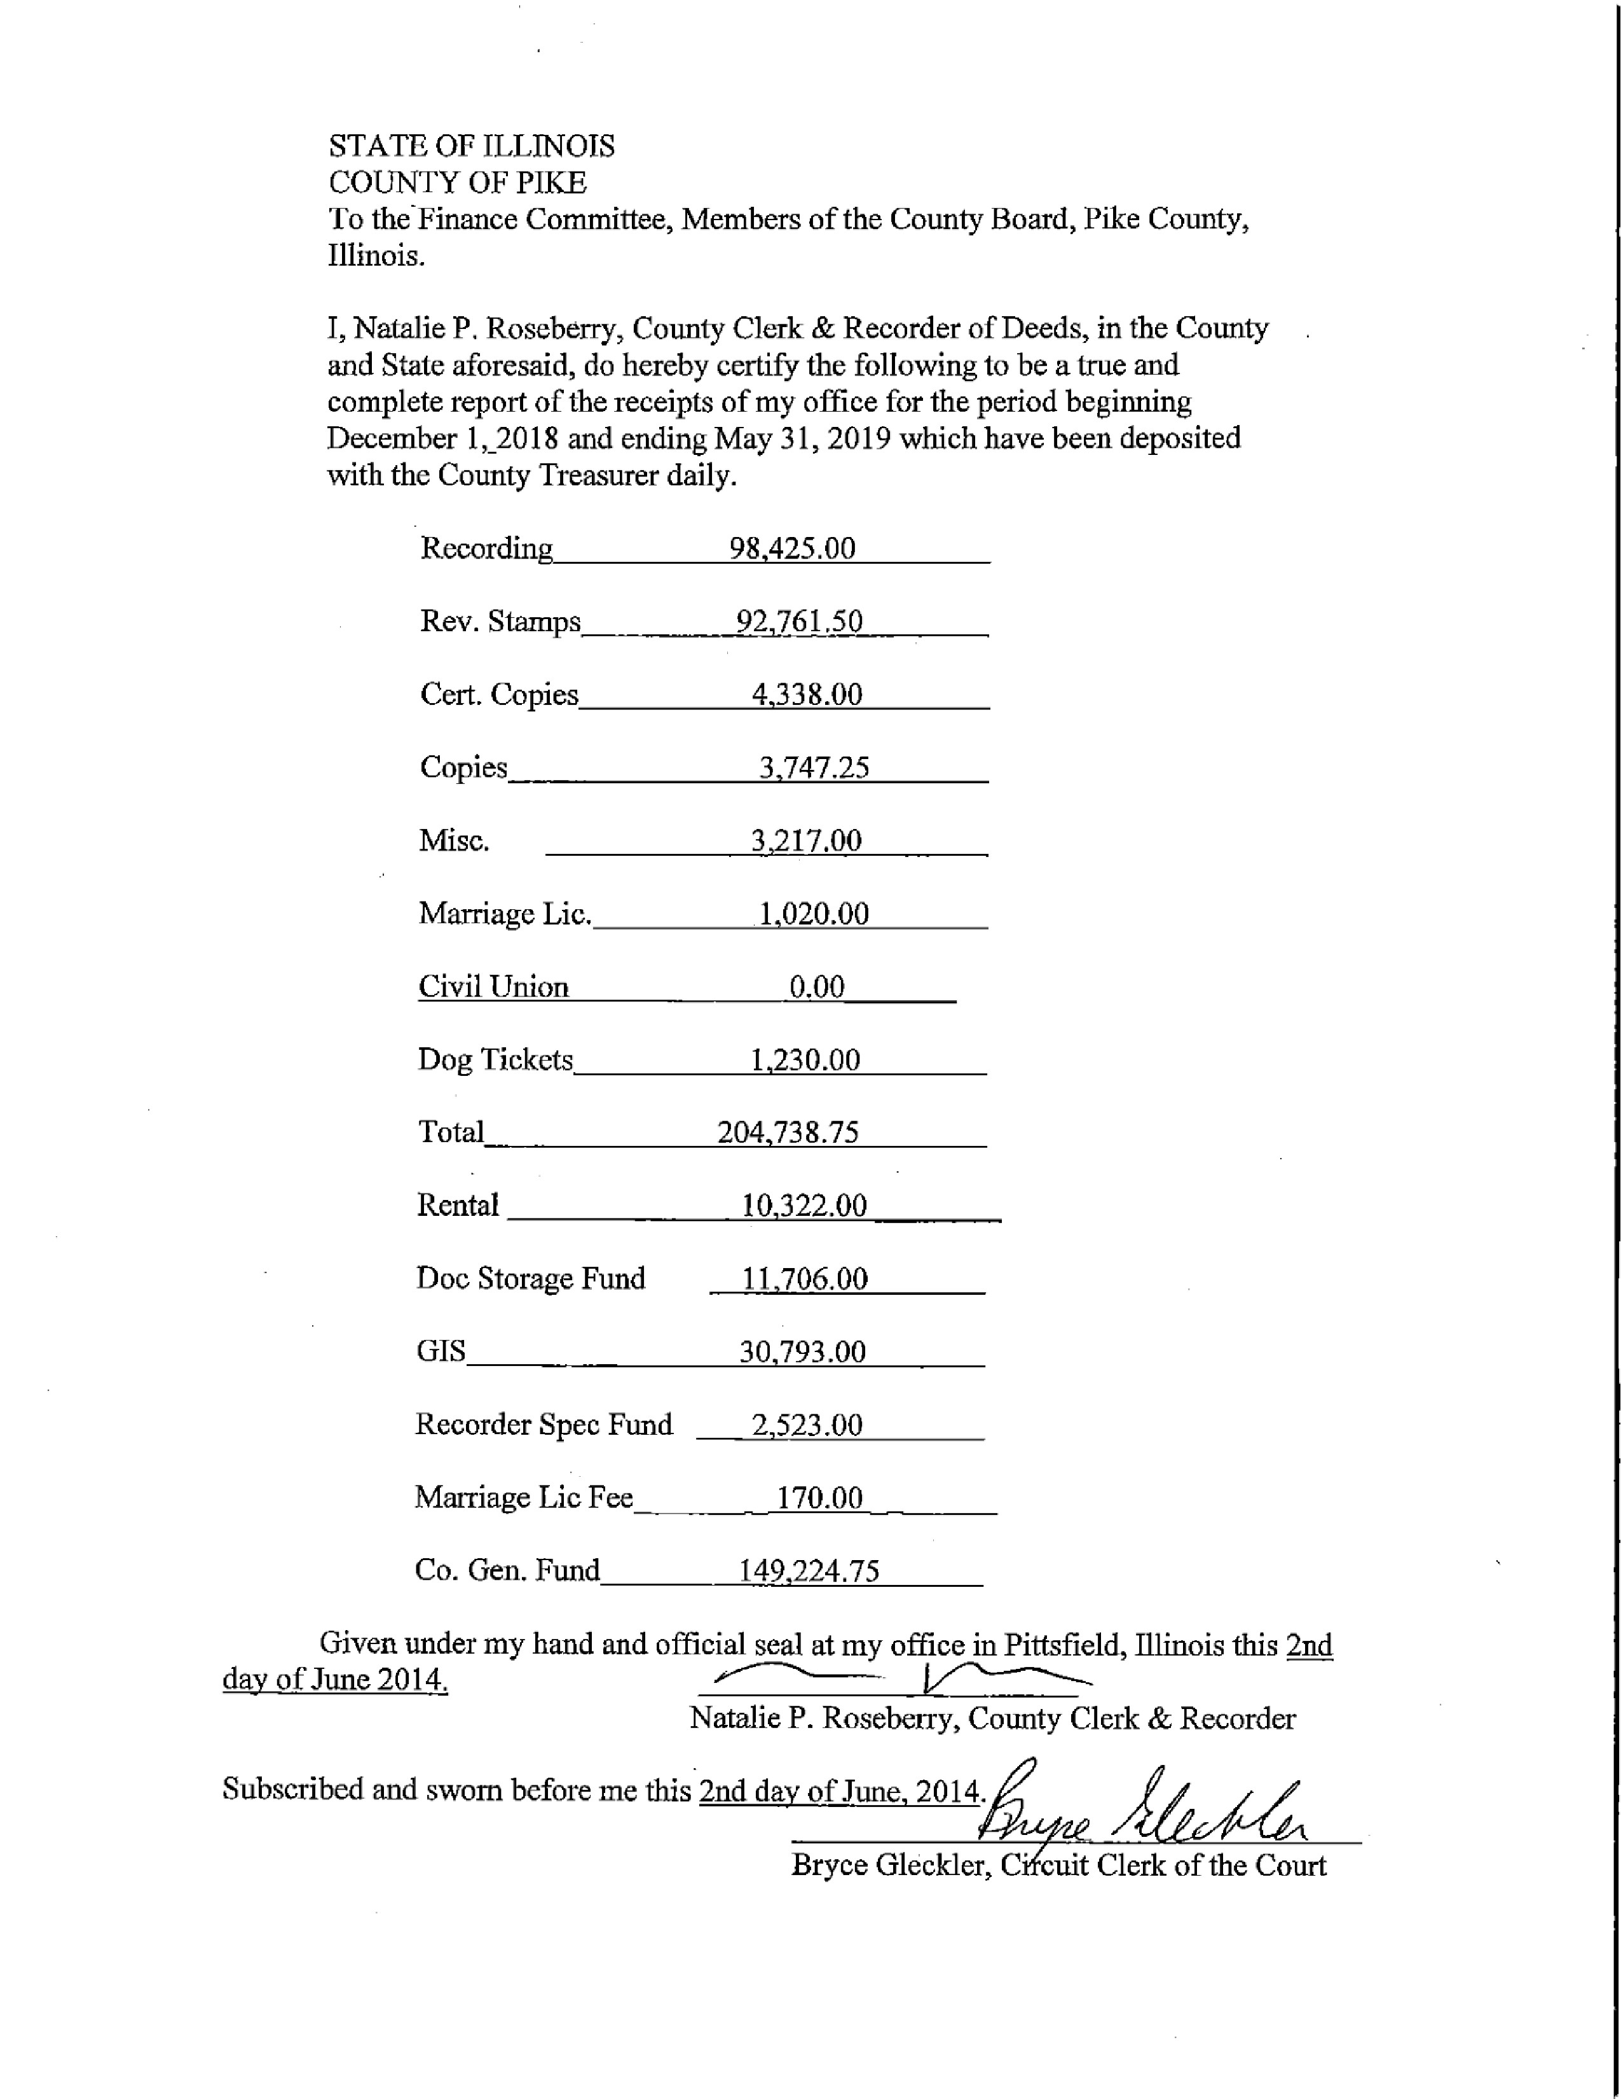
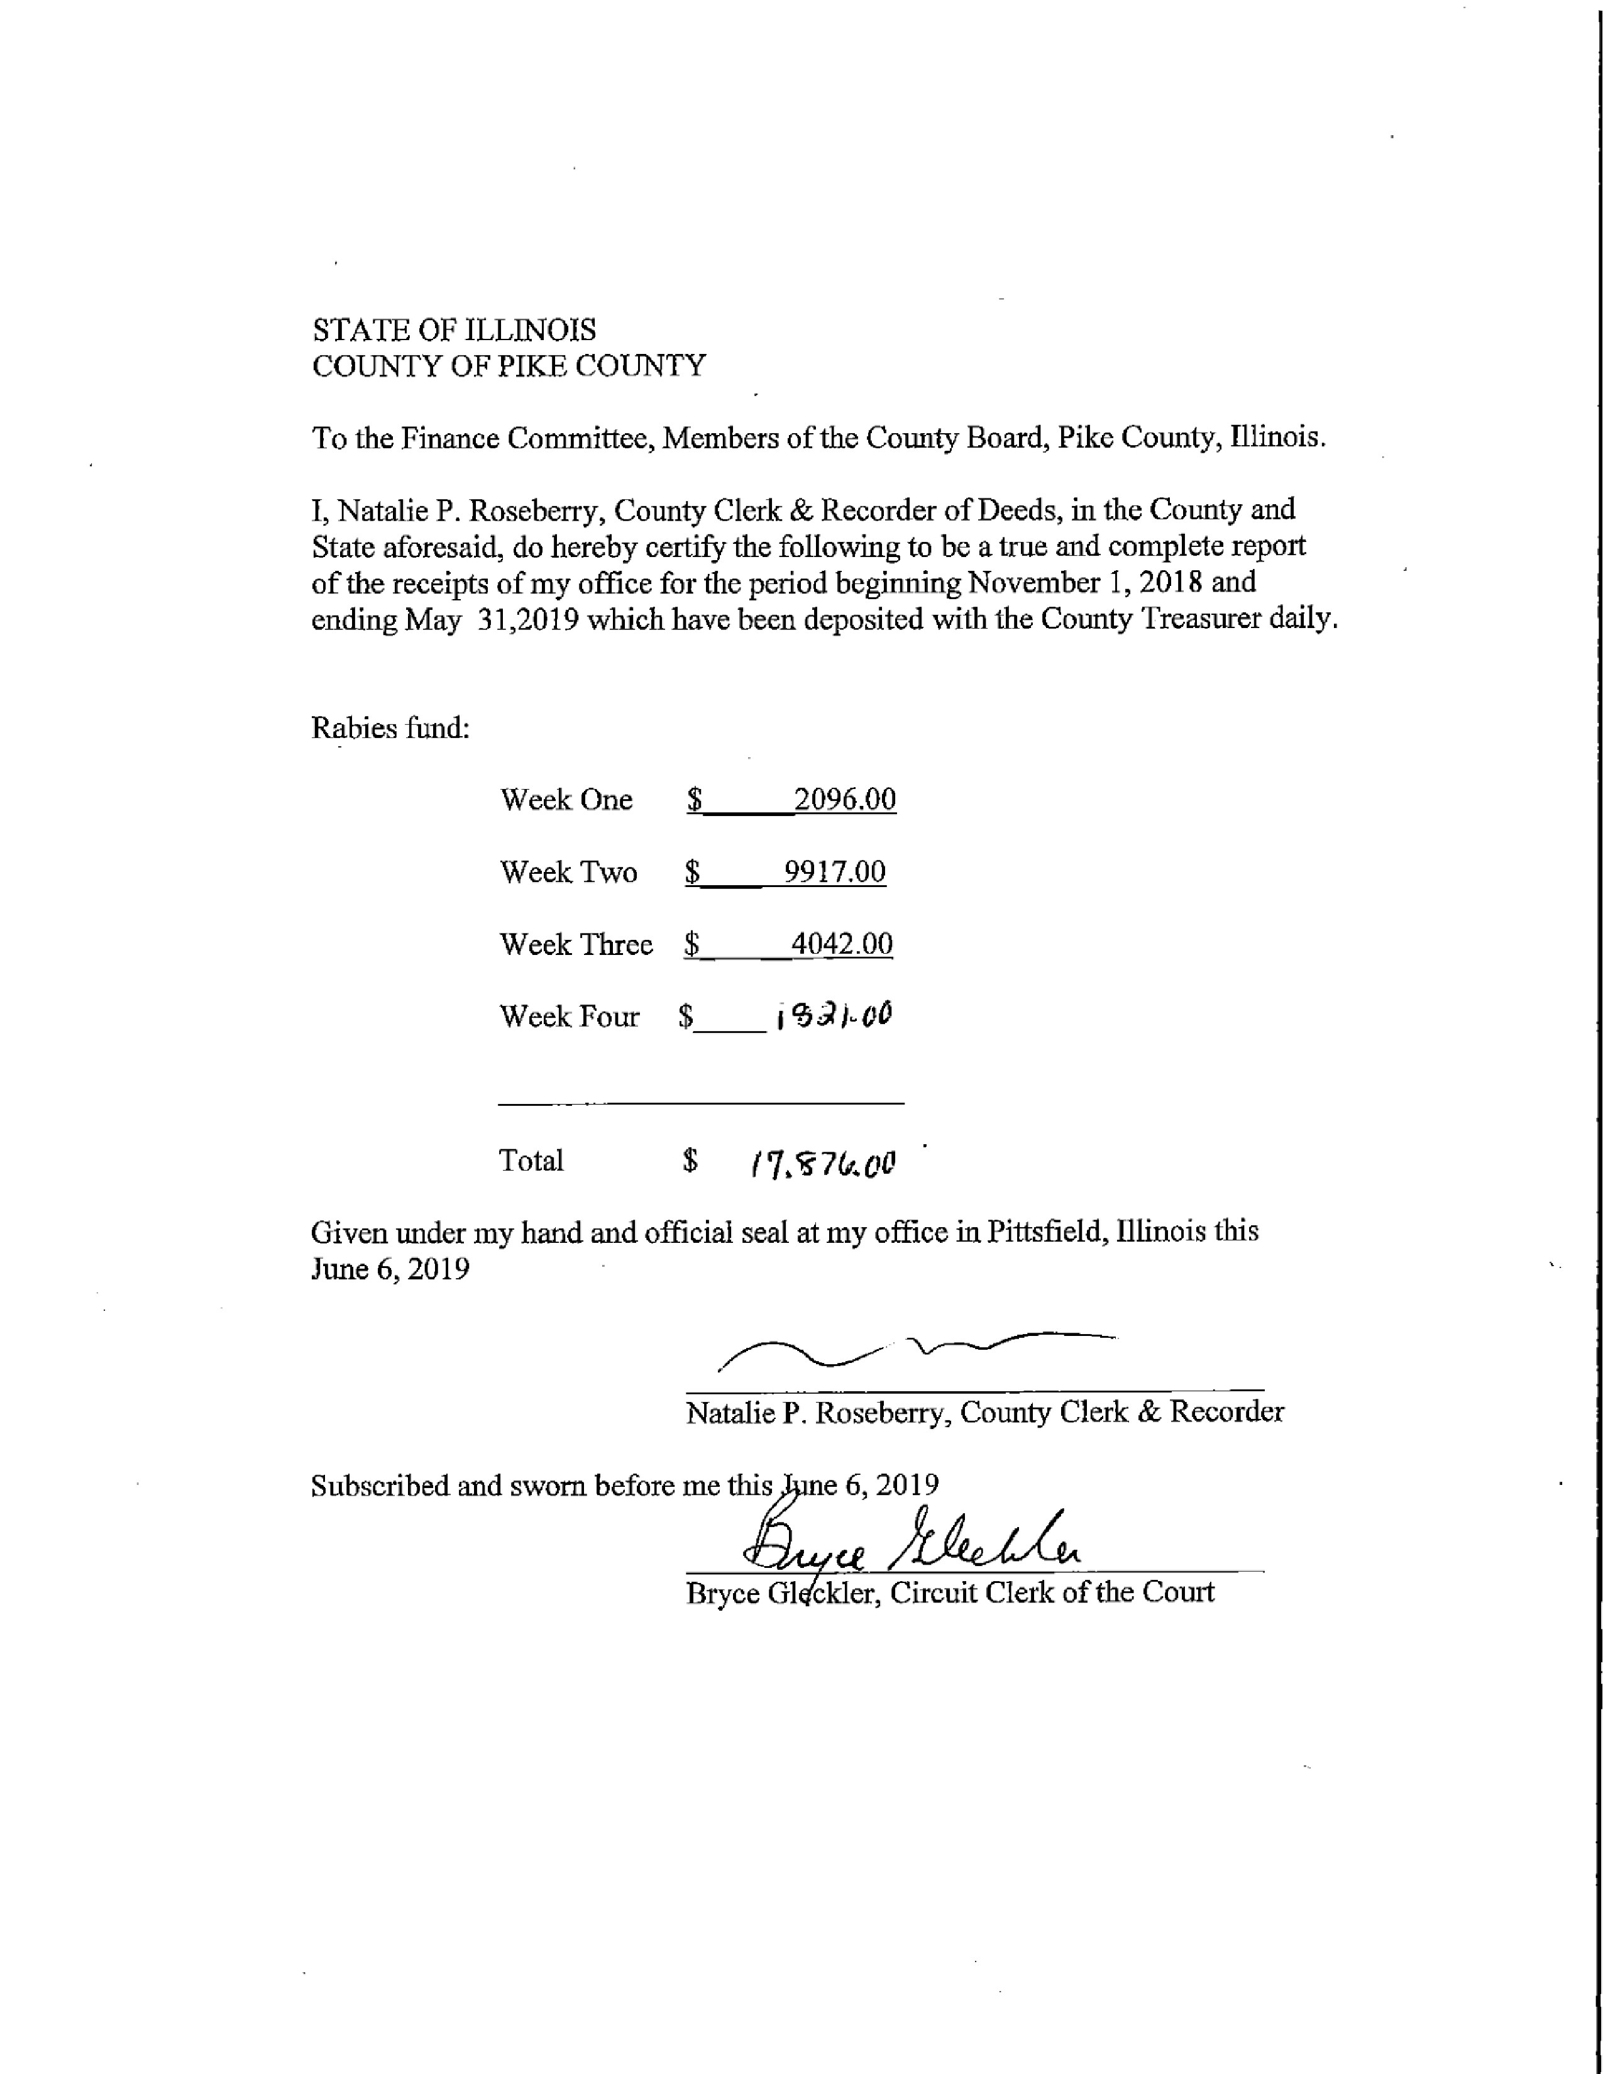
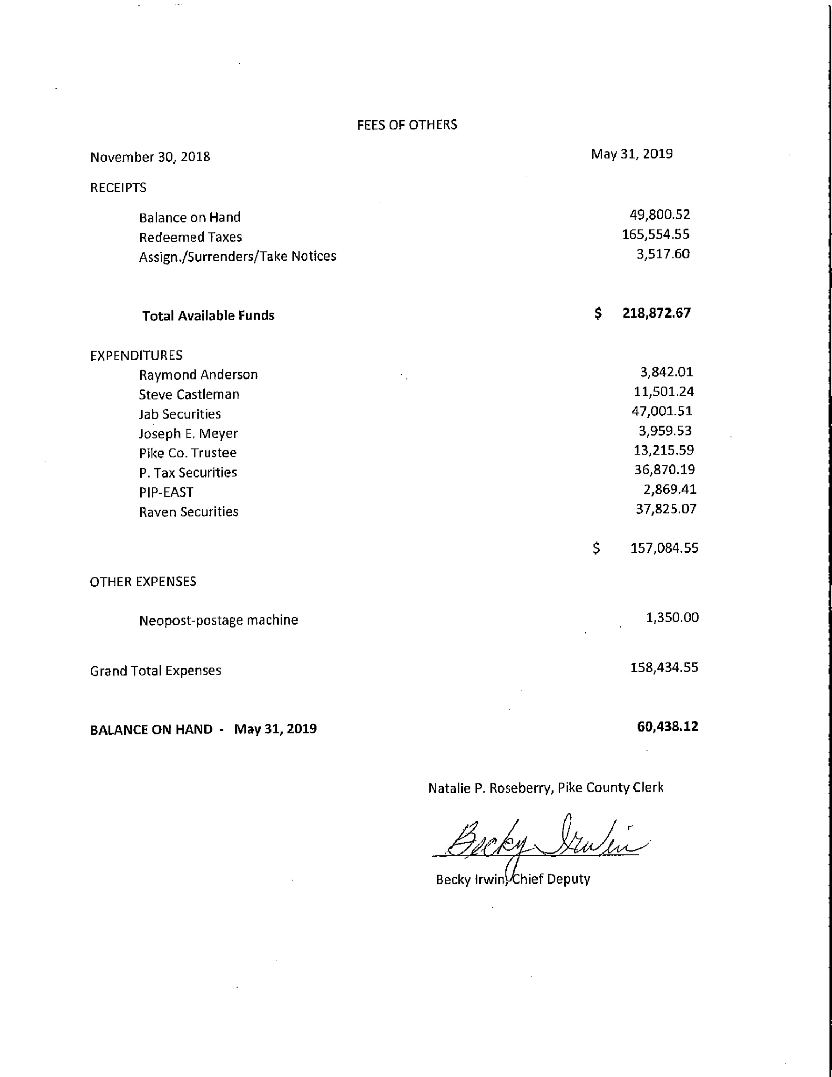
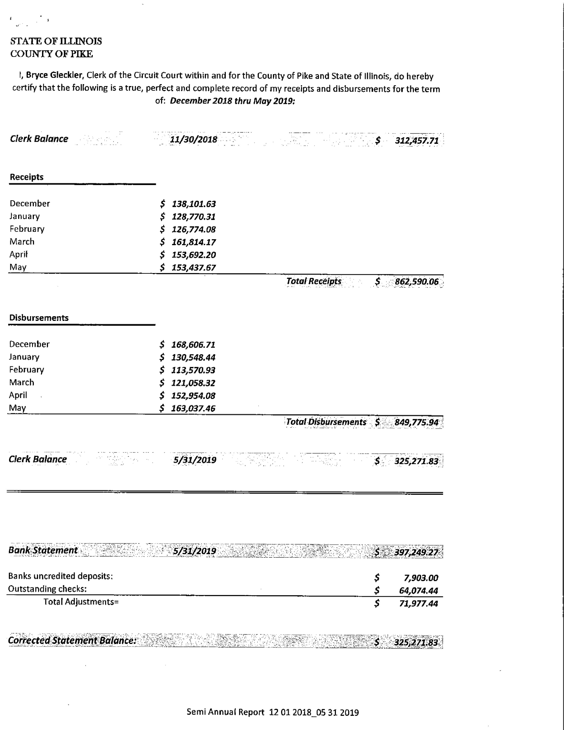
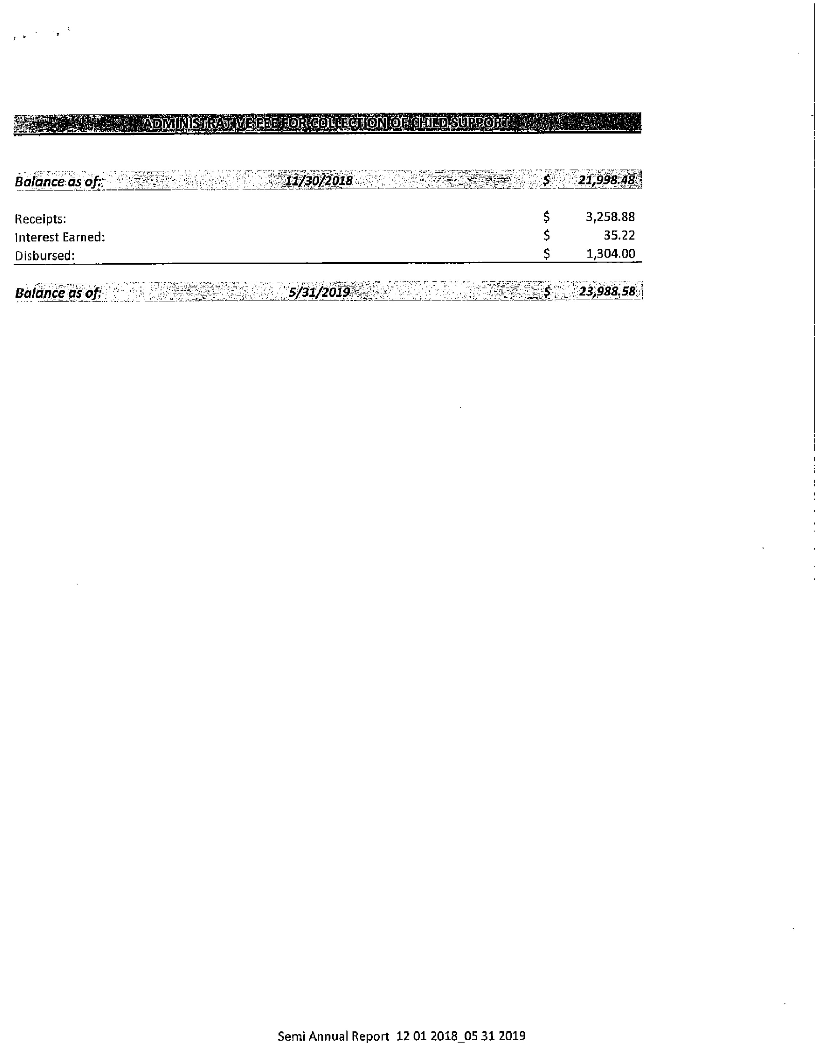
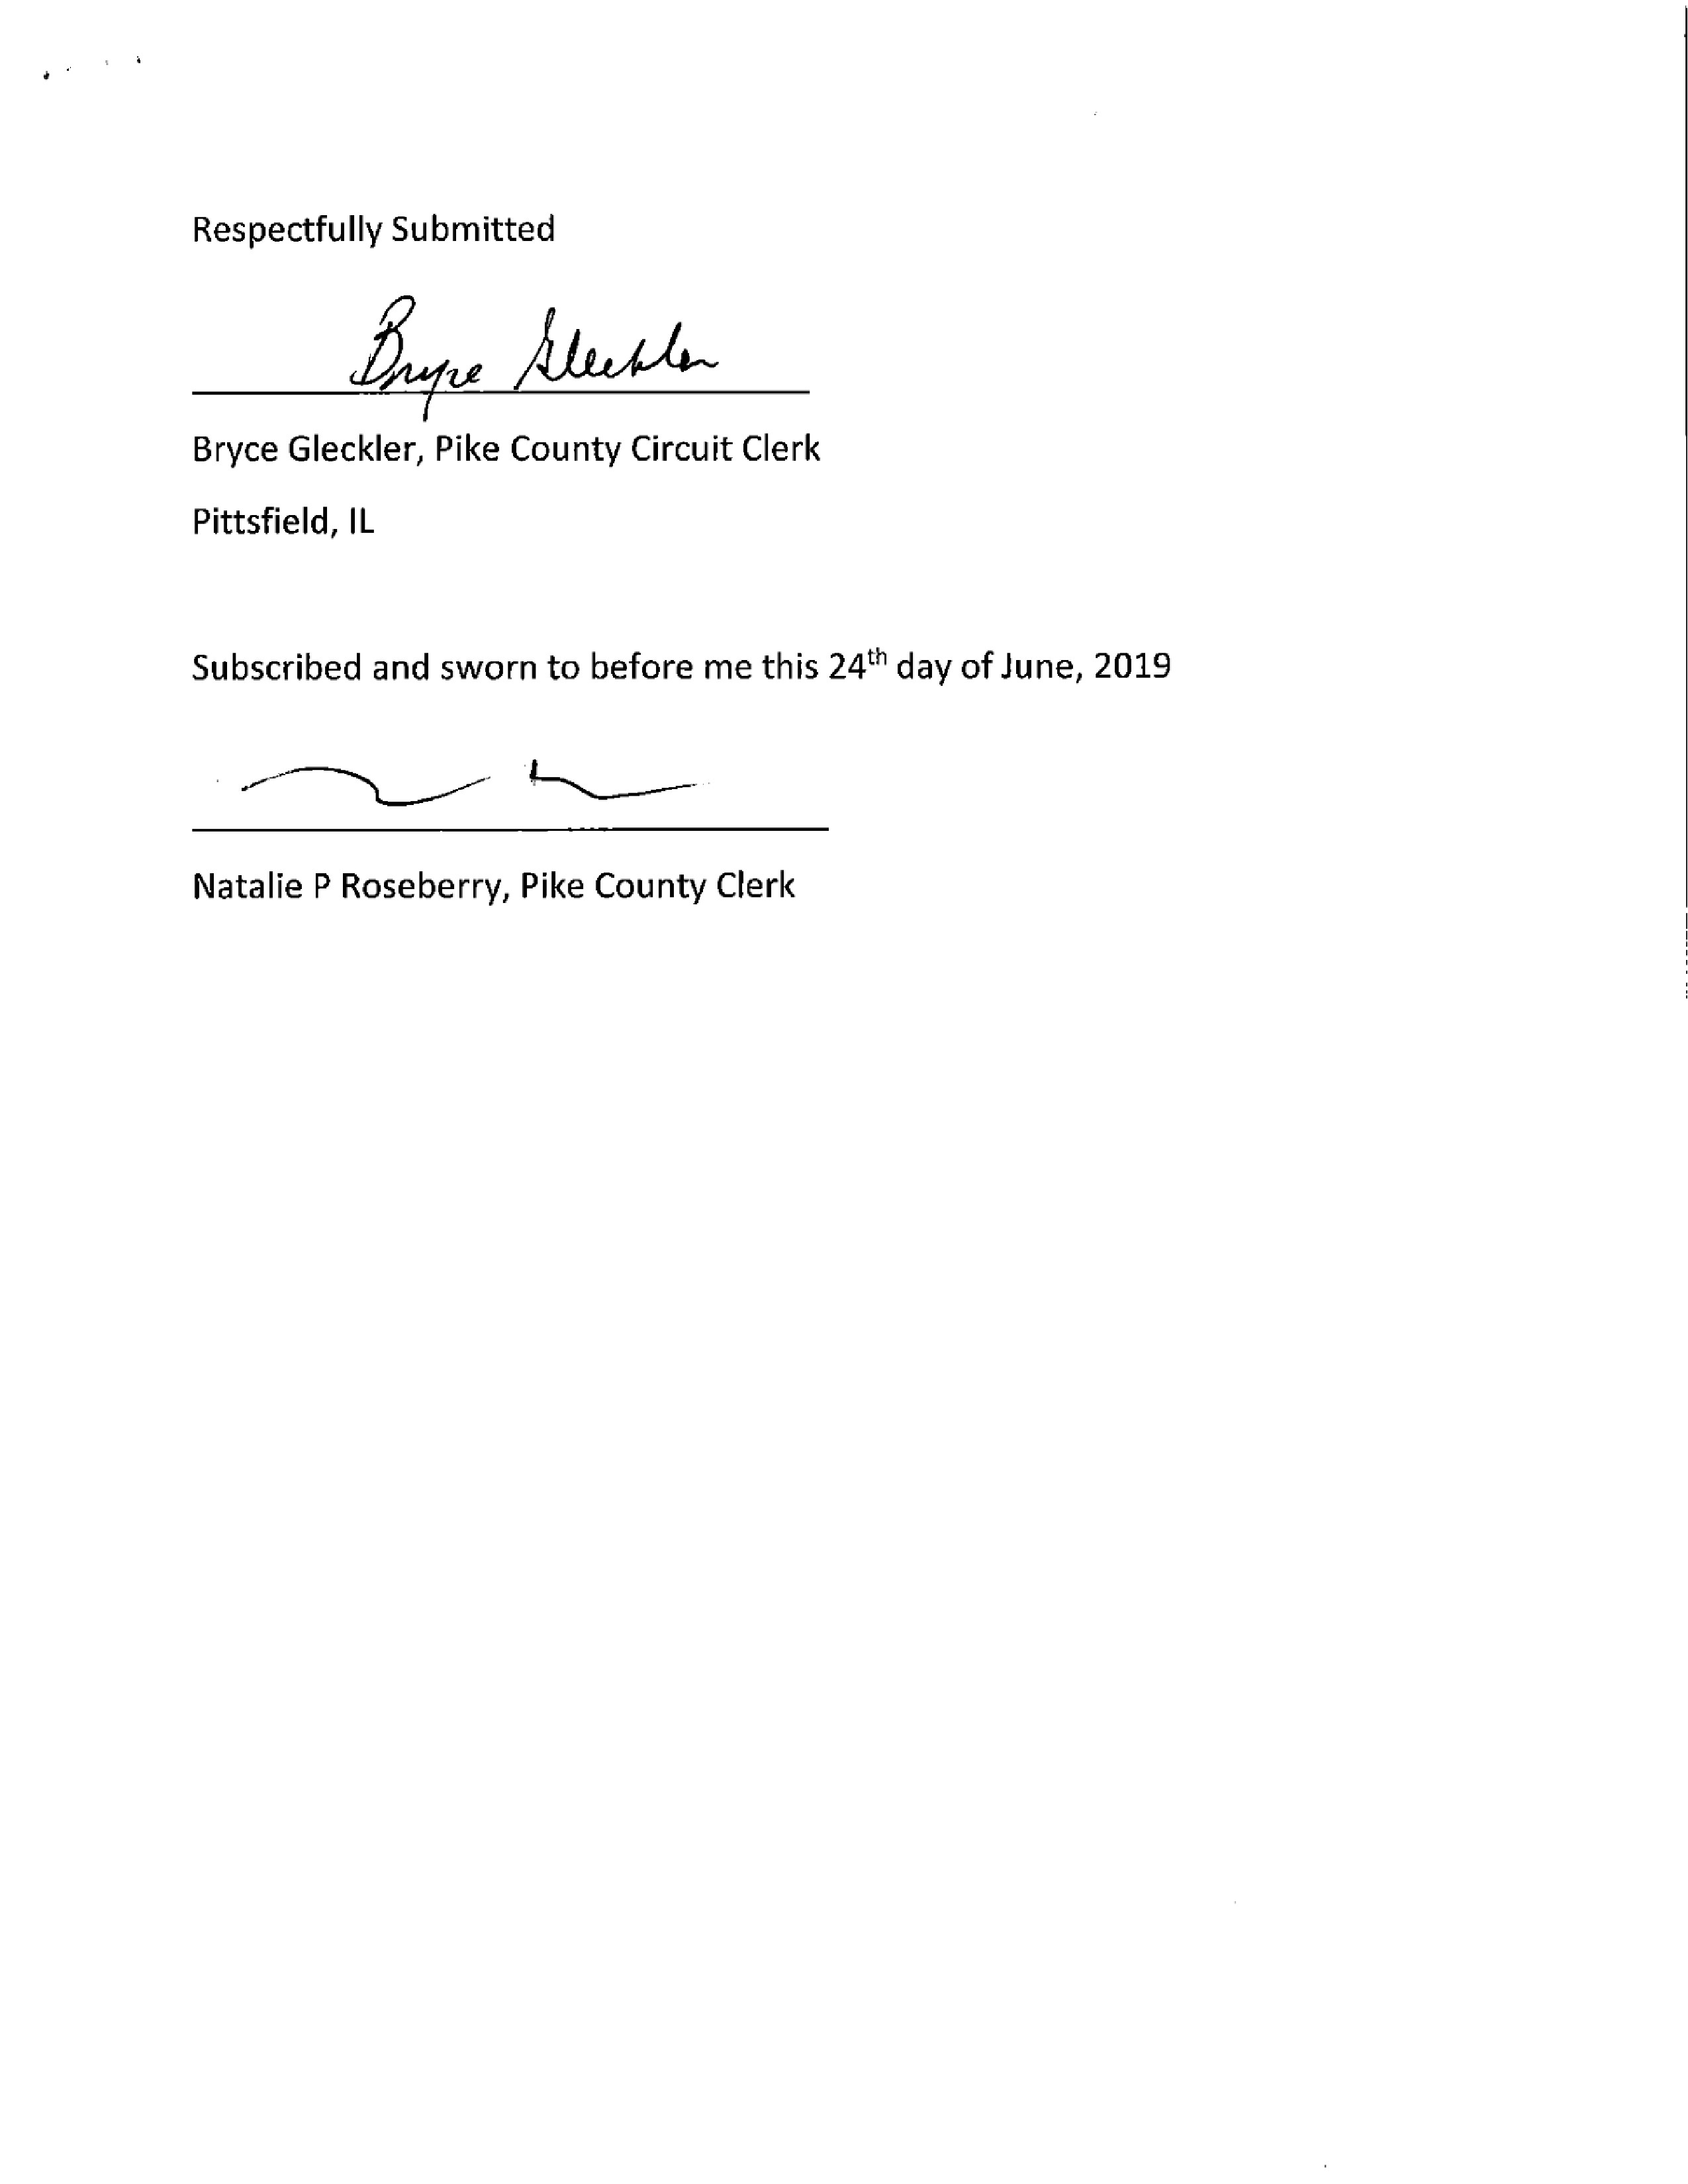
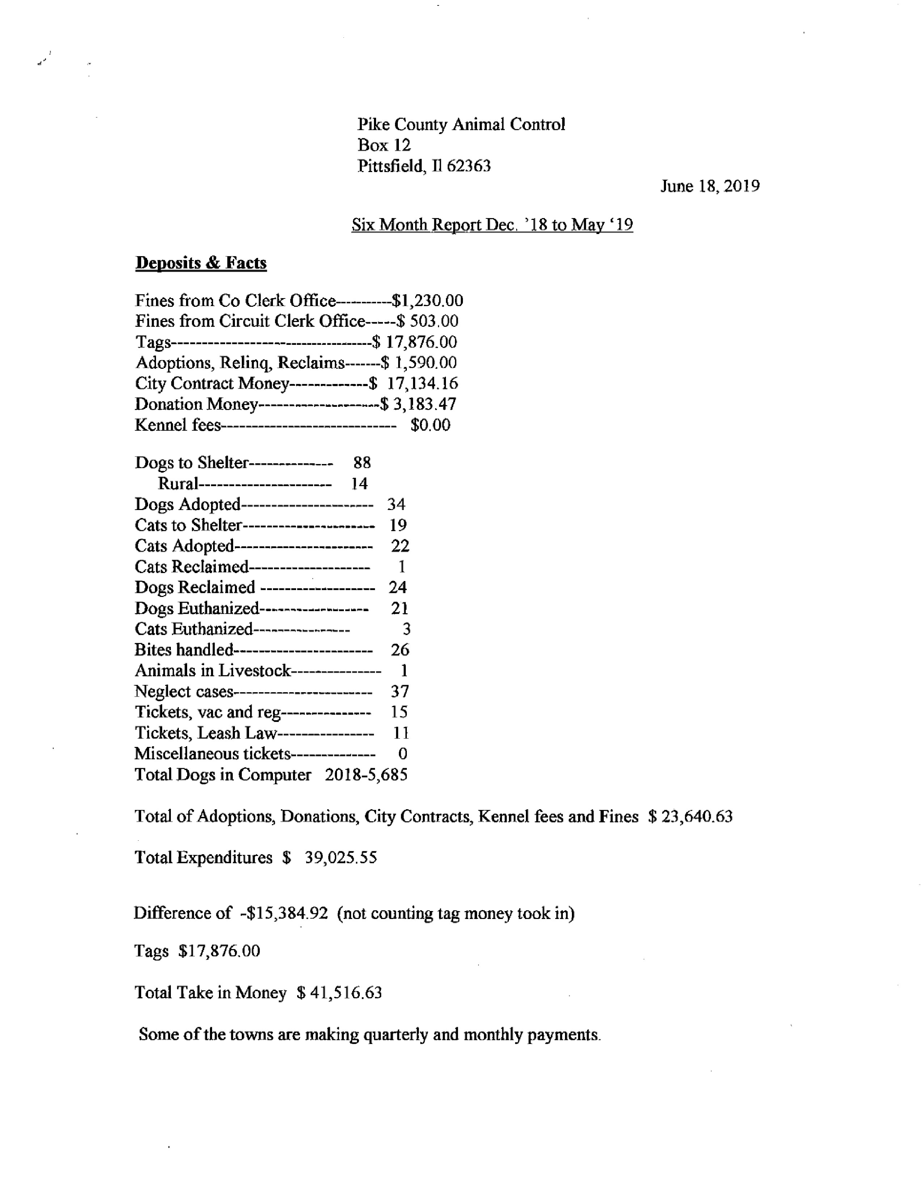
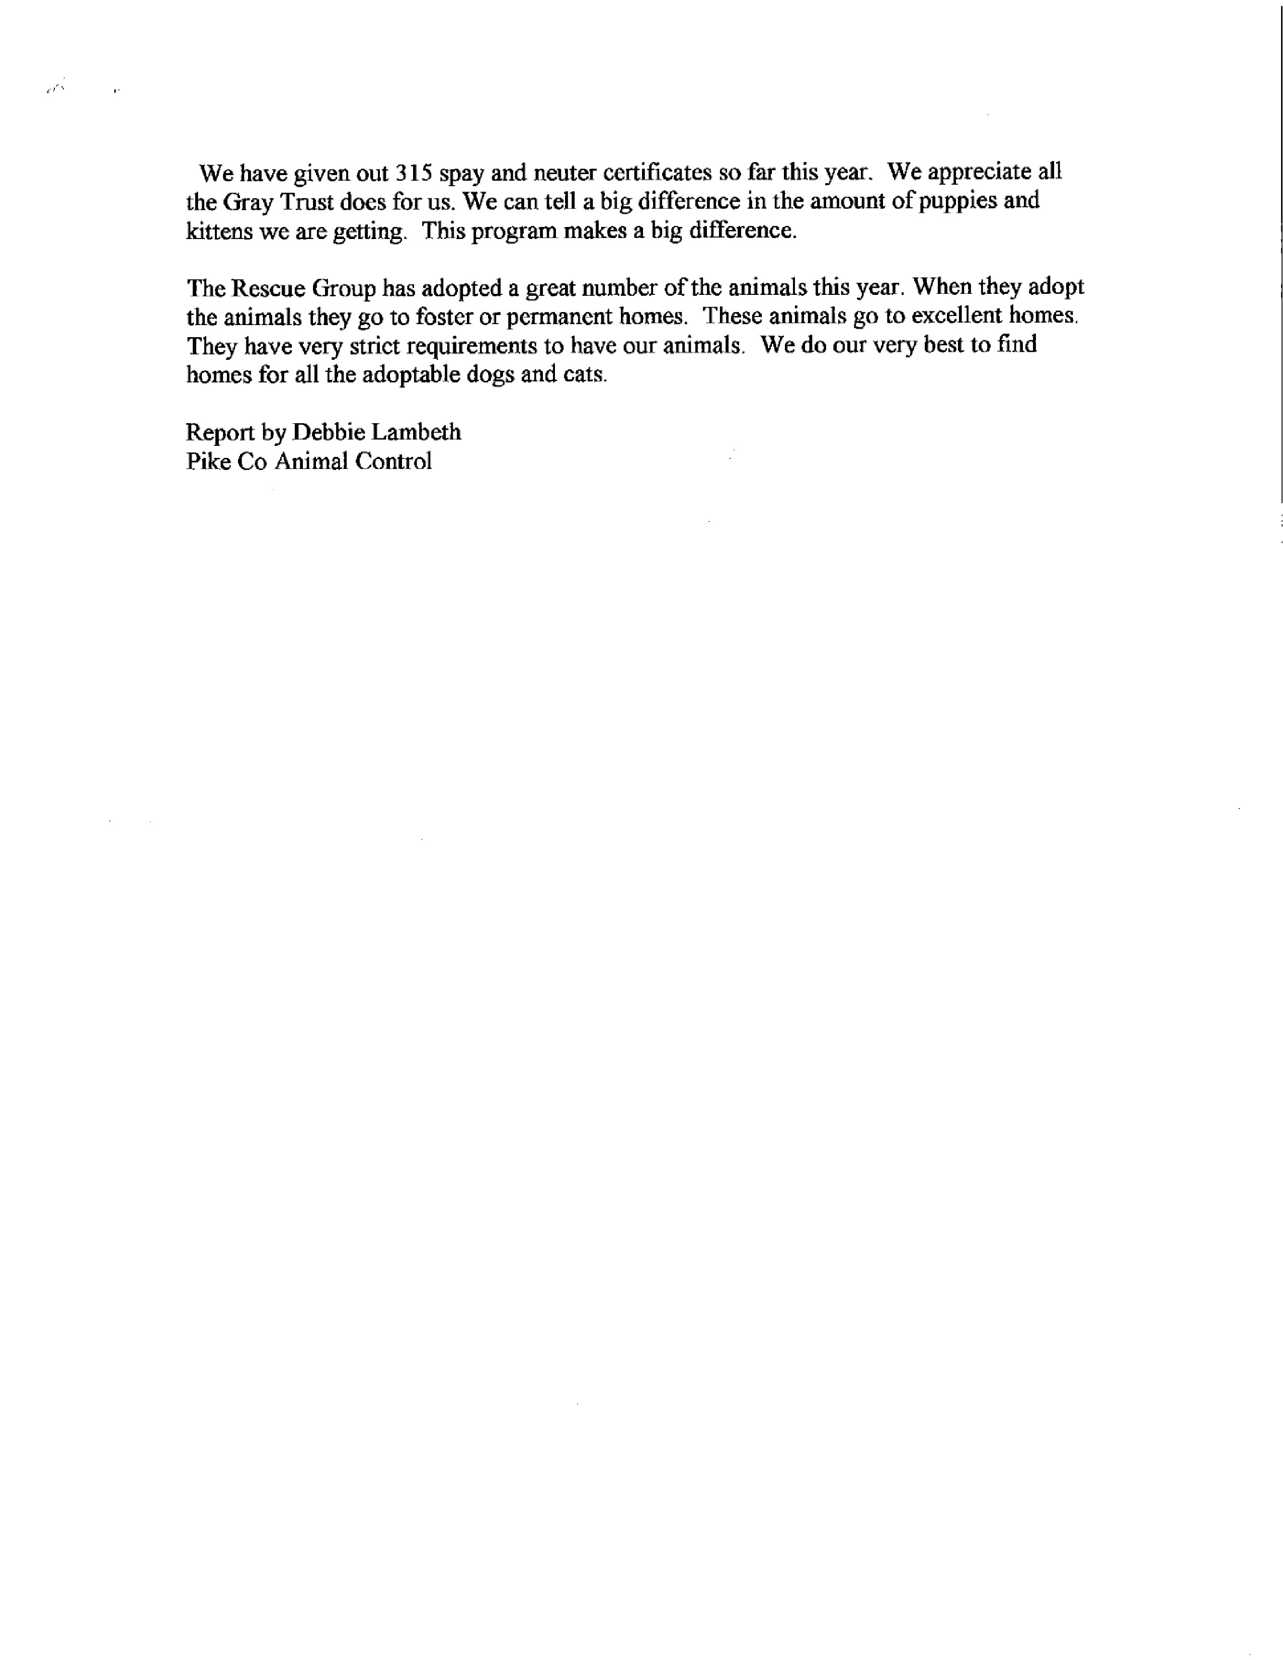
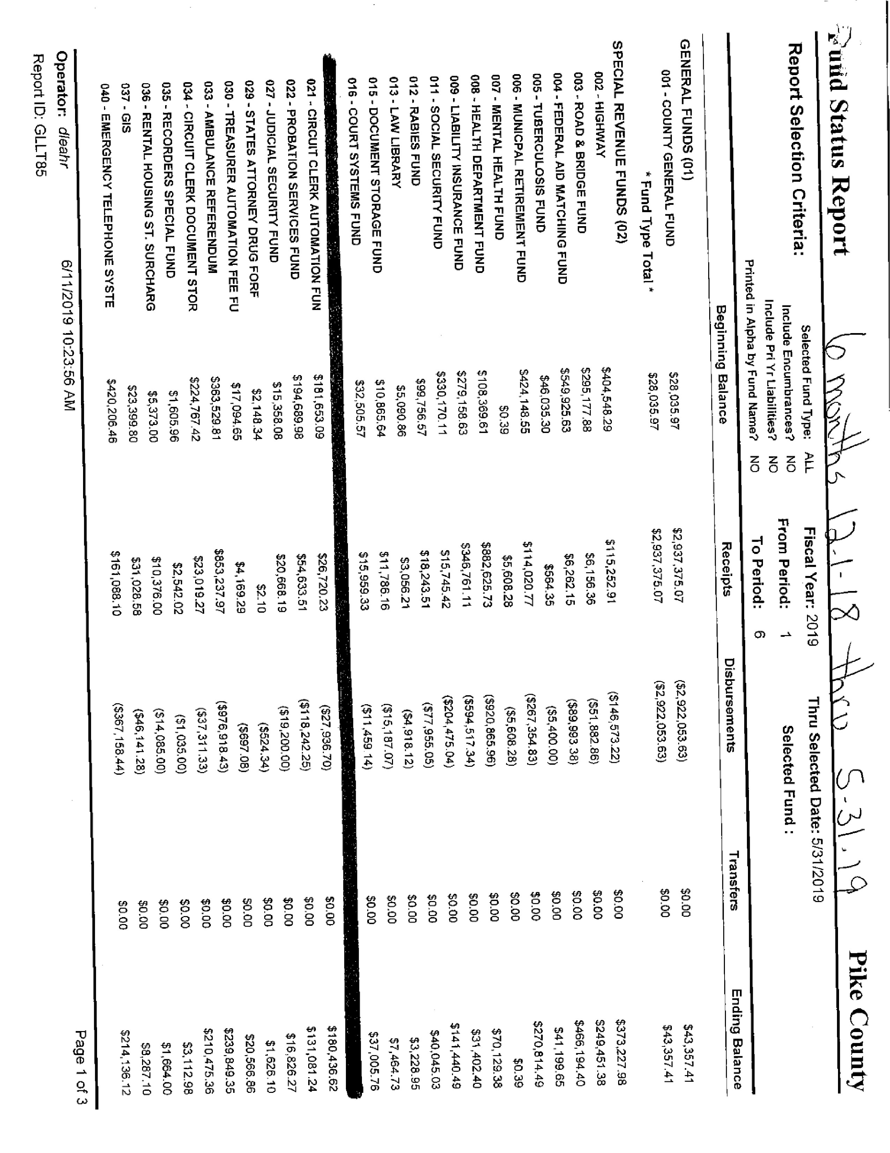
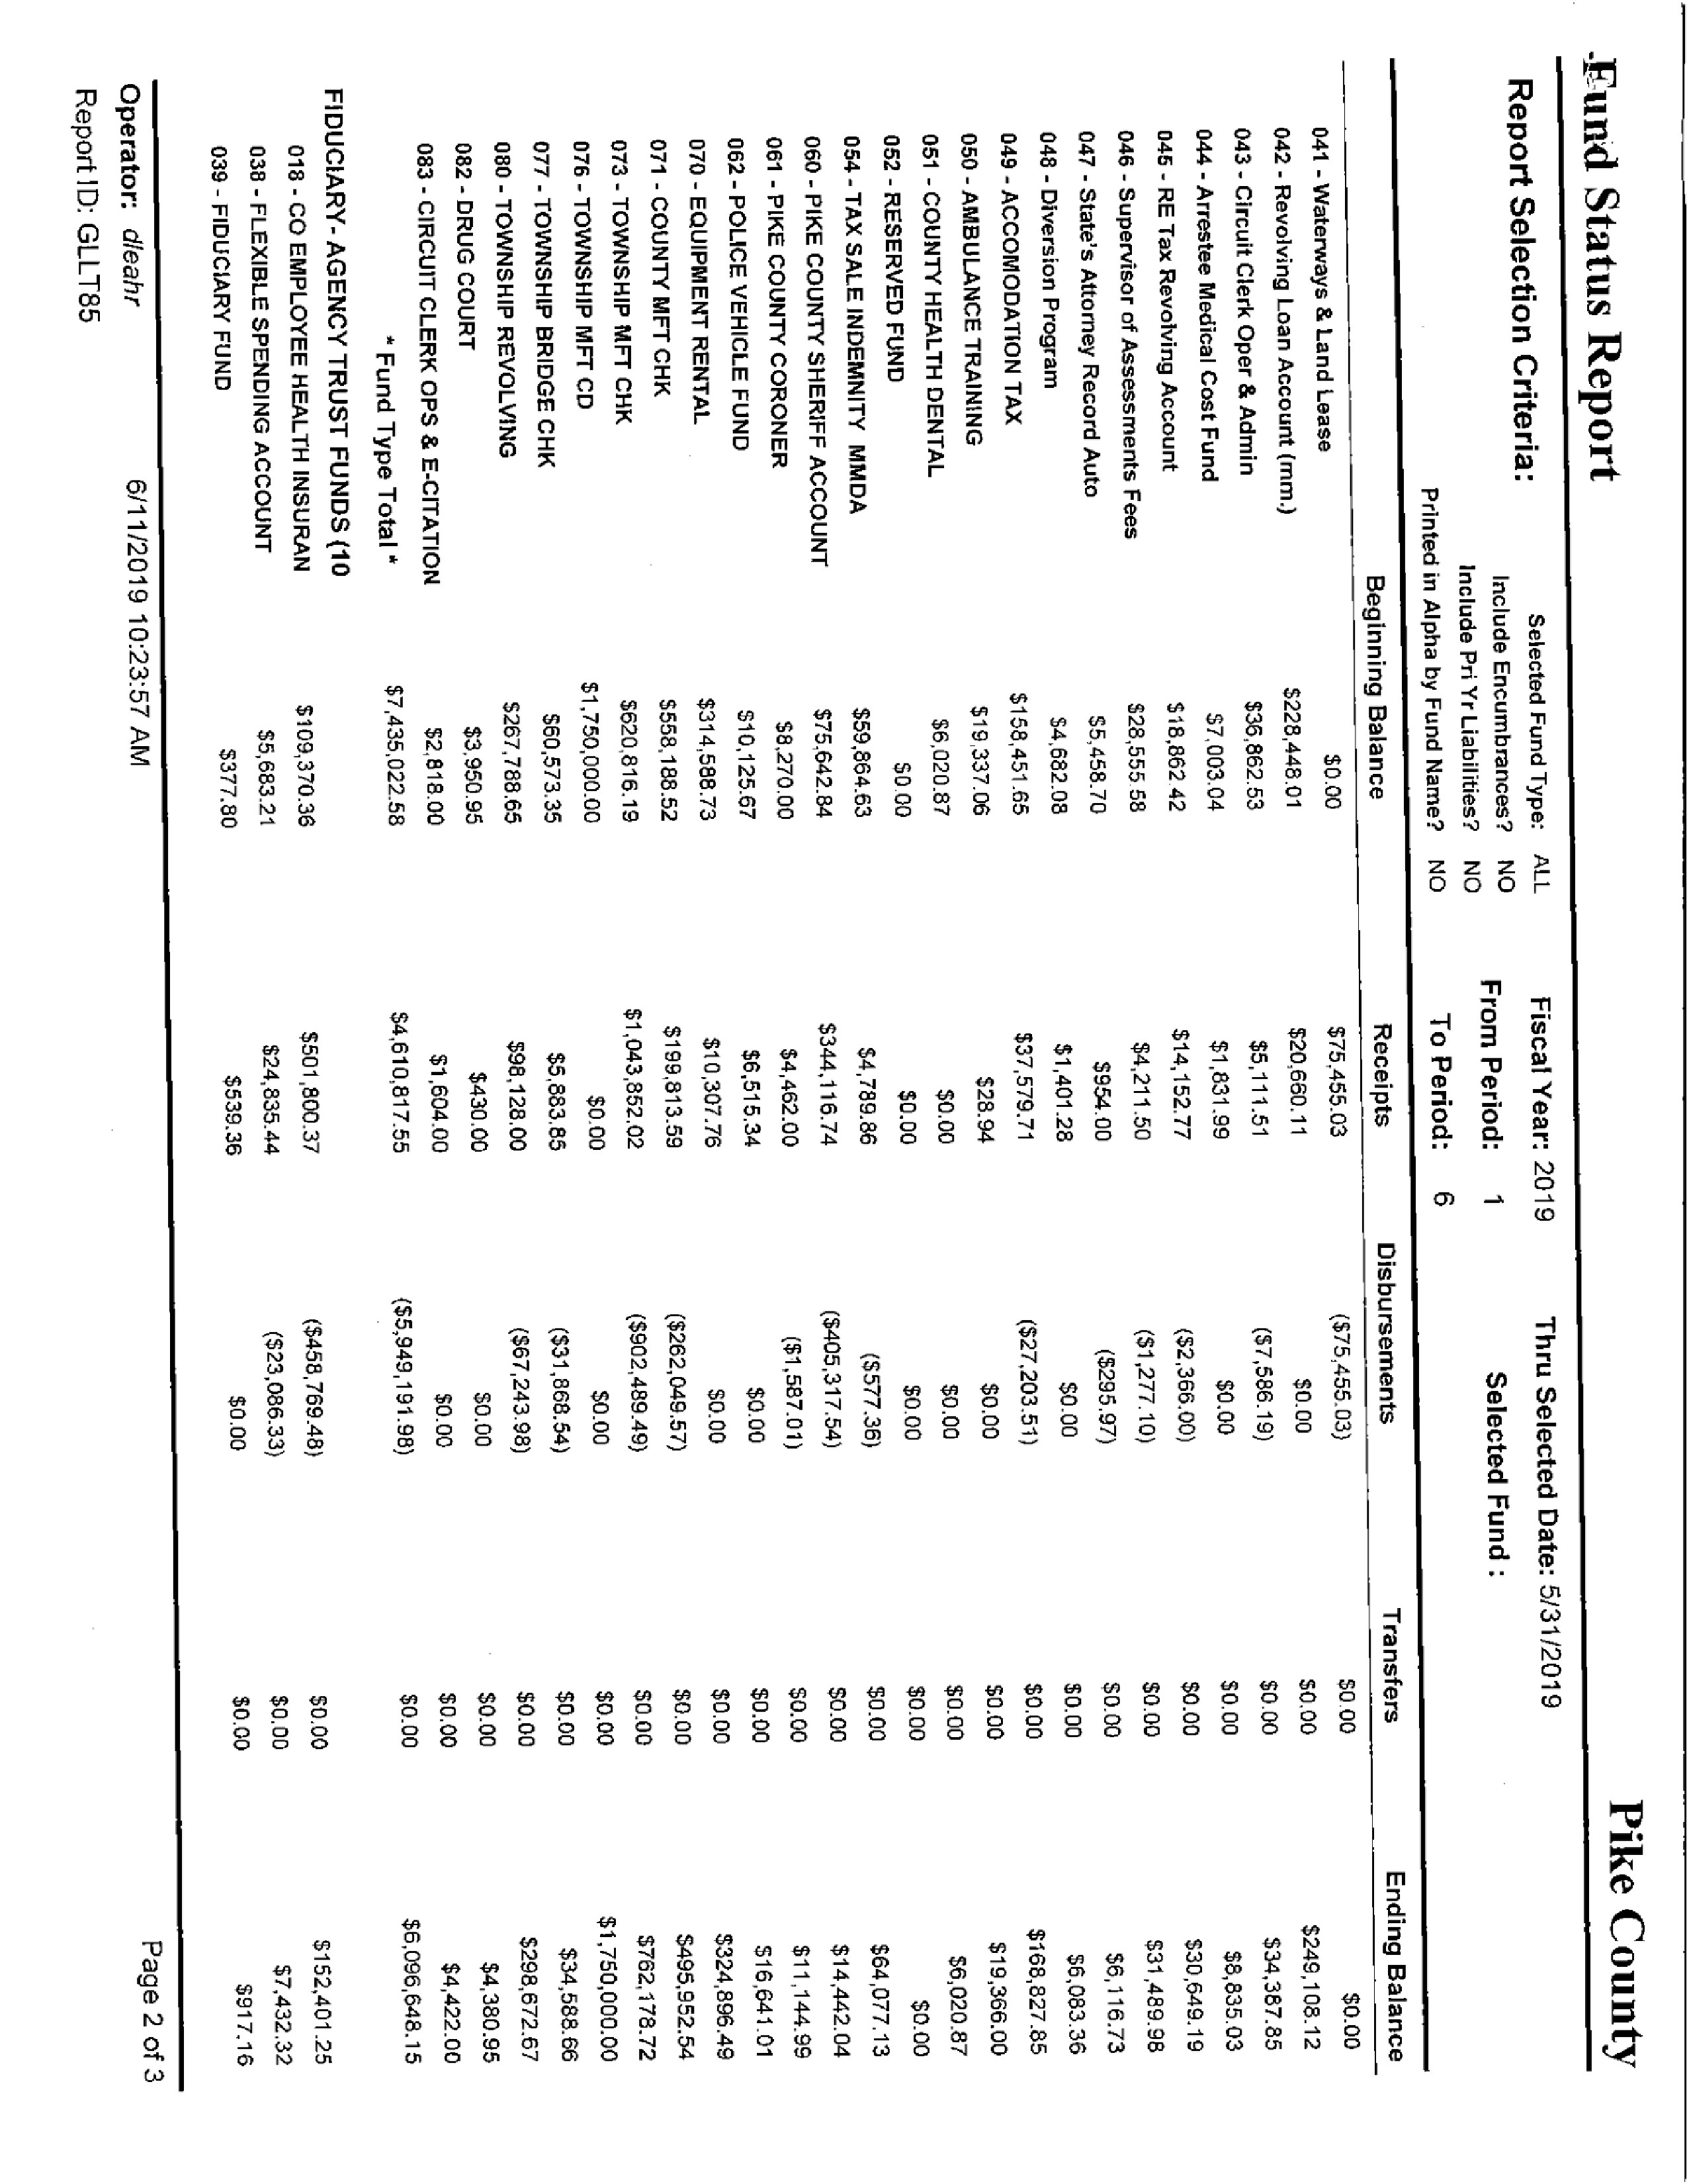
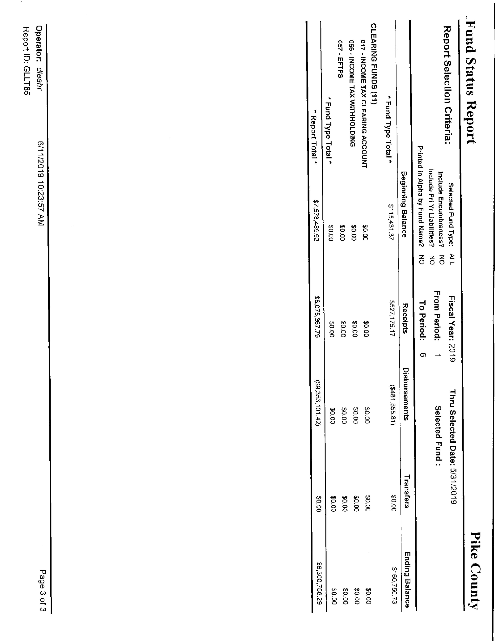

COMMITTEE REPORTS
Finance

The finance committee of the Pike County Board met at 5:00 p.m. on Wednesday June, 12th, 2019 in the conference room of the Pike County Government building. Members present were Rodger Hannel, Amy Gates, Jim Sheppard and County Board Chairman Andy Borrowman. County Clerk Natalie Roseberry, Judge Frank McCartney, Circuit Clerk Bryce Gleckler, Brenda Middendorf, Justin Krohn, and County Treasurer Scott Syrcle were also present. Routine Bills in the amount of $131,202.62 were approved for payment on a motion by Amy Gates and a second by Rodger Hannel. Natalie Roseberry brought forth her idea to raise the minimum number of hours that an employee must work each year before they are required to contribute to IMRF from 300 to 1000 hours a year. Amy Gates seconded, motion carried. Judge McCartney was present to bring forth a resolution to distribute the fees associated with traffic and criminal cases. This is in reaction to the Criminal and Traffic Assessment Act. Amy Gates made a motion to recommend full board review of an ordinance establishing Civil Fees and Criminal Traffic assessments. Rodger Hannel seconded, motion carried. Brenda Middendorf presented the status of collections on two of our revolving loans. We got half of the principle of one of the two. Amy Gates made a motion to adjourn. Rodger Hannel seconded. Motion carried. Meeting adjourned at 5:54 P.M.

Natalie Roseberry stated she is waiting on the information from IMRF to make the change and hopes to have a representative present at finance in the upcoming months.

Amy Gates made a motion to approve the finance committee minutes. Seconded by Mark Sprague. Voice vote 8-0. Minutes approved.

Highway

The Road and Bridge Committee met Wednesday, June 12th, 2019 at 3:30 p.m. at the County Highway Department. The meeting was called to order at 3:30 p.m. Members present were Rodger Hannel, Mark Mountain, John Birch and Andy Borrowman. Others present was Chris Johnson, County Engineer. There was no public comment. A motion was made by John Birch and seconded by Mark Mountain to pay claims per claim reports dated June 12, 2019. All in favor. Motion carried. No update on White Bridge and no closed session. Mark Mountain and Chris Johnson met with the next-door neighbor today at 9:00 a.m. to discuss the possible purchase of discussed property and Chris and Mark will work to negotiate a purchase price with the owners to present to the board in the near future for approval.

The committee discussed the request for variance on setback for 3 turbines. The committee approved the variance for turbines 7 and 17 as presented, they approved a variance on turbine 6 but limited the turbine height to 594 feet tall. A motion was made by John Birch, seconded by Mark Mountain, all voted in favor. Motion carried. County Engineer’s report stated that County Highway 13 improvements are about finished. A stretch of gravel will be seal coated this summer. The Kiser Creek bridge letting is scheduled for June 14th, 2019. Both new dump trucks have been delivered and there was a discussion on the final funding needed for the Nebo City Bridge. A motion was made by Mark Mountain seconded by Rodger Hannel, to adjourn meeting at 4:13 p.m. Motion Carried.

Chairman Borrowman expounded upon the issues with the Wind Turbines and the movement of one to prevent it from hitting the road if it were to ever fall.

Derek Ross asked for clarification on if the Board was voting to approve the minutes or the setbacks? Zack Boren stated that it is up to the Board and by voting on the minutes approves the setbacks. Kirby Hobbs stated that he has not signed off on one of the setbacks from the township standpoint.

Building and Grounds

The Building and Grounds Committee met on Wednesday, June 19th, 2019 at 3:30 p.m. Present were Tom Lewis, Derek Ross, Rodger Hannel, Andy Borrowman, Judge Frank McCartney, Sheriff David Greenwood, architect Joe Petty, John Birch, Marcie and Kay Dehart, Chris and Robert Crowder, Jim and Noue Filbert, Lloyd Lawber, Pat Brown, Natalie Roseberry and Mark Sprague. The Meeting began with Joe Petty reviewing four options for increased security at the Pike County Courthouse. Option 1 was estimated to cost $158,200.00. Option 2 was estimated to cost $218,600.600. Option 3 was estimated to cost $251,400.00. Option 4 was estimated to cost $383,100.00. Options 1-3 were new options to be considered with option 4 being the same option considered at our May County Board Meeting. Each option would have to have new controls, etc…for the elevator, which would cost between $75,000 to $80,000. As Joe Petty reviewed each option, the B & G committee members and guests in the audience asked numerous questions about each option. Joe Petty, Judge McCartney and Sheriff Greenwood answered their questions about each option and how to pay for them. After much discussion, Derek Ross made a motion to recommend Option 1 to the full County Board for approval. Tom Lewis seconded the notion, and the motion passed. Joe Petty, Judge McCartney and Sheriff Greenwood will be present at the August 26 County Board Meeting. The consensus of the guests present also supported Option 1 as the best option. Later, if Option 1 needs some improvements, parts of Option 2 may be considered if needed.

Tom Lewis made a motion to approve the bills of $7,214.50. Derek Ross seconded the motion, and it passed. Sheriff Greenwood discussed with Jim Sheppard about amending his budget to help pay the extra personnel needed for the increased Courthouse security. Also, Sheriff Greenwood said a problem with an Ameren electric line caused a major surge in electricity that damaged the electronics at the Jail and caused many problems with computers, phones and 911 system. Ameren will pay for the damages and repairs caused by the surge. Also, Sheriff Greenwood will seek bids for some roof repairs at the Jail and the Annex.

Pat Brown and Lloyd Lawber asked the County Board to consider a video camera to be installed on the Annex roof to focus on the Pike County Courthouse and the memorials on the Courthouse grounds. The B & G committee thought this sounded like a good idea, and asked Pat Brown to provide more information to the committee. The cost appears to be minimal and would help promote tourism for Pike County. Derek Ross made a motion to adjourn the meeting at 4:45 p.m., and Tom Lewis seconded the motion. The motion passed.

Judge Frank McCartney went over the proposed designs and stated that Option 1 was the cheapest and the security is confined to inside of the courthouse however elevator modifications need to be made. If this is approved it allows for a potential upgrade to Option 2 if it is not working out.

Amy Gates asked if Judge had gotten any figures from court fines etc that was discussed in finance. He stated he did not but will get them to her. He also stated that within the approved fine structure, money is going to go towards judicial security to help pay the salaries of the security officers.

Amy Gates expressed concern that the aesthetics of the doors would change and Sheriff Greenwood stated they plan on using the existing doors. Chairman Borrowman asked what the next step is if the board approves an option. Judge McCartney stated he will let Joe Petty know and we can start the open bid process through the County Clerk’s office.

Tim Lewis expressed concern that all option but 4 require the elevator and the issue being what happens if it shuts down? All agreed that could be a potential issue. Jim Sheppard expressed concerns over the Personnel cost to staff it and asked Sheriff Greenwood the expense of the security officer. Sheriff Greenwood stated that it would potentially be a starting salary of $31,000.00. Amy Gates inquired if this person would be a security officer as well as a deputy. Sheriff stated that the individual would double as corrections but would not be a deputy Sheriff. He also stated that there might be times a deputy Sheriff might fill in.

Scott Syrcle asked if someone is canvassing the courthouse before lock up and how this security will prevent the situation from occurring again where someone was locked inside the courthouse. Judge McCartney stated that the building has and is being canvassed nightly and as well known, if someone wants to get in they are going to find a way. Amy Gates asked for clarification that this was not a state mandate as of now and Judge McCartney agreed it was not mandatory.
Mark Mountain made a motion to approve Option 1 and allow Joe Petty to proceed with bids/specs. Seconded by John Birch. Voice vote 8-0. Motion carried.

Mark Mountain made a motion to approve the amended Building and Ground committee minutes. Seconded by John Birch. Voice vote 8-0. Minutes approved.

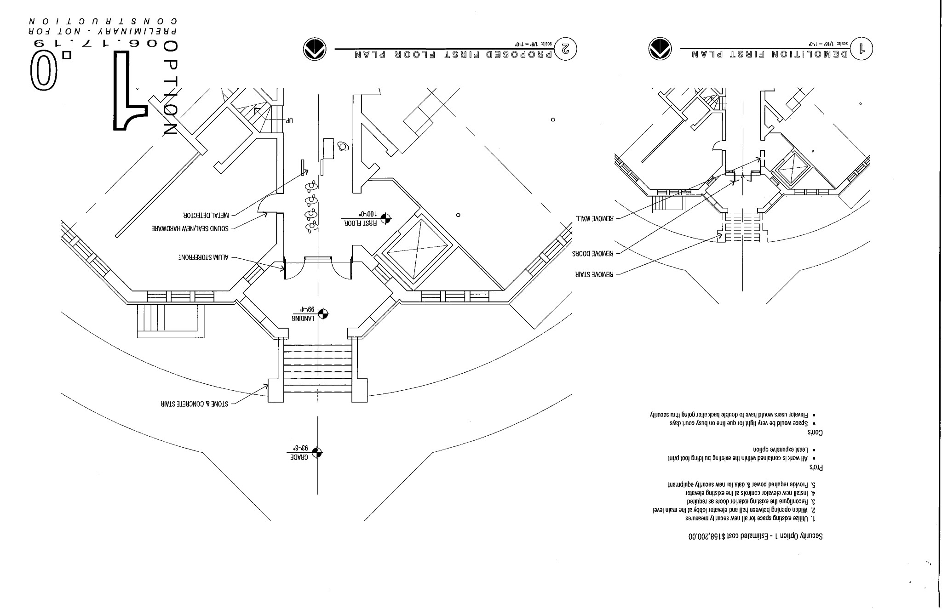
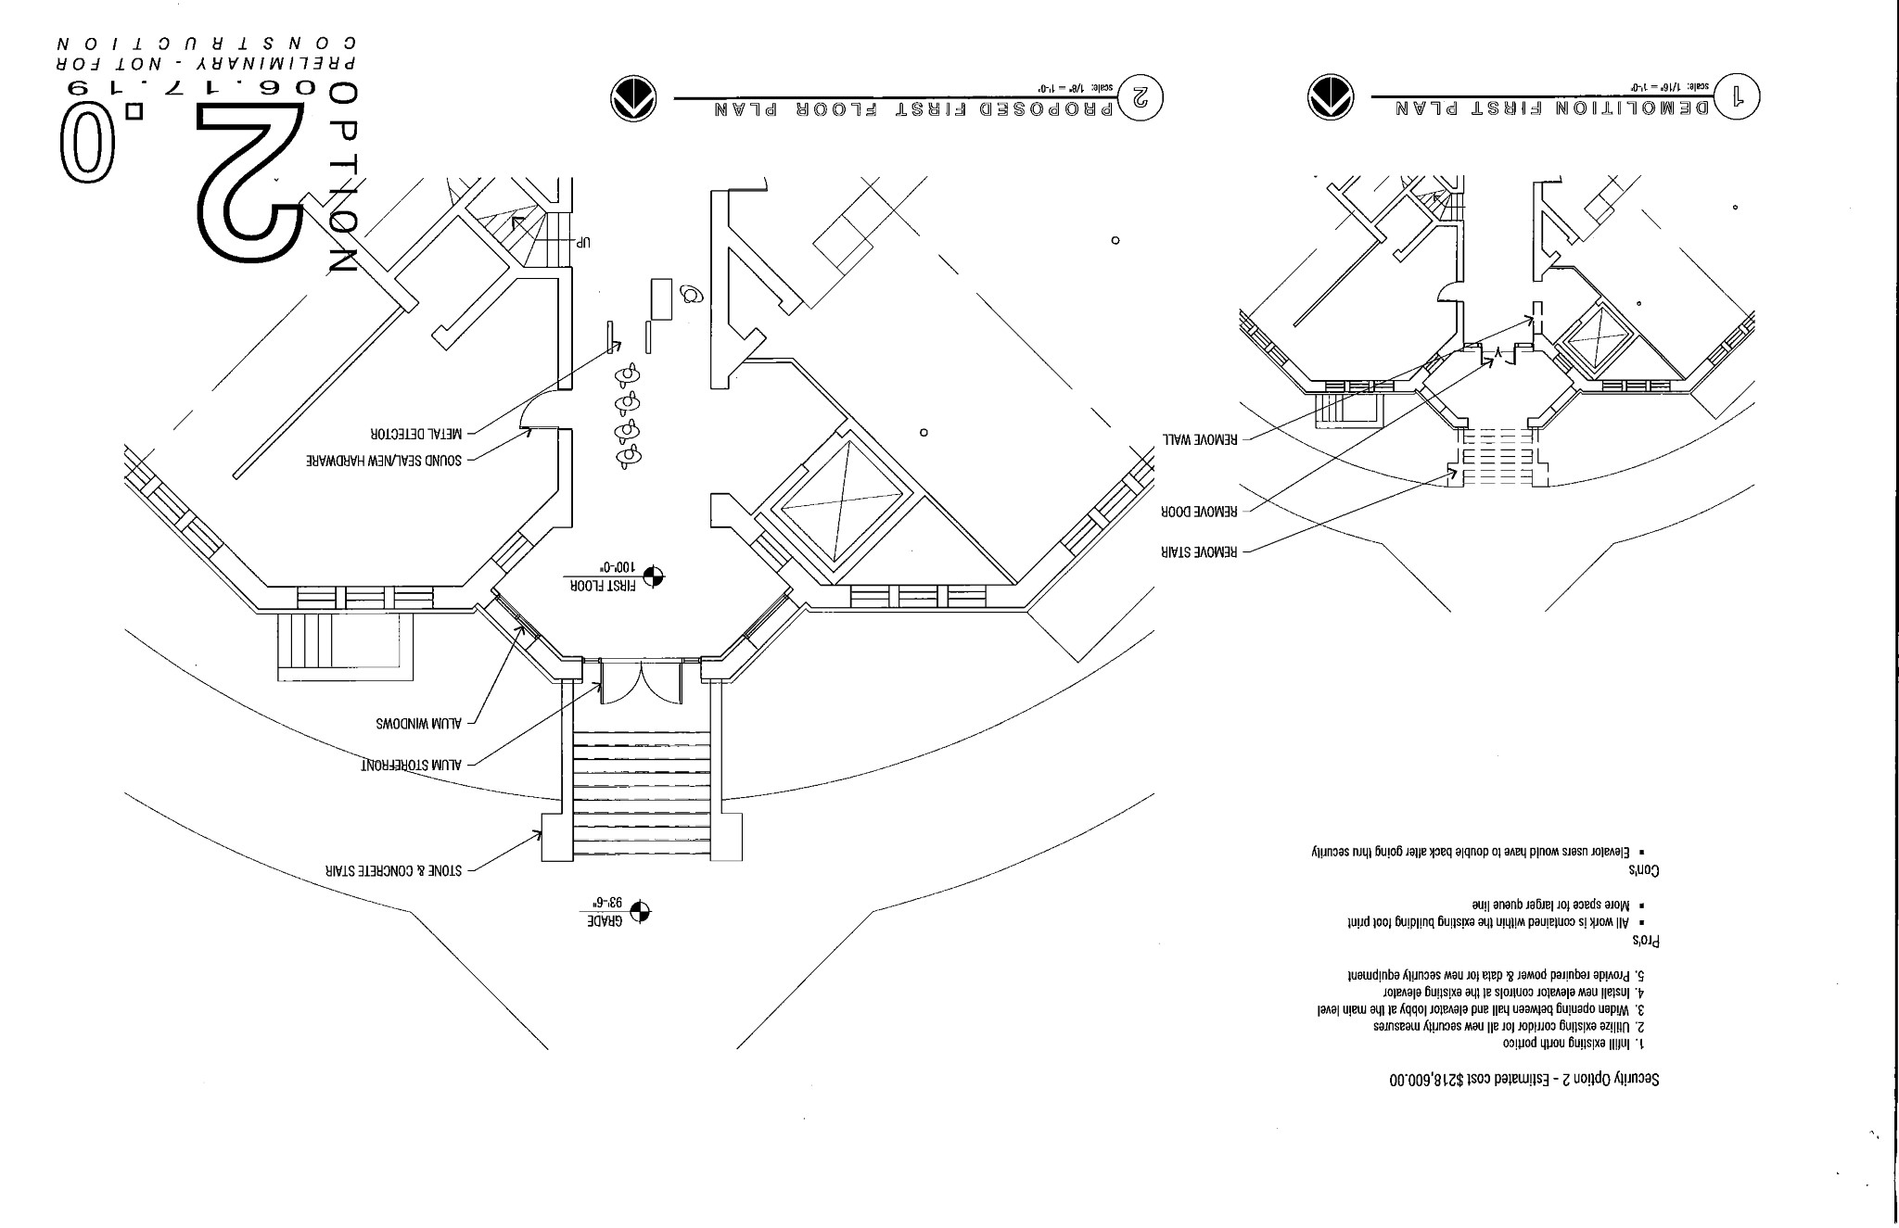
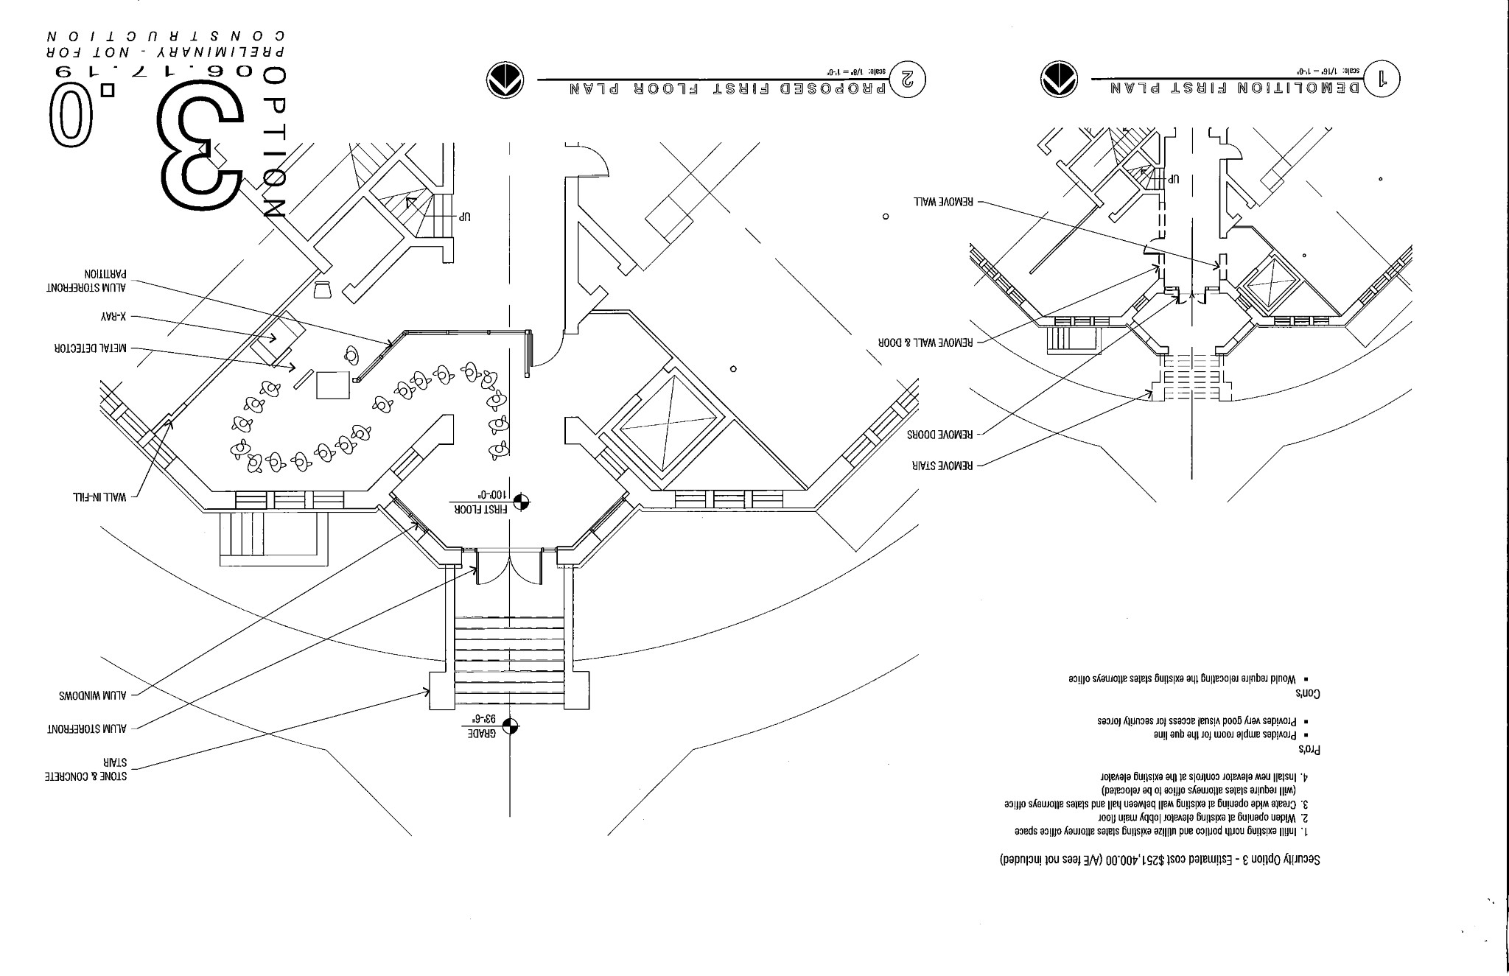
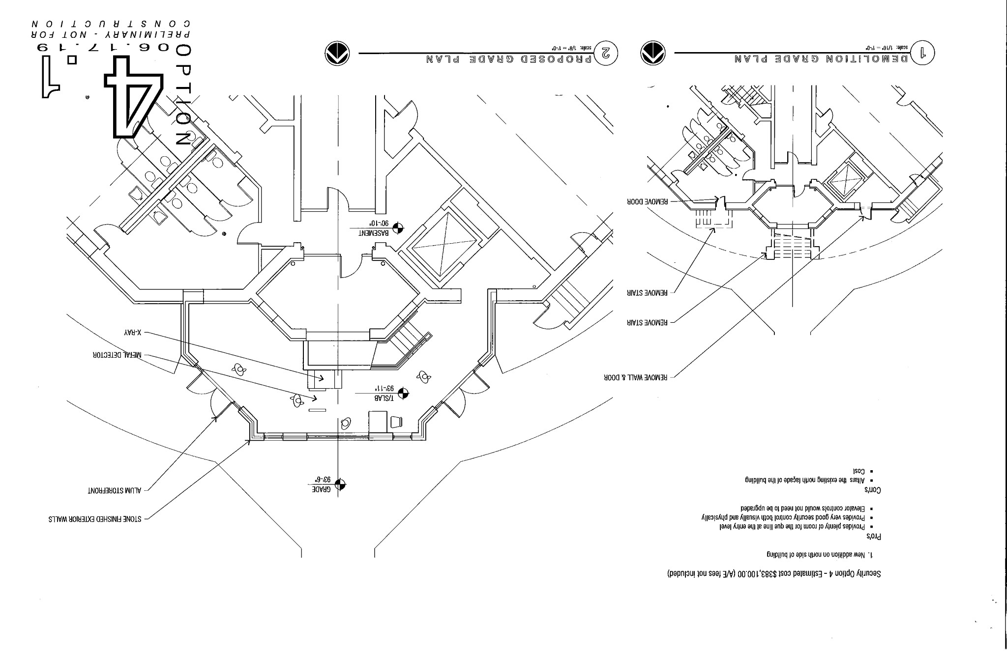
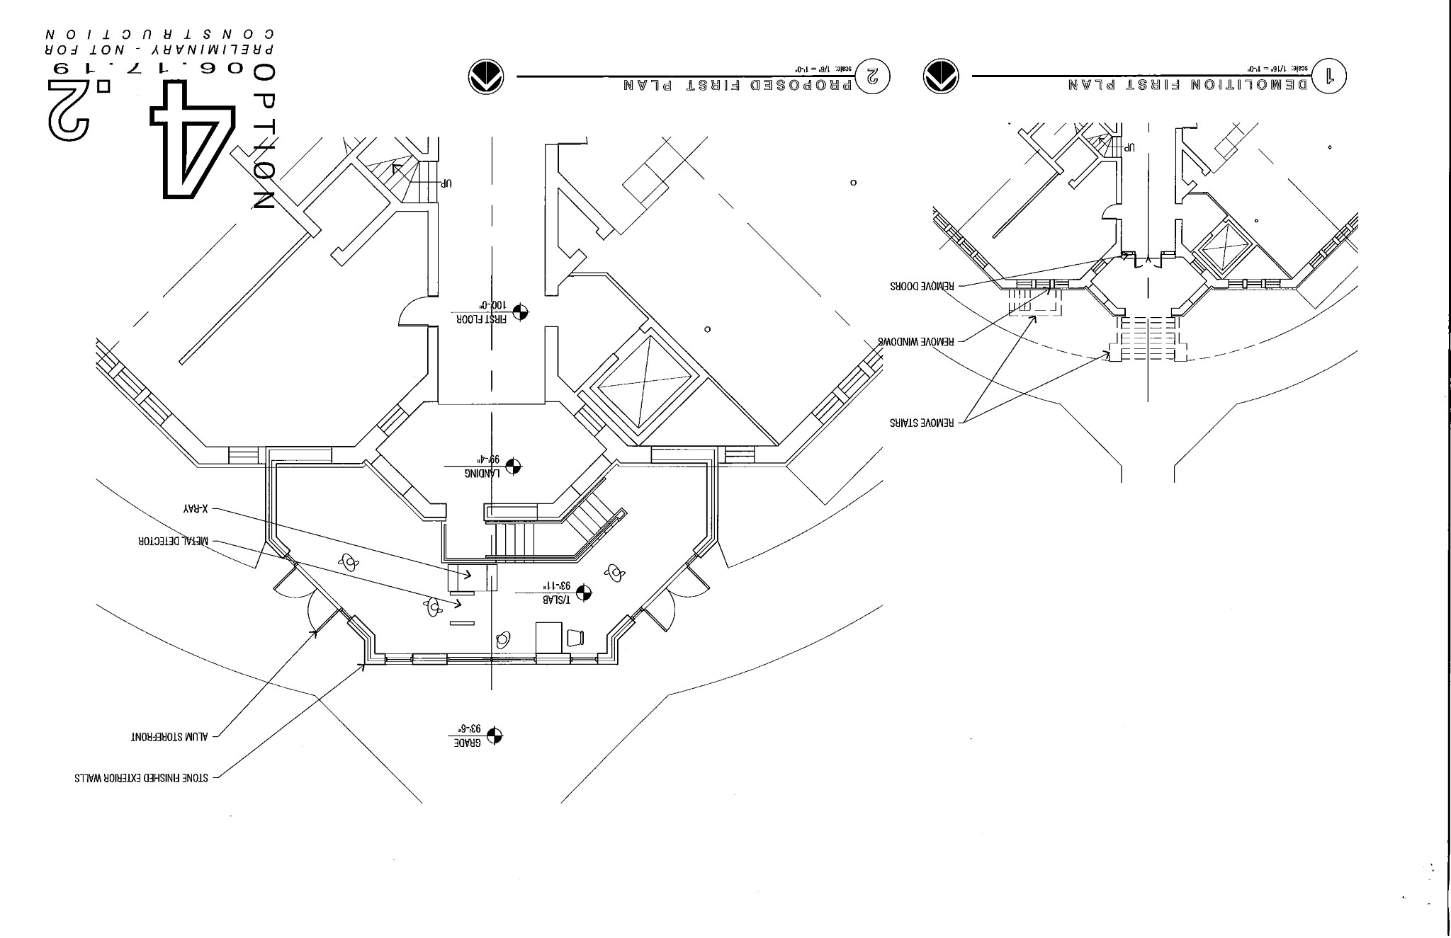

GIS/IT

The GIS/IT committee of the Pike County board met at 5:00 p.m. on Wednesday, June 19th, 2019 in the Emergency Operations Center of the Pike County Jail. Those present were; Amy Gates, Mark Sprague, Jim Sheppard, Board Chairman Andy Borrowman, Sandy Schacht, Paula Dean and Deputy Dan Brennecke. Mark Sprague made a motion to pay the bills in the amount of $4,218.55. Amy Gates seconded. Motion Carried. WE discussed information and quotes that we had received on managed IT services. Amy Gates made the suggestion that we put it out for bid and tell the vendors what we needed instead of the other way around. We then worked on a list of what we needed and Sandy was going to put this out to interested parties. WE talked about the Ameren issue that caused the surge at the sheriff’s department and the phone issue from the 18th.

We then looked at the quote for a new phone system for the Health Department to replace their 19 year old phones. The quote we were given was $19,663.36 but the committee felt that there was some wiggle room on a couple of items. A motion was made by Amy Gates to have paula Dean enter into final negotiations with Adams Experts for the purchase of a new phone system for the Pike County Health Department. Mark Sprague seconded. Motion carried. We then moved on to the agenda for the administrators meeting scheduled for Wednesday June 26th, 2019 at 4:00 p.m. in the Emergency Operations Center of the jail. We are going to discuss email security, new hire information and work out details on the fall administrators meeting which will be basically a benefits symposium. Sandy also gave a brief report on the spring cleanup project- we got rid of a great deal of unused electronics, rehomed some office furniture within the county departments and gave a little bit away. We had one office that did not respond until after the program was over otherwise we had great cooperation from the offices. On a motion by Amy Gates and a second by Mark Sprague, meeting adjourned at 6:41 p.m.

Derek Ross had some questions over the phone lines and gave a scenario that he has experienced with voice over. Jim Sheppard explained that they are not an extension and will not be accessed through the 7000 number.

Motion to approve the GIS/IT minutes made by Tom Lewis Seconded by Amy Gates. Voice vote 8-0. Minutes approved.

Public Safety

The Pike County Public Safety Committee was called to order at 7:00 PM on June 19th, 2019. Those in attendance were committee members Derek Ross, Andy Borrowman, Tom Lewis, Amy Gates, Pike County Ambulance administrator Josh Martin, and assorted guests. Administrator Martin made the committee aware of a couple of ambulances that may need repair work due to deer hits. He also indicated there may need to be some adjustments made to the EMA budget to accommodate recent bill submissions for recent emergencies and he also said we believe there is a working protocol for billing of transfers for inmates at the Sheriff’s office. It is the committee’s understanding that the Ambulance department’s billing vendor will bill the Sheriff’s office at discounted Medicaid rates, to then be paid by the Sheriff’s office. The committee also understands that past bills to the Sheriff’s office have been reprocessed at the Medicaid rates and have been paid or are in the process of being paid by the Sheriff’s office. There was no public comment. Amy gates made a motion and seconded by Tom Lewis to pay bills in the amount of $65,221.92. A dispatcher’s annual salary was included as part of the amount. The motion passed. Amy Gates made a motion and seconded by Tom Lewis to adjourn. The motion passed and the meeting adjourned at 7:30 p.m.

Minutes were amended from Medicare rates to Medicaid rates.

Amy Gates made a motion to approve amended Public Safety minutes. Seconded by Rodger Hannel. Voice vote 8-0. Minutes approved.

Agriculture

The Agriculture committee met on June 18th, 2019 at 6pm in upper conference room at Pike County Government building. Members in attendance were Mark Mountain, Rodger Hannel, Mark Sprague and Chairman Andy Borrowman. Others in attendance were Cindy Shaw, Blake Roderick, Zack Boren, Greg Wyatt, Don Foster, Debbie Lambeth, Fred Ruzich, Jane Johnson and Payton McKinnon. The floor was opened up for debate on Zoning Ordinance including repealing the Ordinance. Mark Mountain asked the question is the Ordinance stifling new construction or is the requirements of the Ordinance. Blake Roderick gave an overview on how the ordinance is designed to protect all zoning districts. Several counties that do not have a zoning Ordinance was discussed. Mark Sprague talked about the declining population of the County and how farming operation shave changed over the years. The committee set next month’s meeting for 7/18/19 at 6pm at Government building in upper conference room. The committee will be discussing Articles One, Two and Three.

Jane Johnson presented members of the AG committee a packet of information she would like the committee to consider during zoning ordinance review. Jane also stated the county should consider helping small towns concerning flood plain issues. Pike County Health Department discussed how important it is for zoning and the Health Department to work together.

Supervisor of Assessments- See attached document.

Debbie Lambeth from Animal Control advised the committee that due to an illness of a staff member she may have to amend her budget for help.

Mark Sprague discussed incentives that the County could pursue to make new construction more likely under new business. The Pleasant Hill Zoning map was also discussed. There was no old business or public comment. Motion to adjourn made by Mark Sprague and seconded by Rodger Hannel. All voting in favor. Meeting adjourned at 8:00 p.m.

Jim Sheppard asked who was keeping track of time of the employee at the Animal Shelter that is dealing with an illness. Natalie Roseberry stated she is working closely with Debbie Lambeth to keep track of the time and to process FMLA if and when needed. Mark Mountain read the letter that Supervisor of Assessment, Cindy Shaw, submitted to the board and stated that since the letter, Mr. Risley has gotten back to her and there is a meeting scheduled on July 8th, 2019 at 2:00 p.m. Mark Sprague clarified that this situation referrers to 2018 taxes payable to 2019 and is not effecting the current tax cycle.

Motion to approve the Agriculture committee minutes made by Mark Sprague. Seconded by John Birch. Voice vote 8-0. Minutes approved.

Insurance

The insurance committee of the Pike County Board met at 2:30 p.m. in the conference room of the Pike County Government building. Members present were Rodger Hannel, Jim Sheppard and Chairman Andy Borrowman. Also present were County Clerk Natalie Roseberry, Jason Boothe and Becky Irwin. Our first item of business was a review of the audit of last year’s Property, Casualty, and Workers Compensation policies. The audit resulted in an invoice for $20,258.00. This was attributed mainly to increases in payroll at the ambulance and Health Department.

Natalie brought forth a proposal to increase the number of hours and employee must work each year before they and the county must contribute to IMRF to 1000 hours from the current 600 hours. This would affect about 12 employees. She has checked with other department heads and they are in favor of such a move. We then reviewed the Health Department’s situation regards to monies owed the general fund. The settlement between the board and the health department has not been finalized. We then reviewed the OPE trust performance year to date and an issue with one employee and Core Source. On a motion by Rodger Hannel and a second by Jim Sheppard meeting adjourned at 3:41 p.m.

Minutes were amended and a motion to approve amended minutes made by Mark Mountain. Seconded by Mark Sprague. Voice vote 8-0. Motion carried.

Etsb

Jim Sheppard stated minutes will be submitted at next month’s meeting due to the meeting adjourning a few minutes before the County Board meeting.

NEW BUSINESS
None

OLD BUSINESS
Pike County State’s Attorney Zach Boren gave an update on Illinois Winds. He stated the completion goal of the end of 2020 for tax incentives has been pushed back due to lack of skilled labor and the amount of work there is.

CHAIRMAN’S REMARKS
None

SUMMARY OF EXPENSES FOR THE MONTH/MILEAGE AND PER DIEM REPORT
Amy Gates made a motion to approve the summary of expenses and the amended mileage and per diem report. John Birch seconded. Voice vote 8-0. Motion passed.

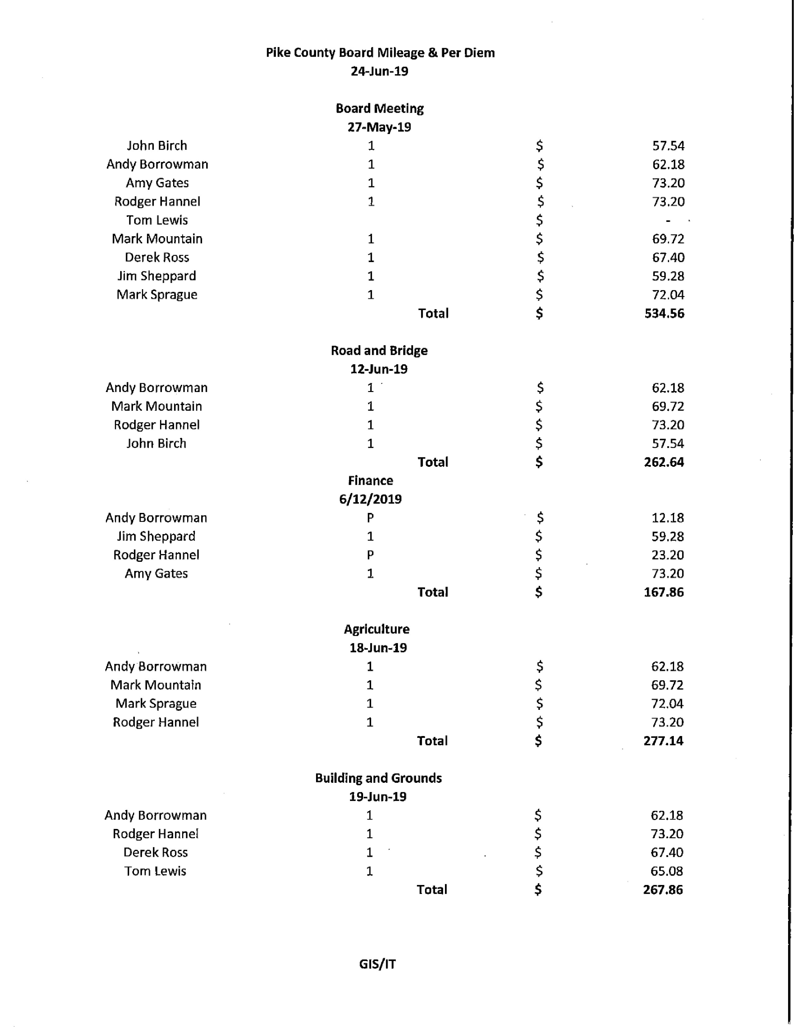
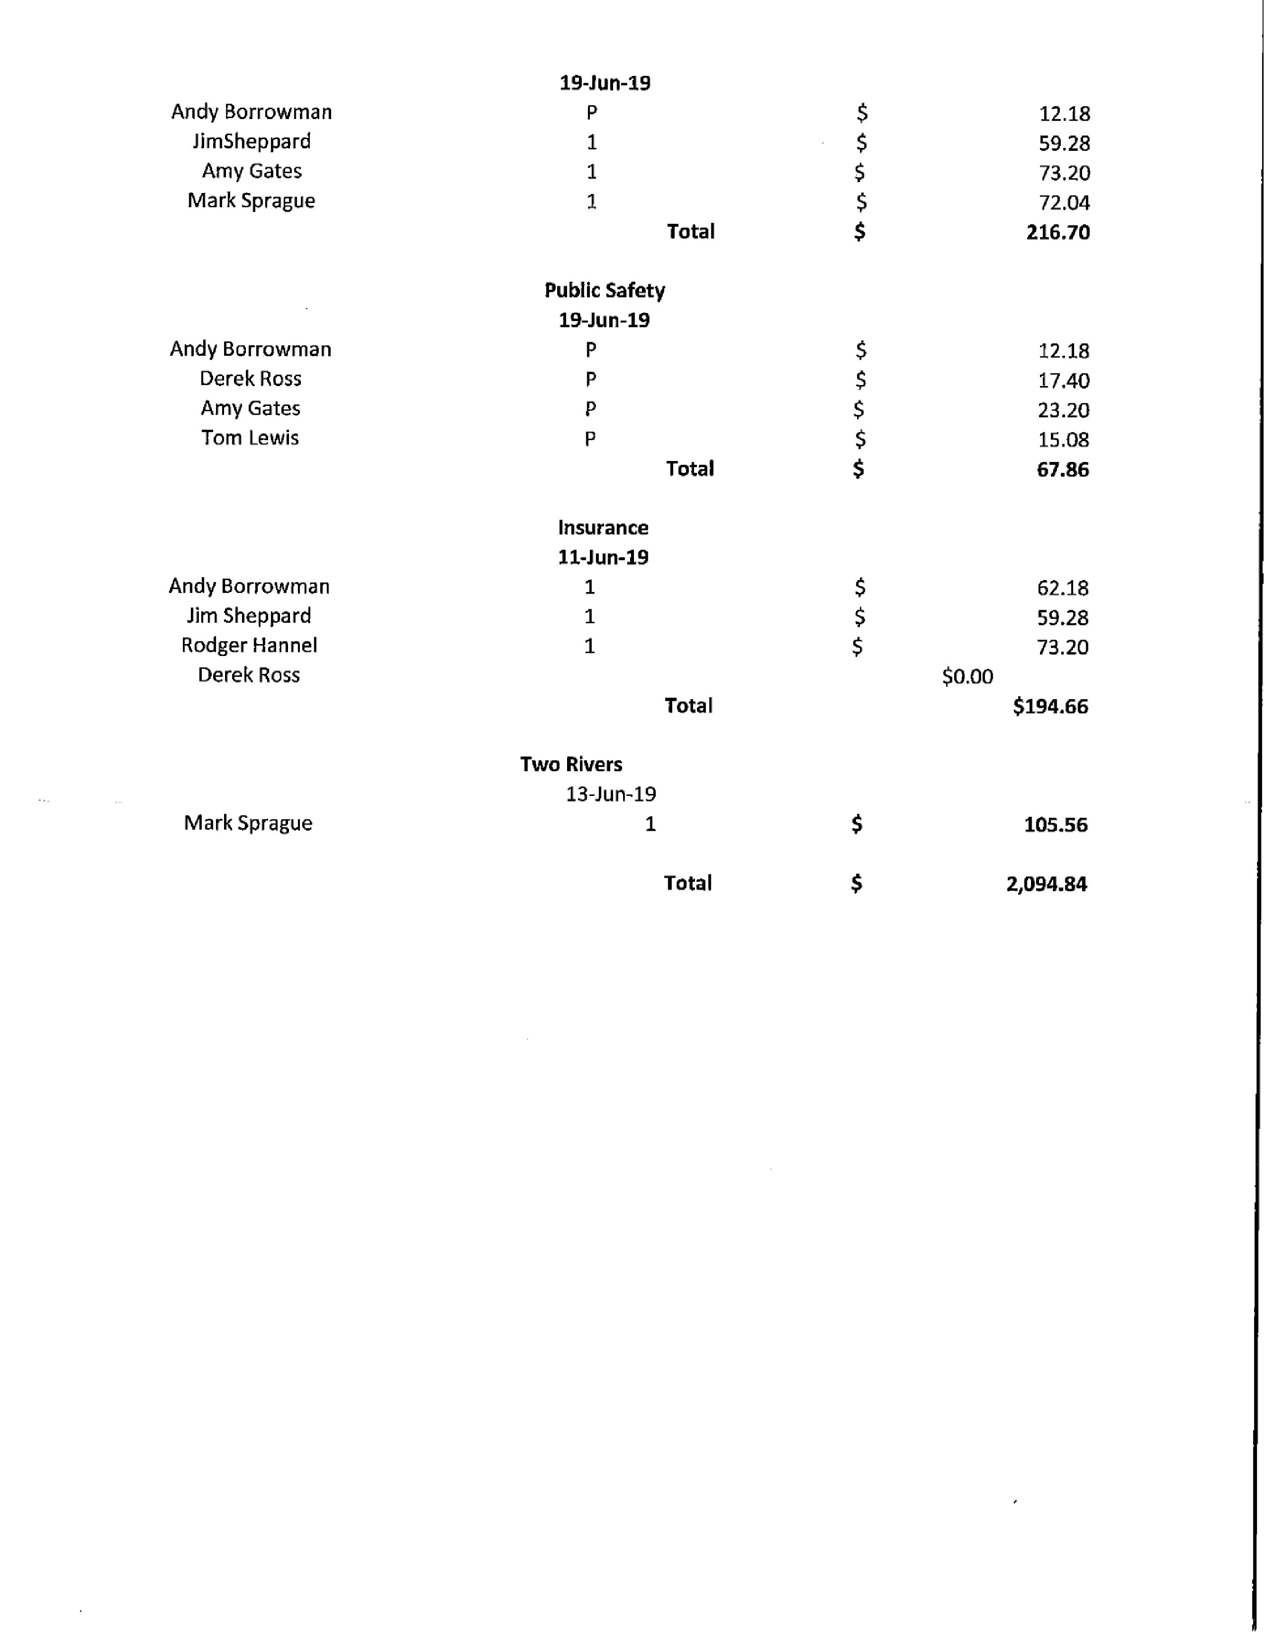
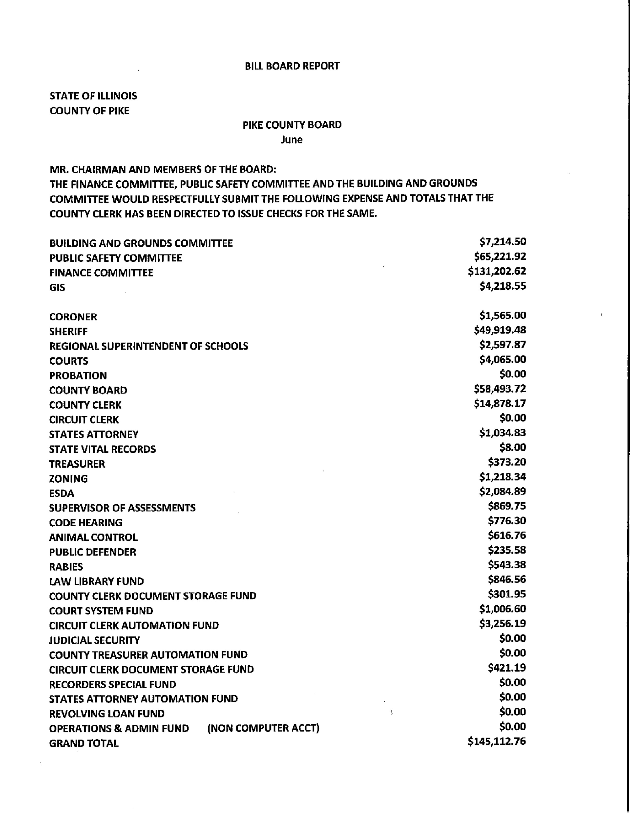

QUESTIONS FROM THE PRESS AND VISITORS
Mike Boren reminded the Board that 125 years ago the first cornerstone of the Courthouse was laid and inquired about commensuration plans?

Regina Johns thanked the board members and invited them all to a tour of the Stage Coach Inn prior to the scheduled public meeting. She has, is willing, and will continue to reach out to the neighbors to try come to a resolution.

ADJOURNMENT
Amy Gates made a motion to adjourn the meeting. Tom Lewis seconded. Voice vote 8-0. The meeting adjourned at 8:43 p.m.

