PIKE COUNTY BOARD MEETING MINUTES

May 29th, 2019

The regular monthly meeting of the Pike County Board was held on May 29th 2019 at 7:00 PM in the Pike County Courthouse by Chairman Andy Borrowman. Greg McClain gave the invocation and Chairman Andy Borrowman led the Pledge of Allegiance. Chairman Andy Borrowman asked County Clerk, Natalie Roseberry, to call the roll. Those answering the roll call were John Birch, Andy Borrowman, Amy Gates, Rodger Hannel, Mark Mountain, Derek Ross, Jim Sheppard and Mark Sprague.

APPROVAL OF MINUTES OF APRIL 22ND, 2019 PIKE COUNTY BOARD MEETING

Mark Sprague made a motion to approve April 22nd, 2019 Pike County Board minutes. Mark Mountain seconded the motion. Voice vote was 7-0 to approve.

APPROVAL OF MINUTES OF MAY 10TH, 2019 PIKE COUNTY BOARD SPECIAL MEETING

Rodger Hannel made a motion to approve May 10th, 2019 Pike County Board minutes. Mark Sprague seconded the motion. Voice vote was 7-0 to approve.

UPDATE FROM REGIONAL SUPERINTENDENT OF SCHOOLS JILL REIS
Jill Reis, ROE superintendent announced the retirement of Pike County’s current ROE supervisor, Judy Sutton on June 6th, 2019. She stated they have hired in her place and the replacement is currently training. She thanked the county for being proactive in truancy and its involvement in the education system. Ms. Reis also stated that the ROE is looking into a smaller building to save costs within Pike County.

ANNOUNCE THE RESIGNATION OF THE CURRENT PIKE COUNTY ZONING ADMINISTRATOR
Chairman Andy Borrowman read the resignation letter from current Zoning Administrator Fred Ruzich effective June 30th, 2019. Chairman Borrowman thanked Mr. Ruzich for his service to the county. Mark Mountain thanked Mr. Ruzich and stated that Mr. Ruzich did an excellent job and he will be hard to replace. Mark Sprague also thanked Mr. Ruzich and stated that he was very impressed with his service to the county. John Birch made a motion to accept Fred Ruzich’s resignation as Pike County Zoning Administrator. Amy gates seconded the motion. Voice vote 7-0. Resignation accepted.

APPOINTMENT OF NEW PIKE COUNTY ZONING ADMINISTRATOR
Chairman Andy Borrowman stated that Gregg Wyatt is in consideration for the position of Pike County Zoning administrator and would begin on July 1st. He stated Mr. Wyatt currently works in the field and is familiar with surveying and the duties of the office. Mark Mountain approved the appointment of Gregg Wyatt as the new Pike County Zoning Administrator. Mark Sprague seconded. Voice vote 7-0. Appointment approved.

ACTION ON PROPOSED ORDINANCE ESTABLISHING CIVIL FEES AND CRIMINAL AND TRAFFIC ASSESSMENTS TO BE CHARGED BY THE CLERK OF THE CIRCUIT COURT
This item was not addressed due to the ordinance not being entirely ready for action. This will be addressed in the June board meeting as the assessments aren’t effective until July 1st, 2019.

APPOINTMENT OF RICHARD HOOVER TO THE BAY CREEK WATERSHED CONSERVANCY DISTRICT BOARD FOR A FULL TERM OF 5 YEARS
Motion made by Mark Mountain to approve Richard Hoover to the Bay Creek Watershed Conservancy. Seconded by Rodger Hannel. Voice vote 7-0. Appointment approved.

APPOINTMENT OF LARRY MOORE AND LESTER VINCENT TO A 3 YEAR TERM EXPIRING ON THE FIRST MONDAY IN MAY 2022 TO THE HULL-KINDERHOOL FIRE PROTECTION DISTRICT AS TRUSTEES.
Mark Sprague made a motion to approve the appointments of Larry Moore and Lester Vincent to the Hull- Kinderhook Fire Protection District. John Birch seconded. Voice vote 7-0. Appointment approved.

APPOINTMENT OF LARRY SPENCER TO A 3 YEAR TERM EXPIRING ON THE FIRST MONDAY IN MAY 2022 TO THE NORTH PIKE FIRE PROTECTION DISTRICT AS A TRUSTEE.
Mark Mountain made a motion to approve Larry Spencer to the North Pike Fire Protection District. Mark Sprague seconded the motion. Voice vote 7-0. Appointment approved.

APPOINTMENT OF WAYNE BINGHAM TO A 3 YEAR TERM EXPIRING ON THE FIRST MONDAY IN MAY 2022 TO THE RURAL GRIGGSVILLE FIRE PROTECTION DISTRICT.
John Birch made a motion to approve Wayne Bingham to the Rural Griggsville Fire Protection District. Mark Mountain seconded the motion. Voice vote 7-0. Appointment approved.

APPOINTMENT OF JEFF HART AND RICHARD SYRCLE TO A 3 YEAR TERM EXPIRING ON THE FIRST MONDAY IN MAY 2022 TO THE BARRY FIRE PROTECTION DISTRICT
Rodger Hannel made a motion to approve Jeff Hart and Richard Syrcle to the Barry Fire Protection District. Amy Gates seconded. Voice vote 7-0. Appointment approved.

APPROVAL OF LESLIE HENRY TO THE PIKE COUNTY HOUSING AUTHORITY FOR A TERM TO EXPIRE JUNE 30TH, 2021
Mark Mountain made a motion to appoint Leslie Henry to the Pike County Housing Authority Board. Mark Sprague seconded. Voice vote 7-0. Appointment approved.

APPROVAL OF DIANNA CASTLEBERRY TO THE PIKE COUNTY HOUSING AUTHORITY FOR A TERM TO EXPIRE ON JUNE 30TH, 2024
Rodger Hannel made a motion to appoint Dianna Castleberry to the Pike County Housing Authority Board. Mark Mountain seconded. Voice vote 7-0. Appointment approved.

COMMITTEE REPORTS
Finance

The finance committee of the Pike County Board met at 5:00 p.m. on May 8th, 2019 in the conference room of the Pike County Government building. Members present were Amy Gates, Rodger Hannel, Jim Sheppard and County Board Chairman Andy Borrowman. Also present were Scott Syrcle, Anita Andress, Don Beard, Zack Boren, Frank McCartney, David Greenwood and Natalie Roseberry. On a motion by Rodger Hannel and second by Amy Gates routine bills in the amount of $106,614.07 were approved for payment. Judge Frank McCartney was present to discuss funding avenues for courthouse security. Given the financial strains that the general fund is currently under is was explained that we cannot pay for this addition from that source. Judge McCartney stated that he would work on a proposal that would shift enough expenses from the general fund to other funds to free up monies to pay for most if not all of the cost of the construction of the project. Natalie Roseberry informed the committee that she would be looking into some fees within the County Clerk’s office that might be raised to put us more in line with other counties. We then moved to the issue of the monies owed to the county by the Health Department. Those funds are due to the employer’s share of the health insurance. There was a discussion about money that had been paid to the liability insurance fund for premium in the past. The idea of forgiveness of some of the money for the liability insurance was discussed. The committee thought that it would be a good idea to formalize and agreement between the two entities about this. WE discussed the continued issue of funds at the Sheriff’s department. While we are making progress there is more work to do in this area. Meeting adjourned at 6:22 p.m. on a motion by Amy Gates and a second by Rodger Hannel.

Amy Gates made a motion to approve the finance committee minutes. Seconded by John Birch. Voice vote 7-0. Minutes approved.

Highway

The Road and Bridge Committee met Wednesday, May 8th, 2019at 3:30 p.m. at the County Highway Department. The meeting was called to order at 3:30 p.m. Those in attendance were Rodger Hannel, Mark Mountain and Any Borrowman. John Birch was absent. Others in attendance were Chris Johnson. Pike County Engineer. There was no public comment. A motion was made by Mark Mountain seconded by Rodger Hannel to pay claims per claim reports dated May 8, 2019. All in favor. Motion Carried. There was not closed session. A motion was made by Mark Mountain and Seconded by Rodger Hannel to raise the boot allowance to $150.00 per year for safety or steel toe boots. The survey of the Highway Department property has been completed. The County Engineer will contact the landowner and discuss purchasing the neighboring property. No new business. Old business was the County Engineer received information which indicates the State Match Funds received annually in the sum of $173,431.00 will be lowered to $113,000.00, representing $60,000.00 less this year. A motion was made by Mark Mountain seconded by Rodger Hannel to adjourn meeting at 4:06 p.m. Motion carried.

Jim Sheppard asked if anyone knew why the state contribution on the Match Funds was $60,000 less. There was no one present from the highway department to answer the question. John Birch made a motion to approve the minutes. Derek Ross seconded. Voice vote 7-0. Minutes approved.

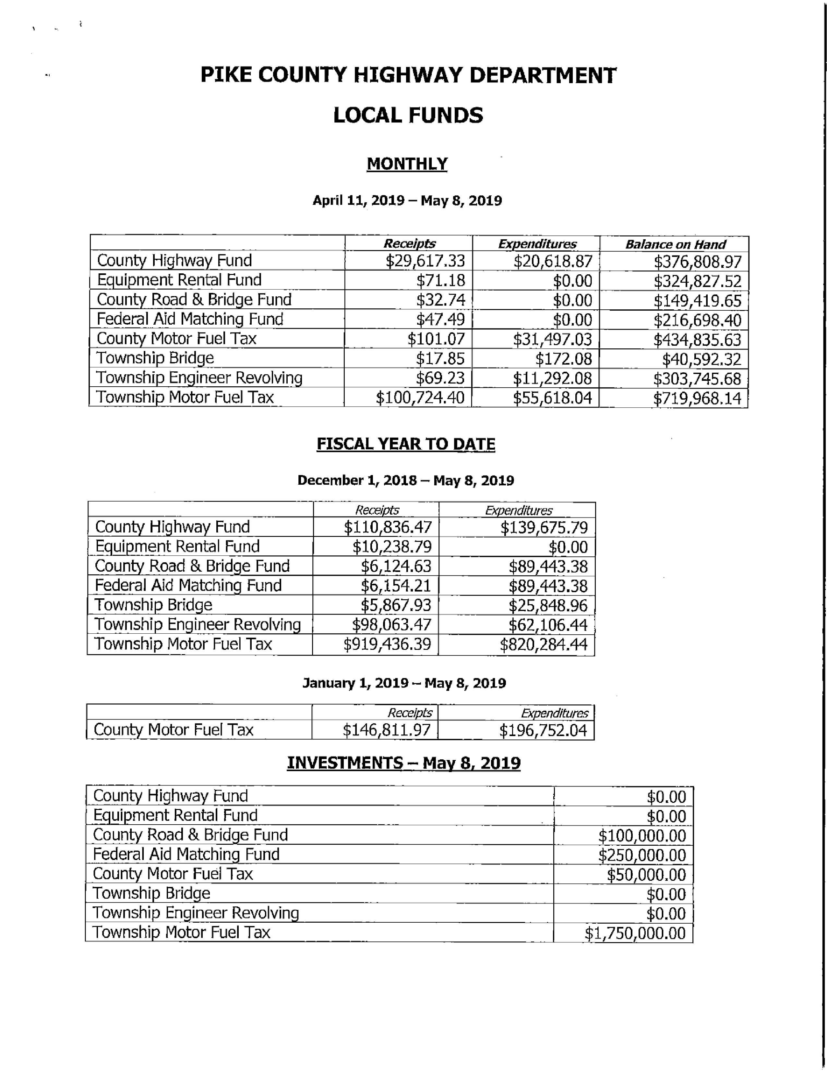
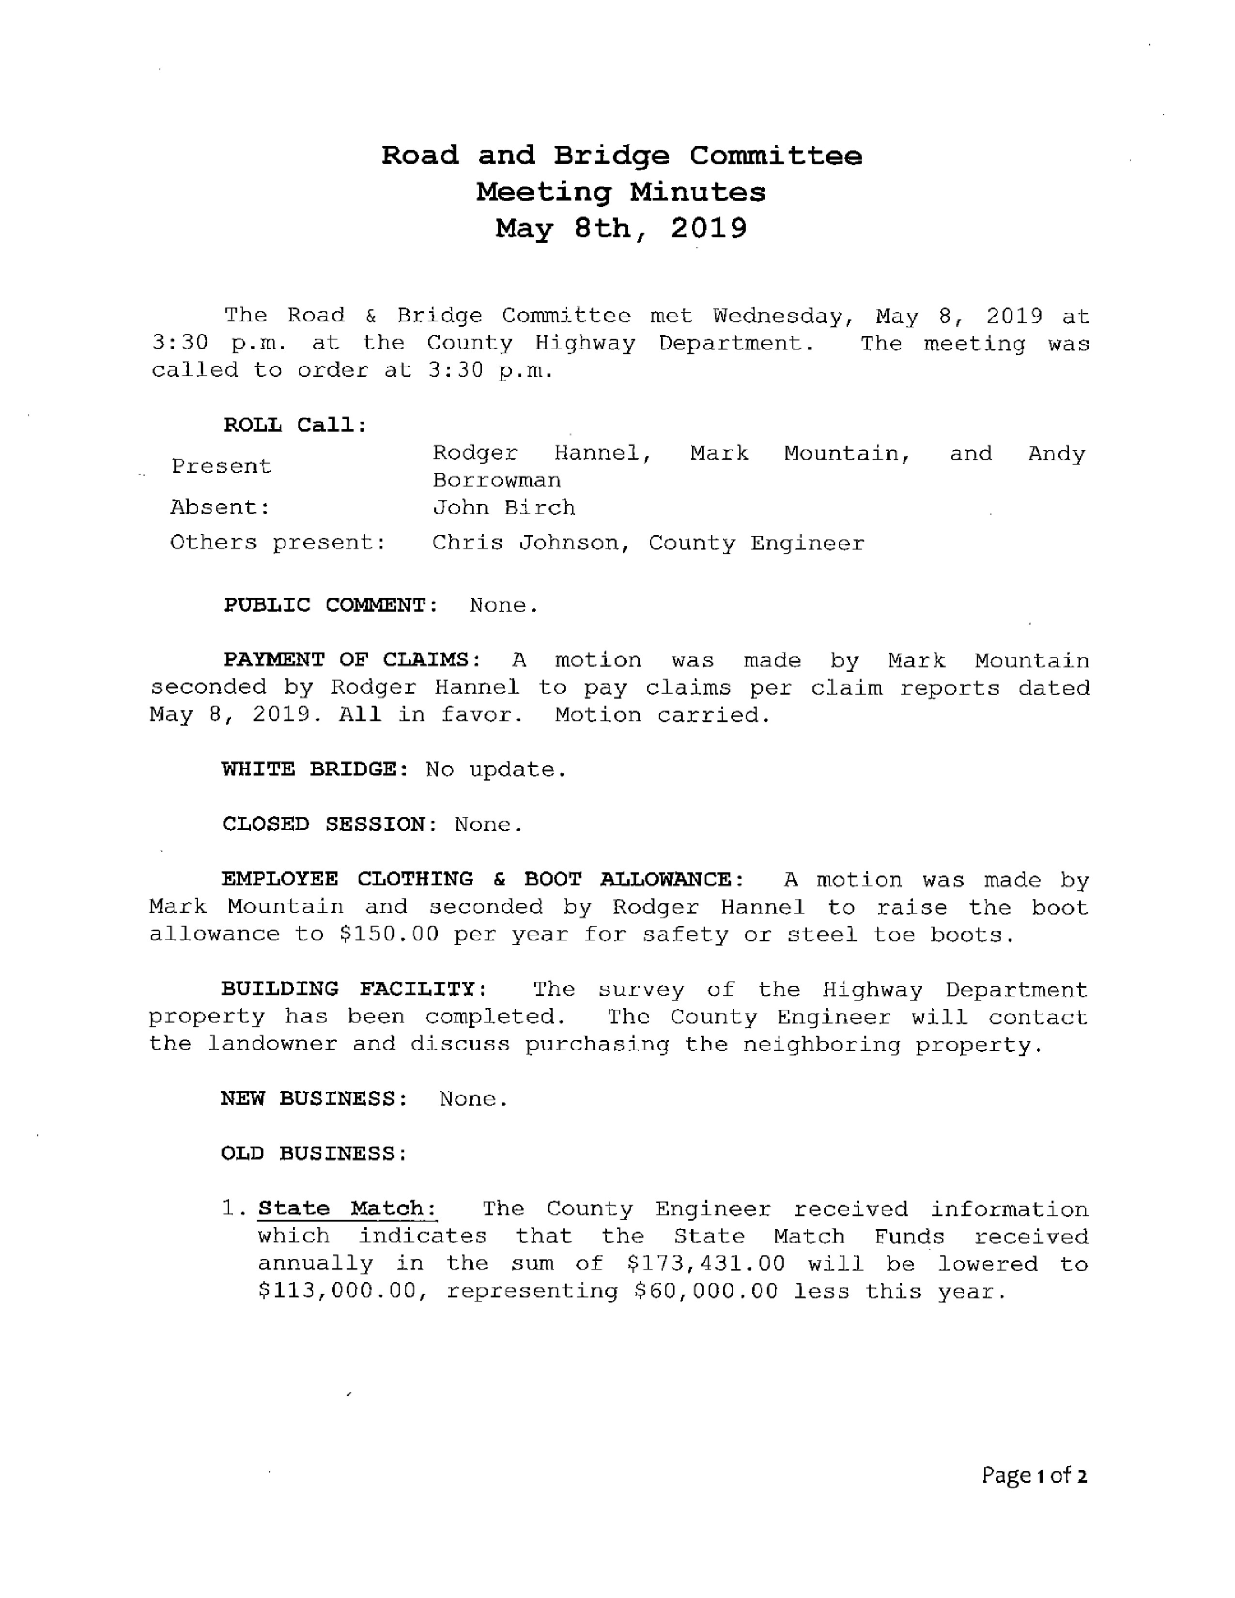
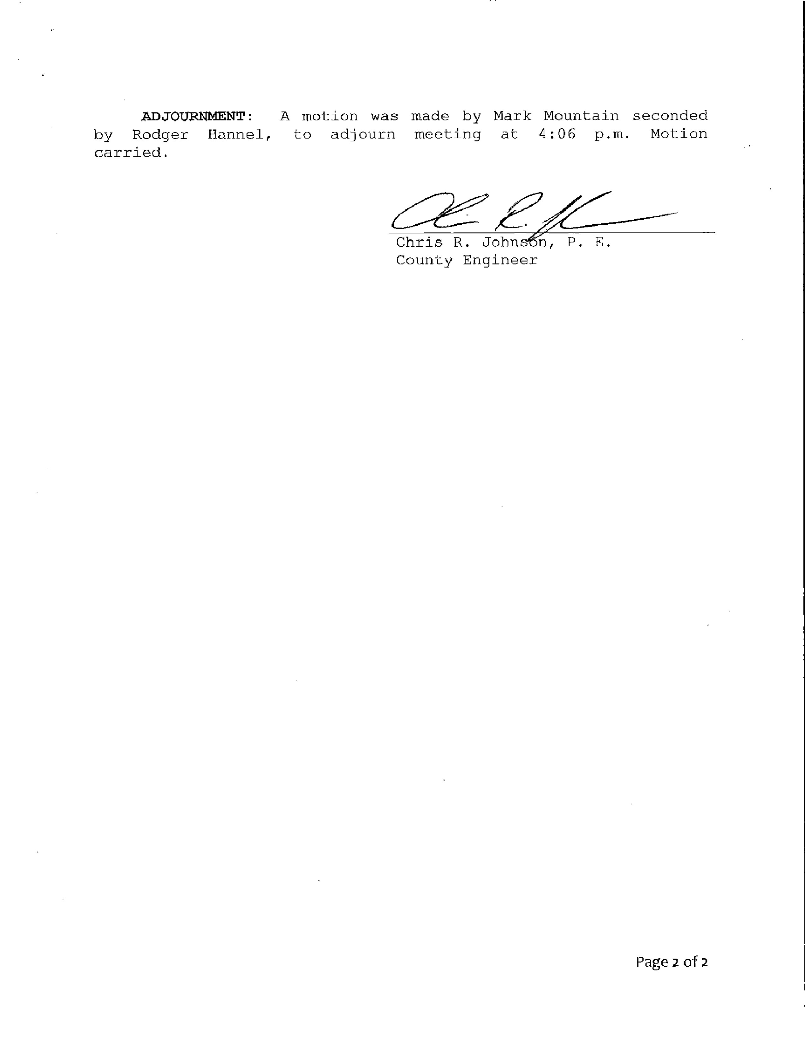
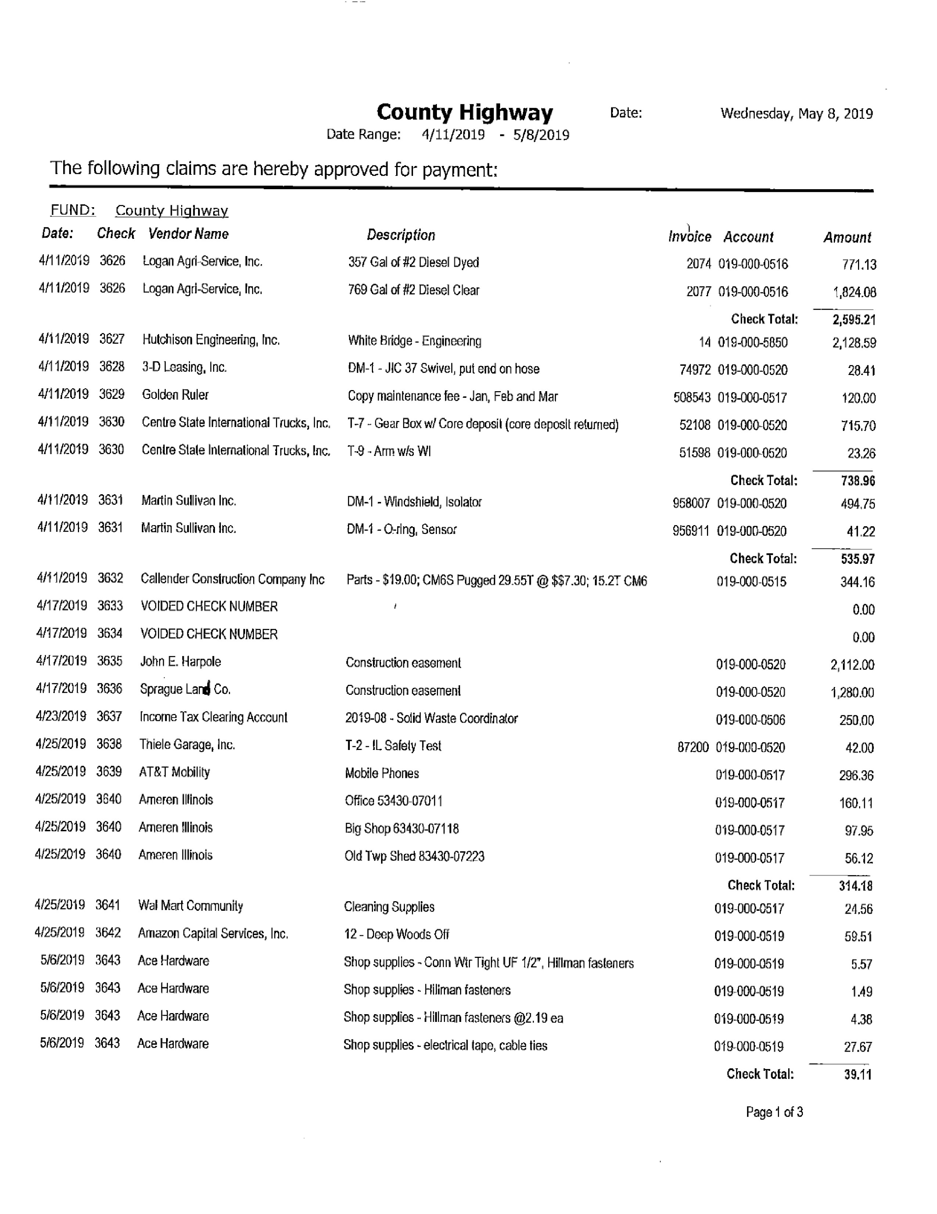
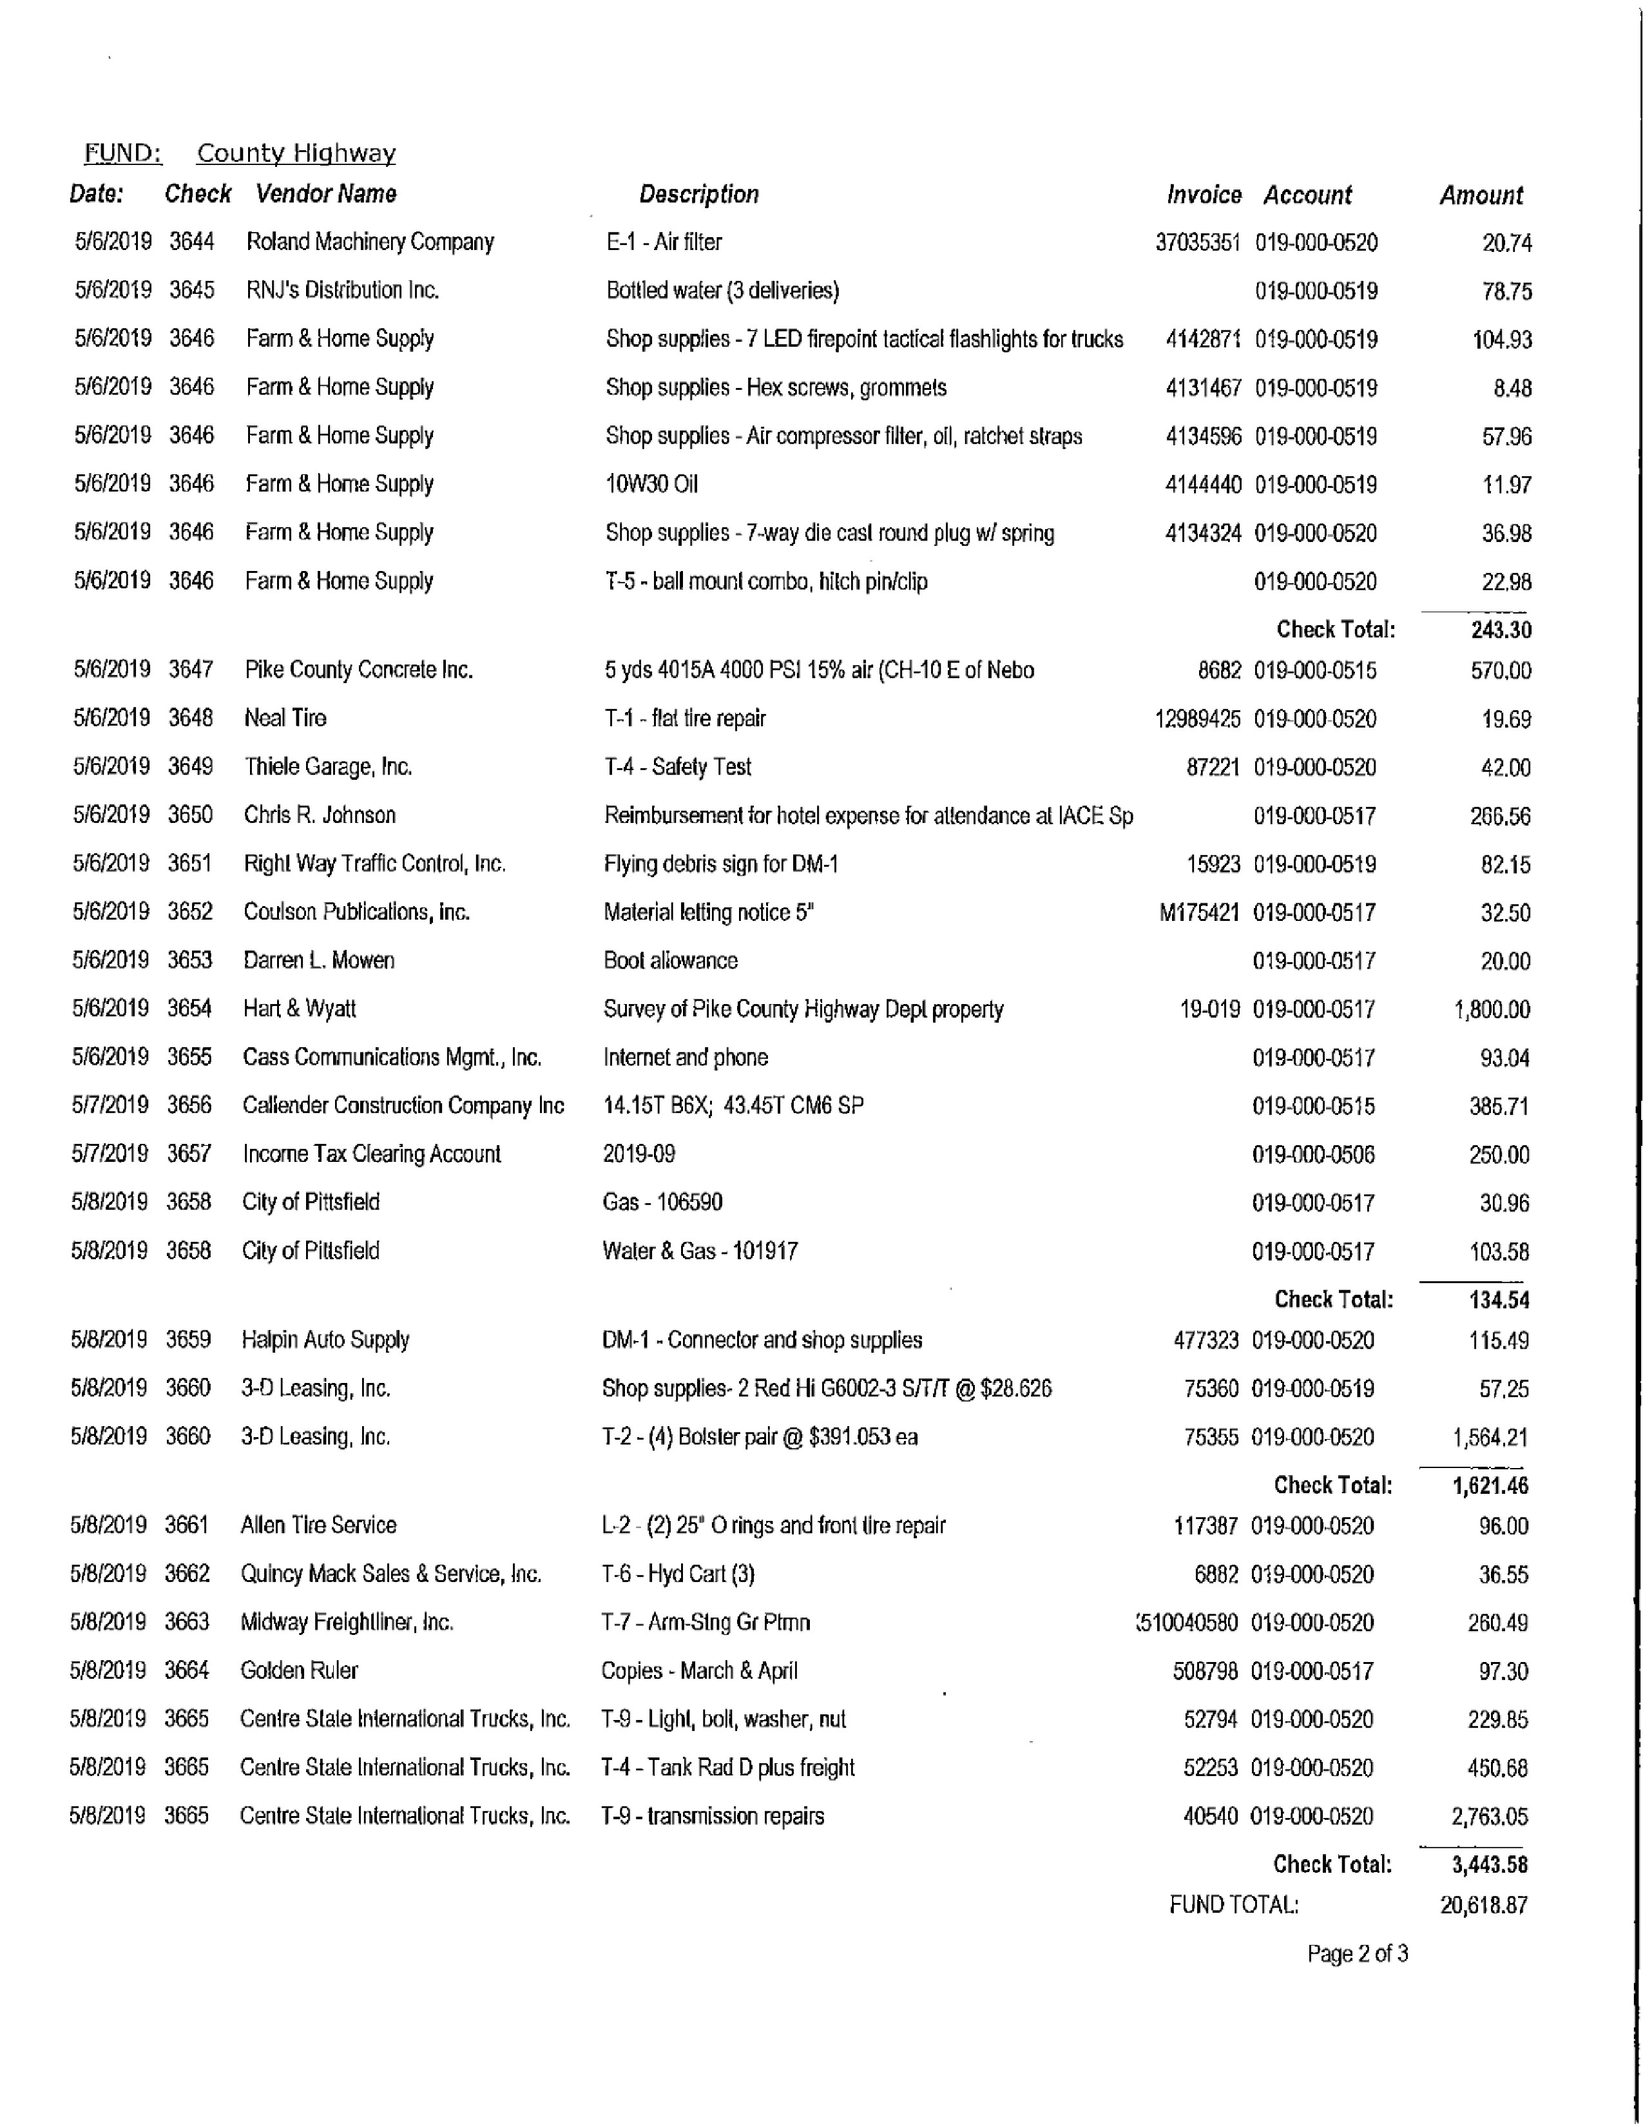
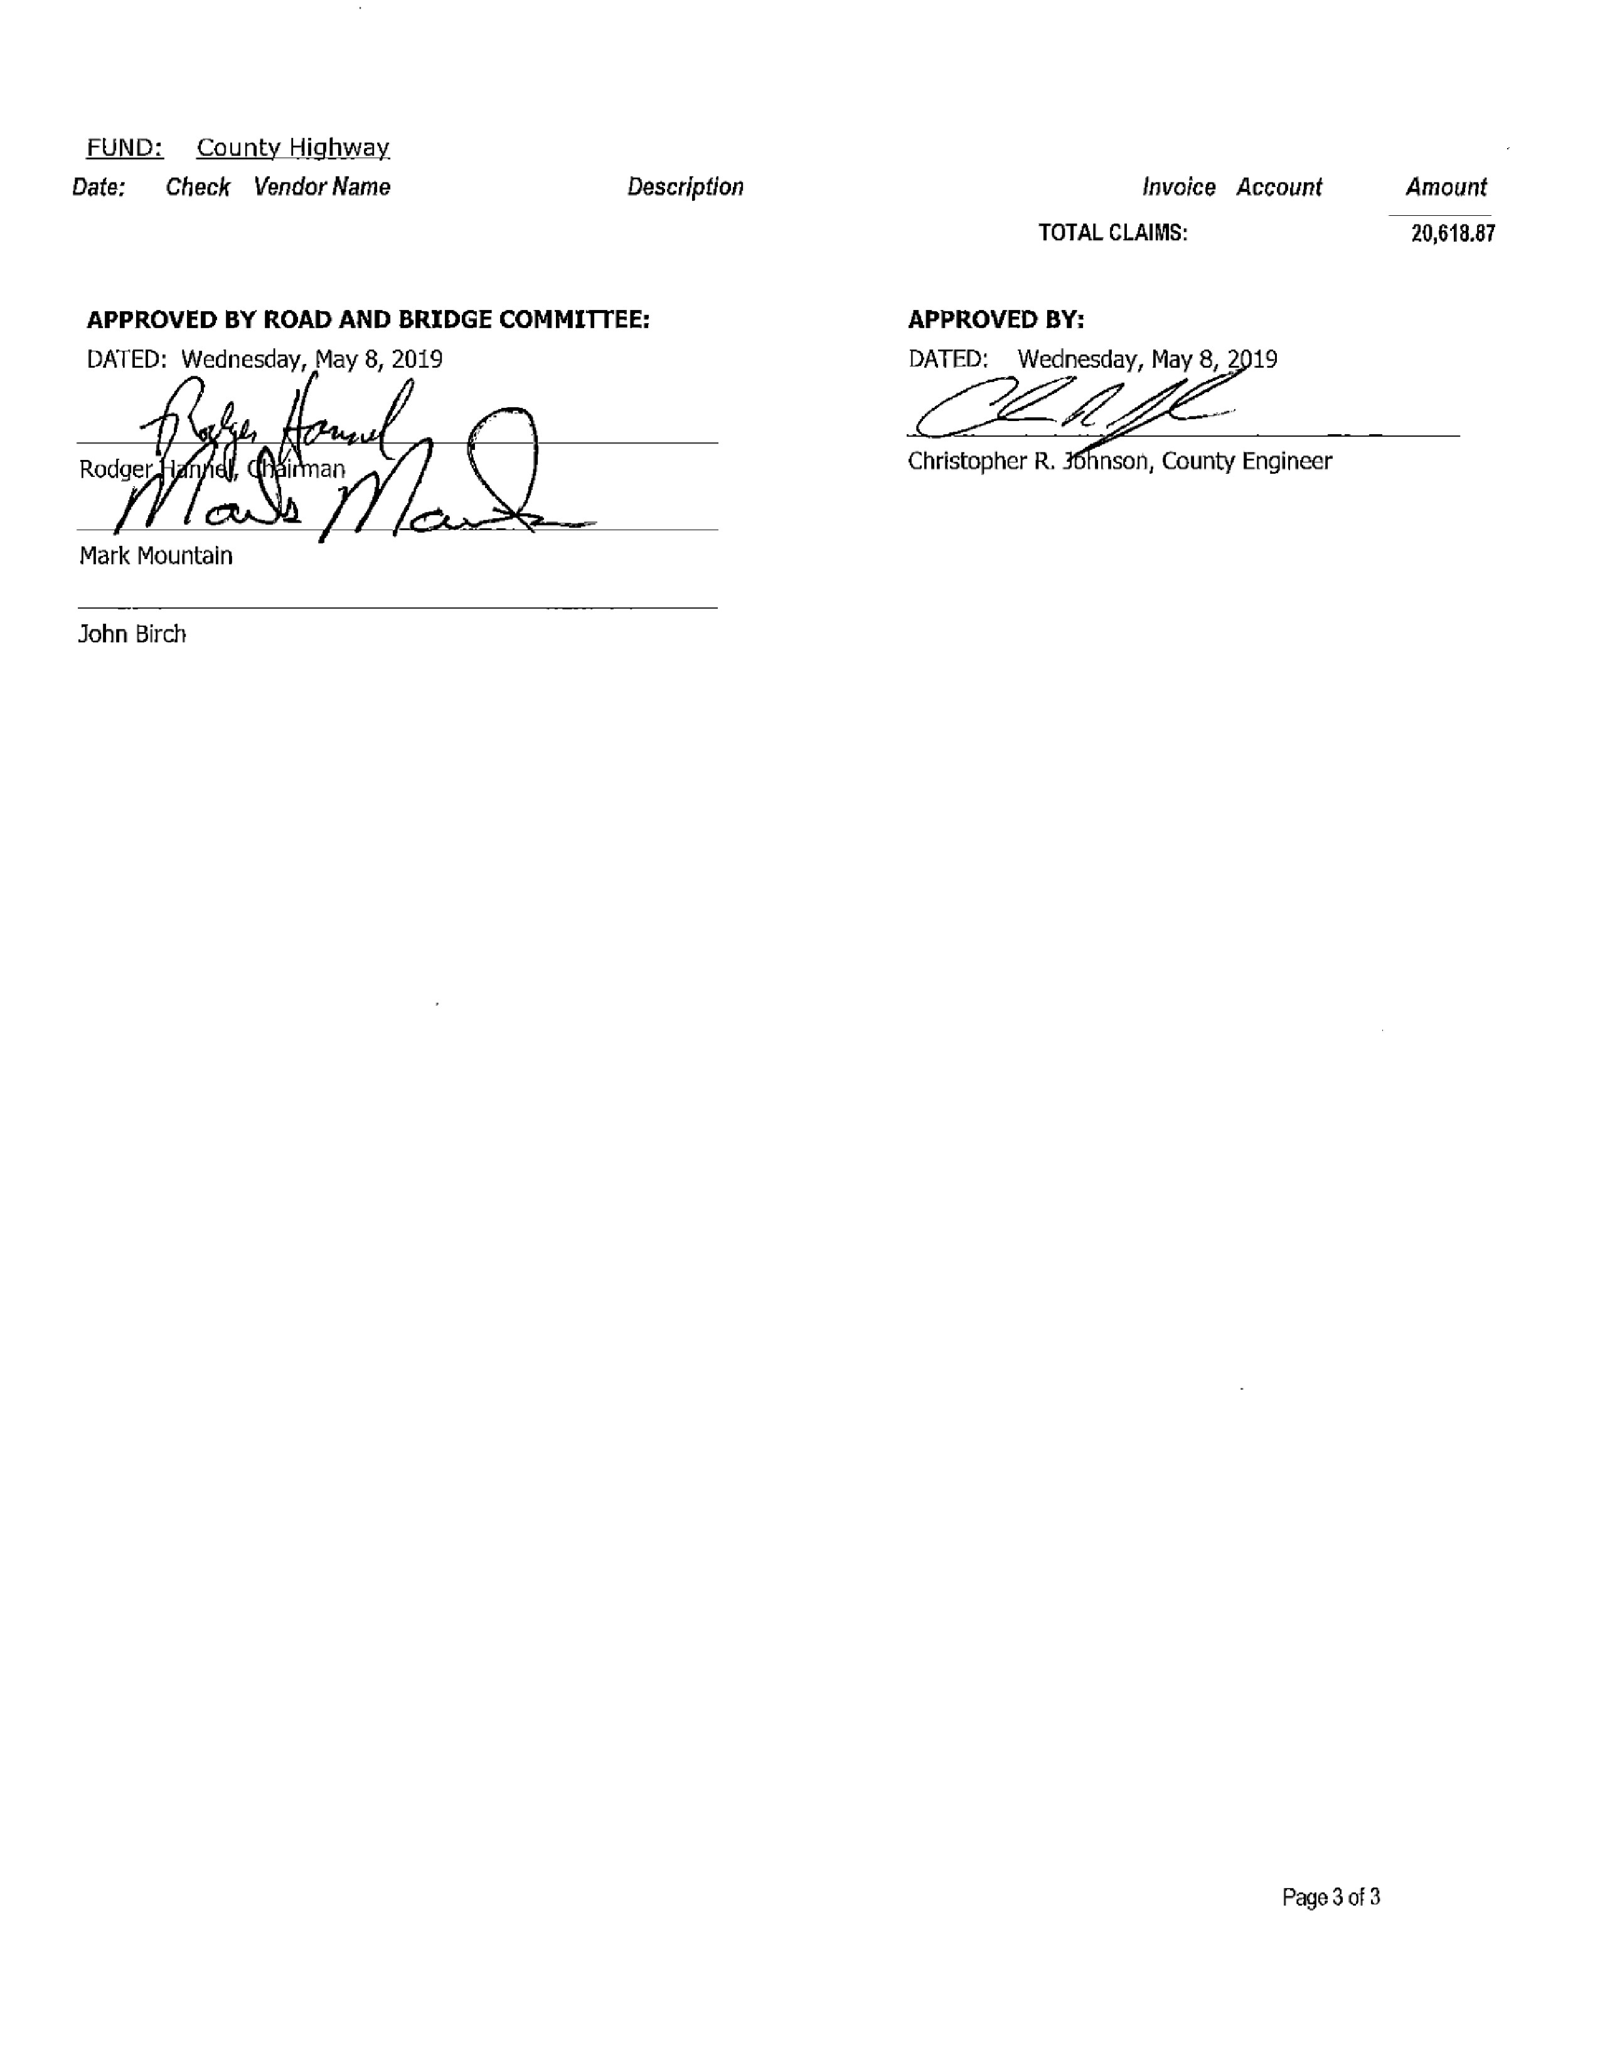
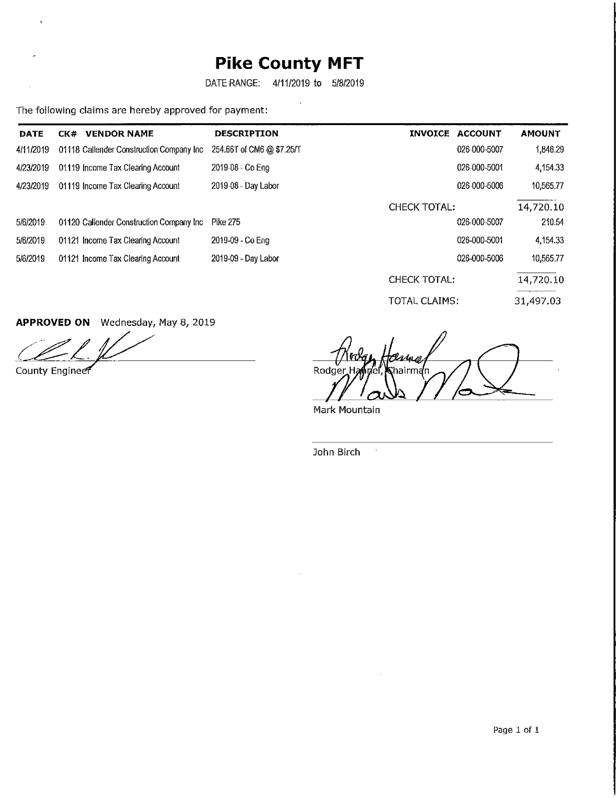

Building and Grounds

The Building and Grounds Committee met on Wednesday, May 15th, 2019 at 3:30 p.m. Present were Tom Lewis, Rodger Hannel, Andy Borrowman, Derek Ross, Natalie Roseberry, Frank McCartney and David Greenwood. Absent was Darwin Feenstra. Judge Frank McCartney and Sheriff David Greenwood were present to update the committee on the Courthouse Security proposal. Judge McCartney presented a letter to the B & G Committee that describes a financial commitment from Judge McCartney and County Clerk Bryce Gleckler to help fund paying for the Courthouse Security project up to $70,000.00 per year. Judge McCartney, David Greenwood and Bryce Gleckler will be present at the County Board meeting on May 29th, 2019 to explain how these funds could be used to help the County pay for the project. Derek Ross made a motion to recommend to the full Pike County Board to consider Judge McCartney and Gleckler’s proposal to fund the $380,000.00 security project. Tom Lewis seconded the motion, and it passed. Sheriff David Greenwood informed the B & G committee that the roof on the south side of the Courthouse needs to be repaired on the underneath soffit part of the roof. Tom Lewis made a motion to approve the repairs, and Derek Ross seconded the motion. The motion passed. Also, Sheriff Greenwood mentioned that on the northwest side of the courthouse an area has recently been washed out near the sidewalk. The inmates will be used to fill it in. Natalie Roseberry mentioned that she recently found $25.00 in cash and a few old checks that were used to get specs for the remodeling in 2008 of the Annex building. Tom Lewis made a motion to close out this old account, and a second was made by Derek Ross. The motion passed. Derek Ross mentioned that Two Rivers will probably just repair the Pittsfield Outreach building. He informed the B & G committee that the parking lot near the Outreach building is owned by Pike County. Derek wanted to know fit he county would want to donate this parking lot to Two Rivers since it really has little benefit for the county to own and maintain, since the county doesn’t use it. No decision was made after some discussion on what to do about this parking lot. Tom Lewis made a motion to adjourn the meeting at 4:30 p.m., with a second by Derek Ross. The motion passed.

An amendment to the minutes included a motion by Tom Lewis to pay routine bills in the amount of $23,711.46 and seconded by Derek Ross. Motion passed.

Discussion was held regarding the proposed courthouse addition regarding security. Judge J. Frank McCartney stated the he appreciates the board being pro-active instead of re-active regarding the consideration of security. He believes that the situation isn’t if something happens it is when something happens, which promotes the need for higher security measures. He stated the proposed structure would cost between $350,000 and $380,000 and the funds that would subsidize the general fund payments would be the Probation Services Fund which he controls as Chief Judge, the Circuit Clerk Document Storage Fund and the Circuit Clerk’s Automation Fund that Bryce Glecker controls as Circuit Clerk. These funds would pay more employees’ salaries over a period of years to pay for the new addition of security. He stated while the funds cannot pay directly for courthouse security, there is nothing improper about using them for salaries.

Mark Mountain expressed clarification on these dedicated funds and addressed that they were not general county funds. He also expressed concern that the discussion of safety should be a closed session discussion.

Noue Filbert submitted a letter to each board member in opposition of the addition to the structure of the current Courthouse. She did research in the short amount of time that she was made aware of the potential addition and found many other solutions. She believed that this was a quick decision and she just found out about it a week prior. She vehemently opposes changing the structure of the historic building.

Rodger Hannel stated that security of the courthouse has been looked at for many years and the motion that was recommended from Building and Grounds was a motion for the “full board to consider.”

Mark Mountain thanked the Building and Grounds committee for their hard work on this and sometimes these committees and the board are faced with difficult decisions.

Architect Joe Petty was present and stated that they went through multiple scenarios to secure the courthouse within the “original footprint” of the building and it just wasn’t possible. He stated that any changes to a historical building regarding architecture must be approved by the Illinois Historical Preservation Society. He preemptively submitted the building plan a few weeks ago to the society and has not heard back from them at this time.

Walker Filbert also presented a letter to each board member in opposition of the addition to the courthouse. While he values security and safety, he believes this addition would change the integrity of the building. He, being a prior member of the county board, appreciates the tough decisions that are brought to them. However, he believes that at least, this issue needs to go through finance because it will affect the budget that has already been passed for this fiscal year. He stated that he has practiced law in multiple courthouses and counties and in house security is possible instead of building an outside addition.

Derek Ross stated that the board began considering this because of pending legislation on courthouse security. He stated that this has not been passed yet and it still is a process. He appreciates the dialogue about this but without knowing what the state mandates on security are, or are going to be, these are just ideas.

Buddy Crowder asked how much space was needed for in house security to exist without adding to the structure.

Mr. Petty explained that currently there would be space for 8 people and the idea would be to accommodate 30 people for high traffic court days. There is just no space in the main north entrance for this due to heating and air and the private door that leads into the State’s Attorney’s office.

The Pike County State’s Attorney mentioned the possibility of bolting his door shut and Mr. Petty said it is a width issue and that would not alleviate the problem.

Buddy Crowder questioned that since everyone is concerned with the security, why was the previous metal detector removed?

Sheriff Greenwood stated that it was old and is not in perfect working order.

Jim Sheppard also said that the county couldn’t afford to staff the previous metal detector. He elaborated and said while there is a proposed plan to pay for the structure what is missing is the counties responsibility of the salaries that it will take to staff the security. He believes that this could be an annual expense to the general fund of $50,000 to $100,000 that has not been discussed and is not allocated for.

Noue Filbert asked about the potential for contracting out the entire security to a company that will maintain and be “boots on the ground.” Judge McCartney stated he believed this could be looked into.

Chairman Borrowman addressed the County Board and asked where they would like to go from here. Jim Sheppard stated that this needs more discussion and needs to be sent back to Building and Grounds for more consideration and for the public to be able to speak their mind. Mark Mountain Agreed.

Jim Sheppard made a motion to return the proposal back to the Building and Grounds committee. John Birch seconded. Voice vote 7-0. Motion passed.

Chairman Andy Borrowman thanked all of those who attended to speak their opinions on this proposal.

Amy Gates stated that no one has discussed the possible 3rd option. She stated that if we are looking at spending this kind of money would it be worth considering building an entirely new structure that would house all government offices. This courthouse was built without many to date considerations and some things cannot be circumvented. She stated this isn’t the building for a secure judicial area.

Chairman Andy Borrowman stated that the Building and Grounds committee will discuss this matter further on June 19th, 2019 at 3:30 p.m. in the conference room of Government Building.

Jim Sheppard made a motion to approve the amended Building and Ground committee minutes. Seconded by John Birch. Voice vote 7-0. Amended minutes approved.

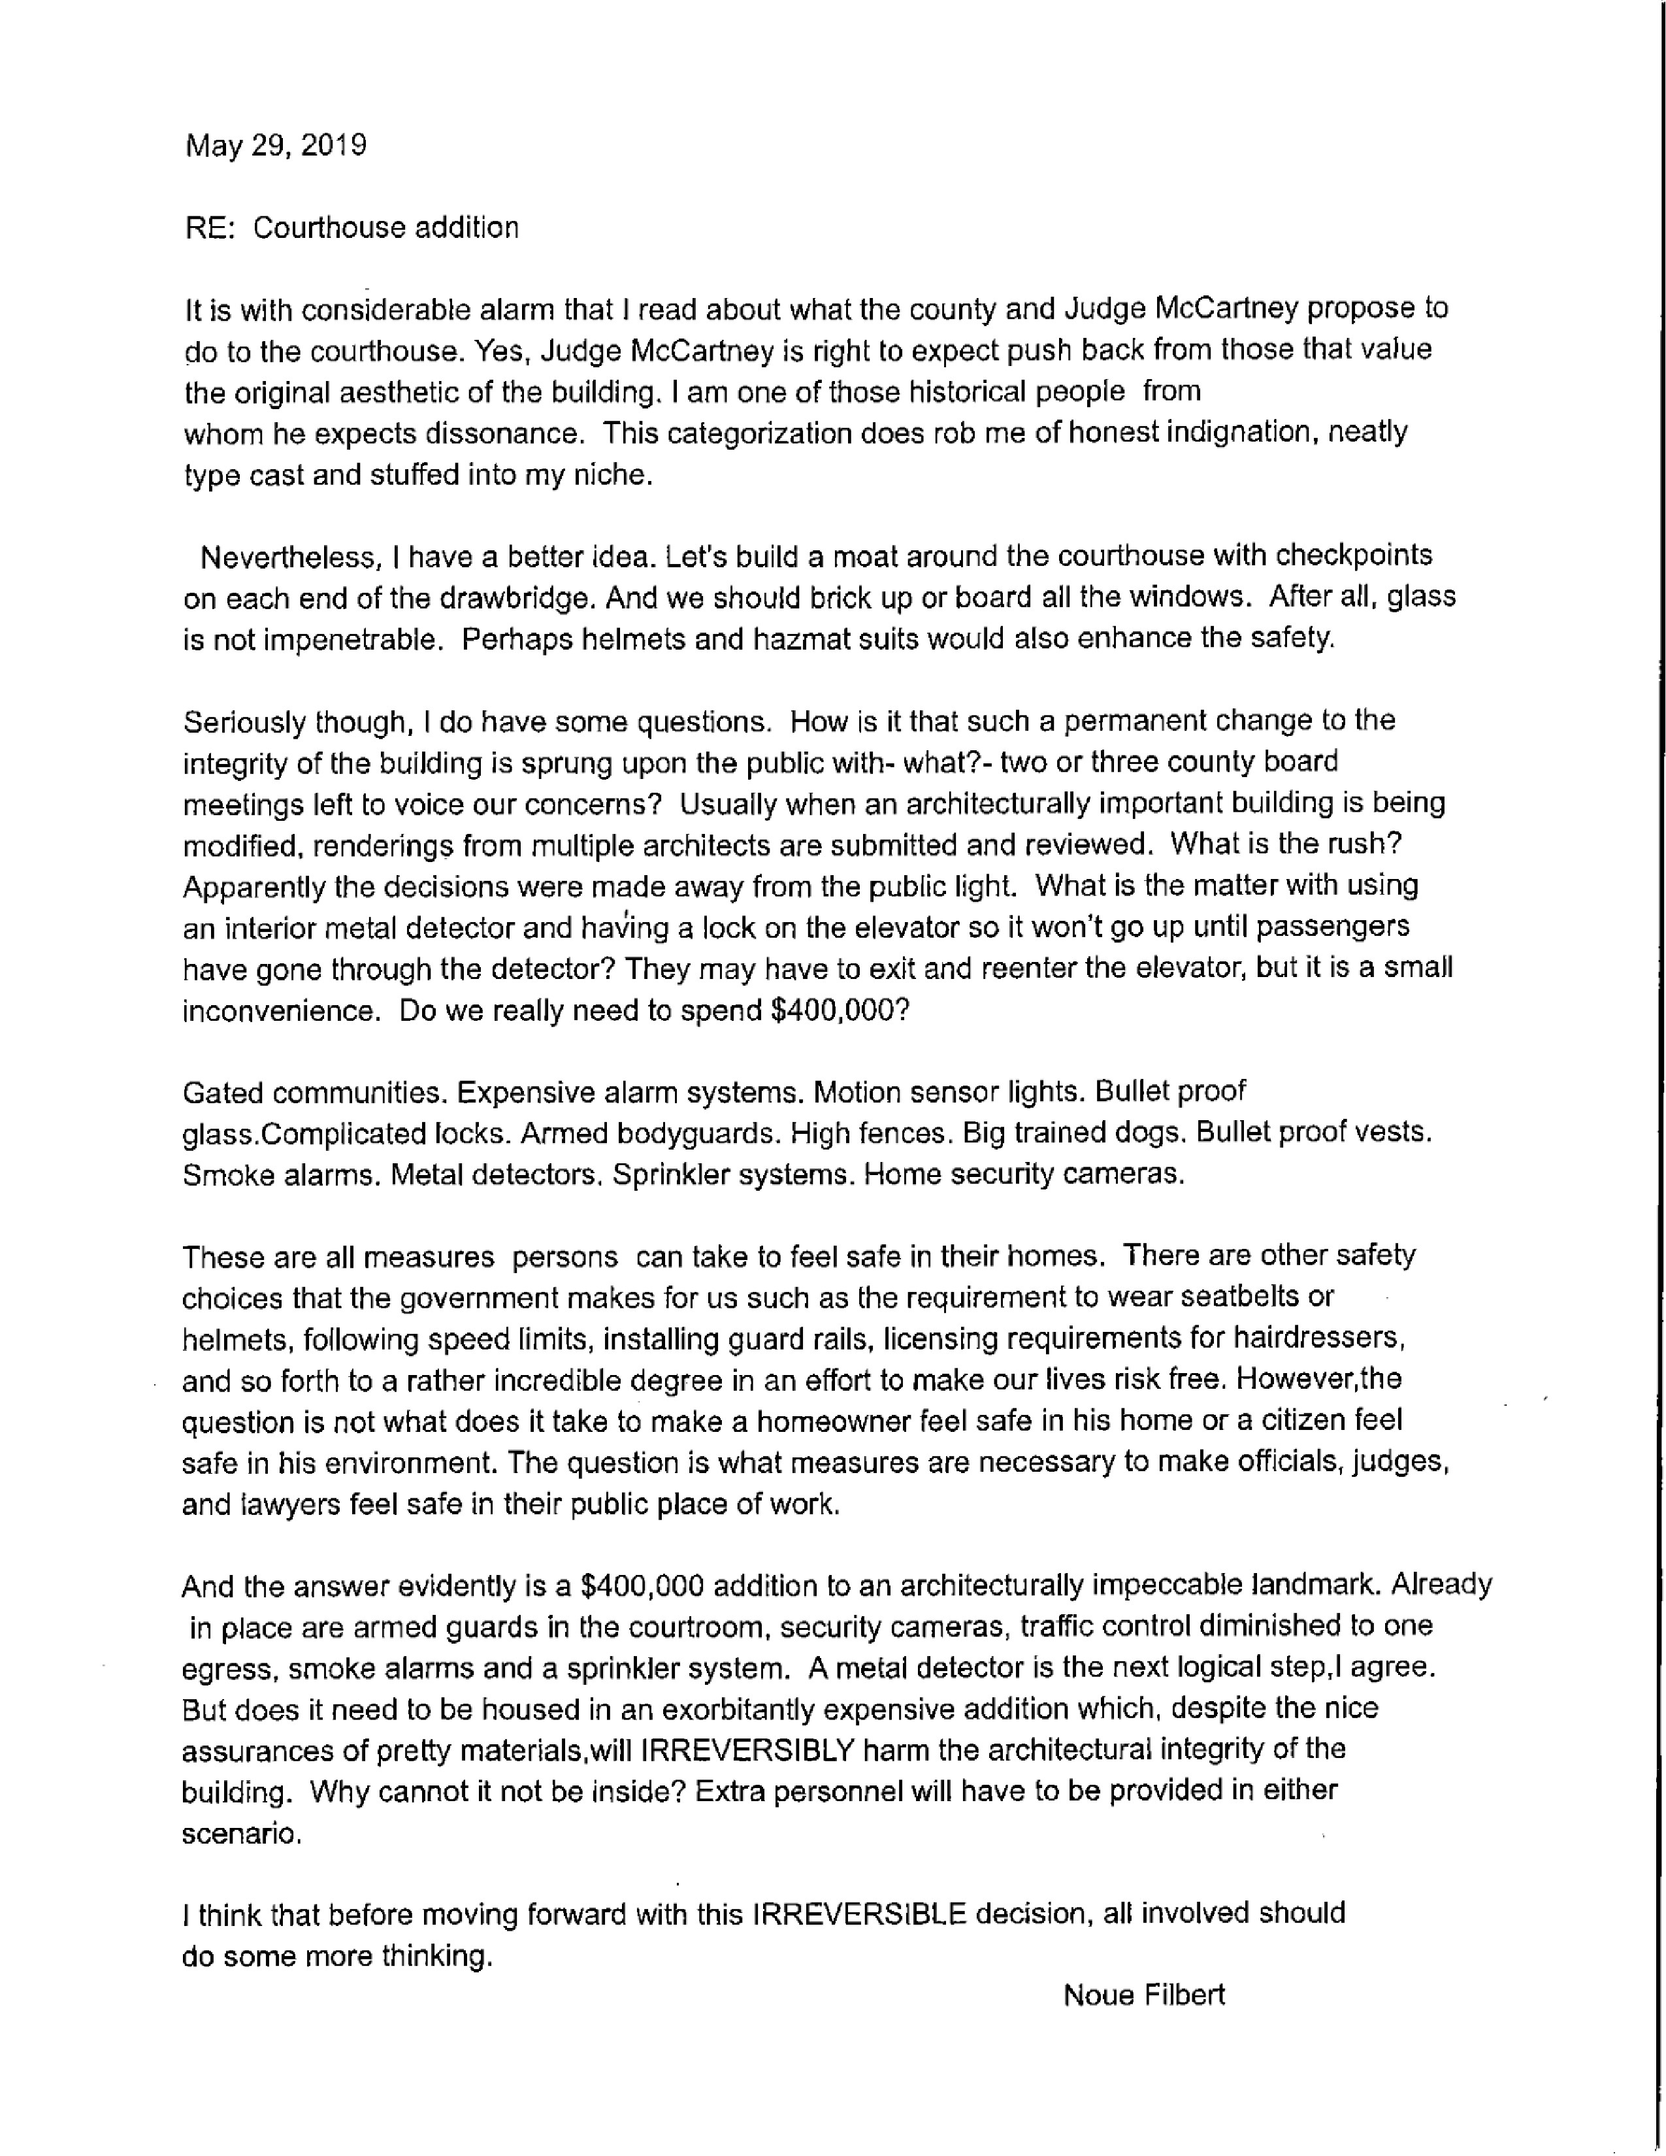
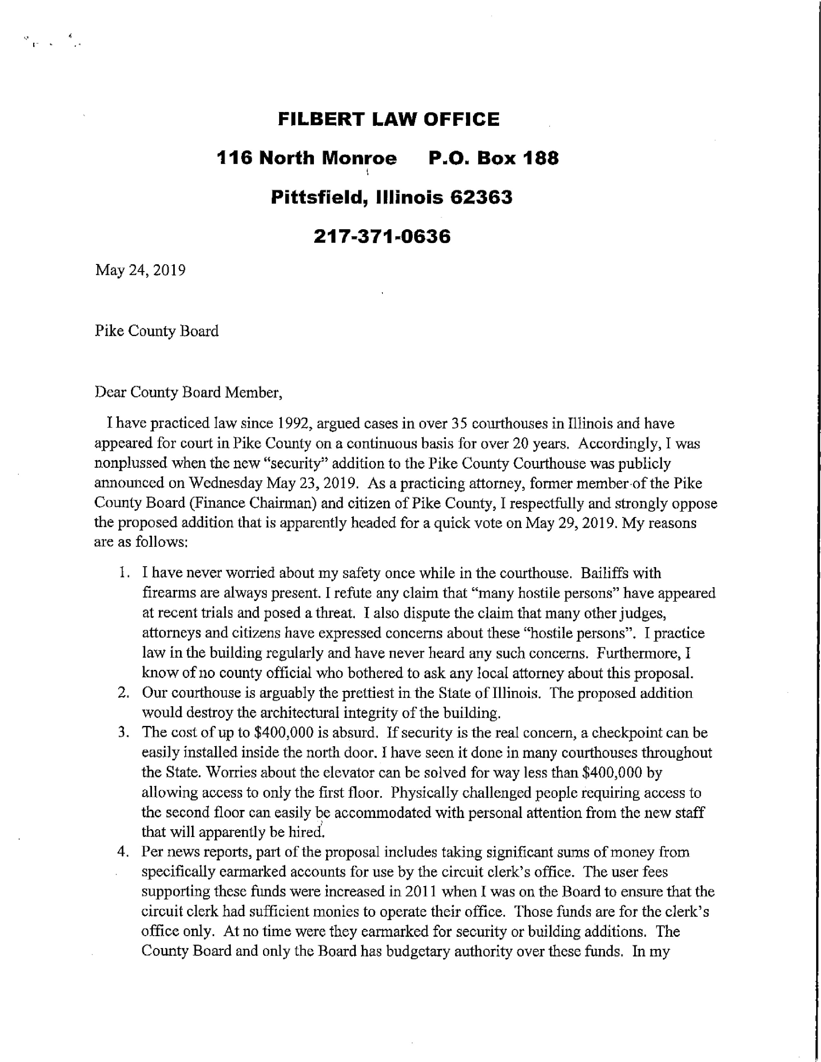
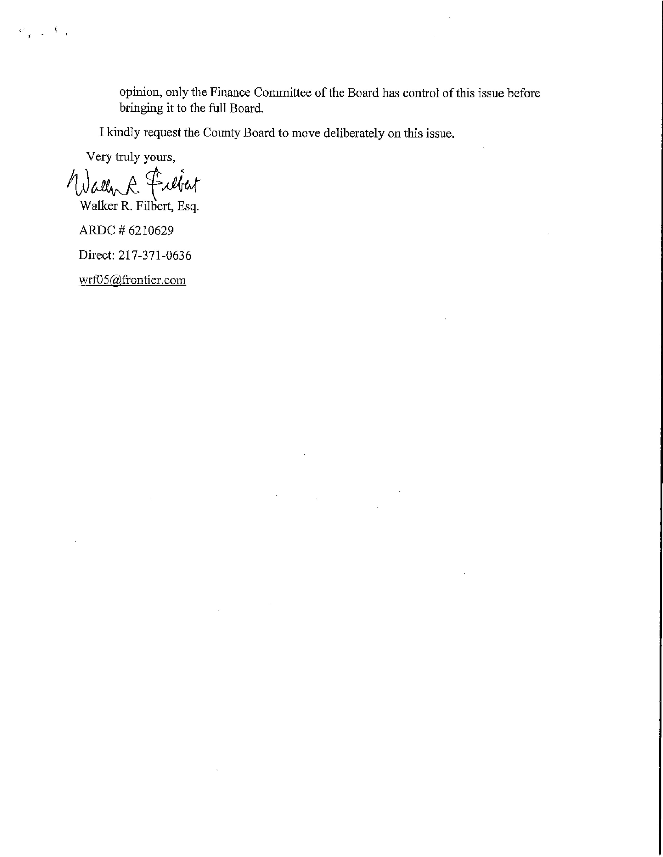

GIS/IT

The GIS/IT committee of the Pike County board met at 5:00 p.m. on Wednesday, May 15th, 2019 in the Emergency Operations Center of the Pike County Jail. Those present were; Paula Dean, Natalie Roseberry, Judge J. Frank McCartney, Mark Sprague, Jim Sheppard, Board Chairman Andy Borrowman and Sandy Schacht. Also present during the meeting were representatives of Marco and CDS Office Technologies. Routine bills in the amount of $10,349.18 were approved for payment on a motion by Mark Sprague and a second by Jim Sheppard. Since our prepaid contract with Marco is essentially exhausted we had invited Marco and CDS to make proposals to us for IT management services. Marco presented a three year contract for everything they are providing and now and answered questions about their past service. CDS presented the results of an audit of the Sheriff’s department. The committee found this very interesting and discovered some issues that should be addressed. Mark Sprague made a motion to have CDS Office Technologies get more information in order to present firm numbers for consideration. Jim Sheppard seconded. Motion carried. Natalie Roseberry presented information about IT Impact. This company would write us a program to organize and track all appointments made by the county board and contract information for municipal and township officials since there is no system in place at this time. This would be a onetime cost of $6725.00 once the program is written it becomes our property. WE discussed the contract terms and level of after purchase support. Mark Sprague made a motion and Jim Sheppard seconded to proceed with a contract for IT Impact. Motion carried. Meeting adjourned at 7:35 p.m. on a motion by Mark Sprague and a second by Jim Sheppard.

Motion to approve the GIS/IT minutes made by Rodger Hannel. Seconded by Mark Mountain. Voice vote 7-0. Minutes approved.

Public Safety

The Pike County Public Safety Committee was called to order at 7:05 p.m. on May 15th, 2019. Those in attendance were committee members Derek Ross, Andy Borrowman, Tom Lewis and assorted guests. Pike County Ambulance administrator Josh Martin was absent from the meeting, so most topics to discuss were tabled until the June meeting. During public comments, Rob Holcomb brought forth information regarding the revenue generated for the County from gaming machines. He provided state records that show the County received around $23,527 in 2018 and offered that as an idea of a funding source to help the Pike County Health Department in their licensing efforts, instead of charging licensing fees to establishments. This revenue source had been briefly mentioned by Jane Johnson from the Pike County Health Department because the revenue is generated by establishments that may also fall under Pike County Health Department licensing. Derek Ross thanked Mr. Holcomb for the information and said he would pass it on to the full board as an idea. Tom Lewis made a motion and seconded by Derek Ross to pay bills in the amount of $35,440.89. The motion passed. Tom Lewis made a motion and seconded by Derek Ross to adjourn. The motion passed and the meeting adjourned at 7:19 p.m.

Jim Sheppard stated that he believed these numbers to be inflated due to a mistake that was make regarding the Copperhead revenue being sent to New Canton instead of to the County and the state had to reimburse.

Mark Mountain made a motion to approve Public Safety minutes. Seconded by Mark Sprague. Voice vote 7-0. Minutes approved.

Agriculture
The Agriculture committee met on May 21st, 2019 at 5:00 p.m. in the upper conference room at Pike County Government building. Members in attendance were Mark Mountain (chairman), Rodger Hannel, Mark Sprague and Andy Borrowman (Chairman of the Board). Others in attendance were Natalie Roseberry, Blake Roderick, Zack Boren, Greg Wyatt, Cindy Shaw, Fred Ruzich, Jane Johnson and Payton McKinnon. Meeting was called to order at 5:00 p.m. The Solar Ordinance was discussed. Section 3.4 1D Minimum lot size, it was determined by the committee to remove this section from the Ordinance. Section 3.4 1J Noise, it was determined by the committee to allow State’s Attorney to modify language to include: or standard of pollution control board whichever is more restrictive. Mr. Hannel made a motion to approve Solar Ordinance and send to the Planning Commission and Zoning Board of Appeals for public hearing. Seconded by Mr. Sprague. All voting in favor. The Zoning Ordinance was reviewed for possible changes. Article V-Yard and Density regulations were discussed. Current problems with setbacks were discussed and the need for further review. Due to the pending weather, we moved on. (765 ILCS 205/) Platt Act Compliance is mandatory. The only part the County Board can change is the number of acres. It was determined by the committee that no action established the 5 acre minimum. If in the future it is determined that 5 acres is too restrictive then review would take place at that time. Jane Johnson from the Pike County Health Department advised the committee of a Bed and Breakfast Ordinance presented in the past that was not approved. Jane would like the Ordinance to be reviewed again. The Supervisor of Assessments, Cindy Shaw, presented the following notes:

- 2019 Quadrennial
- Sny Island DD has Special Assessment that I have to debase on, (along with regular yearly debasement).
- We and Sny both use Devnet software for the assessment software. The Sny has tracts. Pike has Parcels. Their tracts do not match up to our parcels. Example it may take 3 tracts to equal one of my parcels, or vice versa.
- If their tracts matched our parcels, Devnet software could calculate the DD for Pike’s debasement, based on Sny’s assessments.
- We have WTH working on getting a spreadsheet that matches tracts/parcels up.
- This should help debasement on actual Sny taxes, as their taxes are based on elevation.
- In talking with Adrainne with IDOR, she said it was up to the Sny to give me the information in a usable form. (In other words, tract/parcels matched and actual assessments, over the last 5 years so it can be done on individual parcels on a 5 year average).
With 2019 being the Quad and all the extra work we will have to be doing on the Sny’s Special Assessment, I am looking at going over my budget on my extra help line item.

There was no business from Animal Control and no New Business. Old Business set next month’s meeting for June 18th, 2019 at 6:00 p.m. There was no public comment and motion to adjourn was made by Mark Sprague. Seconded by Rodger Hannel with all voting in favor. Meeting adjourned at 6:31 p.m.

Motion to approve the Agriculture committee minutes made by John Birch. Seconded by Derek Ross. Voice vote 7-0. Minutes approved.

NEW BUSINESS
Jim Sheppard and the board have set an Insurance meeting for June 11th, 2019 at 2:30 p.m. in the Pike County Government building.

OLD BUSINESS
Josh Martin, the Emergency Management Director, requested an extension on the Disaster Proclamation and gave an update on the current river stages and the expected river stages. Chairman Andy Borrowman and members of the county board thanked Josh Martin on his continued service and the work that he has done.

Rodger Hannel made a motion to allow the Chairman to extend the Disaster Proclamation for 30 days beginning on June 1st, 2019. Amy Gates seconded the motion. Voice vote 7-0. Motion passed.

CHAIRMAN’S REMARKS
None

SUMMARY OF EXPENSES FOR THE MONTH/MILEAGE AND PER DIEM REPORT
John Birch made a motion to approve the summary of expenses and the mileage and per diem report. Amy Gates seconded. Voice vote 7-0. Motion passed.

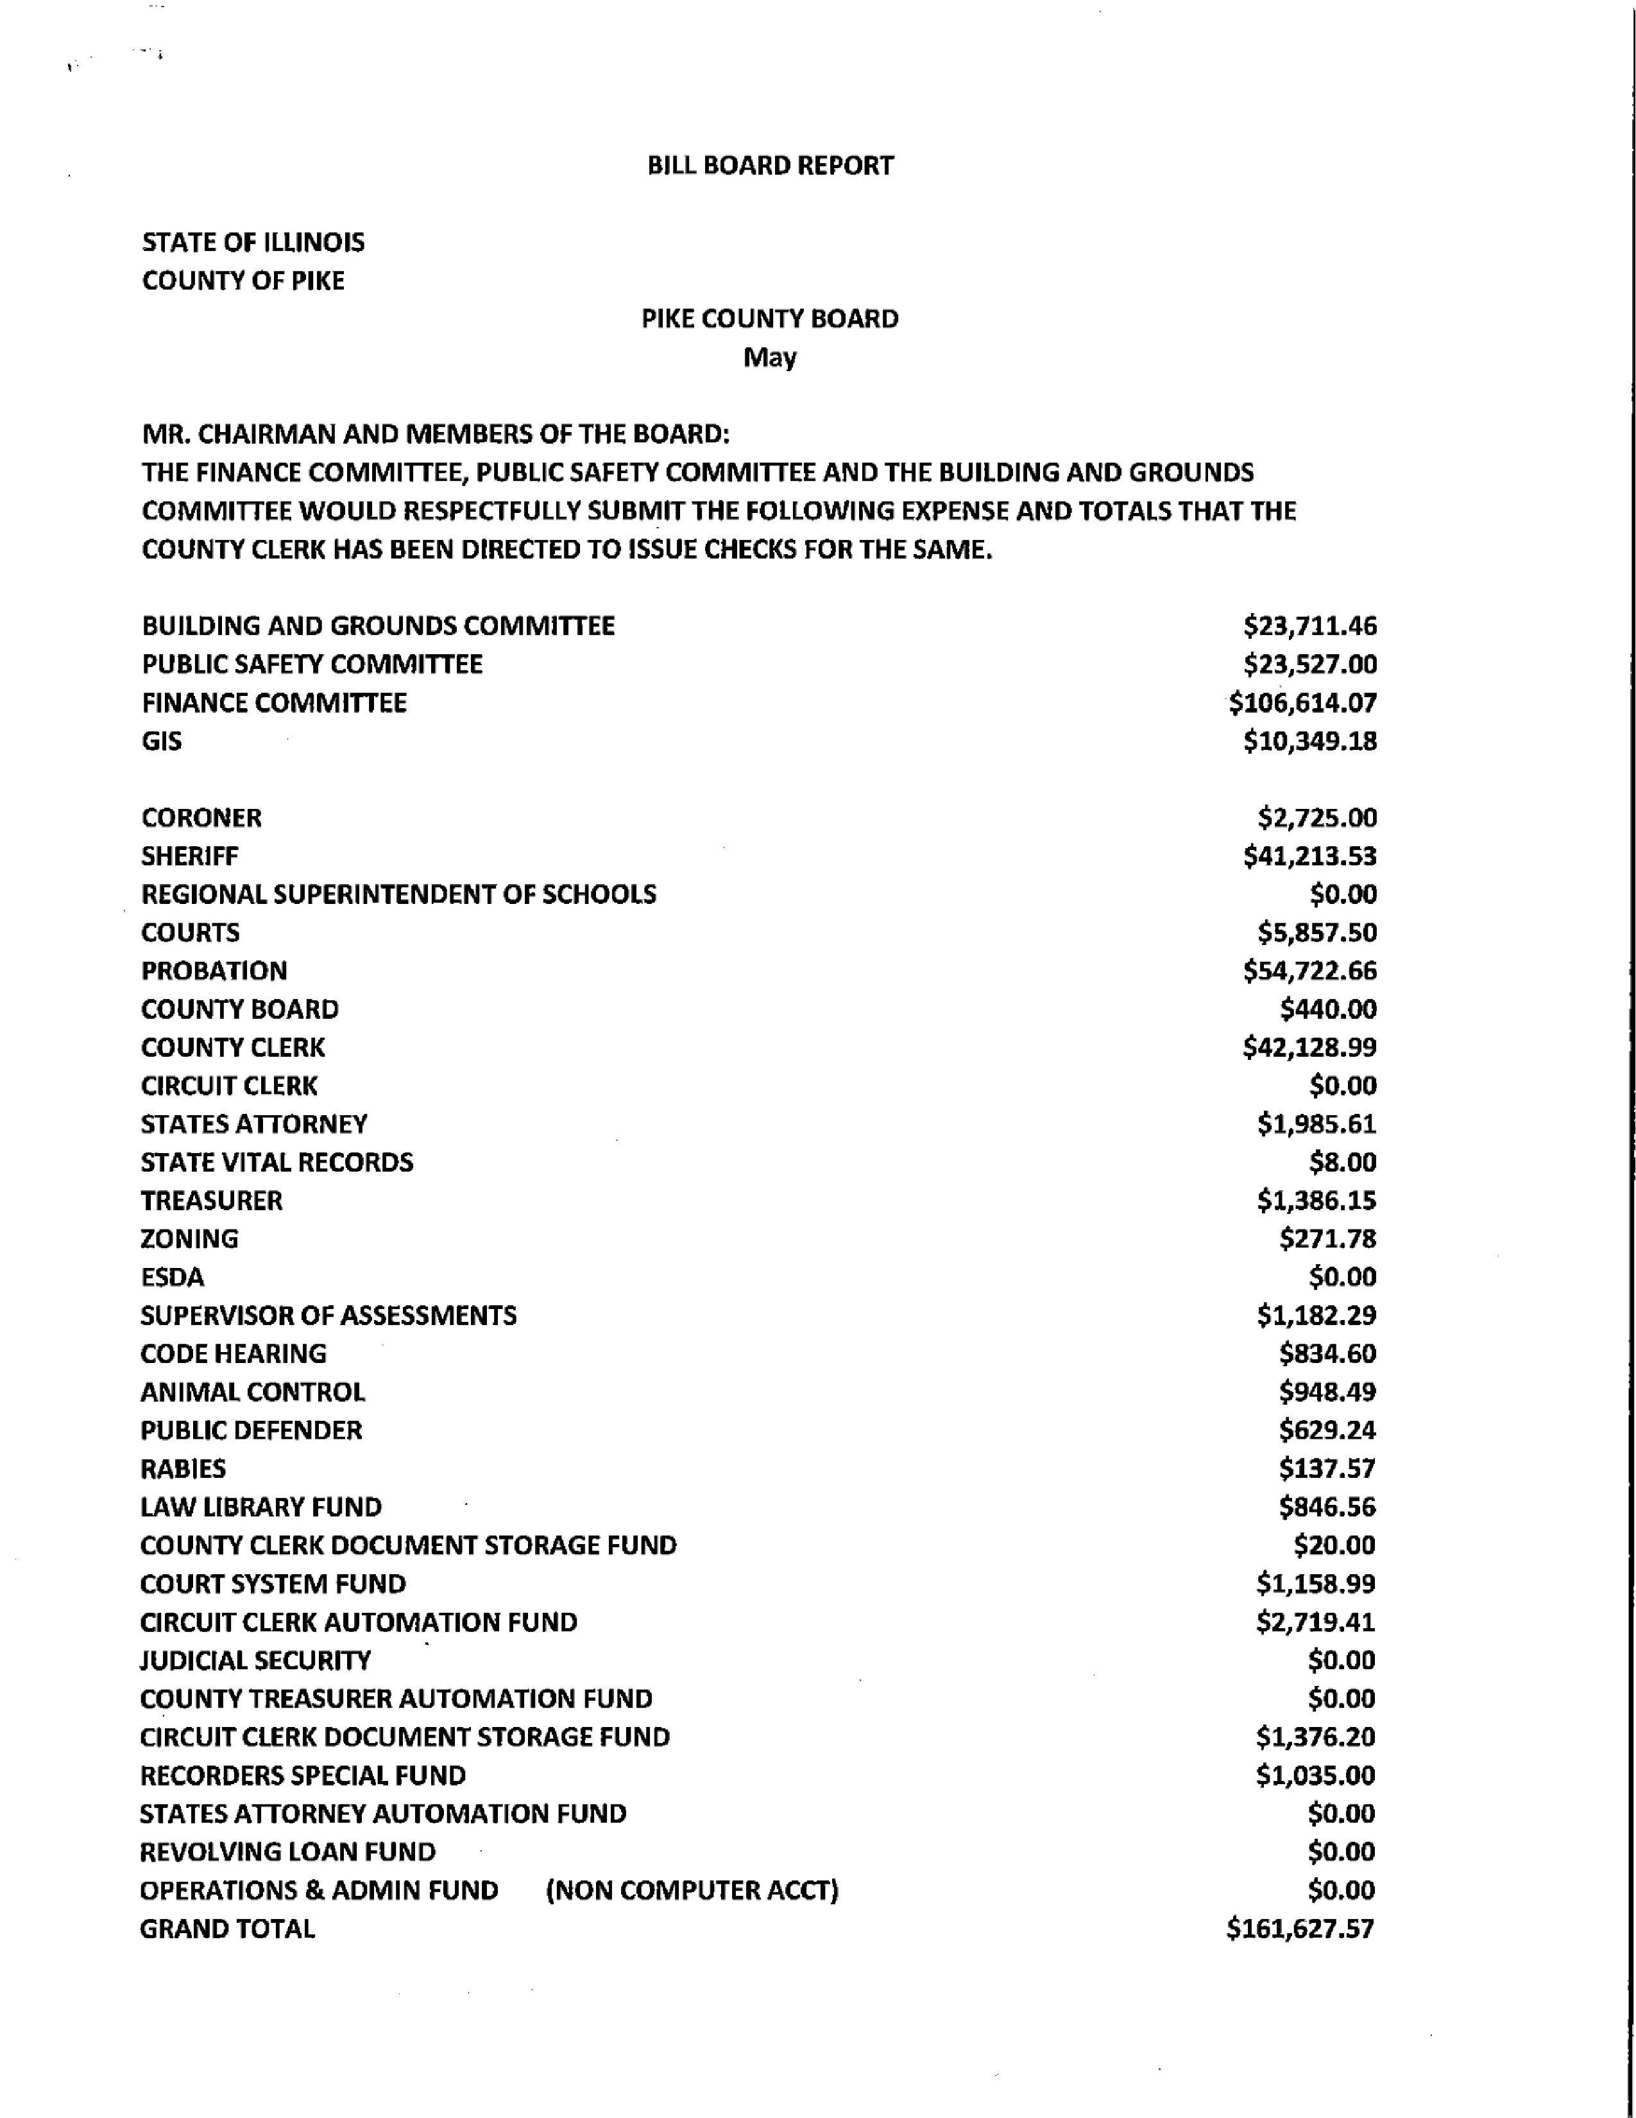
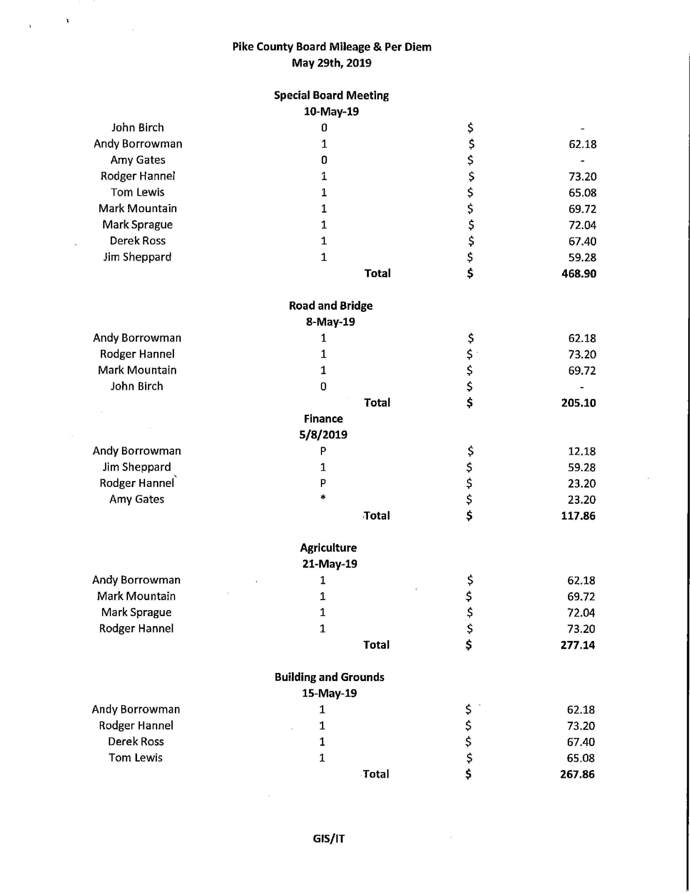
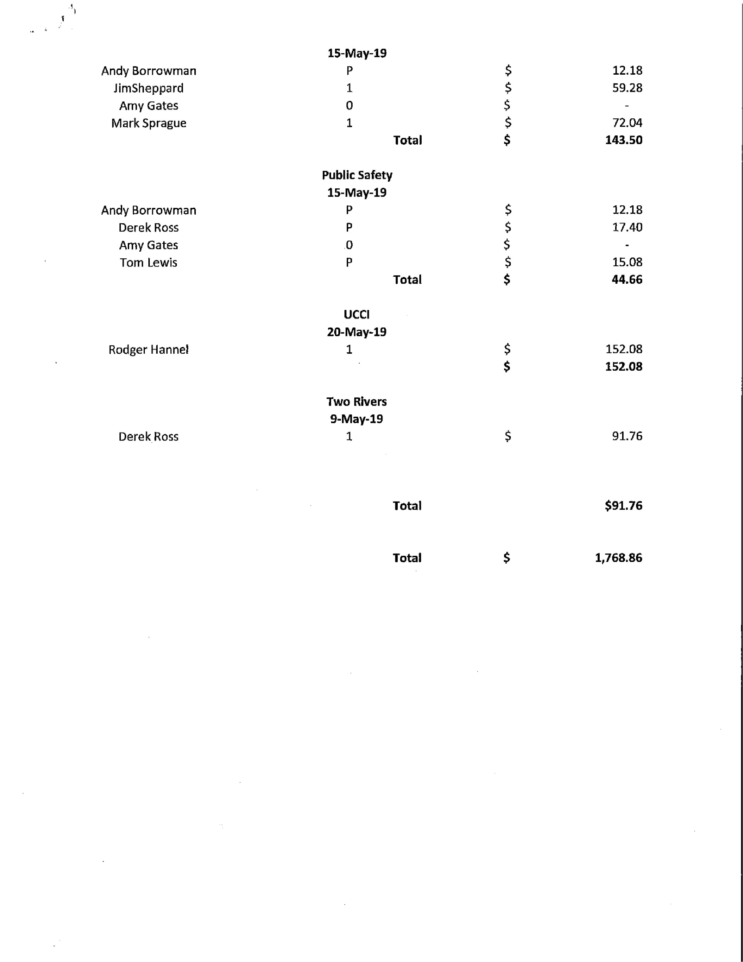

QUESTIONS FROM THE PRESS AND VISITORS
Mike Boren inquired as to what the exact fund balances were in the three accounts that were discussed for the courthouse proposed security addition.

CLOSED SESSION PURSUANT TO 5 ILCS 120/2(C)(11) POSSIBLE PENDING LITIGATION AND REVIEW OF CLOSED SESSION RECORDS
Amy Gates made a motion to enter into closed session. John Birch seconded. Voice vote 5-2. Closes session was entered into at 8:57 p.m. Closed session ended at 9:15 p.m.

A motion was made by Amy Gates that all previous closed sessions of the Pike County Board shall remain closed. John Birch seconded the motion. Voice vote 7-0. Motion passed.

ADJOURNMENT
Amy Gates made a motion to adjourn the meeting. John Birch seconded. Voice vote 7-0. The meeting adjourned at 9:16 p.m.

