PIKE COUNTY BOARD MEETING MINUTES

March 25TH, 2019

The regular monthly meeting of the Pike County Board was held on March 25th, 2019 at 7:03 PM in the Pike County Courthouse by Chairman Andy Borrowman. Mr. B.J. Thelander gave the invocation and Chairman Andy Borrowman led the Pledge of Allegiance. Chairman Andy Borrowman asked County Clerk, Natalie Roseberry, to call the roll. Those answering the roll call were John Birch, Andy Borrowman, Amy Gates, Rodger Mark Mountain, Mark Sprague and Jim Sheppard.

APPOINT A NEW PIKE COUNTY BOARD MEMBER
Chairman Andy Borrowman recommended Tom Lewis to fill the vacancy on the Pike County Board to fulfill the term of Carrie Martin. A Motion to seat Tom Lewis was made by Mark Mountain and seconded by John Birch. Voice vote of 6-0, motion carried.

APPROVAL OF MINUTES OF FEBRUARY 25TH, 2019 PIKE COUNTY BOARD MEETING

John Birch made a motion to approve February 25th, 2019 Pike County Board minutes. Mark Sprague seconded the motion. Voice vote was 7-0 to approve.

APPROVAL OF RESOLUTION TO DESIGNATE MAY 10TH, 2019 AS “100 YEARS OF FARM BUREAU IN PIKE COUNTY” DAY
Chairman Andy Borrowman congratulation the Farm Bureau for its service and longevity. Kim Curry, President of the Pike- Scott Farm Bureau thanked the County board for its support and how important the Farm Bureau is for the education and program services for its members. He sated the main event will occur on August 3rd and hopes to see everyone in attendance. Rodger Hannel made the motion to approve the resolution and seconded by Mark Mountain. Voice vote of 7-0 to approve.

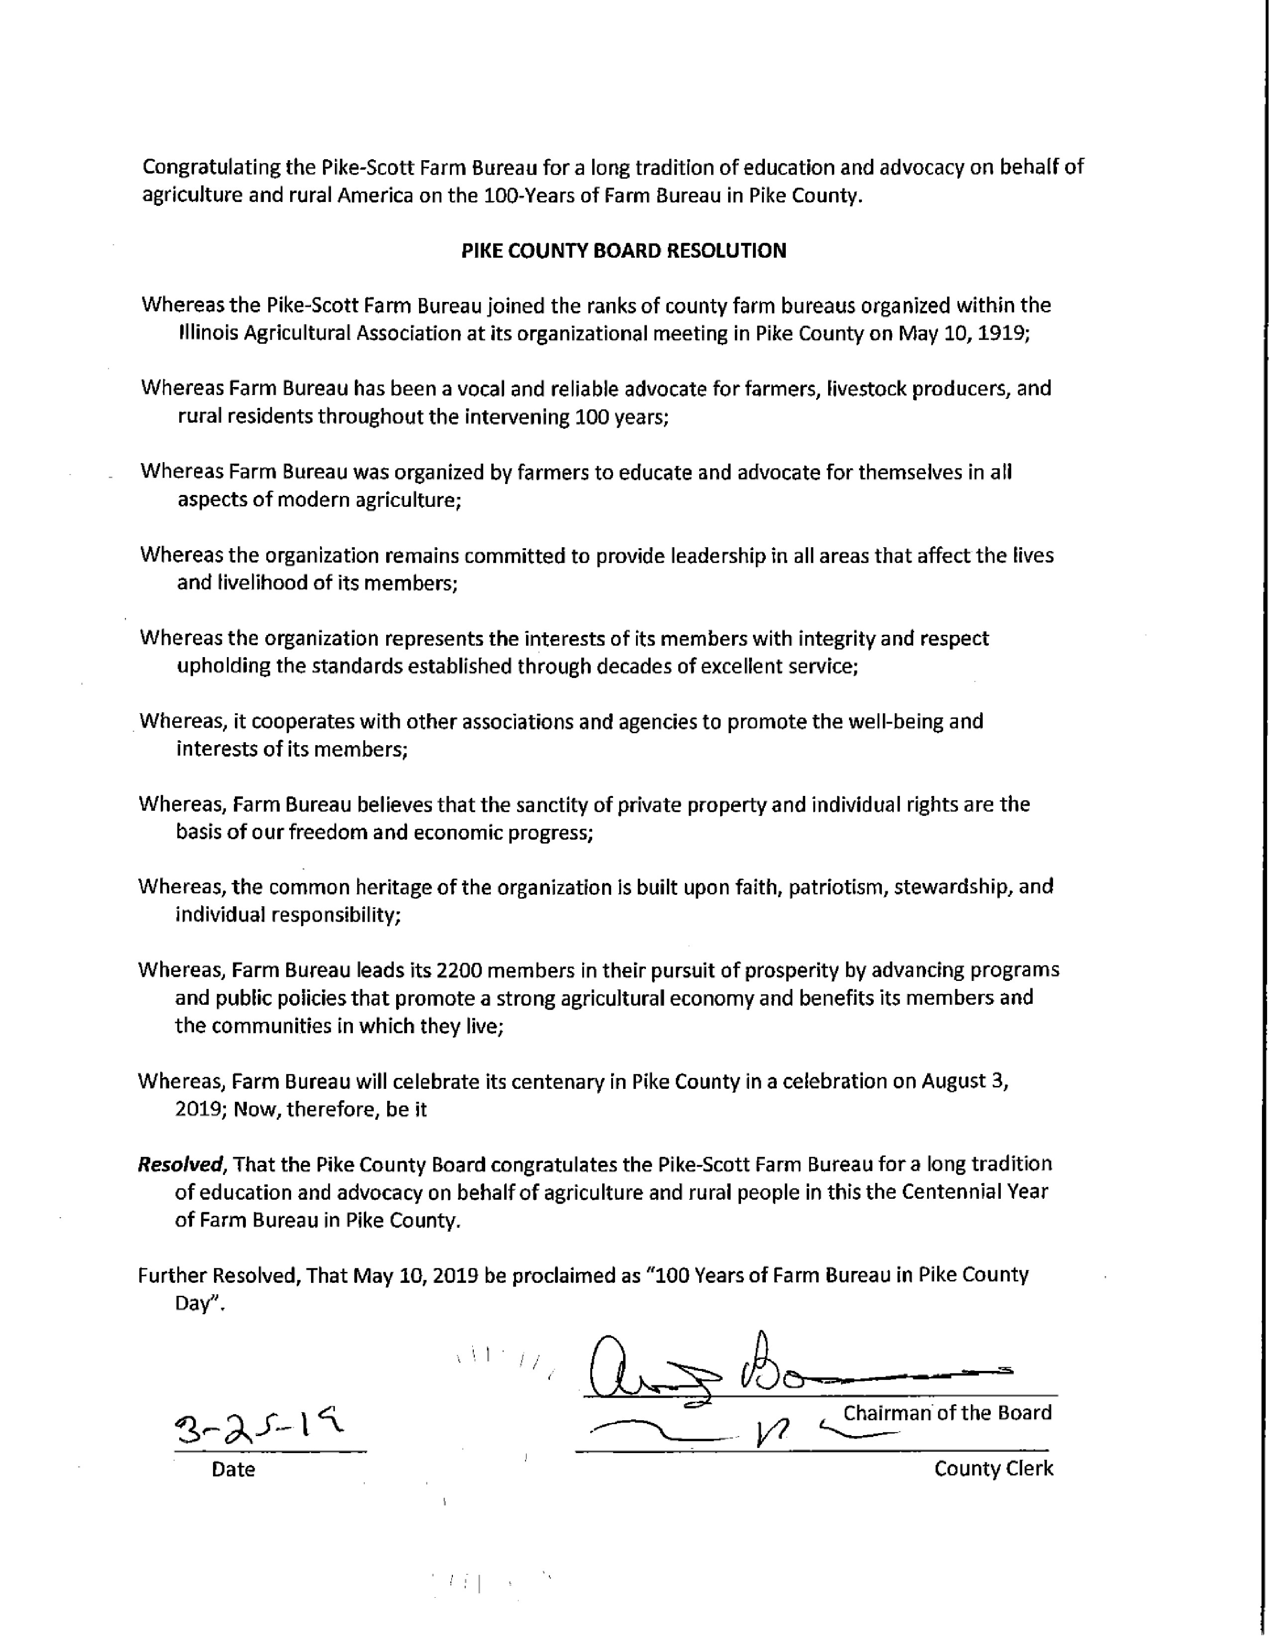
APPROVAL OF RESOLUTION RECOGNIZING THE QUINCY CONVENTION AND VISITORS BUREAU AS THE ENTITY AUTHORIZED TO REPRESENT PIKE COUNTY IN ITS TOURISM PROMOTIONAL EFFORTS.
Motion made to approve resolution by John Birch and seconded by Mark Sprague. Voice vote of 7-0 motion carried.
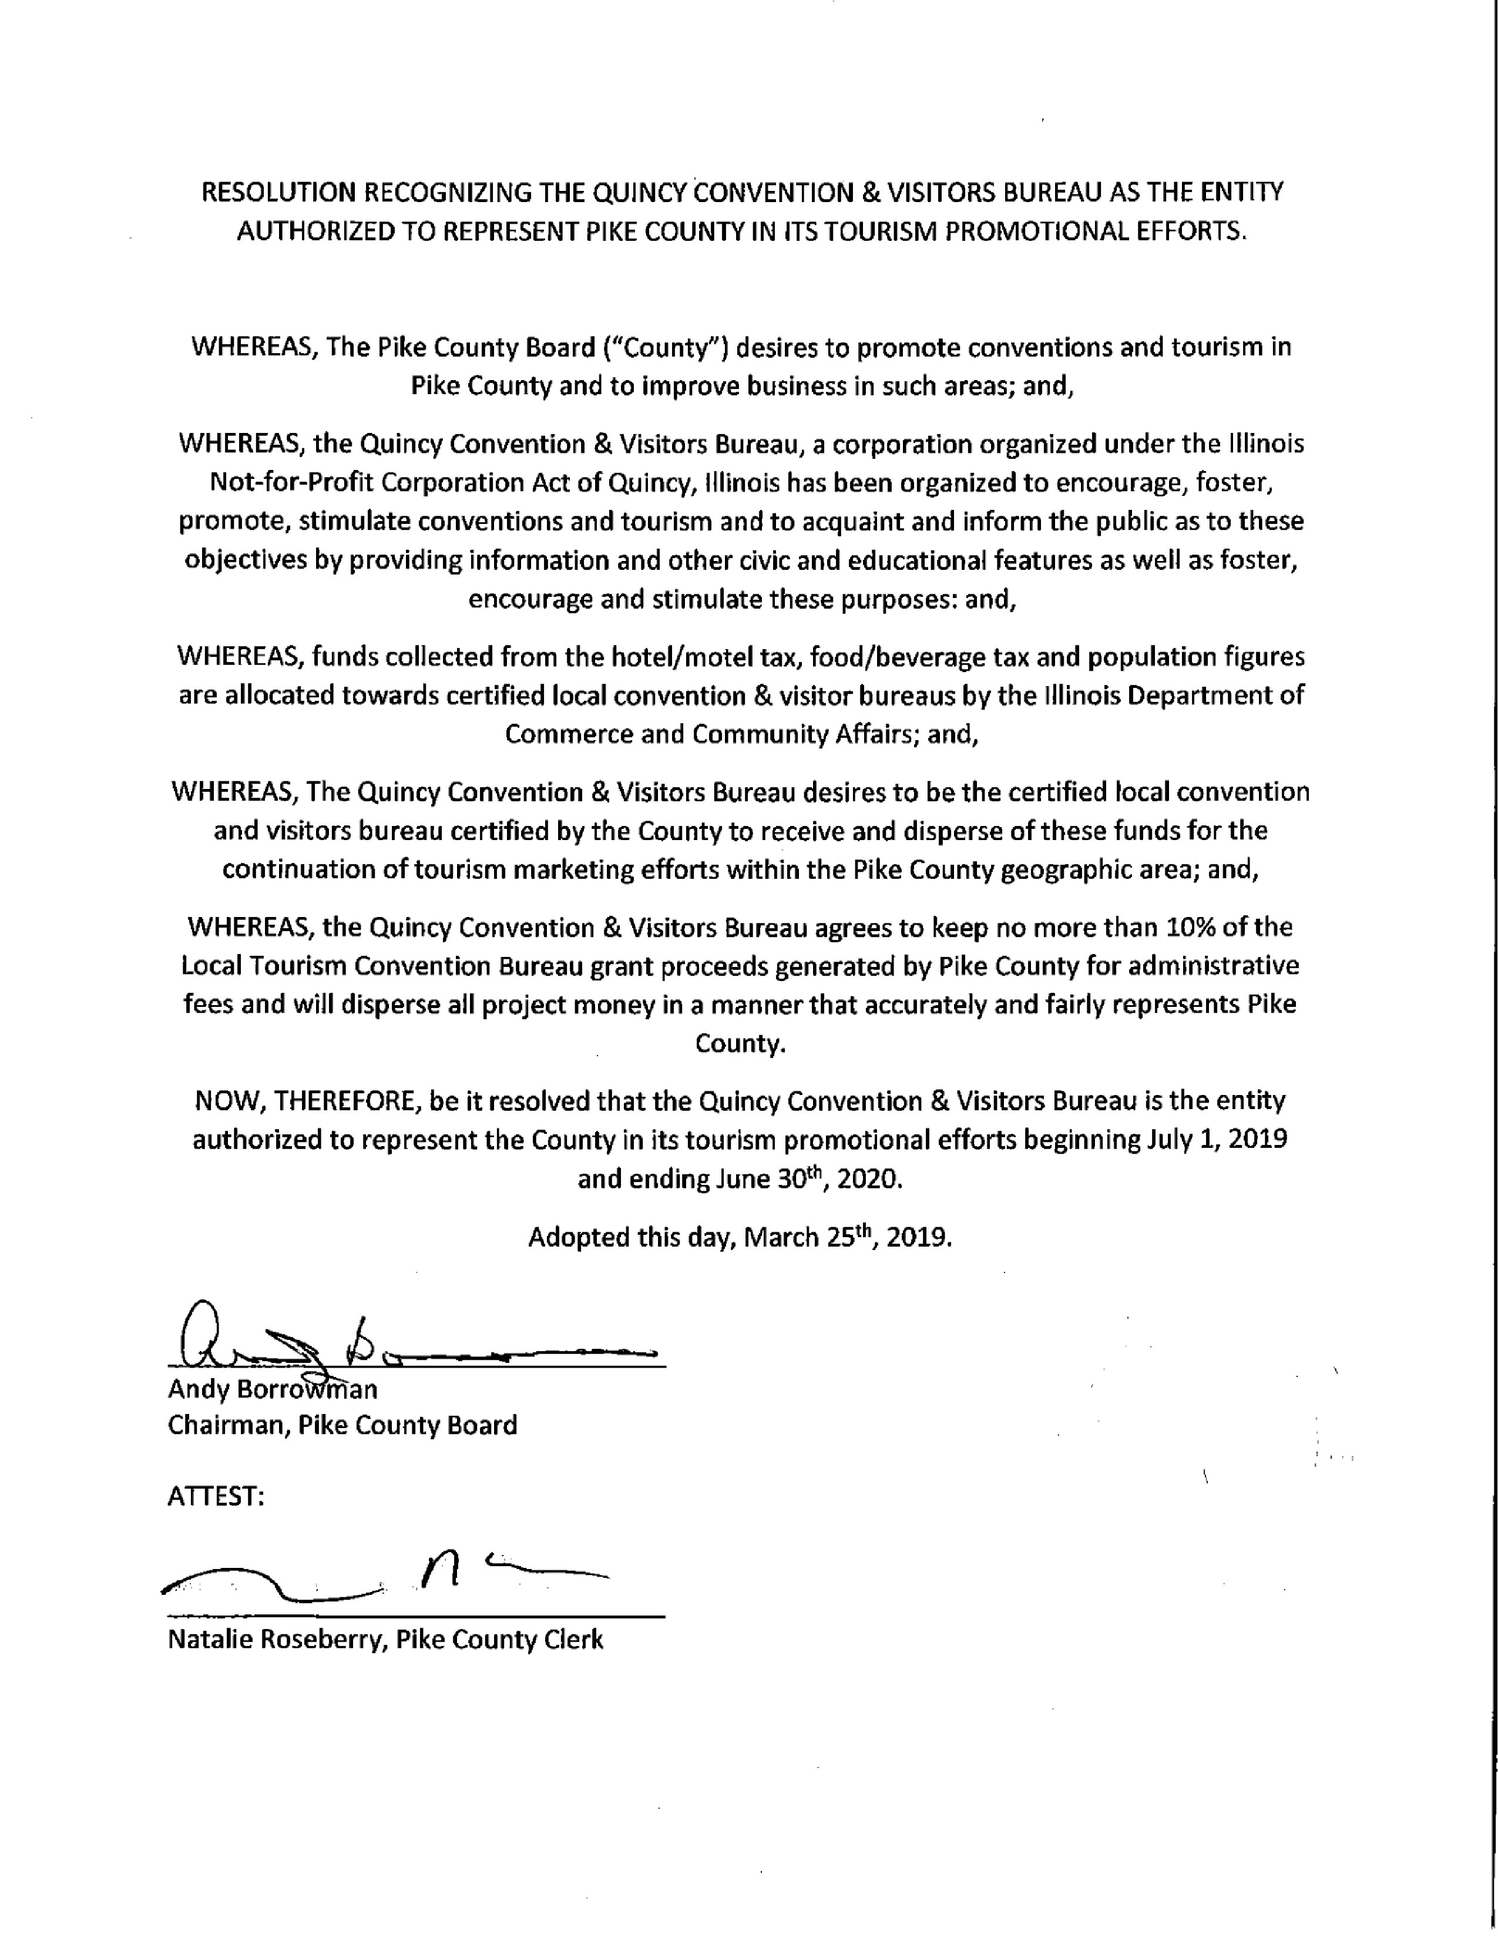
APPOINT WAYNE BINGHAM TO THE RURAL GRIGGSVILLE FORE DISTRICT FOR A 3 YEAR TERM
Motion to approve Wayne Bingham made by Mark Mountain and seconded by Tom Lewis. Voice vote of 7-0, motion passed.
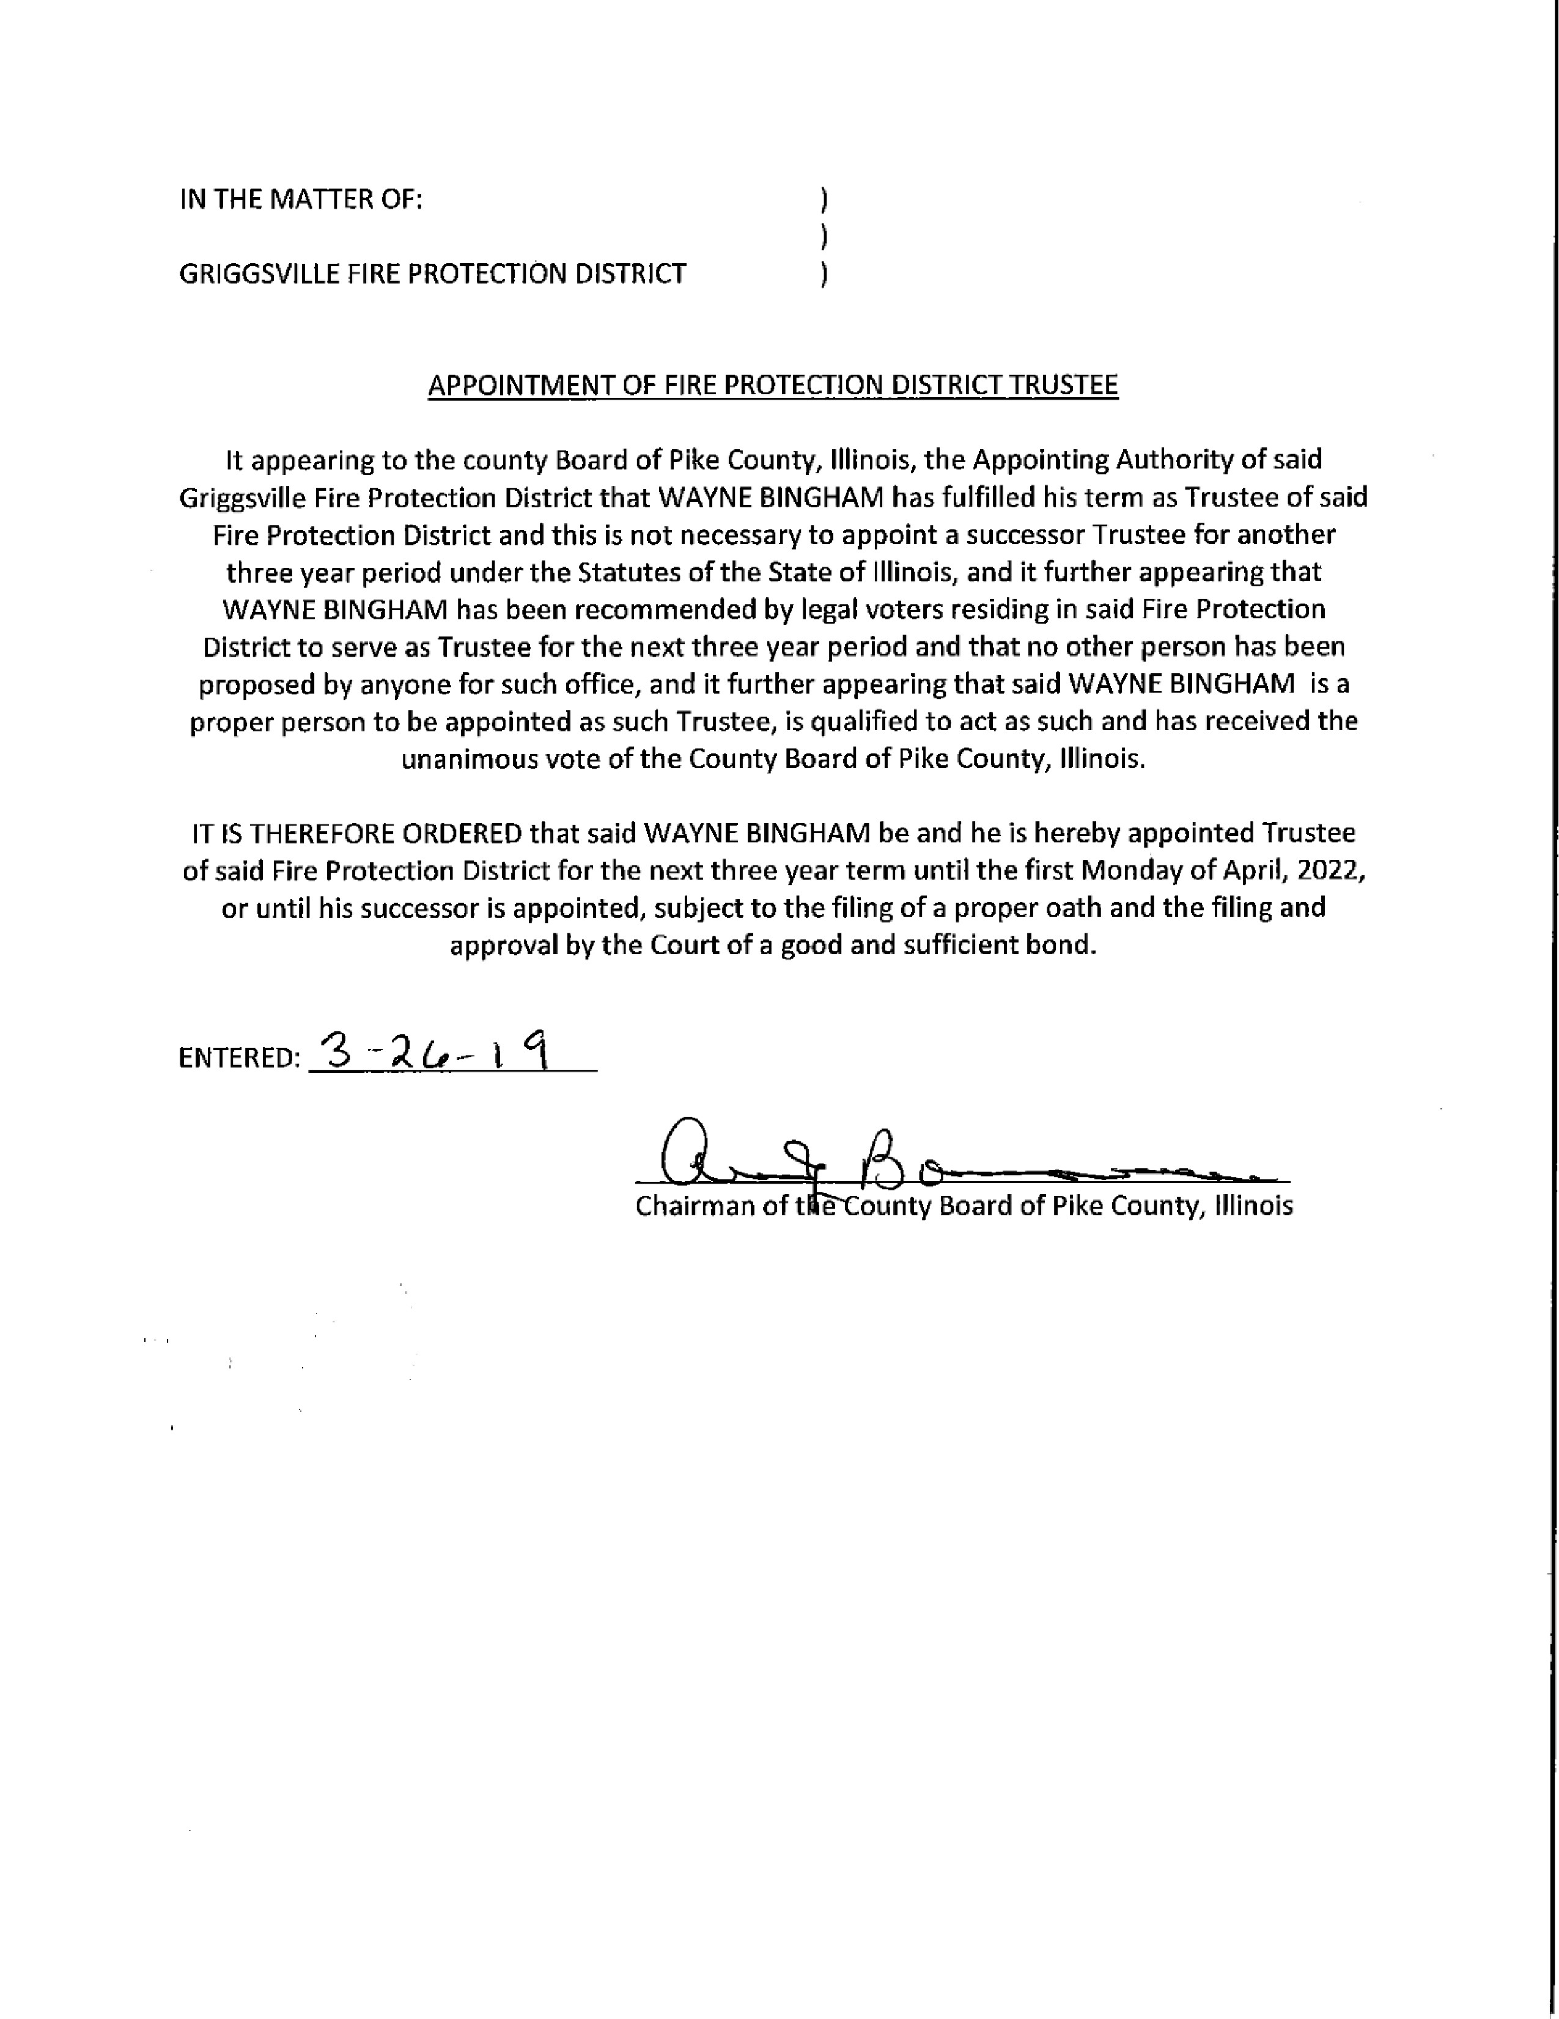
ACTION ON PROPOSED AMENDMENT TO PIKE COUNTY ZONING ORDINANCE INCREASEING MAXIMUM HEIGHT FOR WIND TURBINES TO 700 FEET AS APPROVED BY FAA
Chairman Andy Borrowman asked Zoning Administrator if he would like to comment and he deferred to Zachary Boren, Pike County State’s Attorney. Mr. Boren read the ordinance and stated that this was the recommendation by the Zoning Board of Review. Mr. Boren stated that Mr. Damon was present from Illinois Winds to answer any questions. Chairman Borrowman stated that passing this ordinance would prevent another permit process and Mr. Bored agreed along with the following resolution. Mark Mountain made a motion to approve the Amendment and seconded by Mark Sprague. Roll Call vote was 6-1 to approve.
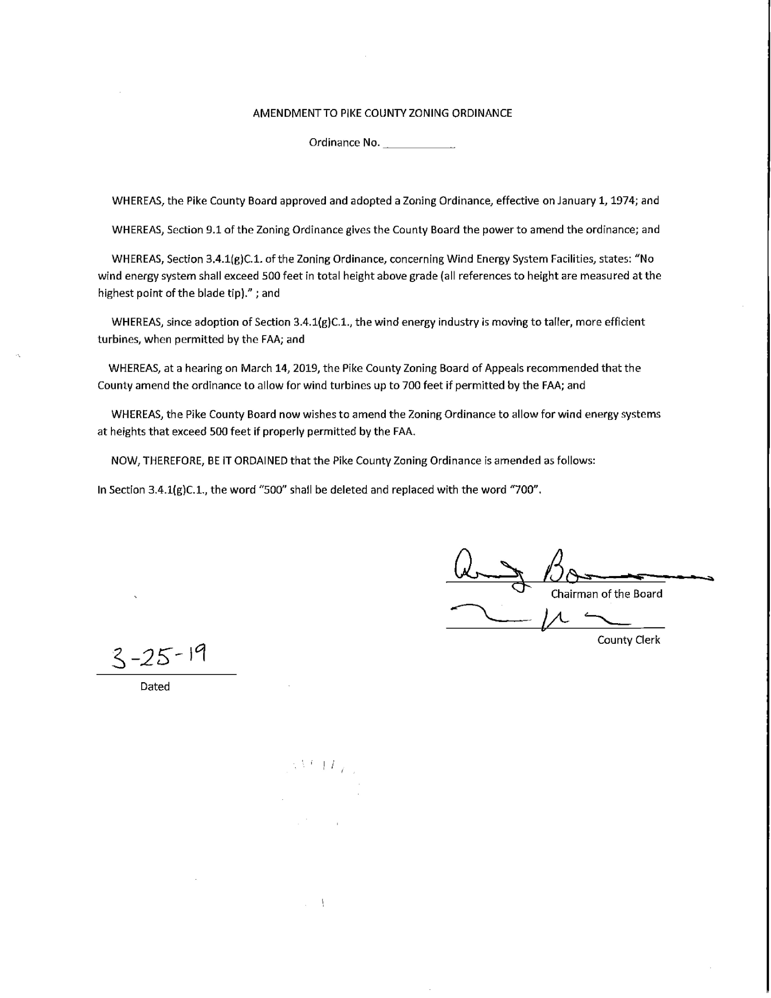
ACTION ON RESOLUTION ADDING ADDITIONAL CONTINGENCY TO APPROVED SITING APPLICATION BY ILLINOIS WINDS LLC.
Zack Boren read the resolution and Chairman Borrowman asked Illinois Winds if he had any comments. No comments were provided and Mark Mountain made a motion to approve the resolution seconded by Mark Sprague. Voice vote was 7-0 to approve. Chairman Borrowman stated that he looked forward to working with Illinois Winds and thanked them for doing business within the County. Rodger Hannel asked Representative Mr. Damon the time frame for the project to which Mr. Damon stated the projected completion was the end of 2020.
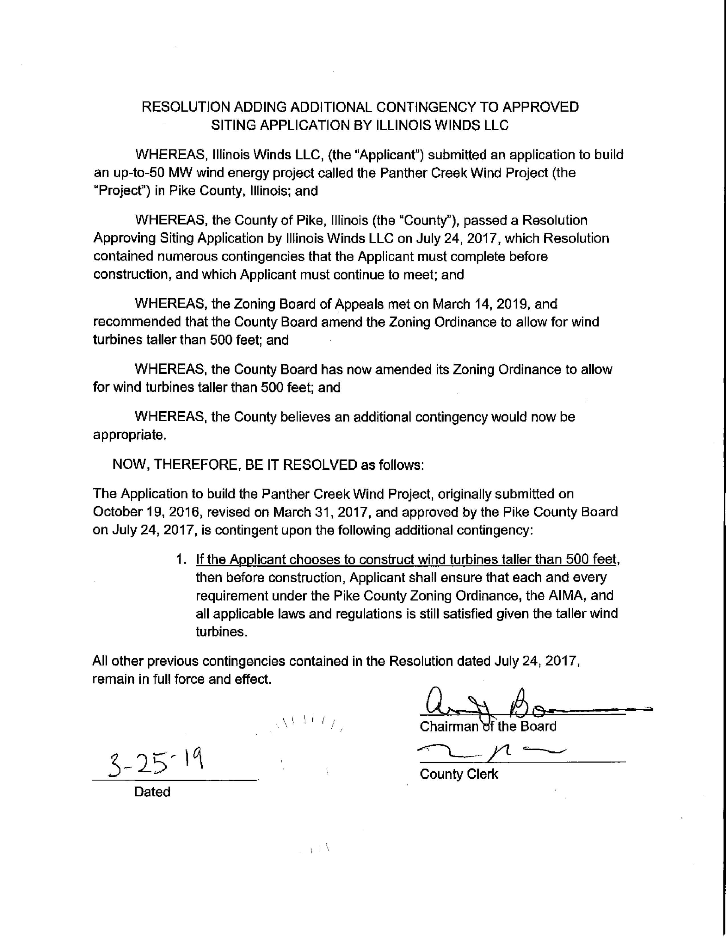
COUNTY AUDIT REPORT
Cindy Foote from Zumbahlen, Eyth, Surratt, Foote & Flynn, LTD. presented the counties annual audit for Fiscal Year 2018. Amy Gates expressed concerns at how the suggestions of improvement would be monitored. Jim Sheppard stated they would be addressed within the Finance meeting on April 10th. Amy Gates had a questions regarding a few accounts within the Sheriff’s Department’s control and about their accounting software.
Jim Sheppard made a motion to approve the Audit report seconded by John Birch. Voice vote of 7-0, motion approved.

Committee Reports
ETSB

The Pike County Emergency Telephone Systems Board met at 6:30 p.m. on Monday, March 11th, 2019 in the Emergency Operations Center of the Pike County Jail. Those members present were: Larry Bradshaw, Tom Lewis, Trent Crane, David Greenwood and Jim Sheppard. Also present was Stephanie Reinhardt.

Routine Bills in the amount of $40,291.14 were approved for payment on a motion by Bradshaw and second by Lewis.

Stephanie Reinhardt reported that the new radio system was up and running with no issues. This is why the board authorized the last payment to Motorola. After looking at the account status there was a motion by Larry Bradshaw and a second by Tom Lewis to pay off the loan if it was feasible. After checking with the treasurer this was done last Friday.

Member attendance was mentioned and it was requested that the Chairman find a copy of the bylaws for ETSB.

Next meeting of the ETSB will be April 8th, 2019 at 6:30 p.m.

On a motion by Tom Lewis and a second by Trent Crane, Meeting adjourned at 7:52 P.M.

Jim Sheppard stated that Mr. Lewis in currently on the ETSB board in capacity of Fire Chief and has recently been appointed to the Pike County Board. Mr. Zack Boren, Pike County State’s Attorney is looking into legislation to see if Mr. Lewis still can serve on ETSB board.

Mark Mountain made a motion to approve the ETSB minutes, seconded by Rodger Hannel. Voice vote was 7-0 to approve.

Highway

The Road and Bridge Committee met Wednesday, March 13th, 2019 at 3:30 p.m. at the County Highway Department. The meeting was called to order at 3:30 p.m.

Members present were Rodger Hannel, Mark Mountain, John Birch and Andy Borrowman.
Others present were Chris Johnson, County Engineer, and Gary Laux, resident Engineer.

No Public Comments

A Motion was made by Mark Mountain, seconded by John Birch to pay claims per claim reports dates March 13, 2019. All in favor. Motion carried.

The County Engineer noted that the White bridge now has a scour critical rating of 3. A scour plan of action is being developed by the County Engineer and will be submitted to the Illinois Department of Transportation for approval. The State’s Attorney informed the County Engineer via phone conference that a phone conference with the Judge is scheduled for May 6th, 2019, and the committee was advised.

No Closed Session
No New Business

Old Business: The County Engineer noted that he has copies of the deeds and MECO Engineering will soon be doing a survey to establish property lines for a new maintenance facility on the North end of the property. The County Engineer will contact the neighbor to see if adjoining property is for sale at this time.

The new dump trucks are in and rigging is being done by Woodys. The plans are to sell the old trucks through govdeals.com.

A motion was made by John Birch seconded by Mark Mountain to adjourn meeting at 3:47 p.m. Motion Carried.

Motion to approve the minutes made by John Birch and seconded by Tom Lewis. Voice vote 7-0, motion approved.
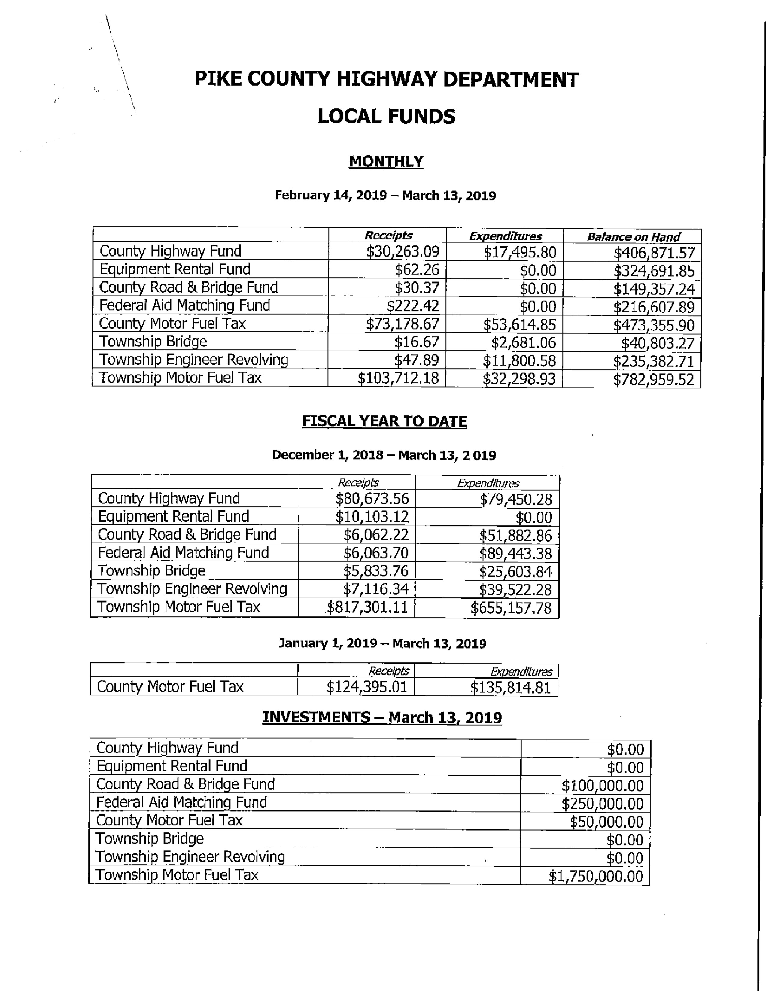
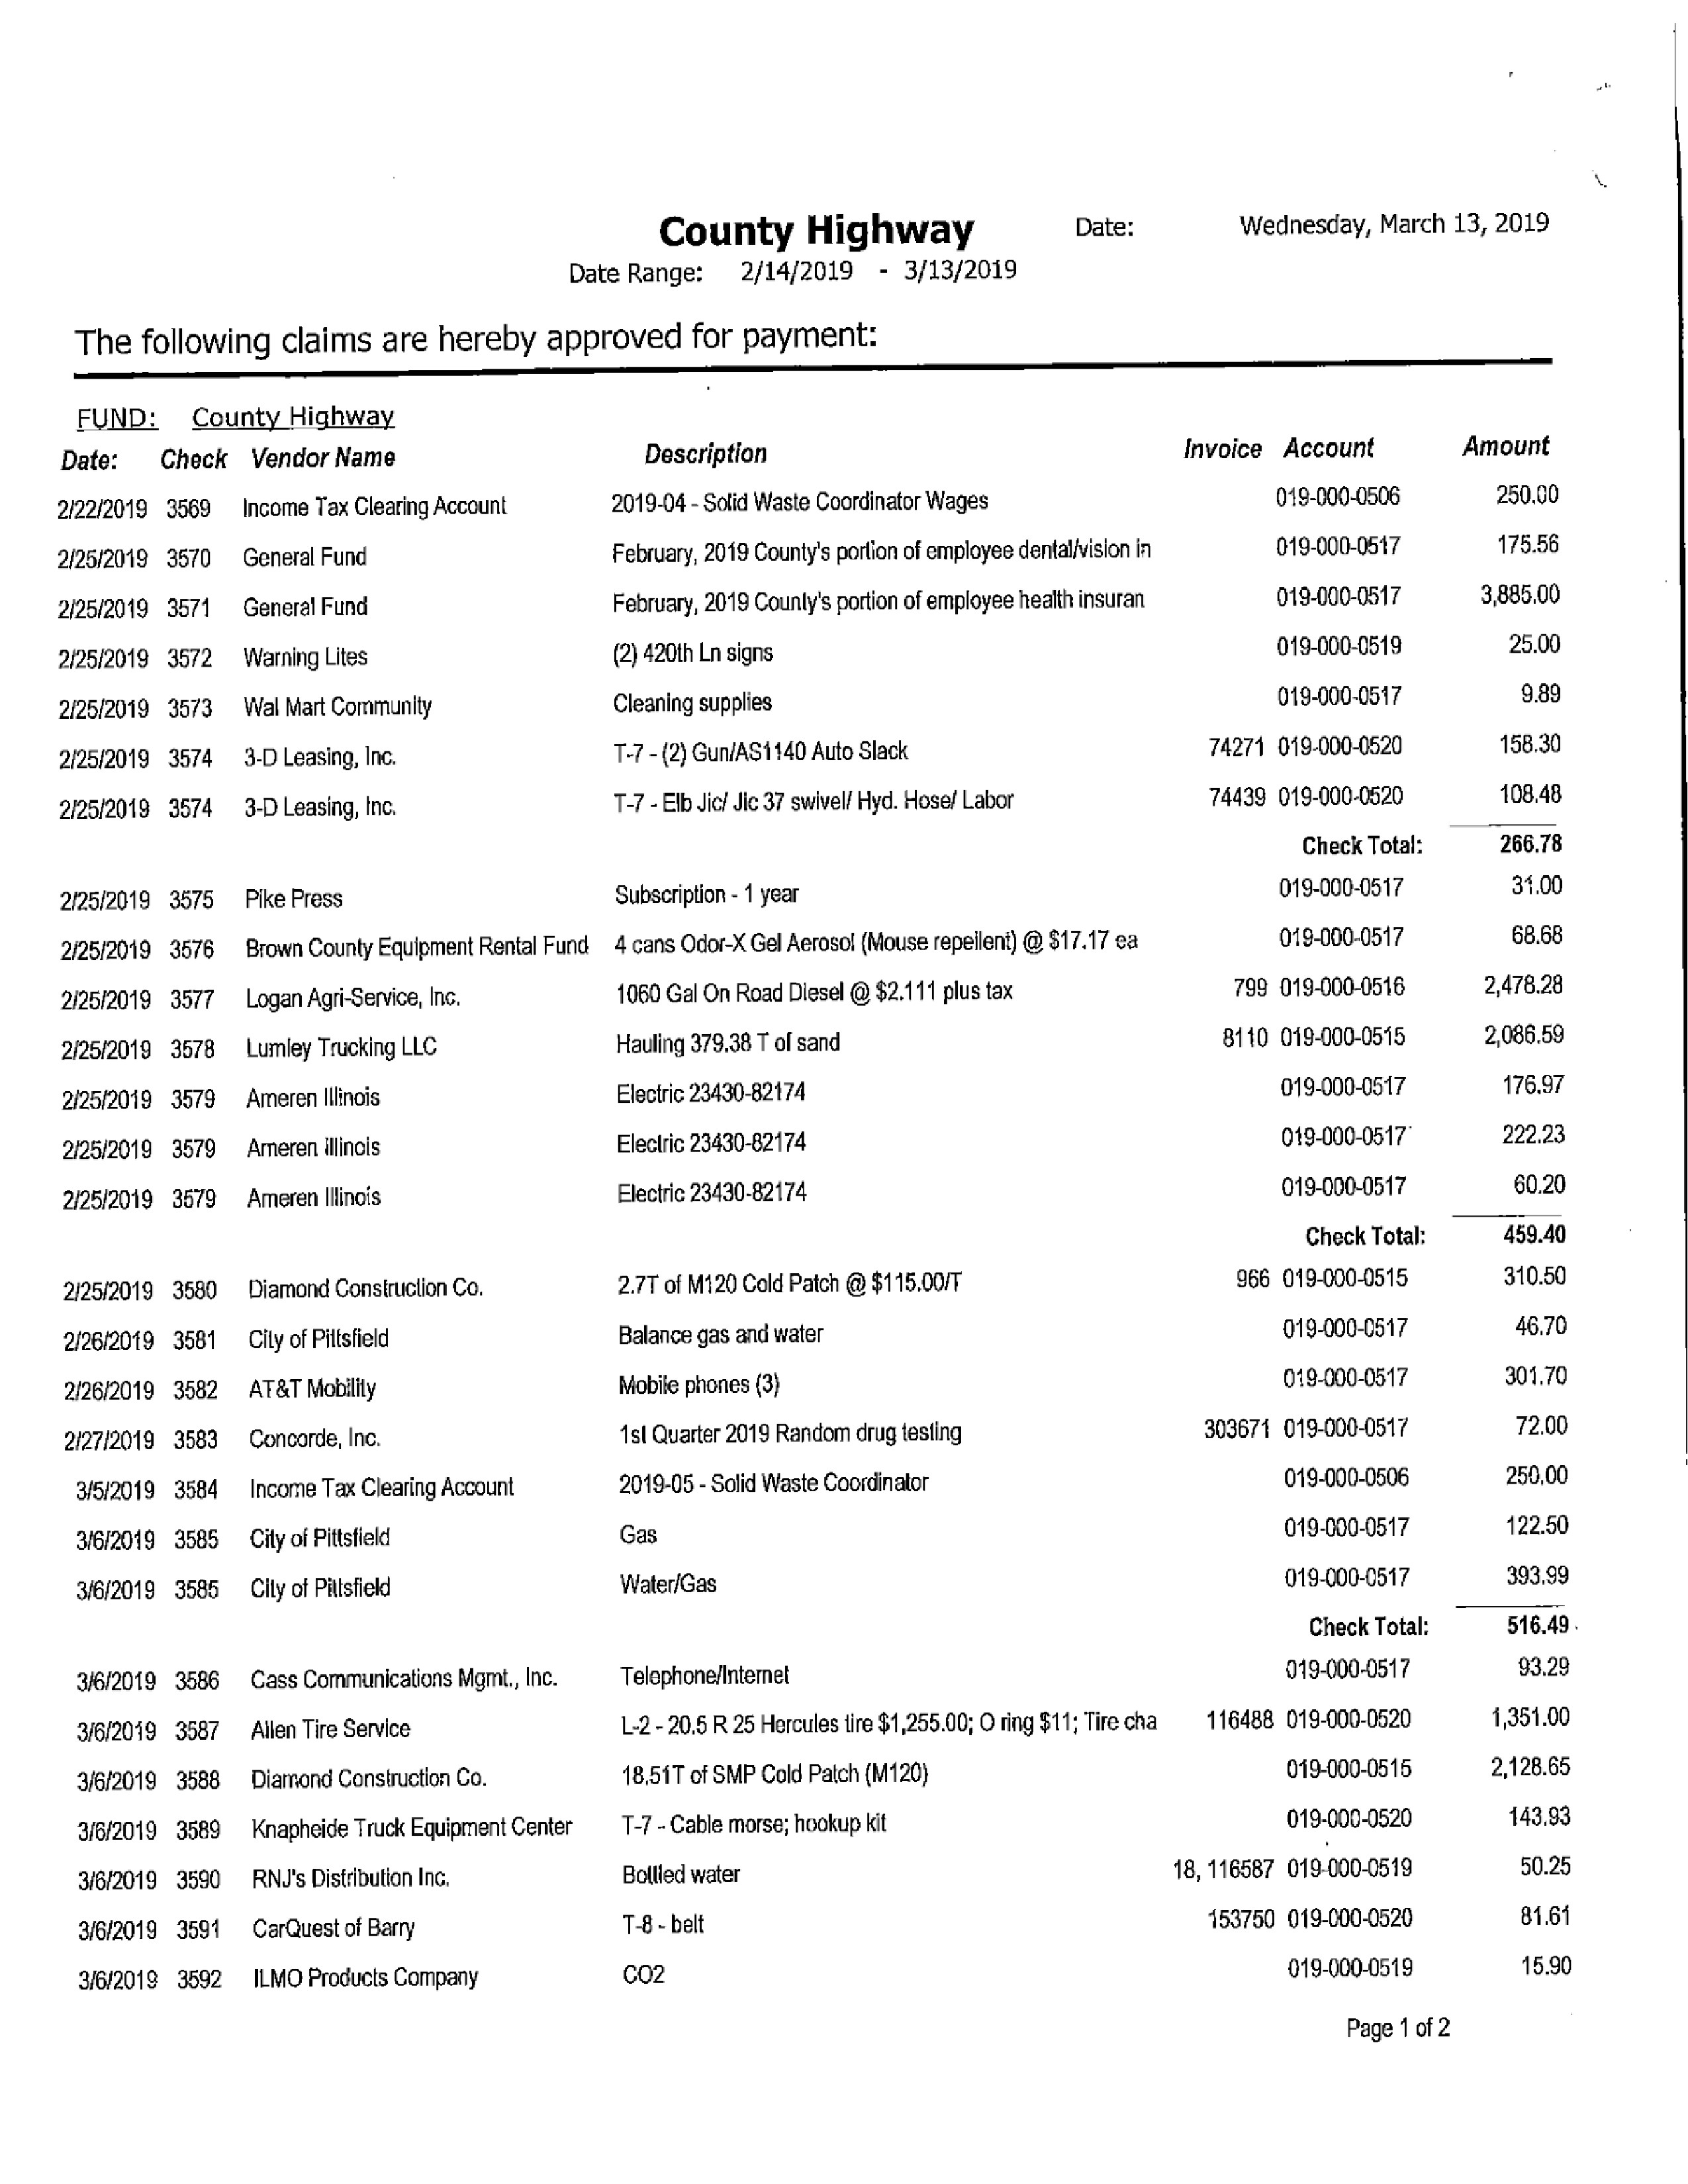
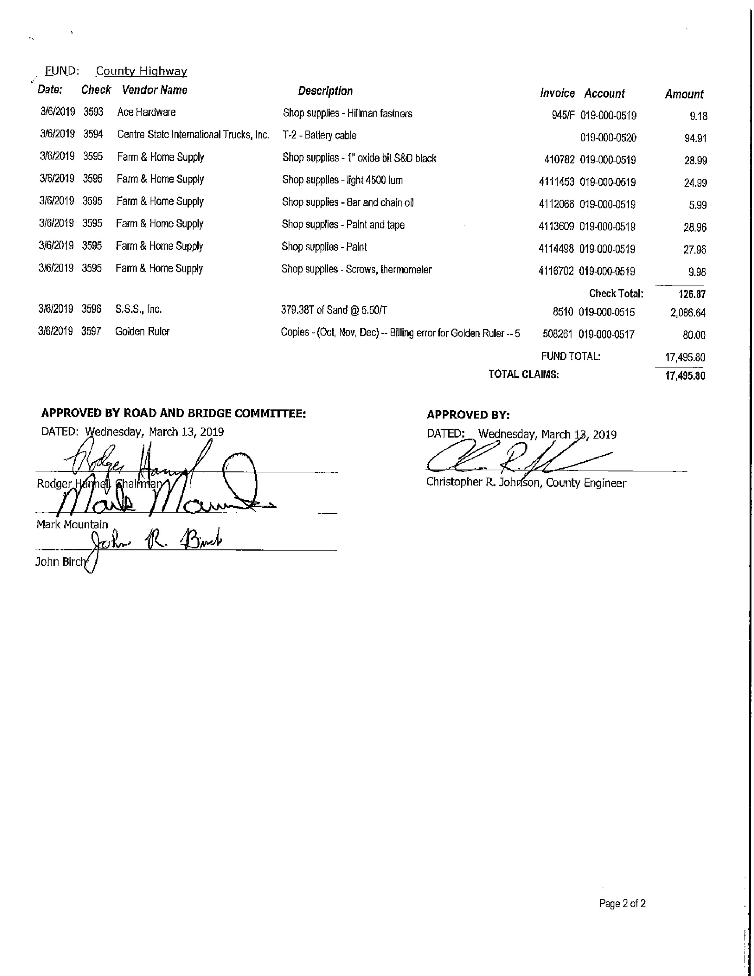
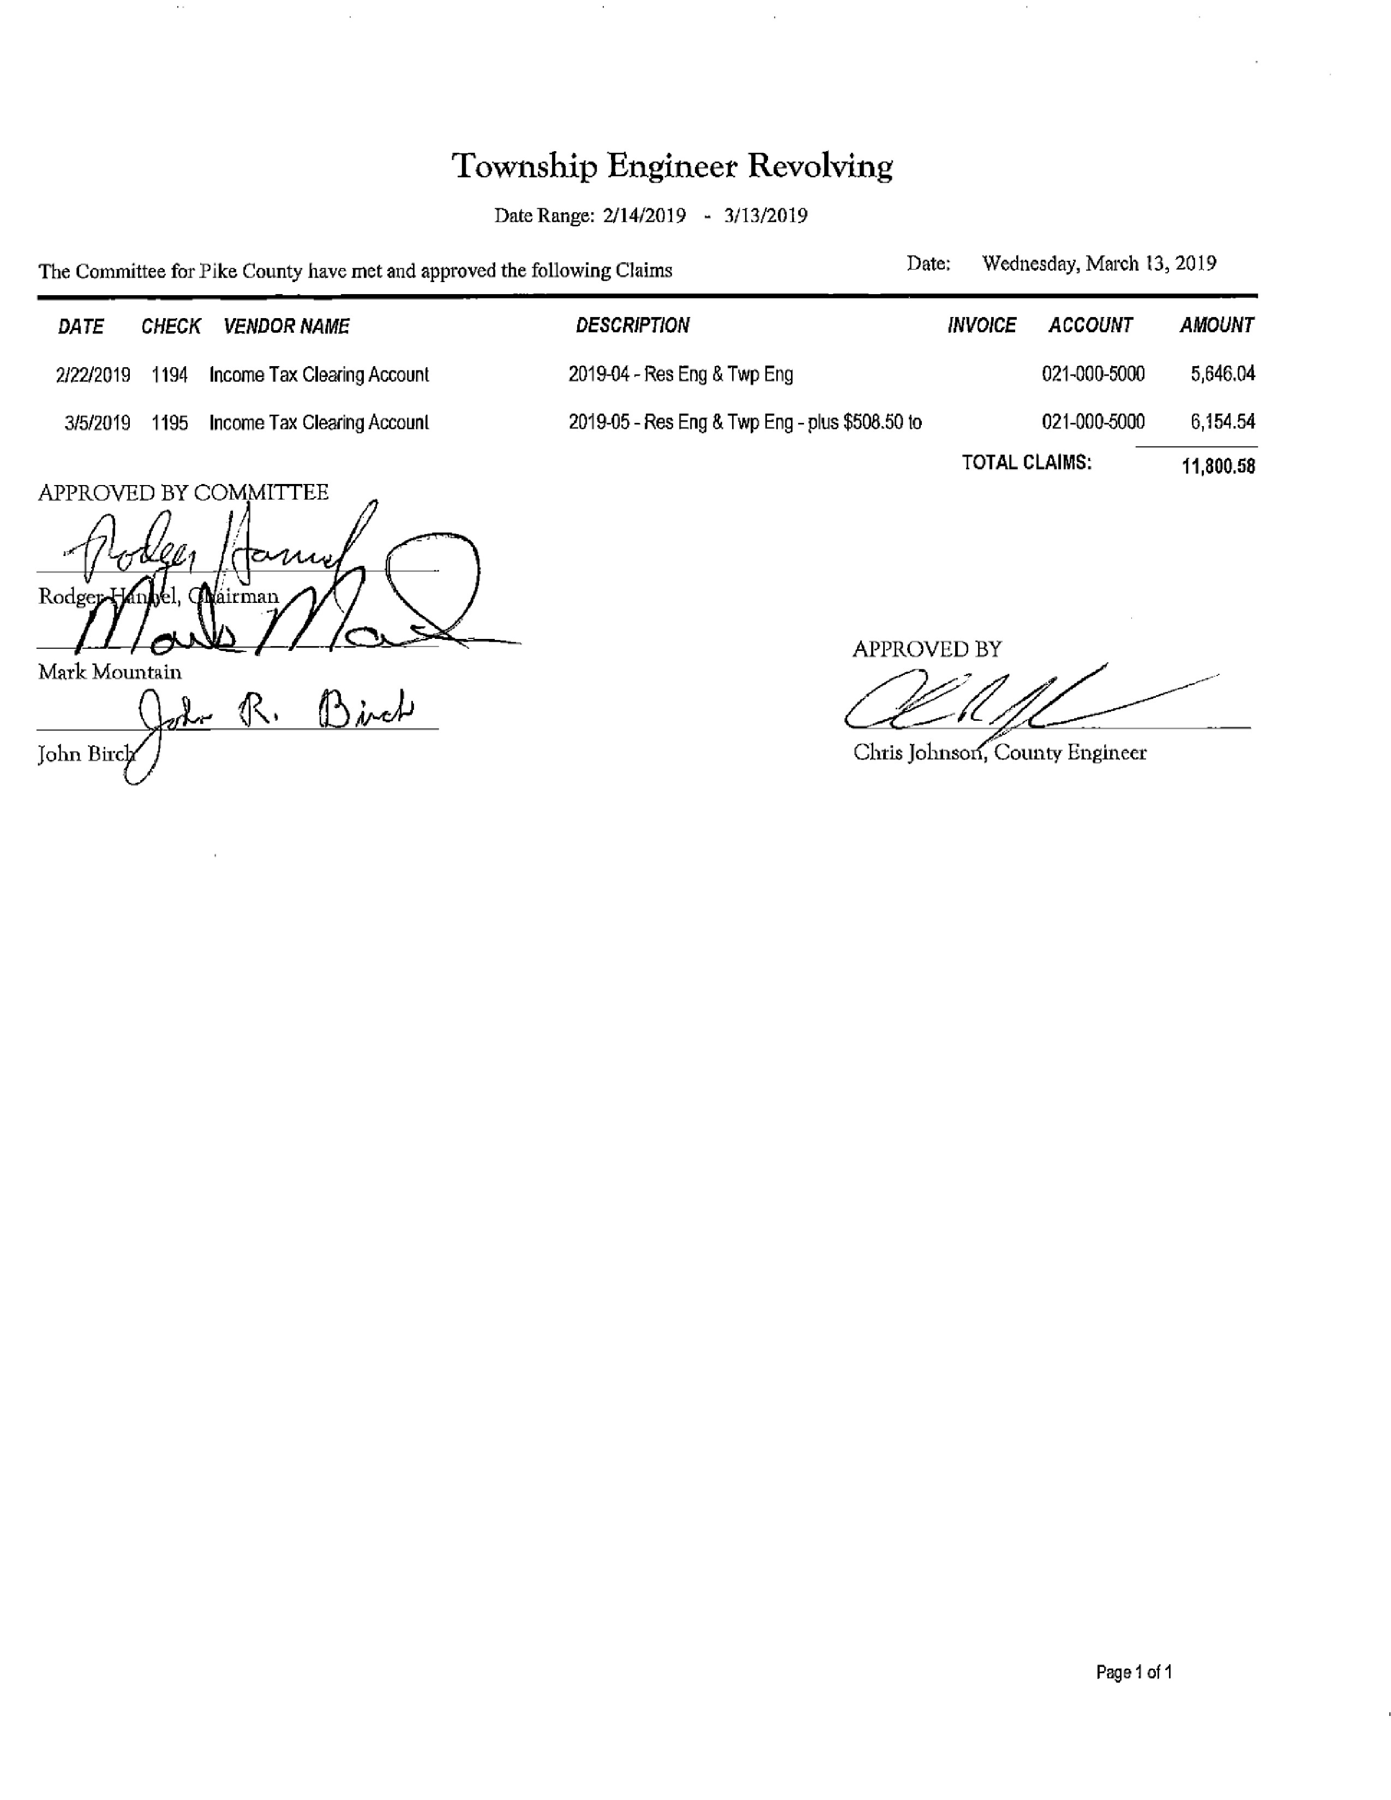
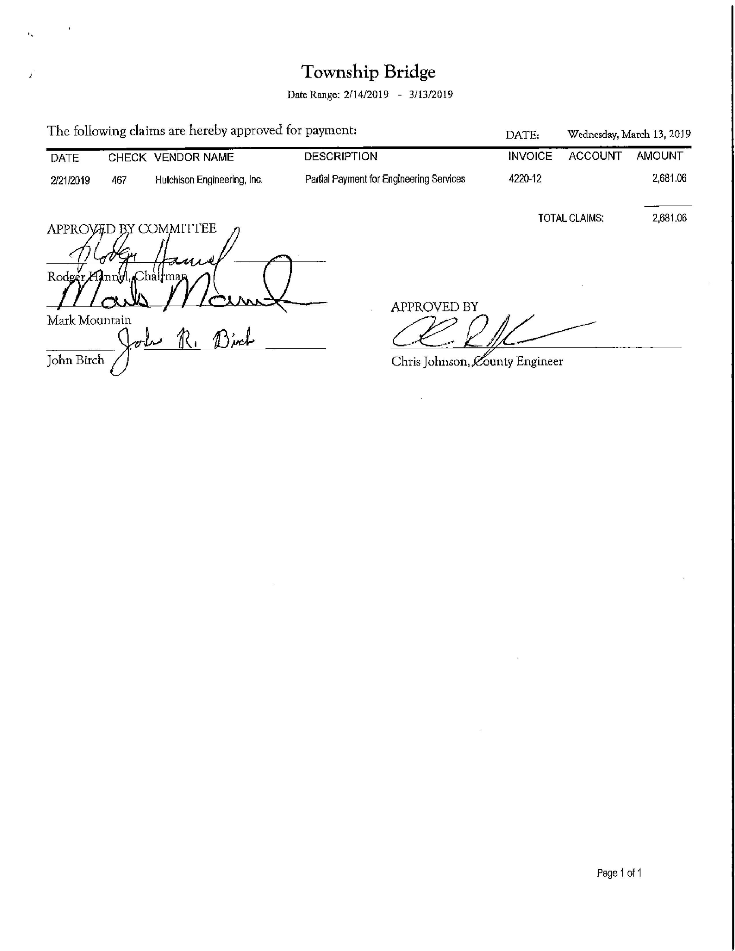
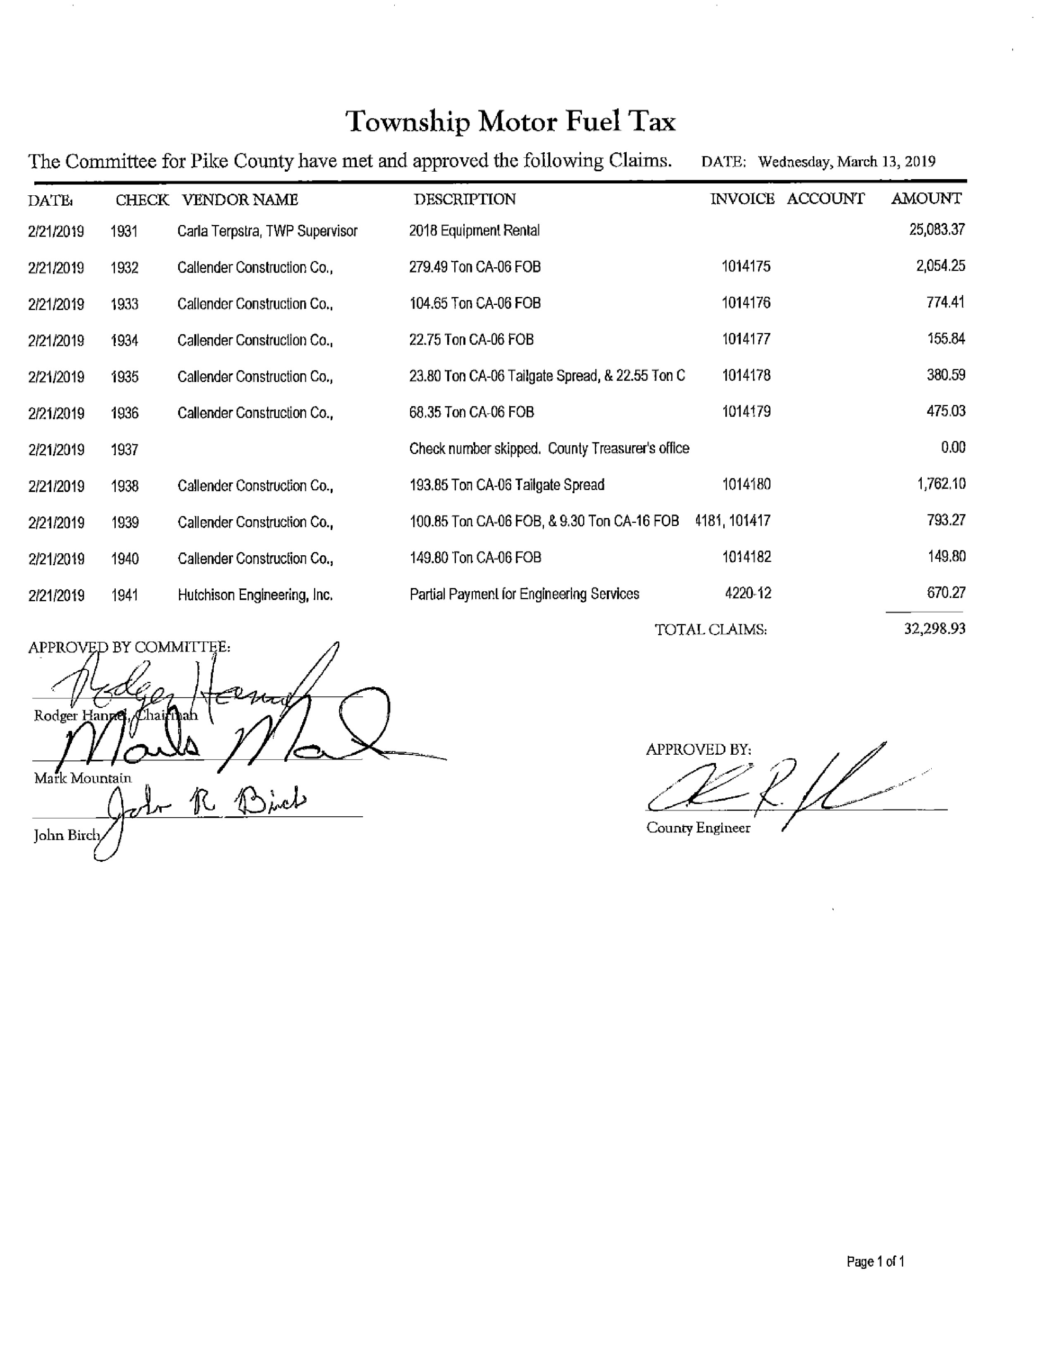
Finance Committee

The finance committee of the Pike County Board met at 5:00 p.m. on Wednesday March 13th, 2019 in the conference room of the Pike County Government building. Members present were Rodger Hannel, Amy Gates, Jim Sheppard and County Board Chairman Andy Borrowman. County Clerk Natalie Roseberry, County Treasurer Scott Syrcle were also present.

Routine bills in the amount of $128,796.52 were approved for payment on a motion by Rodger Hannel and a reluctant second by Amy Gates.

The committee first discussed the resolution to participate in the Federal Surplus Property Program for David Greenwood. Rodger Hannel made a motion to approve and Amy Gates seconded. Motion carried. We had a discussion about who else amongst our officials and office heads might benefit from the program and will bring it up at the administrators meeting.

Natalie Roseberry talked about the computer switch issue that the government building had experienced and the timetable for the new election software.

Amy Gates made a motion to adjourn. Rodger Hannel seconded. Motion carried.

Meeting adjourned at 5:43 p.m.

Scott Syrcle stated that the final payment was made on the Government Building.

Motion to approve the minutes made by John Birch and seconded by Amy Gates. Voice vote of 7-0, motion carried.

Agriculture Committee

The Agriculture Committee met on March 19th, 2019 at 5:00 p.m. in the upper conference room at the Pike County Government Building. Members in attendance were Chairman Mark Mountain, Mark Sprague and County Board Chairman Andy Borrowman. Others in attendance were Rob Hoskins, Natalie Roseberry, Blake Roderick, Debbie Lambeth, Fred Ruzich, Zack Boren and Jane Johnson.

The meeting was called to order at 5:00 p.m.

Solar Ordinance: Last month’s changes were discussed and a couple of new issues were debated. It was decided to do a final review next month at the April 16th, 2019 meeting at 5:00 p.m. in the upper conference room. Also all members were directed to review Zoning Ordinance for possible text change.

(765 ILCS 205/) Plat Act Compliance
The Plat Act was discussed and the many ways to comply with it by January 1st, 2021. The biggest sticking point was the minimum acres 2 to 5 and what number of acres would have as little impact on the buyer and seller as possible. By law the county can choose the number of acres between 2 and 5. It was determined that Andy Borrowman would appoint a sub-committee to research the number of acres and the affidavit format to be used and make a recommendation to the Ag Committee.

Pike County Health Department
Jane Johnson advised the committee that the tire collection went well. Jane also recommended that the County put on a new elected officials meeting.

Animal Control
Debbie Lambeth updated the committee on the new vehicle for animal control. 2018 Ford Expedition 17304 miles total price with trade in $30306.

New Business- none
Old Business-none
Public Comment-none

Motion to adjourn by Mark Sprague and seconded by Mark Mountain. Meeting adjourned at 6:40 p.m.

Motion to approve the minutes by Mark Sprague and seconded by John Birch. Voice vote 7-0 motion carried.

Building and Grounds

The Building and Grounds Committee met on March 20, 2019 at 3:30 p.m. in the Pike County Government Building. Those attending were Andy Borrowman, Derek Ross, Rodger Hannel, Darwin Feenstra, Natalie Roseberry and guest Mike Boren.

Mike Boren and Darwin Feenstra made a picture presentation to the committee on behalf of the Pike County Historical Society. The picture is of the Pike County Courthouse that preceded our current courthouse. The pictured courthouse was torn down about 125 years ago. In fact, our present courthouse was built to replace it. Our present courthouse began being built in 1894. The picture will be placed in the Pike County Courthouse where the Civil War flag used to hang. Derek made a motion to approve the picture placement, and Rodger seconded it. Motion passed.

Two lawn care proposals for treating the Courthouse lawn and the Government Building lawn were received. After much discussion and a review of the bids received from Mid USA Landscaping and Yelliott Lawn Care, a motion was made by Derek and seconded by Rodger to approve the bid by Yelliott Lawn Care. The motion passed. The Yelliott bid was to do both the Courthouse Lawn and the Government Building for $1,425.00. The Mid USA bid for the Courthouse lawn only was $1,868.00.

Natalie Roseberry mentioned that the “Picture Pittsfield” organization wants to coordinate at least two Pike Pikins’ events on the Courthouse lawn. The Building and Grounds Committee decided that the “Picture Pittsfield” group would need to make three separate applications to the Building and Grounds Committee and Sheriff Greenwood before approvals could be given. Derek made a motion to tentatively approve “Picture Pittsfield” to the full County Board if they follow through with their applications and get approval from Sheriff Greenwood. Rodger seconded the motion, and it passed.

Natalie mentioned that the Government Building security buttons needed repaired. Darwin stated he would take care of it. Also, Natalie stated she would compile a list of surplus items to present to the Building and Grounds Committee for approval of disposal.

On a motion by Derek Ross and seconded by Rodger Hannel, the meeting adjourned at 4:39 p.m.

Pike PIckins’ has the approved dates of May 17-19th, October 18-20th and Picture Pittsfield has the date for December 1st 2019 all to be held on the Courthouse Lawn.

Mike Boren stated that this year is the 125th Anniversary for the Pike County Courthouse.

Motion was made by Mark Mountain to approve and allow Chairman Andy Borrowman to act on IDOT’s request for sale of property and easement for ADA ramp construction at Pike County Government Building. John Birch seconded the motion, voice vote of 7-0, motion carried.

Motion to approve the minutes made by Tim Lewis and seconded by John Birch. Voice vote of 7-0, motion carried.

GIS/IT Committee

The GIS/IT committee met at 5:00 p.m. on Wednesday, February 20th, 2019 in the downstairs conference room of the Pike County Jail. Those present were Amy Gates, Mark Sprague, Jim Sheppard, Board Chairman Andy Borrowman, Sandy Schacht, Natalie Roseberry, Kim Ator and Deputy Dan Brennecke.

Mark Sprague made a motion to pay the monthly bills in the amount of $10,857.18. Amy Gates seconded, motion carried.

We reviewed the estimate for the switch to be installed in the government building to prevent the network issues that we have experienced from reoccurring. The estimate was $2,715.00.

We have $4,794.91 left on our Marco contract. Obviously we have incurred a great deal of expense with them in the last month. We are going to review the bills and have a discussion with them about those charges we feel may have resulted from the actions of others.

Natalie stated that she was looking to replace some old workstations. She also mentioned that CIC has a product similar to Devnet. Also that the Federal Government would be willing to test our computer security for free.

Sandy Schacht suggested we have Dan Brennecke as a backup for her on IT issues. Amy made a motion to have Dan Brennecke act as our backup IT person. Mark Sprague seconded. Motion Carried. We also discussed the administrators meeting for the 27th.

On a motion by Amy Gates and a second by Mark Sprague meeting adjourned at 6:38 p.m.

Motion to approve the minutes made by Mark Mountain and seconded by Mark Sprague. Voice vote was 7-0, motion approved.

Public Safety

The Pike County Public Safety Committee was called to order at 7:03 p.m. on March 20th, 2019. Those in attendance were committee members Amy Gates, Derek Ross, Andy Borrowman, Pike County Ambulance Administrator Josh Martin and assorted guests.

Amy Gates made a motion and seconded by Derek Ross to pay bills for $21,560.21. The motion passed.

Jane Johnson, from the Pike County Health Department (PCHD), spoke regarding the State’s mandatory requirement for Temporary Food Service Establishment Licensing. Where it has been voluntary for temporary establishments to participate in receiving a temporary license in the past, the State of Illinois now requires those establishments to be licensed. This discussion brought us back to the topic of fees being charged for licensing.

With mandatory licensing being required, the Pike County Health Department needs to get information together and have it available for those vendors that may want to participate in the upcoming “festival” season. The Health Department has asked again if there will be fees charged for those vendors that will receive a temporary license. The committee has tabled the discussion of implementing Temporary Food Service Establishment Licensing fees until the next Public Safety meeting to be held in April.

Anita Andress, from the Pike County Health Department, explained to the committee how the Health Department is partnering with SIU Federally Qualified Health Center to pursue a New Access Point (NAP) Grant. If awarded, this partnership will provide additional and more comprehensive services to some residents of Pike and the surrounding counties at virtually no additional cost to the County. Hopefully they should know something by August or sooner to whether they received the grant funding or not.

Pike County Ambulance administrator Josh Martin reported that he will begin training for Facility to Facility to Facility “Critical Transport” services in June. The designation of the Pike County Ambulance being a Critical Transport provider allows for additional revenues to be generated by the ambulance department.

Amy Gates made a motion and seconded by Derek Ross to adjourn. The motion passed and the meeting adjourned at 9:04 p.m.

Motion to approve the minutes made by Amy Gates and seconded by Mark Mountain. Voice vote of 7-0, motion approved.

New Business
None

Old Business
None

Chairman’s Remarks
None

Summary of Expenses for the Month/Mileage and Per Diem
Motion to approve the summary of expense and mileage and per diem made by John Birch and seconded by Rodger Hannel. Voice vote 7-0, motion approved.
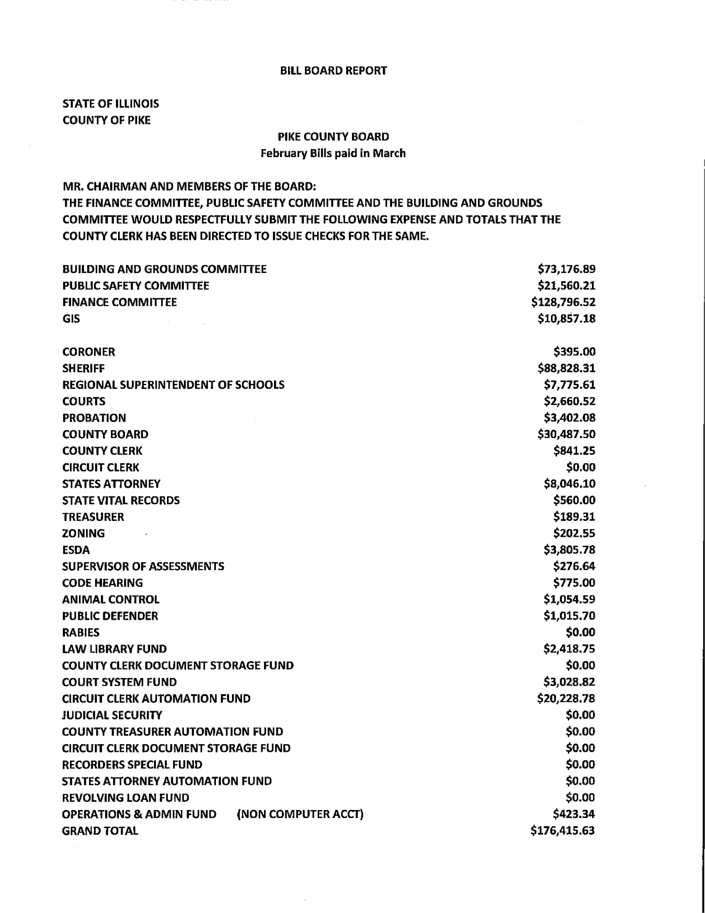
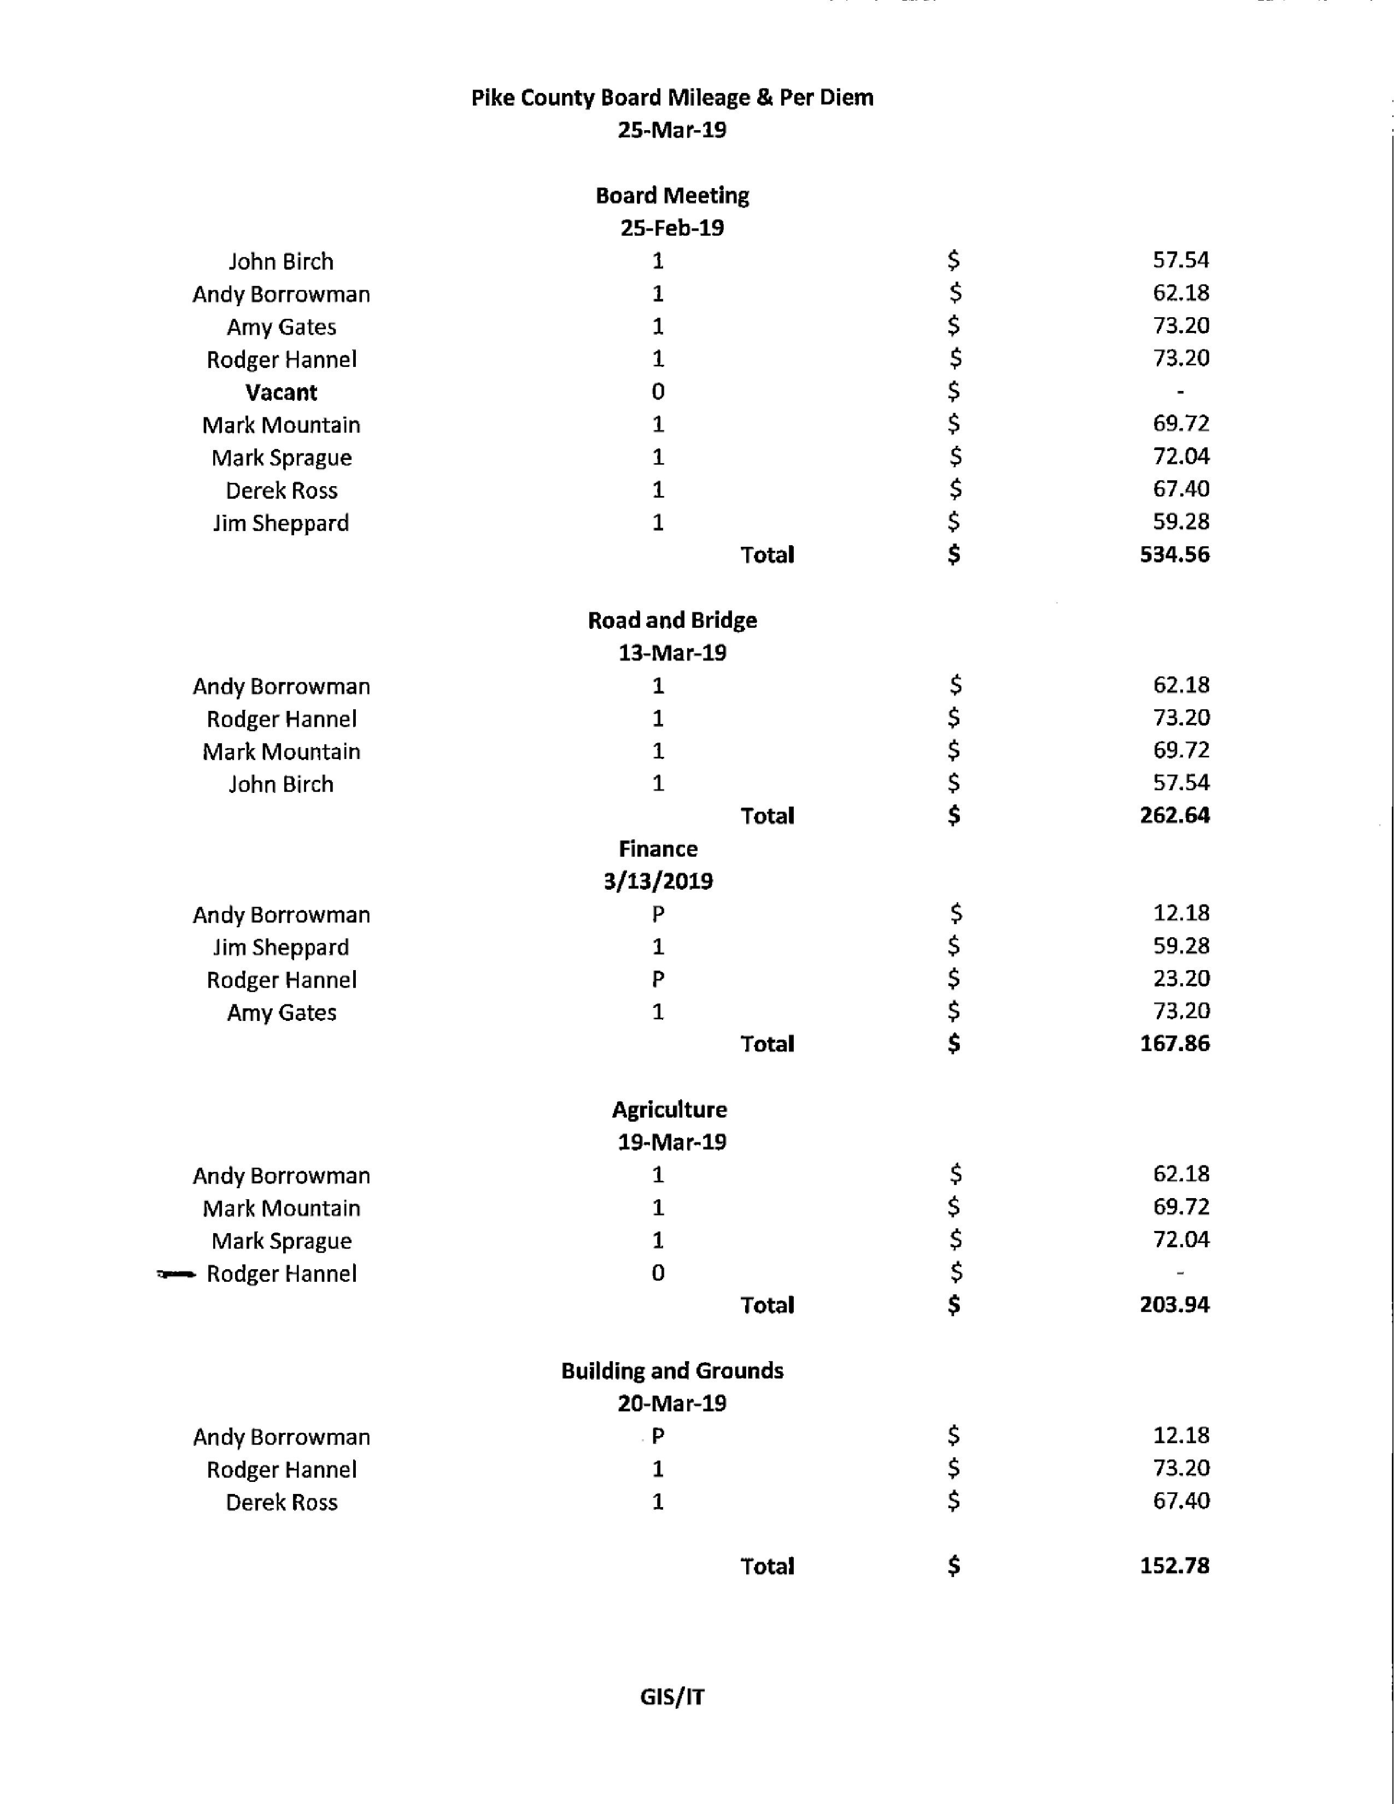
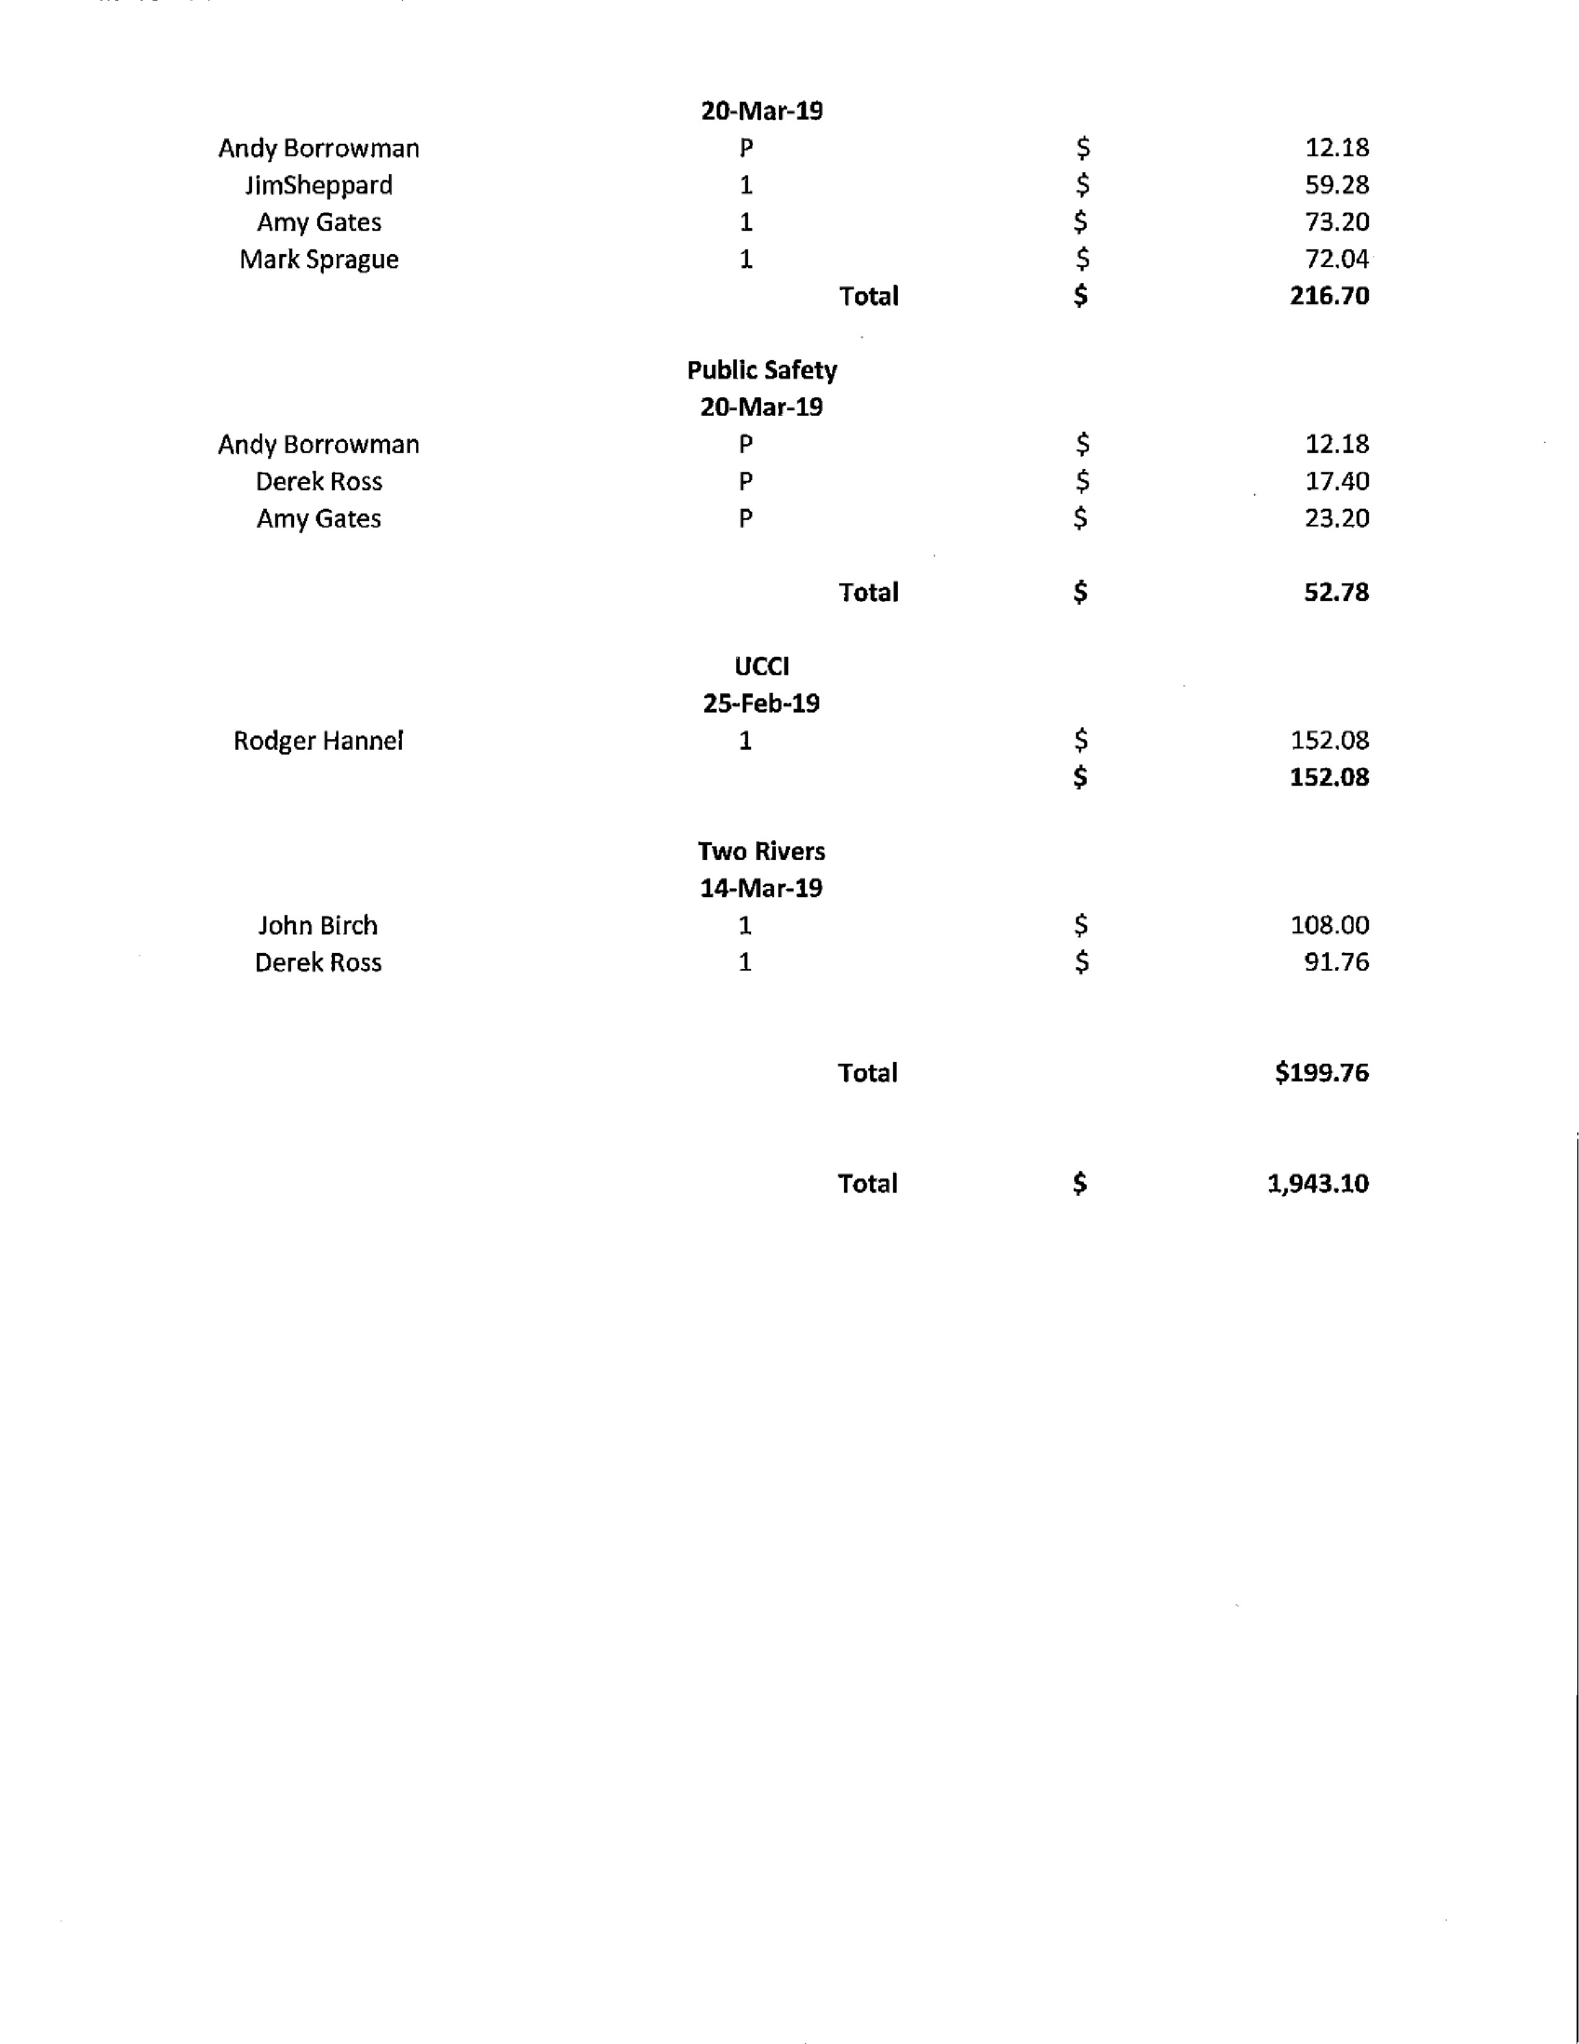
Questions from the Press and Visitors
Brenda Middendorf stated her 2012 application to host a free residential Household Hazardous Waste Collection was approved by IEPA and will be held February 13th, 2019 at the Western Illinois Fair Grounds. She also stated that the spring “landfill day” will be May 14th, 2019 and residents are allowed to bring one pickup load of household type of garbage and dump it for free.

Closed Session Pursuant to 5 ILCS 120/2(C)(11) Possible Pending Litigation
Motion to enter closed session made by John Birch, seconded by Rodger Hannel. Voice vote 6-1, closed session was entered at 8:48 p.m. and adjourned at 9:37 p.m.

Board voted unanimously to direct the State’s Attorney to reject the offer on the table concerning an employee back pay dispute.

Mark Sprague made the motion to accept the vote and reject the offer, seconded by John Birch. Voice vote was 7-0, motion passed.

Adjournment
Motion was made by Amy Gates and seconded by Tom Lewis to adjourn the meeting. Voice vote was 7-0, meeting adjourned at 9:40 p.m.

