PIKE COUNTY BOARD MEETING MINUTES

February 25th, 2019

The regular monthly meeting of the Pike County Board was held on February 25th, 2019 at 7:00 PM in the Pike County Courthouse by Chairman Andy Borrowman. Dr. Calvin Warpula gave the invocation and Chairman Andy Borrowman led the Pledge of Allegiance. Chairman Andy Borrowman asked County Clerk, Natalie Roseberry, to call the roll. Those answering the roll call were John Birch, Andy Borrowman, Amy Gates, Rodger Mark Mountain, Derek Ross, Mark Sprague and Jim Sheppard.

APPROVAL OF MINUTES OF JANUARY 23RD, 2019 PIKE COUNTY BOARD MEETING

John Birch made a motion to approve January 23rd, 2019 Pike County Board minutes. Mark Mountain seconded the motion. Voice vote was 7-0 to approve.

APPROVAL OF MINUTES OF FEBRUARY 19TH, 2019 SPECIAL COUNTY BOARD MEETING

Amy Gates asked Clerk Natalie Roseberry to amend the minutes to include her comment that she has a potential conflict with Monday night meetings due to Church commitments and that Wednesday’s would be better for her. Mark Mountain made a motion to approve the amended minutes. John Birch seconded the motion. Voice vote was 7-0 to approve.

ACTION ON PROPOSED SALARY INCREASE FOR NON-UNION COUNTY EMPOYEES TO MATCH INCREASE FOR UNION 965 EMPLOYEES

Rodger Hannel made a motion to increase non- union employees to match the 965 increase. Mark Mountain seconded the motion. Voice vote was 7-0 to approve.

VOTE ON IDOT HUMAN SERVICE TRANSPORTATION REPRESENTATIVE
Chairman Borrowman states they would not be voting at this meeting on the Representative and the question was skipped.

ACTION ON IDOT’S REQUEST FOR SALE OF PROPERTY AND EASEMENT FOR ADA RAMP CONSTRUCTION AT PIKE COUNTY GOVERNMENT BUILDING
The Pike County State’s Attorney, Zachary Boren, looked at the proposed agreement with Chris Johnson, the Pike County Engineer, and stated that the proposed agreement would be IDOT paying Pike County for a small amount of property to make the sidewalk in front of the Government Building ADA accessible. Mr. Bored stated it is the NE corner of the property and it isn’t really a necessary piece and they are going to pay us for it and make the improvement. Motion was made to approve by Mark Sprague and seconded by John Birch. Derek Ross expressed concerns on why this was not brought up to the Building and Grounds committee. Chairman Borrowman stated that the proposal was sent directly to him and he forwarded it to the State’s Attorney. He stated it was his mistake not to submit it to the Building and Grounds committee. Mark Mountain inquired about the time frame on the project and Chairman Borrowman stated it probably wouldn’t commence until the summer and that the proposal can be sent to the Building and Grounds committee. Mark Sprague withdrew his motion to approve and Chairman Borrowman stated that the proposal will be sent to the Building and Grounds committee and let them refer back to the board.

APPOINTMENT TO THE 708 MENTAL HEALTH BOARD; DAWN MILLER AND CHRISTIE MENDENHALL
Motion to appoint Dawn Miller and Christie Mendenhall to the 708 Mental Health Board made by Rodger Hannel. Mark Mountain seconded. Voice vote 7-0 to approve appointments.

APPOINTMENT OF ZACHARY BOREN AS THE COUNTY’S FREEDOM OF INFORMATION ACT DESIGNEE PURSUANT TO 5 ILCS 140/3.5(a).
Pike County State’s Attorney explained that the person appointed as the designee must complete training once a year regarding the Freedom of Information Act. He stated that practically speaking, department heads can appoint an in office designee and if they have questions they would then go to Mr. Boren as the State’s Attorney so it makes sense. Mr. Boren stated that if we ever get a County Administrator that could be one of their jobs. Motion to approve made by Mark Mountain. John Birch seconded the motion. Voice vote 7-0 to approve designation.

APPOINT NATALIE ROSEBERRY AS THE COUNTY’S OPEN MEETINGS ACT DESIGNEE PURSUANT TO 5 ILCS 120/1.05(a).
Motion to approve nomination made by Rodger Hannel. Seconded by Mark Sprague. Voice vote was 7-0 to approve designation.

PROPOSED AMENDMENT TO THE PIKE COUNTY ZONING ORDINANCE TO ALLOW FOR WIND TURBINES TALLER THAN 500 FEET IF APPROVED BY FAA
Chairman Borrowman stated that this has been under discussion for several months and needs to go to the Zoning Board of Appeals. Zoning Administrator Fred Ruzich stated that the Board is scheduled to meet on March 14th, 2019 to discuss the proposition. Zachary Bored gave a summary stating that “Illini Winds” is a company that is actively pursuing the project and agrees that it needs to be addressed through the Zoning Board of Appeals and then back to the County Board with a recommendation. Part of the next agenda item is that Patrick Engineering will be hired by the County to represent it and Illini Winds hopes that action can be taken at the March County Board meeting to approve the ordinance and to approve a project of wind turbines if FAA approved. Mark Sprague asked Mr. Boren if they are requesting a hearing or if the Zoning Board of Appeals have to approve? Mr. Boren stated that the public can attend the Zoning Board meeting for the public hearing and a recommendation will return to the County Board. Chairman Borrowman states that the County Board is not asked to take action on the amendment until a recommendation is made from the Zoning Board of Appeals.

APPROVAL OF CLIENT PROJECT AGREEMENT FOR PROFESSIONAL SERVICES WITH PATRICK ENGINEERING, WITH COST TO BE PAID BY ILLINOIS WINDS, LLC.
Zack Boren stated that Patrick Engineering has already made sure the engineering and the permit process has been done correctly. Illinois Winds is asking to allow a change in the zoning requirements. Illinois Winds would bear the cost of the project and the County would not be liable for any funding. Mark Mountain made a motion to approve the agreement. Mark Sprague seconded. Voice vote was 6-1, motion approved.

VOTE TO APPROVE WM. DANIEL KENDRICK AND GARY CLARK TO THE NEW CANTON CEMETERY ASSOCIATION FOR A TERM EXPIRING JANUARY 31ST, 2025.
Motion to approve appointments made by Any Gates and seconded by John Birch. Voice vote was 7-0, motioned approved.

BOARD ACTION PROPOSED AMENDMENT TO ZONING ORDINANCE, GRANTING PETITION TO RE-ZONE BY STEVE BRINK INVOLVING TWELVE CONTIGUOUS PARCELS IN BARRY TOWNSHIP.
Fred Ruzich stated that he sent all board members the information. Prior to 1995, the land was zoned as agriculture (there are no maps back that far) but it has been used for the extraction of gravel. Mr. Brink would like to build a home and will be unable to sell the gravel due to an agreement with Western Illinois Stone. The Zoning Board of Appeals recommendation is to return the property back to an agriculture zoning. Mr. Boren wanted to clarify that the vote was to amend the ordinance. A motion to approve the amendment was made by Mark Sprague and seconded by Mark Mountain. Voice vote of 7-0, motion approved.
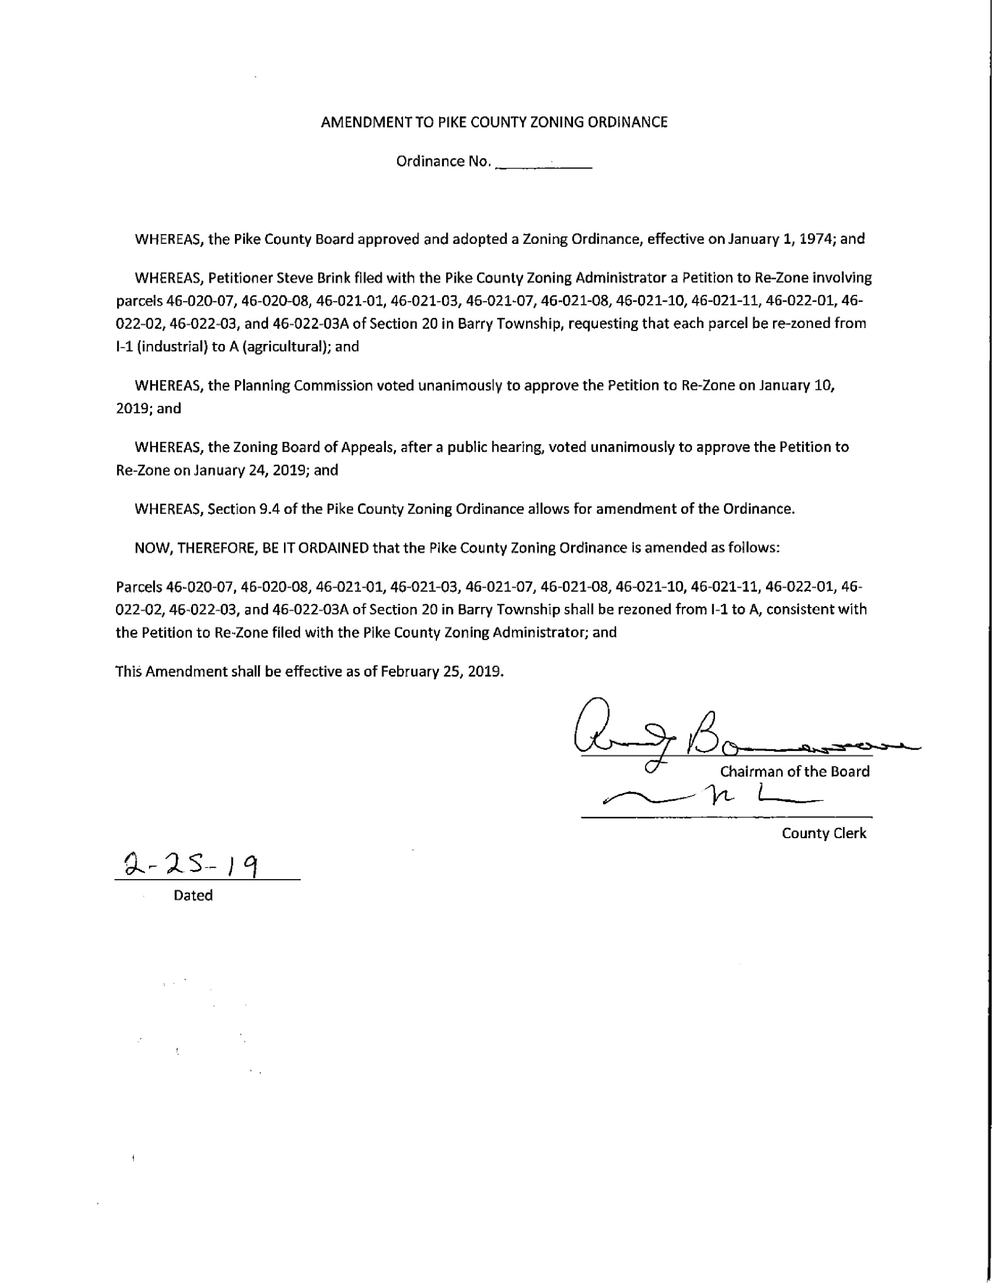

APPROVAL OF FEES FOR PIKE COUNTY HEALTH DEPARTMENT FOOD LICENSE 2019
Jane Johnson informed the board members that the proposed fee schedule that was approved by the Pike County Board of Health is in their packets and the Health Department is asking for their approval. Jane stated that she is reluctant to ask for fees, however, the state hasn’t made an increase in funding to the Health Department for over 25 years and understands that it is relying on the local government and community to help maintain. A majority of other counties within the state impose these funds. These fees include annual event fees and business fees as well as late fees for incompliance. She stated that these fees are to support the Food Safety program and would not benefit any other programs that the Health Department administers. Mark Mountain had questions regarding the finances and current funding of the Health Department regarding grants etc. He asked Mrs. Johnson if the Health Department is only mandated to provide programs to which she answered “yes.” Mr. Mountain stated he did some research on the website and there is a lot of information but regarding finances, he would like to know more. Mark Sprague agreed. Both Mr. Mountain and Mr. Sprague expressed an interest in meeting with the Pike County Health Department Administrators to gain a better understanding of their needs. Anita Andress offered for any board member to come to the Health Department and see what they are operating with as well as invited them to attend the Board of Health meetings that occur quarterly. Mark Mountain made the suggestion that the board might consider tabling this find out more information. Anita Andress confirmed her offer to have any board member visit with the Health Department administrators to gain a better understanding. Jane Johnson addressed that this is a “user fee” and it would not affect the current inspection program. Rodger Hannel had a few financial questions that led into the climate of the other programs offered. Mrs. Andress addressed the fees they receive from Birth and Death records as well as Environmental Health and Food Safety. She outlined a few situation where a lot of money has been spent on investigations and on behind the scenes work to ensure the citizens safety. She also addressed the Home Health Program, to which she stated that is not for profit. Mark Mountain questioned that with all of the programs, how do they keep it going? Anita Andress stated that it is a struggle and they do the best they can with what they have and everything is stretched. She stated that insurance companies are behind in their payments to them and currently the VA owes them $ 40,000.00. She stated that they manage their budged with help from their employees and through other non-guaranteed funding. She stated the new dental clinic was purchased through a grant and was able to help the Health Department as a while. They work with the Western Illinois Strategic Alliance to try and keep things going and she would like to offer her services to anyone who would like to see the inner workings of the department. Mark Sprague addressed letter to the editor in the paper by Sheila Holcomb and he applauds the work of those at the Health Department and knows the work is important. He would like to see more information and would also like to see the county’s audit report before voting on a fee schedule. Rodger Hannel asked if it would be a problem to table the vote and Mrs. Andress stated that she is ok with it but the earliest she would like it addressed would be April due to scheduling issues and that their time is valuable and they need to get back to work. Mark Sprague asked if Church’s have to pay and Mrs. Johnson stated they are already inspected and it would be covered under an annual fee. Mark Sprague also asked about special events to which Mrs. Johnson stated that they will issue temporary permits up to two weeks in advance because scheduling is important. Chairman Borrowman requested comments from Rob Holcomb who stated that after a lot of thought he agreed with Mrs. Andress that his time was valuable and given consideration to those affected the Health Department does a great job and he doesn’t see how adding a new fee schedule would change the current job they do. He expressed concerns as a business owner of the new $15 an hour wage increase and what it will do to his business and thinks that there should be a better solution then to require small business to pay as they are already hurting and just trying to stay in business. Chairman Borrowman thanked him for his remarks and his commitment to this topic. Zack Boren asked about the current motion to table and when it would be tabled to. Mrs. Andress stated that she would prefer April-June. The motion to table until April was made by Rodger Hannel and seconded by Jim Sheppard. A roll call vote was taken and the motion failed 3-4. Chairman Borrowman asked for a motion to approve as presented. Rodger Hannel made the motion to approve the fee schedule and was seconded by Jim Sheppard. Roll call vote was taken and the motion failed with a vote of 3-4. Chairman Borrowman declared the motion defeated and Mark Sprague asked if the board could bring it back at any time. Derek Ross questioned if the fees were the issue and if it could be passed with no fees. Chairman Borrowman stated that the proposal needed to go back to the Public Safety committee for a recommendation. Jane Johnson stated that she is looking forward to working with the board. Mark Mountain and Mark Sprague stated they would schedule a time with the Health Department to get some more information. John Birch stated he would like to be included as well. Chairman Borrowman stated the board would take a short break.

Committee Reports
Finance
The Finance committee of the Pike County Board met at 5:00 p.m. on Wednesday, February 13th, 2019 in the conference room of the Pike County Government building. Members present were Rodger Hannel, Amy Gates, Jim Sheppard and County Board Chairman Andy Borrowman. County Clerk Natalie Roseberry, County Treasurer Scott Syrcle, Zack Boren, Brenda Middendorf and Justin Krohn were also present.
Routine bills in the amount of $169,852.99 were approved for payment on a motion by Rodger Hannel and a second by Amy Gates.
Brenda Middendorf made a presentation about the County’s efforts to comply with the state mandated close out of the revolving loan fund. We reviewed the status and decided we would discuss the process with the whole board. Brenda also reminded us she had not gotten payment on a PCEDC invoice she had sent in December for $25000.00. Justin gave the committee a briefing on the Local Efficiency Assessment Program.
We then discussed the raises for the non-union employees. It was determined that Darwin, Joyce, Sherry, Debbie and Fred would get the same increase as the union contract which was recently settled. With Joyce in probation that amounts to an adjustment of $5. Leecia Carnes is to receive $1320.00 in reflection of her advanced degree. This was all done on a motion by Rodger Hannel and second by Amy Gates. Motion Carried.
Scott Syrcle opened bids for the loan for the liability insurance fund. There were only two bidders
United Community Bank 3.39%
Farmers State Bank 3.27%
Amy Gates made a motion to accept the Farmers State Bank bid. Rodger Hannel seconded, and motion carried. Scott also brought up the need for the authority to transfer funds out of accounts for reimbursements to the general fund when the funds become available. There was a discussion as to whether such a resolution was necessary since the budge authorizes these transfers.
Amy Gates made a motion to adjourn. Rodger Hannel seconded. Motion carried.
Meeting adjourned at 6:51 p.m.
Zack Boren asked if the raises were all retroactive to December 1st, 2018 and Jim Sheppard stated yes they were.
A motion to approve the minutes was made by Mark Sprague and seconded by John Birch. Voice vote of 7-0 motion carried.
A motion was made by Derek Ross to approve the resolution for the Liability Insurance Fund and seconded by Mark Mountain. Voice vote was 7-0 motion carried.
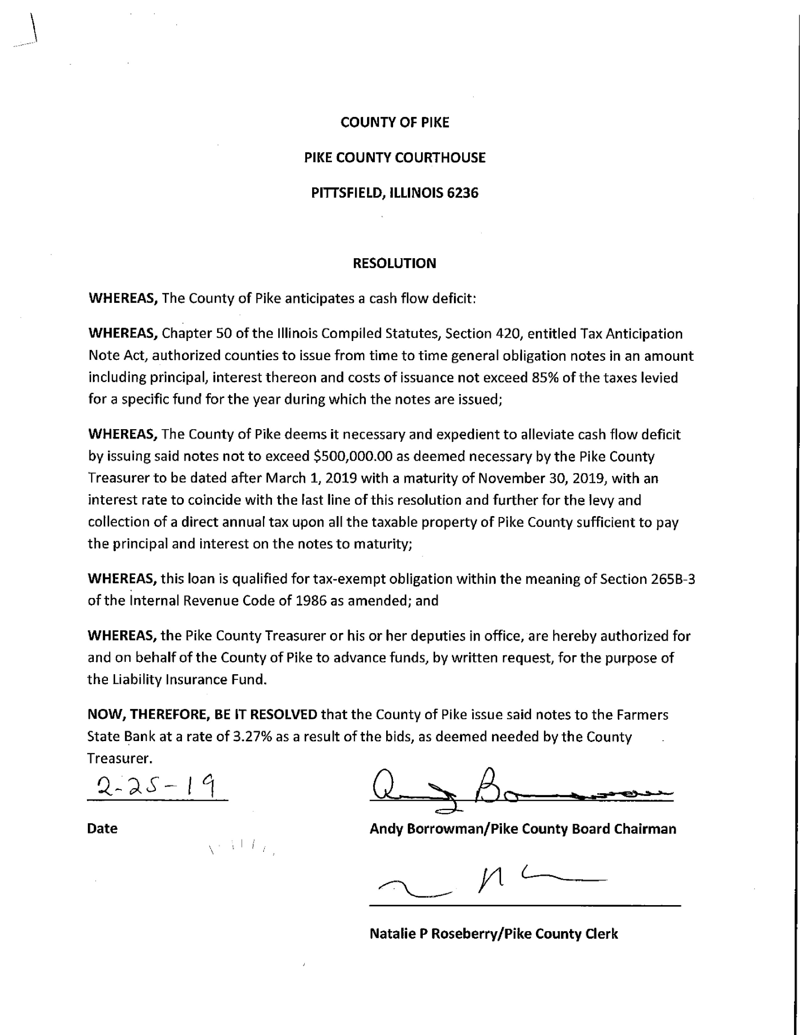

Building and Grounds
The Building and Grounds Committee met on Wednesday, February 20, 2019 at 3:30 p.m. at the Courthouse Annex Building. Present were Rodger Hannel, Derek Ross, Darwin Feenstra, Andy Borrowman and Natalie Roseberry.
Natalie stated that her office is reorganizing some space in order to make it more efficient for her staff and the Public. Presently, Natalie has a need to locate a longer conference table for this space. Also, Natalie mentioned that they need to find space for some old equipment and/or dispose of some outdated equipment. The B & G committee suggested that inventory of excess or outdated equipment and computers needs to be made and be shared among department heads and staff. Perhaps the GIS committee would help with what to do with older computers.
Natalie also mentioned that there is a gray area on which fund or department to pay some bills she has received from Adams Experts. Again, the B & G committee recommended this be discussed at the next Administrators meeting. There have recently been some high phone charges to check out some static issues. Also a review of our phone maintenance program needs to be done. This could also be discussed with the GIS committee.
Darwin Feenstra stated there was a major problem with the boiler/chiller connection and the existing system circulation pumps. He received a id from Xcell mechanical service company to fix the problem. The bid was $14,832.00. After much discussion, Derek Ross made a motion to approve the bid, and Rodger Hannel seconded the motion. Motion passed.
A second bid was tabled that would do some re-piping of the system return heater. The bid was for $6,770.00.
An estimate and bid specs for proposed roof work at the west section of the courthouse annex was submitted from Joe Petty. Bids for the work will be pursued by Sheriff Greenwood to roofing vendors to complete this job. A motion was made by Derek Ross and seconded by Rodger Hannel to approve the monthly bills totaling $108,148.56. The motion passed.
Derek Ross made a motion to adjourn at 4:15 p.m., and Rodger Hannel seconded. The motion passed.
A motion to approve the minutes was made by Mark Mountain and seconded by Mark Sprague. Voice vote of 7-0 motion passed.
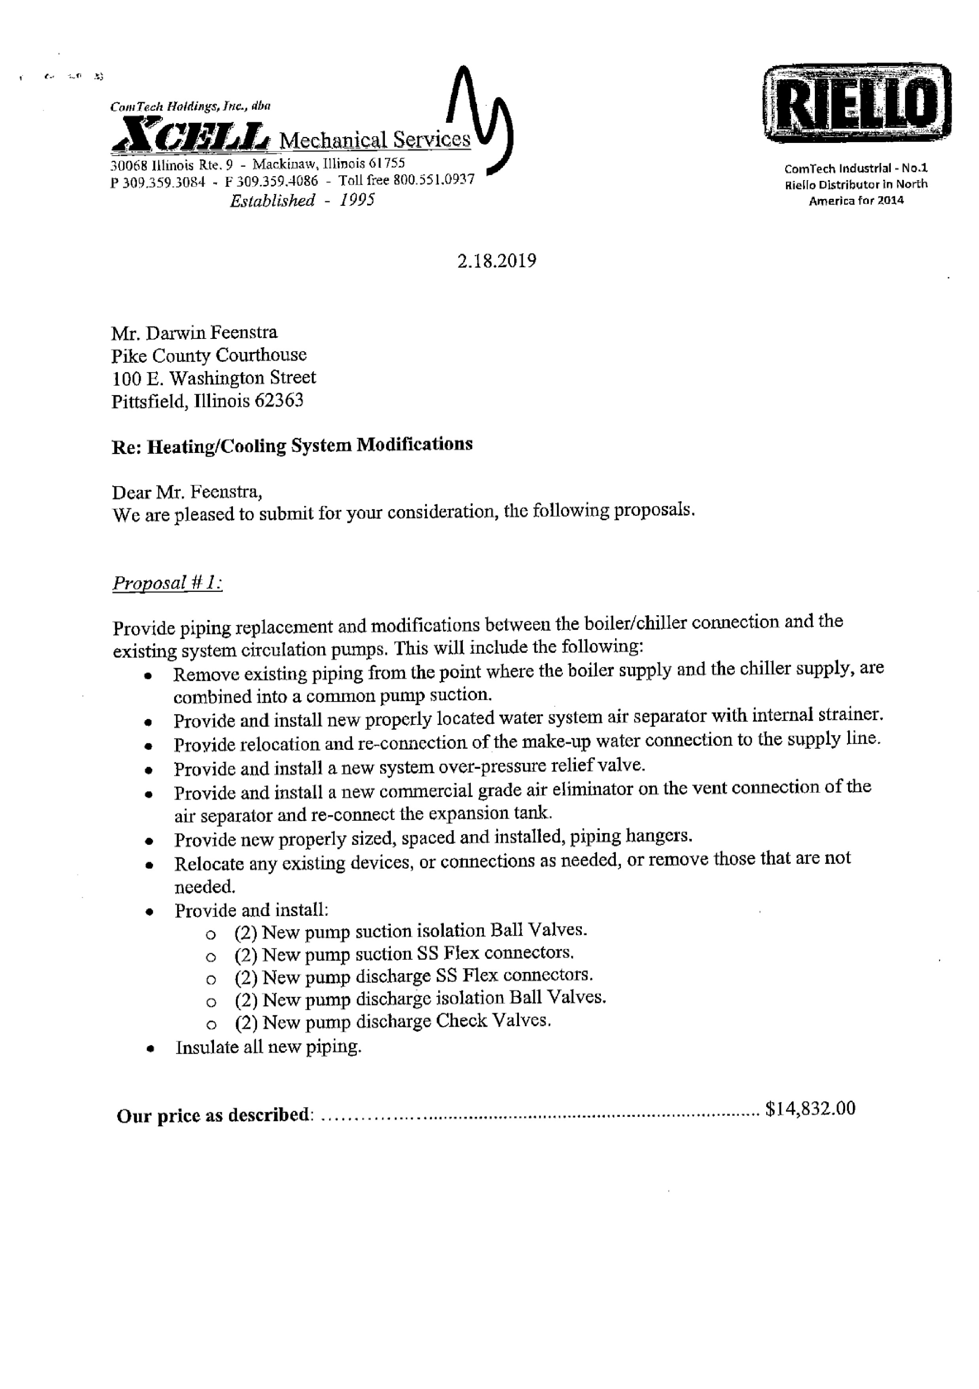

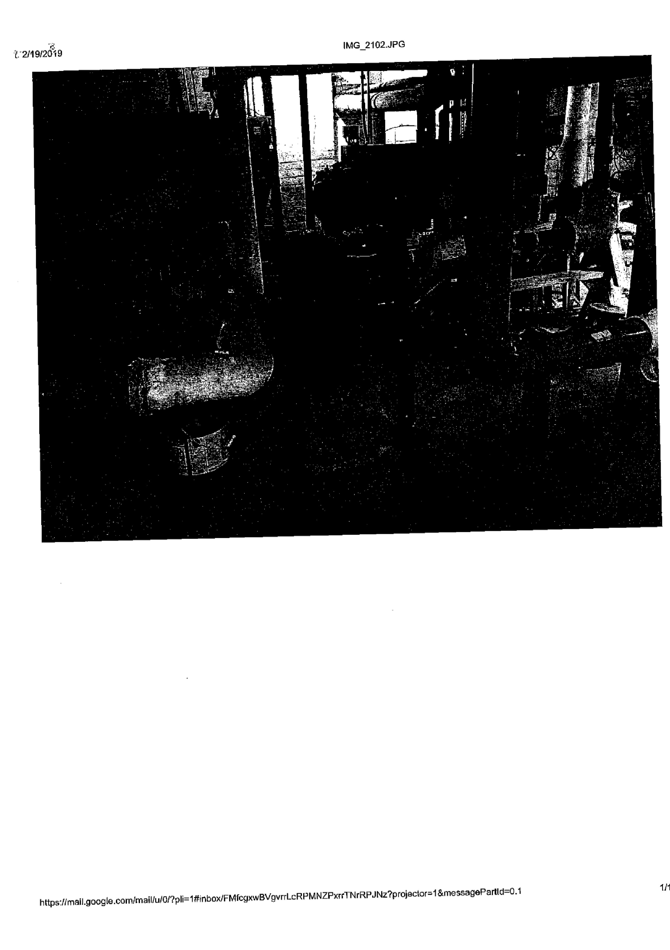
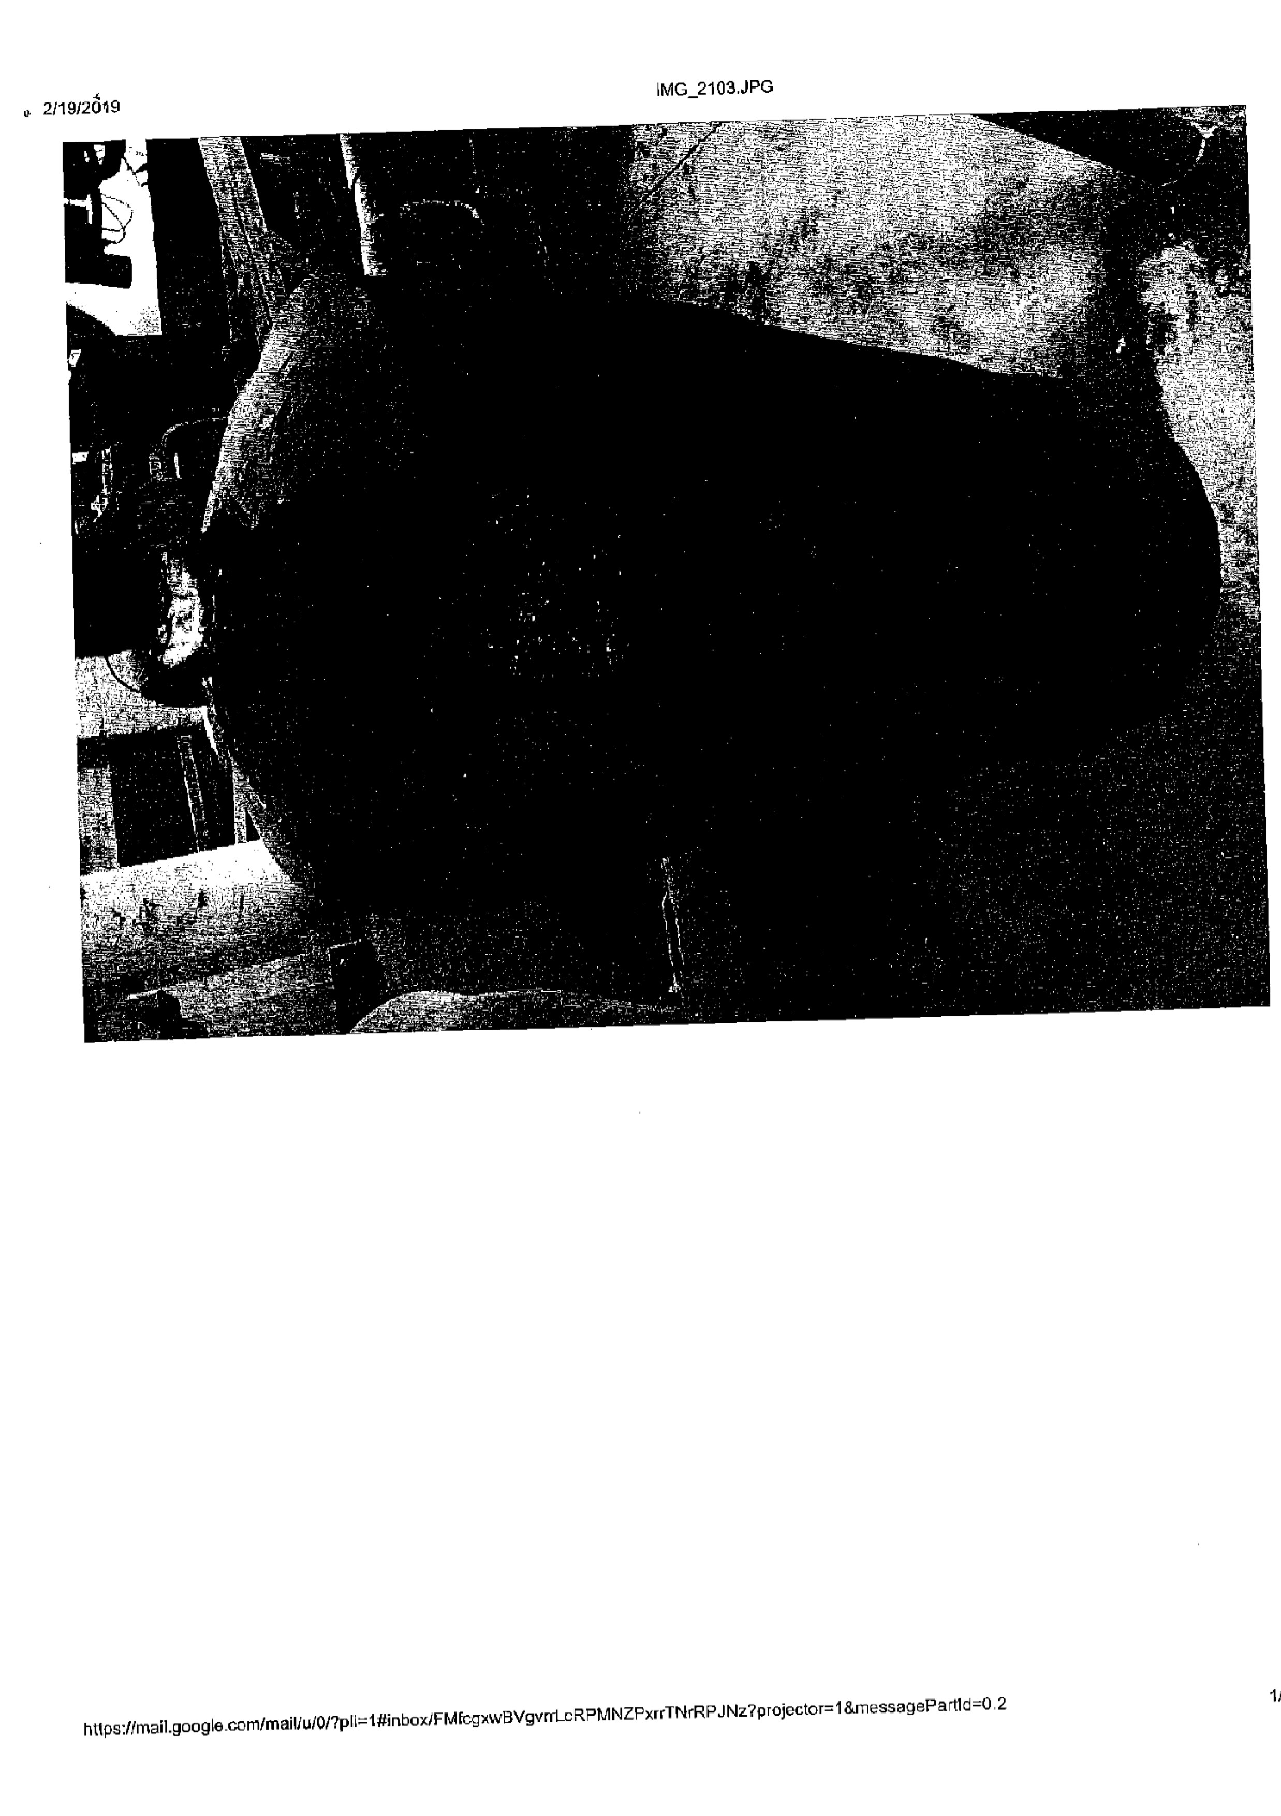

Highway Committee
The Road and Bridge committee met Wednesday, February 13th, 2019 at 3:30 p.m. at the County Highway Department. Those present were Rodger Hannel, Mark Mountain, John Birch and Andy Borrowman. Other present were Chris Johnson, County Engineer; Kim Mountain, Perry Twp Supervisor; Richard Goetze, Griggsville Twp Road Commissioner, and Jim Lewis, New Salem Twp Road Commissioner. There was no public comment. A motion was made by John Birch, seconded by Mark Mountain to pay claims per claim reports dated February 13, 2019. All in favor. Motion carried. A motion was made by Mark Mountain seconded by John Birch to approve the Highway department’s Six-Month report as presented. All in favor, motion carried. A motion was made by Mark Mountain, seconded by John Birch to approve the following Half Aid to Bridge Petitions:
- Spring Creek Township: Replacement of “Historic Bridge” Section 17-24112-00-BR, located on Township Road 376 (Spring Creek Road) over the South prong of Spring Creek. Total Project cost is estimated to be $563,533.00. 80% ($450,826.40) to be paid by Township Bridge Fund, 20% ($112,706.20) paid by Spring Creek Township, of which they have petitioned for Half Aid to Bridge in the sum of $56,353.30.
- Martinsburg Township: Replacement of two current 6’ high X 20’ wide culverts located on Cold Run Road at the Section line of Sections 26 and 35. The total project cost is estimated to be $8,500.00. Martinsburg Township petitions the County for Half Aid to Bridge in the sum estimated to be $4,250.00.
- Montezuma Township: Replacement of 48” diameter CMP x 40’ long located on 457th between 170th ln and 175th Ave in section 30. The total project cost is estimated to be $2,336.00. Montezuma Township petitions the County for Half Aid to Bridge in the sum estimated to be $1,168.00.
- Deery Township: Replacement of 36” diameter CMP X 40’ long located on 275th St. 1-mile north of 240th Av in Section 19. The total project cost is estimated to be $6,200.00 Deery Township petitions the County for Half Aid to Bridge in the sum estimated to be $3,100.00
- Griggsville Township: Replacement of bridge, Section 19-09116-00-BR, located on 400th St. in the southwest corner of section 5. Total project cost is estimated to be $287,250.00. 80% ($229,800.00) to be paid by Township Bridge Fund, 20% (%57,450.00) to be paid by Griggsville Township, of which they have petitioned for Half Aid to Bridge in the sum of $27,725.00.
- New Salem Township: Replacement of existing 60’ X 40’ CMP culvert located on 337th ave in the northeast quarter of section 2. The total project cost is estimated to be $4,000.00. New Salem Township petitions the County for Half Aid to Bridge in the sum estimated to be $2,000.00

Half Aid to Bridge Joint Project:
- Griggsville & New Salem Township: Replacement of concrete crossing with culvert located on 390th st I the northwest quarter of section 6, as well as road alignment changes. Option 1: Total estimated project cost is estimated to be $97,323.00. Option 2: Total estimated project cost is estimated to be $81,123.00. Jim Lewis and Richard Goetze discussed why they submitted a petition for the project. They noted the crossing is in bad shape, the culverts are rusting, the road going south is steep, and the road to the north curves as reasons for the project. Chris Johnson noted that he thought the project would be a good improvement but did not feel the project is “necessary” as the statute pertaining to the joint repair process notes in statute 605 ILCS 5/5-501. Chris’ opinion is that the crossing could be used for the foreseeable future and the horizontal realignment of the road is not in the scope of these projects. Minimal approach work is only done when necessary for crossing on these type jobs and the grade of the road is similar to several other typical township roads in the county and nearby. Chris noted that a hydraulic study and survey must be done to finalize a culvert size, establish a vertical alignment, and determine impacts to nearby properties. The estimated cost of a hydraulic study is included in the estimate.

Griggsville and New Salem Townships therefore petition the County for Half Aid to Bridge for option 2 which is estimated to be the sum of $40,561.50. The one-half to be paid by the Townships will be prorated based on assess valuation.

Roll call vote was taken. A motion was made by Mark Mountain, seconded by John Birch to present to the full board for a decision. All in favor. Motion carried

No action on White Bridge

No Closed Session

No New Business

Old Business:
- Facilities: The committee was updated on the collapsed building and future building plans. Approximately $45,000.00 in insurance funds will be available toward a new facility, $30,000.00 immediately and an additional $15,000.00 if rebuilt within 2 years. Chris Johnson discussed a plan with the members to start looking into a new maintenance building along the entire north end of the property. Committee members were in agreement for Chris to start looking into utility issues, financing issues, permitting, and design costs to get a new building built.
- Winter Weather Materials: The committee was also advised that the Highway Department has spent approximately $76,500.00 for salt and sand this winter for treating roads due to bad weather. The figure does not include labor or equipment costs.

A motion was made by John Birch seconded by Mark Mountain to adjourn meeting at 4:49 p.m. Motion carried.
County Engineer, Chris Johnson, addressed the board to summarize the various aid that was applied for. He stated regarding the Joint Aid project that while he felt it would be nice, he did not think it was necessary but agreed that it would be an improvement. Mark Sprague questioned the safety of the current situation and Mr. Johnston stated it could be argued but for that matter it also could all over the county on various roads and bridges. Chairman Borrowman reaffirmed that it would cost the county to do the scope and hydraulic study. Mark Sprague commented on it being nice that Griggsville and New Salem were working together and Mr. Johnson stated it would be a good time to do the project due to new powerlines. Mark Mountain stated this project is necessary and him personally living around there and traveling on the road, it is dangerous. Amy Gates affirmed it was definitely necessary. Chris Johnson stated the statute said “when it is necessary” but doesn’t define necessary. He stated other Griggsville roads have a lower rating to be air. Andy Borrowman asked for input from the Road Commissioners. Mr. Goetze stated that this would straighten the road and they know it is a large project and believe it will come in under the estimate. He stated the road is very dangerous in the winter and also when farmers are hauling grain and they cannot get the Semi through safely. Mr. Lewis stated that they want to fix the problem the way it needs to be done to make it safer. Amy Gates questioned option 1 or option 2. Chris Johnson stated that option 2 is a limited scope.
Motion made to approve Half Aid to Bridge to Spring Creek Township made by John Birch, Seconded by Mark Sprague. Voice vote 7-0 motion passed.
Motion made by Mark Sprague to approve Half Aid to Bridge to Martinsburg Township made by and seconded by Mark Mountain. Voice vote 7-0 motion passed.
Motion Made by Mark Sprague to approve Half Aid to Bridge on Montezuma Township seconded by John Birch. Voice vote 7-0 motion passed.
Motion made by Rodger Hannel to approve Deery Township Half Aid to Bridge seconded by John Birch. Voice vote 7-0 motion passed.
Motion made by Mark Mountain to approve Griggsville Township Half Aid to Bridge seconded by John Birch. Voice vote 7-0 motion passed.
Motion made by John Birch to approve New Salem Township Half Aid to Bridge seconded by Mark Sprague. Voice vote 7-0 motion passed.
Half Aid to Griggsvile and New Salem Township motion made by Mark Mountain to proceed with option 2 and seconded by Mark Sprague. Voice vote 7-0 motion passed.
Amy gates stated that the full report on the Road and Bridge was not read in full to board members.
Motion to approve minutes was made by John Birch and seconded by Mark Sprague. Voice vote of 7-0 and motion passed.
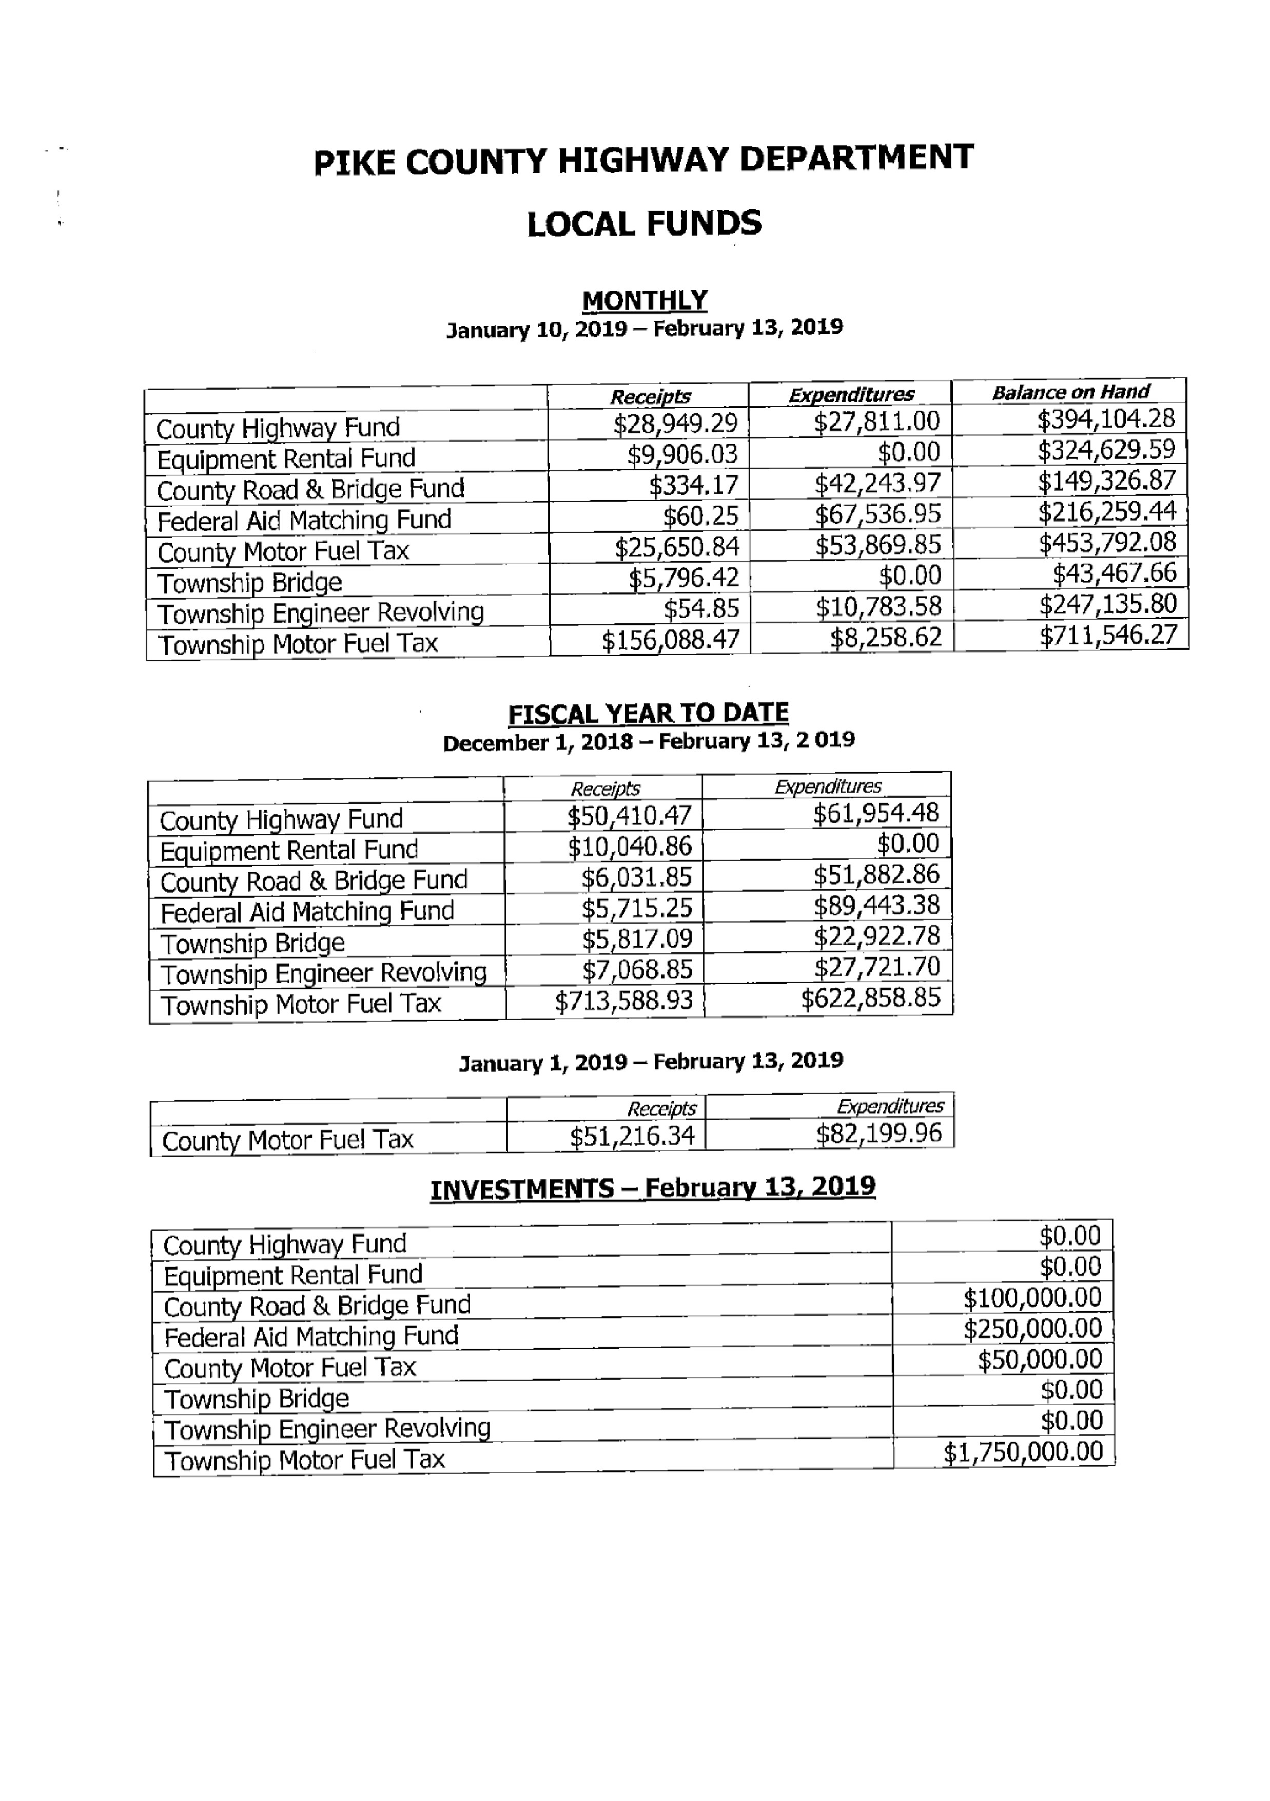
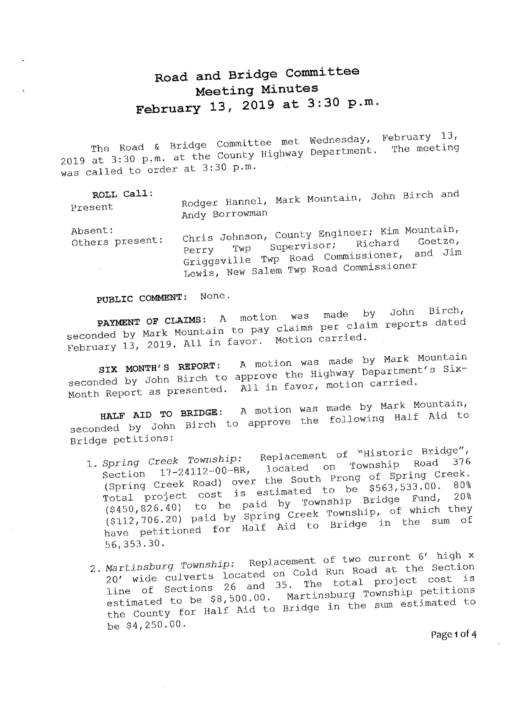
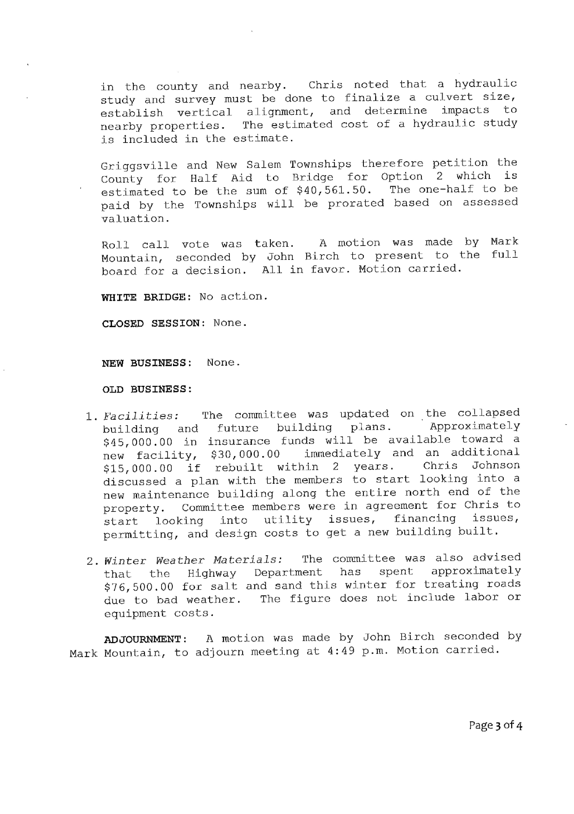
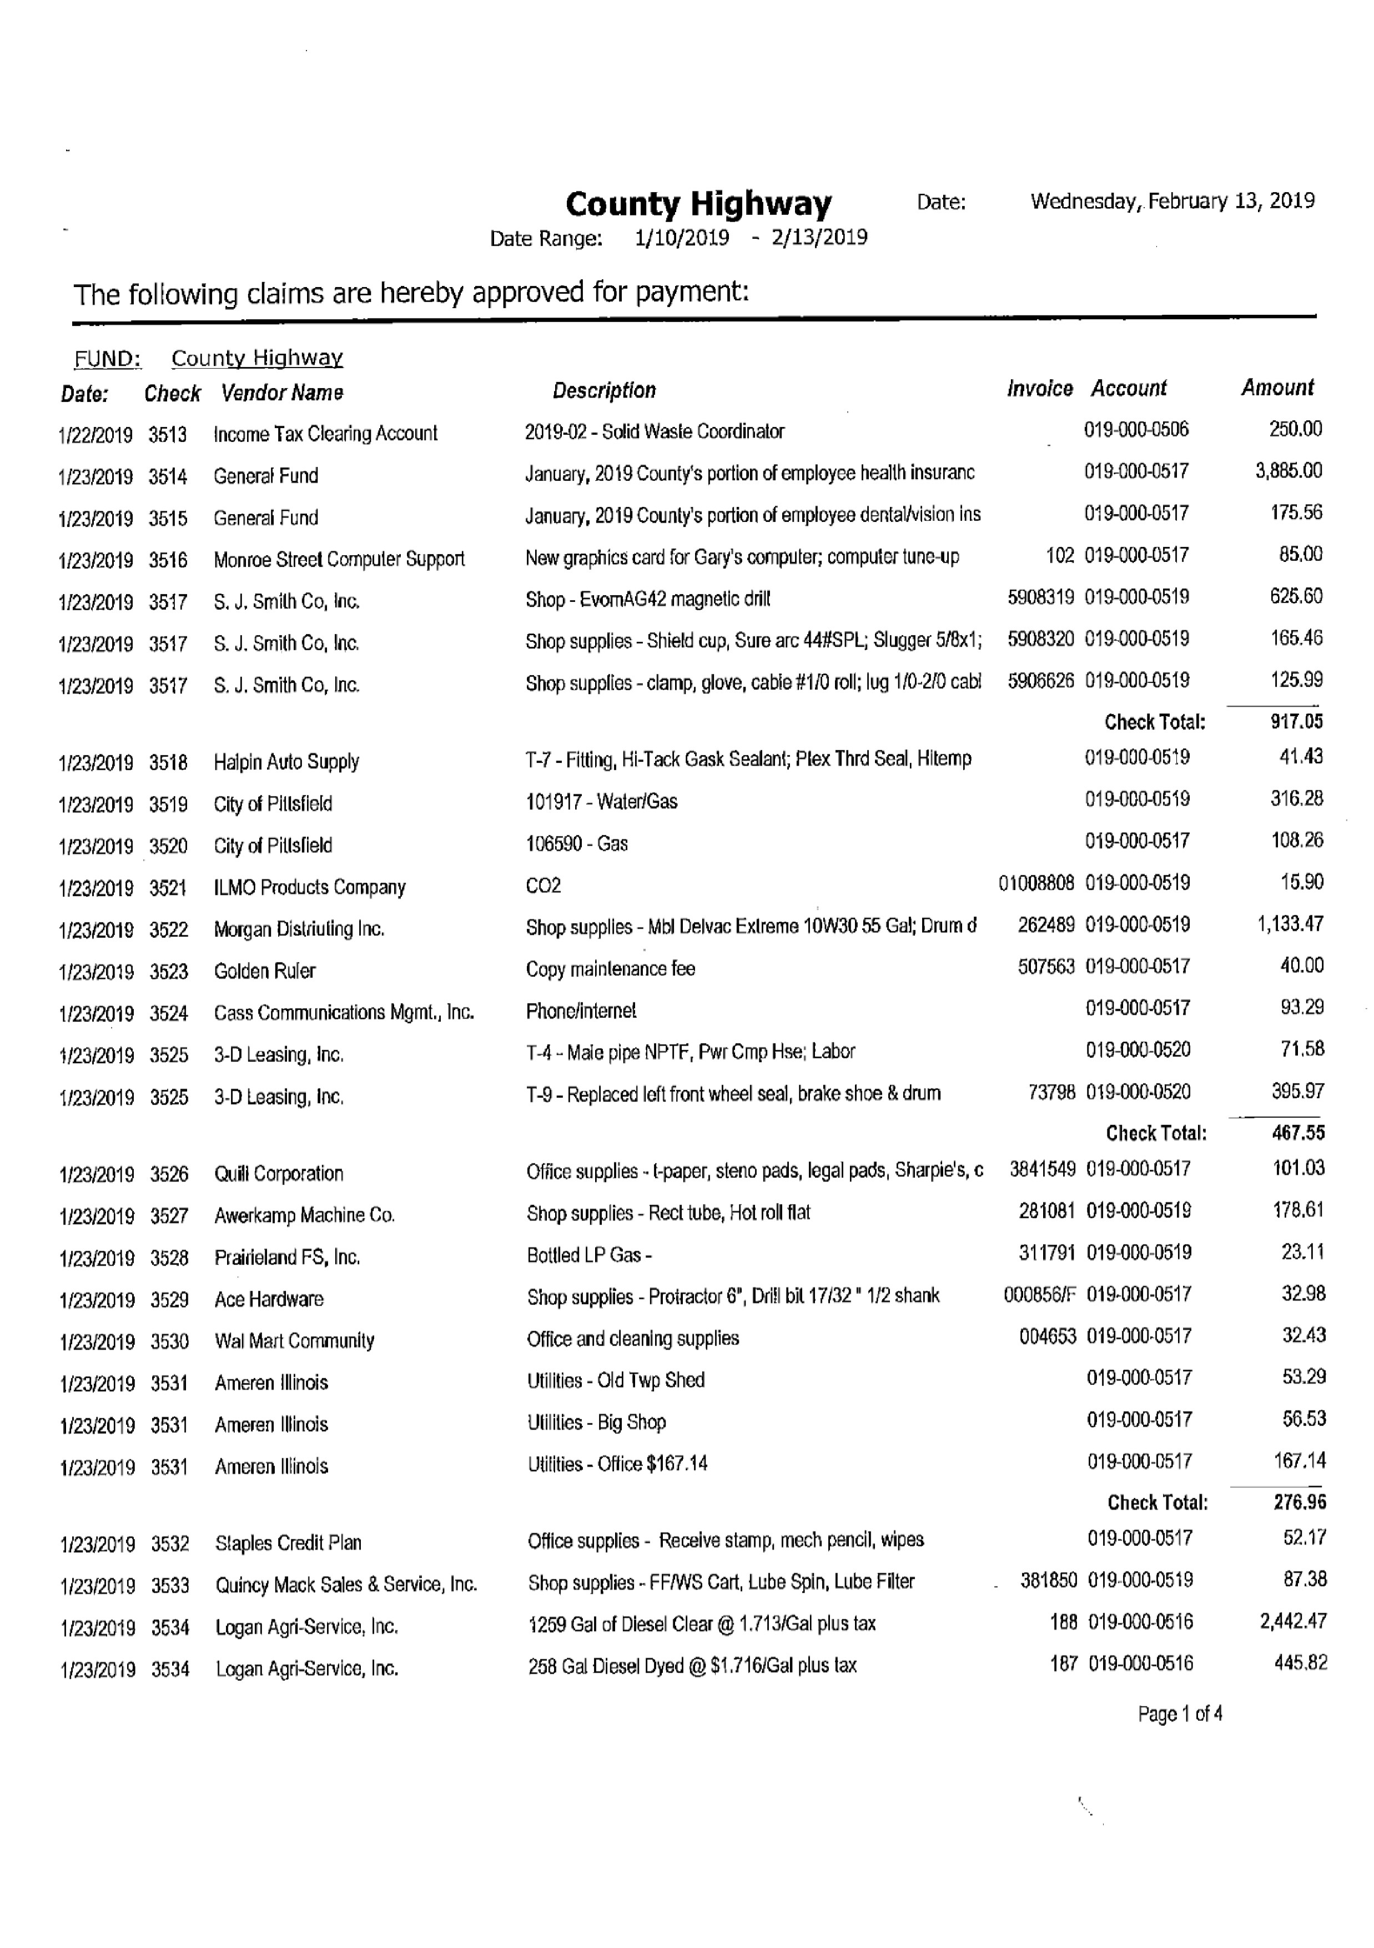
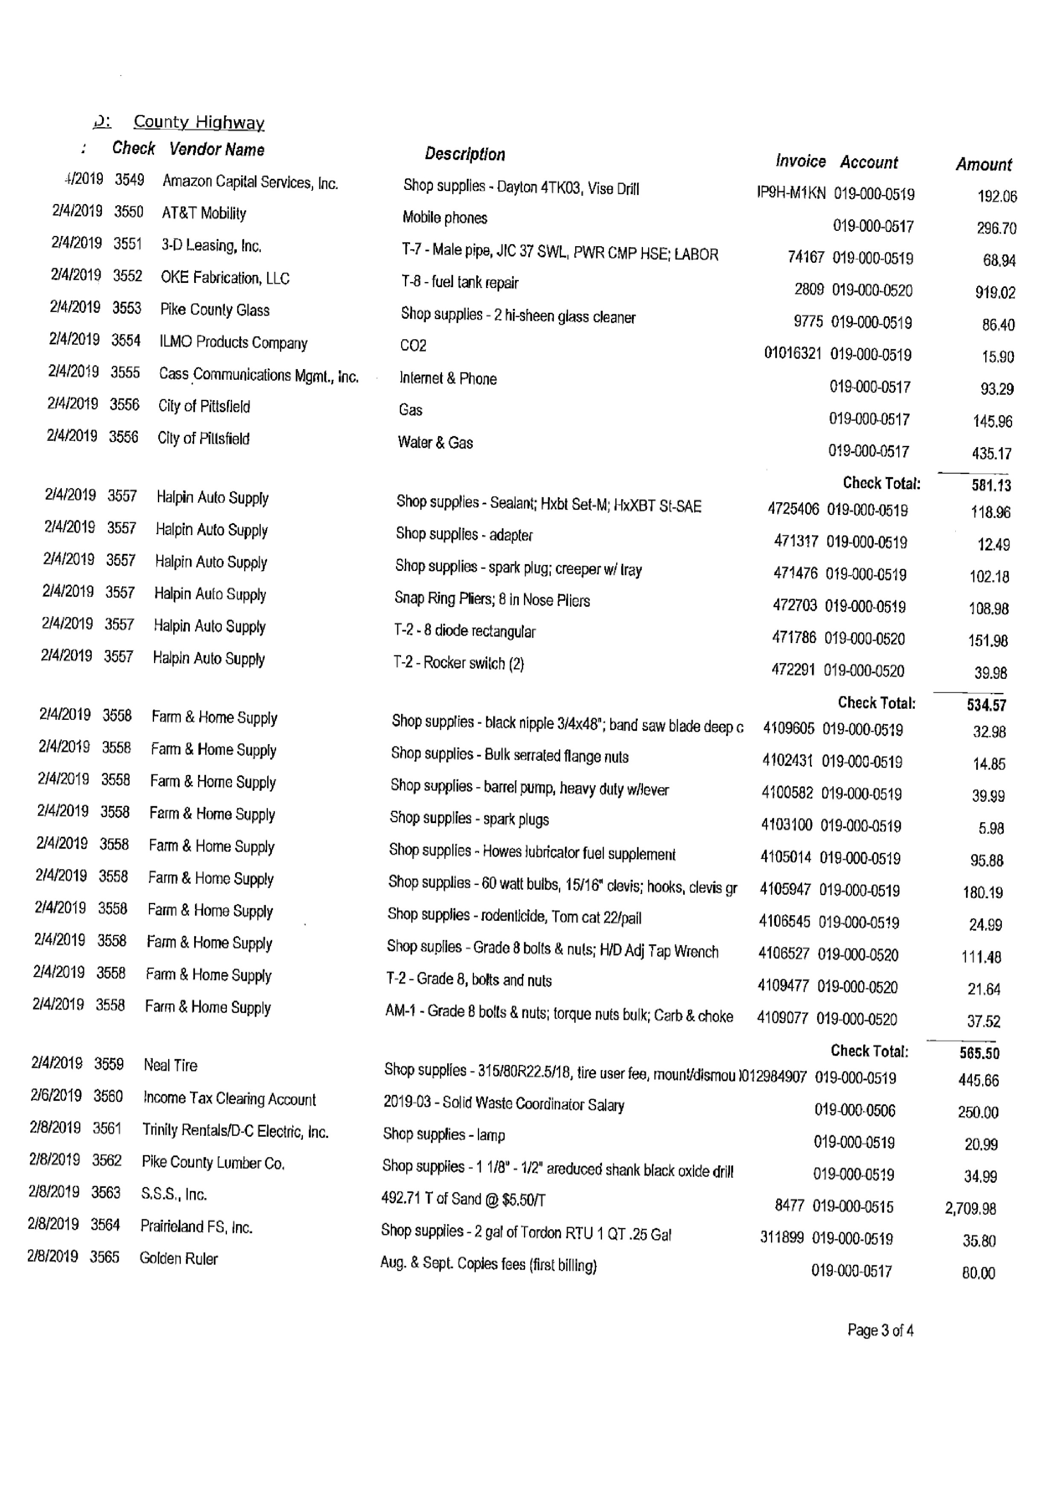
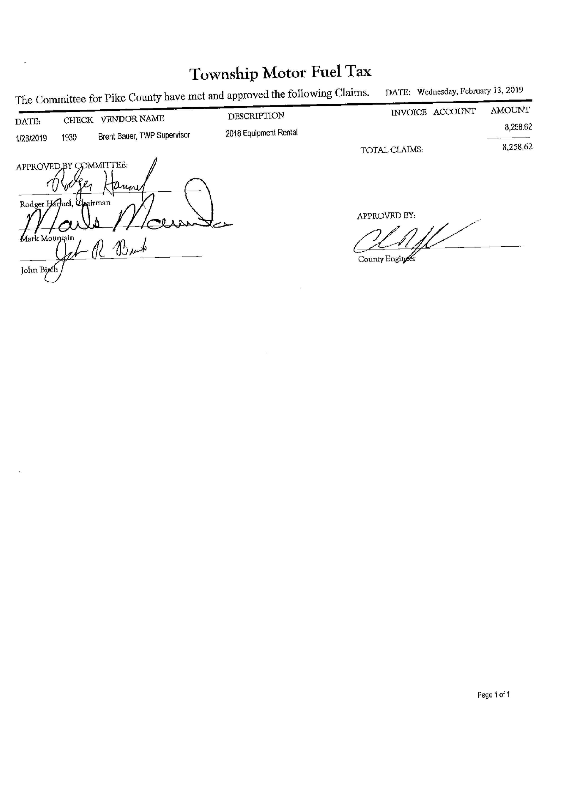
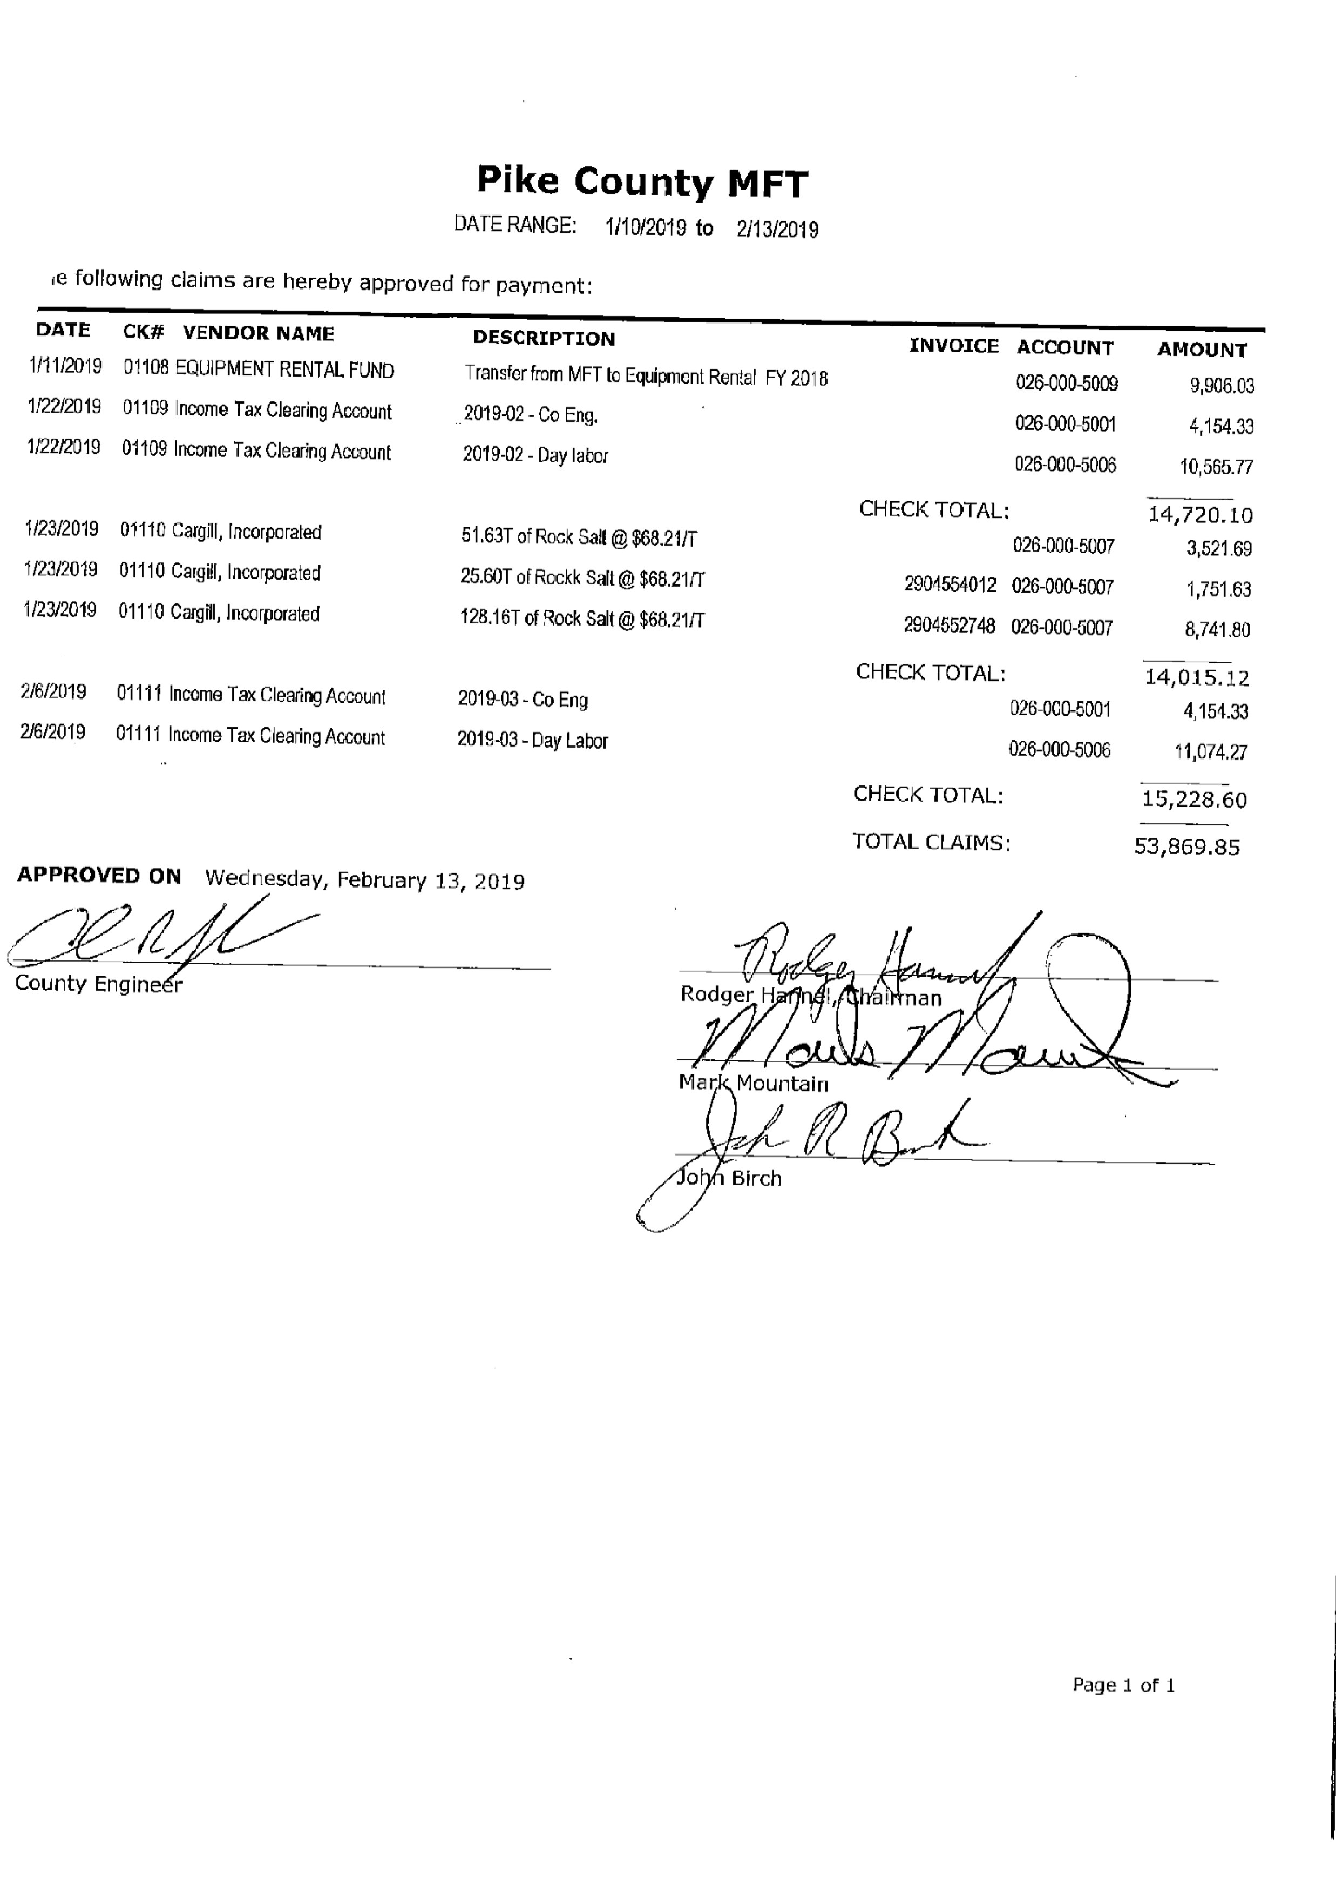
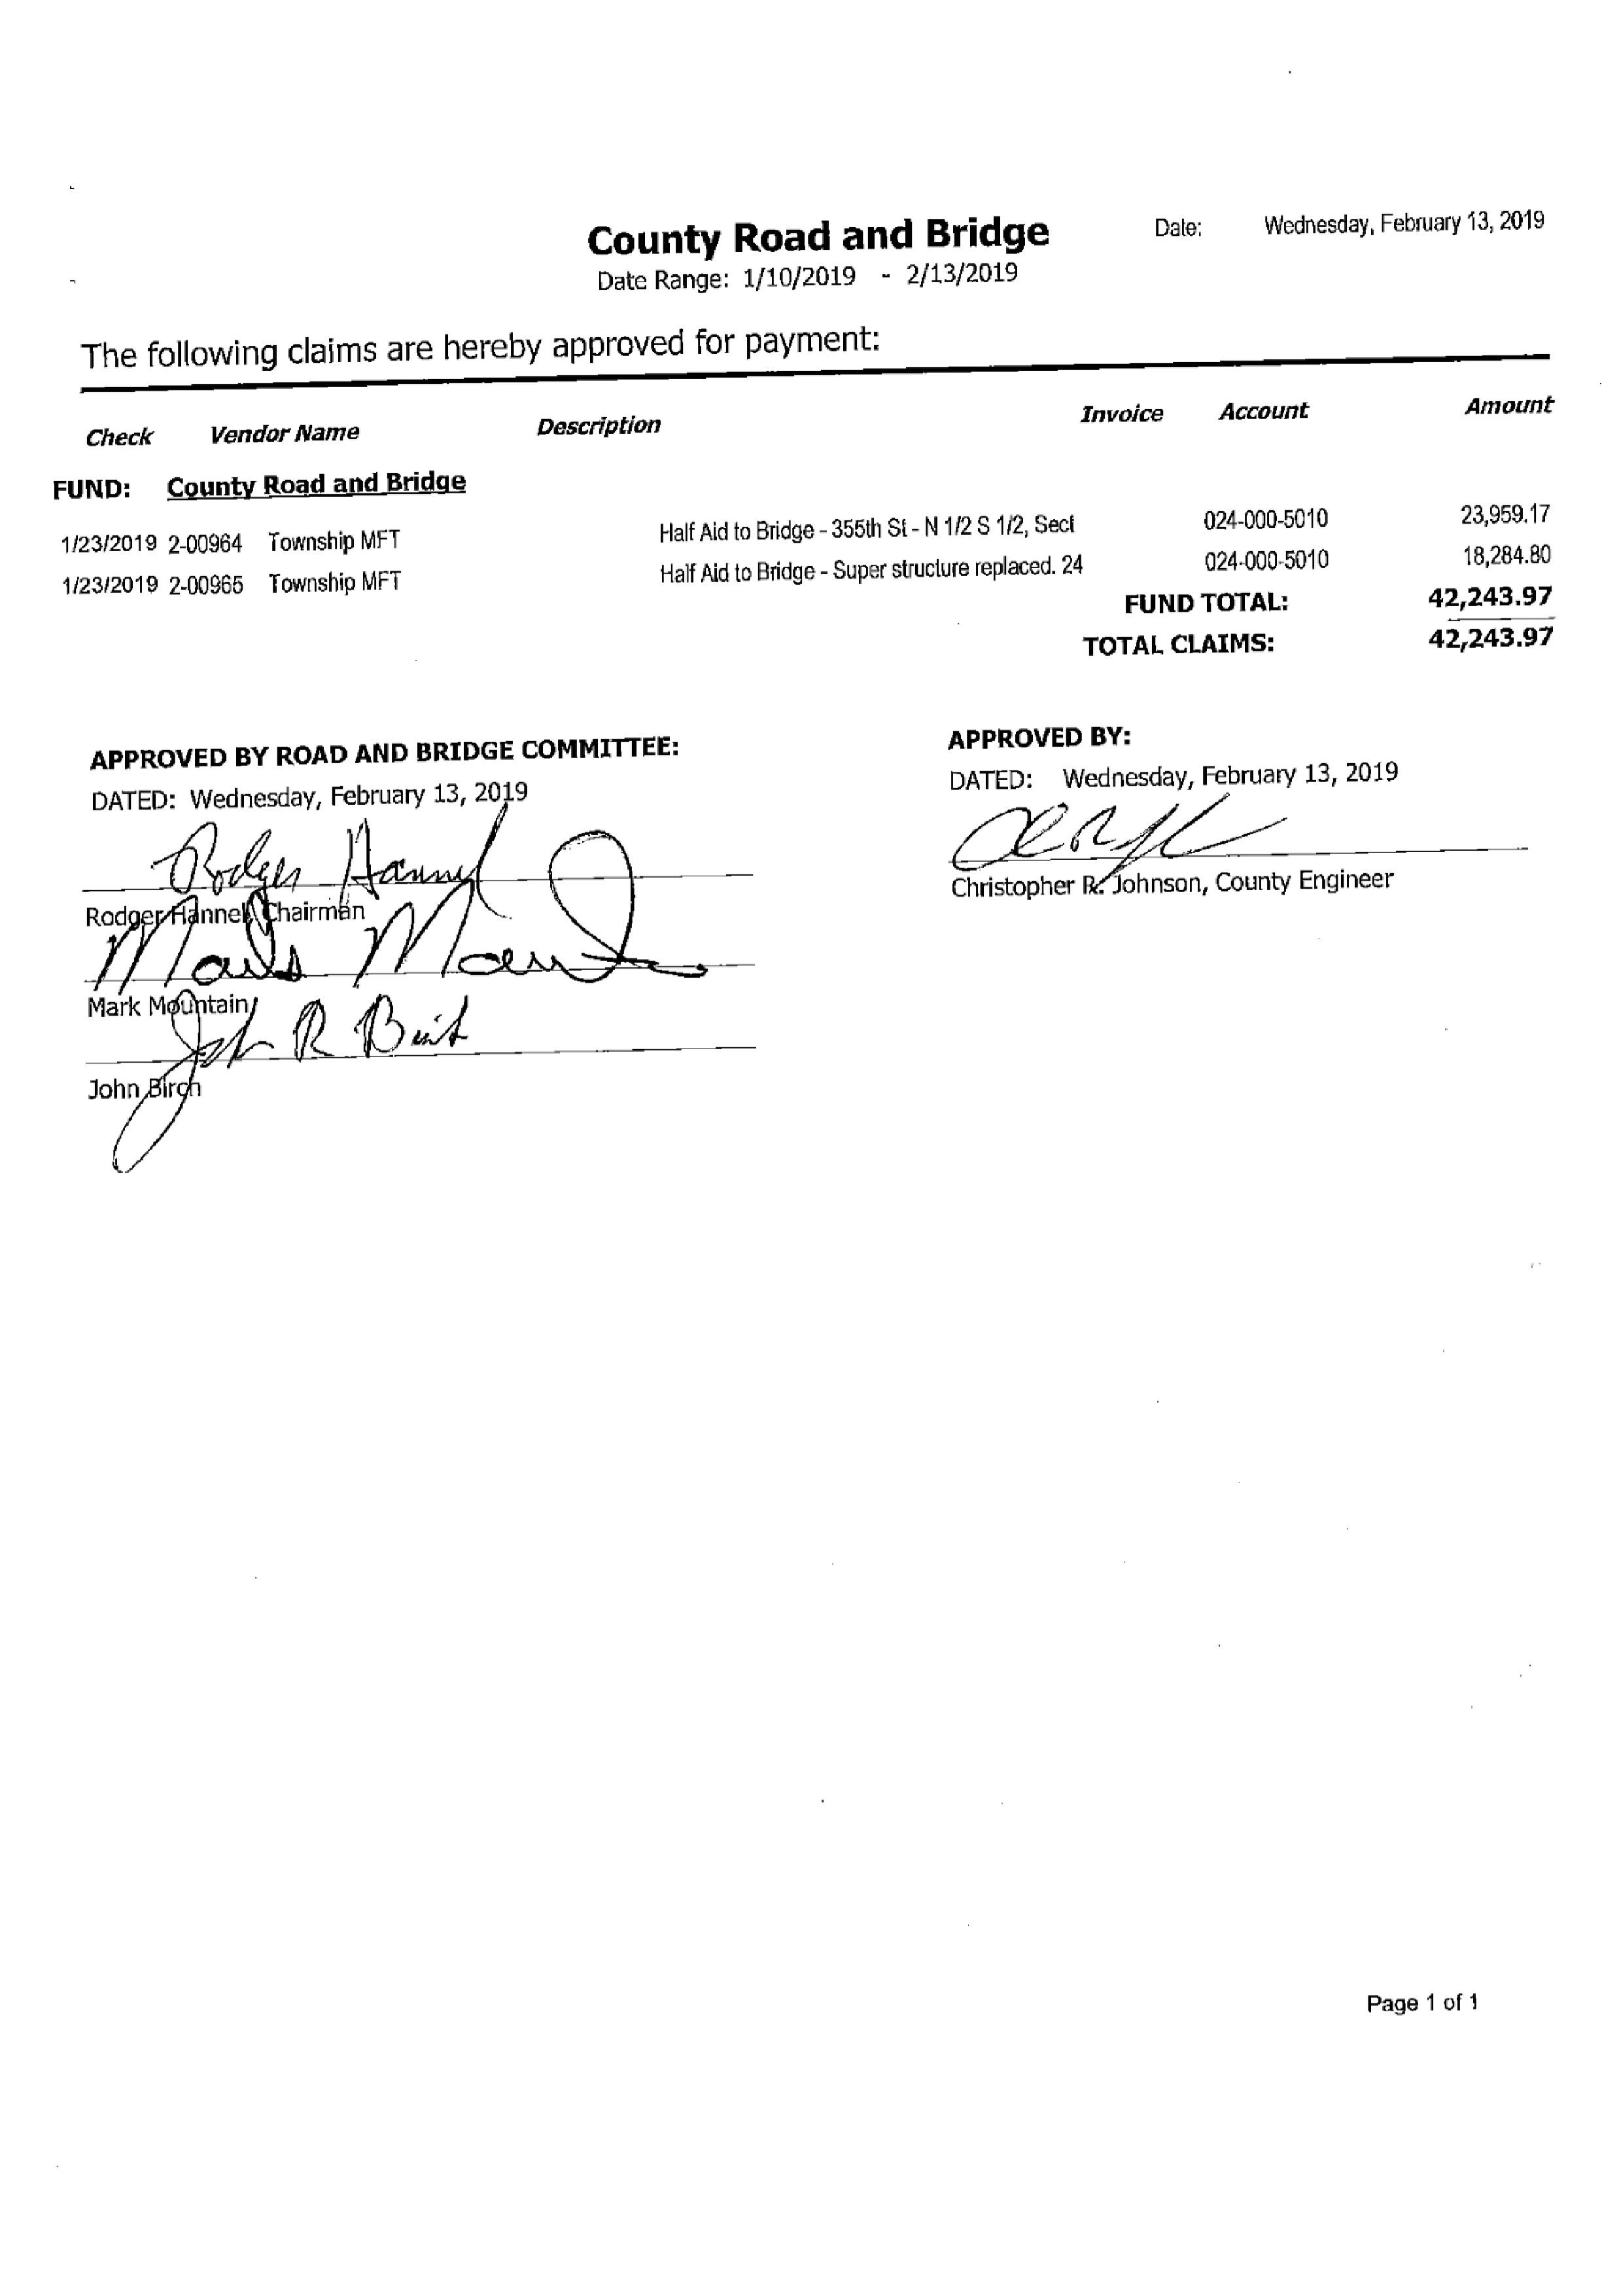
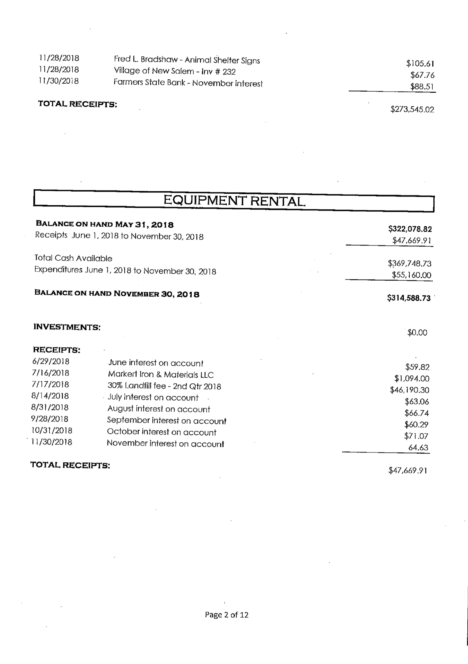
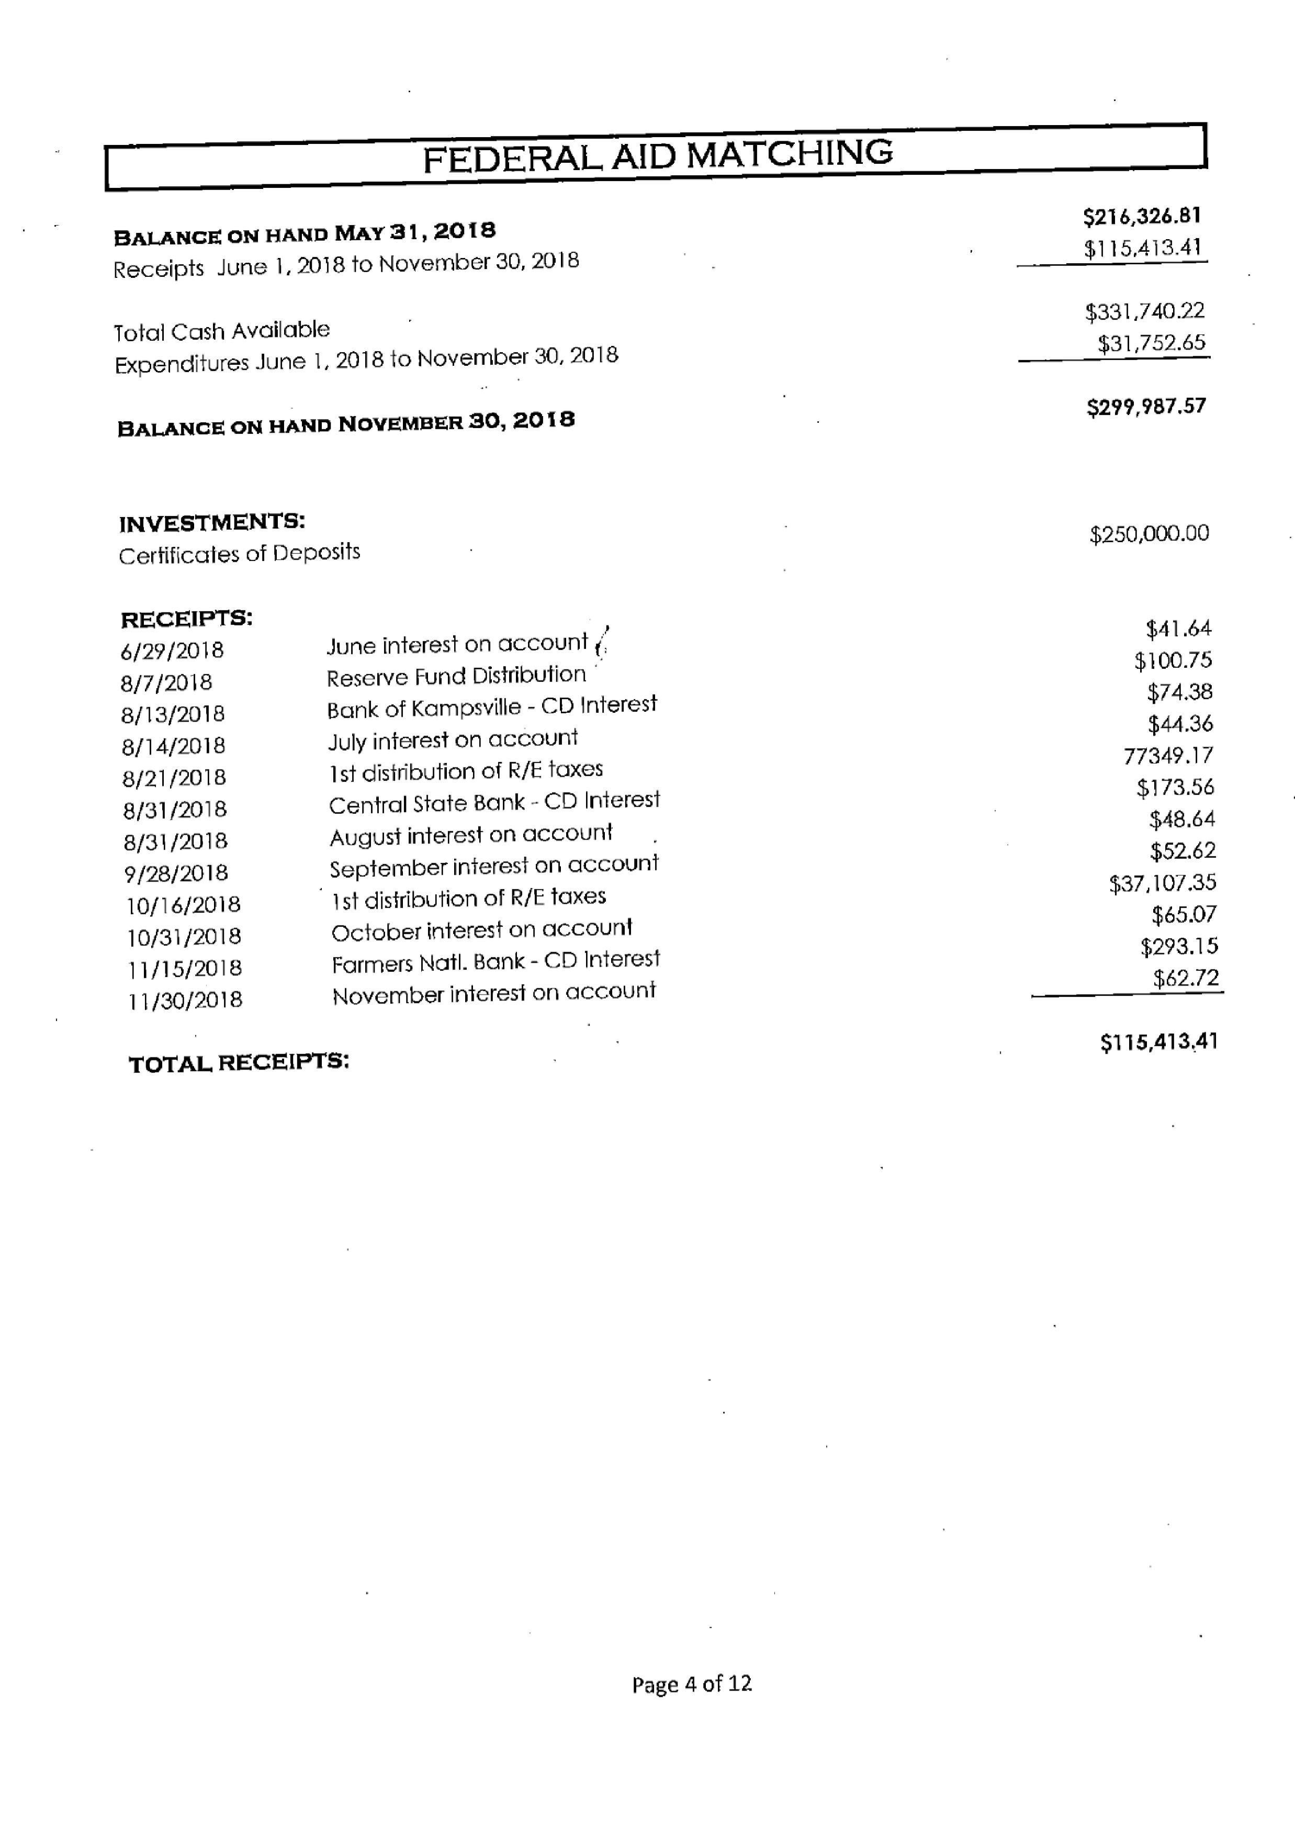
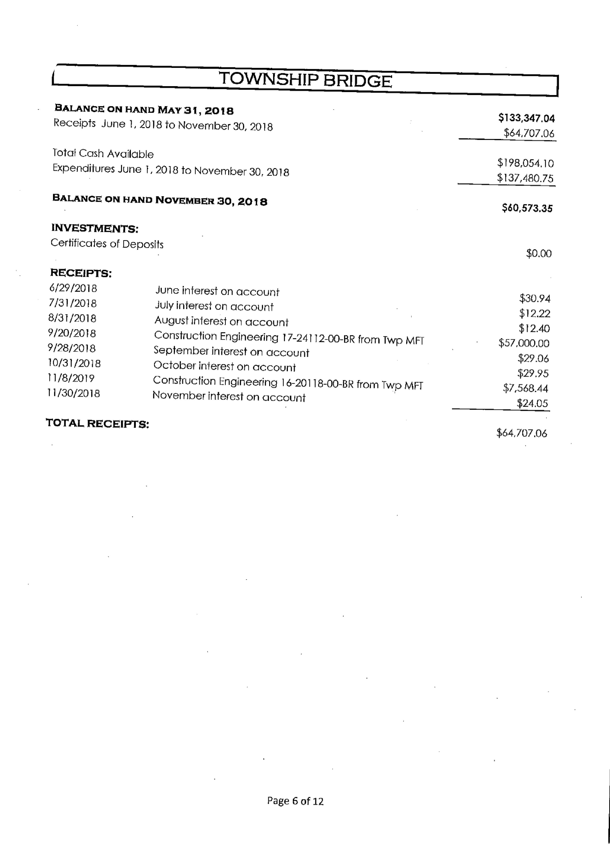
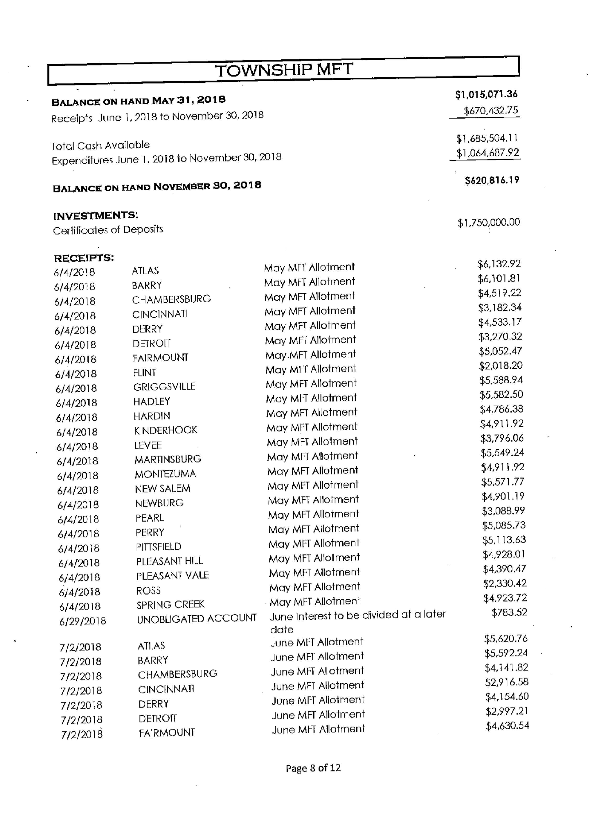
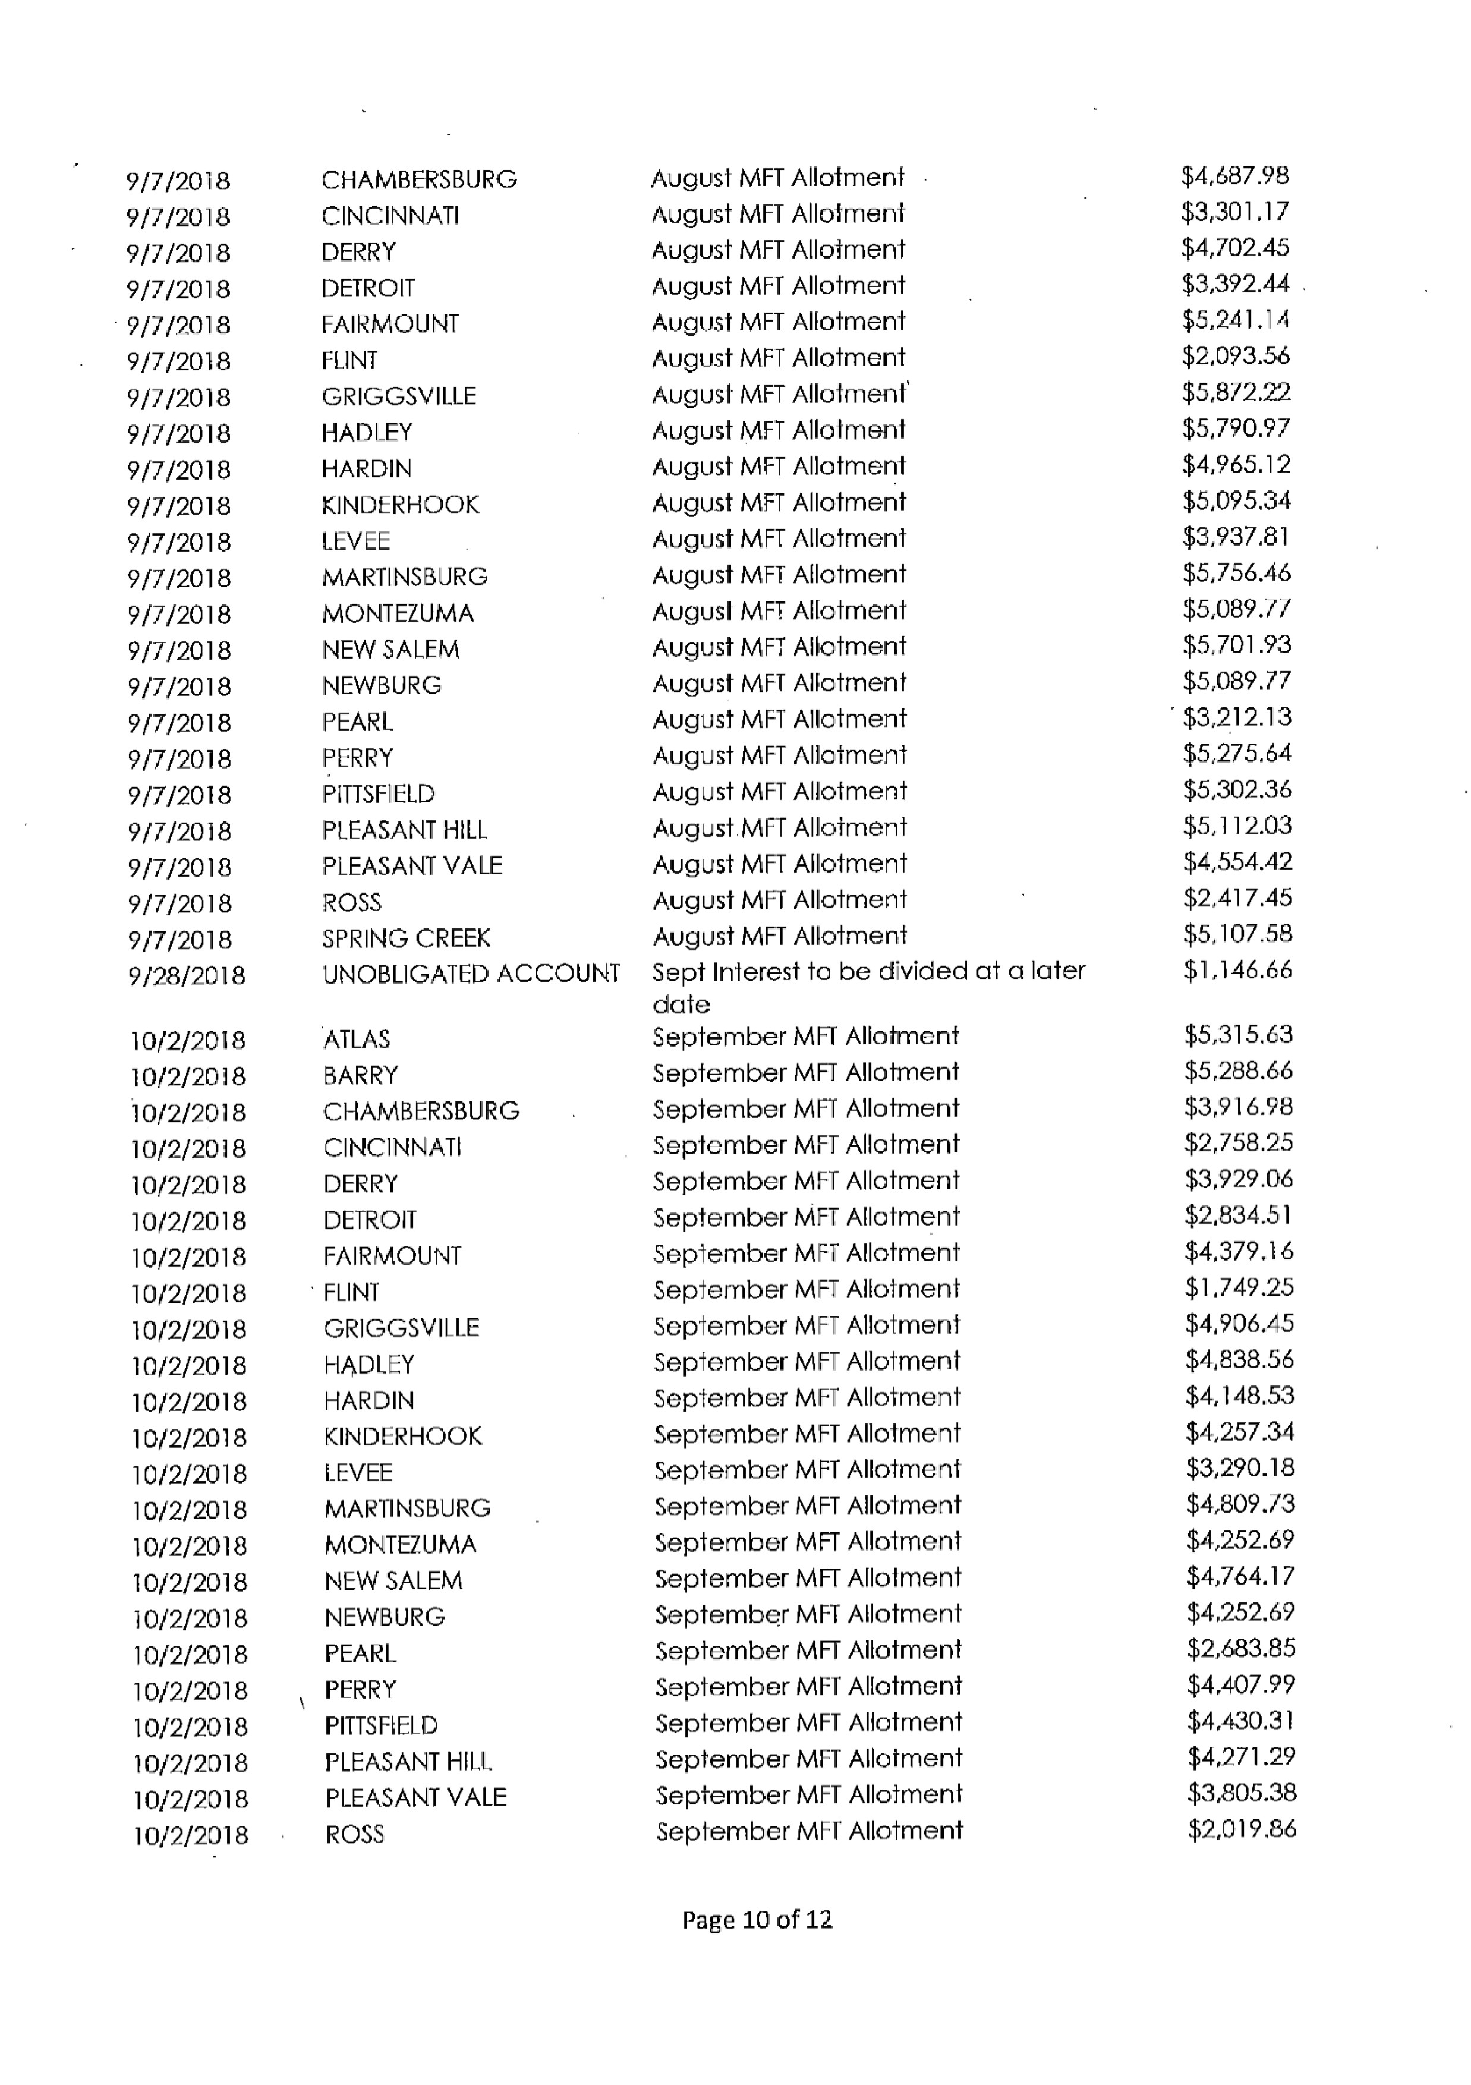
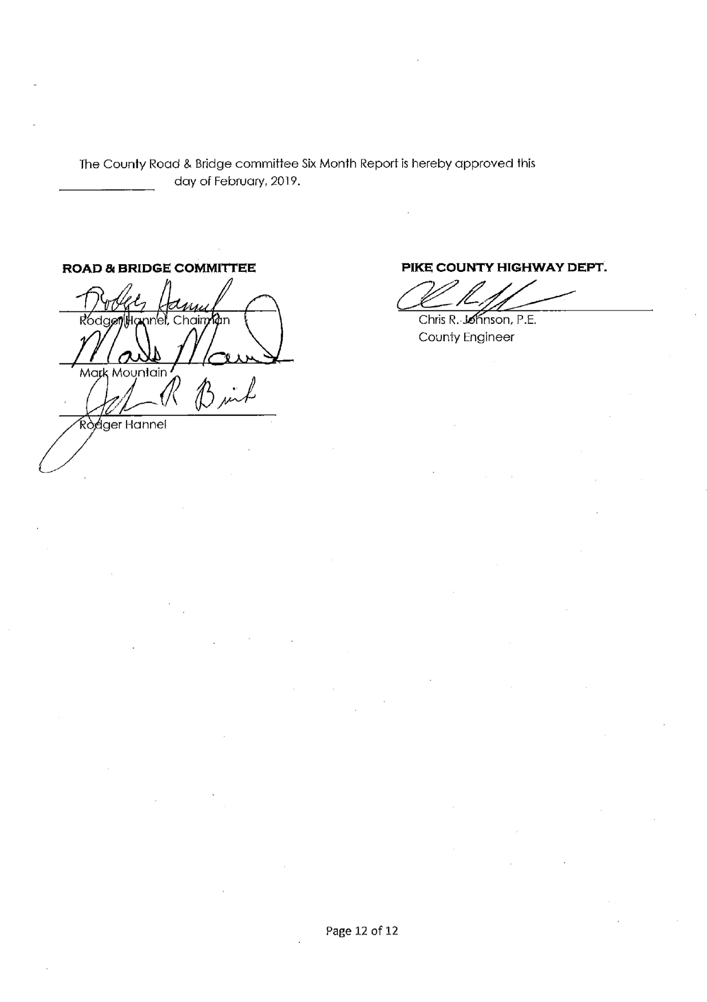
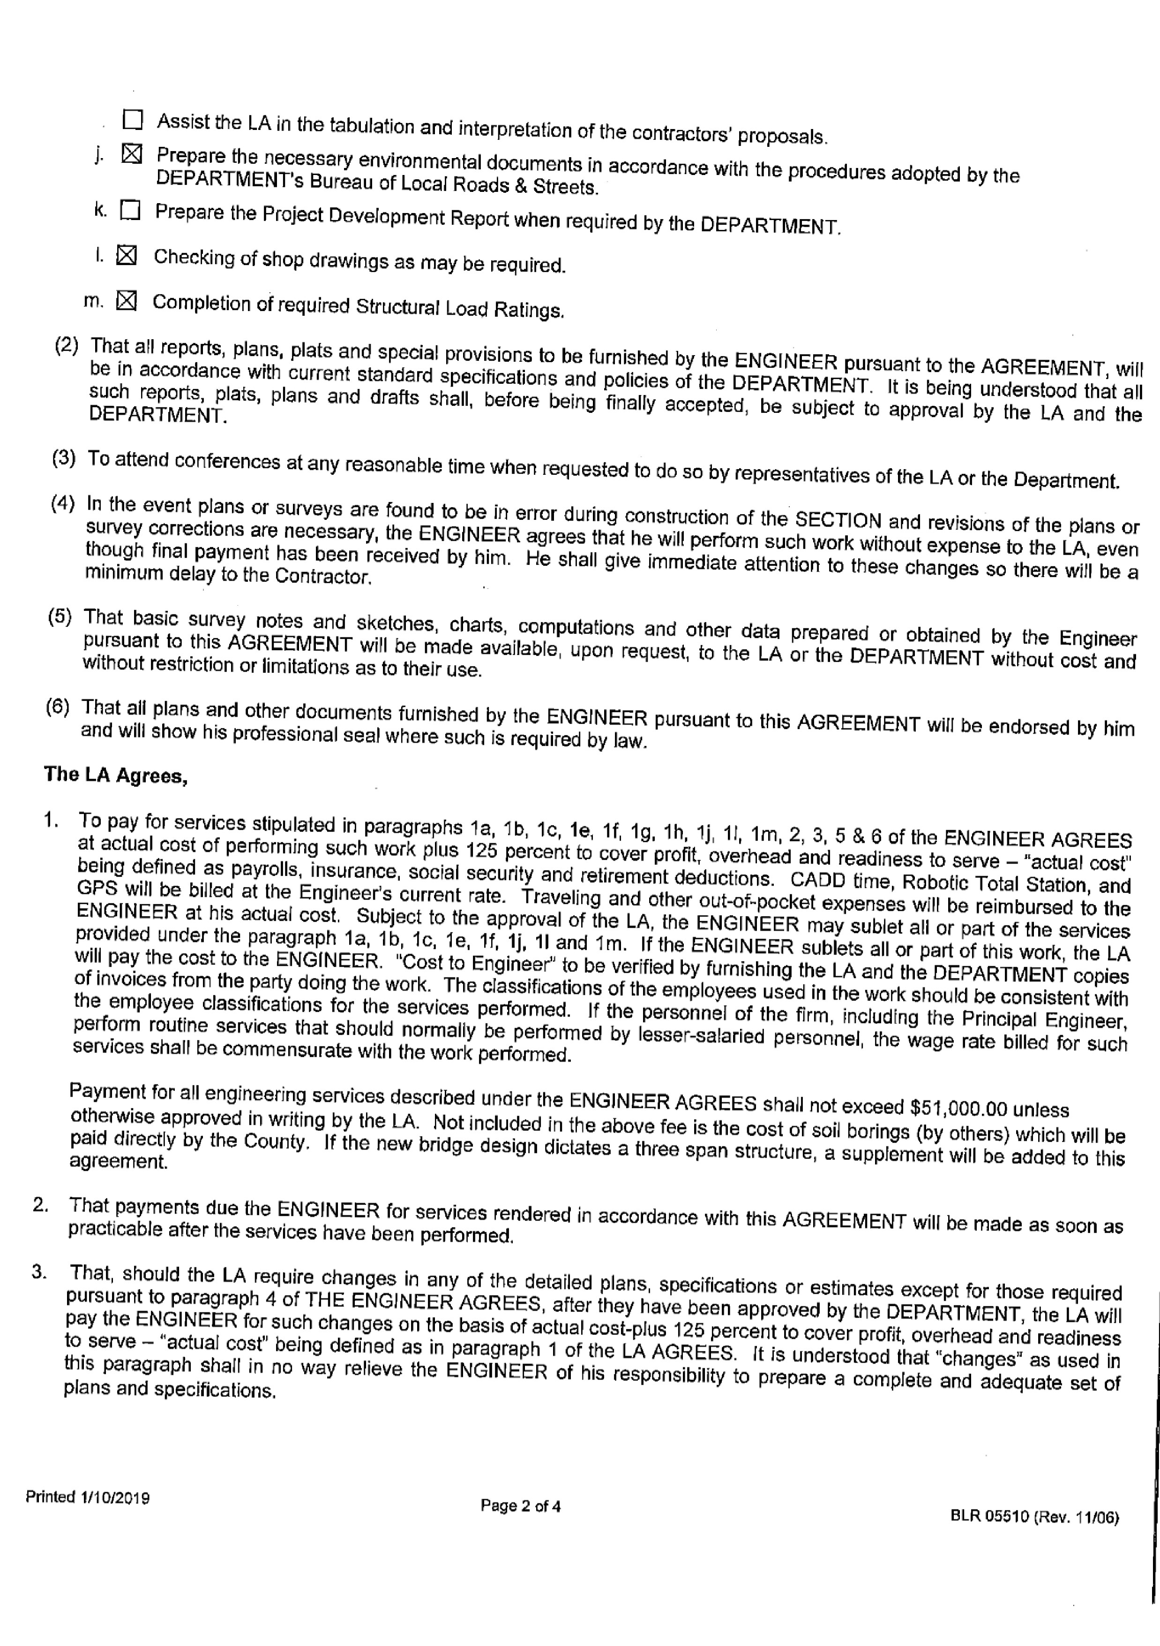
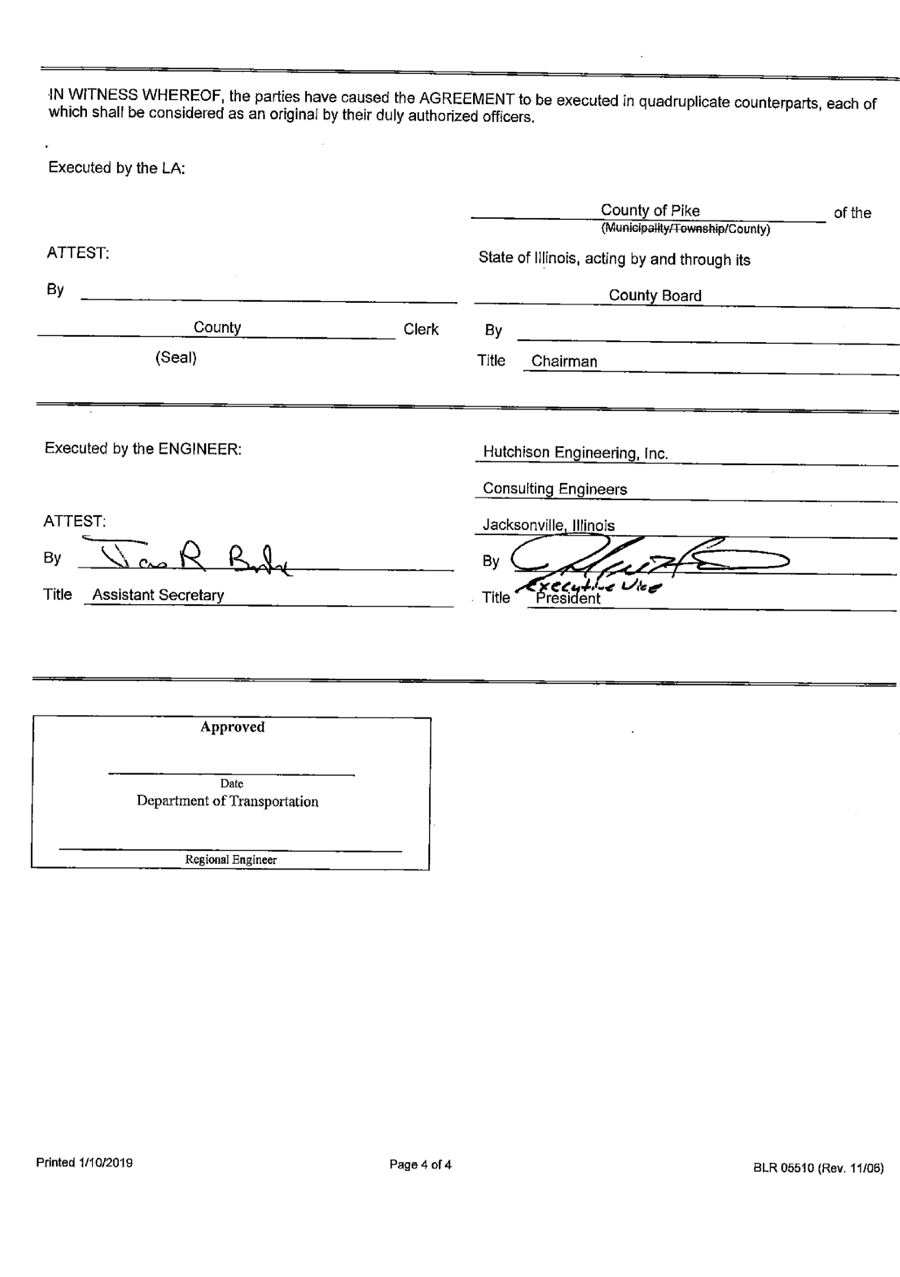
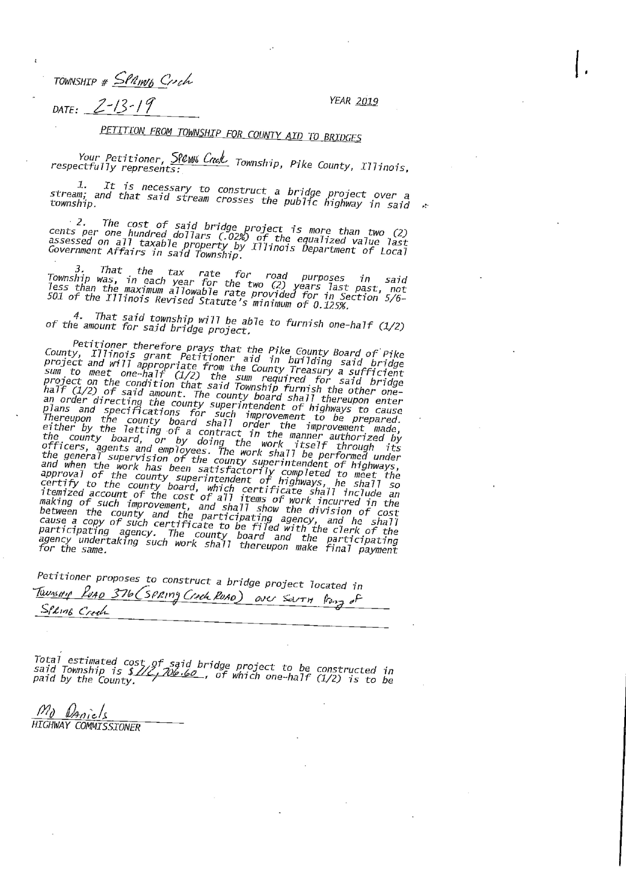
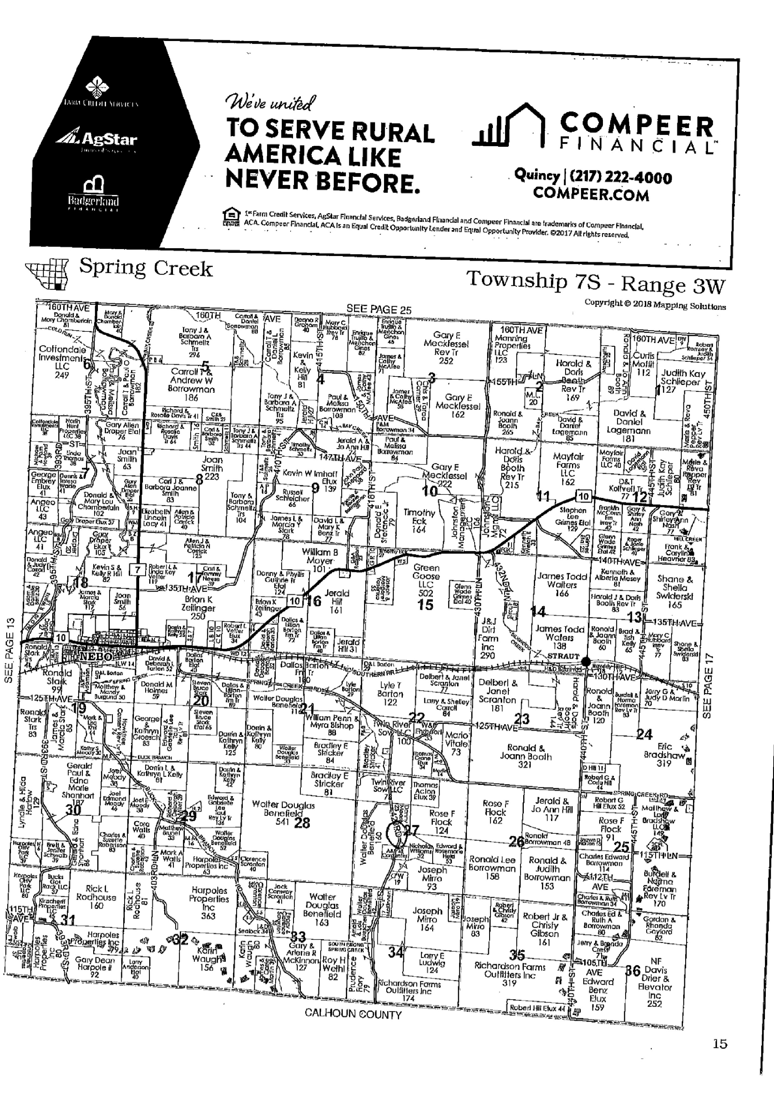
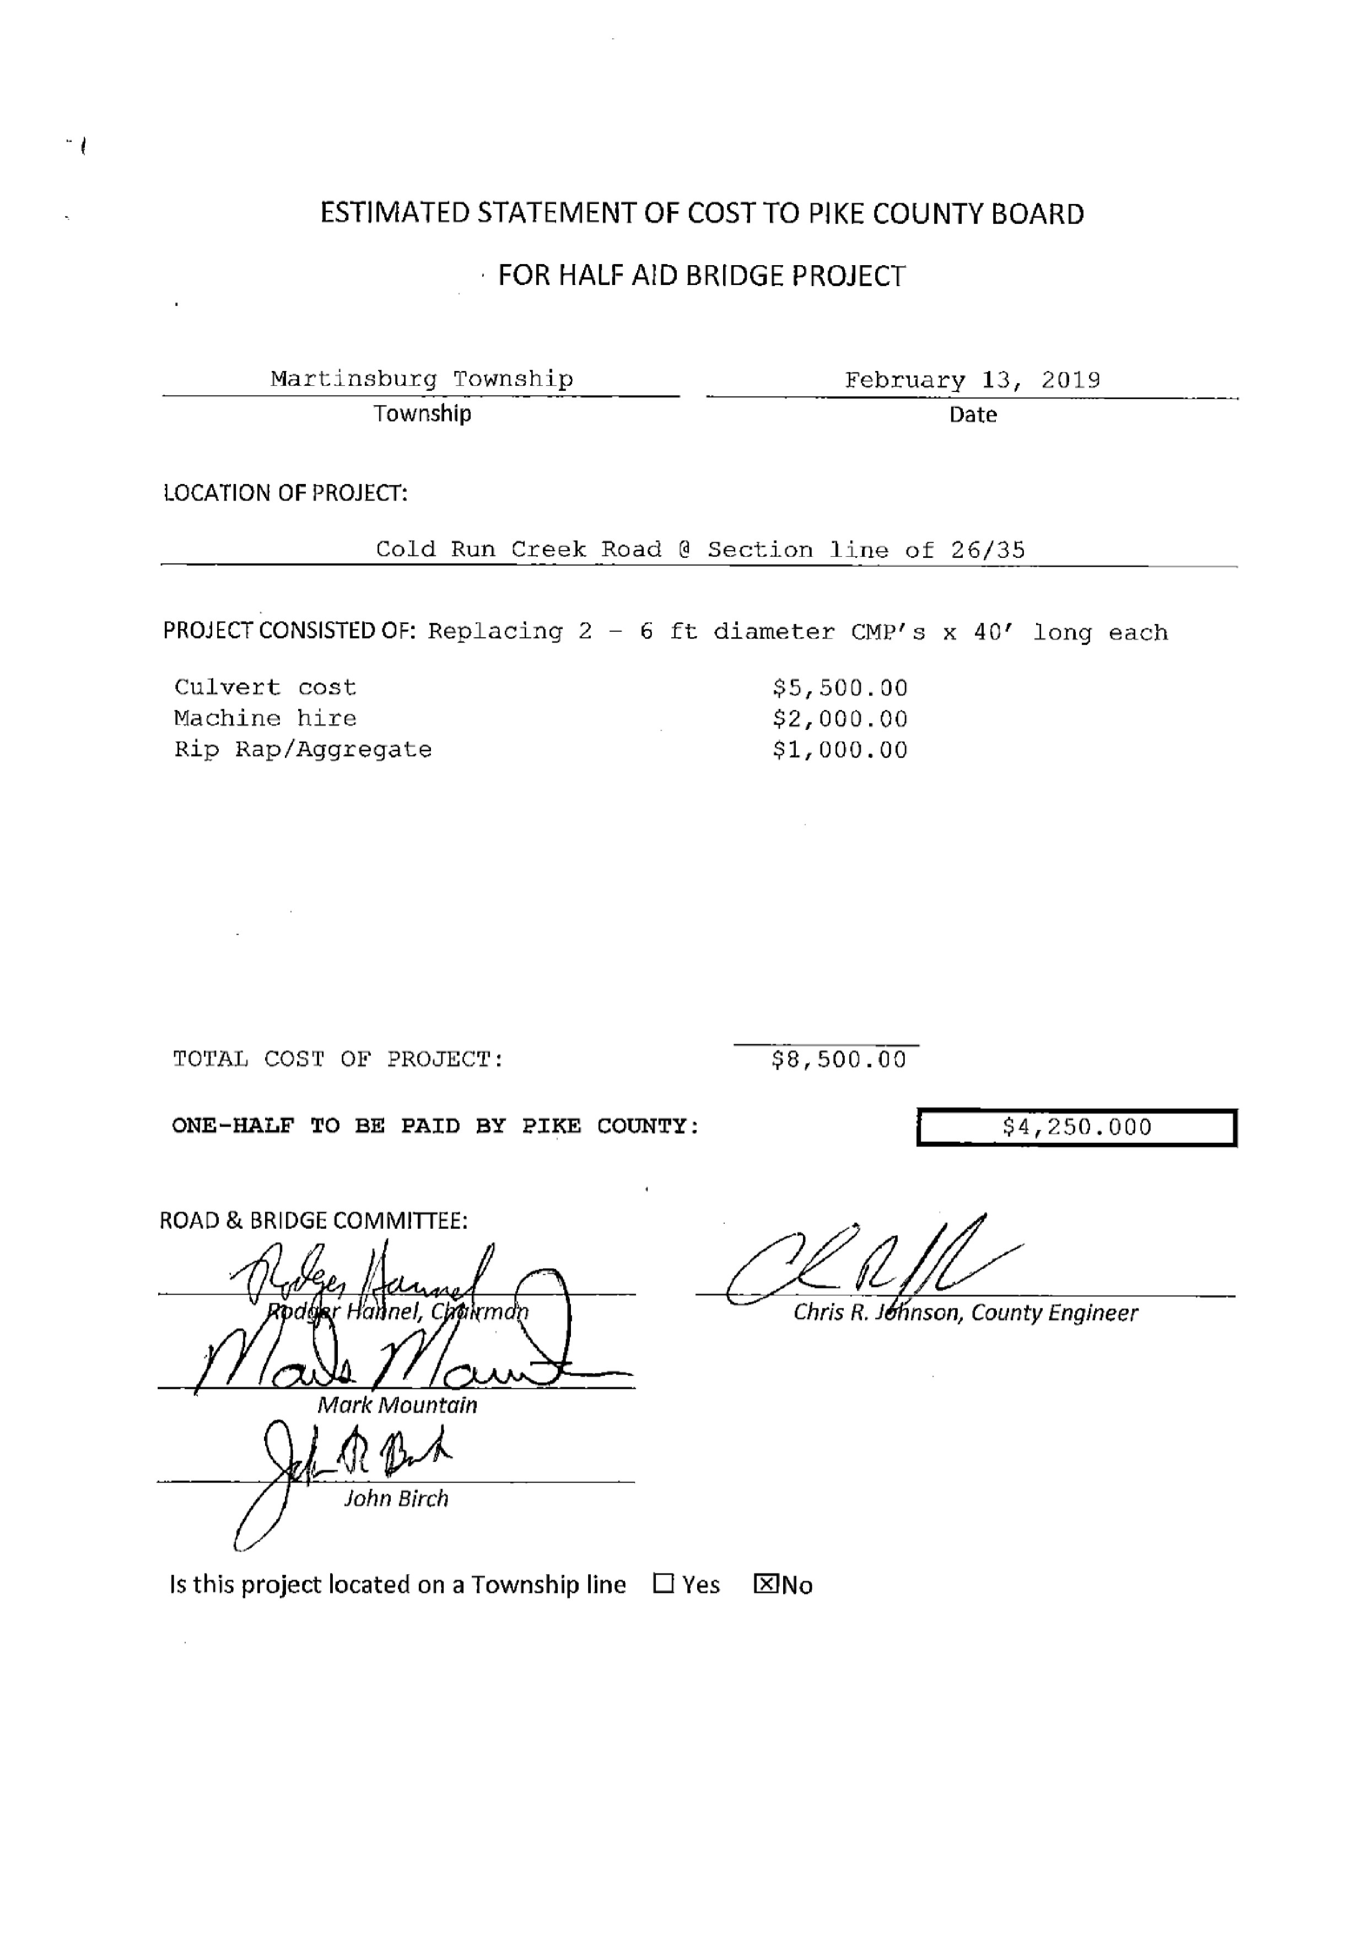
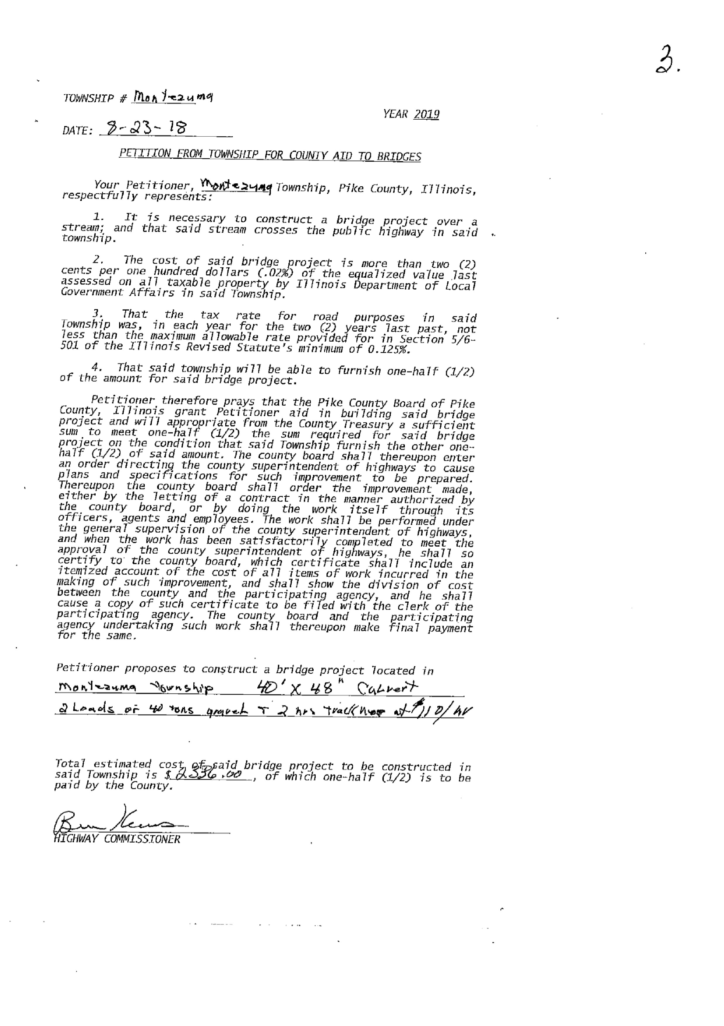
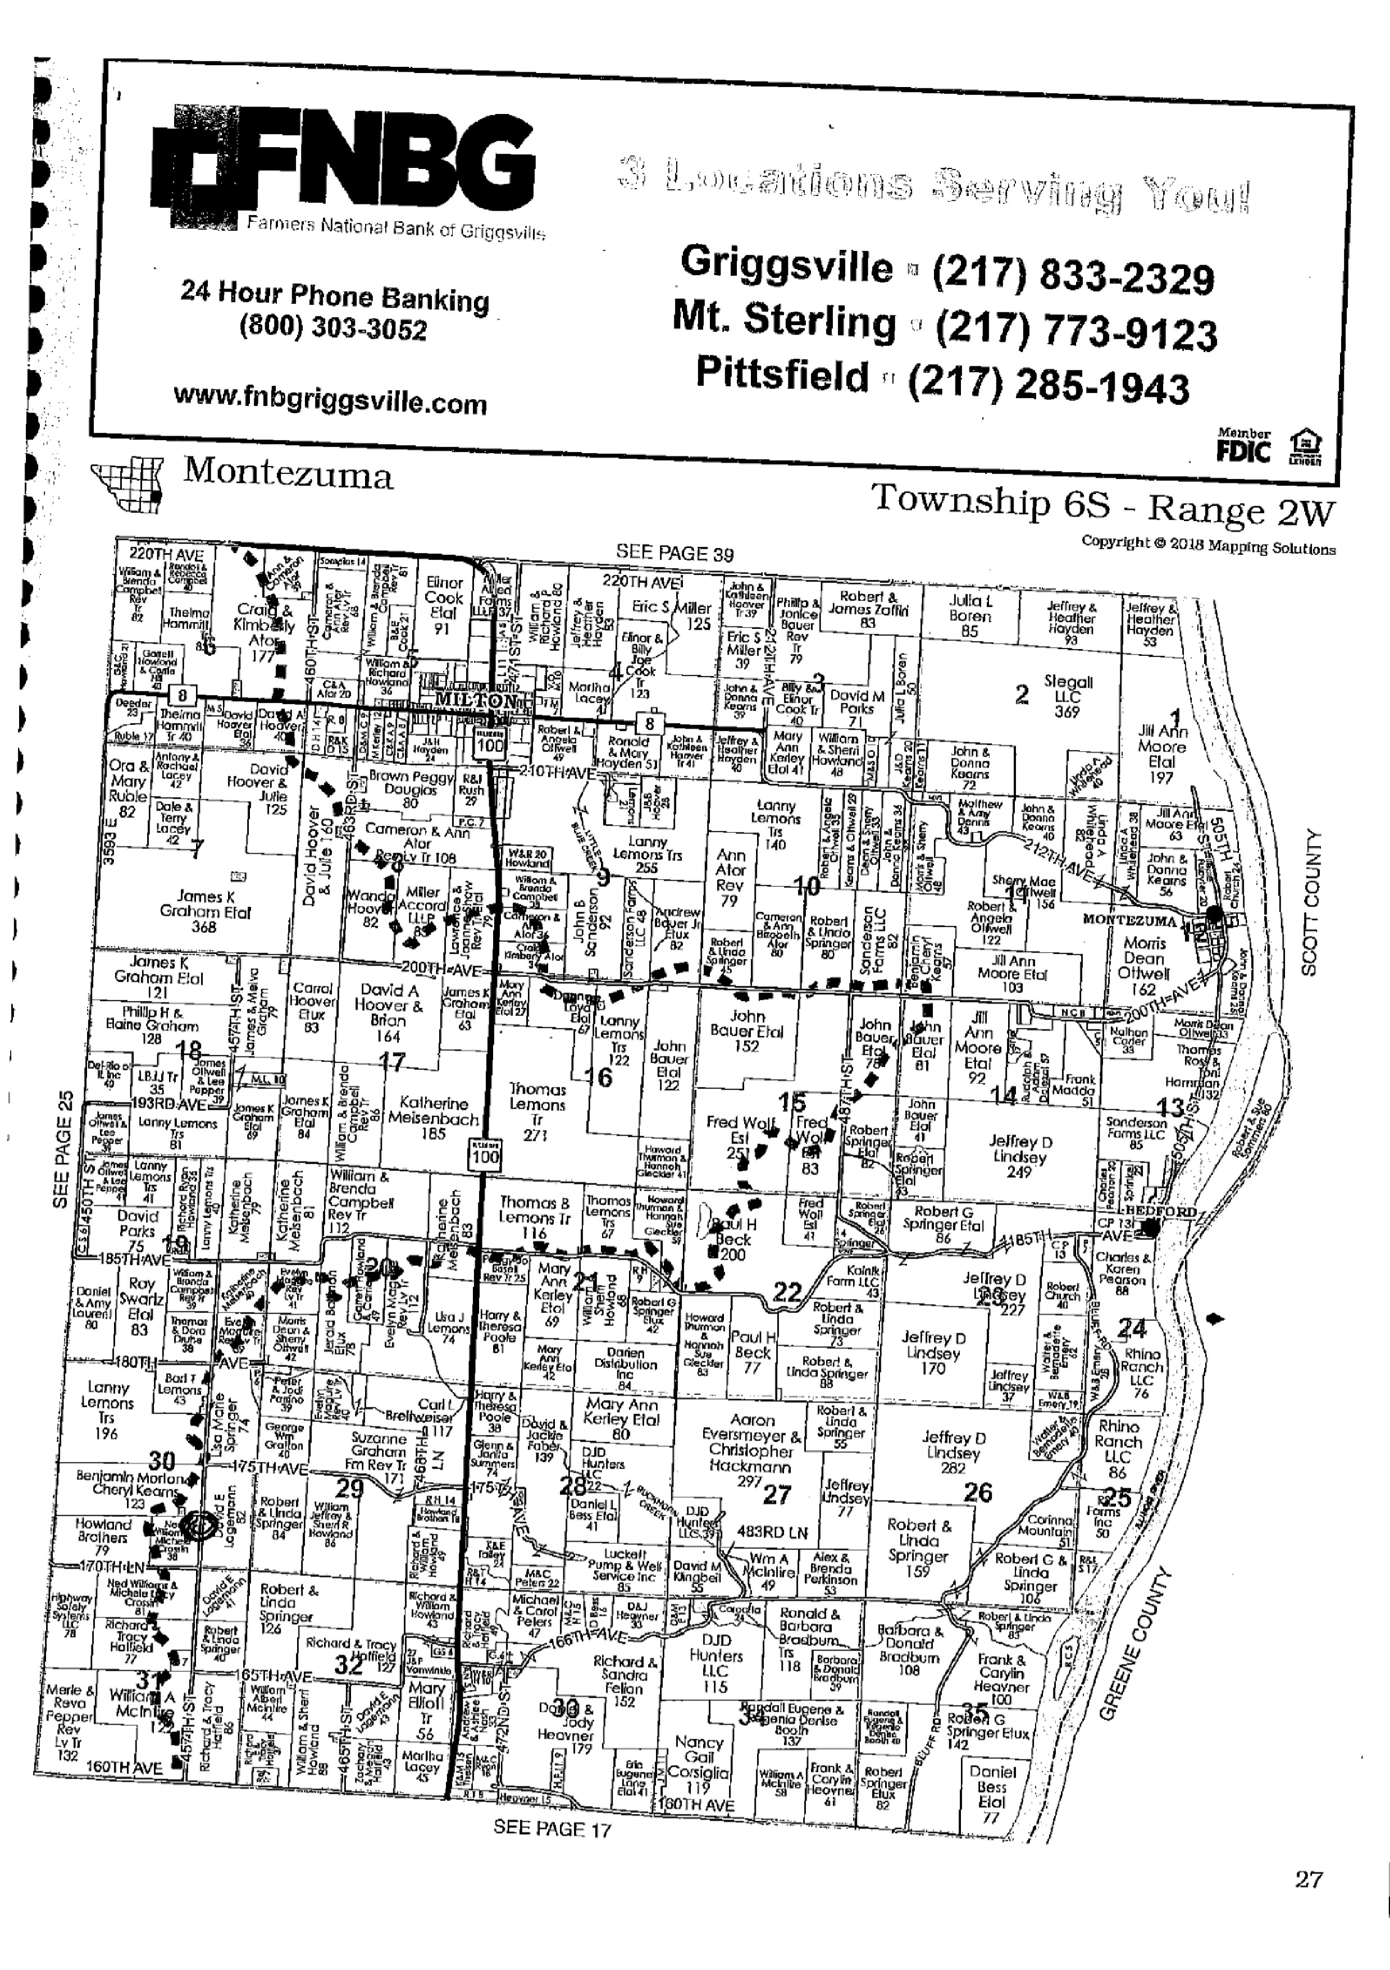
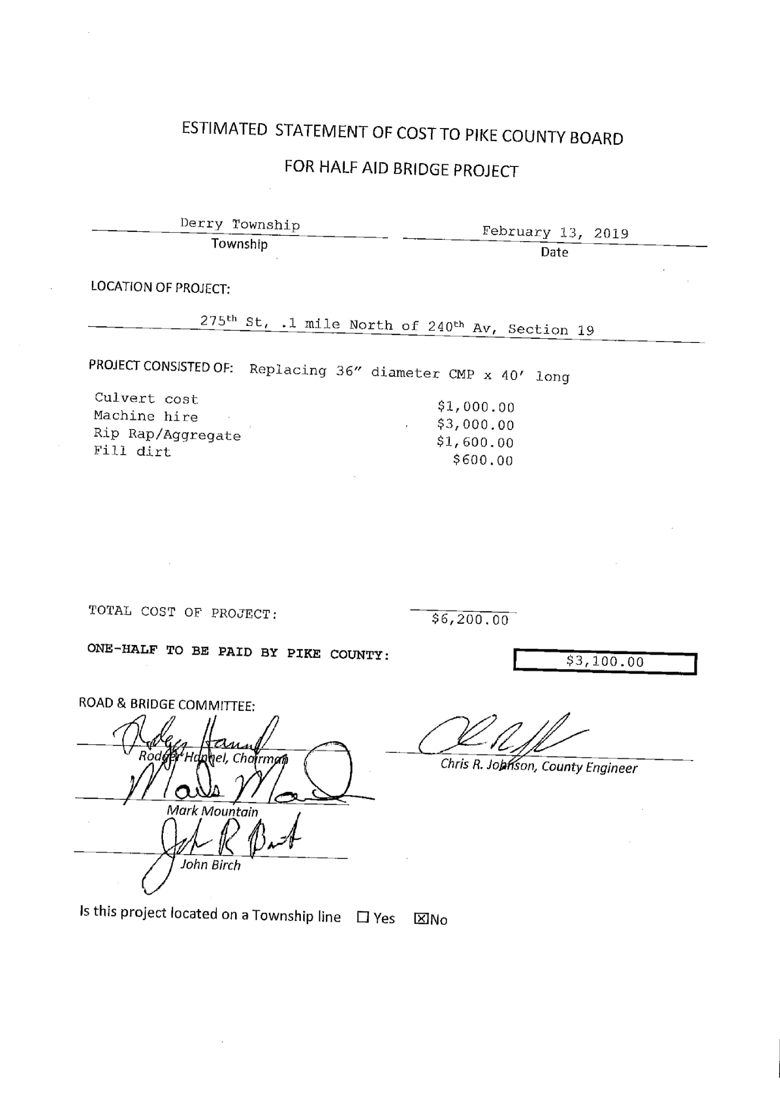
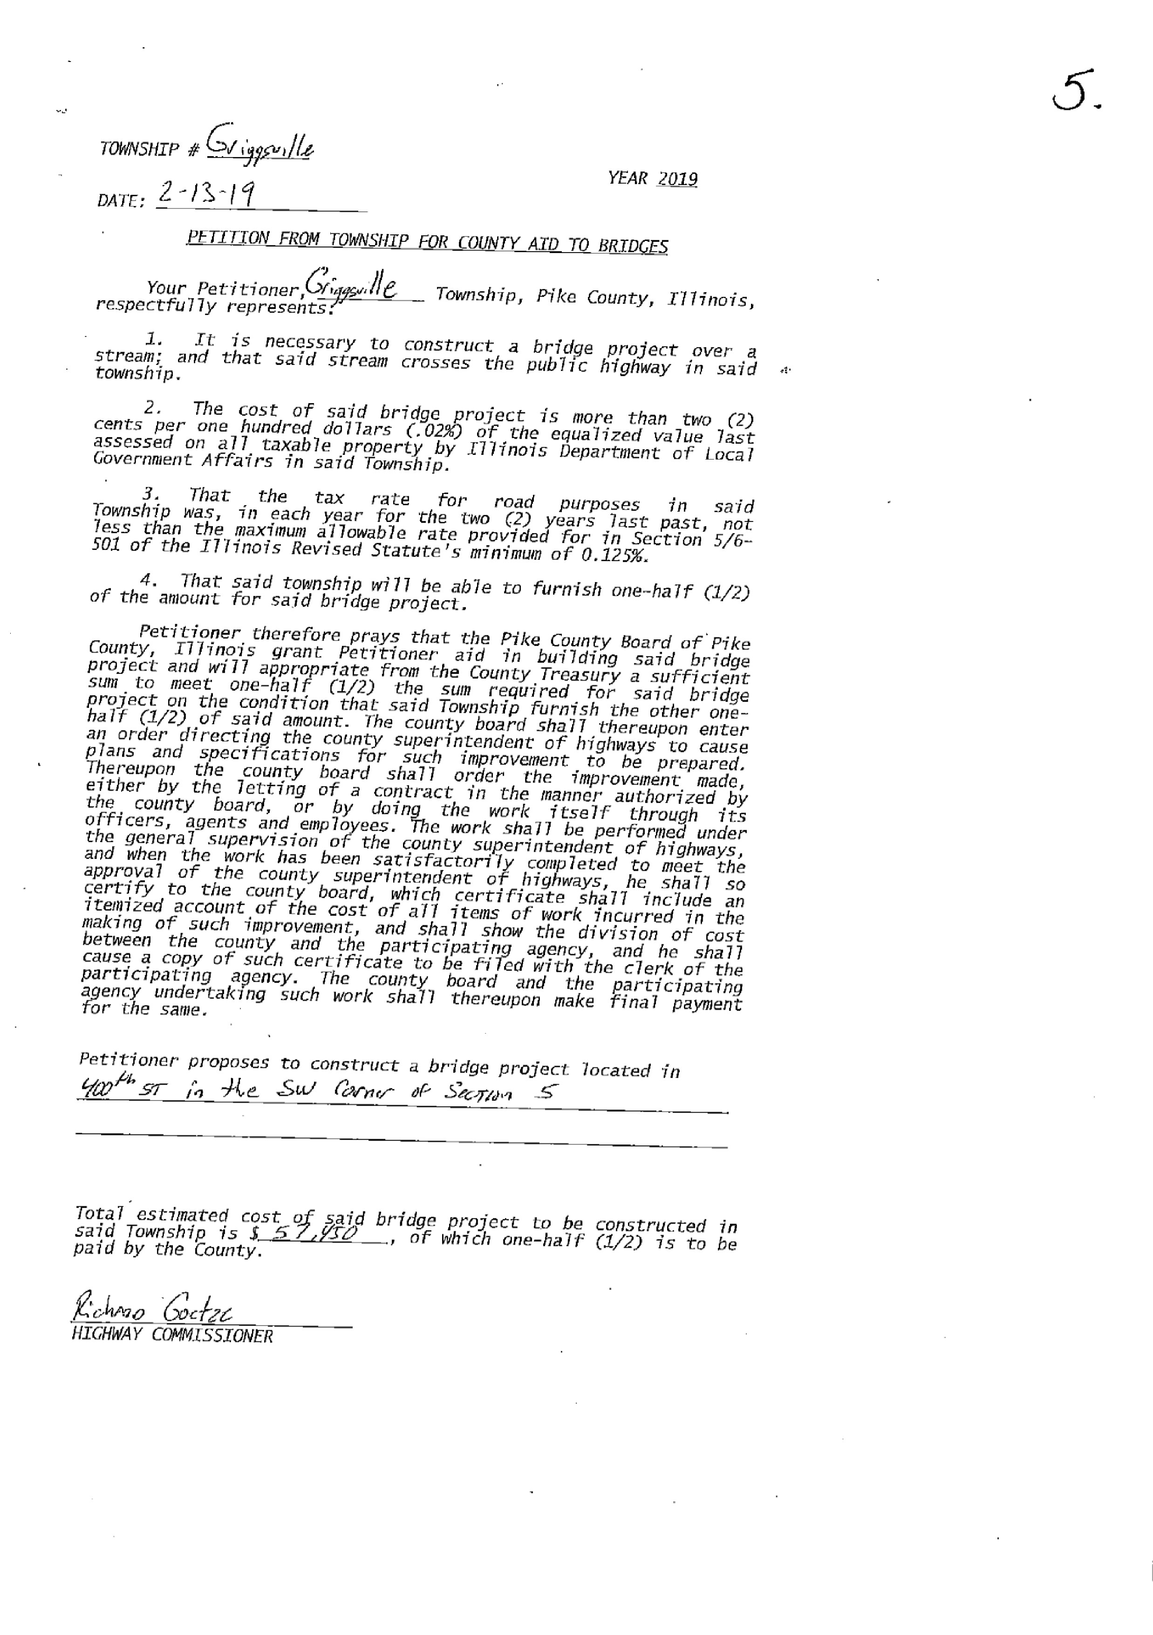
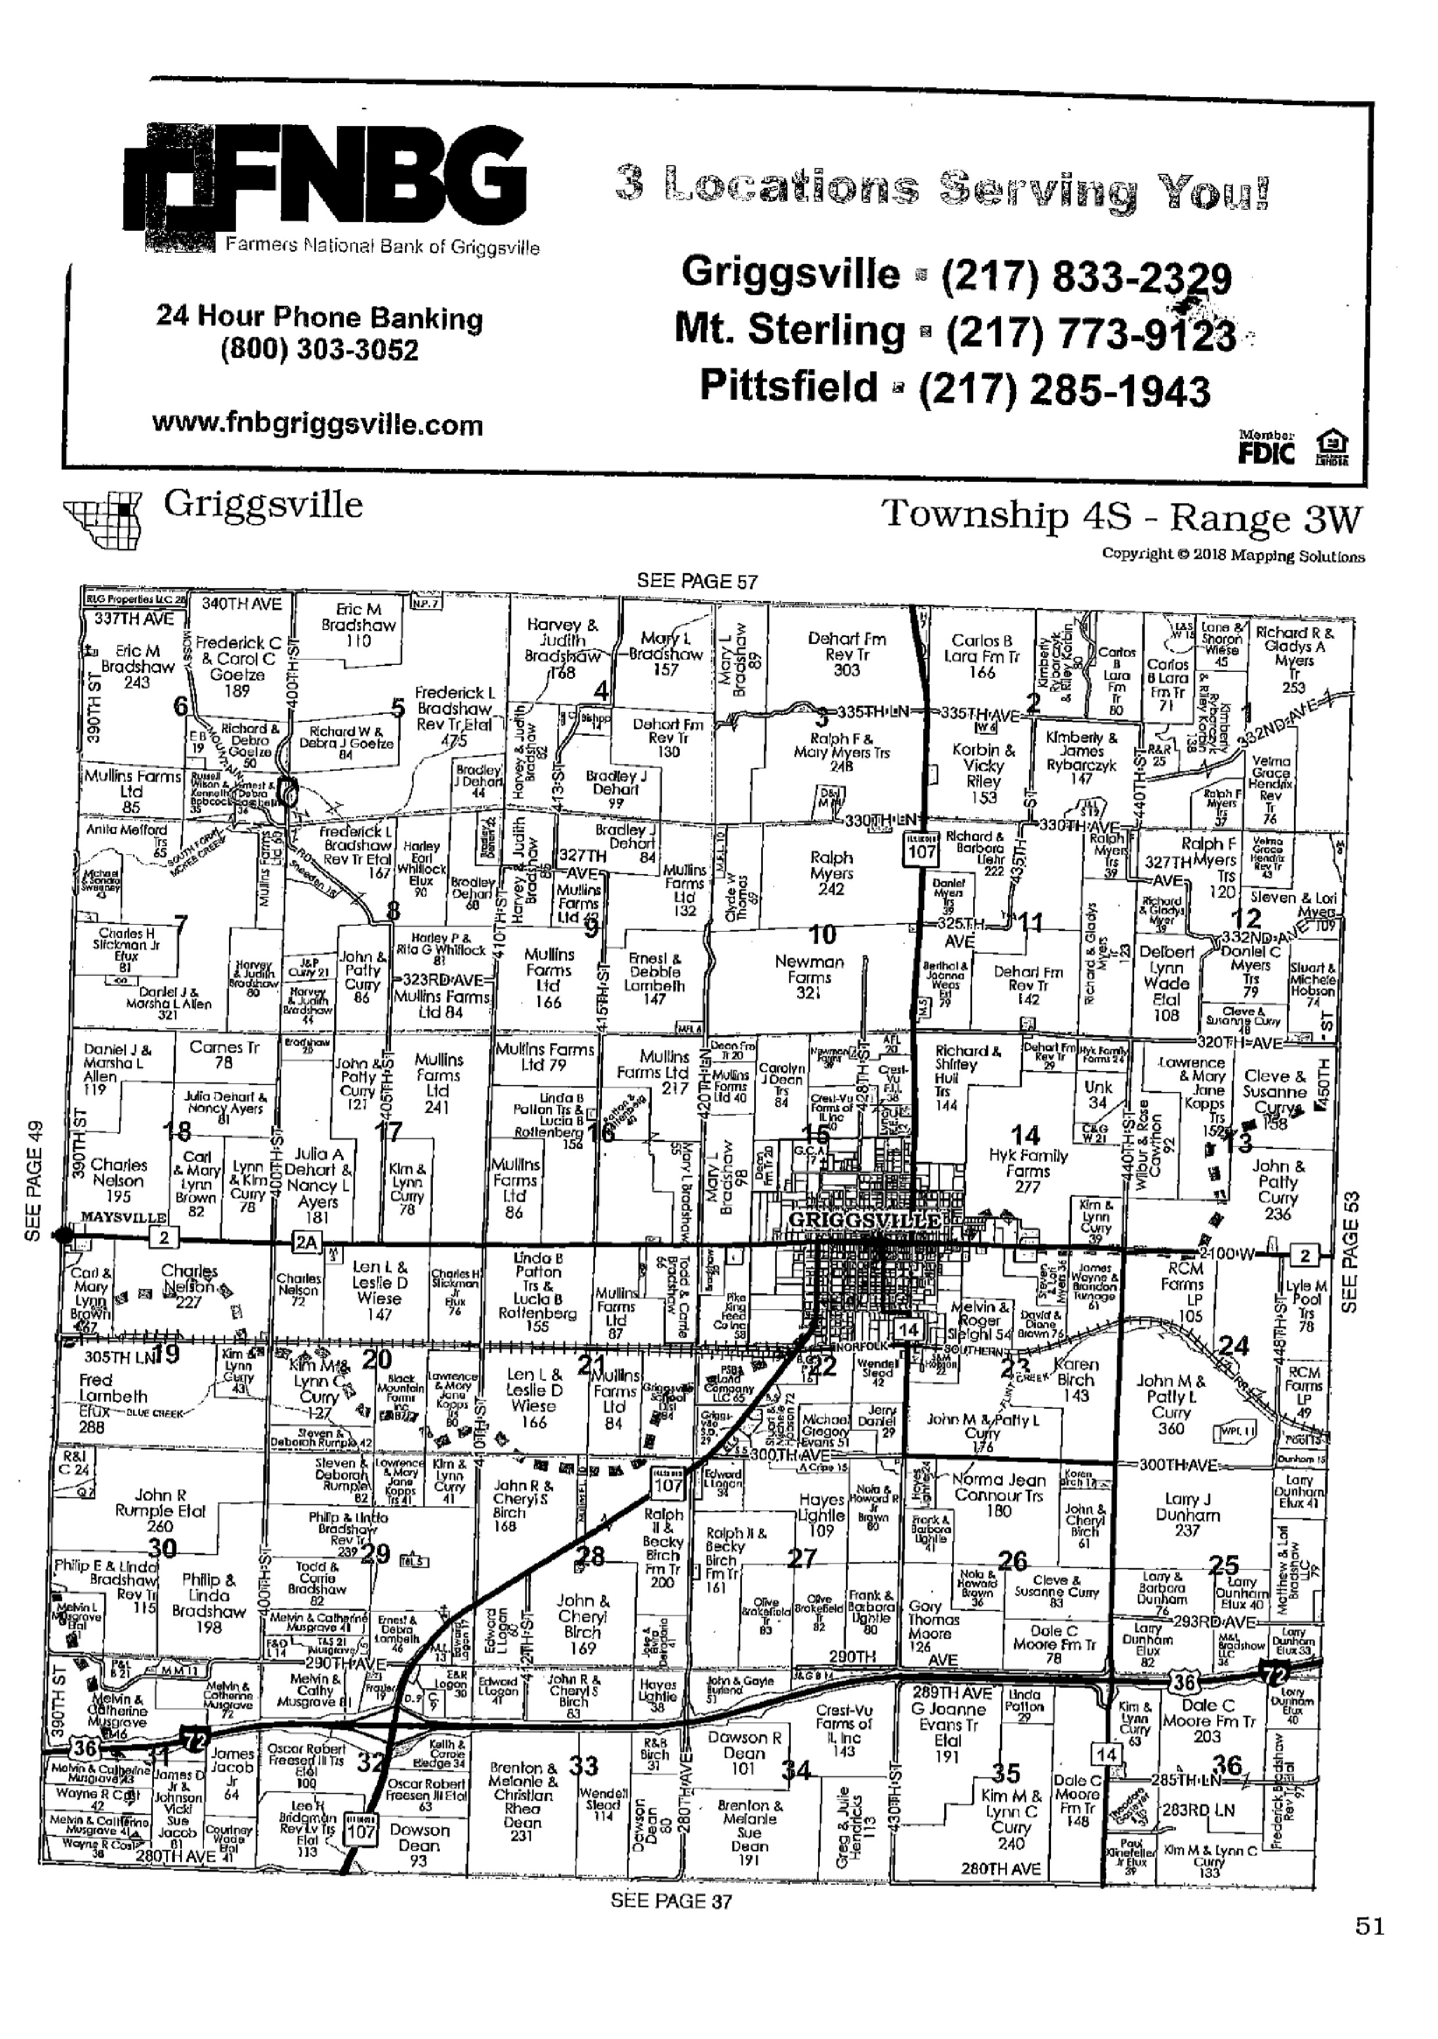
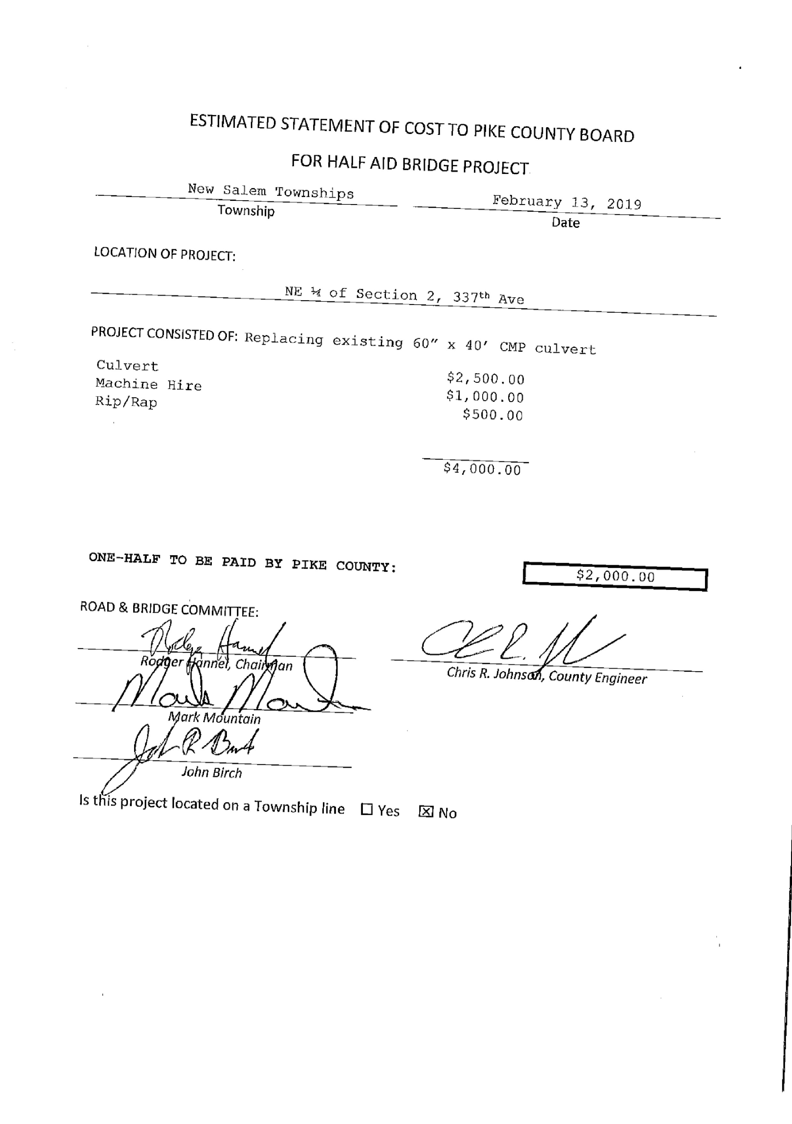
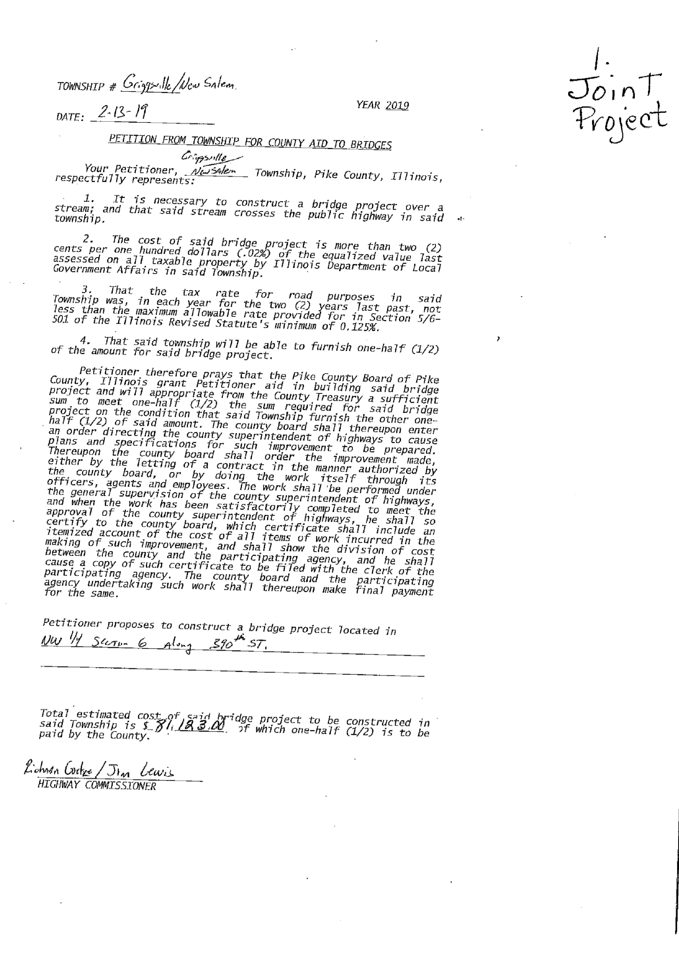
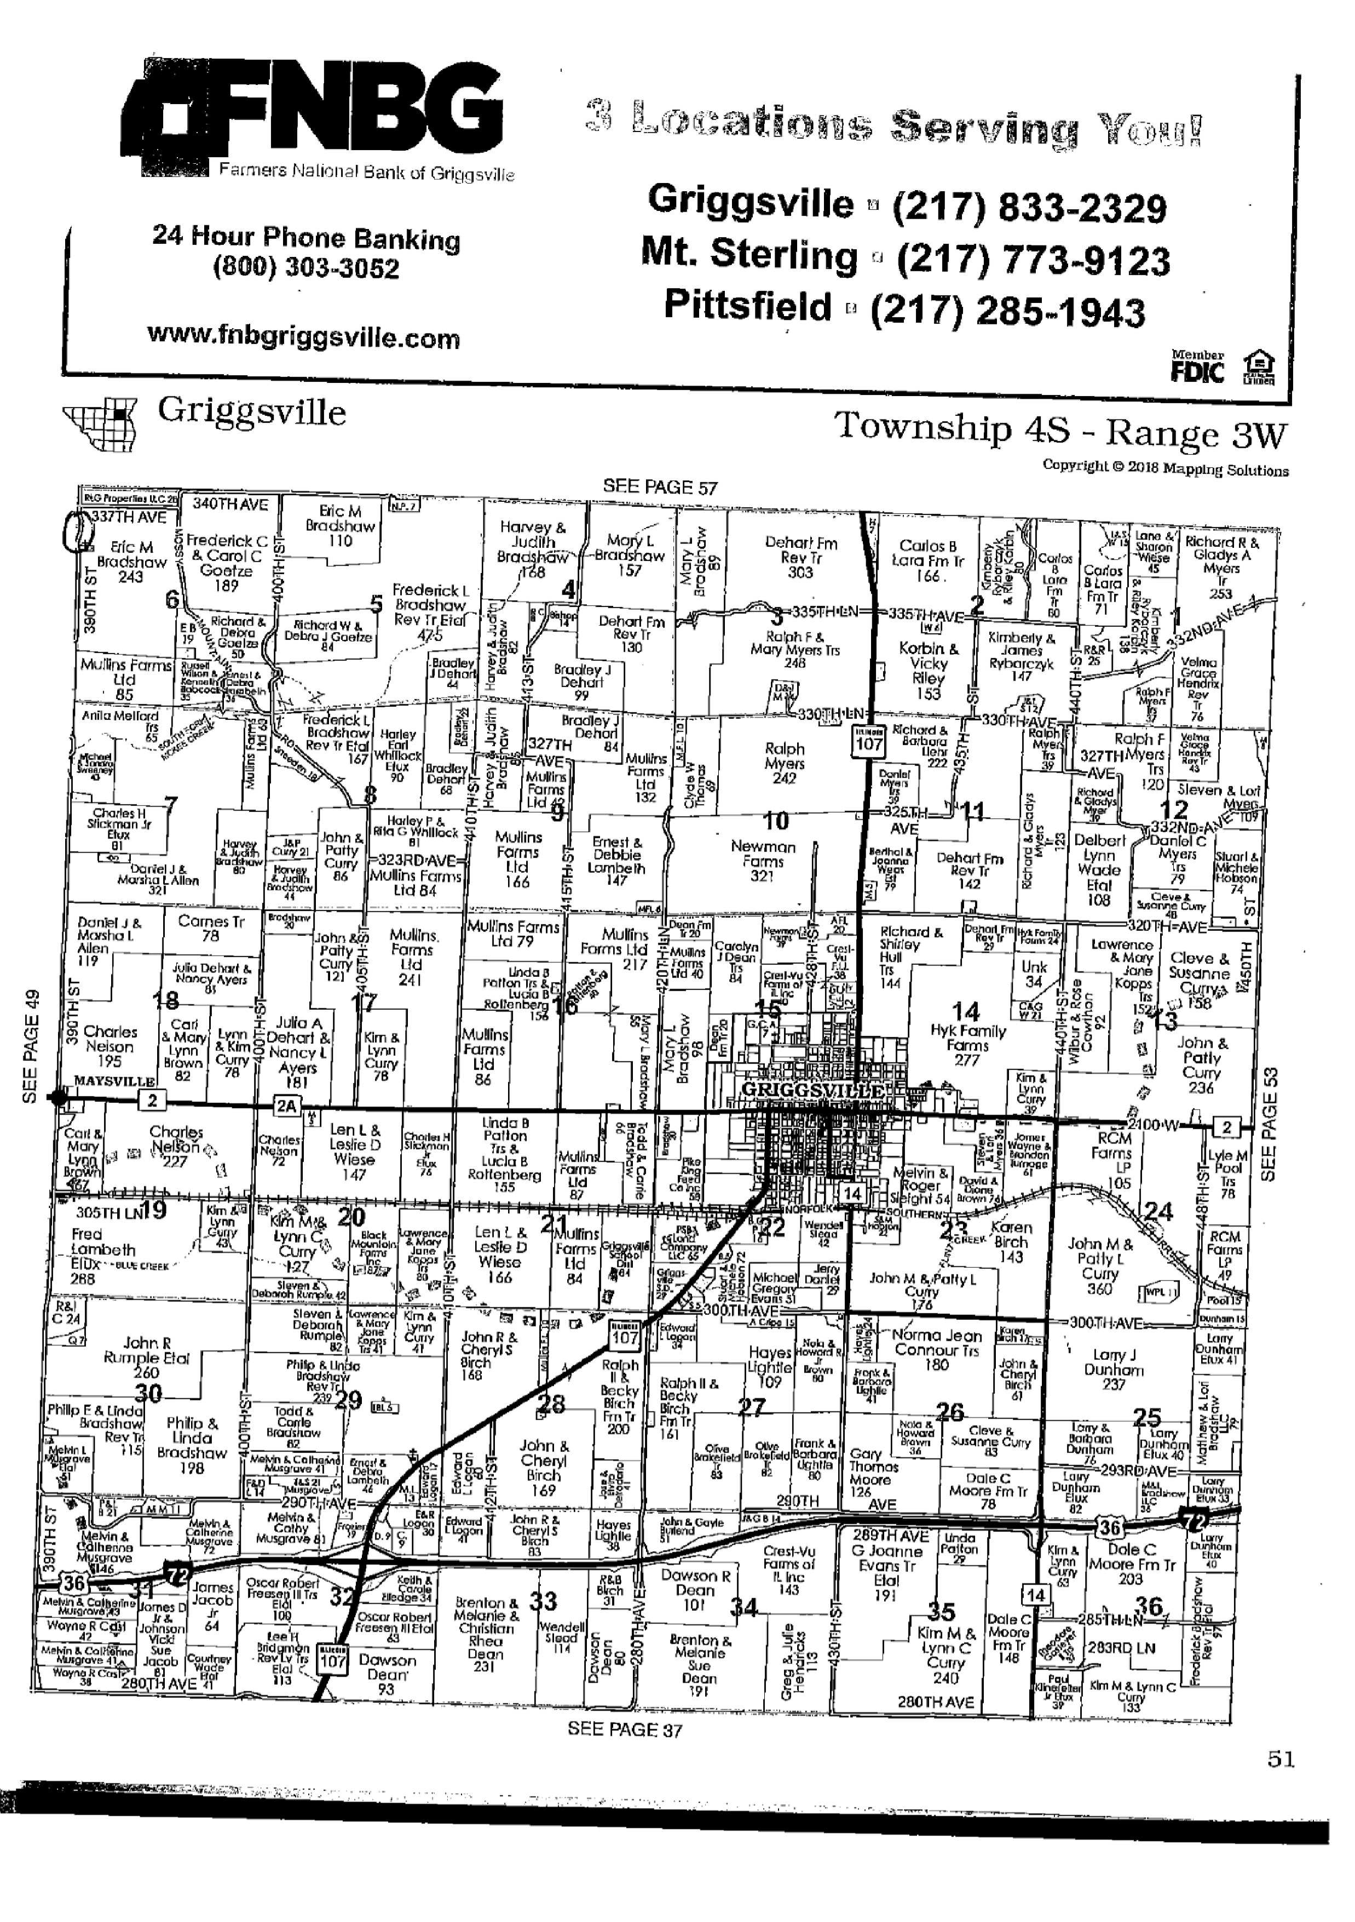

Public Safety:
The Pike County Public Safety Committee was called to order at 6:54 p.m. on February 20th, 2019. Those in attendance were committee members Amy Gates, Derek Ross and Andy Borrowman, Pike County Ambulance Administrator, Josh Martin, and assorted guests.
The Meeting began with a motion by Amy Gates and seconded by Derek Ross to move the time for future Pike County Public Safety Committee meetings from 6:60 p.m. to 7:00 p.m. The motion passed.
Jane Johnson, from the Pike County Health Department (PCHD), spoke regarding the Proposed PCHD Food License Fees 2019 and offered to answer any questions. Clarification was made that this is an annual license fee, not an inspection fee. Further clarification was made that there are no monthly fees on top of an annual fee. Monthly or seasonal fees would only apply where licensing for a year may need to be prorated, instead of a full year’s annual fee being assessed.
Guest Rob Holcomb asked Jane Johnson if an entity had already paid an Annual Fee would they have to pay an Event Permit fee if that entity set up at an event. The answer was no. He also asked if fees were being waived for anyone, for example, school districts or not-for profits. The answer was no. Guest Mark Sprague asked Mr. Holcomb if he felt the minimum wage increase would affect his business. Mr. Holcomb expressed concern about how the trickle down of increased costs on the products he buys and the increased labor cost because of the minimum wage increase will impact his prices. He shared that it’s hard for small businesses to absorb these additional costs without passing some of it on to the customers. And in a competitive market with larger operations like Walmart, small businesses find it difficult to compete.
Administrator Martin presented that the Pike County Ambulance department had $147,771.92 in revenue and $187,156.42 in expenditures for a deficit of $39,384.50. Included in the expenditures was around $90,000.00 for payment for the new cots and lifts.
Amy Gates made a motion and seconded by Derek Ross to pay bills for $57,690.37. The motion passed. Amy Gates made a motion and seconded by Derek Ross to adjourn. The motion passed and the meeting adjourned at 7:54 P.M.
Derek Ross stated in the open board meeting that the committee has gone back and forth over the fees for the PCHD and he wants to internally help the PCHD and not necessarily pass the cost over to the local businesses and that is why he voted the way he did on the motion.
Amy Gates made a motion to approve the committee minutes seconded by Mark Mountain. Voice vote was 7-0 to approve.

GIS/IT
The GIS/IT committee met at 5:00 p.m. on Wednesday February 20, 2019 in the upstairs conference room of the Pike County Jail. Those present were; Amy Gates, Mark Sprague, Jim Sheppard, Board Chairman Andy Borrowman, Sandy Schacht, Scott Syrcle, Dawn Leahr, Paula Dean and Natalie Roseberry.
Amy Gates made a motion to pay the monthly bills in the amount of $362.00. Mark Sprague seconded, motion carried.
Sandy reported that the backup system did not work in the government building on February 19th, 2019 when the fiber optic cable was cut. It did work in the courthouse and jail. She also reported that they had upgraded their Barracude backup at the jail. Natalie discussed a $12,385.00 grant she had received to help change the election software and make it more secure.
We briefly discussed the administrator’s meeting on March 27th, 2019. The main topic will be employment practices. Natalie brought up disposal of excess county equipment. Jim Sheppard stated he would get a legal opinion from the State’s Attorney on how we do this and Natalie stated she would reach out to the office heads and find out how much they had.
Paula Dean was there to talk about the Health Department’s email and rolling it into the rest of the county for billing purposes which was agreed would be a good idea. We also looked at their maintenance contract with Marco. At the end of January we had $11,867.81 left on ours.
Scott Syrcle brough forth some questions about the security of Natalie’s laptop and the installation of the CIC program. Natalie stated that it would take four passwords to get into the program and there would be no data stored on the device.
On a motion by Amy Gates and a second by Mark Sprague meeting adjourned at 6:35 p.m.
Mark Mountain questioned the time of the Administrators Meeting and Jim Sheppard stated it starts at 4:00 p.m.
Motion to approve the GIS minutes made by Amy Gates and seconded by Mark Sprague. Voice vote 7-0 motion approved.
Agriculture Committee
The Agruculture committee met on February 19, 2019 at 5:00 p.m. in the upper courtroom at the Pike County Courthouse. Member in attendance were Mark Mountain (chairman of the committee), Rodger Hannel, mark Sprague and Andy Borrowman (Chairman of the County Board). Others in attendance were John Birch, Natalie Roseberry, Debbie Lambeth, Fred Ruzich, Zack Boren, Jane Johnson, Tom Weisenborn, USDA, Anita Andress, Pike County Health Department, Peyton McKinnon, Pike County Health Department, and Michael Boren, Pike Press.
Meeting was called to order at 5:00 p.m.
Solar Ordinance
Zack Boren and Fred Ruzich gave a brief report on the progress of the ordinance to committee due to new members. Both presented proposed changes they would like to see on the ordinance to match or clear up the gray areas of the Illinois Department of Agriculture STANDART AGRUCULTURAL MITIGATION AGGREEMENT (AIMA).
The Committee agreed that proposed changes would be put in a clean version of the ordinance and emailed to committee for review. The next Ag meeting is scheduled for March 19th, 2019 in the upper conference room of the government building.
(765 ILCS 205/) Platt Act Compliance
Natalie presented to the committee several examples of the Plat Act Affidavit for purposes of the Illinois Plat Act requirements. Mr. Bored talked about the process and how it is supposed to work. The committee discussed the act and how to get the word out to all parties involved with this process. It was decided to invite all parties to next Ag meeting March 19th, 2019 at 5:00 p.m.
Pike County Health Department
Jane Johnson advised committee that the dates for the Tire Collection will be March 19 and 19, 2019 at the Griggsville Fairgrounds.
USDA, Tom Wisenborn
Mr. Wisenborn addressed the committee about concerns with the recycling center’s close proximity to the USDA building. He presented pictures to the committee. He was not sure who the governing authority was. He also stated that Area Disposal was a very good neighbor. Mr. Borrowman said he would discuss this issue with all parties involved.
Animal Control
Debbie Lambeth updated the committee on her search for another vehicle. Mark Sprague made a motion to give the Chairman of the Committee, Mark Mountain authority to authorize purchase of animal control vehicle when located. Motion seconded by Rodger Hannel, followed by all voting in favor.
New Business
Mark Sprague stated he would like to review the zoning ordinance for updates and changes in the near future.
Old Business - None
Public Comment
Michael Boren mentioned he had seen on You Tube a Single-Stream Recycling machine- Leading the Way to Zero Waste.
Motion to adjourn by Mark Sprague. Seconded by Rodger Hannel. Meeting adjourned at 6:23 p.m.
Mark Mountain stated in the Board Meeting that he went out to Area Disposal to look at the recycling center and it is in very close proximity to USDA.
Rob Holcomb asked regarding the search for a vehicle for Animal Control if anyone had talked to CSB due to a large repo lot that they have.
Mark Mountain asked him to inform Debbie Lambeth.
Insurance
The Insurance committee of the PIike County Board met February 22, 2019 at 2:30 p.m. in the conference room of the Pike County Government Building. Members present were, Rodger Hannel, Derek Ross, Jim Sheppard and Chairman Andy Borrowman.
The first item of business was the review of the changes to the county’s policy manual that the loss control committee forwarded to the insurance committee. Those revisions were to the Computer, Internet, and Network Usage policy, Family Medical Leave and Military Leave policy, Discrimination, Harassment, Bullying, and Sexual Misconduct policy, Business Expense Reimbursement policy, and Nursing Mother policy. Derek Ross made a motion to accept the policies as presented. Rodger Hannel seconded, motion carried.
We then discussed the loss due to snow load of the roof of the Quonset building at the Highway department. The building was determined to be a total loss and we will receive a check for $30,186.19 for the claim. Eric Snedeker brought information about educational seminars that the ICRMT is presenting. We also discussed our administrators meeting.
Derek Ross requested information about the health reimbursement program costs to the county. He will be added to the email list.
We then addressed the liability aspect of Natalie’s laptop. Eric stated he had no special concerns but he would prefer it be encrypted and Natalie assured him it was.
Derek Ross made a motion to adjourn and Rodger Hannel seconded. Motion carried.
Meeting adjourned at 3:25 p.m.
Rodger Hannel made a motion to approve the minutes seconded by John Birch. Voice vote 7-0 motion carried.
New Business
Rodger Hannel discussed information from the UCCI meeting and pending legislation and provided a handout to some bills that are currently being considered that would impact the county, specifically metal detectors at the courthouse and permanent absentee voting. Natalie Roseberry spoke on the absentee legislation stating that it would prevent people from calling in every election to request a ballot and would have a list that once you are on you are registered until you call and change. She then spoke about what Colorado and other states are doing regarding all mail by vote. Amy gates expressed concerns regarding voter safety regarding fraud.
Old Business
Derek Ross addressed the recent change on the Pike County Board regarding the vacancy and stated that is was brought up in the January Meeting. He believed this was against the Open Meetings Act and encouraged the citizens to hold the Board accountable and make sure they have their input on things that might affect them. Chairman Borrowman apologized and stated he should have tabled the request.

Chairman’s Remarks
Mr. Borrowman stated that he believed there had been enough remarks already.
Mileage and Per Diem/Summery of Expenses
Motion made to approve the Mileage and Per Diem and Summary of Expenses seconded by Mark Mountain. Voice vote 7-0 to approve.
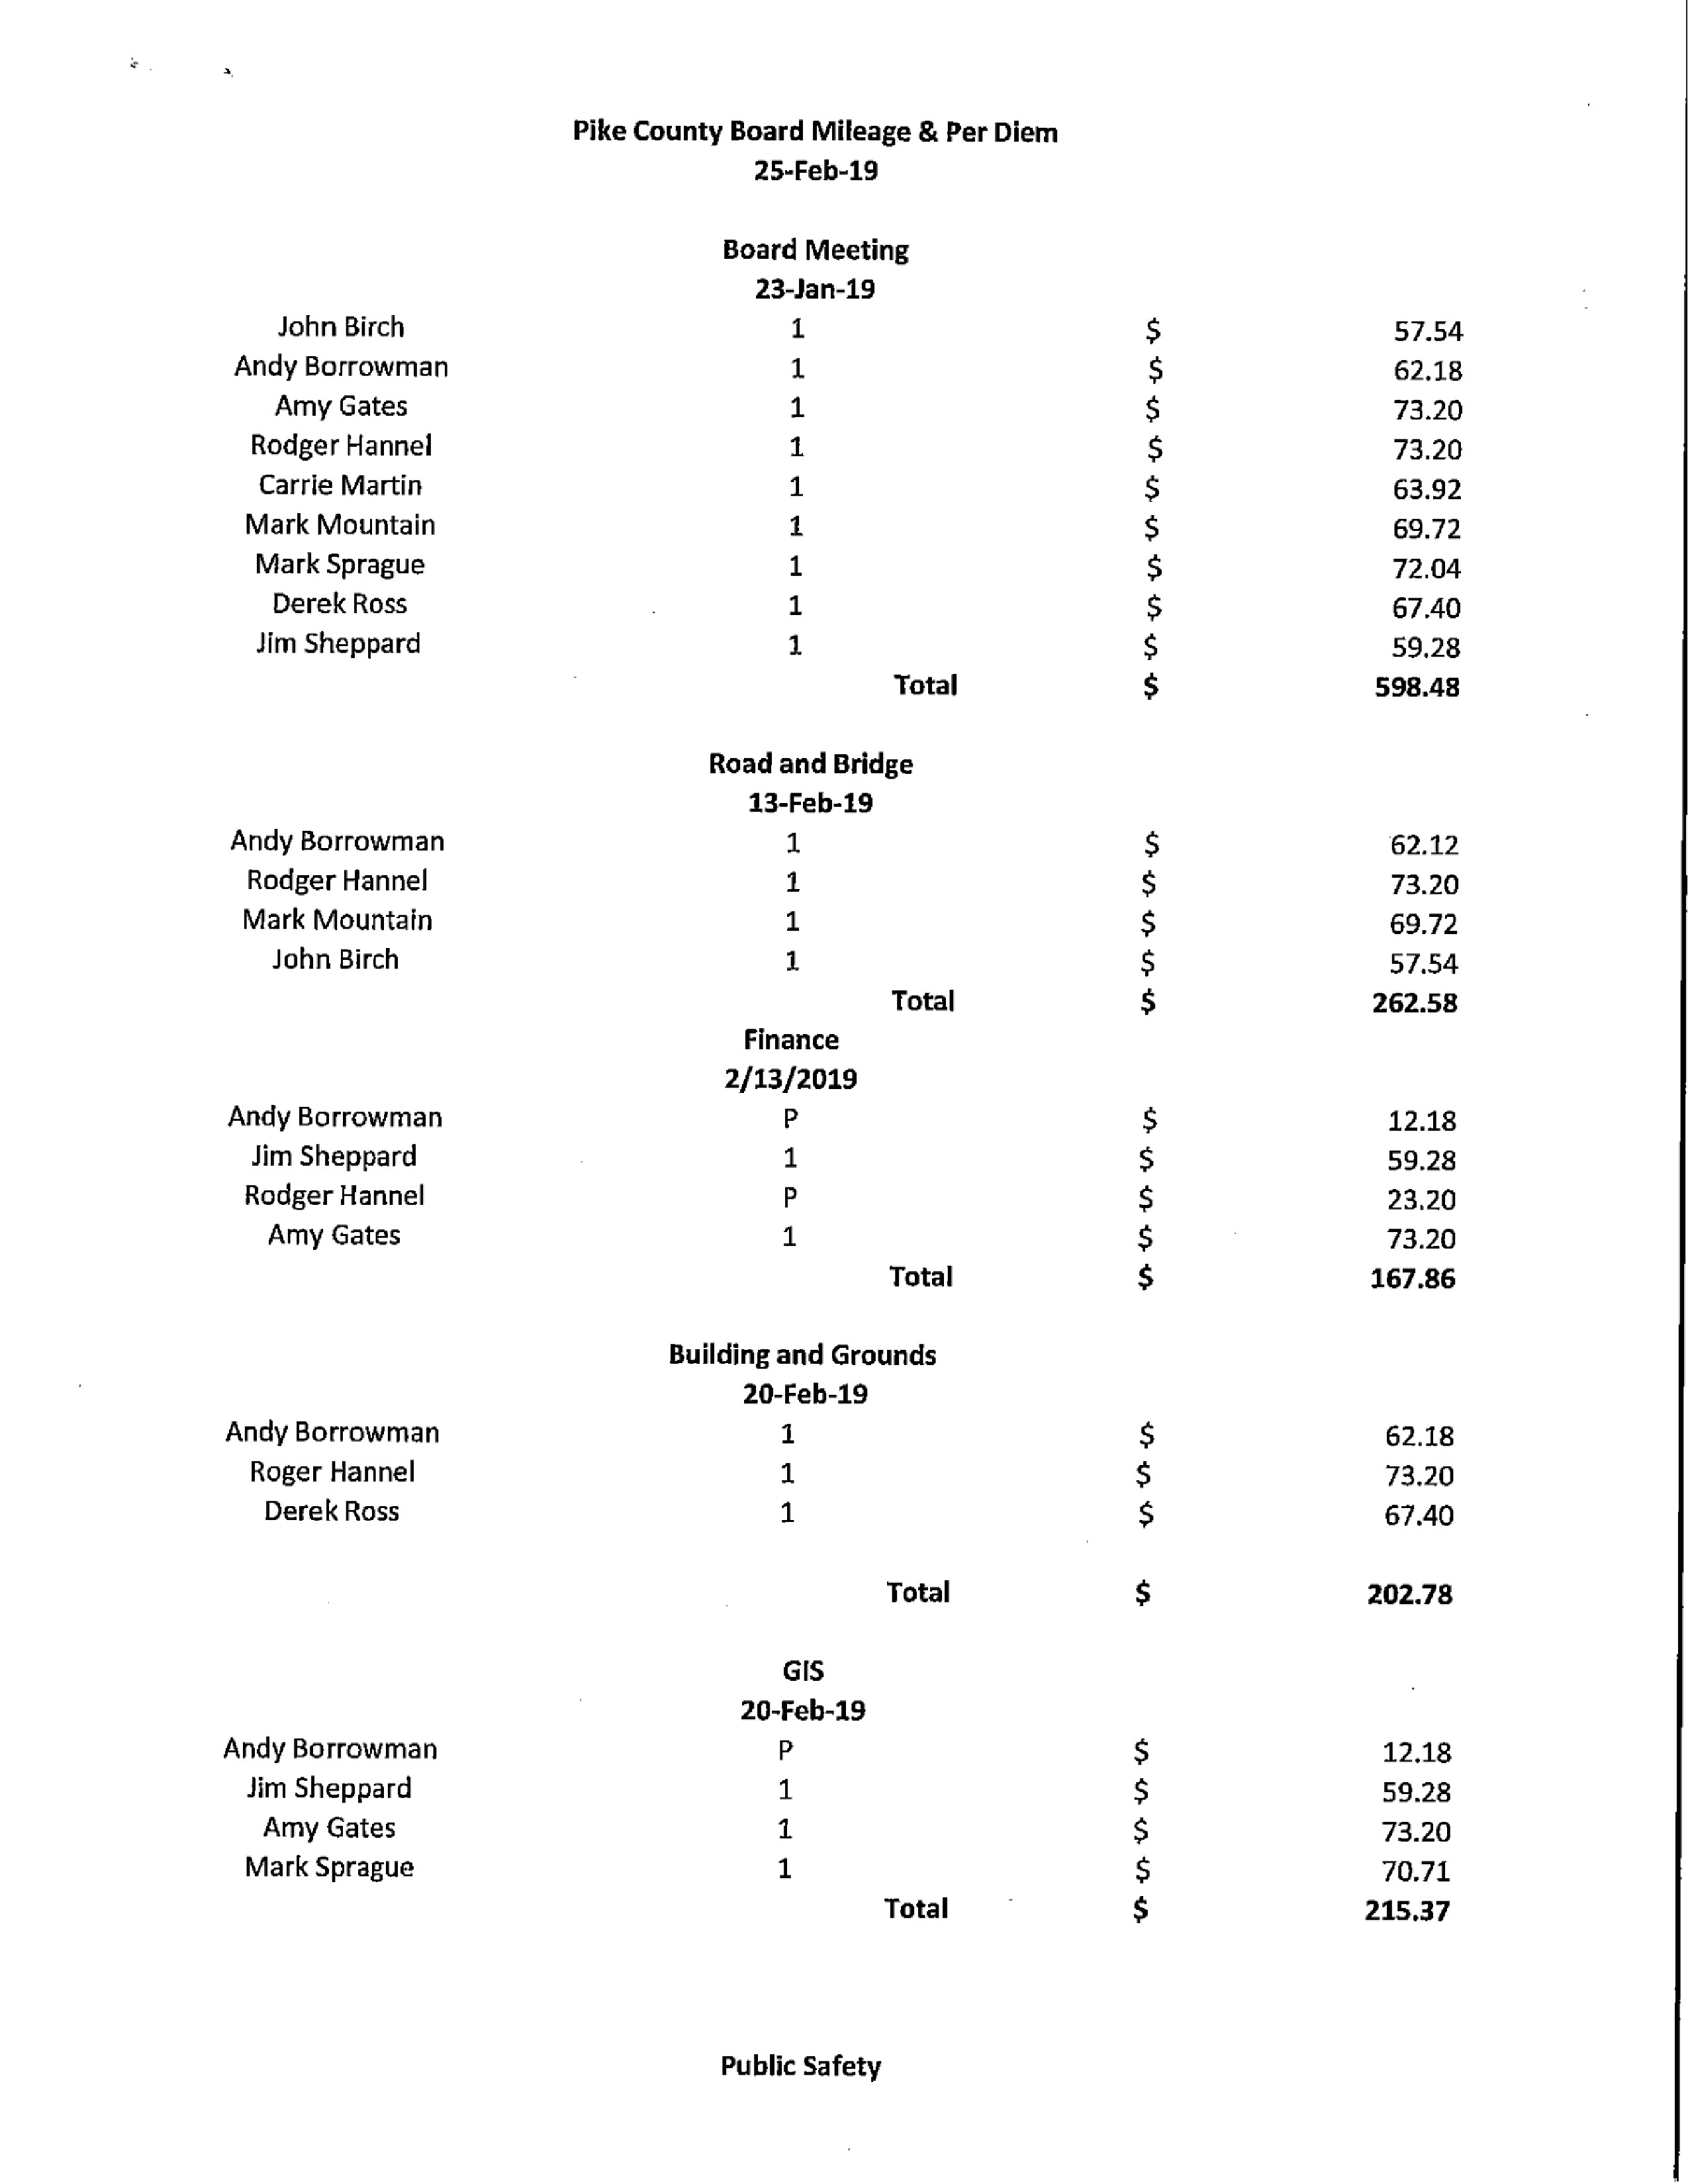
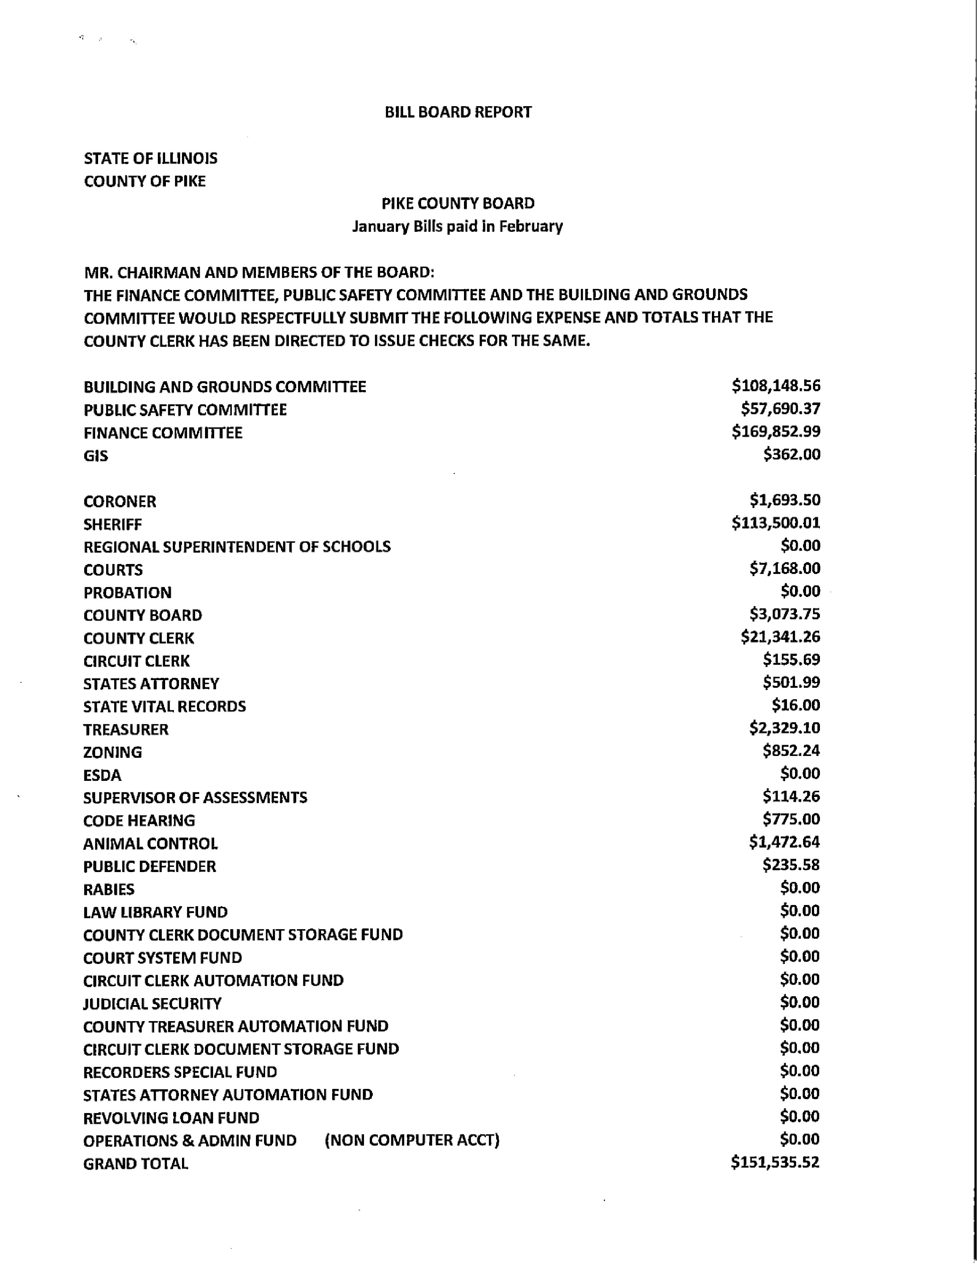

Questions from Press and Visitors
Scott Syrcle expressed his opposition to Clerk Natalie Roseberry having laptops in her office.
Chris Johnson stated the recycling center will not be permanent at Area Disposal and a possibility would be at the Landfill.
Closed Session Pursuant to 5 ILCS 120/2 (c)(11) Possible Pending Litigation
Michael Bored asked Chairman Andy Borrowman if he could comment on the reason for the closed session and Mr. Borrowman stated he could not.
Amy Gates made a motion to enter into closed session seconded by Jon Birch. Voice vote 7-0 motion carried and the Board entered into closed session at 9:21 p.m.
Time out of closed session was 10:17 p.m.
Mark Sprague made a motion to reject the counter offer by White Bridge seconded by Mark Mountain. Voice vote 7-0 motion carried.
Adjournment
Motion to adjourn by Amy Gates seconded by Rodger Hannel. Voice vote 7-0. Meeting adjourned at 10:18 p.m.

