PIKE COUNTY BOARD MEETING MINUTES

January 23rd, 2018

The regular monthly meeting of the Pike County Board was held on January 23, 2018 at 7:00 PM. Jerry Edison gave the invocation and Chairman Andy Borrowman led the Pledge of Allegiance. Chairman Andy Borrowman asked County Clerk, Natalie Roseberry, to call the roll. Those answering the roll call were John Birch, Andy Borrowman, Amy Gates, Rodger Hannel, Carrie Martin, Mark Mountain, Mark Sprague, Derek Ross, and Jim Sheppard.

APPROVAL OF MINUTES OF DECEMBER 26, 2018 PIKE COUNTY BOARD MEETING

Carrie Martin made a motion to approve December 26, 2018 Pike County Board minutes. John Birch seconded the motion. Voice vote was 8-0 to approve.

REGIONAL OFFICE OF EDUCATION AGREEMENT

John Birch made a motion to approve the intergovernmental agreement to fund the Regional Office of Education at 8.7% contribution. Mark Mountain seconded the motion. Voice vote was 8-0 to approve the agreement.
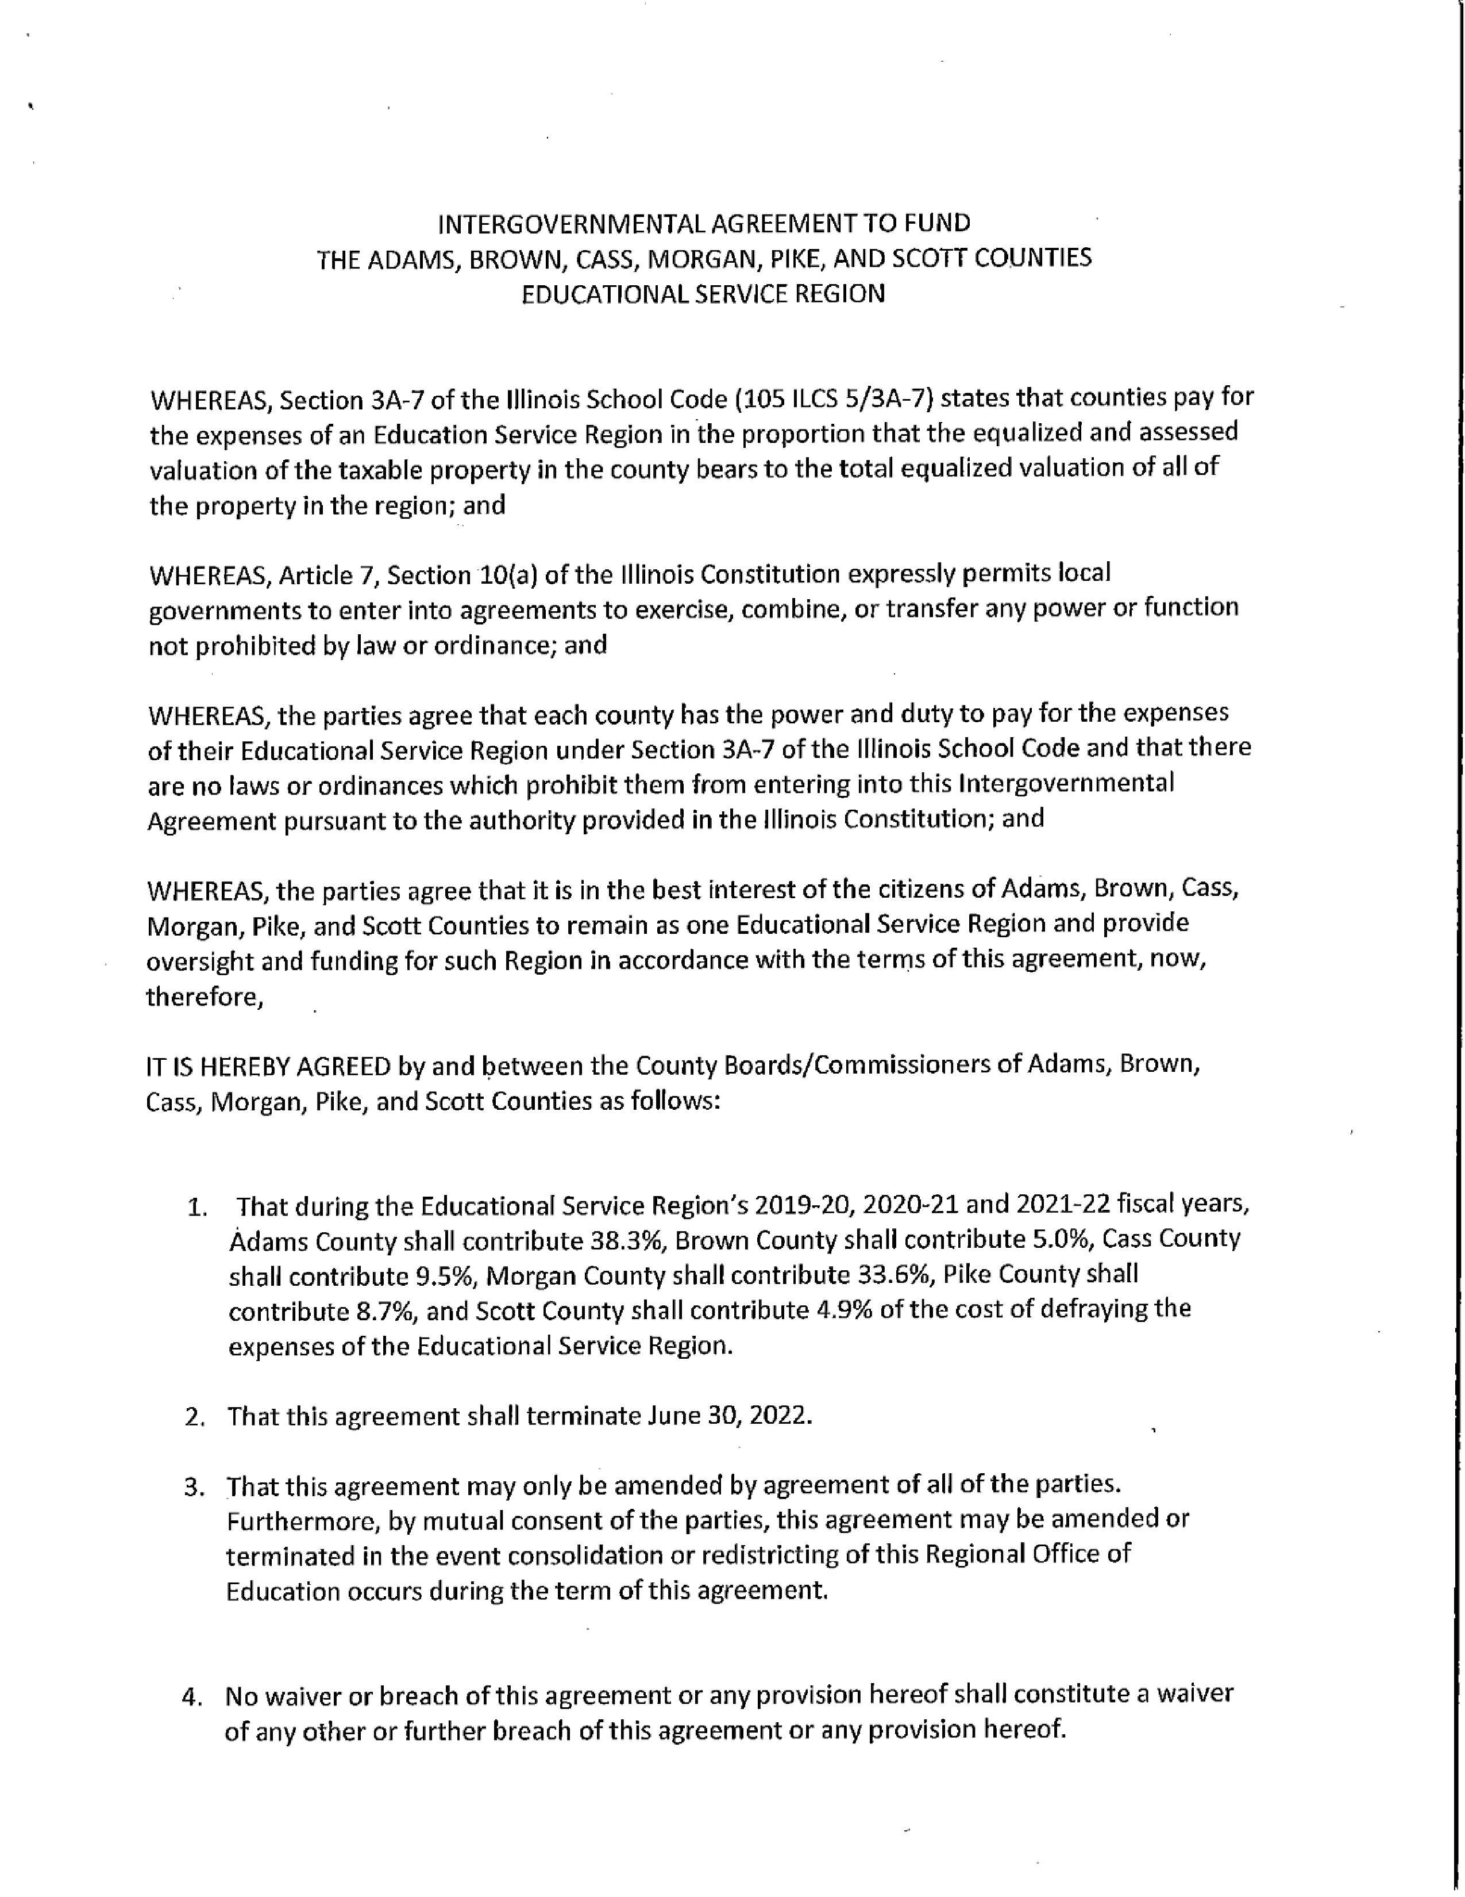
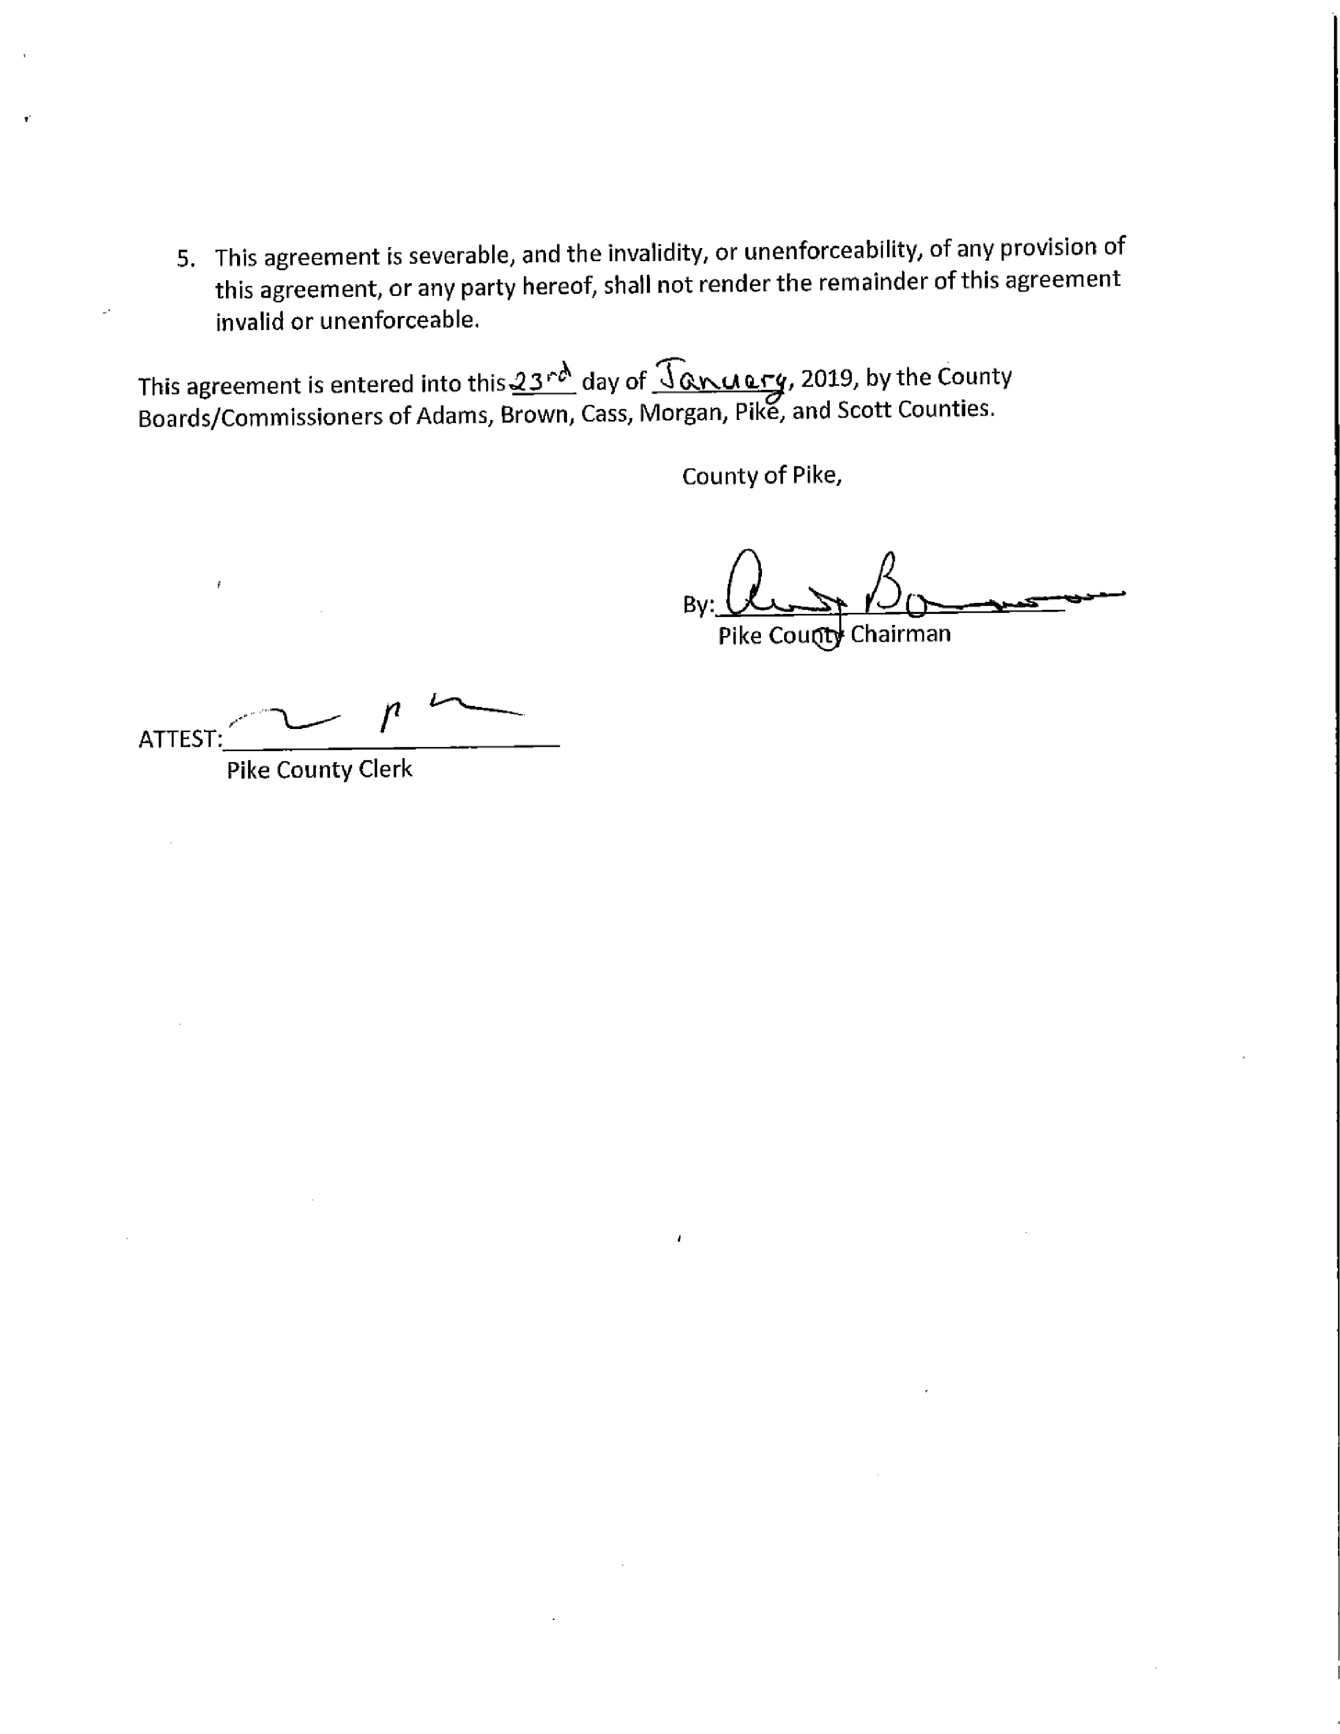

VOTE TO APPROVE LABOR CONTRACT UNION 965
Mark Sprague questioned raises for non-union employees and Chairman Andy Borrowman stated that raise approval for those employees will be on the agenda for February 25th, 2019. A motion was made by Carrie Martin to approve the labor contract and allow for Chairman Andy Borrowman to sign. The motion was seconded by Mark Mountain and a voice vote in favor to approve was 8-0.

APPOINTMENT OF WALKER FILBERT TO THE 708 MENTAL HEALTH BOARD WITH A TERM ENDING JANUARY 2023
Chairman Andy Borrowman stated that there are still two vacancies that will be on the agenda for appointment at the February 25th, 2019 meeting. A motion was made to appoint Walker Filbert to the 708 Mental Health Board with a term to expire January 2023 by Rodger Hannel and a second by Carrie Martin. Voice vote was 8-0 to approve. Chairman Andy Borrowman commented after the vote that Mr. Filbert is an asset to the board and has provided many years of service and is very familiar with it.

VOTE ON IDOT HUMAN SERVICE TRANSPORTATION REPRESENTATIVE
Chairman Andy Borrowman stated that he was going to talk with Mr. Scranton from Transit for recommendations and will bring the vote back to the board February 25th, 2019.

6 MONTH REPORTS
6 month department reports were given by Debbie Lambeth from Animal Control, County Clerk Natalie Roseberry, Treasurer Scott Syrcle and Circuit Clerk Bryce Gleckler. John Birch made a motion that was seconded by Carrie Martin. Motioned passed by voice vote of 8-0.

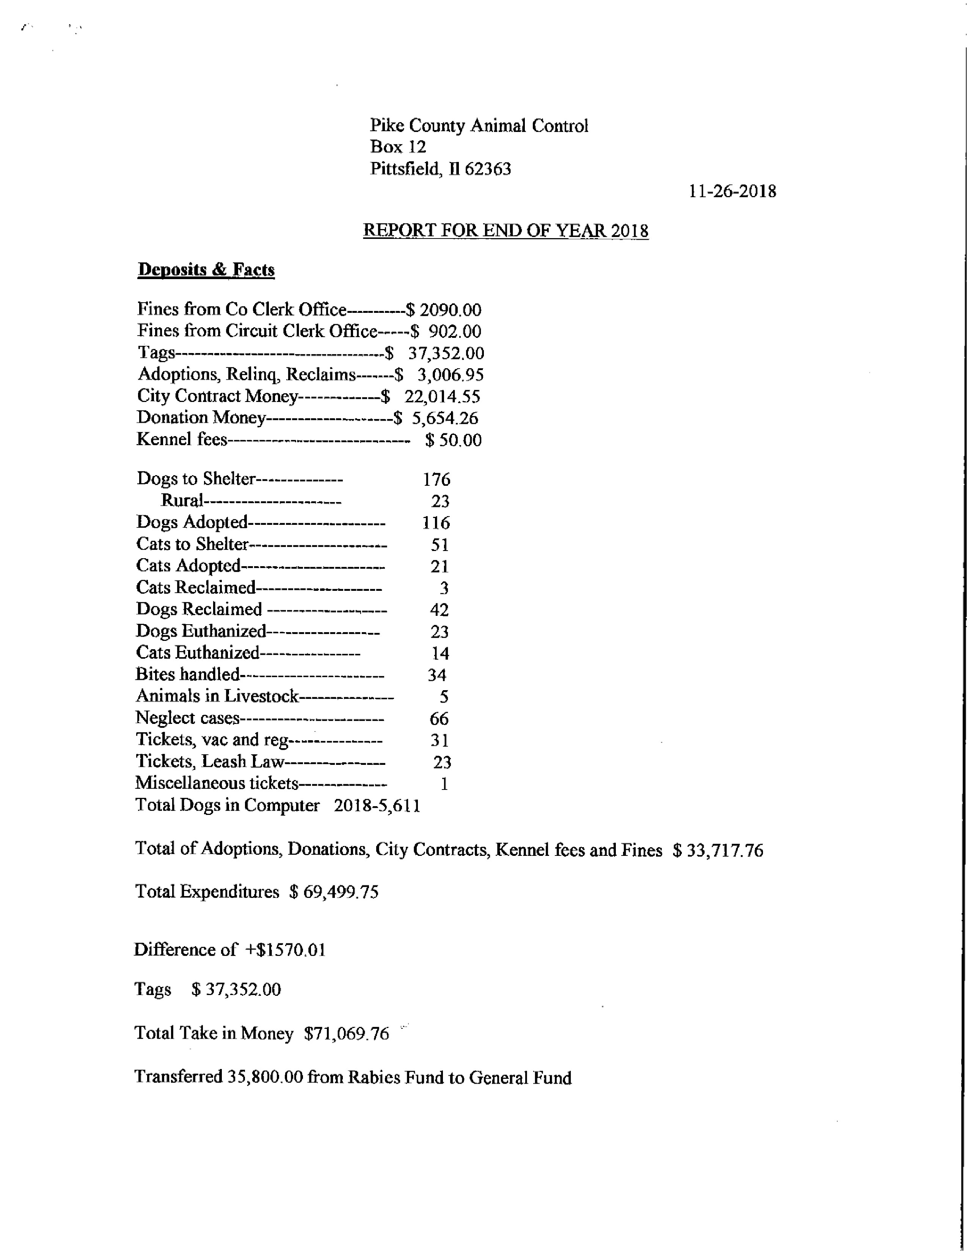
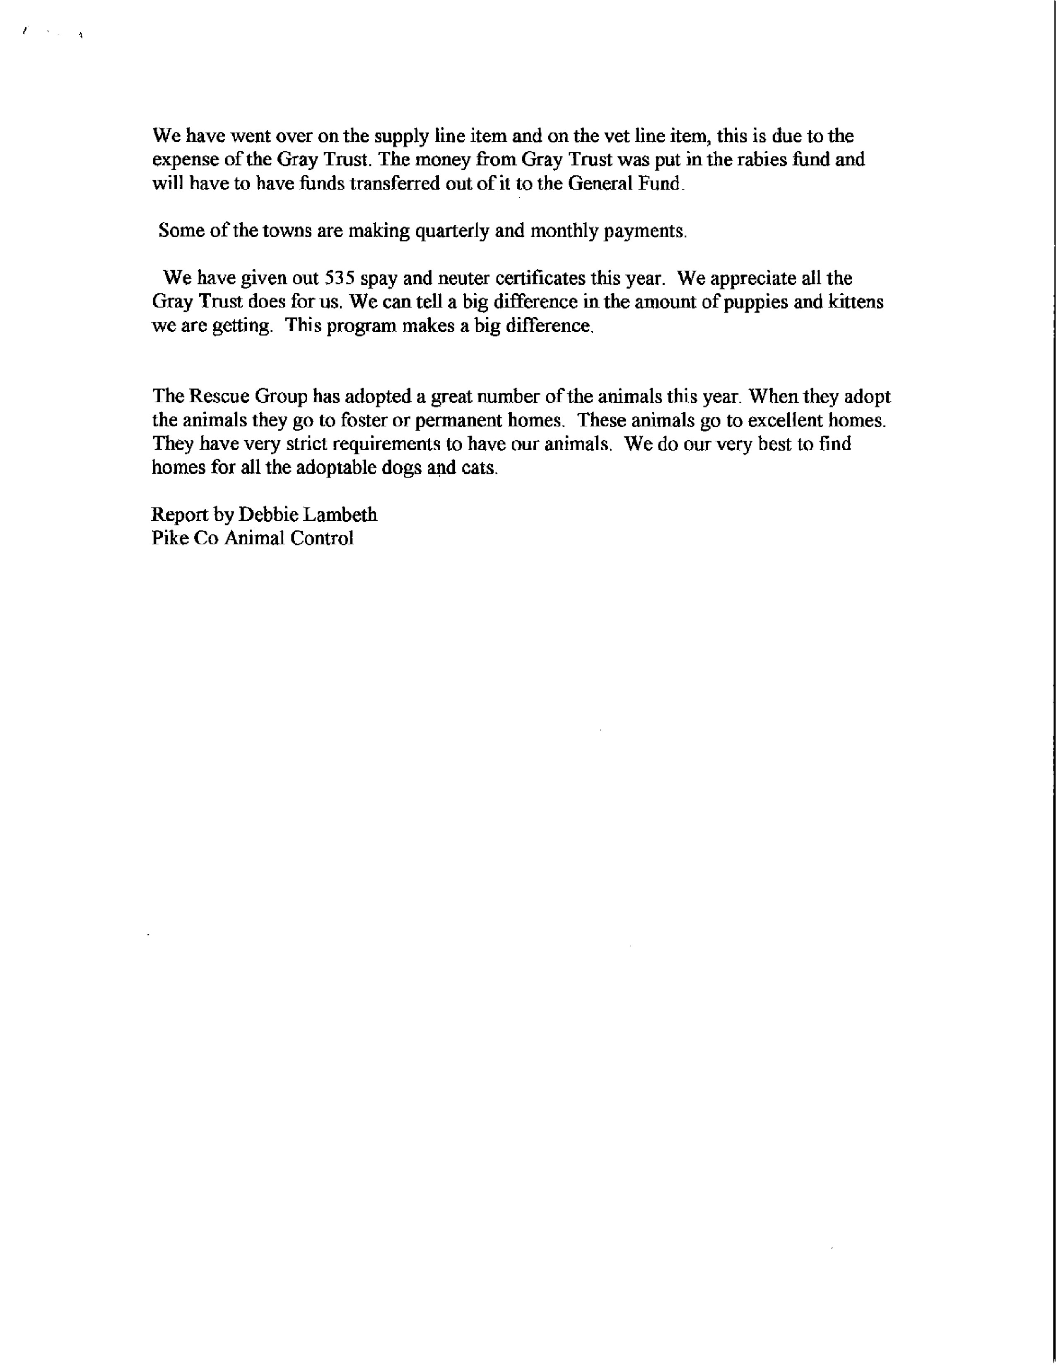
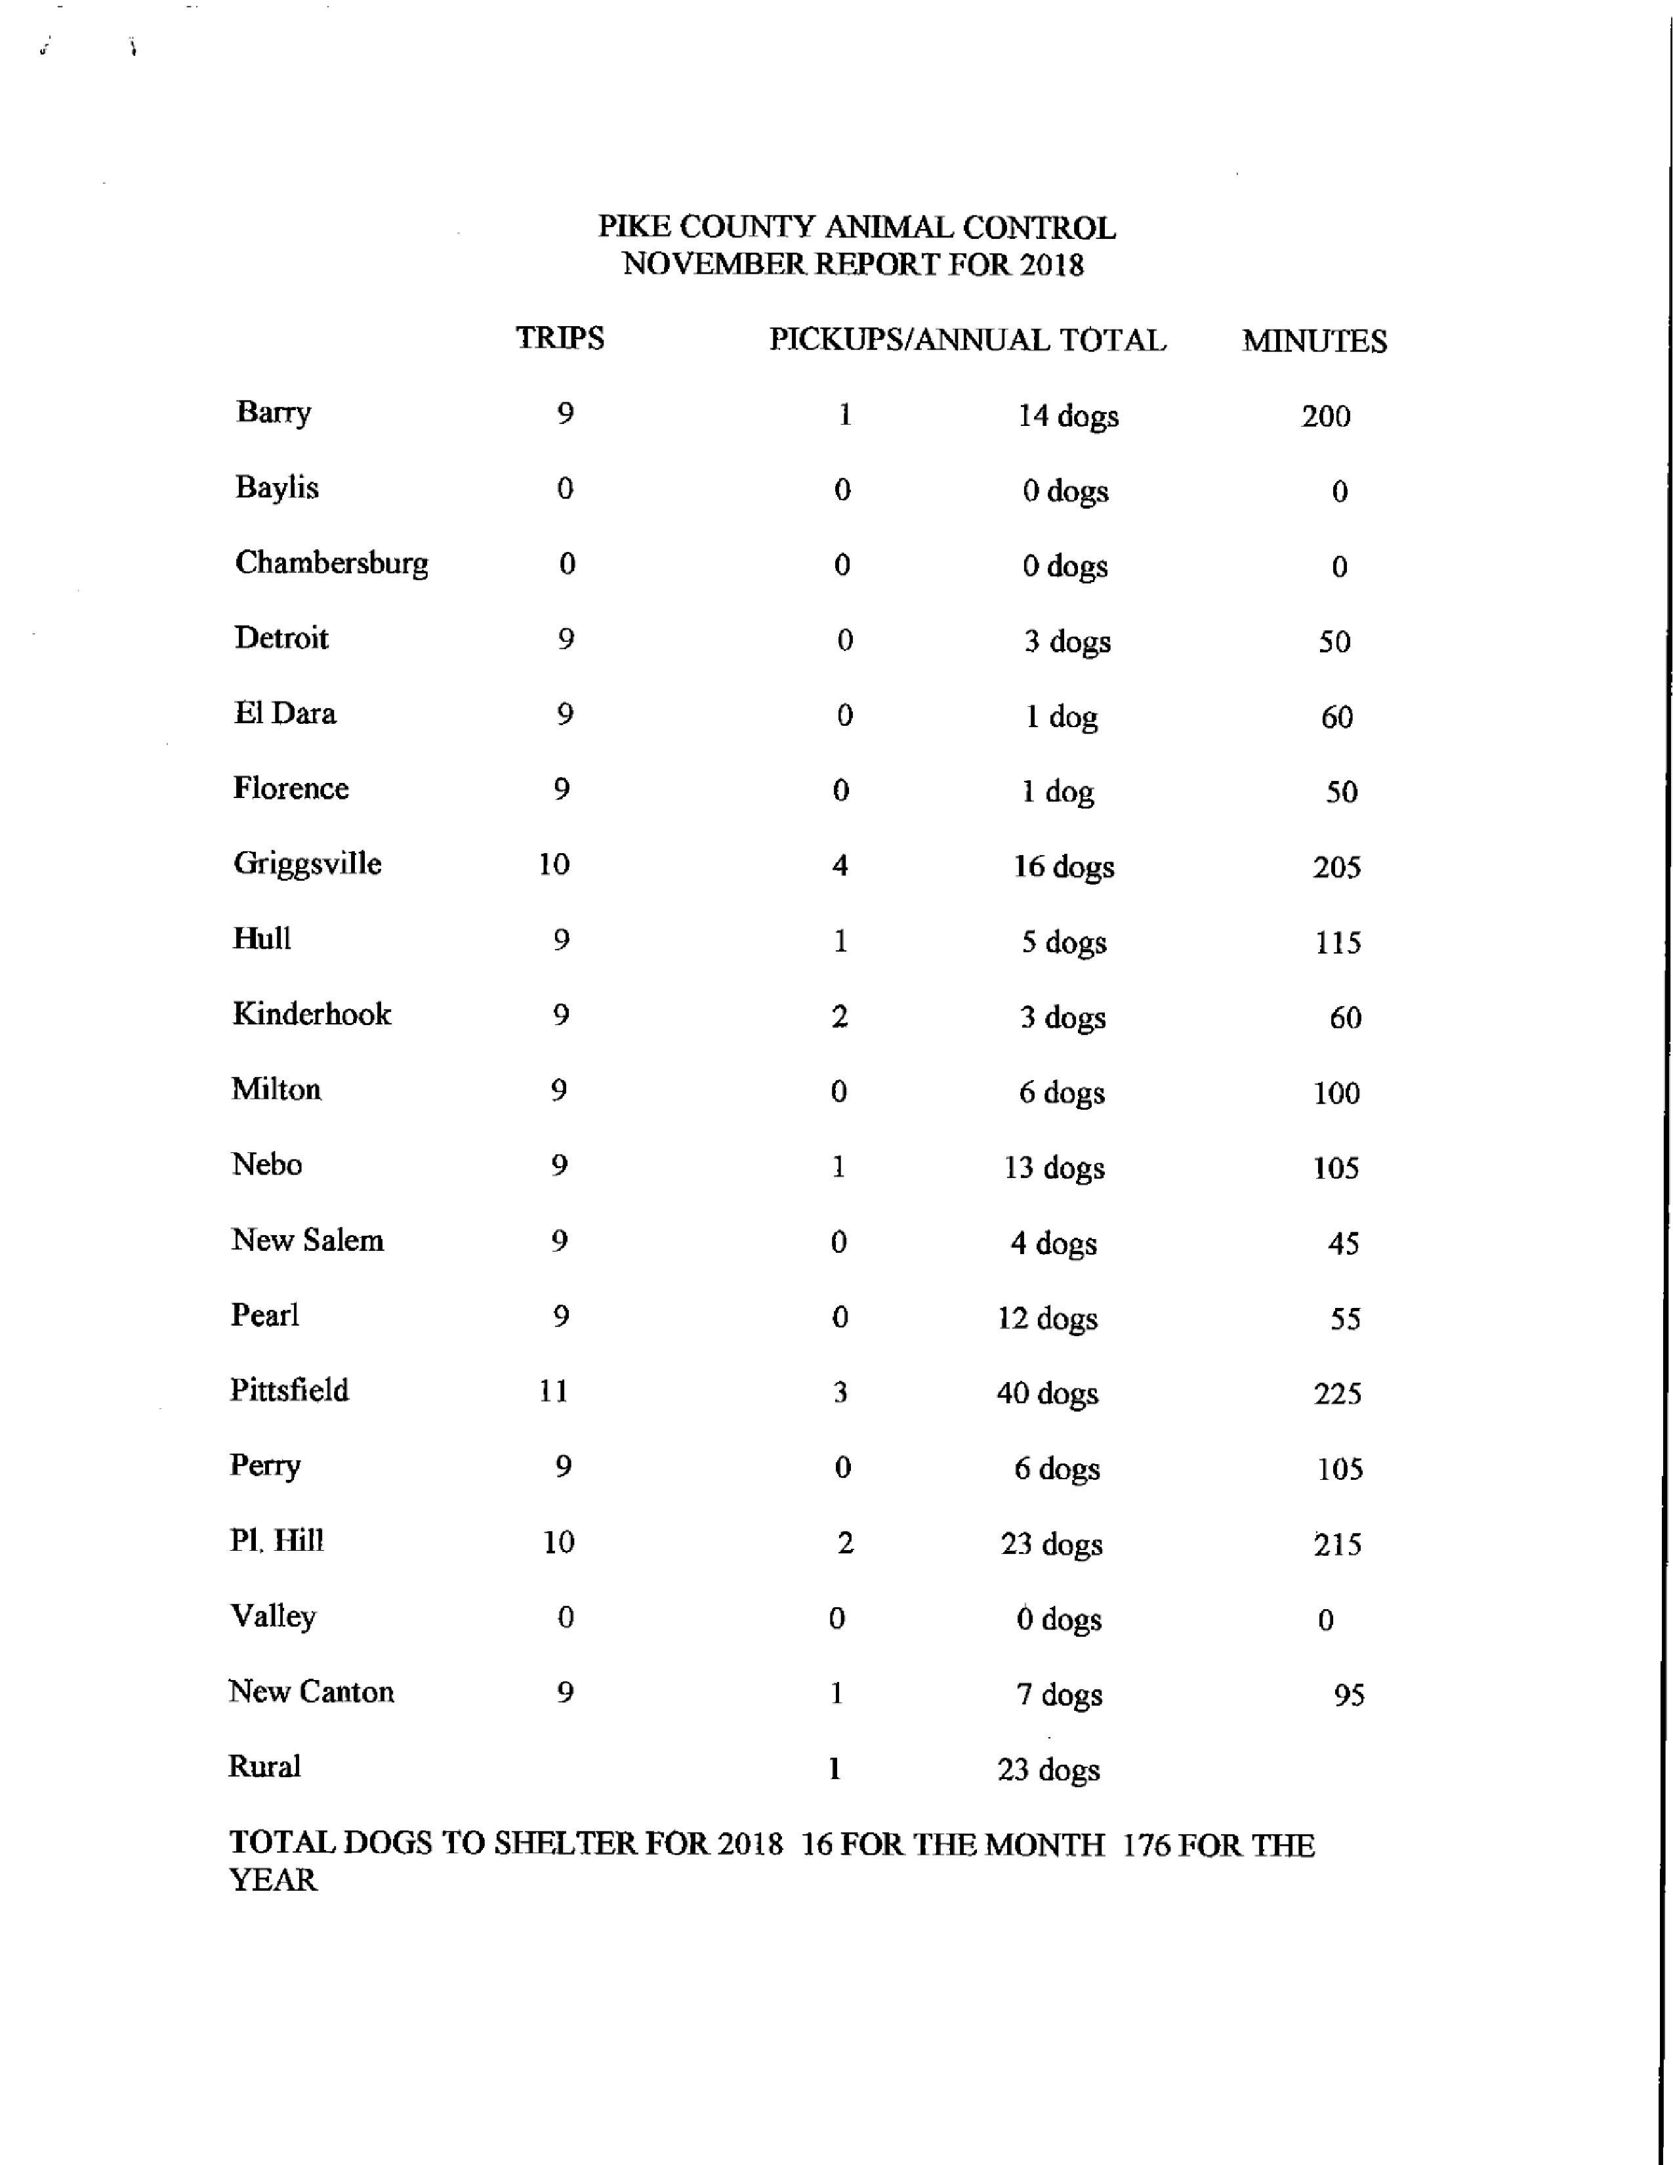
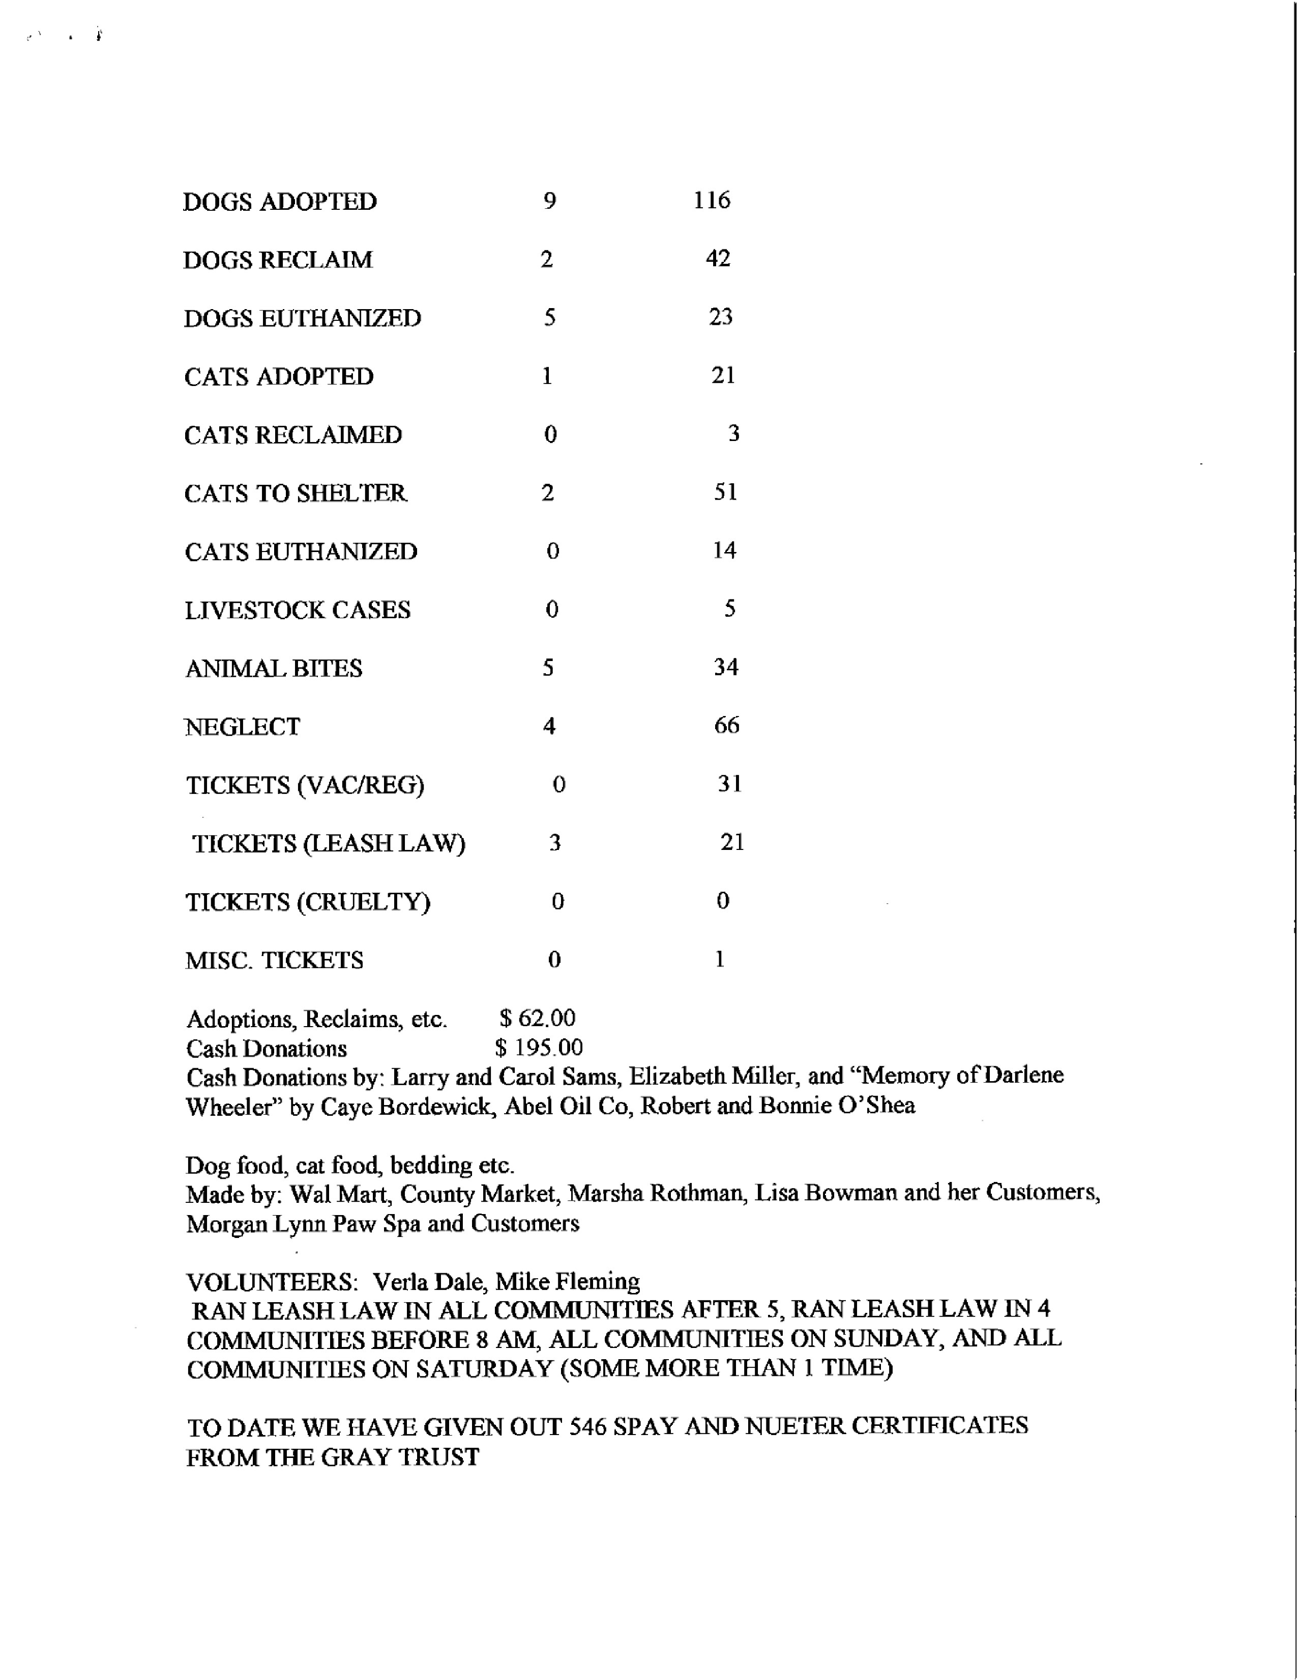
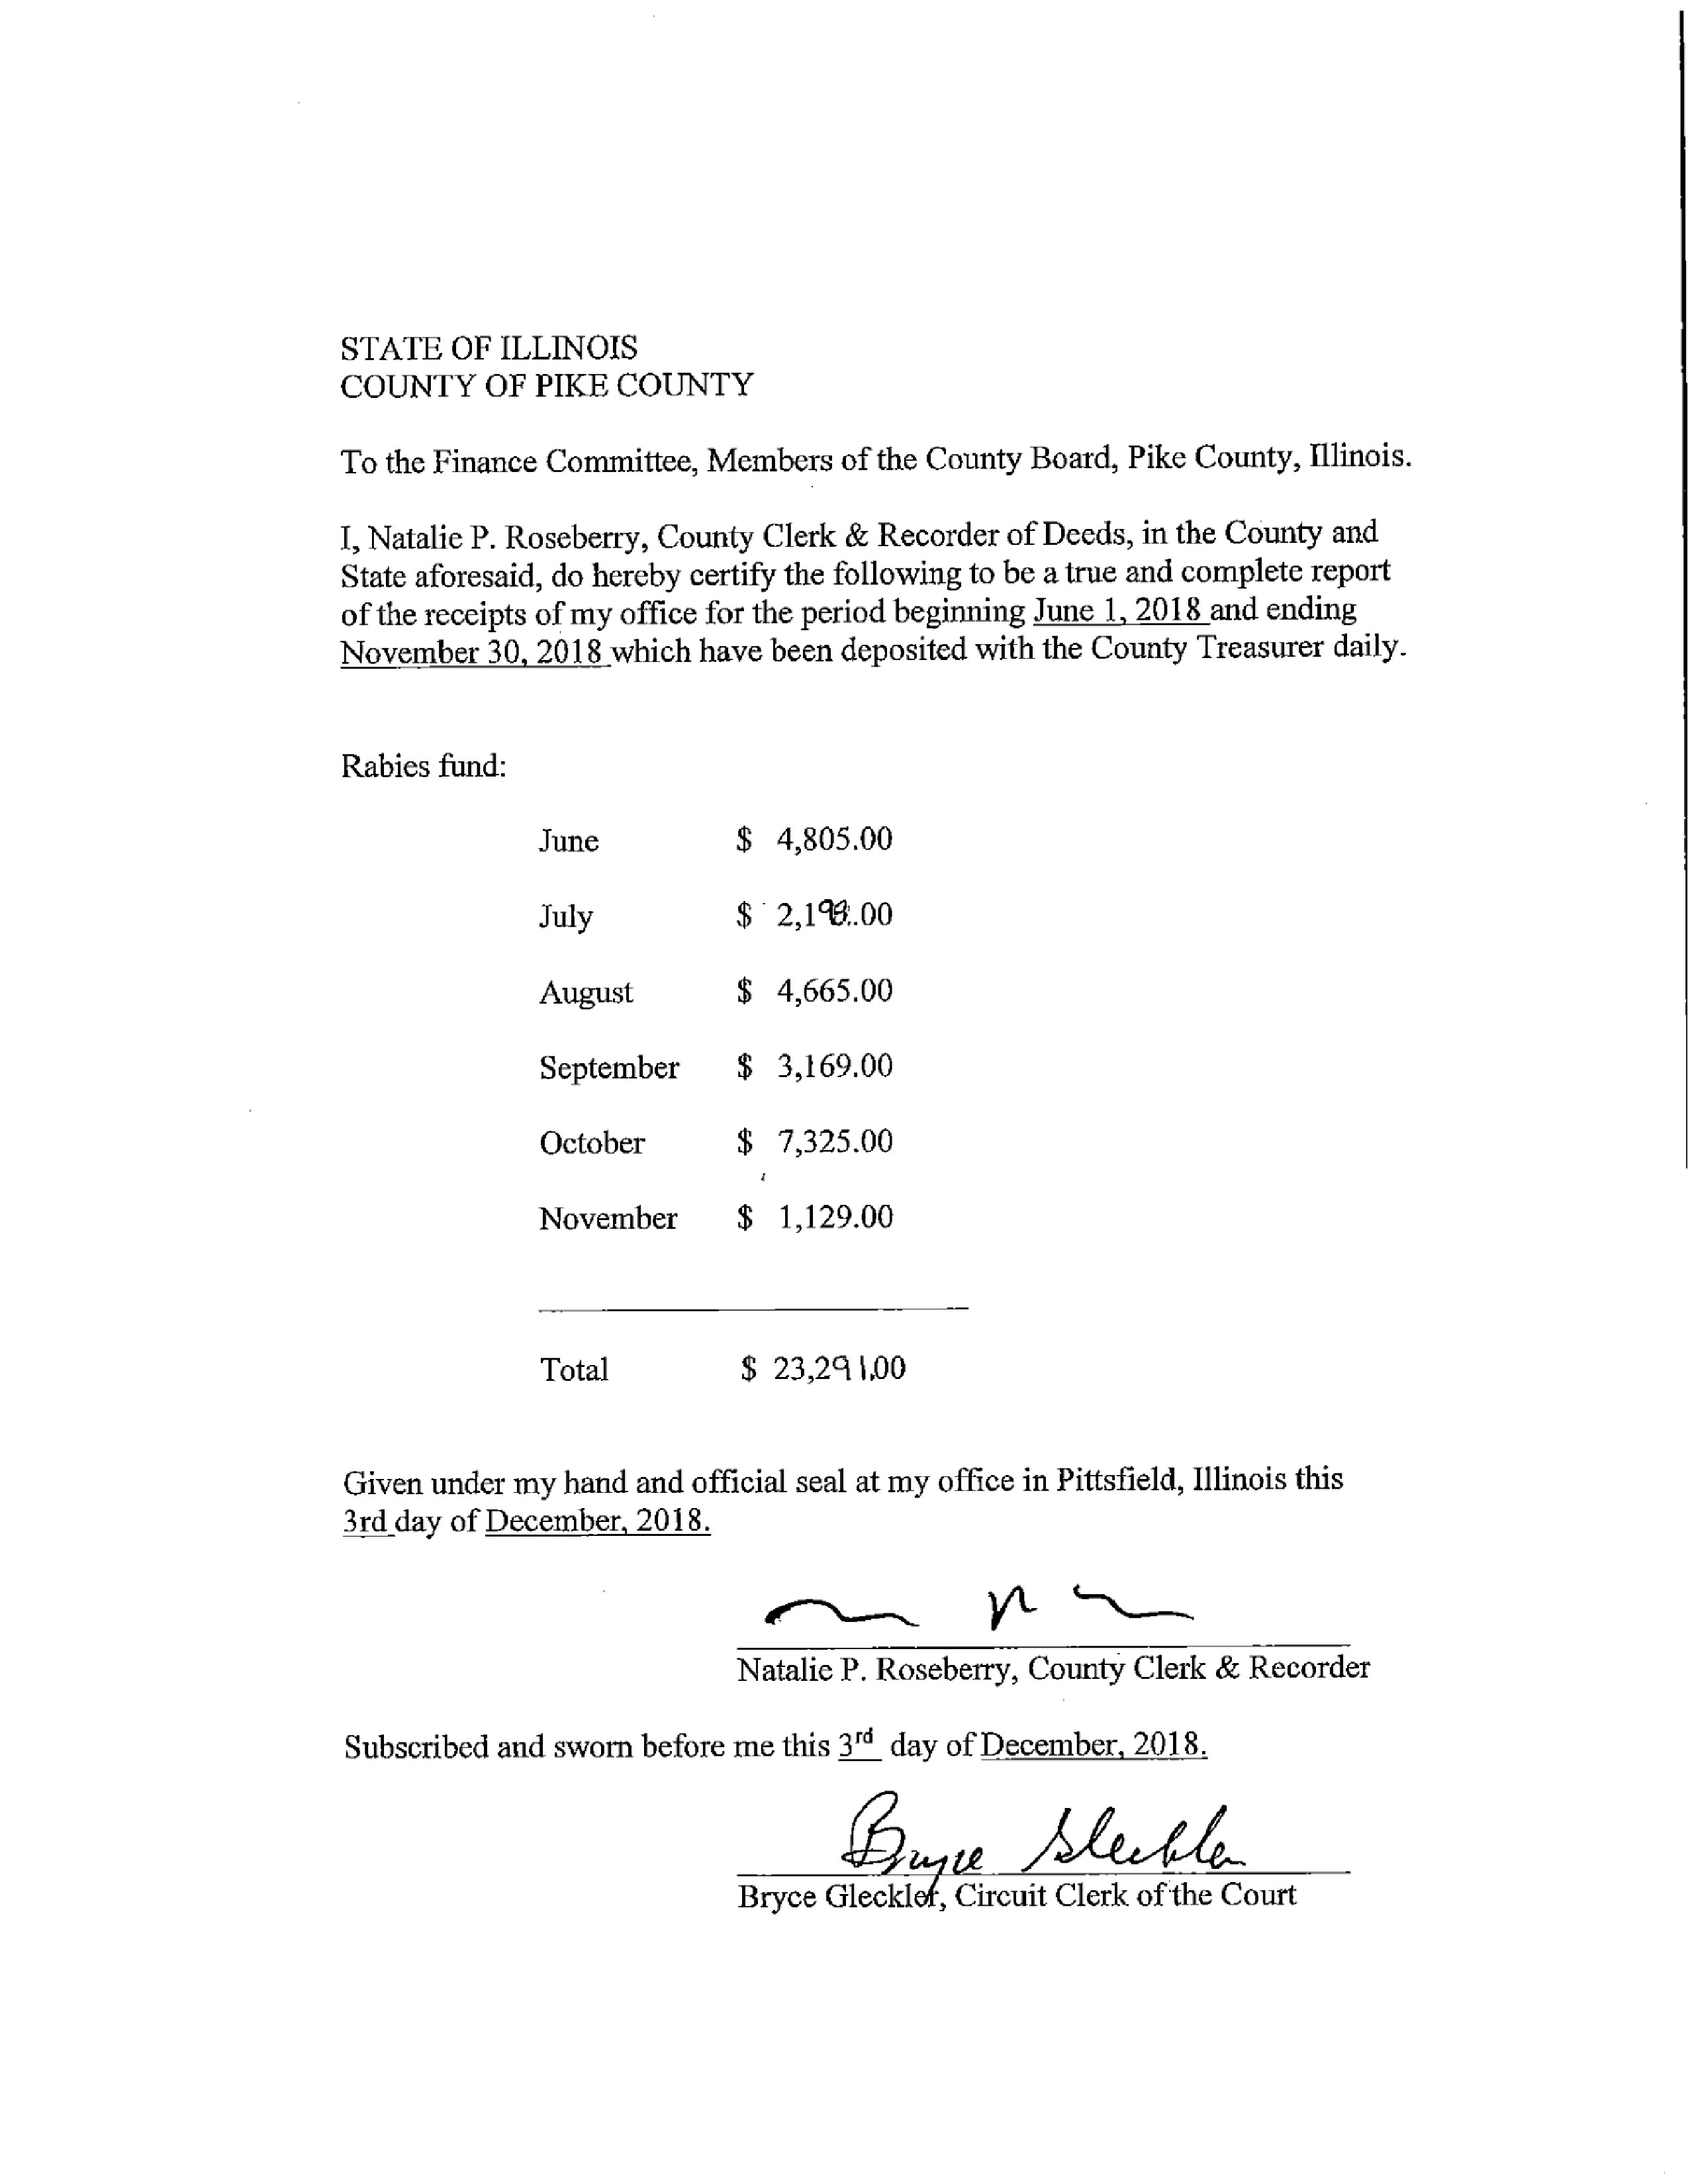
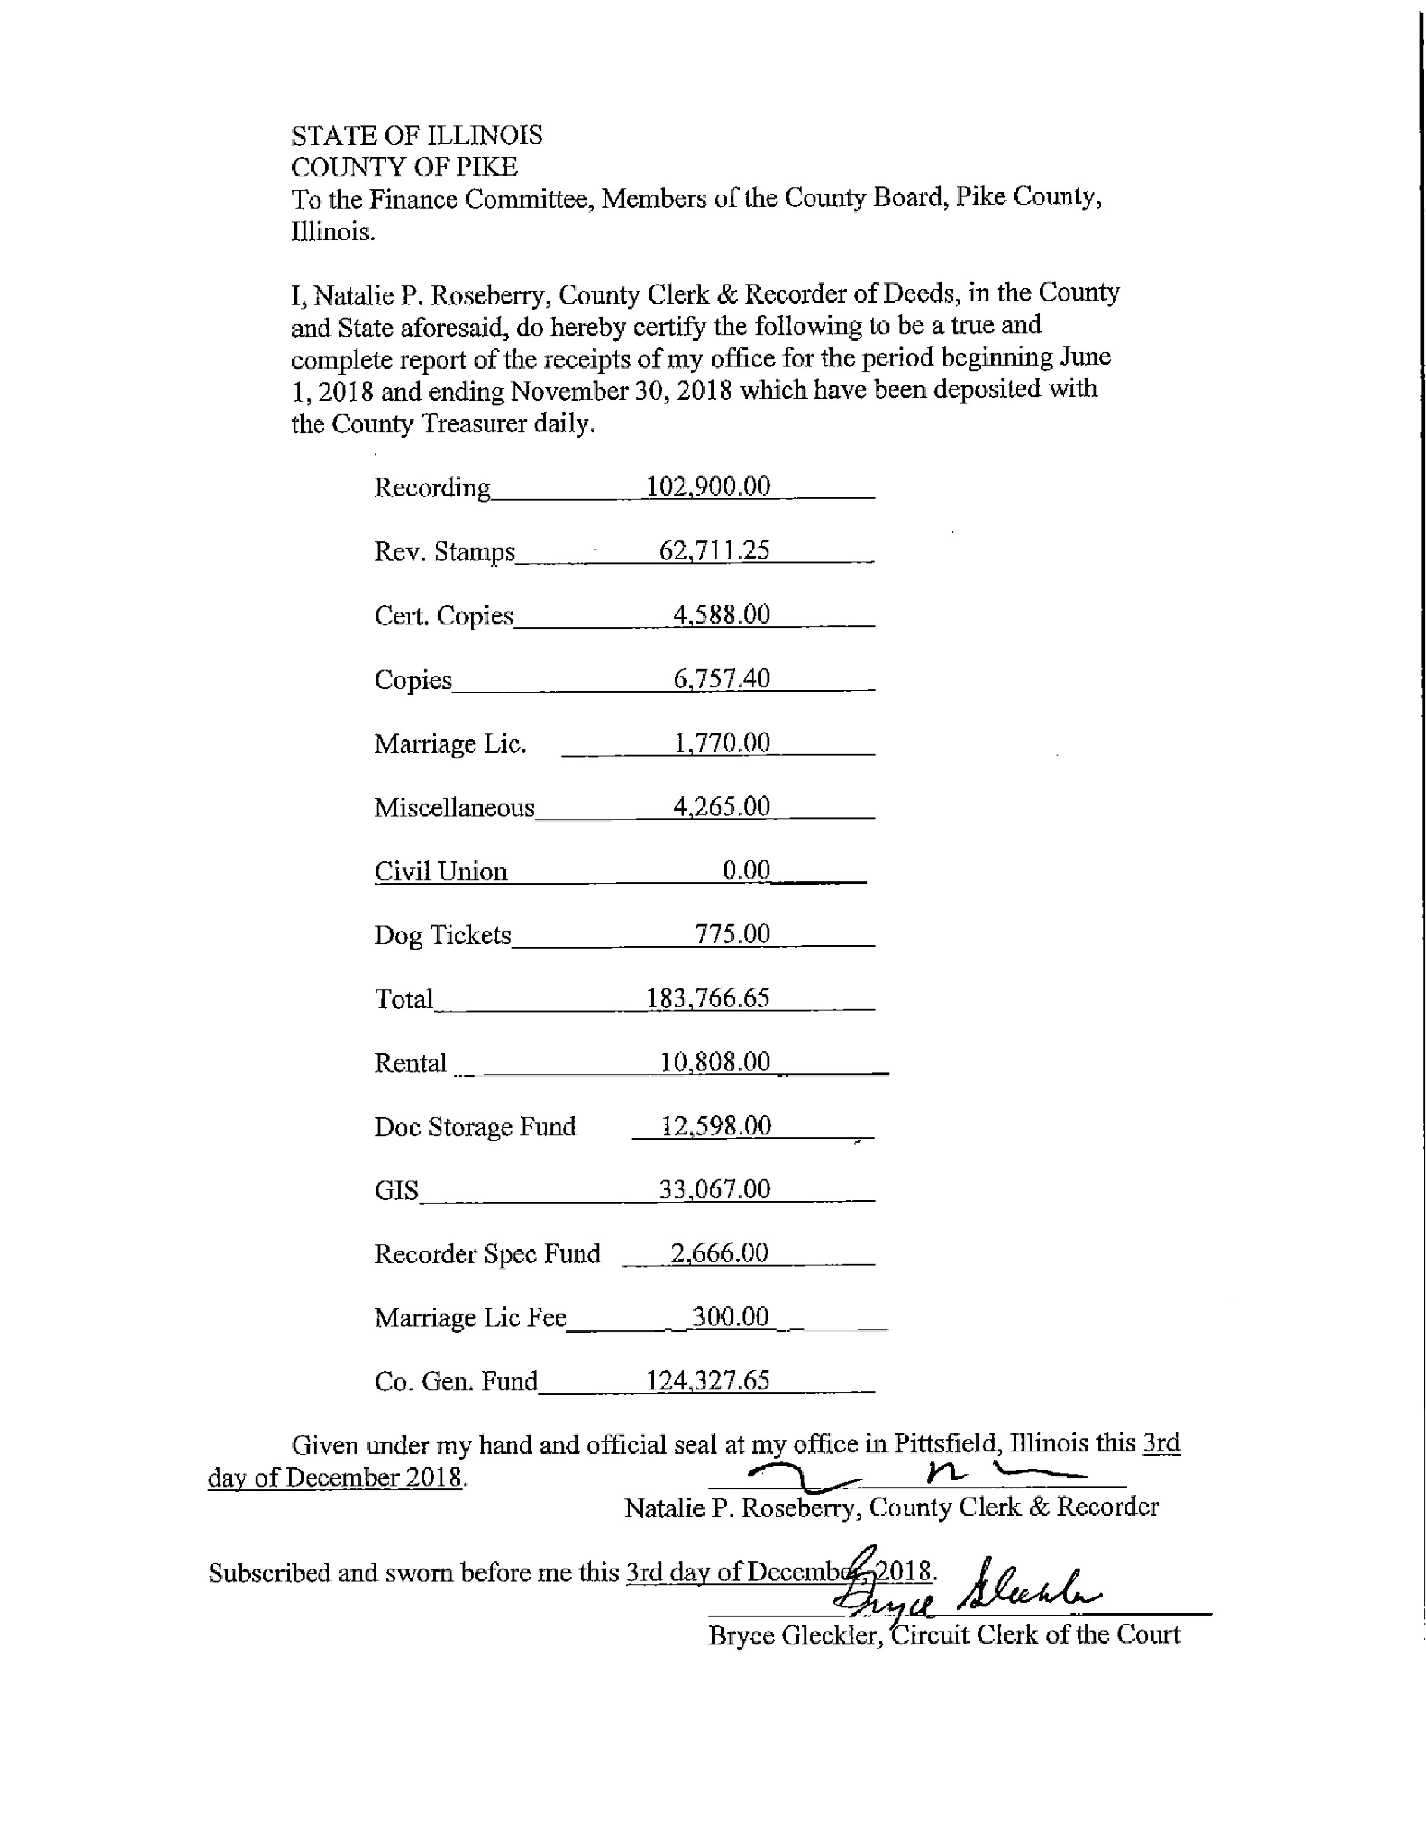
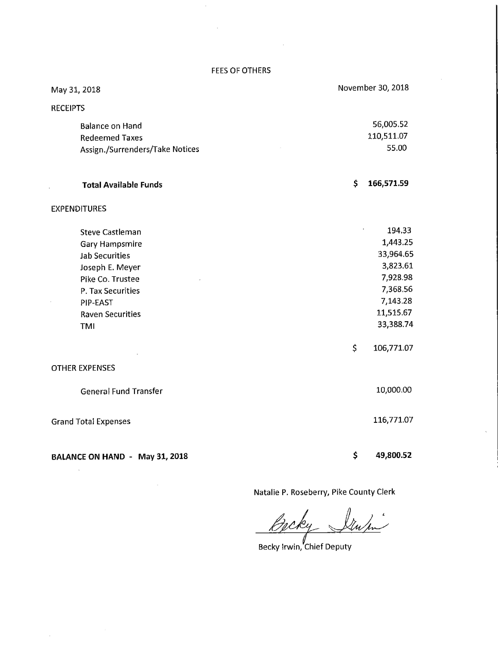
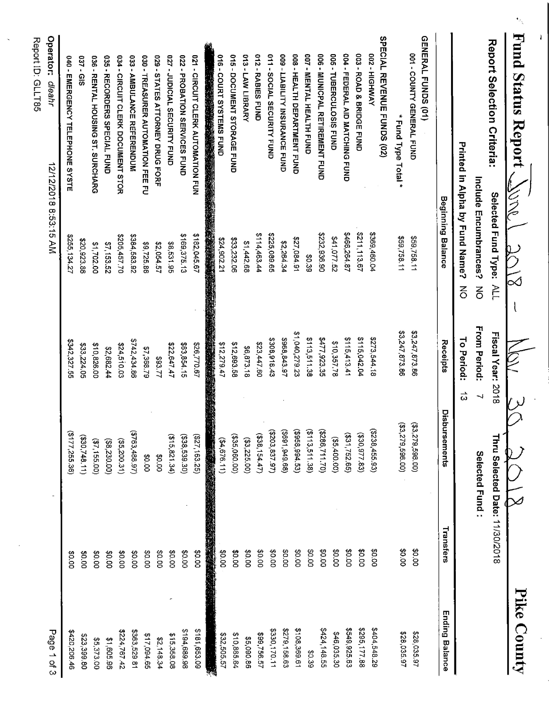
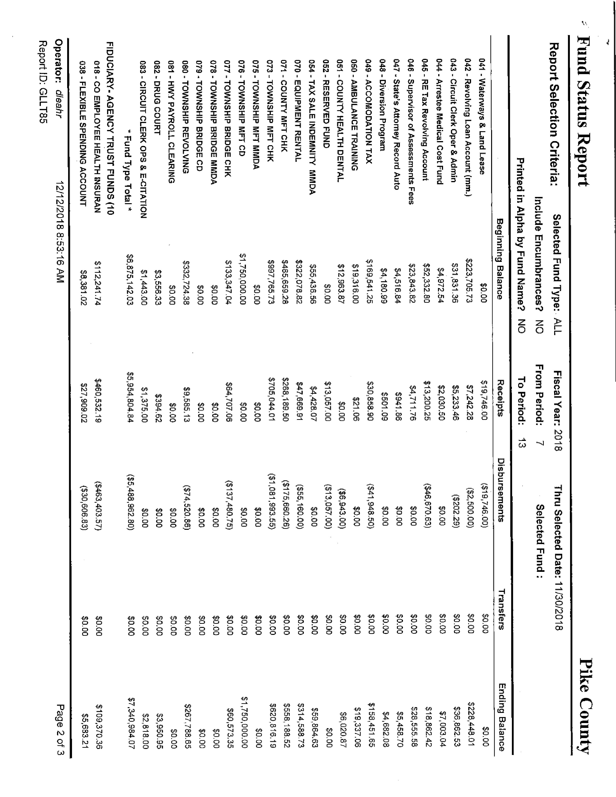
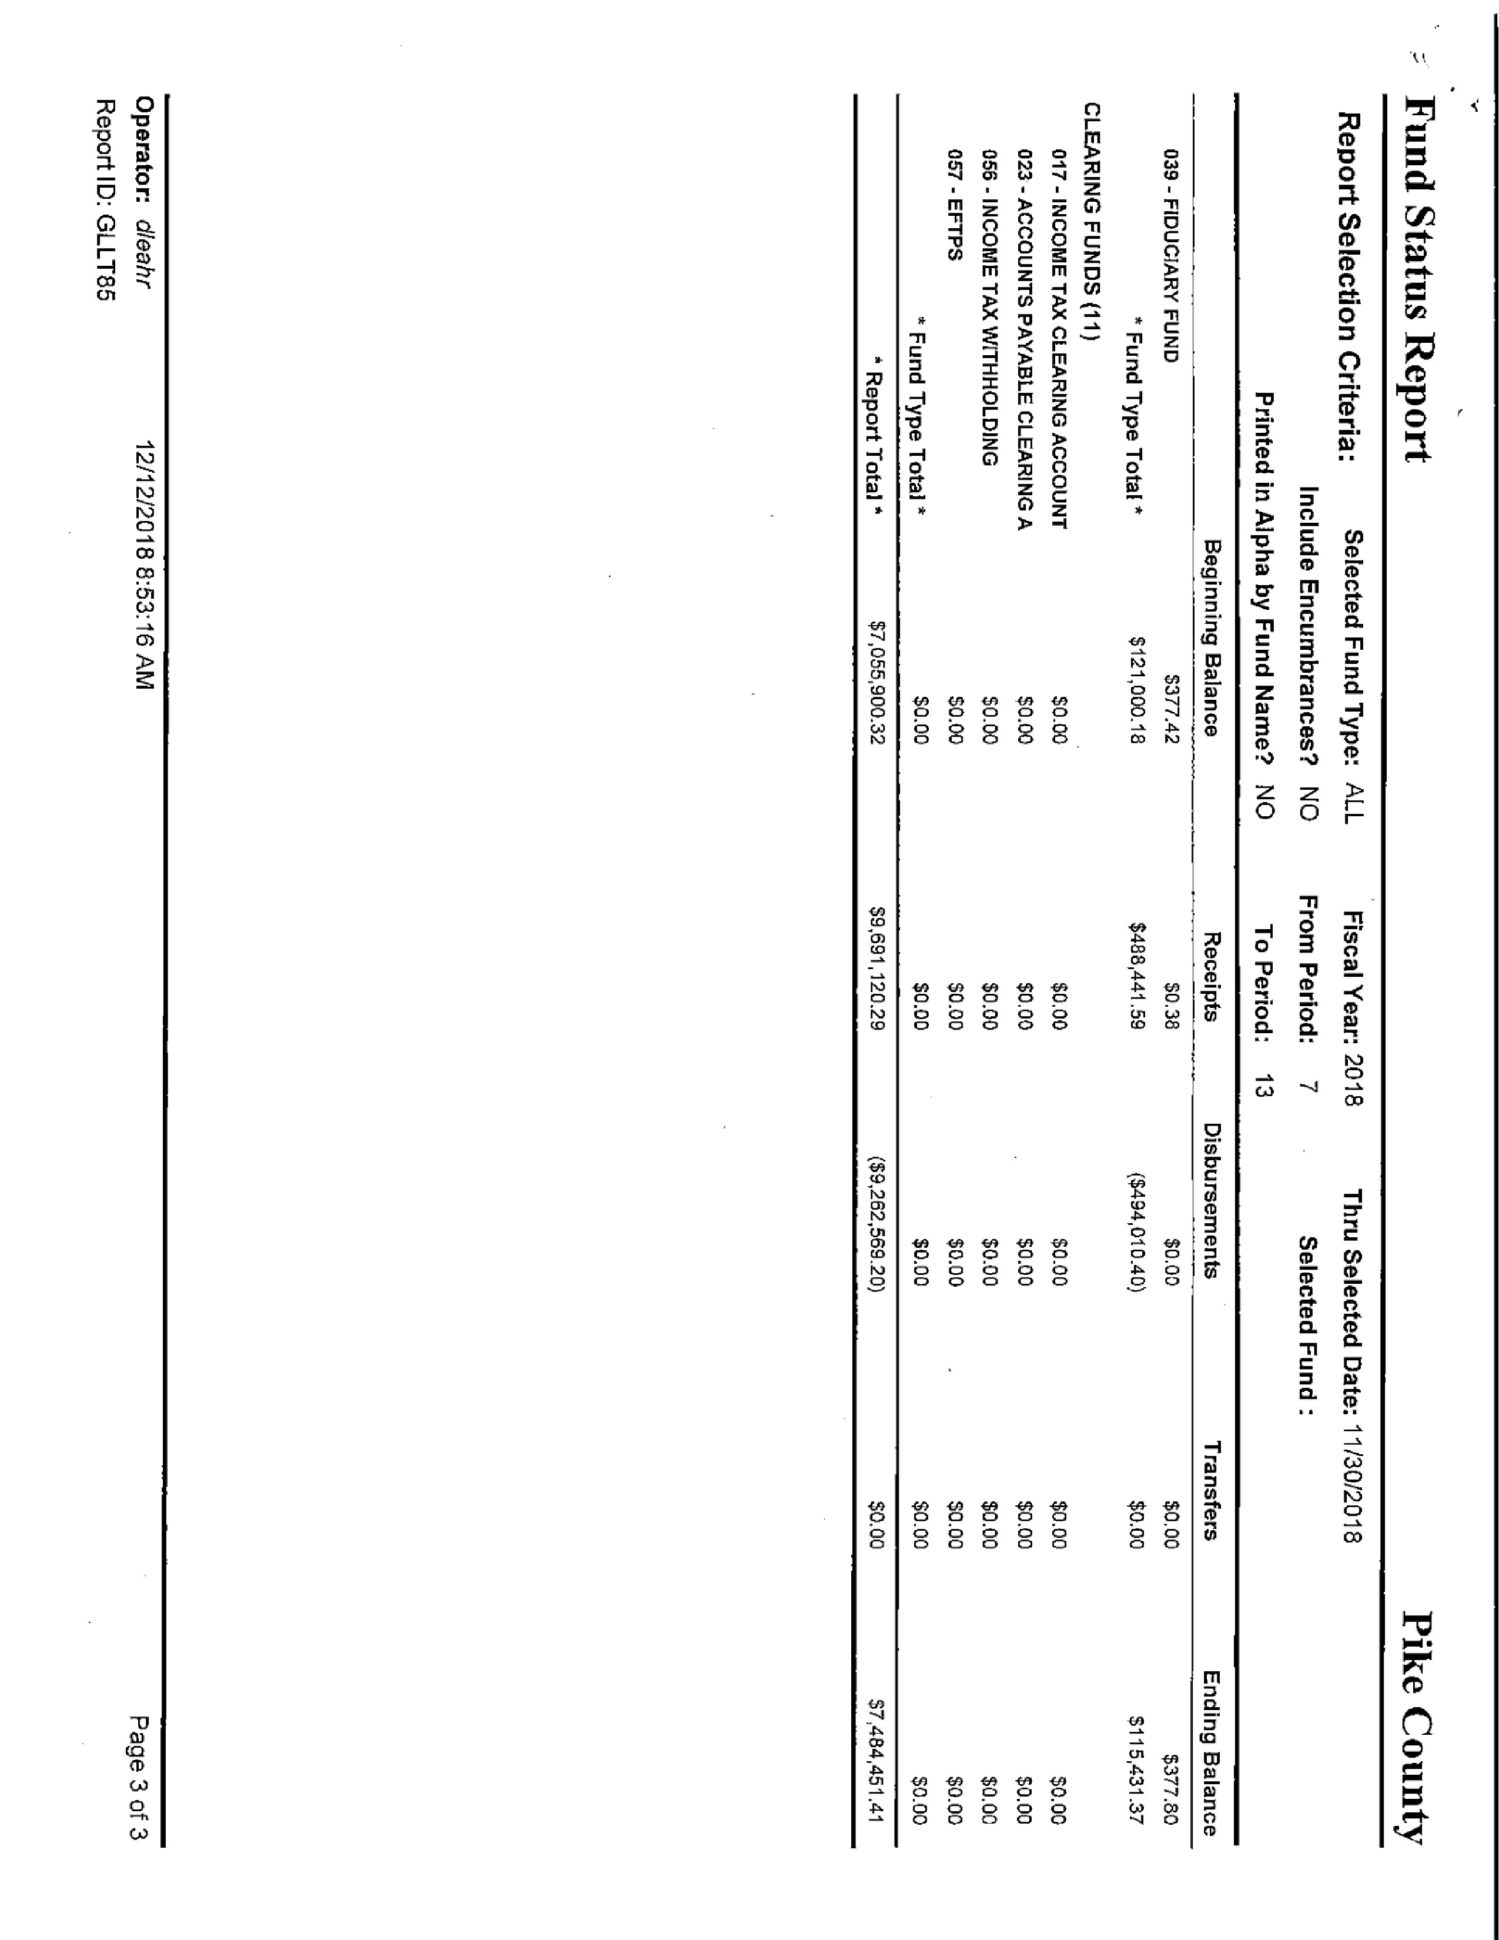
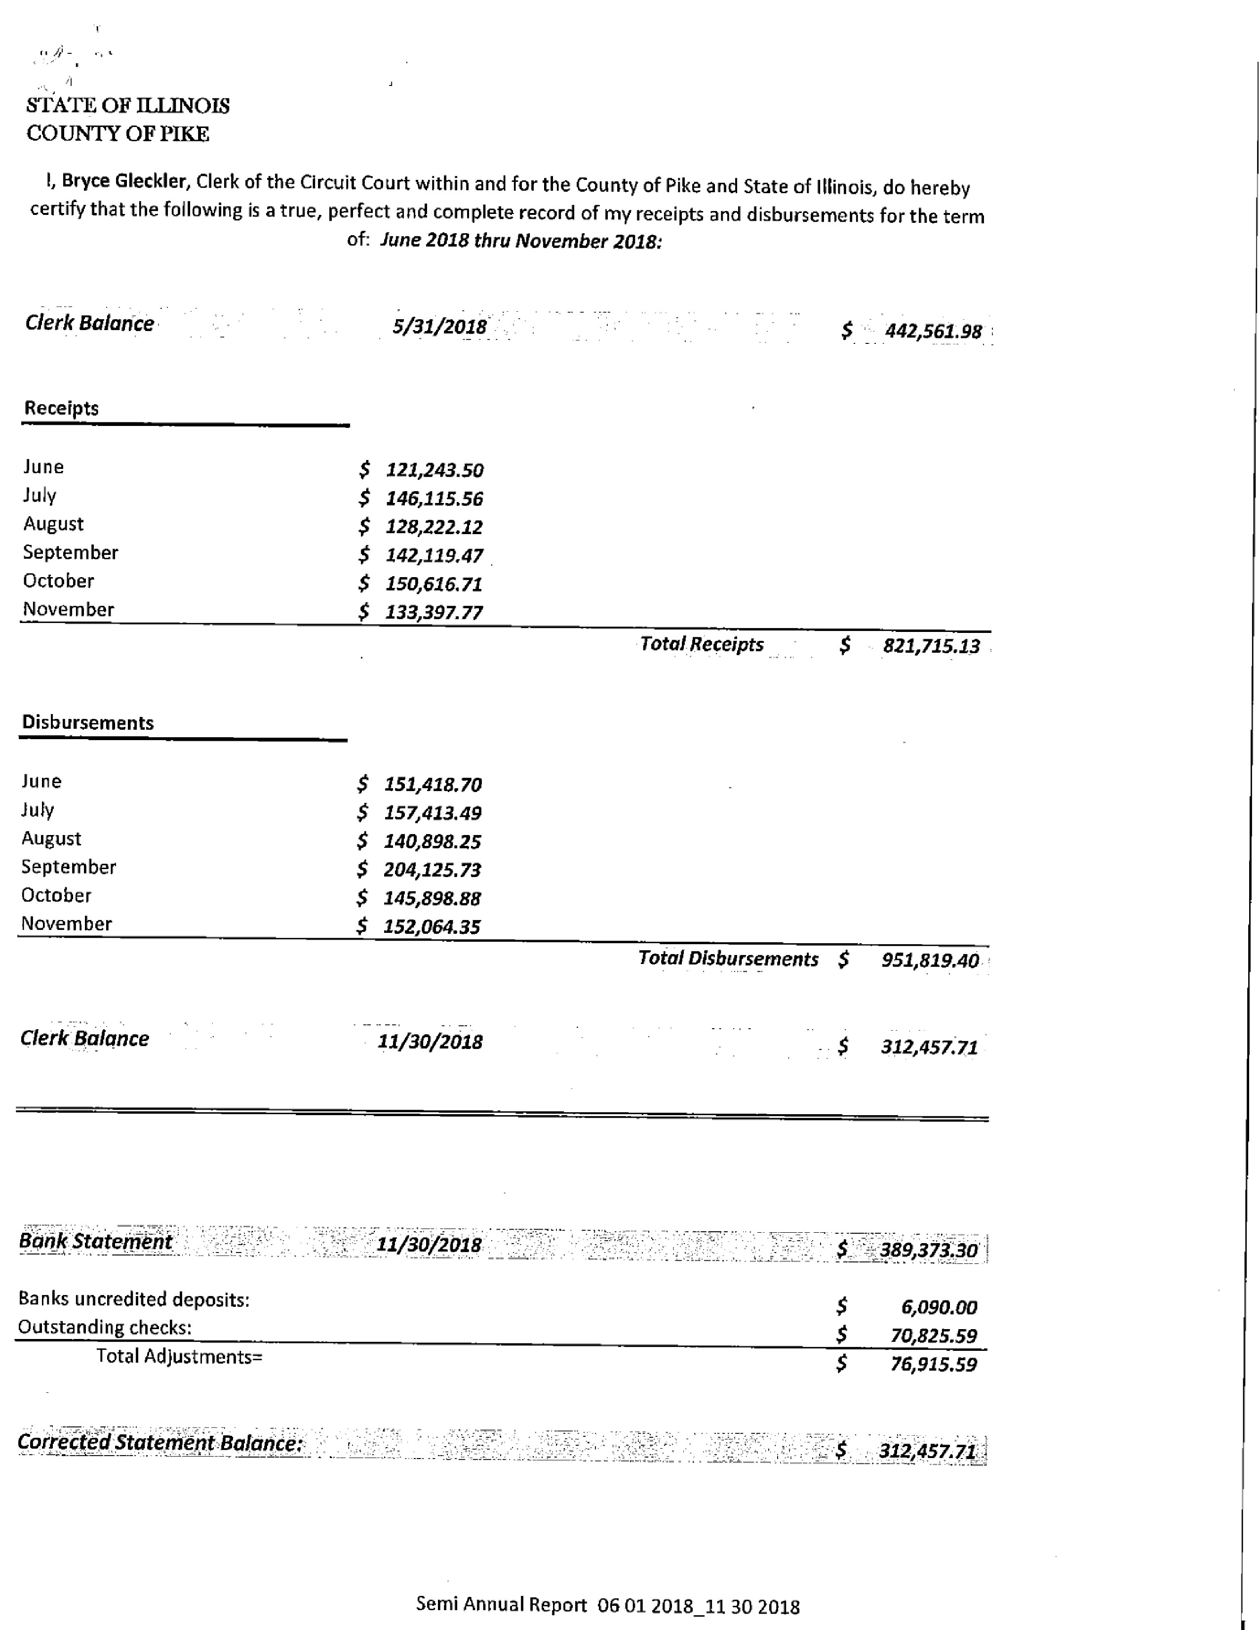
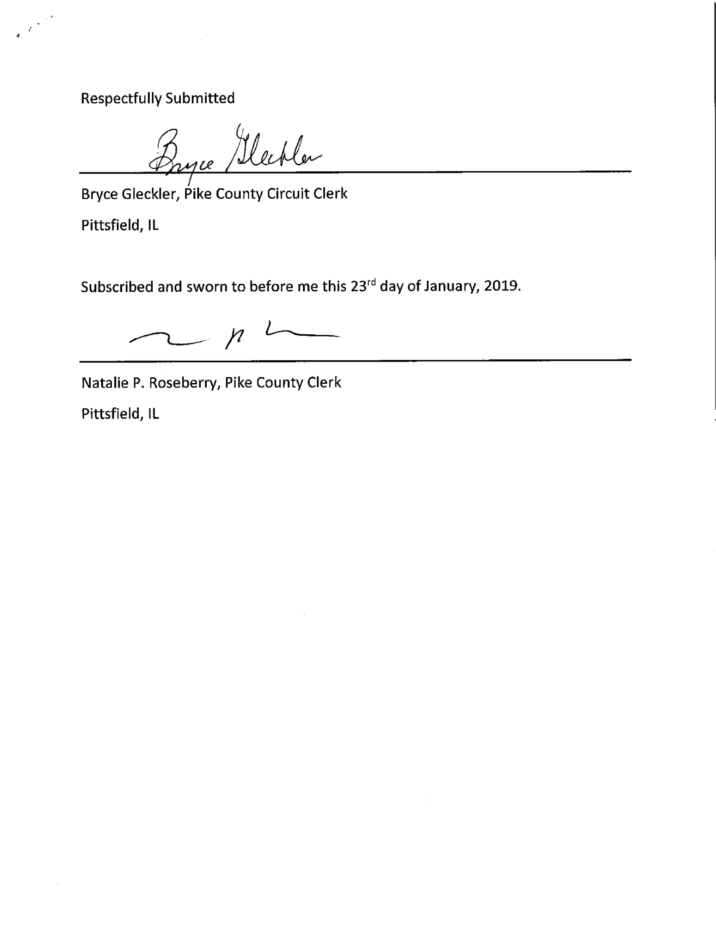
Committee Reports
Finance Committee:
The finance committee of the Pike County Board met at 5:00 p.m. on Wednesday January 9, 2019 in the conference room of the Pike County Government building. Members present were Rodger Hannel, Amy Gates, Jim Sheppard and County Board Chairman Andy Borrowman. County Clerk Natalie Roseberry, County Treasurer Scott Syrcle, and Sheriff David Greenwood were also present.

Routine bills in the amount of $68940.03 were approved for payment.

Regional Superintendent of Schools Jill Reis was present to discuss anew intergovernmental agreement with the county. There would be an annual cost increase to the county of $300. Amy Gates asked several questions about the size and operation of the Regional office and the six county area that they serve. Rodger Hannel made the motion to adopt the agreement and Amy Gates seconded, motion carried.

Natalie Roseberry reported that the auditors were present and progress was being made despite a few hiccups. It was mentioned that next year if both finance and the audit were in the same week that we might potentially move the finance meeting date to make things a little easier on the Clerk’s office. We also discussed the timing of the bills being brought to the clerk’s office and department heads noting on the bills which line item they are to be taken from. David Greenwood gave the committee an update on projects at the Sheriff’s Department.

Amy Gates made a motion to pay the bills. Rodger Hannel seconded. Motion carried.

Rodger Hannel made a motion to adjourn, Amy Gates seconded. Motion carried.

Meeting adjourned at 5:56 p.m.

Motion to Approve Finance Minutes made by Amy Gates, Seconded by Mark Mountain. Voice vote 8-0, motion carried.

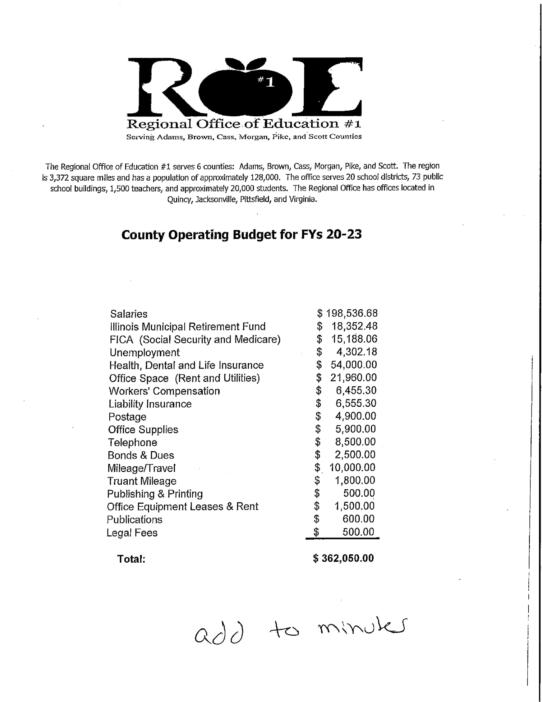

Building and Grounds:
The Building and Grounds Committee met on Wednesday, January 16, 2019 at 3:30 p.m. at the Courthouse Annex building. Present were Rodger Hannel, Derek Ross, Carrie Martin, Sheriff Greenwood, Andy Borrowman, Joe Petty, Judge Frank McCartney, Darwin Feenstra and Scott Syrcle.

Joe Petty, architect, along with Frank McCartney and Sheriff Greenwood were present to review options concerning the Pike County Courthouse A.D.A and security entranceway. The cost for the four options are:

Option 1 - $217,000

Option 2 - $208,250

Option 3 - $155,008

Option 4 - $349,900

After review of all four options, the consensus of the B & G committee was to favor the selection of Option #4 if funding for the project can be found. Judge McCartney will pursue some financing funds to help pay for the project. Judge McCartney will come back to the B & G committee with a report on what he has found out. A final decision on a recommendation to the full County Board will be made once financing options are reviewed.

In addition, Joe Petty and Sheriff Greenwood are pursuing roof bids for the Jail where a major repair is needed. Also, a minor repair on the roof of the Annex building needs to be bid out.

A bid for cleaning carpets in Scott Syrcle’s office for $12.00, Cindy Shaw’s office for $225.00 and Natalie Roseberry’s office for $375.00, to be done by Butler Cleaning Service was approved on a motion by Derek Ross and seconded by Carrie Martin. Motion passed.

Darwin Feenstra reported the second boiler at the courthouse should be installed by the end of this week.

On a motion by Derek Ross and a second by Carrie Martin to approve the monthly bills totaling $116,835.20, the motion passed.

Derek Ross made a motion to adjourn the meeting at 4:45 p.m., and Carrie Martin seconded. The motion passed.

In the County Board meeting, Mark Sprague inquired to what each proposal consisted of. Carrie Martin showed the designs for all of the proposed options. Rodger Hannel explained these were just proposals and no action will be taken until they know what funding is available. Once funding is location they will address the project.
Carrie Martin made a motion to approve the Building & Grounds minutes as read and seconded by John Birch. Voice vote was 8-0 and motion carried.

Highway Committee:
The Road & Bridge Committee met Wednesday, January 9, 2019 at 3:30 p.m. at the County Highway Department. The Meeting was called to order at 3:30 p.m.

Roll Call: Present were Rodger Hannel, Mark Mountain, John Birch and Andy Borrowman

Others Present were Chris Johnson the County Engineer.

Public comments: none

Payment of Claims: A motion was made by John Birch, seconded by Mark Mountain to pay claims per claim reports dated January 9, 2019. Motion carried.

Half Aid to Bridge:
Detroit Township:
A motion was made by John Birch, seconded by Mark Mountain
To pay for one-half of Detroit Township’s portion of the super structure replacement
project, Section 17-06109-00-BR. The project was located at the corner of 240th Ave and
492nd St. in Section 36 over Little Blue Creek. Total project cost was $178,848.05. 80%
($146,278.45) was paid by Township Bridge Fund and the remaining 20% ($36,569.60)
paid by Detroit Township, of which they have petitioned for Half Aid to Bridge in the sum
of $18,284.80. All in favor. Motion carried.

Pittsfield Township:
A motion was made by John Birch, seconded by Mark Mountain to pay for one-half of
Pittsfield Township’s structure replacement project, Section 16-20118-00-BR. The
project was located on 355th St in Section 7 over the East Branch of Kiser Creek. The total
project cost was $239,591.69. 80% 9$191,673.34) was paid by Township Bridge Fund
and the remaining 20% ($47,918.35) paid by Pittsfield Township, of which they have
petitioned for Half Aid to Bridge in the sum of $23,959.17. All in favor. Motion carried.

White Bridge: No action.

New Business:
Training: Training for the Highway Department regarding AED, Haz Mat, CPR etc. was
discussed. Chris Johnson will contact ICRMT, Pike County Health Department and
Josh Martin to see what training they offer.

Old Business: None

Adjournment: A motion was made by john Birch seconded by Mark Mountain to adjourn
meeting at 3:47 p.m. Motion carried.

In the county Board Meeting, County Engineer, Chris Johnson told the board that there was partial damage to a building at the Highway Department from the recent storm and the insurance adjuster is scheduled to be on site on January 24th, 2019.

Mark Sprague made a motion to approve Half Aid to Bridge in Detroit Township, Mark Mountain seconded. Voice vote 8-0, motion carried.

Mark Mountain made a motion to approve Half Aid to Bridge in Pittsfield Township, John Birch seconded. Voice vote 8-0, motion passed.

Mark Sprague made a motion to approve the Road and Bridge minutes, seconded by Mark Mountain. Voice vote 8-0, motion carried.

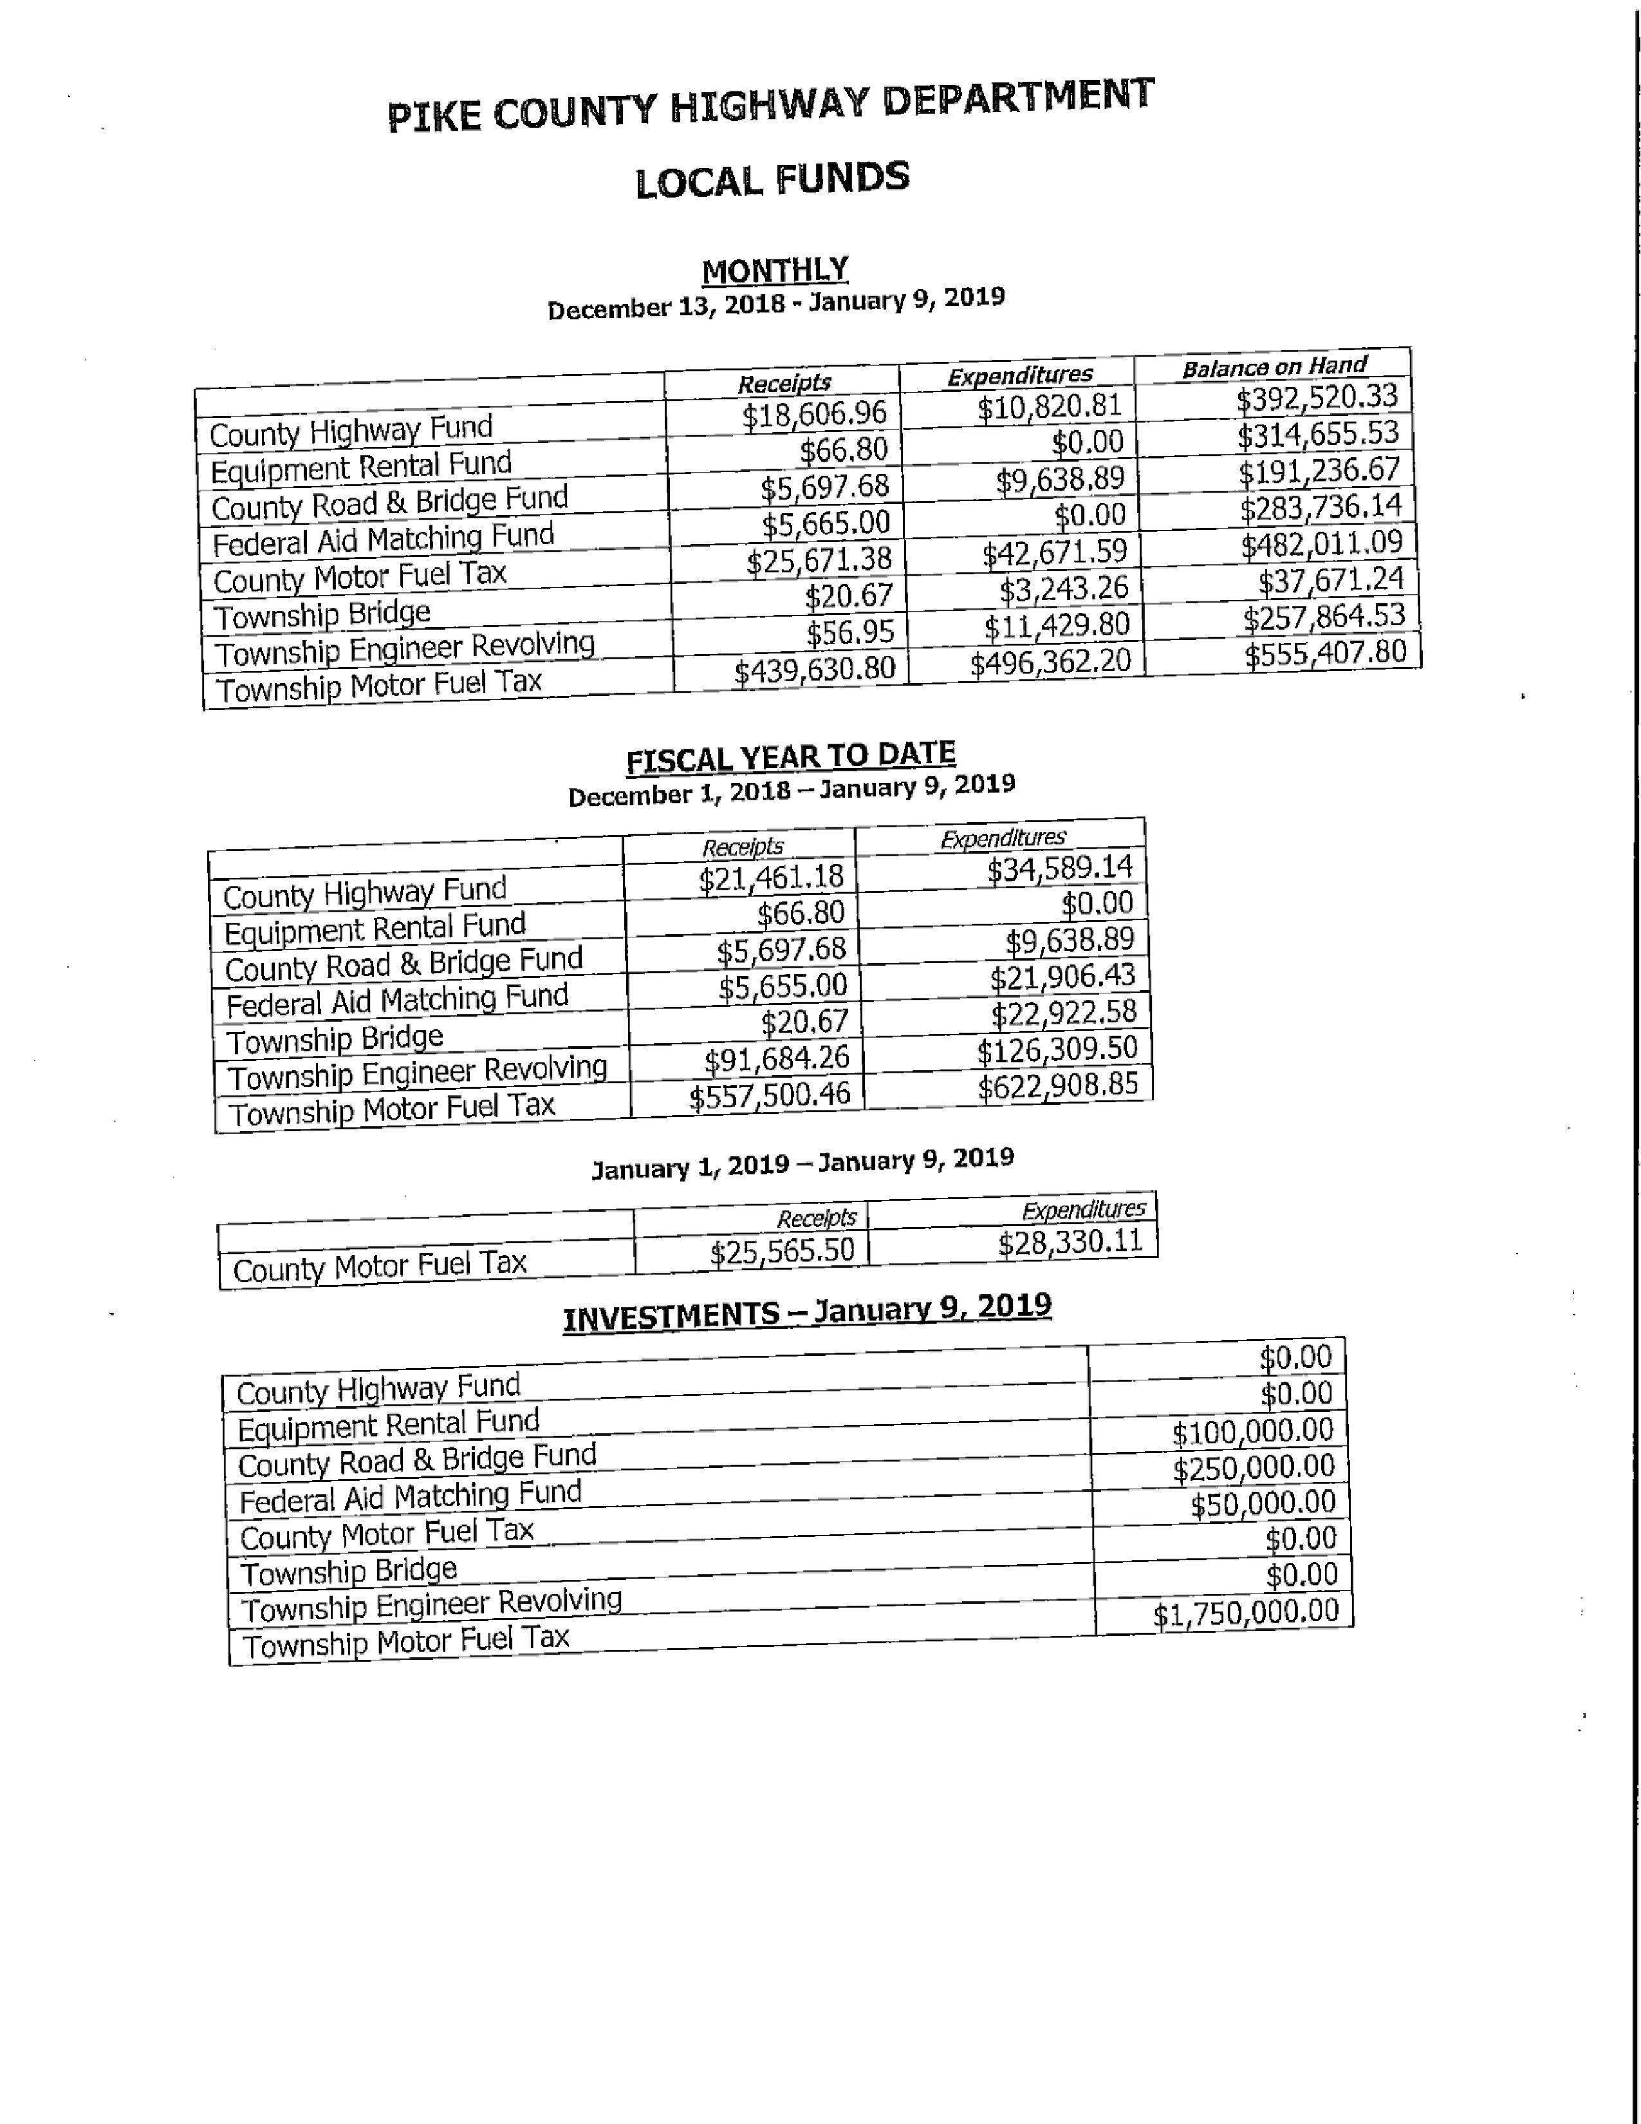
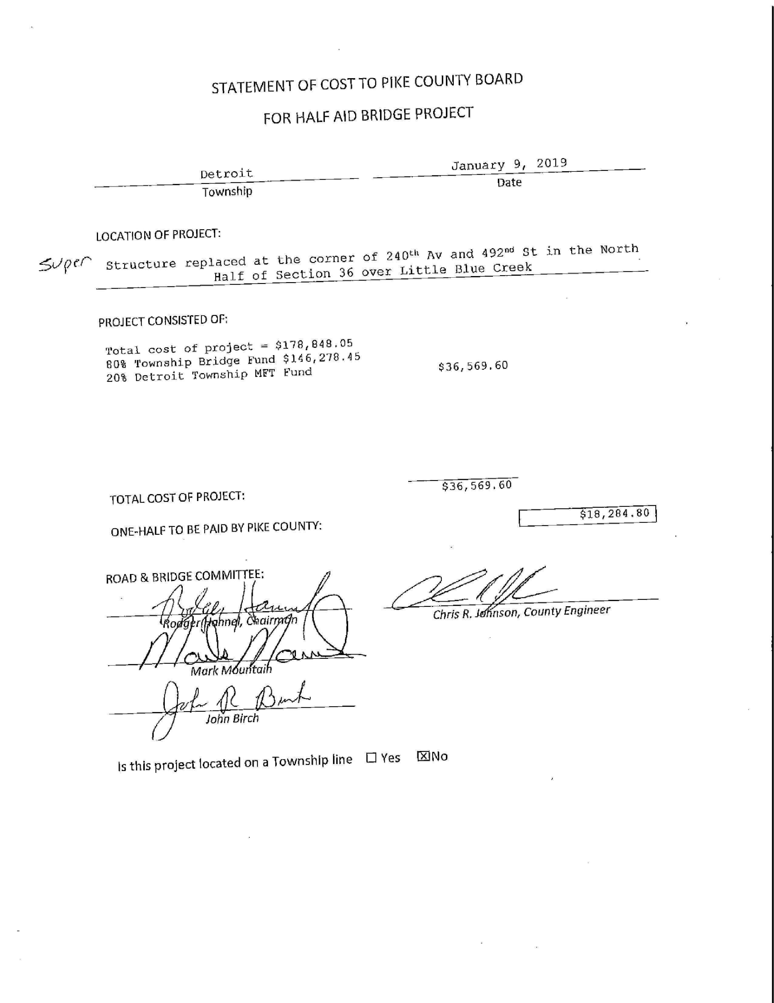
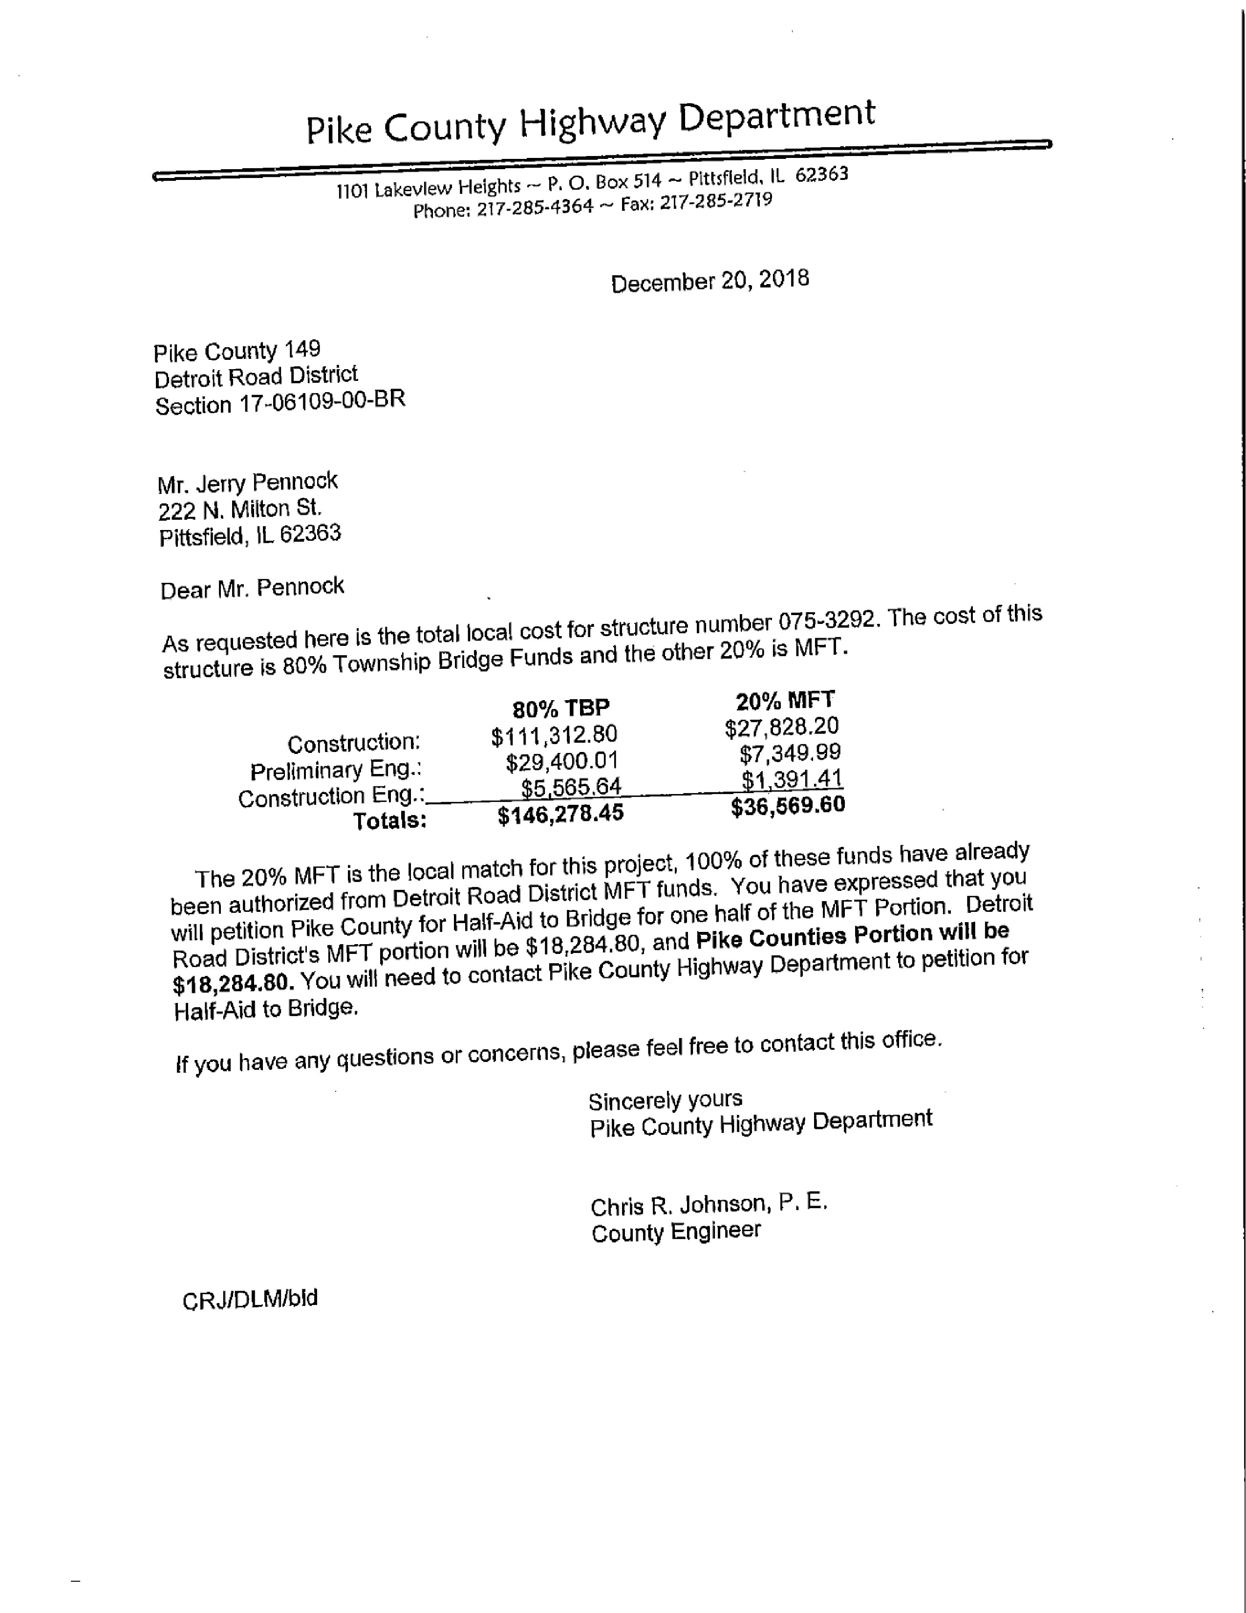
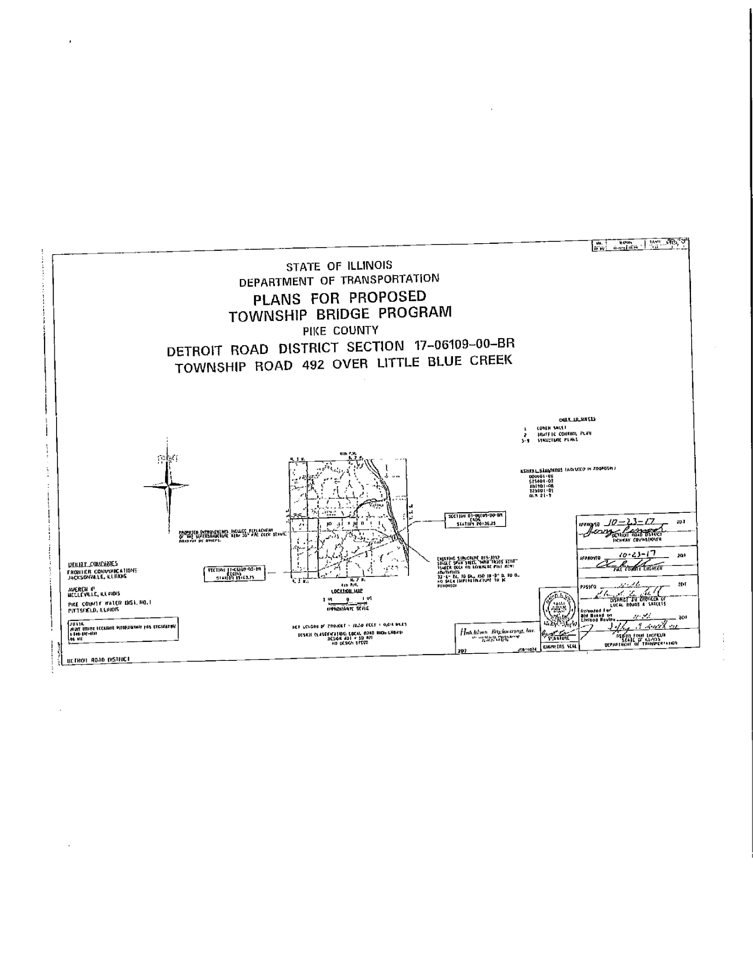
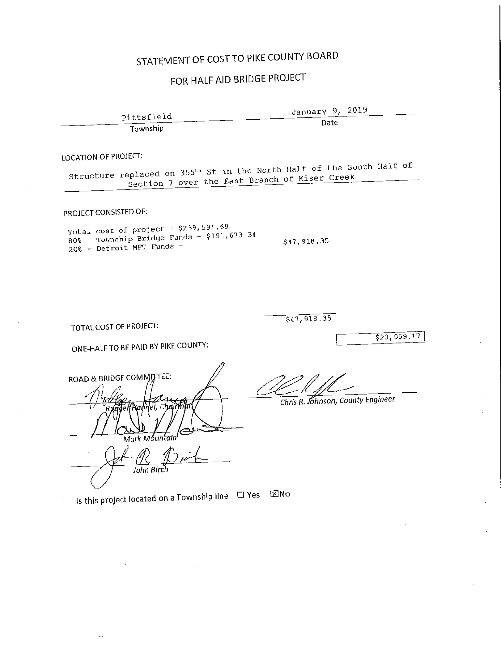
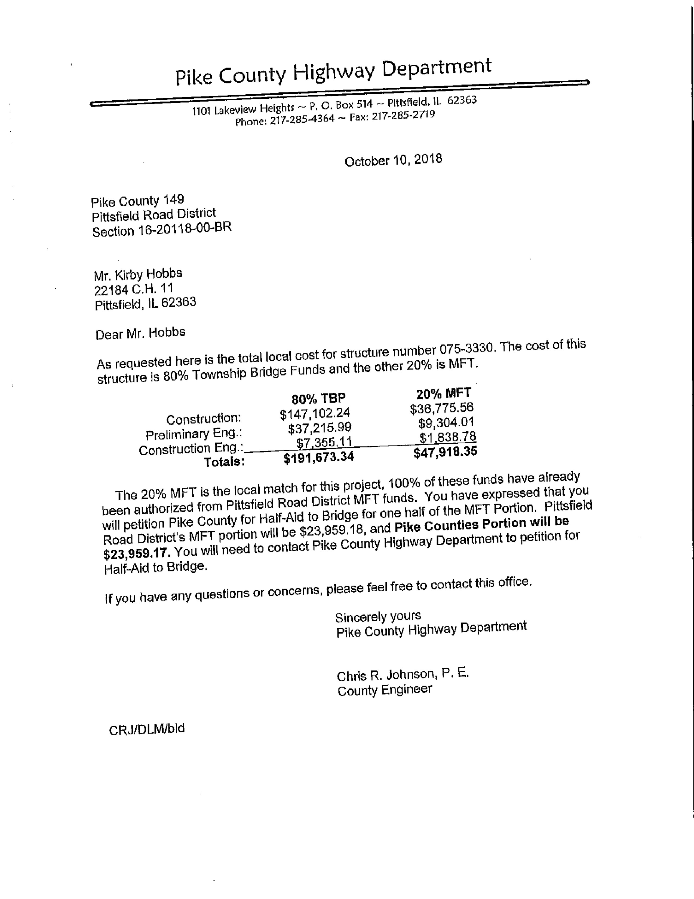
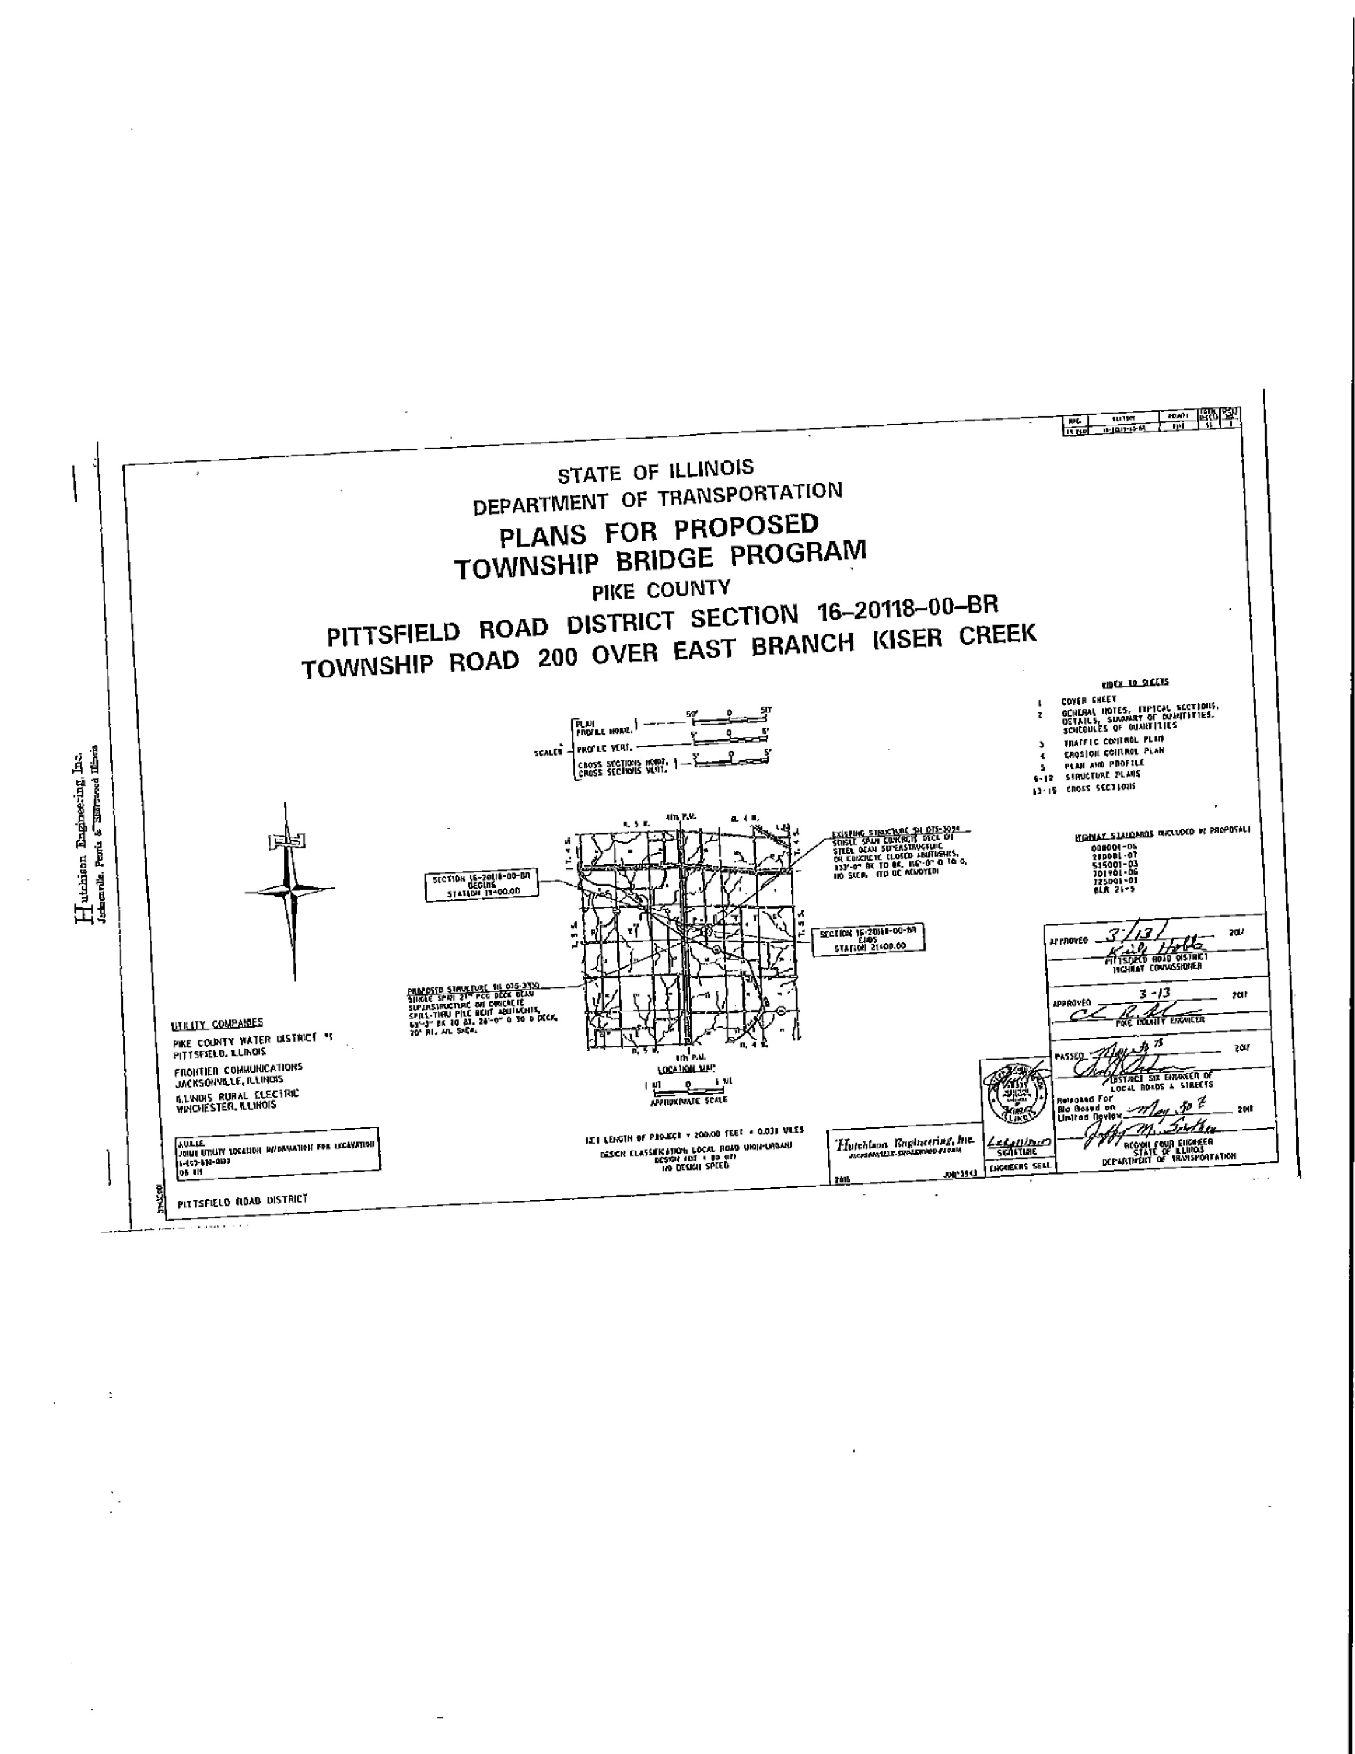
Public Safety:
The Public Safety Committee met at the home of Pike County Ambulance Service on Wednesday, January 16th at 6:30 p.m. Those present were Carrie Martin, Derek Ross, Amy Gates, County Board Chairman Andy Borrowman, PCAS Administrator Josh Martin, Jane Johnson of PCHD, Pike County State’s Attorney Zach Boren, and Jay Arnold.

The public safety committee will be meeting at 6:60 p.m. on the 3rd Wednesday of each month and ask Clerk Roseberry to make the change on the posting in her office.

Total revenue for the month of December was $121,316.69. Expenses totaled $279,677.85. Loss for the month was $158,361.16.

A motion to approve bills totaling $109,683.41 was made by Gates and seconded by Ross. The motion passed.

Johnson shared the amended Food Program Ordinance. SA Boren was present to expand on the changes that were made. A motion was made by Gates and seconded by Ross to recommend for adoption to the Pike County Board a Resolution enacting a Pike County Food Sanitation Program Ordinance as amended; including the draft titles Pike County Health Department Food Enforcement Policy and Procedures. This does not include any fee schedule at this time as those fees have not been recommended by the Pike county Board of Health. The motion passed.

More snow and ice is on the horizon. Josh is getting regular updates from the National Weather Service and sharing them with the board members.

IPMG Grant was approved thus $10,000 will be put toward the purchase of the new power cots.

IDPH inspection for the new ambulance is scheduled for Jan 17th, 2019.

The meeting adjourned at 7:30 p.m. on a motion by Derek Toss and a second by Amy Gates.

In the County Board meeting, State’s Attorney Zack Boren explained that fee language was added to the ordinance and clarified that a “Food Establishment” is anywhere that sells food. A temporary license will be issued for a place selling food for less than 14 days.

Jane Johnson stated that the Ordinance was corrected and updated to reflect the FDA 207 definitions. She also stated that the Board of Health will meet on January 24th, 2019 at 6:00 p.m. and the proposed fees will be presented.

Anita Andress, the director of the PCHD stated that all fees will be deposited back in to the Food Program and since they cannot stop inspections, this will allow them to get the assistance for an unfunded mandate.

Jane Johnson stated that the State of Illinois unfunded mandates are draining the Health Department’s resources.

Board Member Mark Sprague commented that there are not a lot of corporations in Pike County to create a tax base but adding this fee to Ma and Pa restaurants seems like a penalty.

Rob Holcomb spoke from the audience as a food business owner stating that he appreciates the Board’s feedback on small businesses but his concern of when does it stop. His concern is that if they pass a fee schedule this year and it doesn’t bring in the revenue as expected will they pass a higher one next year?

Carrie Martin stated that from the committee level, the fees were put into the County Board’s hands to alleviate Mr. Holcomb’s concerns.

Anita Andress stated that food is a serious issue as Pike County was still dealing with an International situation and this needs to be protected.

Derek Ross stated he was not in favor of the tax. However, he stated that the revenue we are talking about it local and it stays local. It does not go to Springfield. He also stated that there needs to be ways to offset the costs such as possibly talking to Two Rivers or Economic Committee to try and find a solution to offer some free advertising etc.

Mark Sprague made a motion to accept the ordinance with the exception of 2(9) to say “No license fees at this time. Mark Mountain seconded the motion and it went to a roll call vote. The motion was denied by an individual vote of 2-6.

Mark Sprague made a motion to accept the ordinance as submitted and Carrie Martin seconded. Voice vote of 8-0, motion passed.

Amy Gates made a motion to accept the Public Safety minutes and Rodger Hannel seconded. Voice vote was 8-0, motion passed.

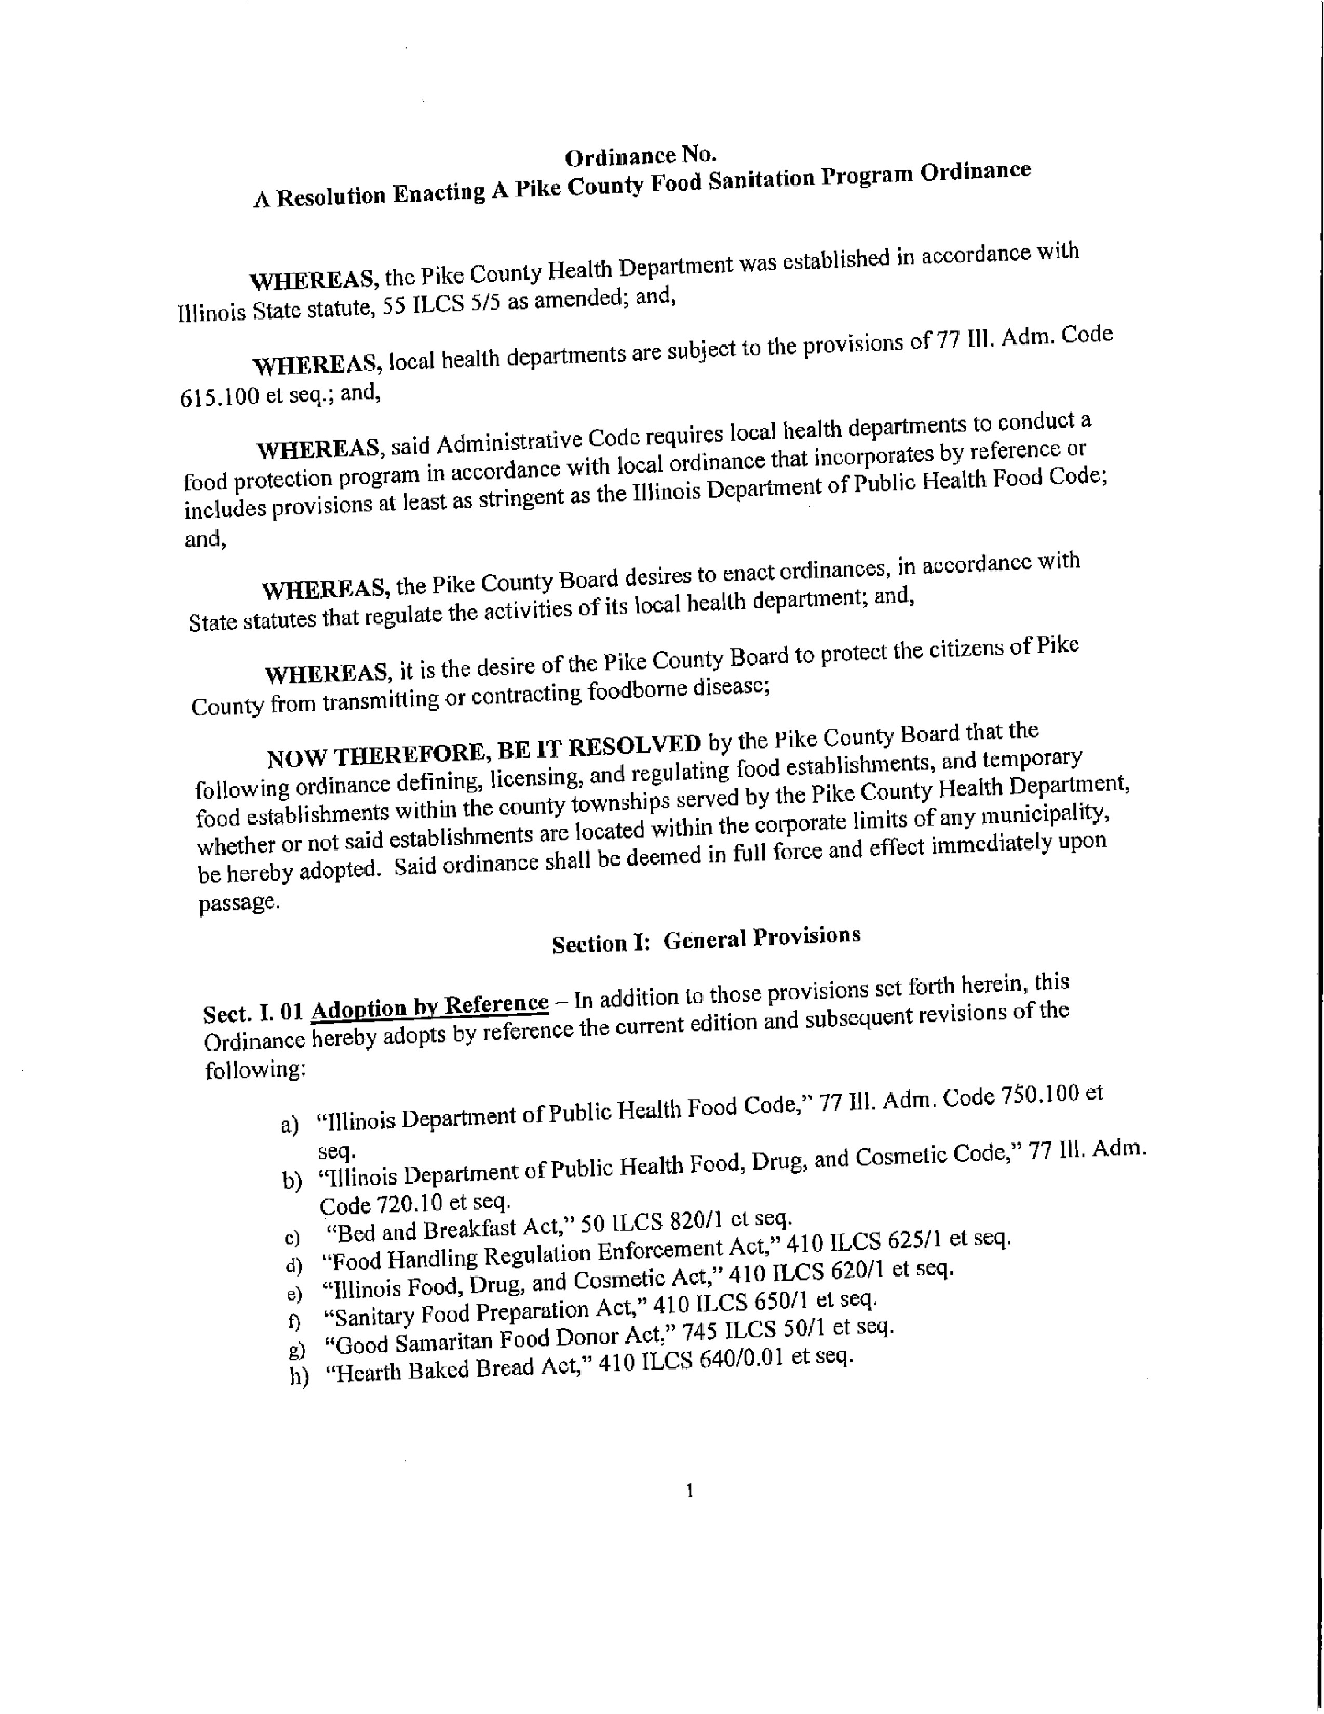
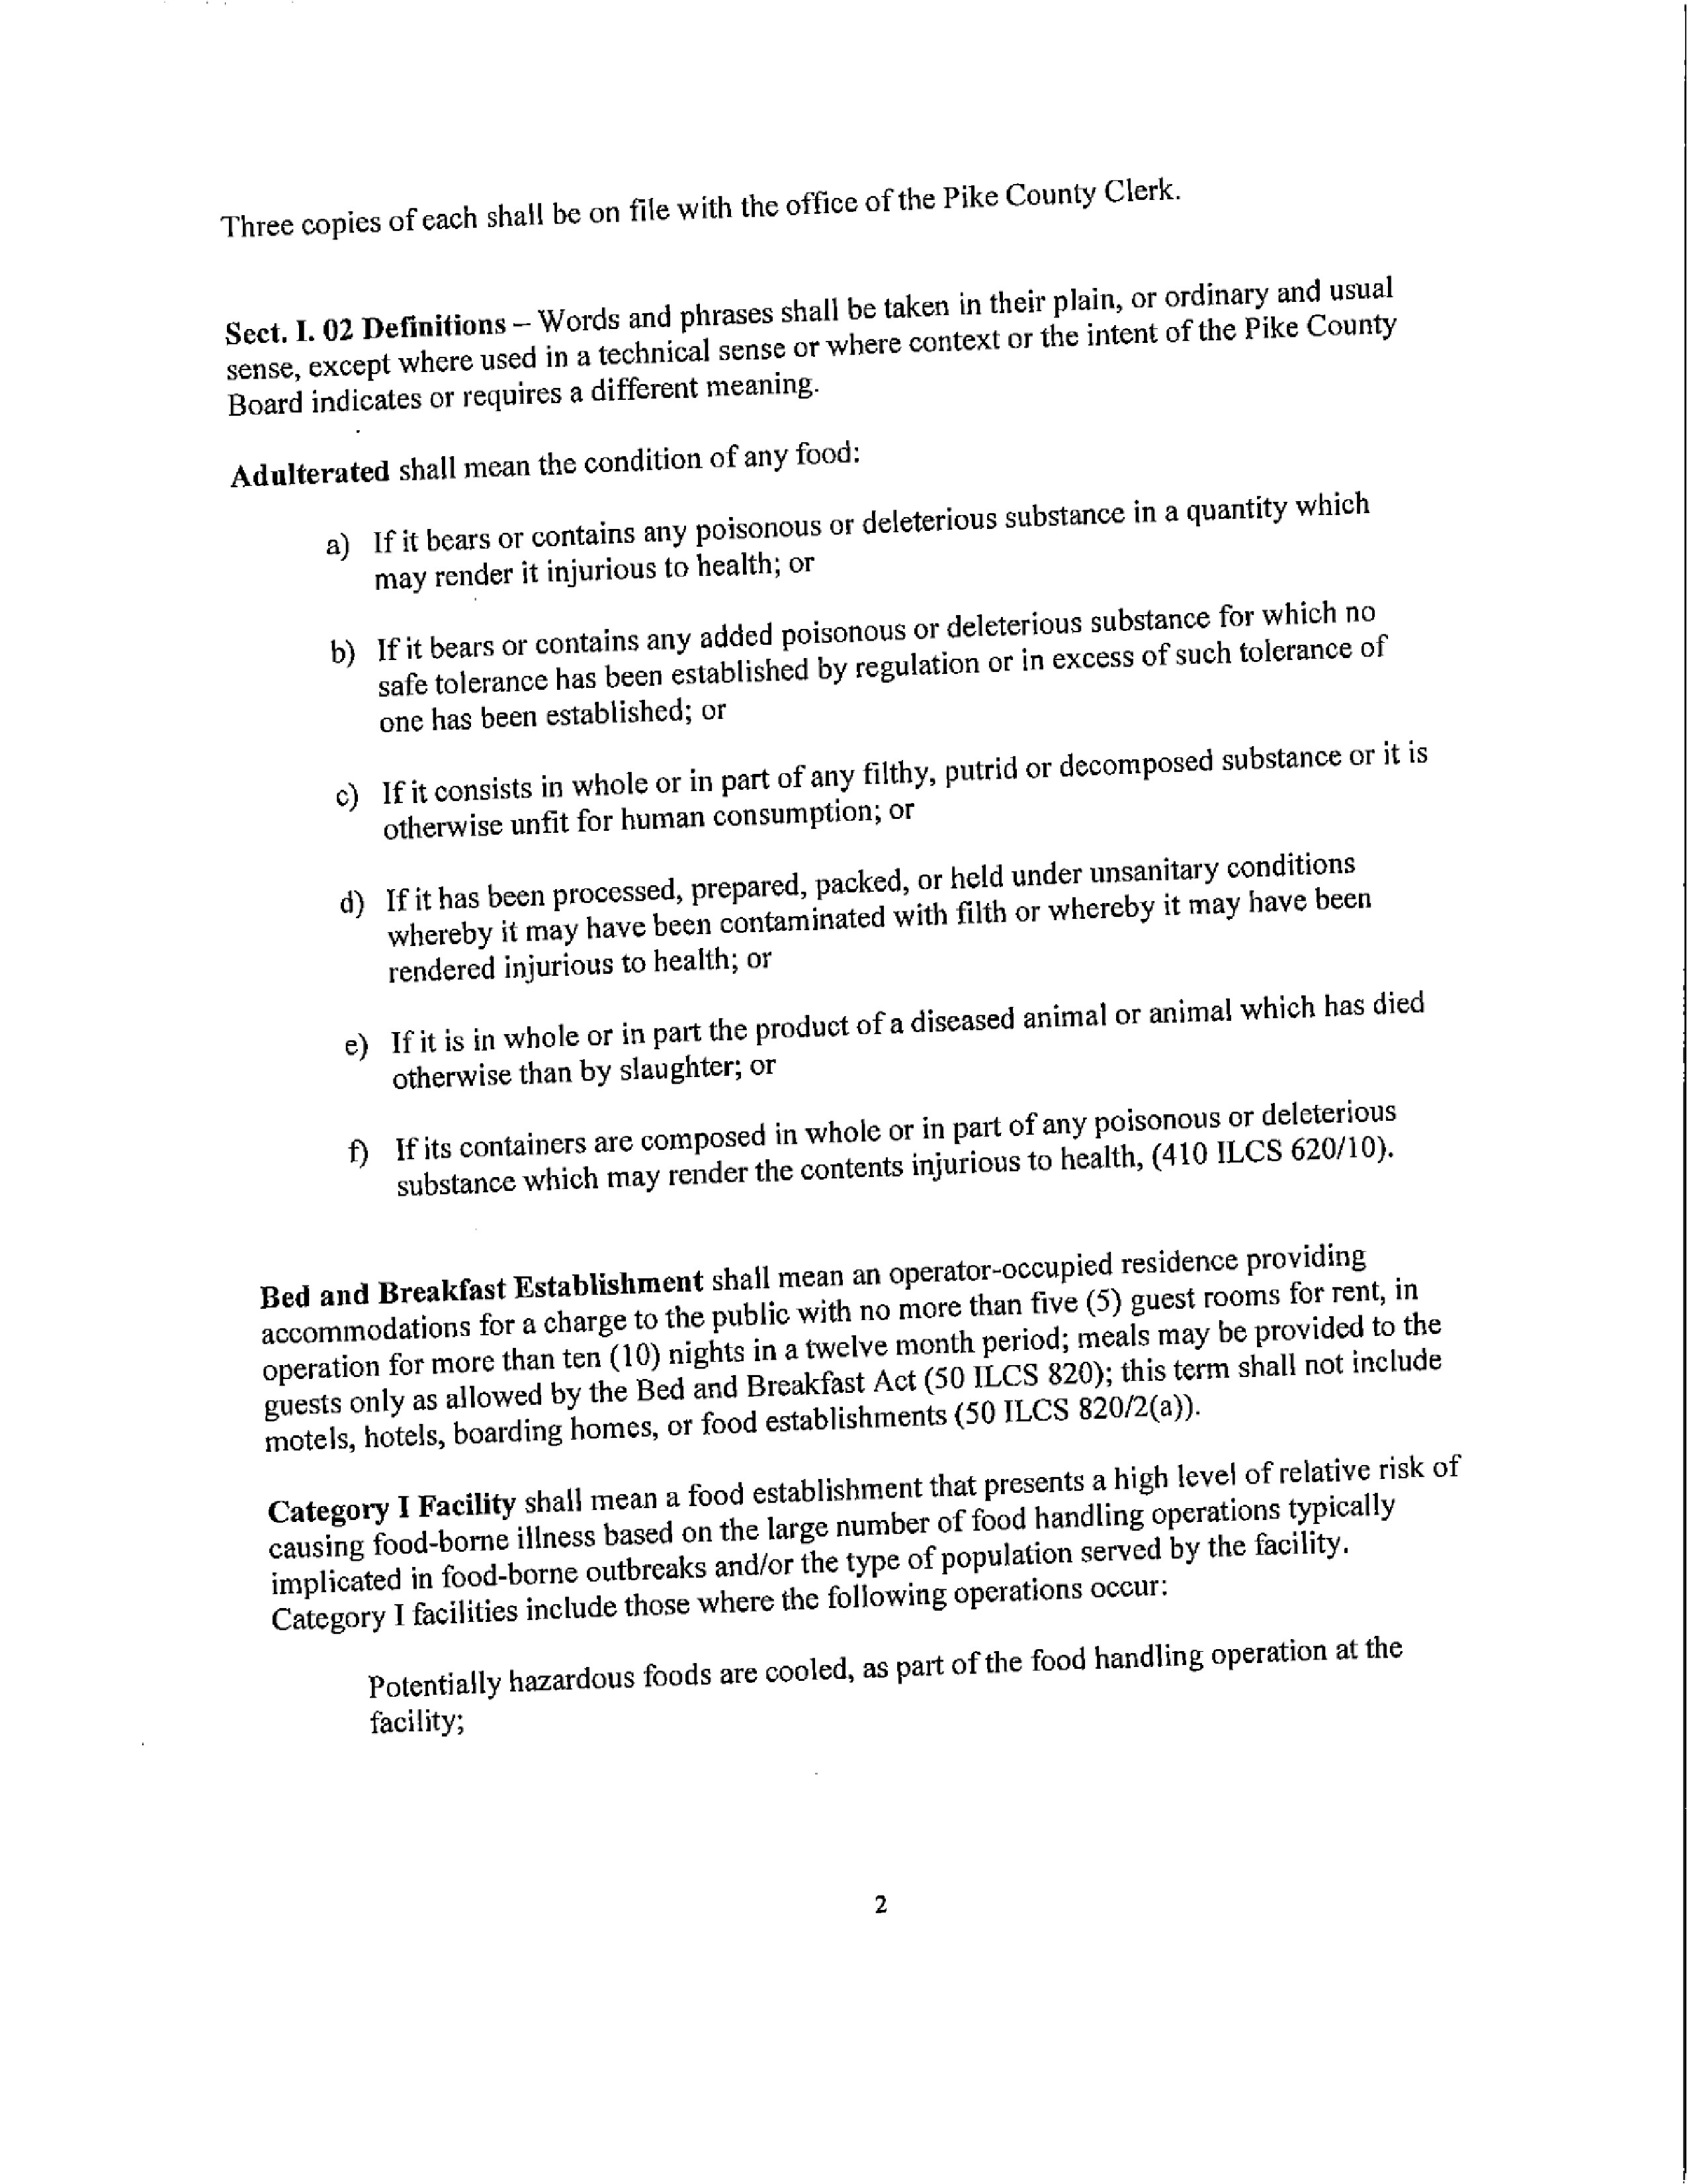
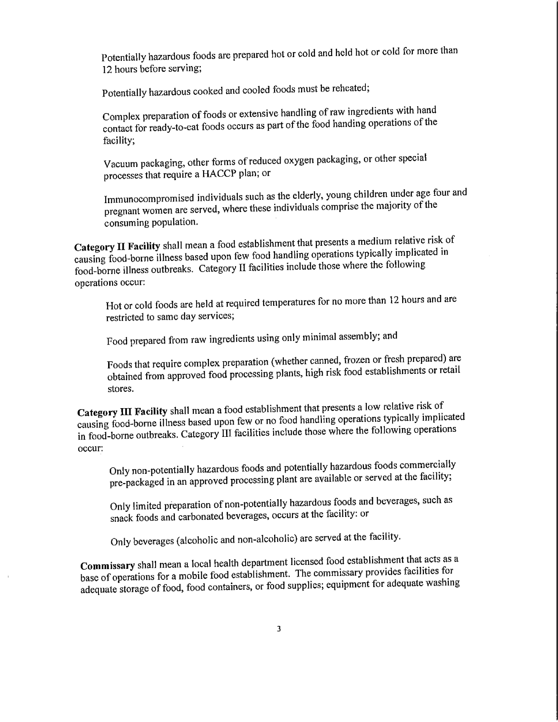
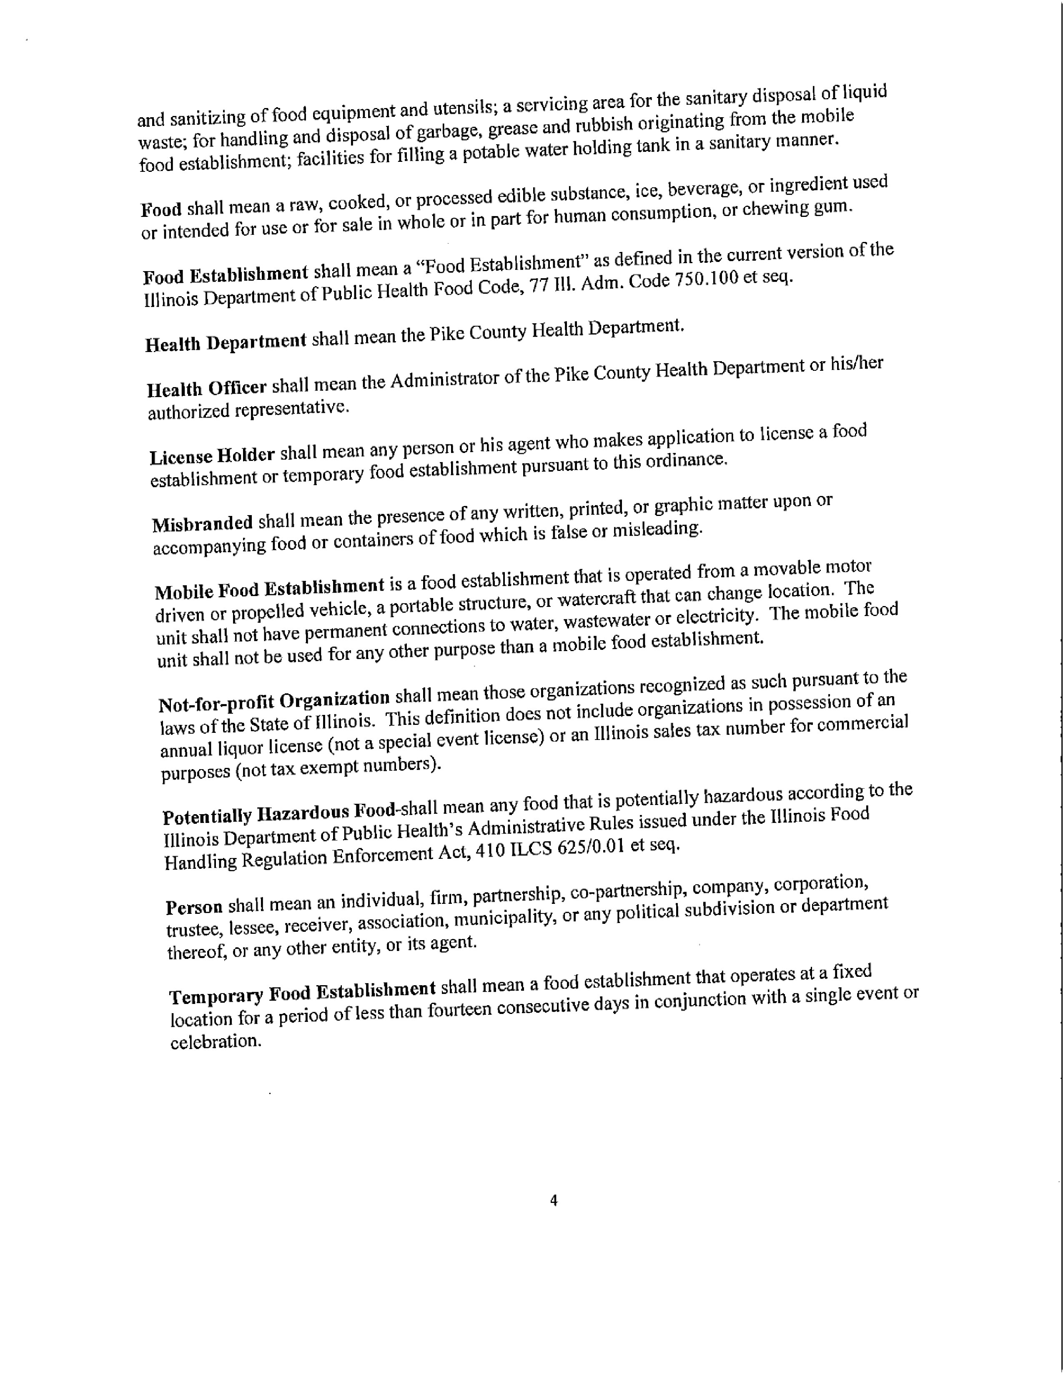
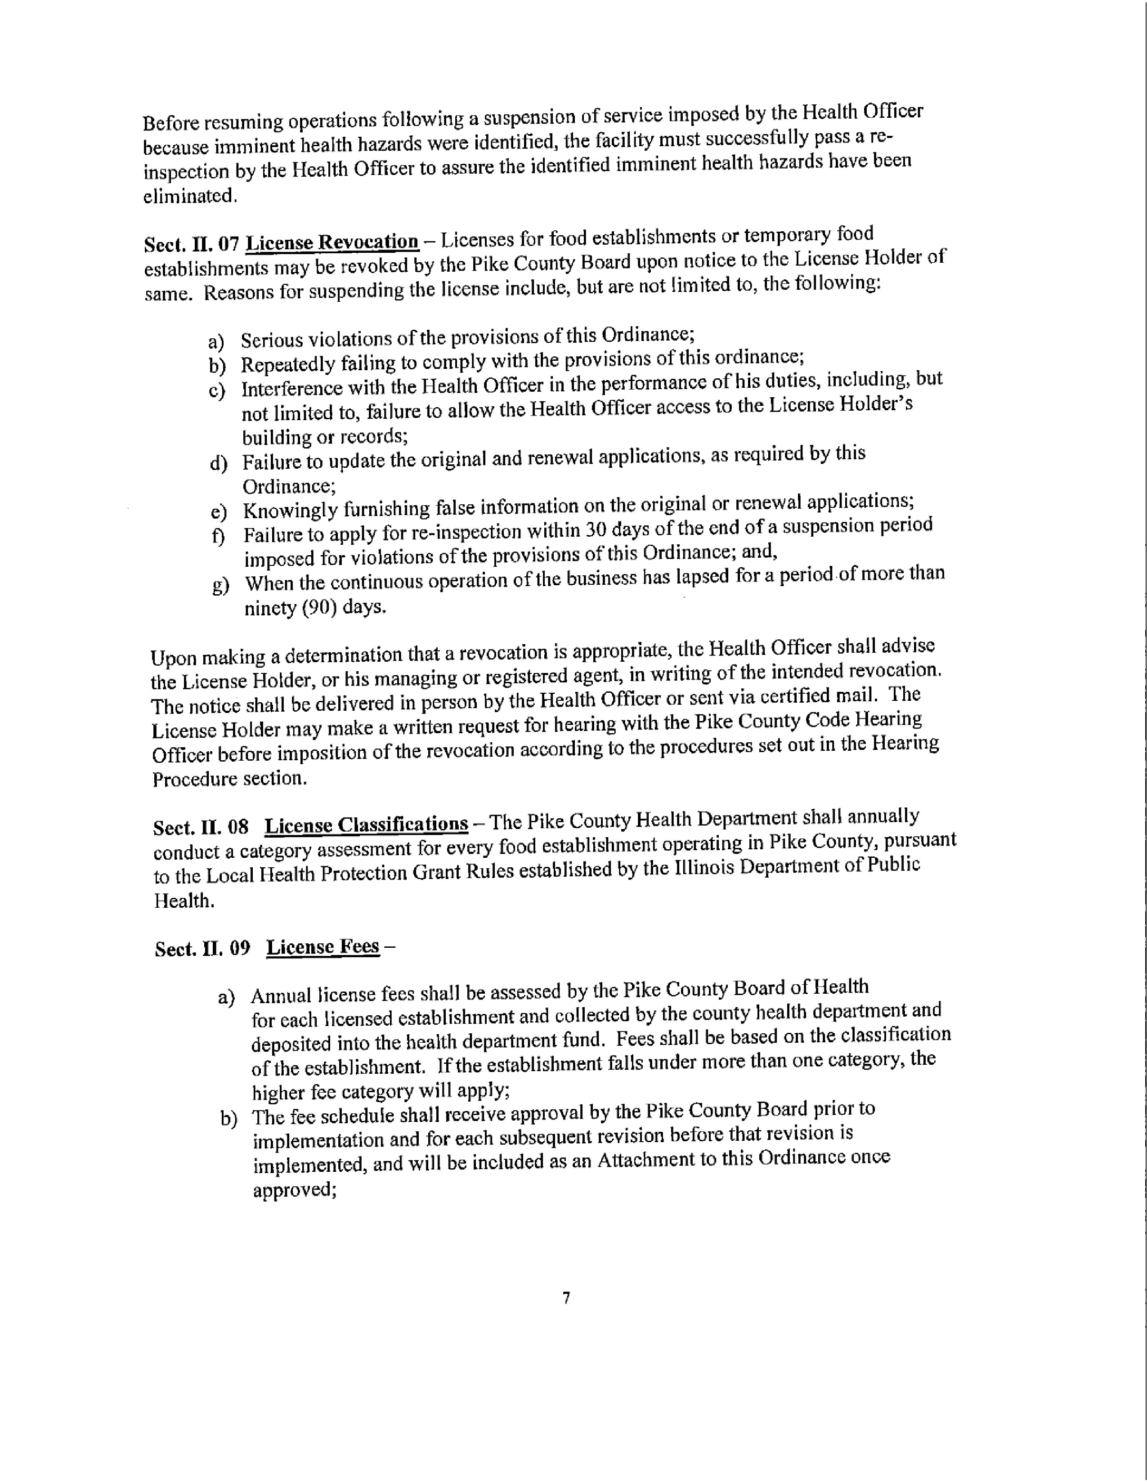
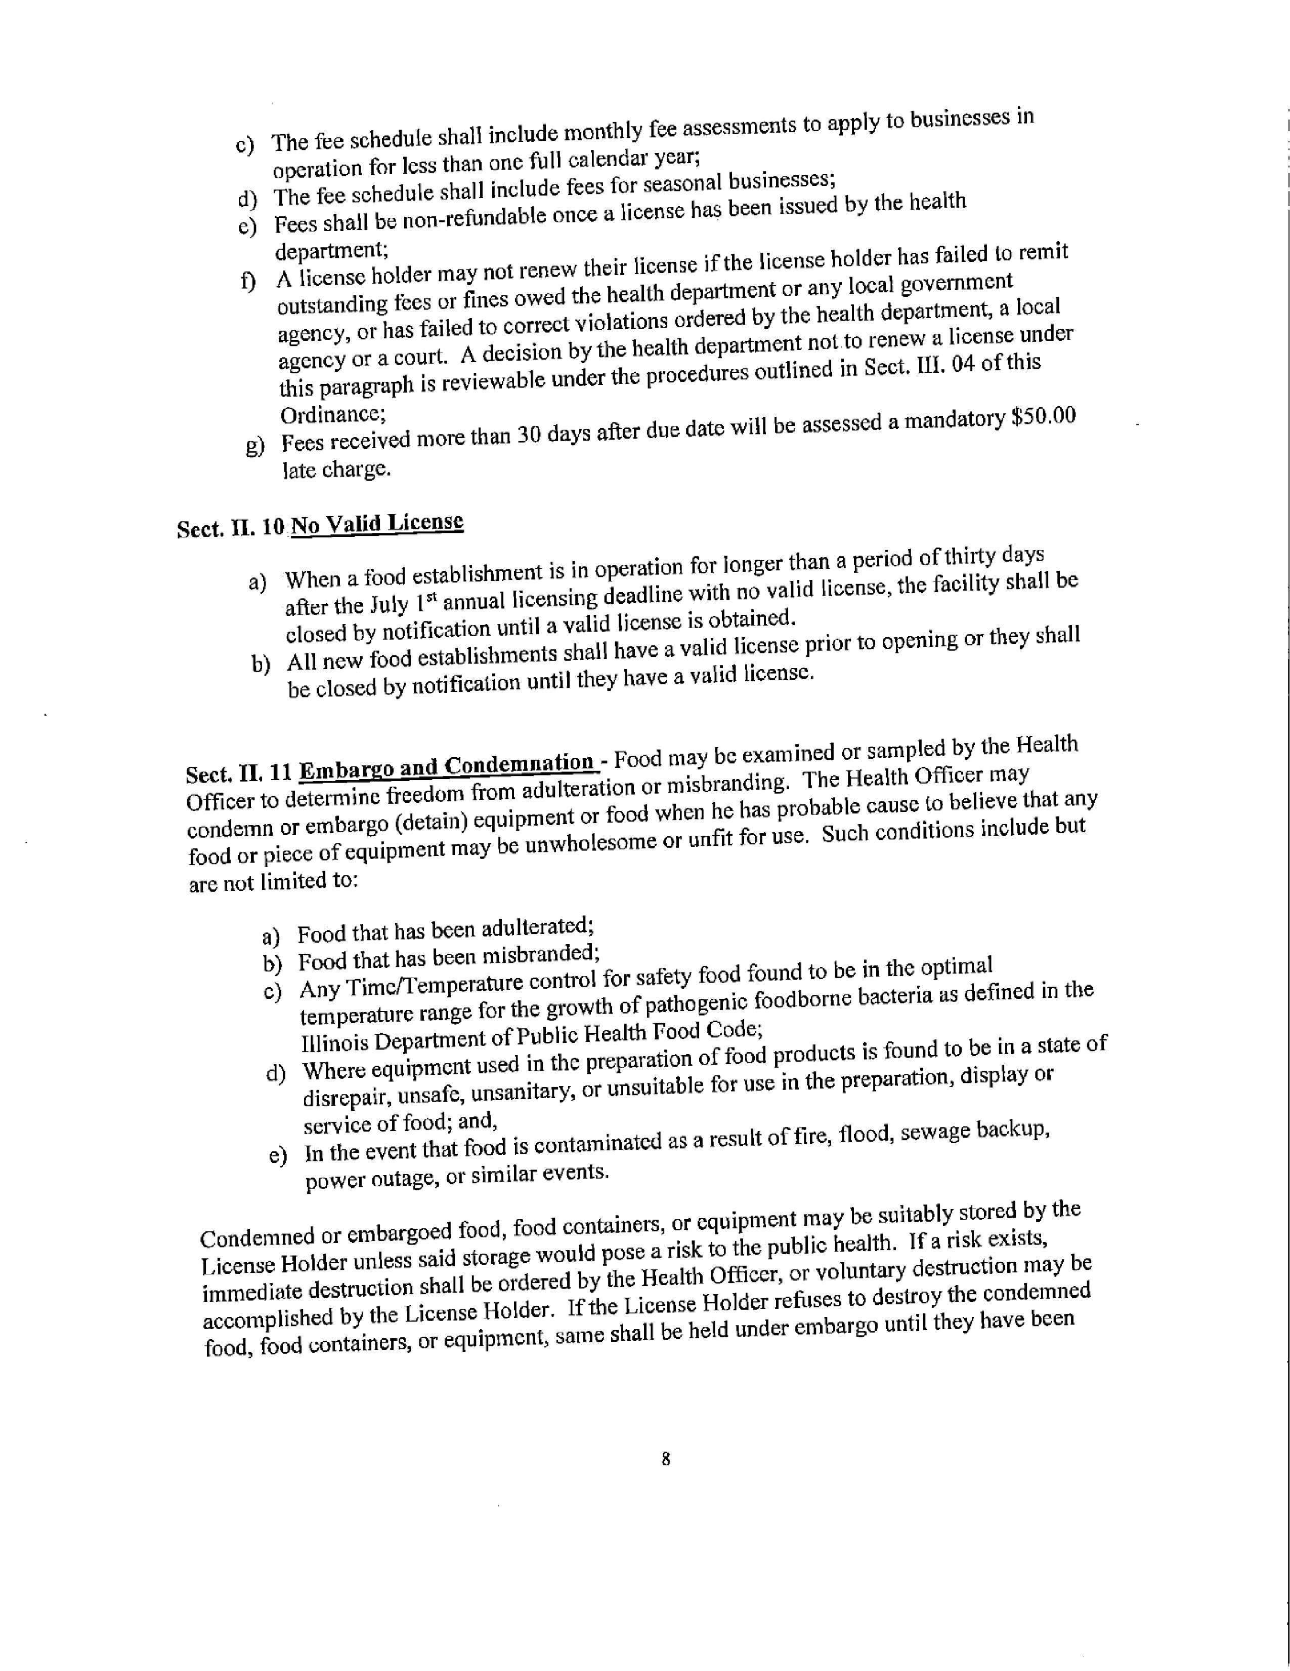
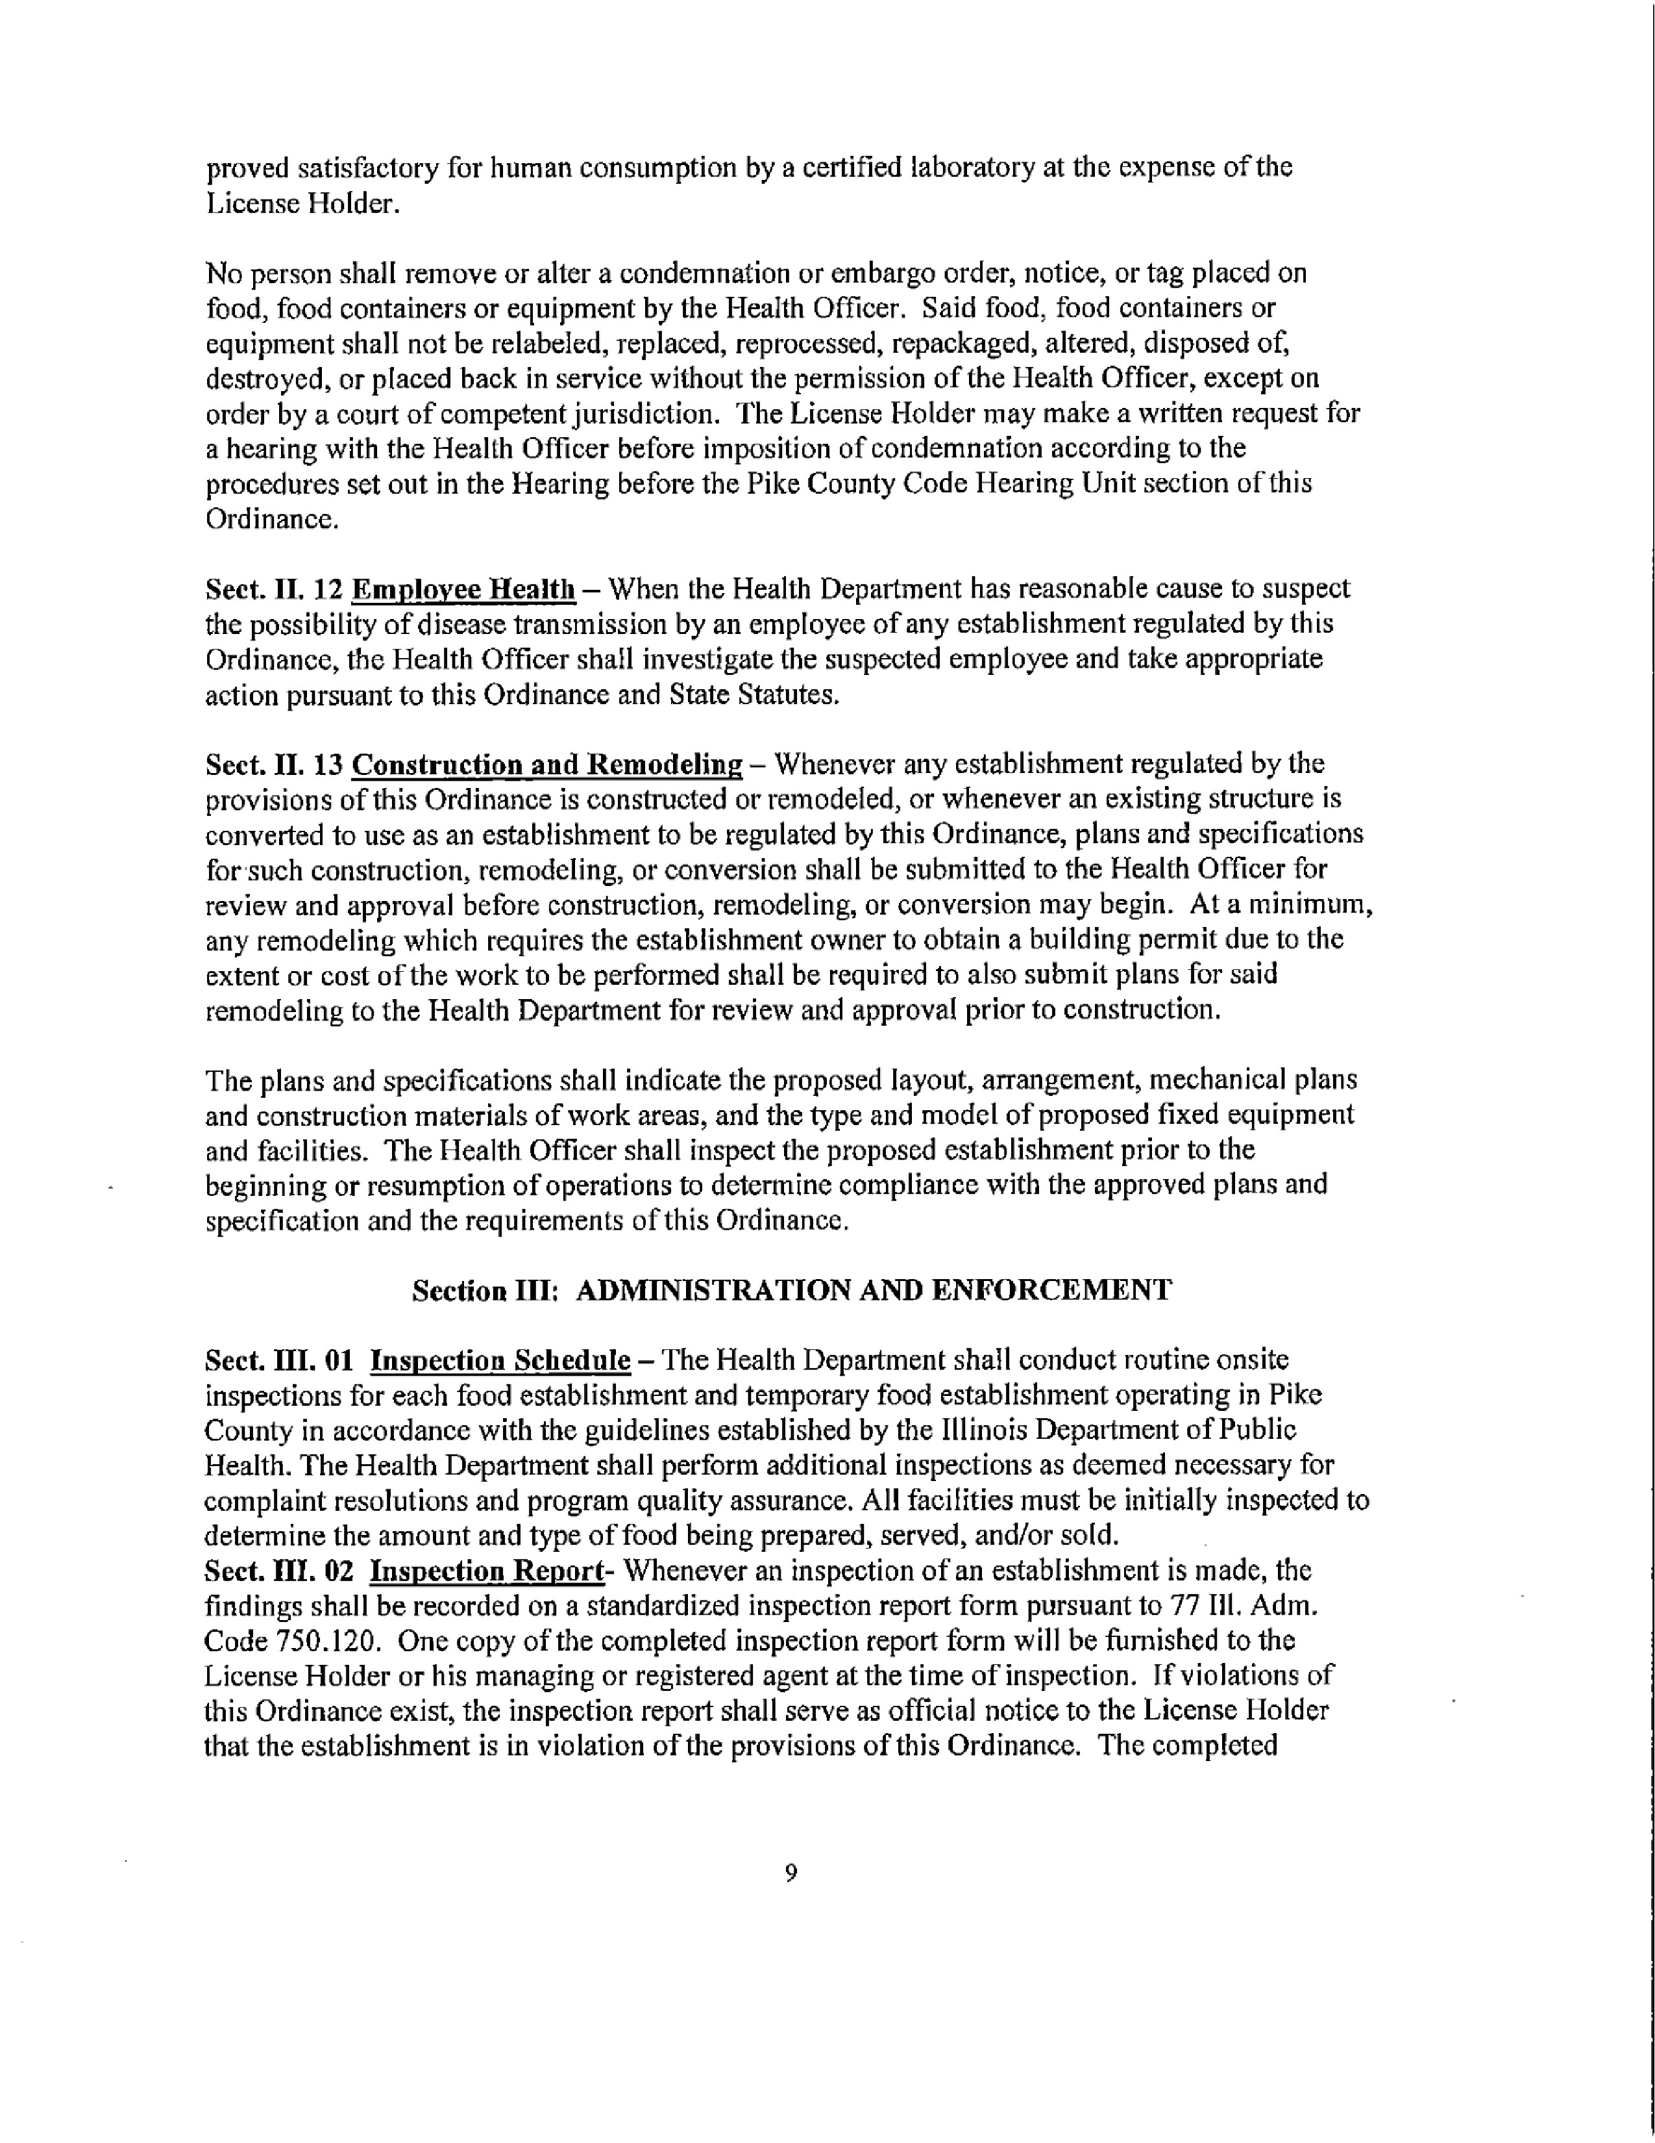
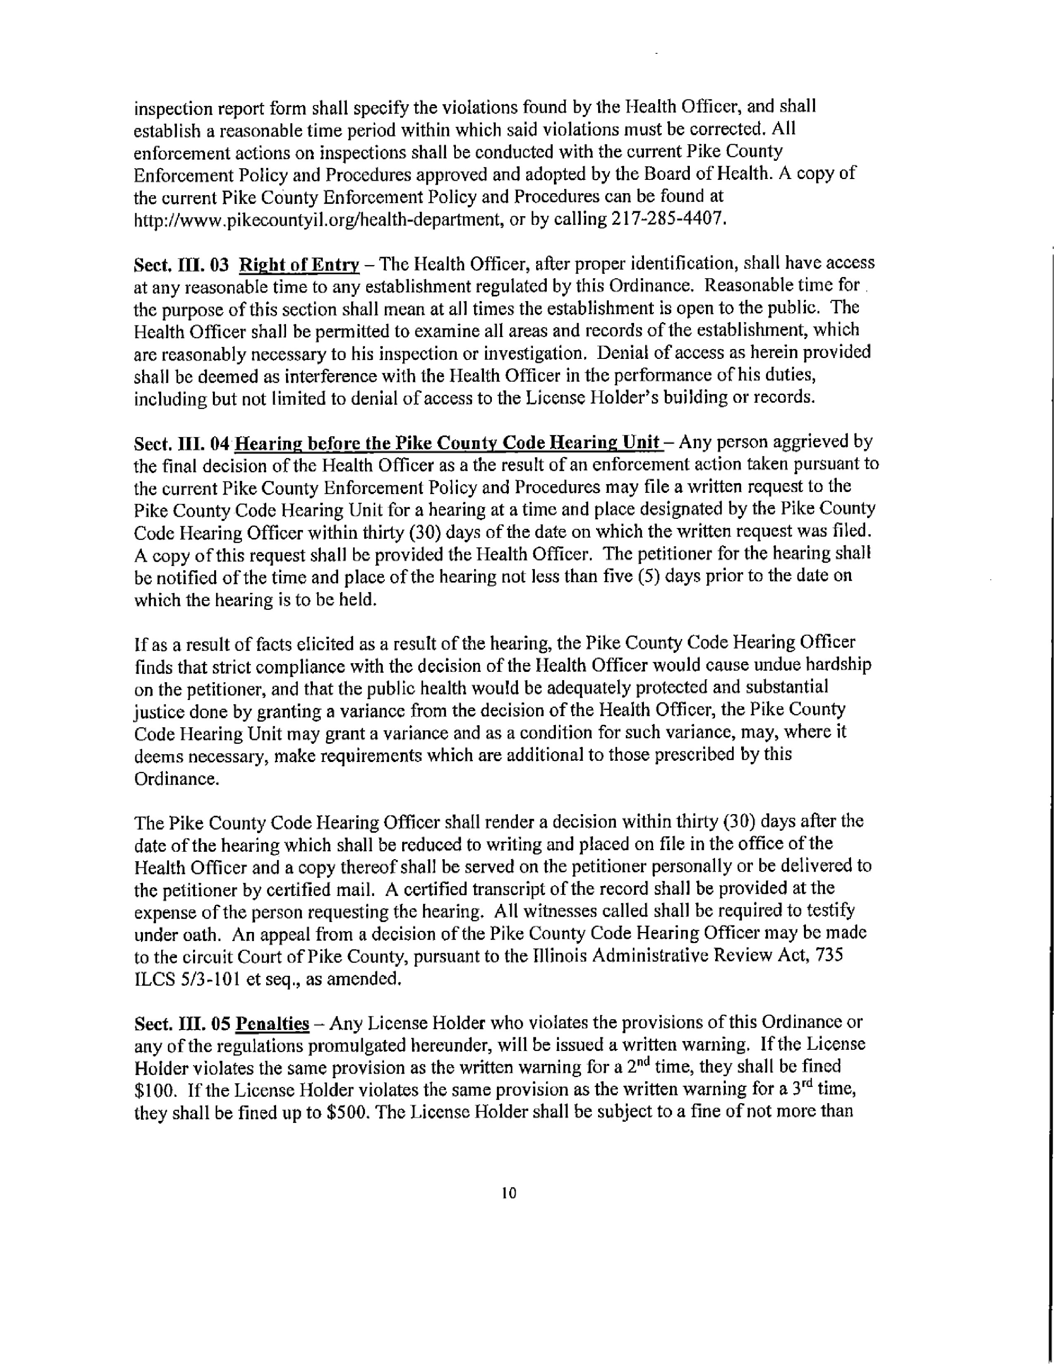
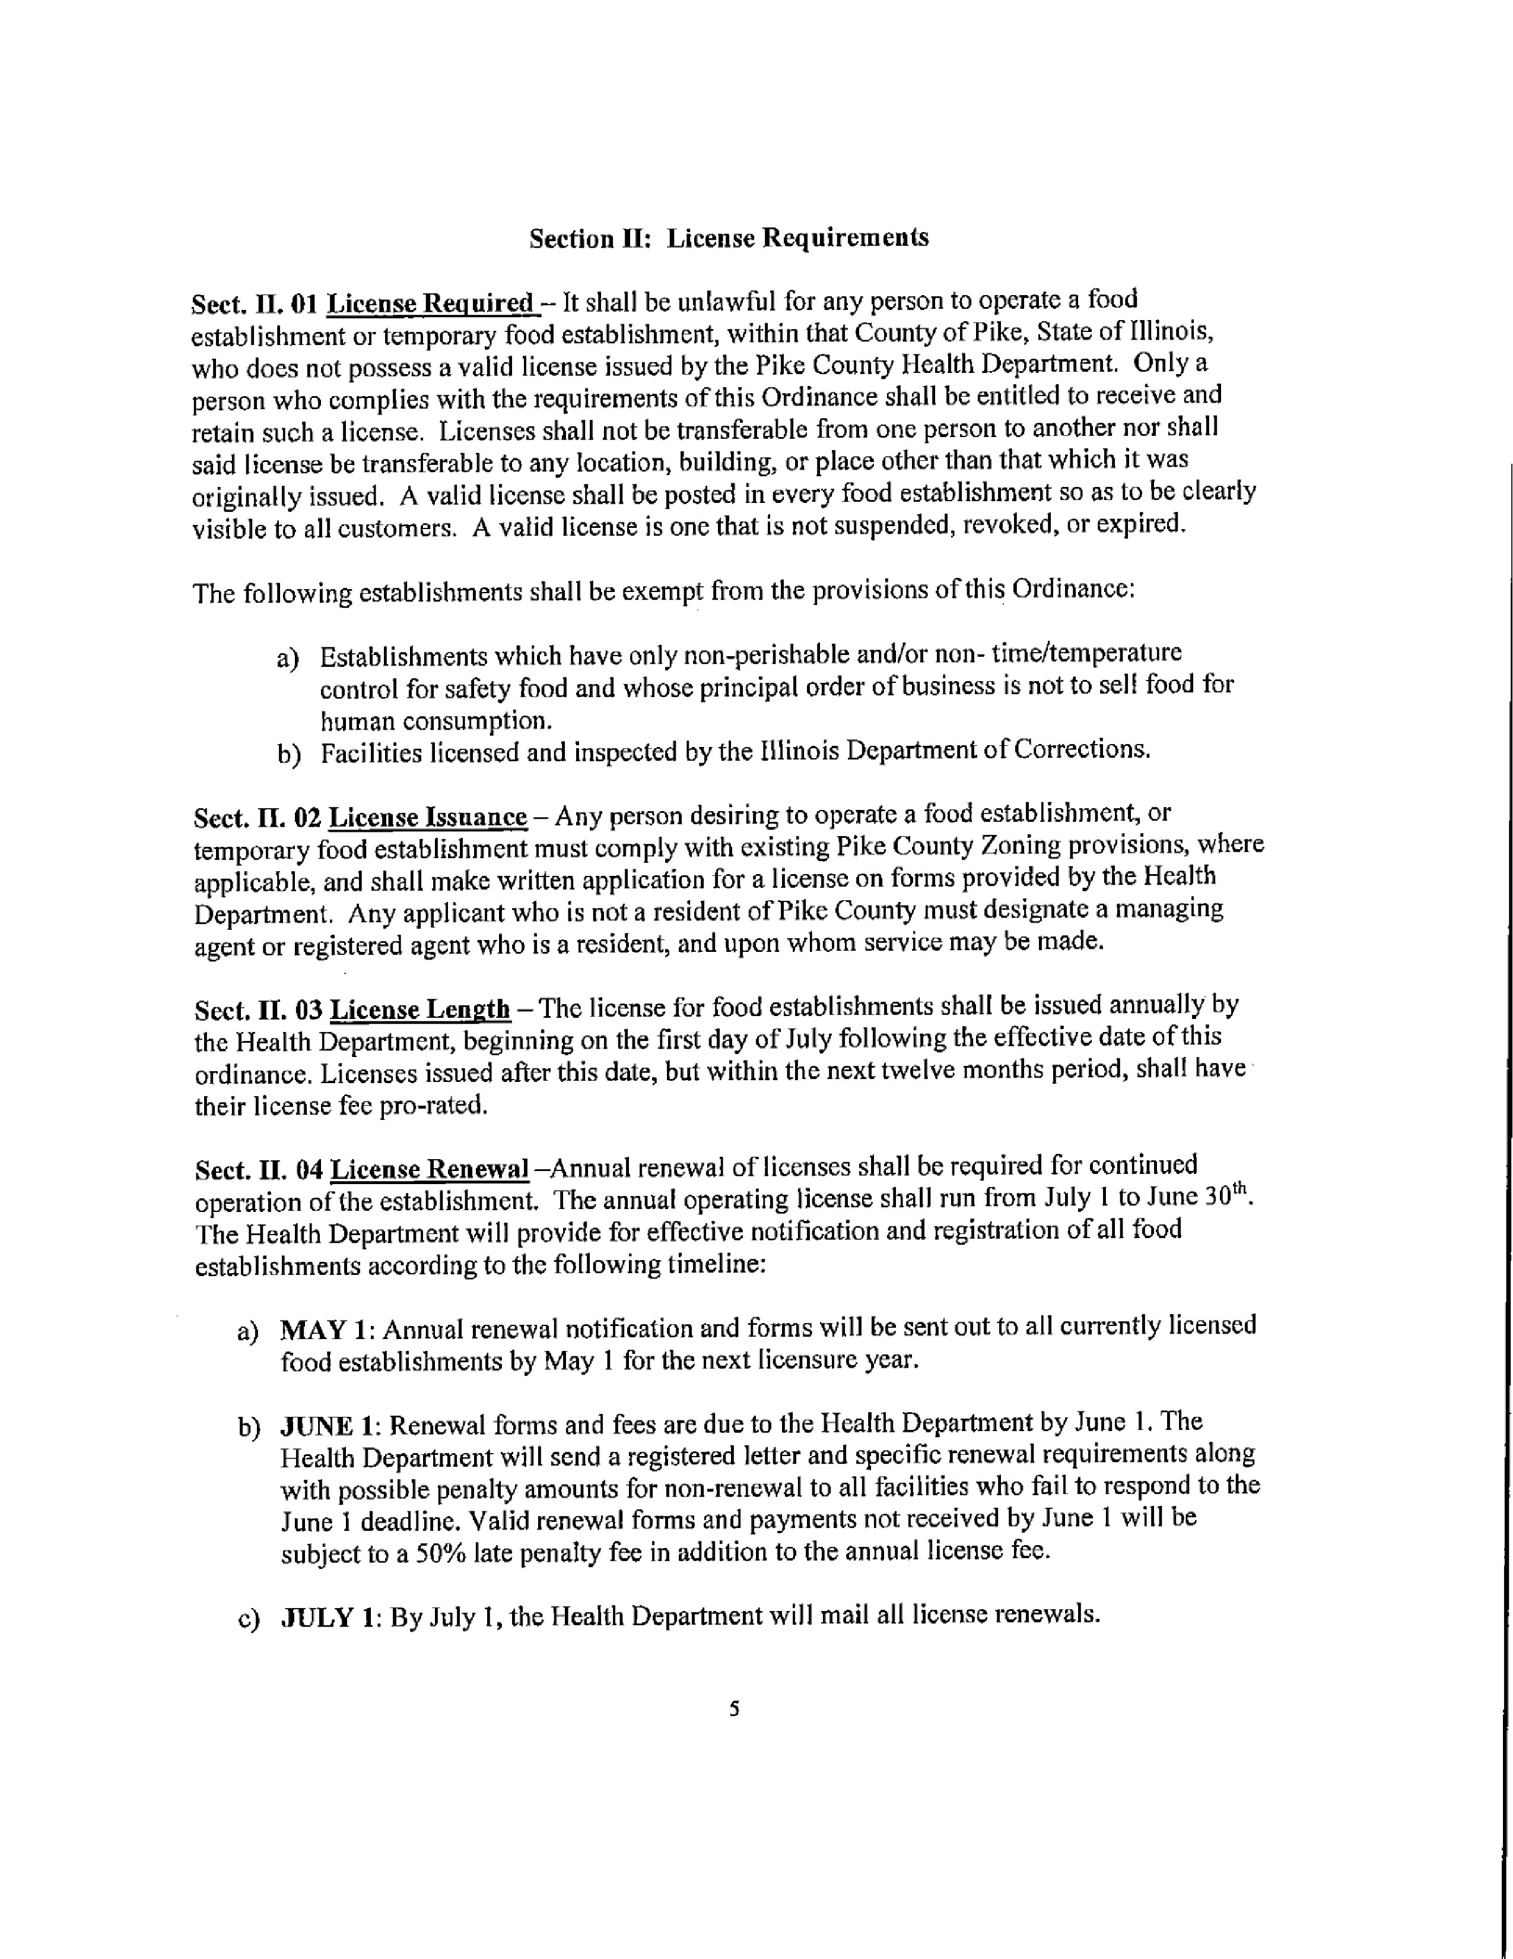
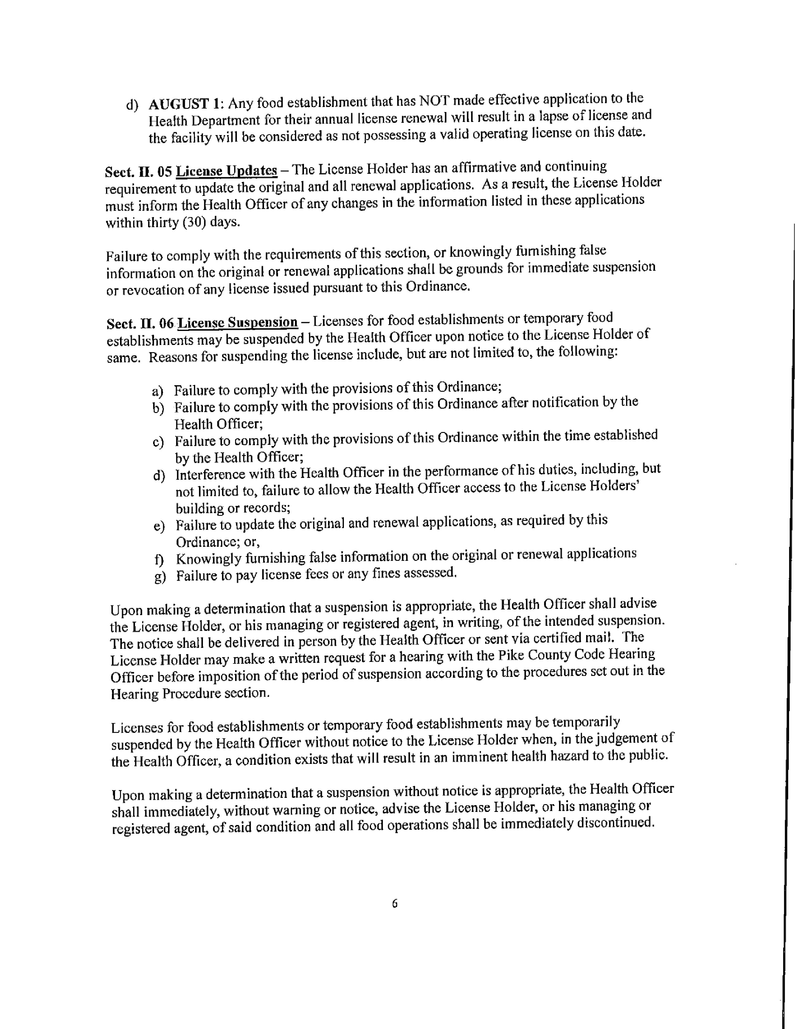
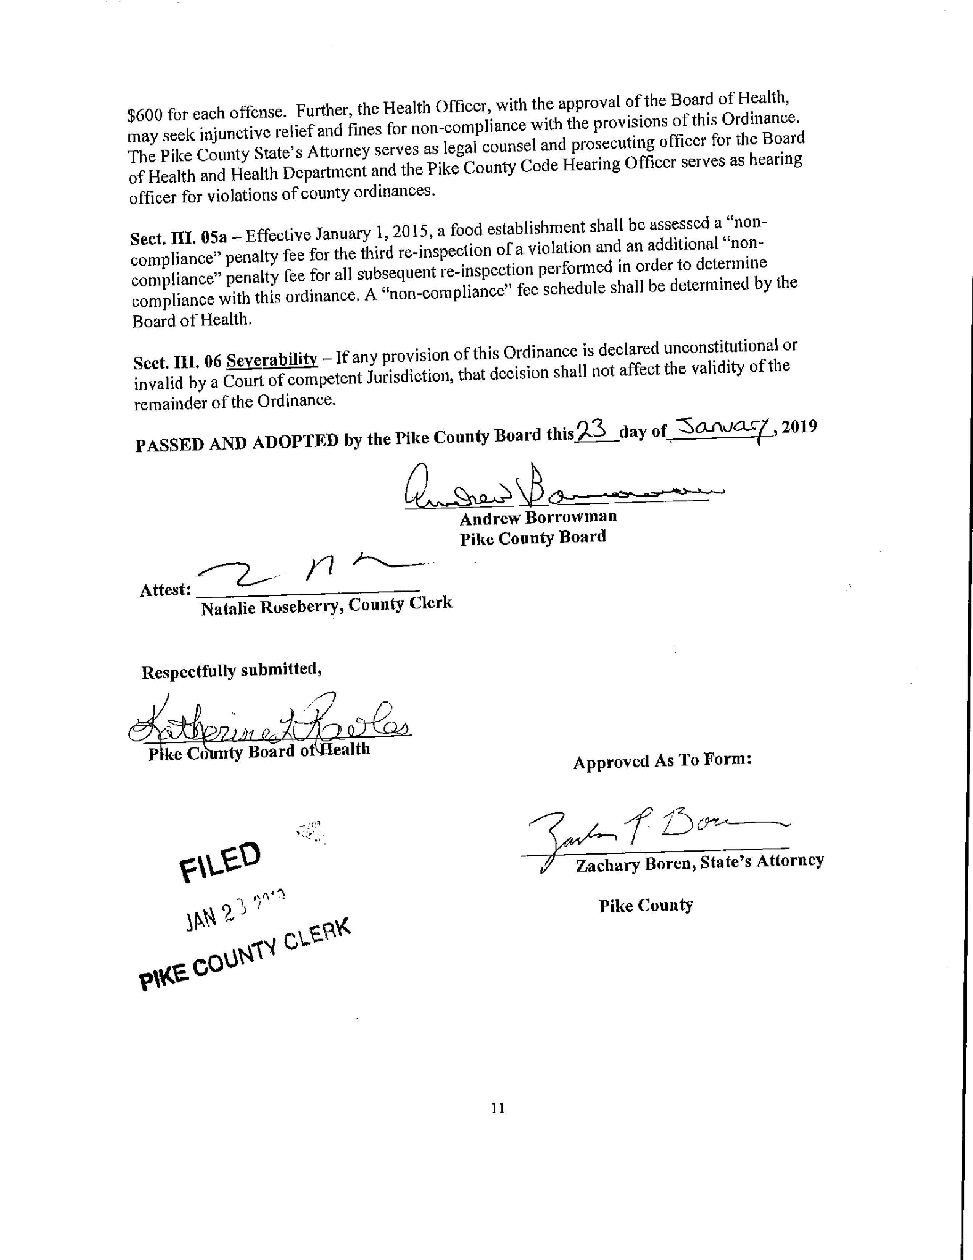
GIS Committee:
The GIS committee of the Pike County board met at 5:00 p.m. on Wednesday January 16, 2019 in the conference room of the Pike County Jail. Those present were Amy Gates, Jim Sheppard, Board Chairman Andy Borrowman, and Sandy Schacht.

In Sandy Schacht’s update she mentioned that we still have $12,916 left on our prepaid computer service contract. We have utilized for of the old computers from the Circuit Clerk’s office. She also mentioned that the new salesman for Marco is Dan Fischer and that she would have him at a future meeting.

We then went over some subjects that we wanted to cover at the administrators meeting concerning IT and other areas that we would like to branch out in the future. We are considering holding these on a quarterly basis and having subjects like IMRF, Insurance and trainings held.

Meetings adjourned at 5:58 p.m. on a motion by Amy Gates and a second by Jim Sheppard.

Addendum; we received two invoices for the RAMP service from Marco after the meeting. The invoices are for $350.00 each for a total of $700.00. We would ask that these be approved along with the minutes in order to avoid late charges.

Motion to approve the minutes including the addendum made by Amy Gates and seconded by Mark Sprague. Voice vote 8-0, motion passed.

Agriculture Committee:
The Agriculture Committee met on January 22, 2019 at 6:00 p.m. in the government building upper conference room. Members in Attendance were: Mark Mountain (Committee Chairman), Rodger Hannel, Mark Sprague and Andy Borrowman. Others in attendance were Debbie Lambeth, Blake Roderick, Fred Ruzich, Zack Boren, Jane Johnson, PCWD Staff, Brad Wilson (Attorney for PCWD), Jenna Tucker and John Megehe.

Pike County Water District is requesting that Pike County consider an Ordinance to increase setbacks of private wells from district wells. Attorney for PCWD, Brad Wilson, presented a hand out to board members for review. A long discussion included effected land owners, PCWD wells and which ones would be effected by possible new setbacks, kinds of contamination, setbacks would limit private wells only, etc. After an hour long discussion the PCWD is requesting that Pike County Board members be given all information and that PCWD request be put on the board’s agenda for February. That request is a vote up or down, a recommendation to proceed with discovery not an approval of the Ordinance at this time.

Wind Farm Illinois Winds consider amending wind farm section of the zoning Ordinance to allow for turbines taller than 500 feet if permitted by FAA. Much discussion on how to proceed at this point in the project. Does it substantially change the project to the point new studies will have to be complete? Or a new citing application? After long discussion it was determined that these issues be discussed with Patrick engineering and a meeting scheduled for January 31st, 2019 at 3:00 p.m. with Morgan Mcgovert (Illinois Winds) Zack Boren, Fred Ruzich and Mark Mountain.

Proposed Solar Ordinance- the IAMA (Agricultural Impact Mitigation Agreement) has been found and will allow committee to proceed with Solar Ordinance. A meeting was set for February 19th, 2019 at 5:00 p.m. to continue discussion.

The PLAT act was discussed and the counties enforcement or lack of enforcement. It was determined to ask Natalie Roseberry and Zack Boren to attend February 19th meeting to discuss.

Used tire collection- Jane Johnson advised the committee that another used tire collection has been approved. That collection is scheduled for the end of March. Details to be released at a later date.

Animal Control truck issues- Debbie Lambeth advised the committee on the condition of the department’s truck. The committee advised Debbie to find a vehicle that meets the department’s needs and report same along with budget information to the committee at the February 19th meeting.

Motion to adjourn by Rodger Hannel and seconded by Mark Sprague. Meeting adjourned at 8:20 p.m.

At the Board meeting, Amy Gates expressed that she was not understanding the Wind Farm information and SA Zack Boren explained that Illinois Winds just wanted to general interest before they invested the money in the research.

Dennis Terpstra, Chairman of the Pike County Water Board, explained that the well Ordinance would prevent someone from building too close and the setback would be for future projects.

Amy Gates questioned the form and Andy Borrowman clarified that it was received by the County from the State.

Amy Gates questioned the PLAT Act and SA Boren explained that it is a State requirement that one cannot transfer property with less than 5 acres without an affidavit of survey and a verification sheet processed through the County Clerk’s Office.

Mark Mountain read a letter my Mr. Cleve Curry regarding Mr. Curry’s concerns on the Multi-township assessments and the delinquency of a 2017 Levy and explaining problems that the Multi-Township is experiencing. Mr. Curry also requested that the Supervisor of Assessments office take over the assessment and then the Multi-Township assessing district would reimburse the county once the Levy monies were disbursed.

Mark Mountain spoke as a prior member of the Assessment Review Board stating that the system is antiquated.
Cindy Shaw, Supervisor of Assessments, brought to the board a copy of the “Establishment of Voluntary/Mandatory Multi-Township Assessment Districts” guidelines. She stated that it is not an option to have her office do the work unless the work is not submitted. She further states that Pike County is not a commission county and is tin the fourth paragraph of the guidelines.

Carrie Martin asked if the State of Illinois has done the Migratory Study regarding wind Farms yet? Mark Sprague answered that the study will not be done until the program is fully developed.

John Birch made a motion to approve the amended minutes and Mark Sprague seconded the motion. Voice vote was 8-0 to approve.

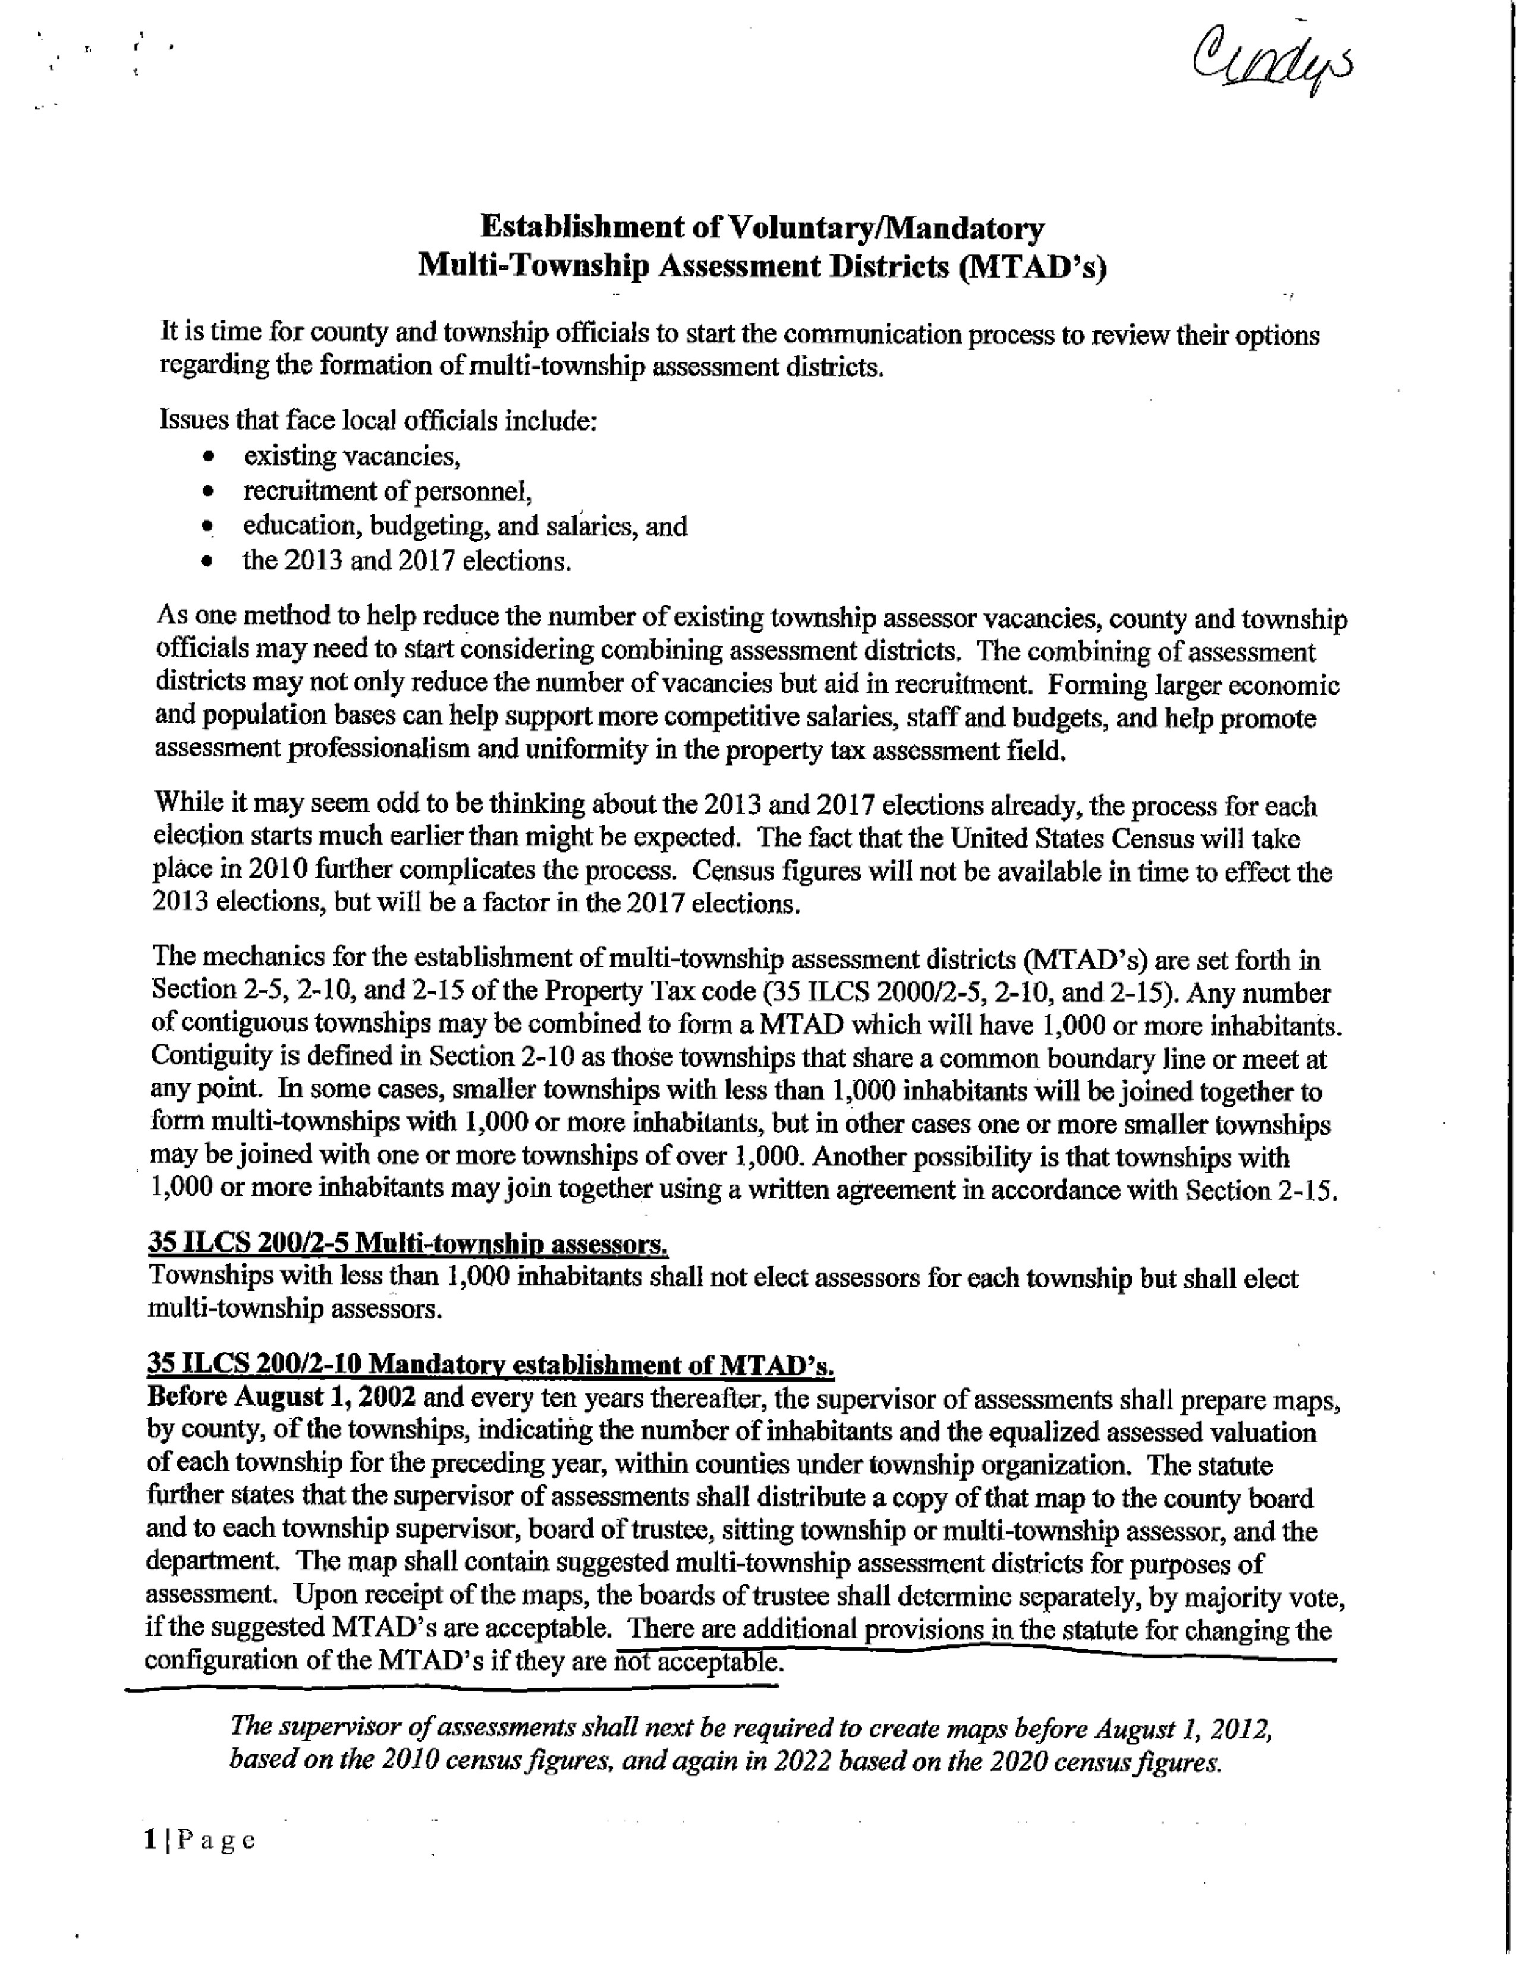
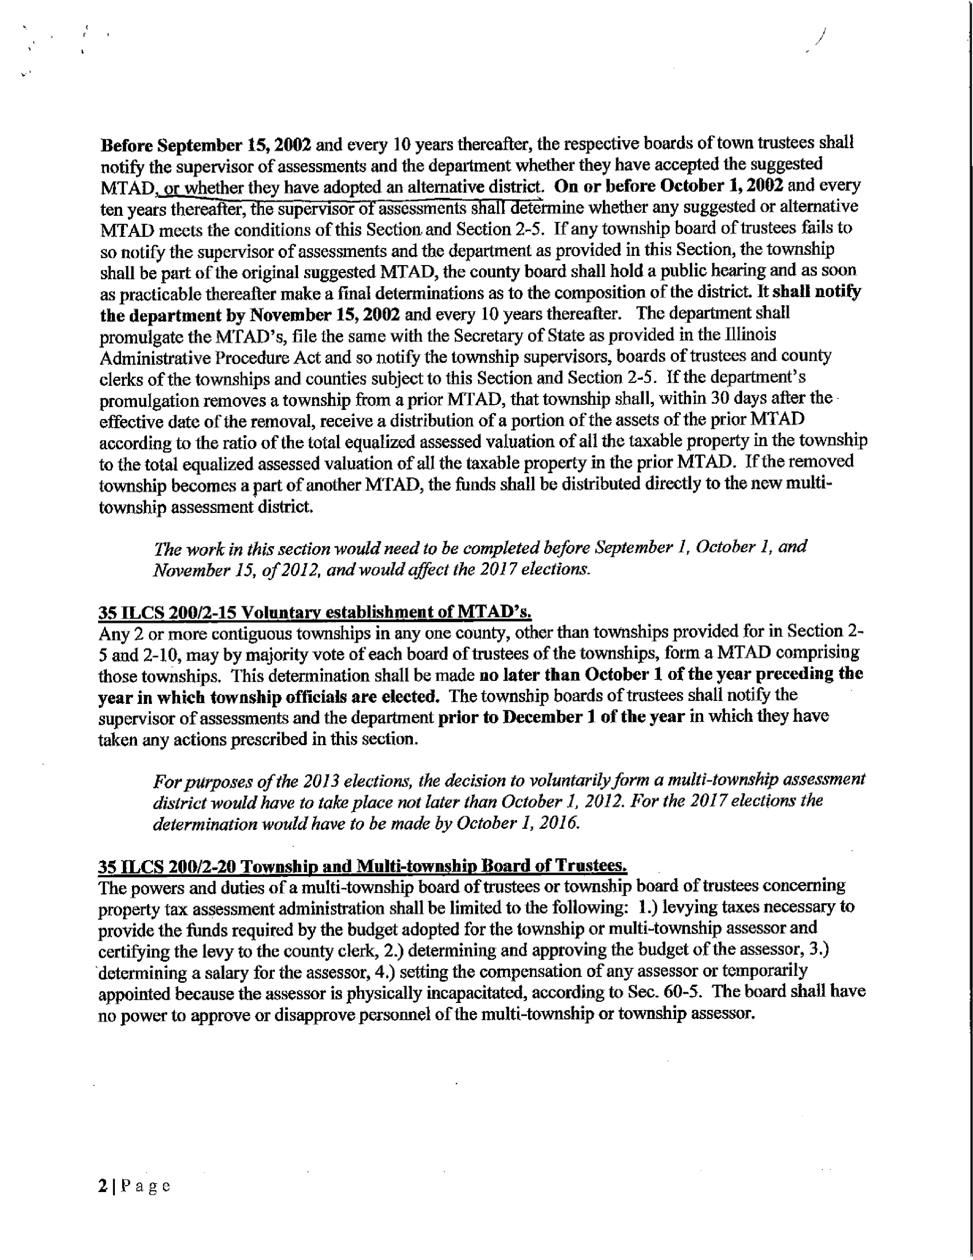
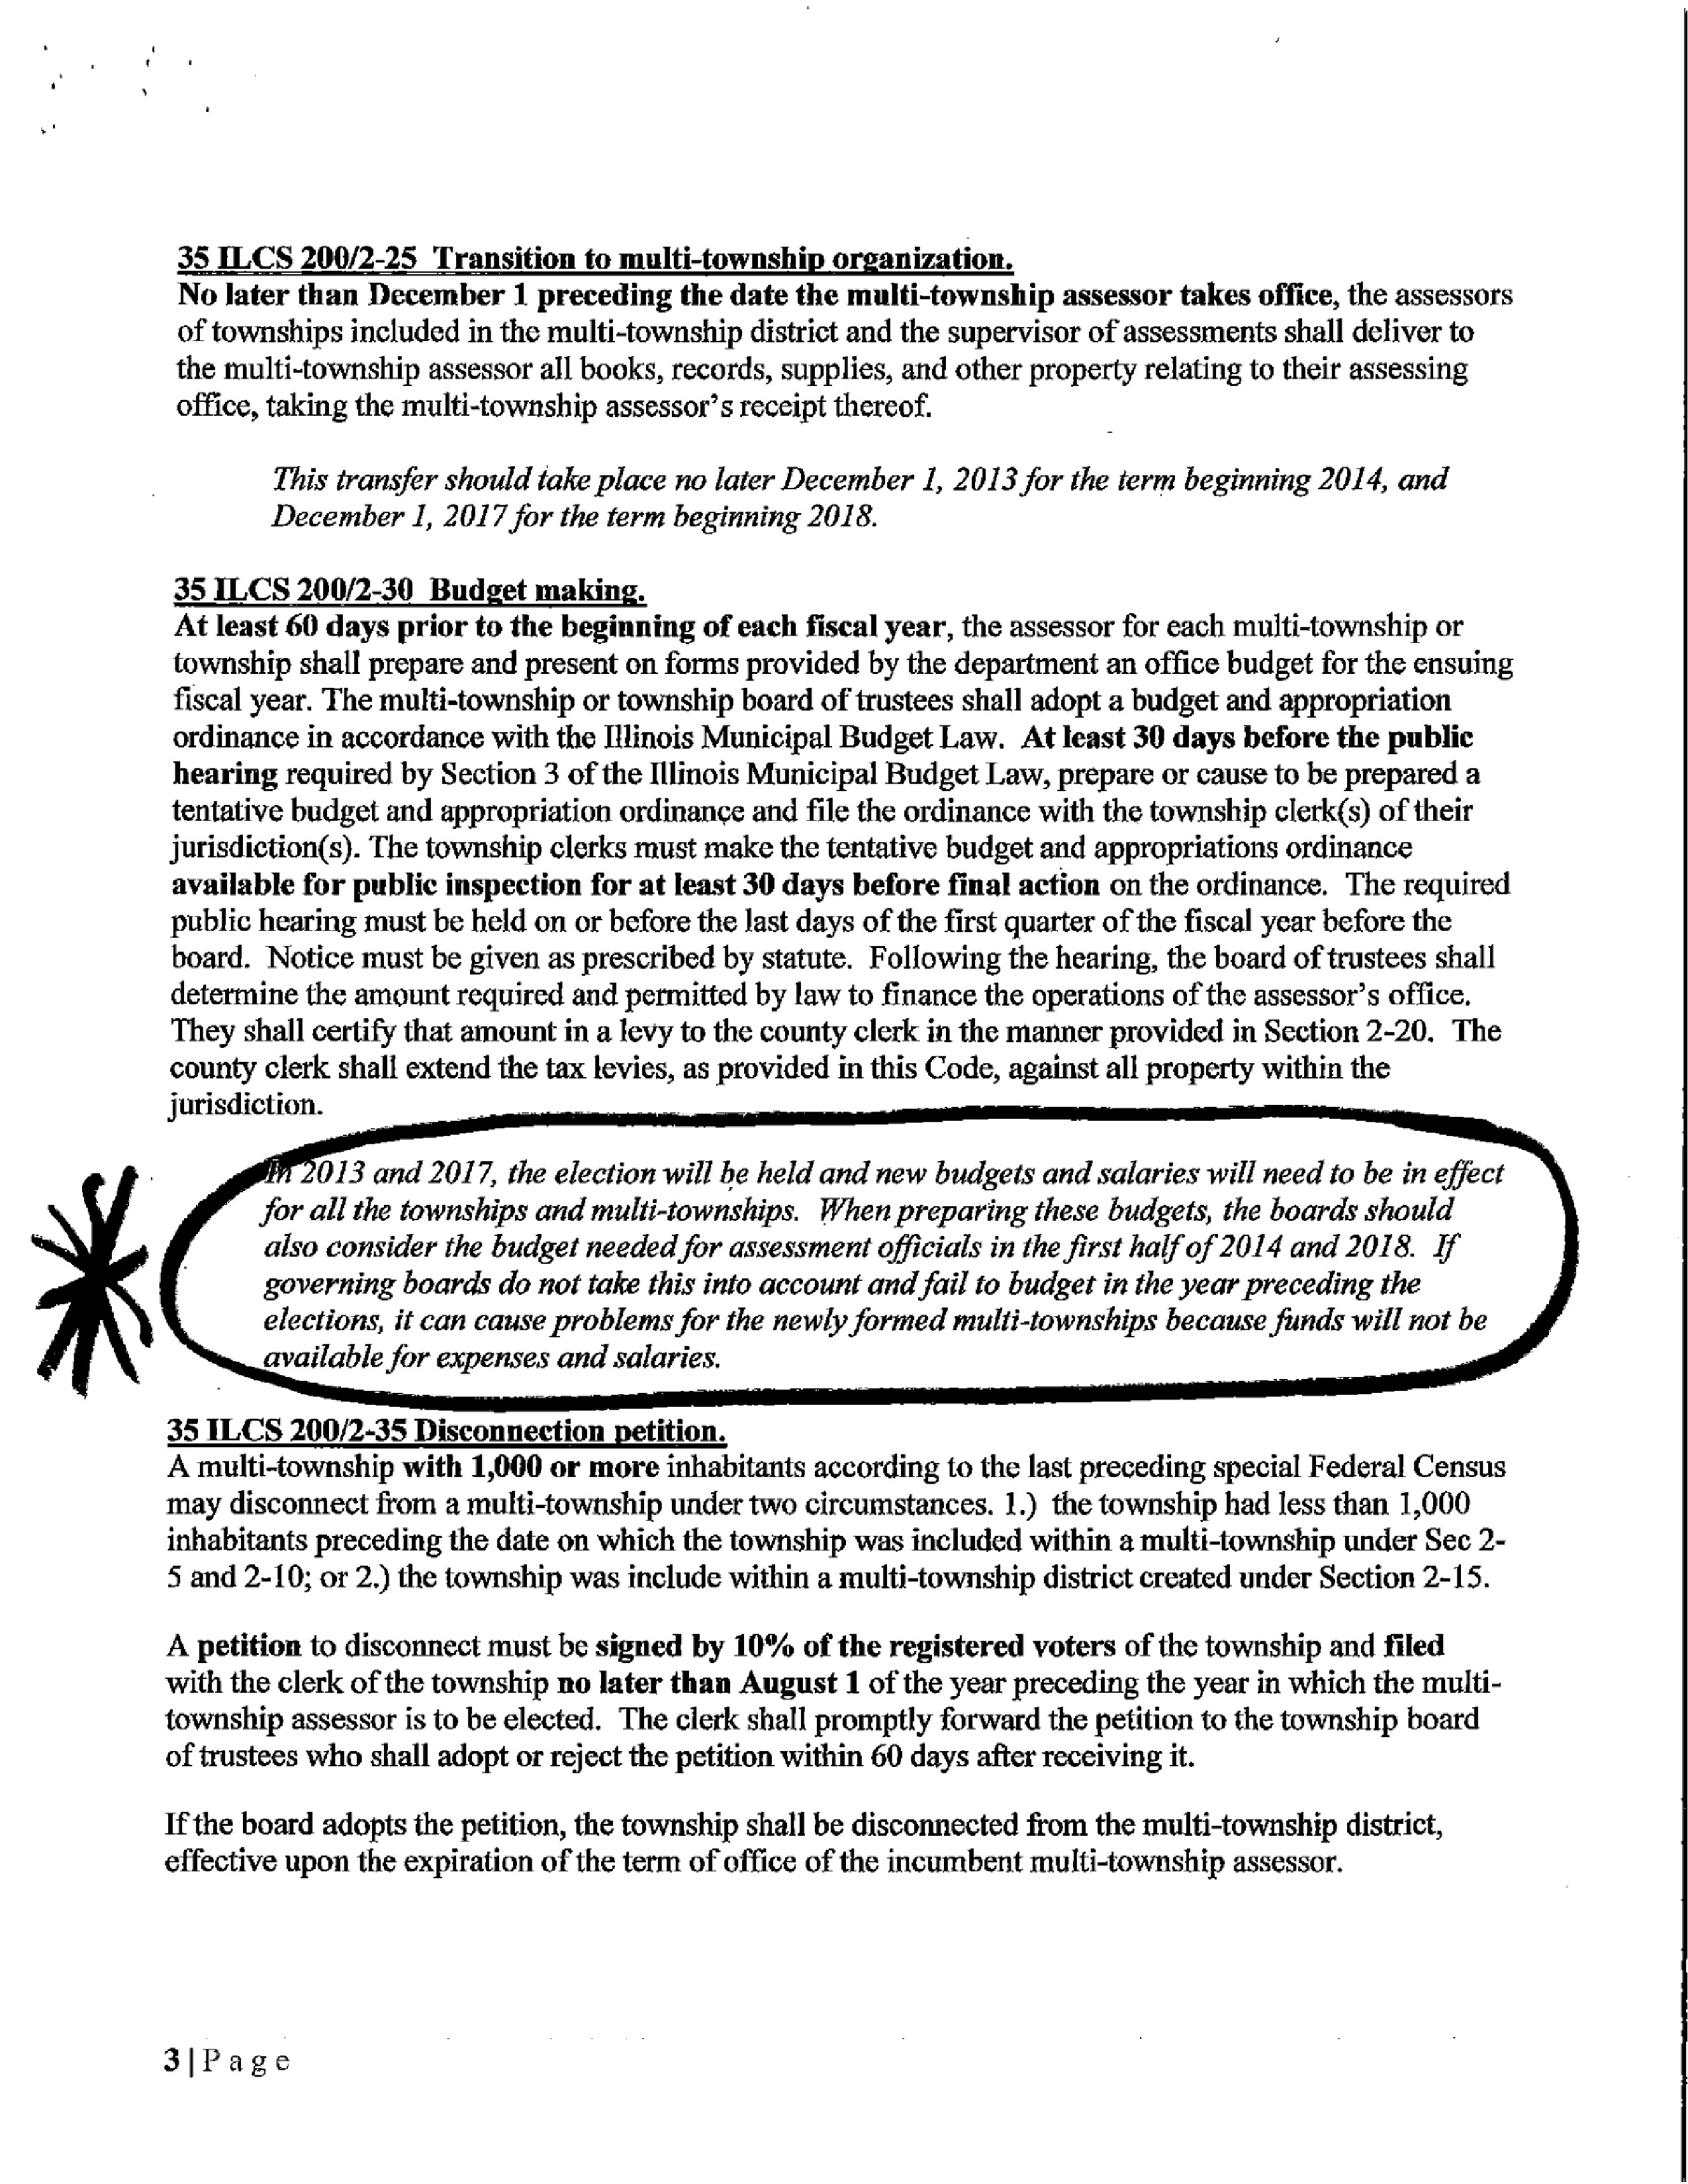
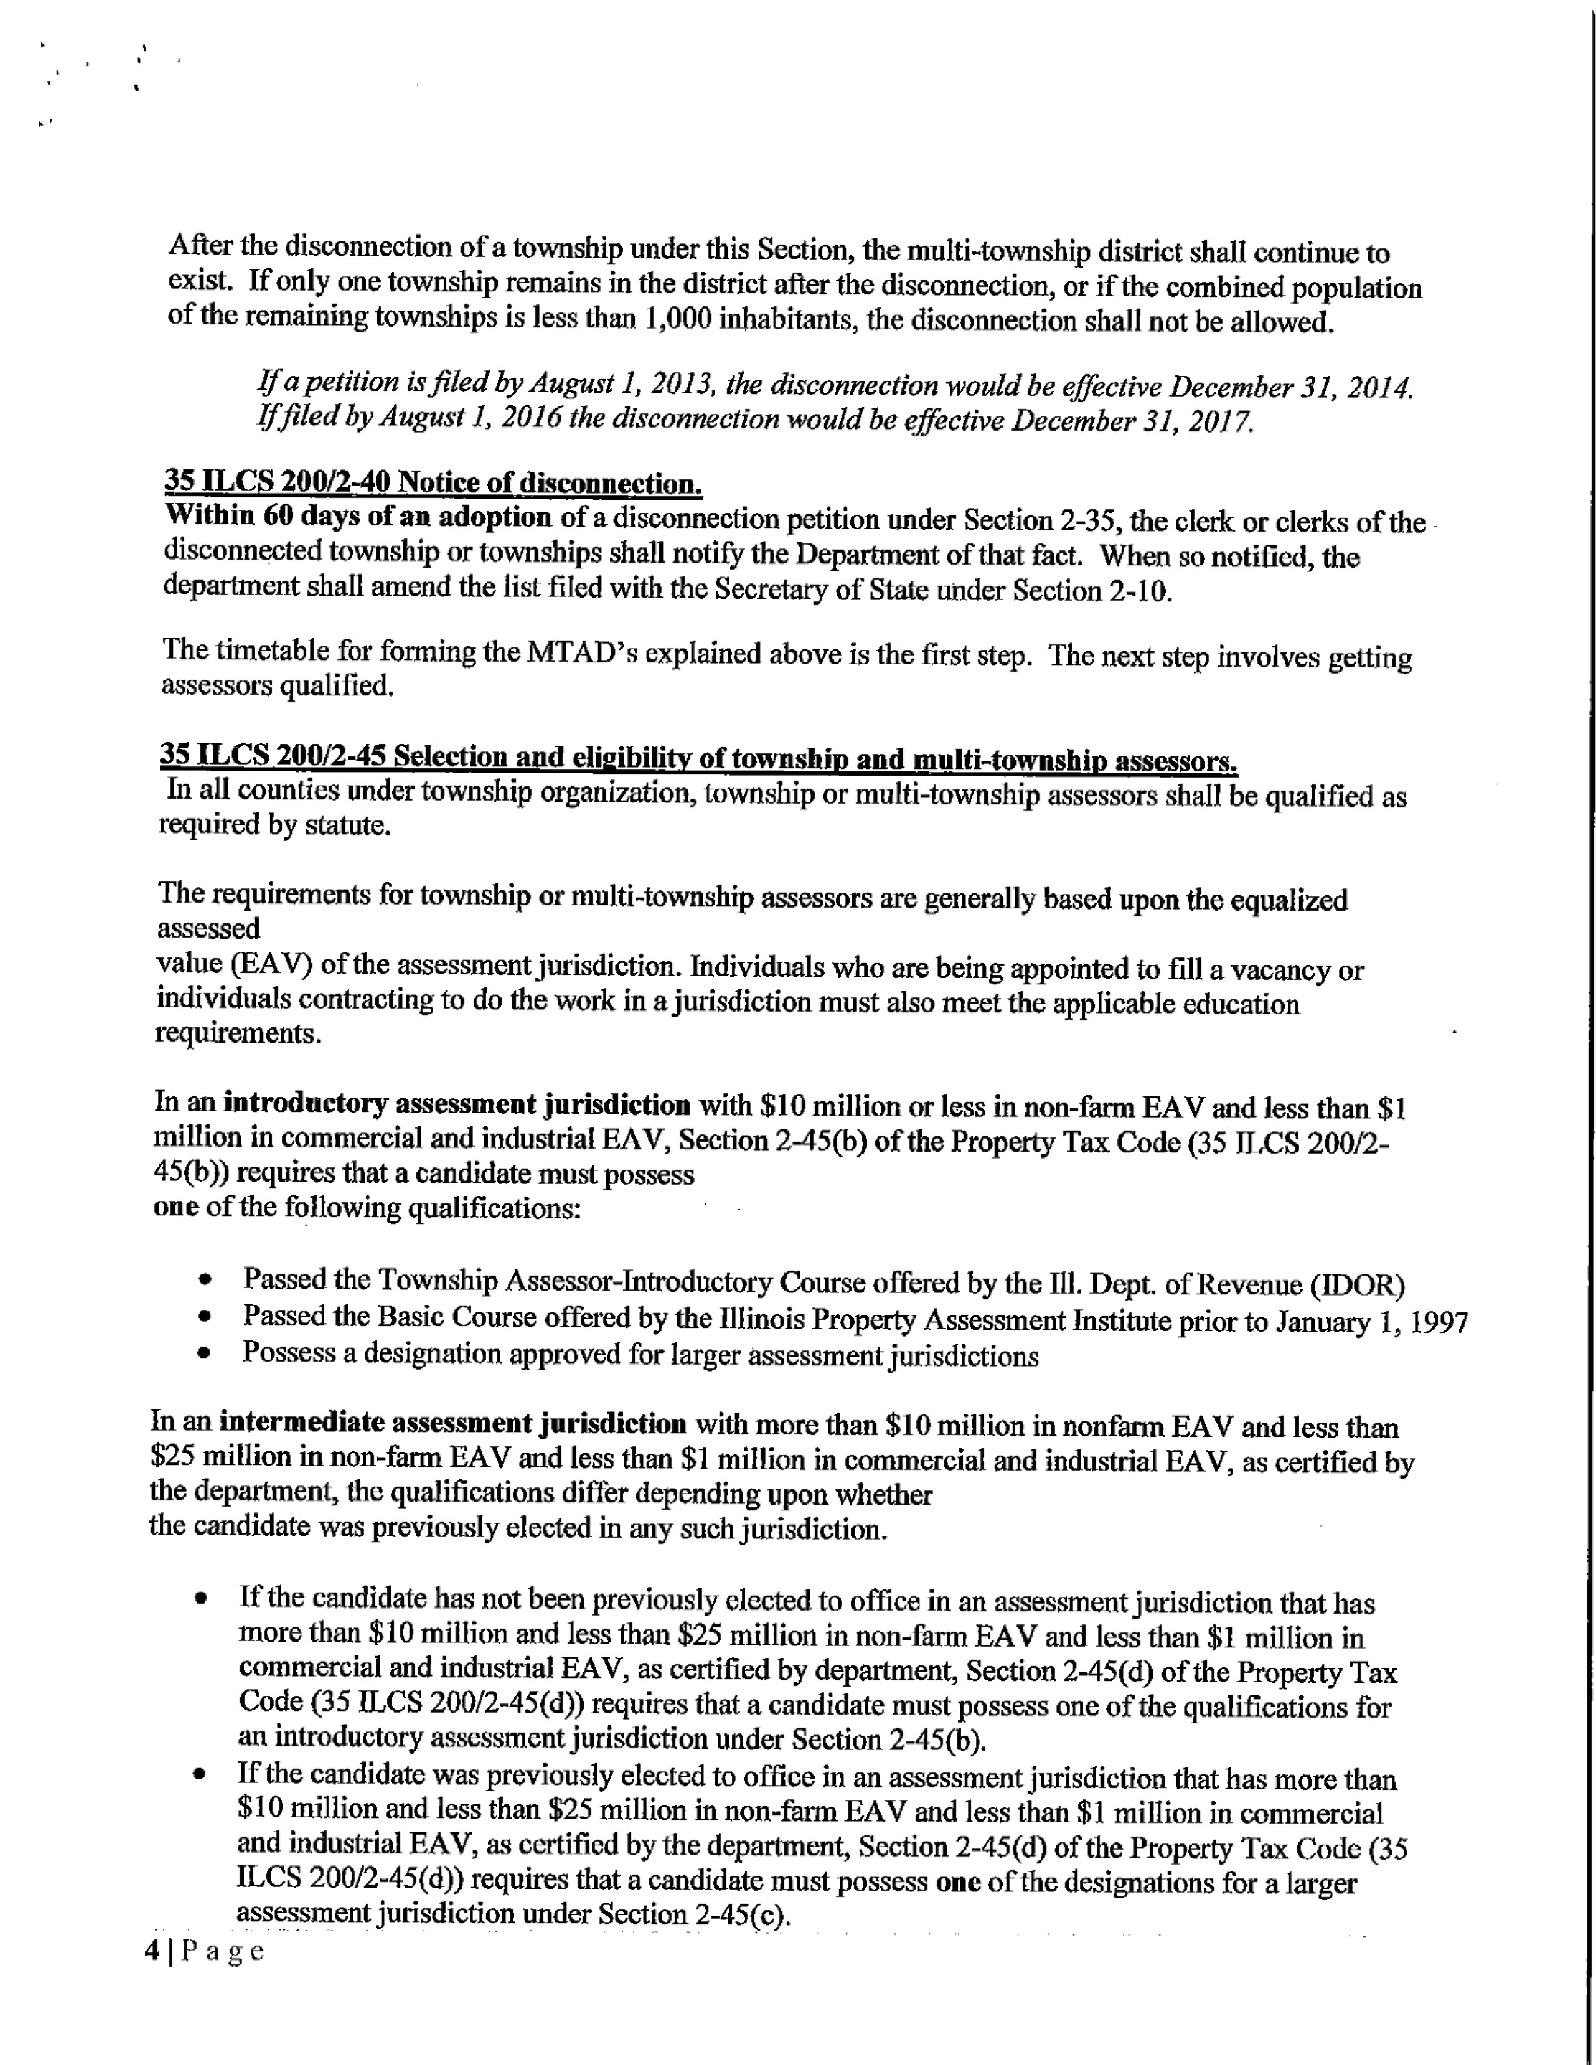
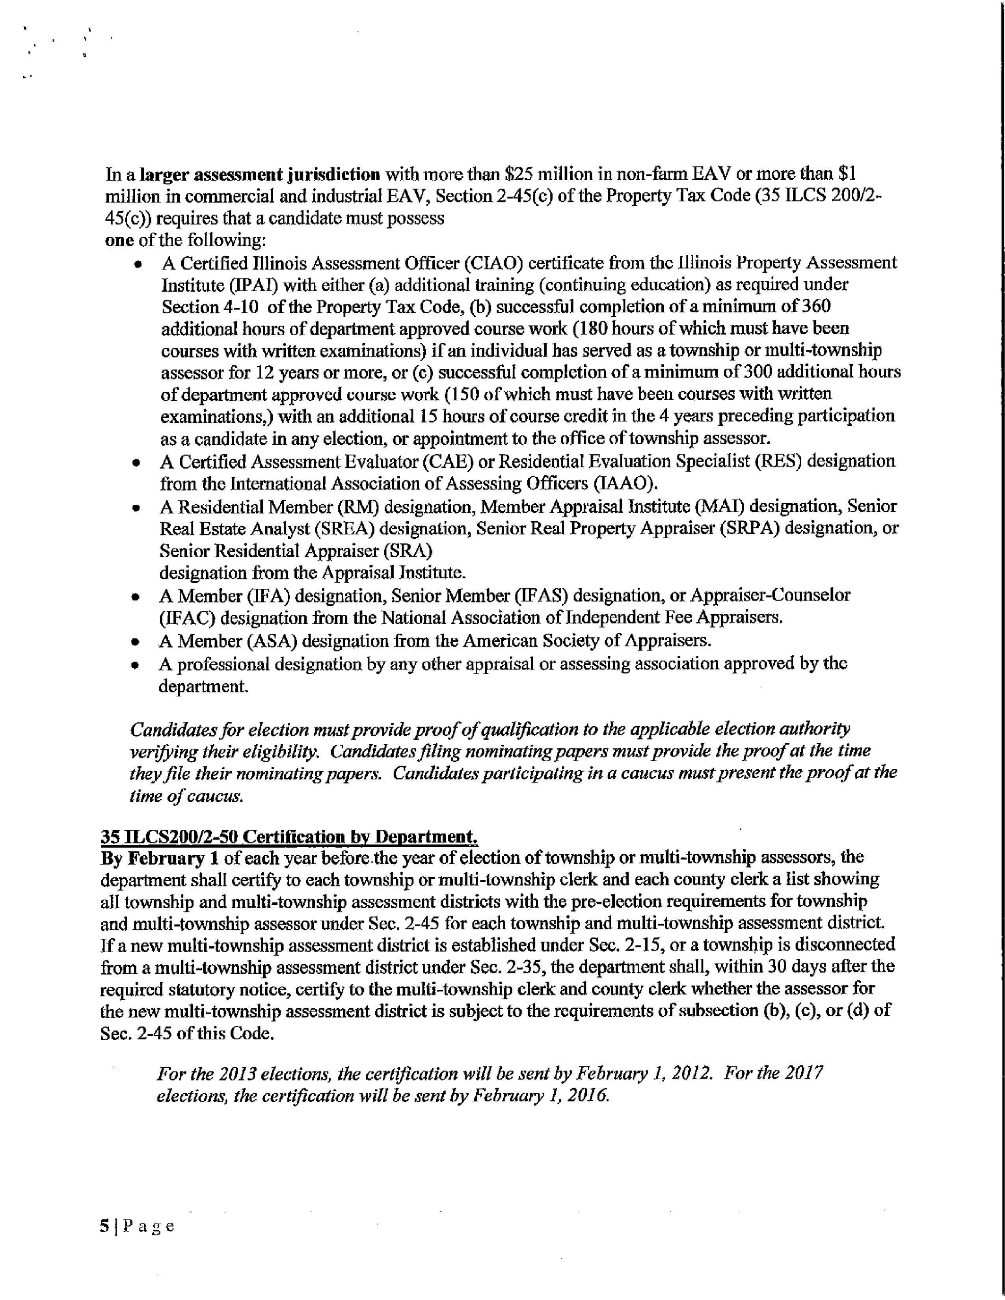
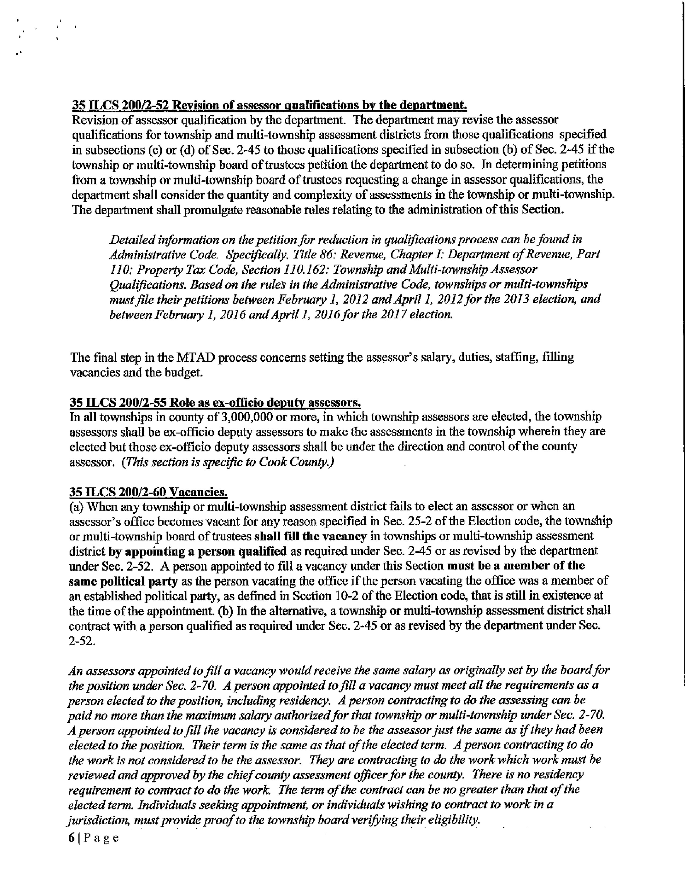
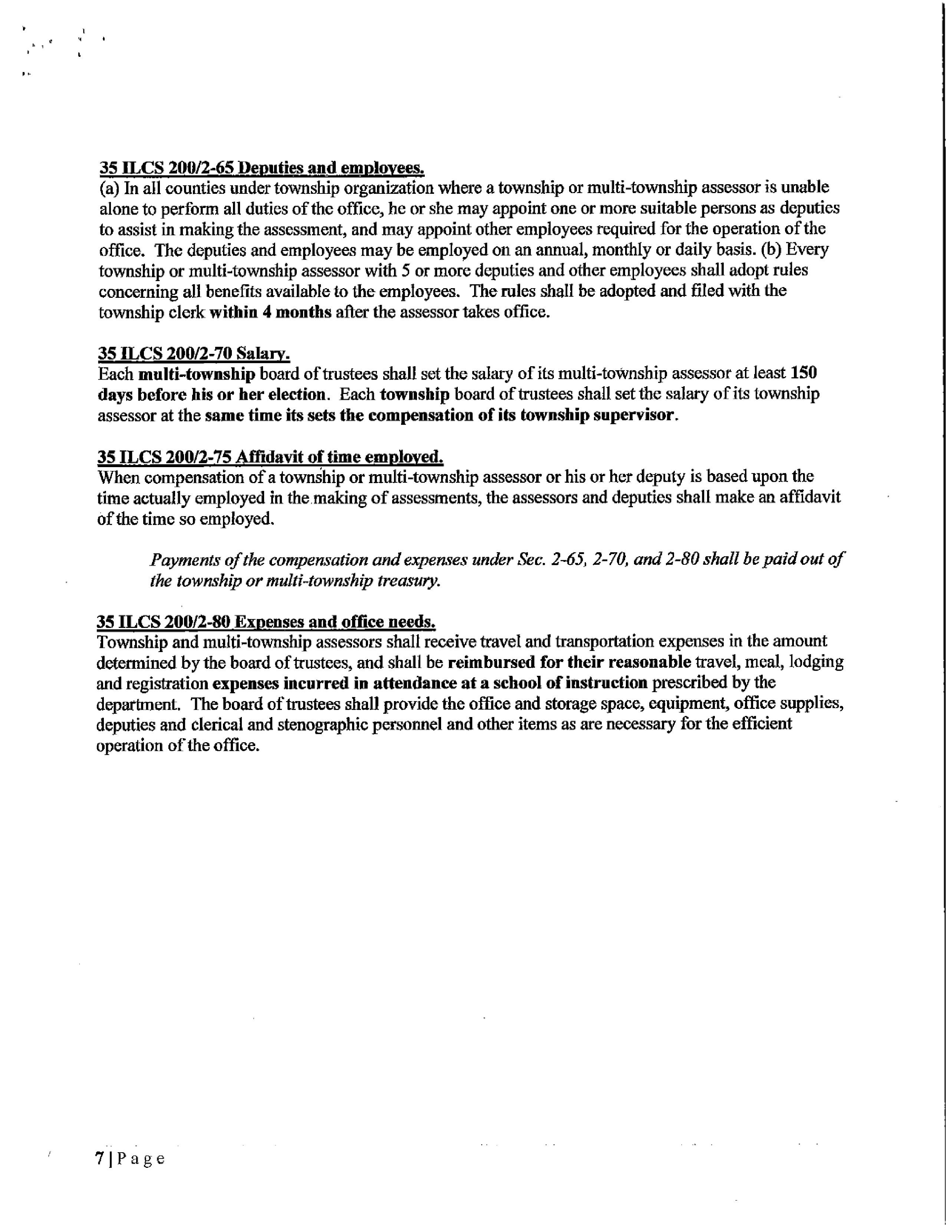

ETSB Committee:
The Pike County Emergency Telephone Systems Board met at 6:30 p.m. on Monday, January 14th, 2019 in the EOC room in the Pike County Jail. Those members present were Larry Bradshaw, Tom Lewis, Jon Fesler, Jason White, David Greenwood, Josh Martin and Jim Sheppard. Also present were Sandy Schacht and Stephanie Rinehart.

Routine bills in the amount of $155,980.10 on a motion by Bradshaw and a second by White.

Sandy Schacht reported that the new radio system had been installed but that we were holding the final payment until we got an issue with the tones worked out to our satisfaction. Dispatch is currently fully staffed and there would be a retirement in a few months which would leave an opening at that time.

Sandy Schacht then presented her letter of resignation as Pike County’s 911 coordinator. Sandy has held this position since 2003 and guided us through the development and implementation of our 911 system. The board thanked her for all of her hard work and dedication before Larry Bradshaw made a motion to accept the resignation. Tom Lewis seconded, motion carried with Jason White voting no.

The board then was presented with the new intergovernmental agreement between the Sheriff’s department and the ETSB. The updates are mostly cleaning up language but we had not had a new agreement since before we went online with the system. Jason White made a motion to approve the agreement and Tom Lewis seconded. Motion carried.

We next went into closed session. Larry Bradshaw made a motion to appoint Stephanie Rinehart as the interim 911 coordinator for six months with half of her overall pay coming from ETSB, Jason White seconded, motion carried.

Sandy Schacht had agreed to continue to handle IT issues with the 911 equipment and do the addressing. Tom Lewis made a motion to continue her stipend for those activities and Jason White seconded. Motion carried. This stipend is $4000.00 annually.

Next Meeting of ETSB will be March 11, 2019 at 6:30 p.m.

On a motion by Tom Lewis and a second by Josh Martin, meeting adjourned at 7:52 P.M.

A motion to approve the minutes was made by Carrie Martin and a second by John Birch. Voice vote wat 8-0, motion approved.

Labor Committee:
The third Collective bargaining meeting between the Pike County Bargaining Committee and the Courthouse Union representatives was on January 10th, 2019 at 10:00 a.m. in the basement of the Pike County Sheriff’s Department. Present were Rodger Hannel, Carrie Martin, Andy Borrowman, Chris Walters and Mark Mountain.

Several proposals were presented and countered by both sides concerning language and pay. After approximately one hour both sides agreed on a new contract, pending ratification by the employees and approval of the County Board.

At approximately 11:15 a.m. the bargaining meeting was complete. The Labor committee then discussed the possibility of a Resolution mandating department heads to establish Job descriptions for all positions in their department. The Committee agreed to have State’s Attorney draft a Resolution that the committee could review for possible full board approval.

Meeting ended at approximately 11:30 a.m.

A motion to approve the minutes as read was made by Carrie Martin and seconded by John Birch. Voice vote was 8-0, motion approved.

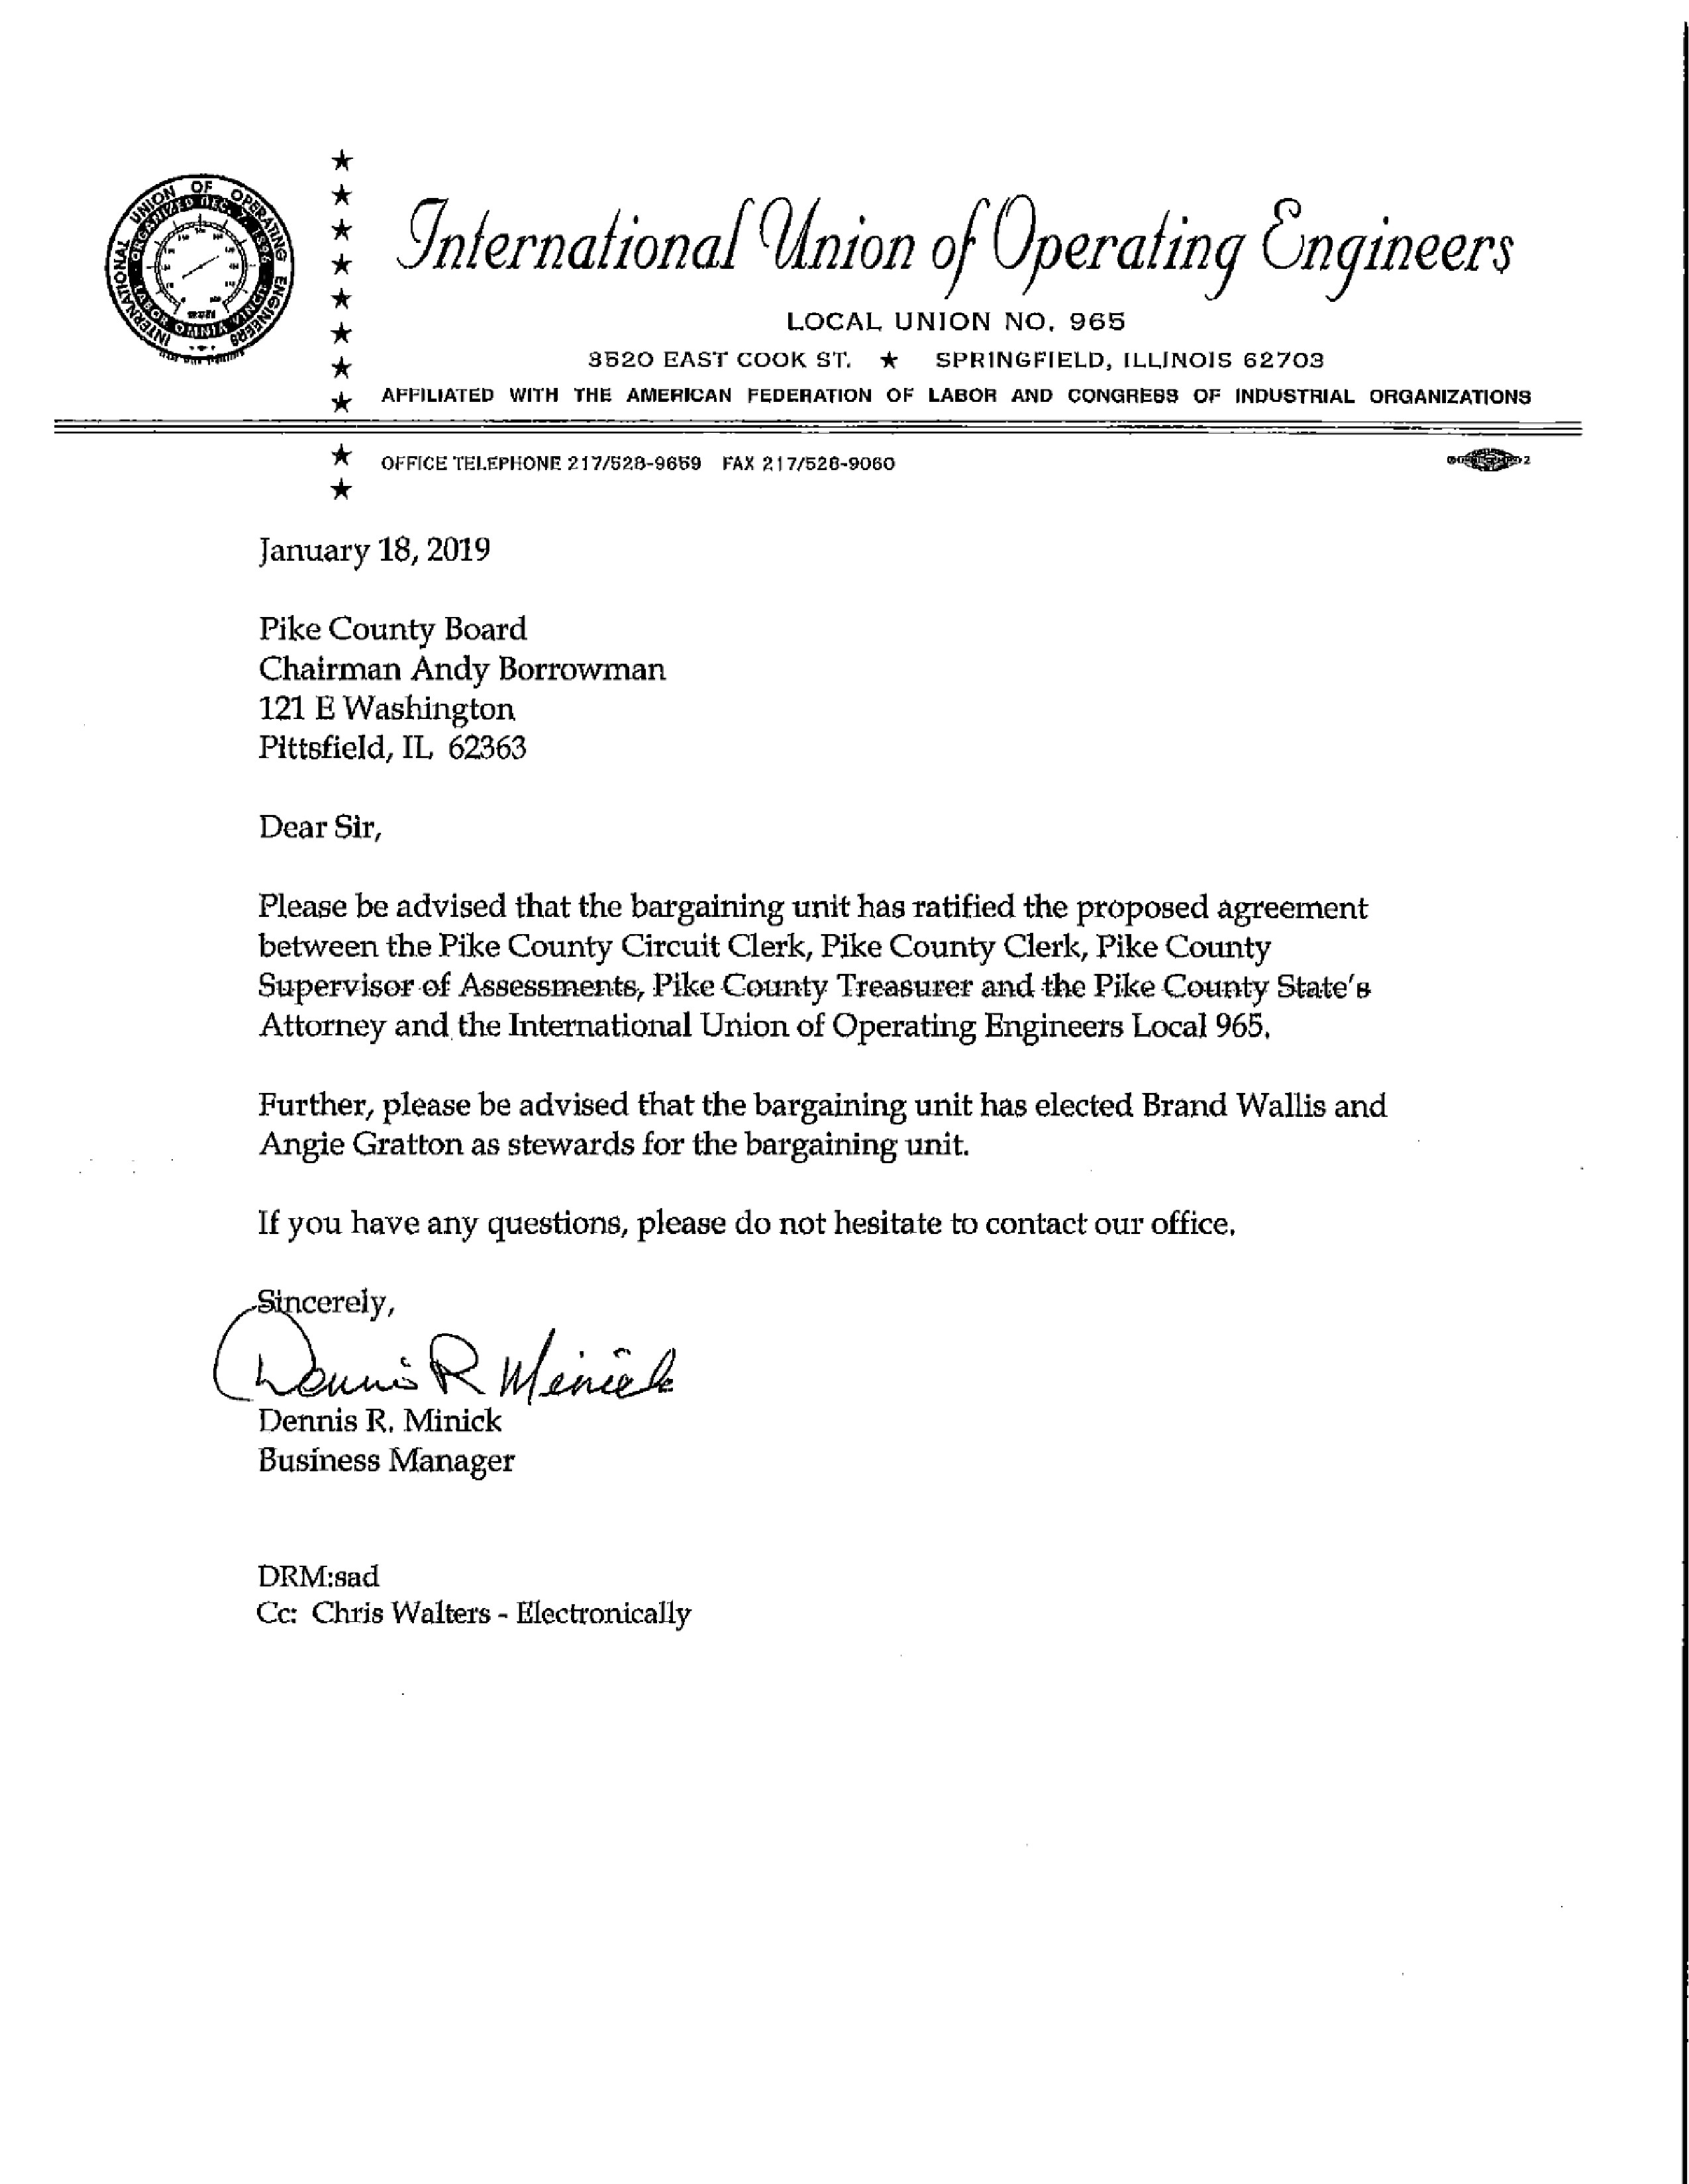
New Business

Jim Sheppard will set an Insurance meeting for the 3rd or 4th week in February. Tentatively the meeting is set for February 22nd, 2019 at 2:30 in the Government Building.

Motion made by Carrie Martin to schedule the Insurance Meeting, seconded by Amy Gates. Voice vote 8-0, motion carried.

Old Business

Mark Mountain brought up the change in the Meeting time from last month that was moved from the 4th Monday of the month to the 4Th Wednesday of the month. Mike Boren stated that meetings had typically been scheduled for the Monday time due to the press and being able to get the information by the Wednesday circular. Mike also stated that there are multiple church conflicts that night which Pike County State’s Attorney agreed would be a conflict for him also. Mr. Jerry Edison stated that Wednesday’s have historically been utilized for church nights and this would prevent some individuals from attending the meetings.

Rodger Hannel moved to change the meeting time from the 4th Wednesday of the month to the 4th Monday of the month. Mark Mountain seconded and the roll call vote was in favor 5-3, motion carried.

After the vote, Board Member Carrie Martin informed Board Chairman Andy Borrowman that he would need to look for her replacement as that day was not available to her due to her employment.

Chairman’s Remarks

None

Summary of Expenses for the Month/Mileage and Per Diem

Mark Mountain made a motion to approve the Summary of Expenses and the Mileage and Per Diem as amended (adding finance and including a present for GIS for Mark Sprague). John Birch seconded the motion and the voice vote was 8-0, motion passed.

Pike County Board Mileage & Per Diem
23-Jan-19
Board Meeting
December 26, 2018

John Birch 1 $57.09
Andy Borrowman 1 $61.45
Amy Gates 1 $71.80
Rodger Hannel 1 $71.80
Carrie Martin 1 $63.08
Mark Mountain 1 $68.53
Mark Sprague 1 $70.71
Derek Ross 1 $58.72
Jim Sheppard 1 $58.72
Total $589.53

Road and Bridge
January 9th, 2019

Andy Borrowman 1 $62.18
Rodger Hannel 1 $73.20
Mark Mountain 1 $69.72
John Birch 1 $57.54
Total $262.64

Finance
January 9th, 2019

Andy Borrowman 1 $12.18
Jim Sheppard 1 $58.72
Amy Gates 1 $71.80
Rodger Hannel P $21.80
Total $164.50

Labor
January 10th, 2019

Andy Borrowman 1 $62.18
Mark Mountain 1 $69.72
Rodger Hannel 1 $73.20
Amy Gates 1 $73.20
Total $278.30

Building and Grounds
January 16th, 2019

Andy Borrowman 1 $62.18
Rodger Hannel 1 $73.20
Carrie Martin 1 $63.92
Derek Ross 1 $67.40
Total $266.70

GIS
January 16th, 2019

Andy Borrowman P $12.18
Jim Sheppard 1 $59.28
Amy Gates 1 $73.20
Mark Sprague 1 $70.71
Total $144.66

Public Safety
January 16th, 2019

Andy Borrowman P $62.18
Carrie Martin P $13.92
Amy Gates P $23.20
Derek Ross P $17.40
Total $66.70

Agriculture
January 22nd, 2019

Andy Borrowman 1 $62.18
Mark Mountain 1 $69.72
Rodger Hannel 1 $73.20
Mark Sprague 1 $70.71
Total $275.81

Two Rivers
January 10th, 2019
John Birch 1 $108.00
Total $108.00

BILL BOARD REPORT
STATE OF ILLINOIS
COUNTY OF PIKE
PIKE COUNTY BOARD
December bills paid in January
MR. CHAIRMAN AND MEMBERS OF THE BOARD:
THE FINANCE COMMITTEE, PUBLIC SAFETY COMMITTEE AND THE BUILDING AND GROUNDS
COMMITTEE WOULD RESPECTFULLY SUBMIT THE FOLLOWING EXPENSE AND TOTALS THAT THE
COUNTY CLERK HAS BEEN DIRECTED TO ISSUE CHECKS FOR THE SAME.
BUILDING AND GROUNDS COMMITTEE |  |  |  |  |  |  |  | $116,835.20
PUBLIC SAFETY COMMITTEE |  |  |  |  |  |  |  | $109,683.41
FINANCE COMMITTEE |  |  |  |  |  |  |  | $68,940.03
GIS |  |  |  |  |  |  |  | $572.00
CORONER |  |  |  |  |  |  |  | $275.00
SHERIFF |  |  |  |  |  |  |  | $55,930.20
REGIONAL SUPERINTENDENT OF SCHOOLS |  |  |  |  |  |  |  | $7,775.63
COURTS |  |  |  |  |  |  |  | $4,365.00
PROBATION |  |  |  |  |  |  |  | $0.00
COUNTY BOARD |  |  |  |  |  |  |  | $122.00
COUNTY CLERK |  |  |  |  |  |  |  | $1,648.82
CIRCUIT CLERK |  |  |  |  |  |  |  | $1,621.97
STATES ATTORNEY |  |  |  |  |  |  |  | $1,521.97
STATE VITAL RECORDS |  |  |  |  |  |  |  | $8.00
TREASURER |  |  |  |  |  |  |  | $30.00
ZONING |  |  |  |  |  |  |  | $332.45
ESDA |  |  |  |  |  |  |  | $1,229.43
SUPERVISOR OF ASSESSMENTS |  |  |  |  |  |  |  | $804.56
CODE HEARING |  |  |  |  |  |  |  | $1,060.70
ANIMAL CONTROL |  |  |  |  |  |  |  | $1,629.36
PUBLIC DEFENDER |  |  |  |  |  |  |  | $251.73
RABIES |  |  |  |  |  |  |  | $45.90
LAW LIBRARY FUND |  |  |  |  |  |  |  | $1,632.50
COUNTY CLERK DOCUMENT STORAGE FUND |  |  |  |  |  |  |  | $0.00
COURT SYSTEM FUND |  |  |  |  |  |  |  | $0.00
CIRCUIT CLERK AUTOMATION FUND |  |  |  |  |  |  |  | $538.19
JUDICIAL SECURITY |  |  |  |  |  |  |  | $0.00
COUNTY TREASURER AUTOMATION FUND |  |  |  |  |  |  |  | $0.00
CIRCUIT CLERK DOCUMENT STORAGE FUND |  |  |  |  |  |  |  | $0.00
RECORDERS SPECIAL FUND |  |  |  |  |  |  |  | $0.00
STATES ATTORNEY AUTOMATION FUND |  |  |  |  |  |  |  | $0.00
REVOLVING LOAN FUND |  |  |  |  |  |  |  | $0.00
OPERATIONS & ADMIN FUND |  |  | (NON COMPUTER ACCT) |  |  |  |  | $0.00
GRAND TOTAL |  |  |  |  |  |  |  | $295,985.64

Motion to approve amended Mileage and Per Diem Reports made by Mark Mountain, seconded by John Birch. Voice vote 8-0, motion carried.

Questions from the Press and Visitors
Mike Boren inquired to Bryce Gleckler about employment changes within his office and Mr. Gleckler stated he replaced two individuals that have retired.
Brian Koeller inquired about well setbacks on personal property and limits.

Motion to approve made by Amy Gates, seconded by John Birch. Voice vote 8-0, motion carried.

Closed Session Pursuant of 5 ILCS 120/2(c)(11), Pending/Probably/Immanent litigation
Closed session was entered at 9:30 p.m. and ended at 10:30 p.m. Board Member Carrie Martin vacated the meeting and did not enter into closed session.

Motion made by Jim Sheppard to allow the Pike County State’s Attorney to talk with legal and make an offer to Mr. Owens’ Attorney for a possible resolution. Mark Mountain seconded, voice vote was 6-1. Motion carried.

Adjournment

A motion by Amy Gates to adjourn the meeting was made, seconded by John Birch. Voice vote of 7-0, motion carried and meeting adjourned at 10:34 p.m.

